PORTABLE MULTI-TENANT
SECURE HOSTING
Architecture Standard, Engineering Handbook, and Zero-Touch Automation Blueprint
Greenfield Reference Architecture
Government-aligned security zoning • vendor-neutral service contract • platform adapters • secure by default
Draft v1.0 | September 2026

Document Control
Field | Value
Document title | Portable Multi-Tenant Secure Hosting Handbook
Version | Draft v1.0
Status | Reference architecture and implementation blueprint
Audience | Enterprise architects, network/security architects, platform engineers, automation engineers, operations, security assessors, service owners
Primary purpose | Define a portable, secure-by-default multi-tenant hosting model and the controls required to implement it consistently across multiple platforms.
Normative vocabulary | SHALL = mandatory; SHOULD = recommended unless justified otherwise; MAY = optional.
Scope | Network and security architecture, platform realization, zero-touch provisioning, Terraform patterns, assurance, operations, governance, and lifecycle.
Out of scope | Application-specific architecture, product selection, firewall vendor selection, detailed site cabling, and platform licensing.
DESIGN INTENT
This handbook deliberately avoids inherited environment-specific naming, department names, existing VRF taxonomies, and legacy topology assumptions. It is a clean reference architecture derived from security boundaries, operational scale, portability, and automation requirements.

Revision History
Version | Date | Summary
1.0 | September 2026 | Initial complete handbook derived from the greenfield reference design.

Source and Standards Baseline
The handbook is architecture guidance. It is not a substitute for system categorization, a threat and risk assessment, the Information System Security Implementation Process (ISSIP), formal authorization, or product-specific security guidance. Requirements in this handbook should be tailored to the information system and documented when they differ from the baseline.
- Canadian Centre for Cyber Security ITSP.80.022 — Baseline Security Requirements for Network Security Zones, version 2.0.
- Canadian Centre for Cyber Security ITSG-33 — IT Security Risk Management: A Lifecycle Approach and its ISSIP annexes.
- Government of Canada Security Control Profile for cloud-based services at Protected B / Medium Integrity / Medium Availability (PBMM), where applicable.
- Current vendor and Terraform provider documentation for the implemented platforms. Provider capabilities change independently and must be validated at implementation time.

Executive Summary
This handbook defines a portable hosting architecture in which consumers request security and service outcomes rather than vendor-specific network constructs. A consumer specifies a tenant namespace, workload security domain, security profile, zone placement, workload networks, intended flows, shared services, external exposure, and availability requirements. A control plane validates that request, allocates addressing, derives routing, selects an authorized platform, invokes platform-specific Terraform adapters, validates the realized state, and produces evidence.
The architecture intentionally keeps the physical network stable. The physical fabric provides resilient IP transport and, where useful, EVPN/VXLAN transport. Tenant lifecycle, security-domain routing, workload microsegmentation, and most high-cardinality network state remain in the platform overlay. Inter-zone routing occurs through an explicit Zone Interface Point (ZIP) or security edge. A new tenant or workload should not normally require a switch configuration change.
Portability is defined as equivalent semantics and verified security outcomes, not identical topology. A Nutanix VPC, an NSX project/Tier-1 realization, and an OpenStack Neutron routing context can all implement the same portable Security Domain semantics without pretending that their native APIs are identical. Each platform must pass a common conformance suite before it is approved for a given assurance profile.
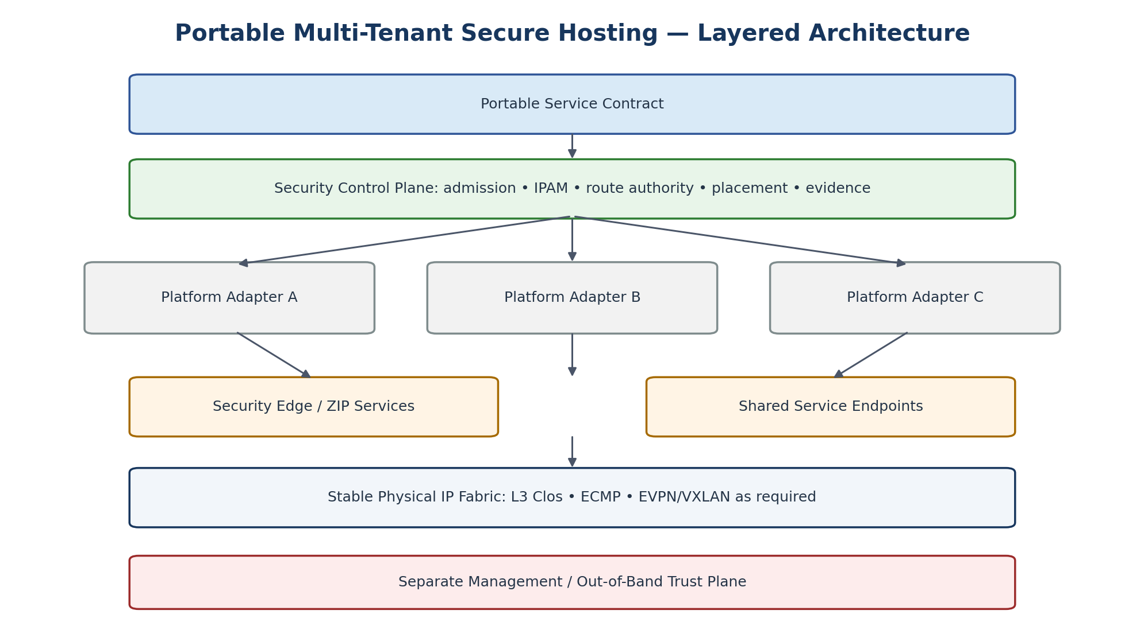
Figure 1. Layered reference architecture.
ARCHITECTURE IN ONE SENTENCE
The physical fabric carries connectivity; platform overlays create isolated routing domains; security edges enforce trust transitions; the service control plane decides what may exist; and automated tests prove the result.

Key Outcomes
- Secure-by-default tenancy: no public exposure, Internet egress, cross-tenant reachability, inter-zone reachability, management reachability, or arbitrary routing unless explicitly authorized.
- Government-aligned security zones and explicit ZIP-mediated trust transitions.
- Zero-touch provisioning through a vendor-neutral service contract and platform-specific Terraform adapters.
- Stable physical fabric with little or no per-tenant configuration.
- Portable service semantics across Nutanix, VMware/NSX, OpenStack, bare metal, and future platforms.
- Continuous conformance and evidence instead of treating successful provisioning as proof of security.
- Clear separation between data-path security, management/OOB, platform control, service consumption, and physical transport.

Table of Contents
Part I — Foundations | Part IV — Zero-Touch Automation and Terraform
1. Purpose, Scope, and Intended Use | 28. Canonical Hosting API
2. Normative Language and Architectural Invariants | 29. Zero-Touch Provisioning Workflow
3. Security Standards Context | 30. Terraform Architecture
4. Core Conceptual Model | 31. State Boundaries
5. Threat and Trust Model | 32. Policy as Code and Security Admission
Part II — Reference Architecture | 33. Secrets and Automation Credentials
6. High-Level Reference Architecture | 34. CI/CD and Change Gates
7. Tenant Namespace | 35. Drift and Reconciliation
8. Workload Security Domain | Part V — Assurance, Testing, and Operations
9. Security Domain Instance | 36. Assurance Profiles
10. Security Zone Semantics | 37. Conformance Test Framework
11. ZIP and Security Edge Architecture | 38. Deployment Evidence
12. Management and Out-of-Band Architecture | 39. Logging, Telemetry, and Observability
13. Physical Fabric | 40. Capacity and Performance Engineering
14. Platform Overlay Architecture | 41. High Availability and Failure Behaviour
15. Routing Architecture and Route Authority | 42. Backup and Restore
16. IP Address Management | 43. Incident Response and Containment
17. IPv6 and Dual-Stack | 44. Change and Exception Management
18. Shared Services and Service Bindings | 45. Lifecycle and Offboarding
19. Public Ingress and Internet Egress | 46. Migration and Transition Connectivity
20. Workload Microsegmentation | Part VI — Governance and Delivery
21. Multi-Site and Disaster-Recovery Network Design | 47. Operating Model and Separation of Duties
Part III — Platform Implementation Profiles | 48. Architecture Review Checklist
22. Portability and Platform Conformance | 49. Tenant / WSD Onboarding Checklist
23. Nutanix Implementation Profile | 50. Delivery Roadmap
24. VMware / NSX Implementation Profile | 51. Initial Reference Implementation
25. OpenStack Implementation Profile | 52. Architecture Acceptance Criteria
26. Bare Metal and Future Platforms | Appendices A–I — Object model • Terraform patterns • policy matrix • tests • evidence • ADR • glossary • requirements • references
27. Platform Capability Registry
NAVIGATION
The handbook uses Word heading styles throughout. The Navigation pane can be used for direct section navigation, and a dynamic Word TOC can be generated from Heading levels 1–3 if desired.

Part I — Foundations
Part I establishes the terminology, standards context, trust model, and architectural invariants that every implementation profile must preserve.

1. Purpose, Scope, and Intended Use
The purpose of this handbook is to define a reusable hosting architecture for multi-tenant virtualized and cloud-like environments while preserving Government network-security-zone semantics and minimizing dependence on any one virtualization or networking product.
The handbook is intended to be both normative and practical. Architecture requirements use SHALL/SHOULD/MAY language. Engineering sections explain how those requirements should be realized without turning any current product capability into an enterprise architecture dependency.

1.1 Intended Users
- Enterprise and solution architects
- Network and security architects
- Virtualization and private-cloud engineers
- Automation and Terraform engineers
- Security assessors and ISSIP practitioners
- Operations, SRE, incident response, and capacity teams
- Service owners and product managers

1.2 Design Constraints
ARCH-001 | The hosting contract SHALL be vendor neutral and SHALL NOT require consumers to specify vendor-specific identifiers or topology objects.
ARCH-002 | Routine tenant and workload lifecycle operations SHOULD NOT require changes to physical leaf or spine configuration.  Rationale: This keeps high-cardinality tenant state out of the fabric and is essential for scalable zero-touch operations.
ARCH-003 | All inter-zone paths SHALL be explicit and SHALL traverse the applicable ZIP/security edge.
ARCH-004 | Management/OOB traffic SHALL be separated from tenant operational traffic and SHALL have independently controlled access paths.

2. Normative Language and Architectural Invariants
Term | Meaning
SHALL / MUST | Mandatory requirement. Any deviation requires a documented exception.
SHOULD | Recommended default. A different choice requires documented rationale and equivalent assurance.
MAY | Optional implementation choice.
Consumer | Person, team, application pipeline, or service catalogue using the hosting service.
Provider | The hosting capability and its operations/control plane; not a specific commercial vendor.

2.1 Invariants
INV-001 | Tenant identity, security-zone identity, workload lifecycle, and platform realization are separate concepts.
INV-002 | A VPC, VRF, Tier-1 gateway, or Neutron router is an implementation mechanism, not the enterprise definition of a security zone.
INV-003 | Routes are derived from authorized intent; workload owners do not provide arbitrary route tables, BGP peers, route targets, or prefix imports/exports.
INV-004 | Shared services are exposed through explicit service bindings; broad reachability to a common-services supernet is not the default.
INV-005 | Portability means equivalent required outcomes and conformance, not identical topology.
INV-006 | A deployment is not Service Ready until realized state and security controls are verified.
INV-007 | Failure of an admission or control-plane dependency SHALL fail new changes closed; failure SHALL NOT silently create a security bypass.

3. Security Standards Context
ITSP.80.022 defines baseline network security zones including PAZ, OZ, RZ, HRZ, MZ and ZIPs. It also states that a zone does not need to map to a business function and that multiple zones may exist. The architecture therefore models security zones as reusable trust domains rather than organizational or service silos.
The handbook treats ITSG-33 as the lifecycle framework: security requirements are identified early, implemented through engineering controls, tested, operated, monitored, reassessed, and eventually disposed of securely. The architecture therefore includes evidence, drift, exception, change, and destruction workflows rather than ending at provisioning.
Where PBMM is applicable, it is treated as a security-control baseline that must be reused only in an appropriate context and tailored following analysis. The architecture therefore carries a Security Profile and Assurance Profile as explicit metadata instead of assuming that a single “Protected B network” topology is universally sufficient.
IMPORTANT
Network zoning is one component of the control set. The handbook does not claim that correct zoning alone establishes authorization for Protected B or any other security category.

4. Core Conceptual Model
The architecture separates administrative ownership, workload lifecycle, security-domain routing, and platform implementation. That separation is the key to both security and portability.
Concept | Purpose | Examples of Implementation
Tenant Namespace | Administrative ownership, quota, RBAC, accounting. | Prism project/RBAC; NSX project; Keystone project; external identity groups.
Workload Security Domain (WSD) | Lifecycle and security-policy unit for a workload or workload set. | Metadata, automation object, policy scope.
Security Domain Instance | An isolated routing/policy namespace associated with one zone class and authority scope. | Nutanix VPC; NSX Tier-1/project routing context; Neutron router/address domain.
Workload Network | Internetwork/segment in a Security Domain. | Overlay subnet; NSX segment; Neutron network/subnet.
Flow Intention | Desired communication outcome between identities/services. | Compiled to Flow/DFW/security-group/gateway rules.
ZIP / Security Edge | Controlled inter-zone path and boundary policy. | Firewall/security context, service insertion, routed security edge.
Service Binding | Explicit consumption of DNS, NTP, identity, logging, backup, etc. | Approved endpoint + route/policy generated by control plane.
Exposure | Approved connection to public, enterprise, partner, or other external domains. | Ingress service, controlled egress, external network attachment.

5. Threat and Trust Model
The design assumes that tenant workloads, platform APIs, external networks, shared services, and management systems do not share a single trust level. It assumes configuration mistakes, compromised workloads, over-permissive routes, provider drift, and operator error are realistic threats. Controls therefore aim to make unsafe connectivity structurally difficult rather than relying only on administrator discipline.

5.1 Principal Threats
- Cross-tenant lateral movement caused by route leakage, shared-policy mistakes, or permissive defaults.
- Inter-zone bypass caused by direct platform routing, generic transit VRFs, or broad shared-services reachability.
- Management-plane compromise through workload-to-management connectivity.
- Uncontrolled public ingress or Internet egress.
- IPv6 or alternate path bypass when only IPv4 is tested.
- Automation identities with excessive privileges or shared credentials.
- Configuration drift outside the infrastructure-as-code workflow.
- Failure-state bypass caused by security controls failing open.
- Platform portability claims that silently downgrade security on a less capable platform.

Part II — Reference Architecture

6. High-Level Reference Architecture
Figure 2. Reference architecture layers.
The service contract is the durable interface. The security control plane compiles desired state into a validated, routable, placeable design. Platform adapters translate that design into native provider resources. The security edge mediates trust transitions. The physical fabric carries traffic but is intentionally kept largely unaware of application and tenant lifecycle.
REF-001 | The service contract SHALL remain stable when a supported platform is replaced, provided the replacement platform passes the required conformance profile.
REF-002 | Platform-specific extensions MAY be offered, but they SHALL be declared as capabilities and SHALL NOT redefine the portable core semantics.

7. Tenant Namespace
A Tenant Namespace establishes administrative isolation. It is the root for RBAC assignments, quotas, ownership metadata, chargeback/showback, policy ownership, and service inventory. It is not automatically a single network or security zone.
Tenant Namespace SHALL define | Notes
Unique tenant identifier | Stable, non-semantic identifiers are preferred for automation.
Identity groups and roles | Mapped from enterprise identity; local break-glass accounts are exceptional.
Quota and entitlement | Compute, storage, network, public exposure, backup, and service limits.
Default security profile | May be overridden only by approved WSD policy.
Ownership metadata | Service owner, technical owner, security authority, cost centre/service code as applicable.
Lifecycle state | Requested, Active, Restricted, Suspended, Retiring, Retired.
TEN-001 | Cross-tenant routing SHALL be denied by default even when two tenants use the same zone class.
TEN-002 | Tenant administrators SHALL NOT have authority to modify provider management, security-edge infrastructure, physical fabric, or another tenant namespace.

8. Workload Security Domain
The WSD is the primary lifecycle object. It captures a workload’s required security and service intent without prescribing the implementation. A WSD can attach to one or more Security Domain Instances depending on its application topology.
WSD Attribute | Purpose
Security Profile | Control baseline and information-security context.
Assurance Profile | Required strength of physical/logical isolation.
Placement Profile | Authorized platforms, sites, availability, sovereignty and lifecycle constraints.
Networks | Workload internetworks and their zone association.
Flow Intentions | Explicit application communication requirements.
Service Bindings | DNS, NTP, identity, PKI, logging, backup and similar services.
Exposure | Internet/public, enterprise, extranet, partner, migration or other external connections.
Evidence Profile | Tests and evidence required before Service Ready.
WSD-001 | Every managed workload SHALL belong to a WSD or an explicitly documented equivalent lifecycle object.
WSD-002 | The WSD SHALL contain security and connectivity intent; it SHALL NOT contain vendor-specific infrastructure identifiers in the consumer contract.

9. Security Domain Instance
A Security Domain Instance is an isolated routing and policy namespace associated with a zone class, authority, platform/site realization, and assurance profile. Multiple WSDs may share an instance if the assurance profile permits and workload microsegmentation provides the required internal separation.
SecurityDomainInstance = {
zone_class = OZ | RZ | PAZ | HRZ | REZ | MZ
tenant_scope = <namespace or provider service scope>
platform = <placement result>
site = <failure domain>
assurance_profile = standard | enhanced | dedicated
address_scope = <IPAM authority>
routing_policy = derived
}
SDI-001 | A Security Domain Instance SHALL contain only networks authorized to share its routing/security authority.
SDI-002 | Sharing a zone class SHALL NOT imply reachability between independent Security Domain Instances.
SDI-003 | Dedicated Security Domain Instances SHOULD be available for workloads whose assurance profile or threat model requires stronger isolation than shared logical segmentation.

10. Security Zone Semantics
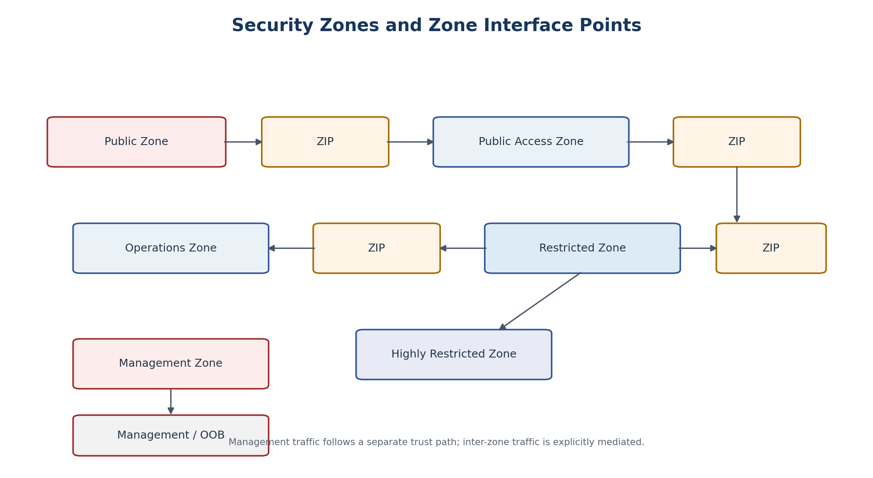
Figure 3. Zone classes and explicit ZIP-mediated transitions.
Zone | Primary Role in This Architecture
PAZ | Mediates access between public/external networks and internal services; appropriate place for WAF, reverse proxy, gateways and controlled external-facing functions.
OZ | Routine operational workload functions and application tiers where the applicable control set allows.
RZ | Concentrations of sensitive systems, repositories, critical server/data tiers and services requiring stronger protection.
HRZ | Higher-assurance environment when required by categorization/threat/risk.
REZ | Controlled extranet/partner interaction where applicable.
MZ | Dedicated administration environment separate from business service activity.
ZIP | Boundary system between two zones that enforces inter-zone communication policy.
INTERPRETATION
The zone class describes required trust semantics. The physical or virtual mechanism that realizes it is selected by the implementation profile and assurance requirements.

11. ZIP and Security Edge Architecture
The ZIP/security edge is the only default place where inter-zone routing is established. It combines routing context, stateful policy, inspection where required, logging, telemetry, management separation, and evidence. A generic transit VRF is not used as an alternate path between zones.
ZIP-001 | All inter-zone network paths SHALL traverse the applicable ZIP/security edge.
ZIP-002 | A ZIP SHALL identify both adjacent Security Domain Instances and SHALL NOT serve as a general-purpose third-zone transit domain.
ZIP-003 | Default inter-zone policy SHALL be deny; allowed flows SHALL be generated from approved Flow Intentions and Service Bindings.
ZIP-004 | ZIP management traffic SHALL be segregated from operational traffic.
ZIP-005 | Data-path ZIPs and management-path ZIPs SHALL be governed and deployed as distinct security services; shared virtualization SHALL only be used where the applicable assurance analysis supports it.

11.1 Multi-Tenant Security Edge
Shared security infrastructure may host multiple logical ZIP contexts. The sharing boundary is the infrastructure, not the routing/policy context. Each logical ZIP retains independent interfaces/VRFs or equivalent contexts, policy objects, logs, ownership, configuration and evidence.
Shared Component | Must Remain Isolated Per ZIP
Physical firewall/security cluster | Routing context / tenant virtual system or equivalent
Compute capacity | Policy objects and rule namespace
Logging transport | Log identity, tenant/context attribution, access controls
Management platform | RBAC scope and change authority
HA platform | Configuration and evidence state

12. Management and Out-of-Band Architecture
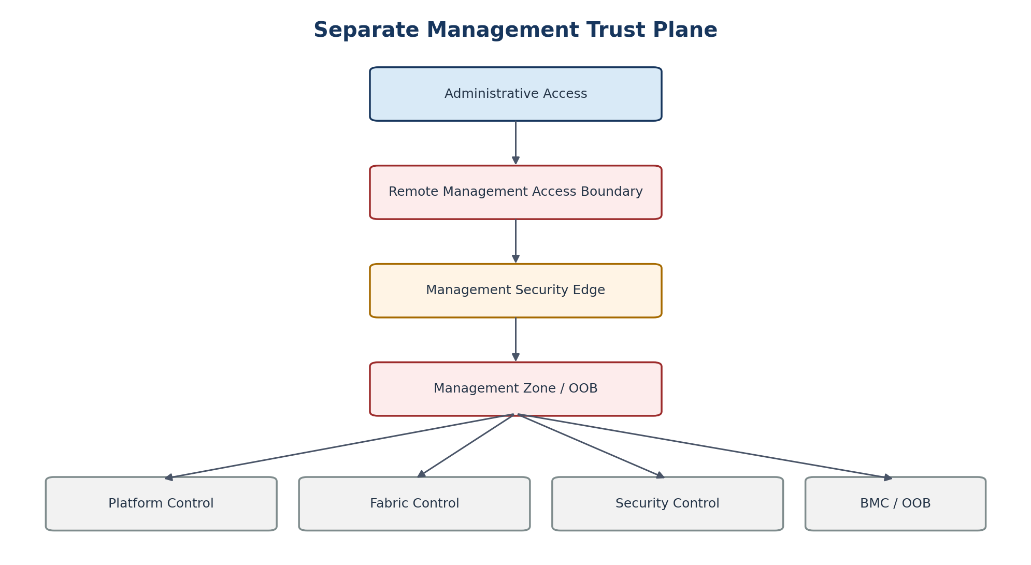
Figure 4. Management trust plane separated from workload data paths.
Management is not a normal workload service. The management plane hosts administration interfaces and control APIs for hypervisors, SDN systems, switches, firewalls/security appliances, BMCs, automation controllers, logging administration and other infrastructure components. Where hardware supports dedicated management interfaces, a physically separate OOB network is the preferred baseline.
MGT-001 | Tenant workload networks SHALL have no direct route to infrastructure management interfaces.
MGT-002 | Administrative access SHALL originate from an authorized management access path and traverse management-specific security controls.
MGT-003 | Automation identities used to manage tenant workloads SHALL be separated from identities able to modify the physical fabric, security edge, or management foundation.
MGT-004 | Break-glass access SHALL be separately controlled, strongly authenticated, logged, time-bounded where feasible, and periodically tested.

13. Physical Fabric
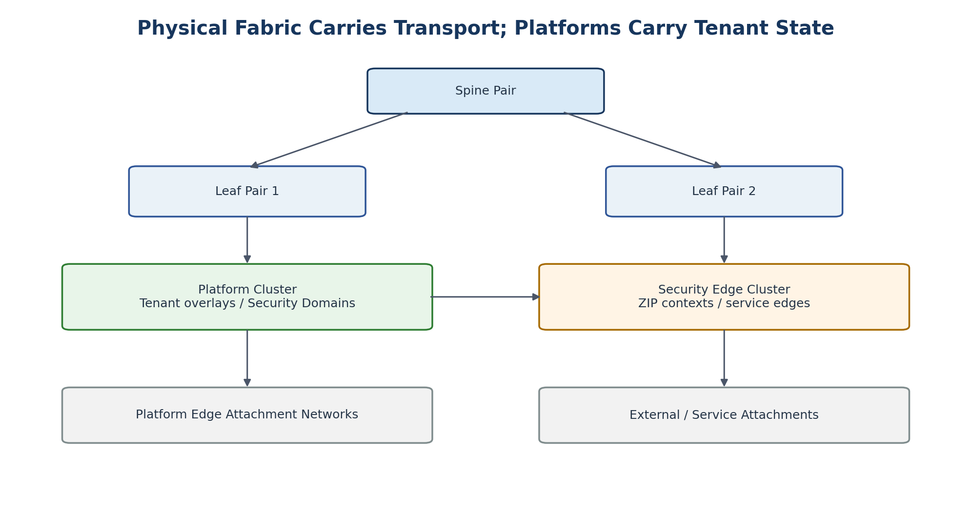
Figure 5. Stable physical fabric with platform and security-edge attachments.
The recommended network foundation is a routed L3 Clos fabric using ECMP, with EVPN/VXLAN employed where overlay transport or physical-service attachment requires it. The design goal is to prevent tenant scale from becoming switch-control-plane scale.
Physical Fabric Responsibility | Default
Resilient IP underlay | YES
ECMP path diversity | YES
EVPN/VXLAN transport where required | YES
HCI / platform attachment | YES
Security-edge attachment | YES
Per-tenant application policy | NO
Per-WSD firewall policy | NO
Routine per-tenant VRF provisioning | NO
Workload lifecycle | NO
FAB-001 | Normal creation, modification, and deletion of tenants, WSDs, workload networks, and workload security policies SHALL NOT require physical fabric changes.
FAB-002 | A physical VRF SHALL be created only when the physical fabric itself must provide L3 routing for a legitimate routing/security domain.
FAB-003 | Function names such as backup, migration, platform, ZIP, or generic transit SHALL NOT by themselves justify a VRF.

13.1 Acceptable Reasons for a Physical VRF
- Physical servers or appliances that must route within the same Security Domain Instance.
- A physical external/partner domain that must be kept separate from other routing authorities.
- A dedicated high-assurance domain whose architecture requires physical-fabric routing separation.
- A site/service architecture in which the fabric, rather than a platform overlay, is the authorized L3 realization.

14. Platform Overlay Architecture
High-cardinality tenant routing and segmentation should normally live in the platform overlay. Each approved platform implements the same Security Domain, Network, Flow, Service Binding and Exposure semantics using native constructs. The platform boundary is where tenant lifecycle changes should normally occur.
OVL-001 | A platform SHALL provide an isolated routing/policy mechanism capable of realizing the Security Domain semantics required by the applicable conformance profile.
OVL-002 | Internal routing inside one Security Domain MAY be provided natively by the platform; routing between different zone instances SHALL follow the security-edge path.

15. Routing Architecture and Route Authority
Routing is generated from security intent rather than accepted as arbitrary consumer input. The Route Authority consumes IPAM allocations, Security Domain membership, ZIP relationships, Service Bindings, External Exposure objects, site topology, and placement results to compile permitted routes and advertisements.
Consumer May Request | Consumer Shall Not Directly Control
“Connect this WSD to the approved identity service.” | Raw route to service subnet
“Allow approved Internet egress.” | 0.0.0.0/0 next-hop
“Expose HTTPS publicly.” | External BGP peer or route target
“Connect to approved enterprise service X.” | Arbitrary prefix import/export
“Enable migration connection for 72 hours.” | Permanent shared transit route
RTE-001 | Routes, route imports/exports, and BGP adjacencies SHALL be provider-controlled outputs of authorized intent.
RTE-002 | A generalized shared transit VRF SHALL NOT be used as a default inter-zone routing mechanism.
RTE-003 | Temporary migration or transition routes SHALL have explicit scope, approval, expiry, telemetry, and automated teardown.

16. IP Address Management
IPAM is an authoritative service, not a spreadsheet or module default. Terraform requests an allocation and records the resulting prefix; it does not choose arbitrary ranges. Unique addresses are the default because they simplify routing, observability, shared-service consumption, incident response, migration, and cross-platform operation.
Address Authority
└── Region / Site
└── Tenant Namespace
└── Security Domain Instance
└── Workload Network
├── IPv4 prefix
└── IPv6 prefix
IPAM-001 | Every managed network SHALL have an authoritative IPAM record and owner.
IPAM-002 | Overlapping address space SHALL be an explicit exception or migration pattern, not the standard tenancy model.
IPAM-003 | Address release SHOULD include quarantine/reuse controls appropriate to DNS, logging, firewall state, and incident-response requirements.

17. IPv6 and Dual-Stack
IPv6 must be part of the architecture from the beginning even where an initial release is IPv4-only. The service schema, security policy, routing authority, logging, conformance tests and evidence model must be capable of representing IPv6 so that an alternate protocol cannot become an ungoverned path.
IPV6-001 | Security semantics SHALL be equivalent across IPv4 and IPv6 unless an explicit, approved protocol-specific exception exists.
IPV6-002 | Conformance testing SHALL include IPv6 negative-path tests before a platform is certified for dual-stack service.

18. Shared Services and Service Bindings
Shared infrastructure functions such as DNS, NTP, identity, PKI, logging, monitoring, backup and KMS should be published as service endpoints rather than broad routable networks. A Service Binding is an explicit relationship between a consumer Security Domain and an approved service endpoint.
Service Binding Field | Example
Service identity | dns-resolver / ntp / identity / logging / backup
Consumer domain | Restricted-zone instance for workload X
Endpoint | Virtual IP, service address, proxy, gateway or service-specific attachment
Allowed direction | Consumer-to-service, service-to-consumer, or controlled bidirectional
Protocol/port | Derived from service profile
Logging | Mandatory / sampled / service-specific
Availability | Local, redundant, multi-site, or service-defined
Evidence | Reachability test + policy/config references
SVC-001 | Consumers SHALL NOT receive broad routing to a shared-services supernet solely because they consume one shared service.
SVC-002 | Where useful, shared services SHOULD expose zone-aligned endpoints so that consumption does not force unnecessary cross-zone routing.

19. Public Ingress and Internet Egress

19.1 Public Ingress
Public exposure is requested as a service outcome, not by creating an external interface in the workload network. The public-access implementation typically includes perimeter policy, a PAZ-hosted ingress function such as WAF/reverse proxy/load balancer where appropriate, and an explicit ZIP-controlled path to the internal application zone.
ING-001 | A workload SHALL NOT obtain direct public ingress by attaching its internal Security Domain directly to a public network.
ING-002 | Public exposure SHALL be represented by an Exposure object with owner, protocol, endpoint, certificate/DNS dependencies, logging, security profile, and lifecycle state.

19.2 Internet Egress
Internet egress is also an explicit service. No WSD receives a default Internet route unless its approved exposure/egress profile permits one. Egress may be mediated by proxy, NAT gateway, security edge, or another approved architecture depending on the platform and security profile.
EGR-001 | Internet egress SHALL be deny-by-default and enabled only through an approved egress profile.
EGR-002 | Egress telemetry SHALL permit attribution to the originating tenant/WSD and should preserve useful source identity where operationally feasible.

20. Workload Microsegmentation
A security zone may contain multiple internetworks. Microsegmentation is therefore the primary mechanism for separating applications and tiers that are allowed to reside in the same Security Domain Instance. Identity/metadata-based controls are preferred where platform capabilities support them because policy follows workload identity instead of depending only on addresses.
MICRO-001 | WSD-to-WSD and tier-to-tier communication inside a shared Security Domain SHOULD default to deny unless an approved policy permits it.
MICRO-002 | Platform metadata used for security policy SHALL be managed, validated, and protected from unauthorized tenant modification.

21. Multi-Site and Disaster-Recovery Network Design
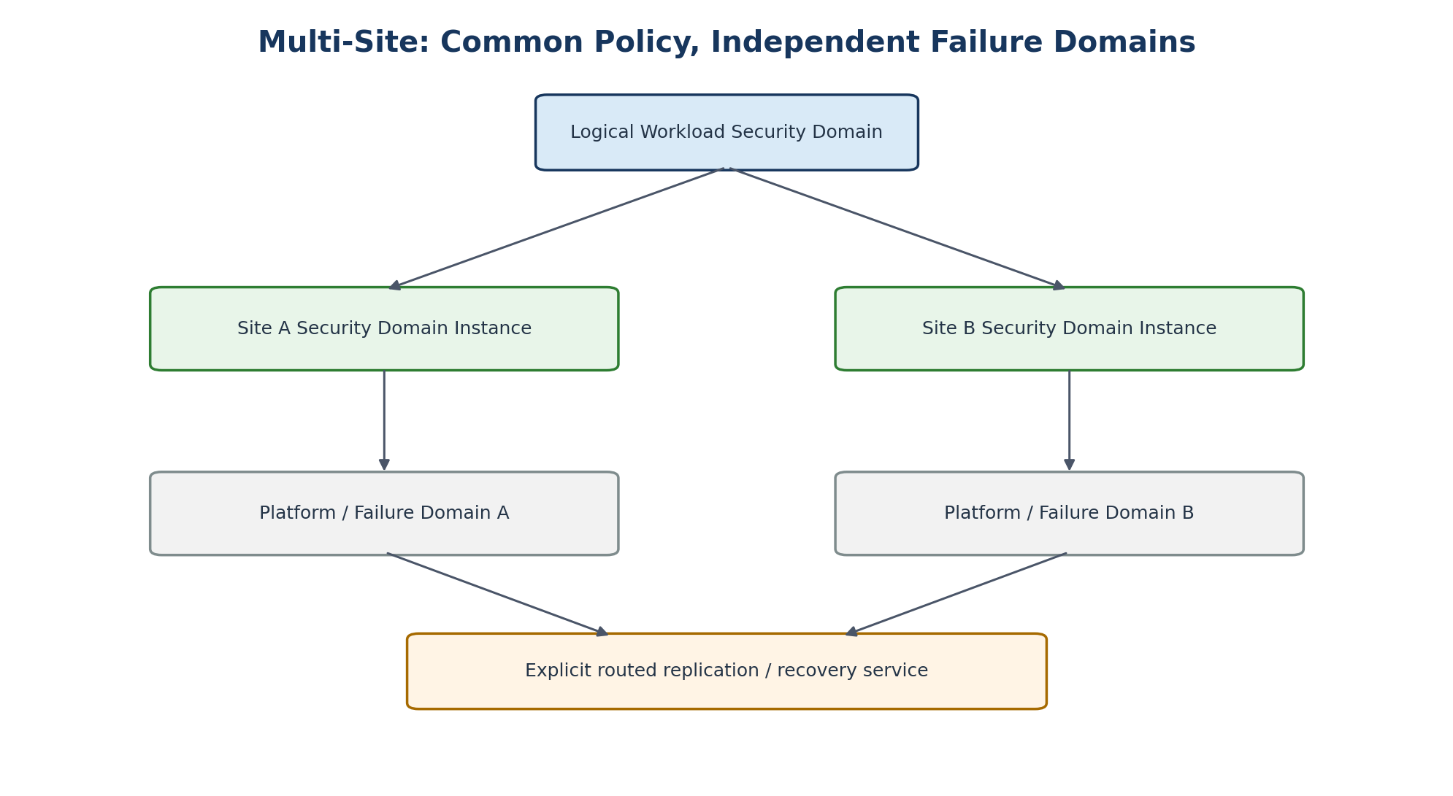
Figure 6. Common logical policy with site-local security and failure domains.
The logical WSD can span multiple sites while each site retains independent Security Domain Instances and failure domains. L2 stretch is not the default. Replication, recovery, application failover and migration should use explicit routed services whose security policy and capacity are independently tested.
SITE-001 | Security Domain Instances SHOULD be site-local by default.
SITE-002 | Layer-2 stretch across sites SHALL require a documented application/availability requirement and failure-domain analysis.
SITE-003 | Recovery-site connectivity SHALL be pre-authorized and tested; emergency recovery SHALL NOT depend on ad hoc route leaking.

Part III — Platform Implementation Profiles

22. Portability and Platform Conformance
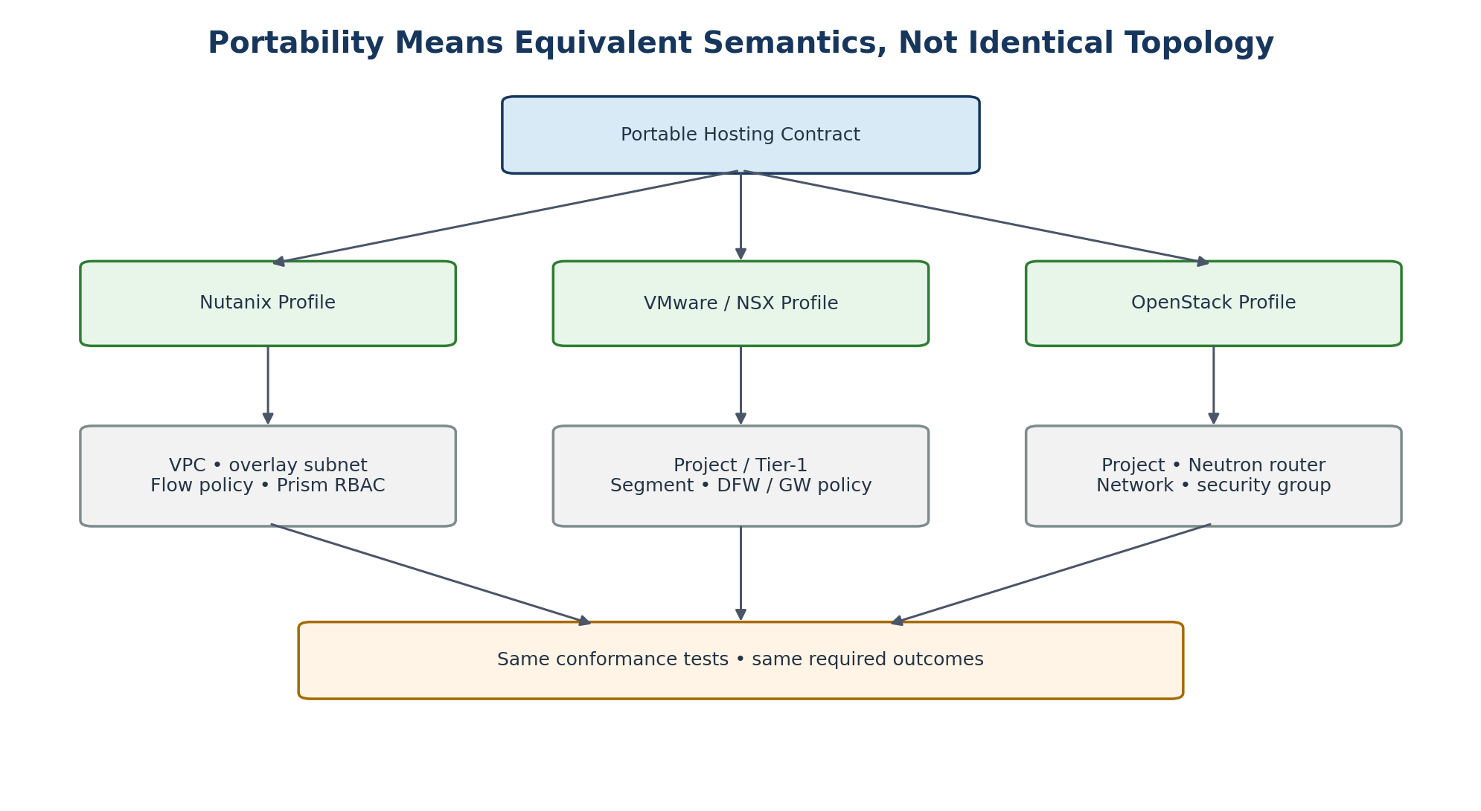
Figure 7. One portable contract, multiple native realizations.
Platform implementations do not need identical topology. They need to satisfy the same portable semantics and pass the same relevant conformance tests. This prevents the architecture from collapsing to the lowest common denominator while still preserving portability at the service layer.
PORT-001 | Every platform SHALL publish a machine-readable capability profile and a tested implementation profile.
PORT-002 | A placement decision SHALL fail rather than silently reduce a requested security or availability capability.
PORT-003 | Platform-specific features MAY be exposed as optional extensions provided the WSD declares the dependency and portability impact.

23. Nutanix Implementation Profile
Nutanix AHV with Flow networking/security is a natural implementation target because VPCs provide isolated IP environments with routed overlay subnets and the current Terraform provider exposes v2 resources for VPCs, subnets, routes/PBR, security policies and related constructs. The enterprise abstraction remains the Security Domain Instance; the VPC is the Nutanix realization.
Portable Concept | Nutanix Realization | Guidance
Tenant Namespace | Project/RBAC/categories and service metadata | Administrative isolation; do not equate project with zone.
Security Domain Instance | VPC | Default mapping for overlay-based tenant zone instance.
Workload Network | Overlay subnet | Address from IPAM; VNI is implementation detail.
Workload Identity | Categories / metadata | Provider-owned security scopes for mandatory controls.
Microsegmentation | Flow Network Security policy | Default deny between WSD/tier identities where required.
Zone edge | External subnet + routing/PBR as applicable | Connect toward security edge, not directly to a lower-trust domain.
Flow intention | Compiled network-security policy and/or ZIP policy | Native policy inside domain; ZIP policy between domains.

23.1 Nutanix Edge Attachment Strategy
Pre-provision platform edge attachment capacity during platform commissioning rather than creating a switch VLAN for every tenant VPC. Multiple VPCs may use standardized edge attachment networks where platform support and assurance permit. Higher-assurance WSDs can receive dedicated attachment contexts. The operational objective is that normal tenant creation causes no switch change.
NUT-001 | New Nutanix automation SHOULD use current supported v2/v4-backed provider resources where those resources satisfy the requirement; legacy resources require an explicit compatibility rationale.
NUT-002 | Nutanix VPC internal routing SHALL NOT be used to bypass a required inter-zone ZIP.
NUT-003 | Provider-managed categories/metadata used for security SHALL be protected from tenant modification.

24. VMware / NSX Implementation Profile
The complete portable networking/security profile requires NSX or an equivalent SDN/security layer; plain vSphere networking alone should not be assumed to provide the same tenant and policy semantics. NSX projects, Tier-1 contexts, segments, distributed security policy and gateway policy can be mapped to the portable model.
Portable Concept | NSX Realization
Tenant Namespace | NSX Project / IAM mapping
Security Domain Instance | Project-scoped Tier-1 / routing context
Workload Network | Segment
Microsegmentation | Distributed Security Policy
Zone edge | Gateway Policy / Edge services
Metadata | Tags / Groups
Workload placement | vSphere compute + NSX network context
NSX-001 | An NSX implementation SHALL keep tenant/project policy distinct from provider/global management and security policy.
NSX-002 | Gateway policy used for zone transitions SHALL be generated from portable Flow/ZIP intent rather than manually duplicated per workload.

25. OpenStack Implementation Profile
OpenStack maps the model to Keystone administrative tenancy and Neutron networking. Neutron networks/subnets, routers, security groups and provider/external networks can realize the portable constructs, subject to the capabilities enabled in the specific OpenStack distribution.
Portable Concept | OpenStack Realization
Tenant Namespace | Keystone project
Security Domain Instance | Neutron router/address/routing context
Workload Network | Neutron network and subnet
Microsegmentation | Neutron security groups
External attachment | Router/provider network
Compute | Nova
Storage | Cinder
Metadata | Project/resource tags and orchestration metadata
OS-001 | Default OpenStack security-group behaviour SHALL be reviewed and normalized to the secure-by-default service baseline.
OS-002 | Provider networks and external-router capabilities SHALL remain provider controlled and SHALL not become unrestricted tenant escape paths.

26. Bare Metal and Future Platforms
Bare-metal and future platforms can participate when they can realize the same semantics. A physical VRF may become the Security Domain implementation if the fabric must provide L3 routing for the physical systems. The portable API does not change; only the implementation profile changes.
FUT-001 | A new platform SHALL pass the applicable conformance suite before it is approved for production placement.
FUT-002 | A platform SHALL declare unsupported capabilities explicitly; unsupported capabilities SHALL NOT be emulated by weakening a mandatory control.

27. Platform Capability Registry
platform_profile:
network_domain: true
ipv4: true
ipv6: true
distributed_firewall: true
gateway_policy: true
dynamic_routing: true
service_insertion: false
native_load_balancer: true
dedicated_edge_context: true
audit_logging: true
tested_assurance_profiles:
- standard
- enhanced
The capability registry is an input to placement. Capability assertions must be backed by test evidence and version-specific implementation documentation. A provider upgrade can invalidate a previously certified capability until regression tests are complete.

Part IV — Zero-Touch Automation and Terraform

28. Canonical Hosting API
The portable API is the consumer-facing contract. It is versioned independently of platform modules and expresses desired outcomes. A schema registry validates syntax and semantic compatibility before platform selection.
apiVersion: hosting.platform/v1
kind: WorkloadSecurityDomain
metadata:
tenant: tenant-001
name: application-prod
security:
profile: protected-b-medium
assurance: standard
placement:
platform: auto
availability: medium
zones:
operations: { enabled: true }
restricted: { enabled: true }
networks:
frontend: { zone: operations, ipv4PrefixSize: 24, ipv6: true }
database: { zone: restricted, ipv4PrefixSize: 24, ipv6: true }
services:
dns: true
ntp: true
identity: true
logging: true
backup: true
flows:
- { source: frontend, destination: database, service: database }
exposure:
publicIngress: false
internetEgress: false
API-001 | The portable API SHALL be versioned and backward-compatibility rules SHALL be published.
API-002 | Vendor identifiers, VLAN/VNI/VRF details, route targets, raw firewall rules and raw next-hop routes SHALL NOT be part of the normal consumer contract.

29. Zero-Touch Provisioning Workflow
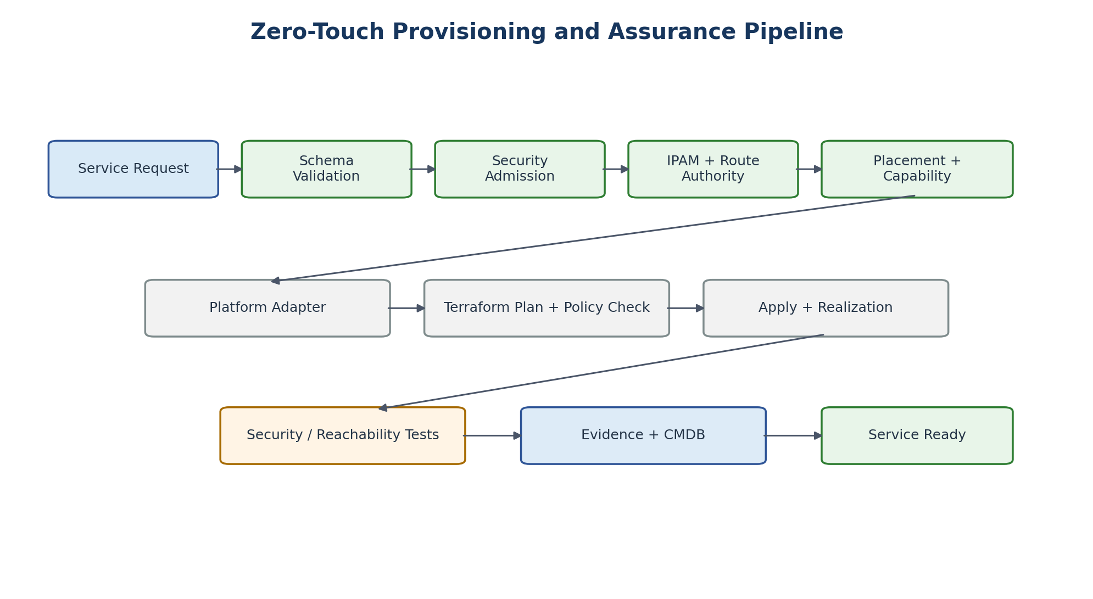
Figure 8. Provisioning is complete only after realization, testing, and evidence.
- Receive a versioned WSD request from a service catalogue or API.
- Validate schema, naming, ownership, quotas, and lifecycle metadata.
- Apply security admission rules to zone topology, exposure, required services, and requested flows.
- Allocate IPv4/IPv6 prefixes and reservations from authoritative IPAM.
- Compile route intent through the Route Authority.
- Evaluate platform capabilities, security authorization, site constraints, capacity, lifecycle and availability.
- Select the platform adapter and construct the Terraform root stack.
- Run terraform plan and policy-as-code checks; require approval where the change class requires it.
- Apply using a least-privileged execution identity.
- Wait for platform realization/readiness rather than treating API acceptance as completion.
- Run security, route, reachability, logging and negative-path tests.
- Generate evidence and register the realized service in inventory/CMDB.
- Mark the WSD Service Ready only when mandatory gates pass.
AUTO-001 | If security admission, IPAM, route authority, or mandatory policy validation is unavailable, new provisioning SHALL stop rather than inventing or bypassing required state.

30. Terraform Architecture
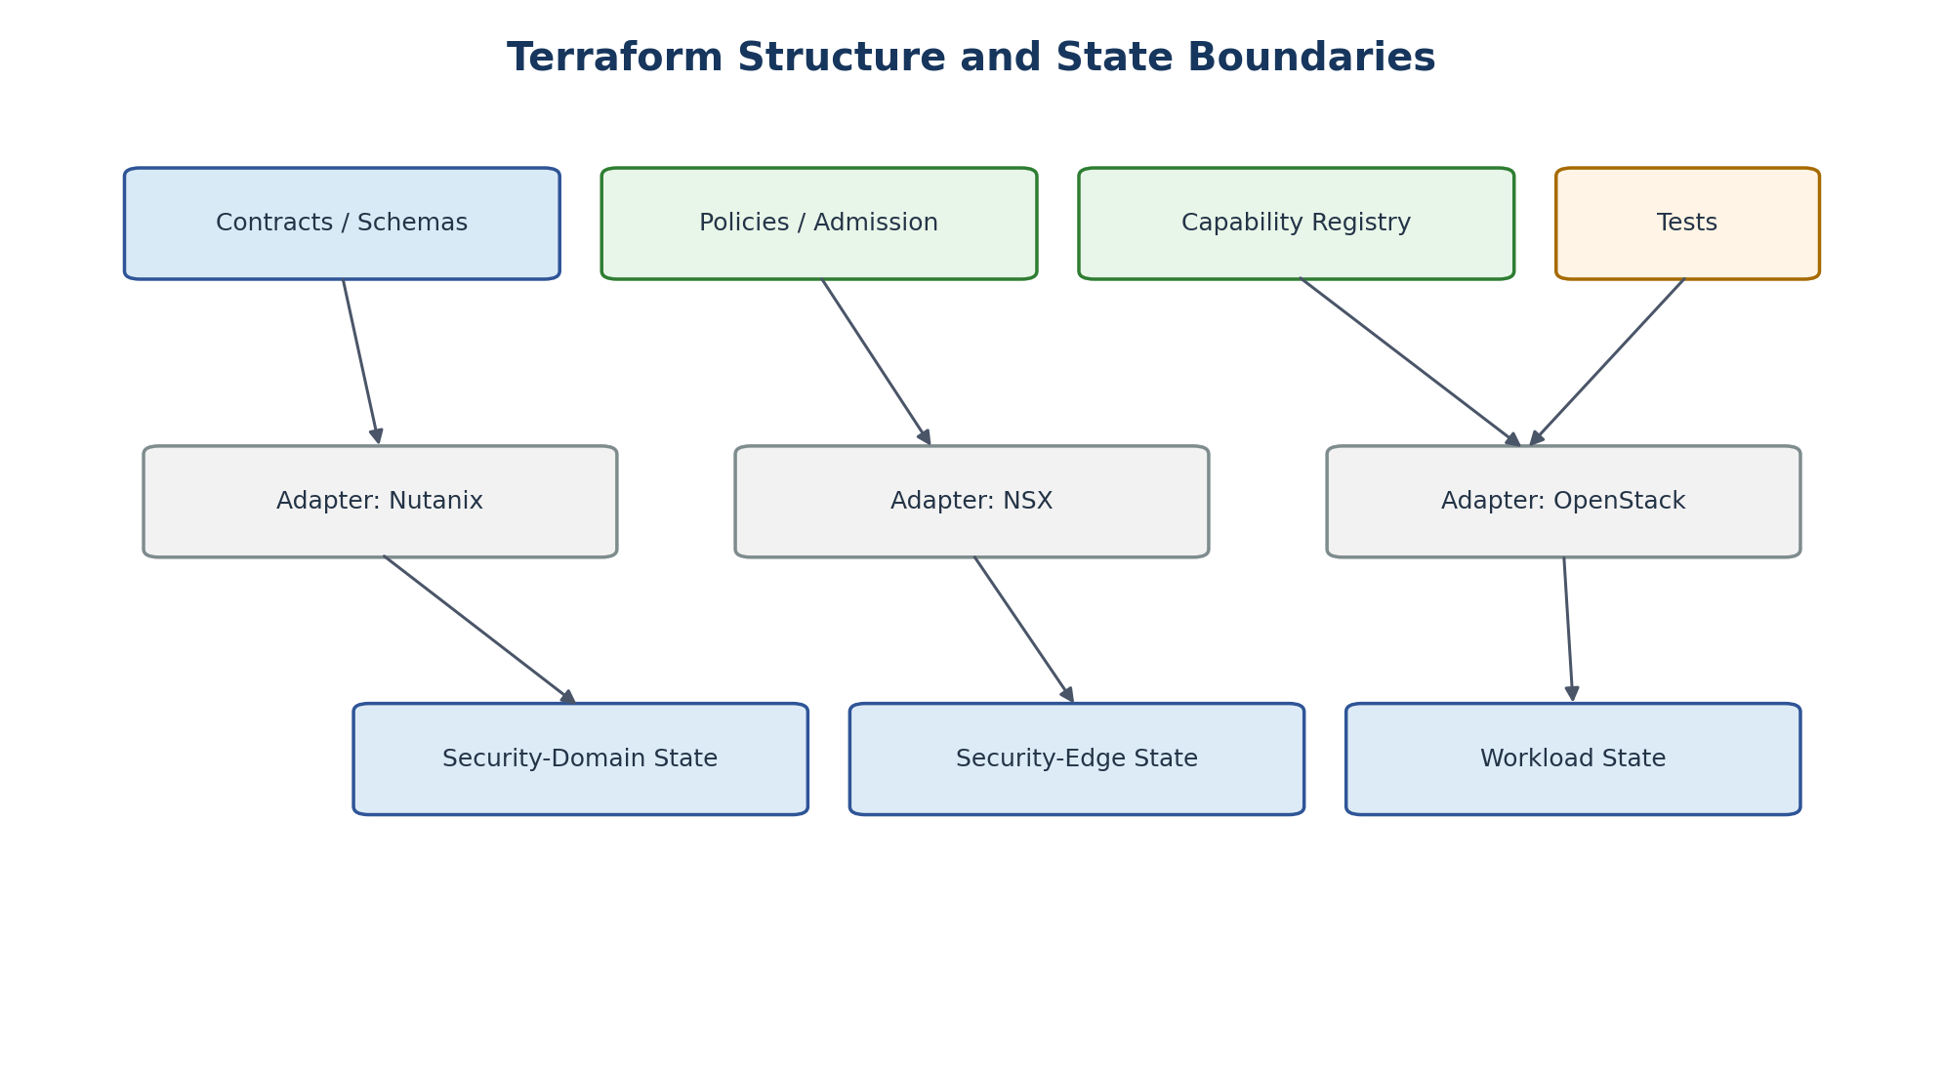
Figure 9. Separate contracts, adapters, tests, and state boundaries.
Terraform is an actuator, not the service API or placement engine. Provider configurations belong in root modules and are passed to reusable child modules. Child modules declare provider requirements but should remain focused on one platform/problem domain.
repository/
contracts/
wsd/
security-domain/
flow/
service-binding/
exposure/
policy/
admission/
routing/
assurance/
adapters/
nutanix/
nsx/
openstack/
modules/
<provider-native reusable units>
stacks/
foundation/
security-edge/
security-domains/
workloads/
tests/
contract/
routing/
security/
conformance/
evidence/
TF-001 | Provider configuration SHALL be defined in root modules and passed to child modules; reusable child modules SHOULD NOT embed provider credentials/configuration.
TF-002 | Provider versions SHALL be constrained and dependency lock files SHALL be committed and reviewed.
TF-003 | The orchestration layer SHALL select the provider adapter; a single giant conditional module SHOULD NOT attempt to implement all platforms.
TF-004 | Module interfaces SHOULD be relatively flat and composable; deeply nested modules that obscure lifecycle or ownership boundaries SHOULD be avoided.

31. State Boundaries
Terraform state is both a blast-radius and authority boundary. State should be divided so that an automation identity can manage only the objects it is authorized to change and a failed or locked run does not block unrelated domains.
State Domain | Typical Contents | Identity Scope
Physical foundation | Fabric bootstrap, physical attachments, core platform foundation | Foundation automation only
Management foundation | OOB/MZ infrastructure and access controls | Management automation only
Security edge | ZIP/security contexts and provider-side edge infrastructure | Security-edge automation only
Security Domain | VPC/Tier-1/router, networks, baseline policies | Tenant-domain automation
Workload | VMs, volumes, application-level objects | Workload automation
Shared service | Service endpoint realization | Service-owner automation
STATE-001 | No single routine tenant automation identity SHALL have authority to modify physical fabric, management foundation, security edge, and tenant workloads simultaneously.
STATE-002 | Remote state backends SHALL use encryption, strong authentication, locking, recovery/versioning, access logging, and separation appropriate to the sensitivity of contained data.

32. Policy as Code and Security Admission
Security admission rejects invalid architectures before provider execution. Policies should evaluate portable intent rather than only vendor plans, with provider-plan policies providing a second line of defense.
Example Request | Admission Result
Restricted zone directly to public network | DENY
Tenant workload directly to MZ/OOB | DENY
Arbitrary BGP peer | DENY
Disable mandatory logging | DENY
Unsupported assurance profile on target platform | DENY
Approved internal flow through declared ZIP path | ALLOW
Approved DNS service binding | ALLOW
POL-001 | Admission policy SHALL be provider independent wherever the rule expresses an architectural invariant.
POL-002 | Provider-specific plan checks SHOULD validate that the adapter compiled the intent into the expected native constructs.

33. Secrets and Automation Credentials
Terraform configuration, state, CI logs and plan output can expose sensitive values. Credentials should be short-lived or externally brokered where supported. Secrets must not be stored in source repositories. Access to state and plan artifacts must reflect their sensitivity.
SEC-001 | Static privileged provider credentials SHALL NOT be embedded in Terraform source code.
SEC-002 | Automation identities SHALL use least privilege and separate duties by control domain.
SEC-003 | Credential rotation, revocation, and break-glass recovery SHALL be tested as part of the platform operational profile.

34. CI/CD and Change Gates
Stage | Mandatory Controls
Commit | Peer review, lint, schema tests, unit tests, secret scanning
Plan | Pinned providers/modules, policy checks, drift awareness, change classification
Approval | Risk-based approval; stronger approval for security edge, management, external exposure
Apply | Least-privileged identity, serialized/locked state, auditable execution
Realization | Wait for platform readiness
Verification | Connectivity/security/logging tests
Evidence | Immutable/tamper-evident record and deployment provenance
CICD-001 | A change that modifies inter-zone policy, external exposure, route authority, management access, or assurance profile SHALL receive a higher change classification than an ordinary workload scale operation.

35. Drift and Reconciliation
Continuous reconciliation compares declared intent, Terraform state, platform state, route/security policy, and evidence. Manual changes should be detected and either reverted or converted into an approved change. Drift is not merely a configuration hygiene issue; it can invalidate authorization evidence.
DRIFT-001 | Security-significant drift SHALL generate an actionable event and SHALL affect the compliance/authorization state of the WSD until resolved or accepted.
DRIFT-002 | Emergency changes SHALL be reconciled back into the source of truth after the incident or maintenance action.

Part V — Assurance, Testing, and Operations

36. Assurance Profiles
Profile | Default Isolation | Typical Use
Standard | Shared physical infrastructure with verified logical isolation, independent tenant/domain policy, mandatory testing | Normal workloads matching the approved baseline context
Enhanced | Dedicated routing/security contexts, stronger inspection/telemetry, constrained sharing, additional tests | Higher sensitivity or threat exposure
Dedicated | Dedicated or independently assured infrastructure where justified | Exceptional cases requiring physical or strong dedicated separation
The assurance profile determines realization choices such as shared vs dedicated Security Domain, shared vs dedicated security-edge context, management separation, telemetry, encryption, platform eligibility, test depth, and whether physical controls are required.
ASSUR-001 | Assurance profile selection SHALL be based on system security requirements and risk analysis rather than tenant preference alone.

37. Conformance Test Framework
A platform is conformant only when it can prove the required outcomes. The conformance suite should run both at platform-certification time and in reduced form for every WSD deployment.
Test Domain | Example Required Outcome
Tenant isolation | No unauthorized path between independent tenant namespaces.
Zone isolation | No inter-zone path except through the declared security edge.
Management isolation | Workload cannot reach management/OOB interfaces.
Route control | Only authorized prefixes/defaults/peers are present.
Microsegmentation | Unapproved east-west traffic fails; approved flow passes.
Service bindings | Only declared service endpoints are reachable.
Public exposure | Ingress reaches only declared service path.
IPv6 | Equivalent negative/positive tests pass.
Logging | Security events and flow evidence are centrally attributable.
Failure | HA/control-plane failure preserves enforcement.
Lifecycle | Modification and deletion remove old connectivity and identity.
TEST-001 | Negative tests SHALL be first-class acceptance criteria; proving that an allowed flow works is insufficient.
TEST-002 | A platform upgrade SHALL trigger an appropriate regression/conformance test set before broad production rollout.

38. Deployment Evidence
Every deployment should produce a machine-readable evidence record so operators and assessors can determine why connectivity exists and which version of policy, modules and provider produced it.
evidence:
deployment_id: <uuid>
tenant: tenant-001
wsd: application-prod
security_profile: protected-b-medium
assurance_profile: standard
platform_profile: <name + version>
site: <site-id>
security_domains: [...]
networks: [...]
zip_relationships: [...]
approved_flows: [...]
service_bindings: [...]
exposures: [...]
policy_bundle_version: <sha>
terraform_source_revision: <sha>
provider_lock_digest: <digest>
tests: [...]
exceptions: [...]
timestamp: <utc>
authorization_state: compliant | exception | failed
EVID-001 | The evidence record SHALL identify the source revision, policy version, provider/module versions, realized security relationships, test results, and active exceptions.

39. Logging, Telemetry, and Observability
Observability must cross control planes without collapsing their trust boundaries. Workload flow telemetry, security-edge logs, platform audit logs, automation logs, route changes, IPAM changes, identity events and management access should be correlated using stable tenant/WSD/domain identifiers.
Telemetry Source | Minimum Questions It Should Answer
Security edge | Which domain-to-domain flow was allowed/denied, by which policy, and when?
Platform network | Which endpoint/identity originated or received traffic?
Terraform/CI | Who requested/applied which desired-state change?
Route Authority | Why is this prefix or default route present?
IPAM | Who owns this address/prefix and when was it allocated?
Management plane | Who administered which infrastructure component?
OBS-001 | Logs SHALL contain stable identifiers sufficient to correlate tenant, WSD, Security Domain, policy, and deployment evidence.
OBS-002 | Security control logging SHALL not depend solely on the tenant workload being healthy or cooperative.

40. Capacity and Performance Engineering
The security edge and shared-service layer become critical infrastructure. Capacity must be engineered so that security controls are not viewed as optional bottlenecks during growth or incidents.
- Aggregate and per-context throughput
- Concurrent sessions and new sessions per second
- Packet-per-second capacity and latency
- Inspection/TLS processing where applicable
- Log/event throughput and storage
- HA failover headroom
- Per-tenant noisy-neighbour limits
- Route and policy object scale
- Platform VPC/Tier-1/router/network scale
- Automation concurrency and provider API limits
CAP-001 | Capacity planning SHALL include N+failure headroom so that loss of a security-edge node does not require disabling or bypassing enforcement.

41. High Availability and Failure Behaviour
Failure | Expected Behaviour
Service catalogue unavailable | Existing workloads continue; new requests pause.
Security admission unavailable | New security-significant changes fail closed.
IPAM unavailable | New address allocation stops; no guessed/manual fallback in automated path.
Terraform runner unavailable | Existing data plane continues; changes pause.
Security-edge management unavailable | Existing enforcement remains; management alert raised.
One security-edge node fails | HA continues enforcement within capacity targets.
Central logging unavailable | Enforcement continues; buffering/alerting follows operational profile.
Platform control plane unavailable | Existing workload data plane should continue where platform design supports it.
FAIL-001 | Control-plane failure SHALL NOT create an implicit permit path.
FAIL-002 | Failover and control-plane-loss scenarios SHALL be included in platform conformance testing.

42. Backup and Restore
Backup is a service, not a routing domain. The backup data path and backup management path must be separated. Workloads should reach only the approved backup data endpoint/proxy/agent service; backup administration belongs on the management trust plane.
BKP-001 | Backup consumers SHALL NOT receive connectivity to backup management interfaces merely because they consume backup service.
BKP-002 | Restore workflows SHALL enforce the same tenant, security-zone, identity, and evidence controls as backup ingestion.

43. Incident Response and Containment
The architecture should allow operators to isolate a WSD, Security Domain, exposure, service binding, or ZIP flow without having to reconfigure unrelated tenants. Containment actions should be pre-defined and automated where possible.
- Quarantine a workload identity or network.
- Withdraw public exposure.
- Block a service binding.
- Move a ZIP to heightened security posture.
- Suspend egress.
- Freeze new provisioning for a tenant or platform.
- Capture route/policy/configuration evidence before emergency changes.
IR-001 | Emergency containment SHALL be possible without requiring a physical-fabric redesign or broad outage to unrelated tenants.

44. Change and Exception Management
Architecture exceptions are explicit objects, not comments hidden in Terraform. Every exception has scope, owner, rationale, compensating controls, approval and expiry. Expired exceptions automatically affect compliance state.
kind: SecurityException
metadata:
id: EX-000123
scope:
tenant: tenant-001
wsd: legacy-app
requirement: IPAM-002
justification: overlapping address space during migration
compensatingControls:
- dedicated NAT boundary
- enhanced logging
expires: 2027-01-31
status: approved
EXC-001 | Every exception SHALL have an accountable risk owner and expiry or review date.
EXC-002 | The control plane SHALL surface expired exceptions as non-compliant state rather than allowing them to become permanent undocumented architecture.

45. Lifecycle and Offboarding
Deletion is a security workflow, not simply terraform destroy. The controller must remove connectivity, identities, certificates/secrets, DNS, service bindings, public exposure, routes, policies and inventory records while preserving required logs and backup retention evidence.
- Set WSD to Retiring and prevent new optional dependencies.
- Identify dependent services, DNS, certificates, backup/retention requirements, and external integrations.
- Withdraw public ingress and discretionary egress.
- Remove/expire application flows and service bindings in dependency-safe order.
- Stop workloads and confirm required backup/retention state.
- Destroy workload and network resources.
- Withdraw prefixes/routes and release addresses through IPAM quarantine policy.
- Revoke identities, secrets, certificates and automation grants.
- Generate destruction evidence and close inventory/CMDB records.
LIFE-001 | Offboarding SHALL remove obsolete routes and policy objects and SHALL produce evidence of completion.

46. Migration and Transition Connectivity
Migration should be modeled as a temporary controlled service. A permanent “migration VRF” is avoided because it tends to become an uncontrolled shared path. Migration intent includes source, destination, protocol/service, bandwidth, start, expiry, logging and teardown.
MIG-001 | Migration connectivity SHALL be time-bound unless explicitly converted to an approved steady-state connection.
MIG-002 | Migration flows SHALL traverse an approved security edge when they cross security-domain boundaries.

Part VI — Governance and Delivery

47. Operating Model and Separation of Duties
Role | Primary Responsibilities
Architecture authority | Own portable contract, invariants, implementation profiles and exceptions to architecture.
Security authority | Own security profiles, assurance requirements, ZIP/control policy and authorization criteria.
Platform engineering | Build and maintain platform adapters and native modules.
Network engineering | Own physical fabric, external routing and approved physical L3 domains.
Security-edge operations | Operate ZIP/security service, policy realization and HA/capacity.
Automation platform | Operate service API, pipeline, state backends, policy-as-code and evidence services.
Service owner | Own WSD business/service requirements and lifecycle.
Operations/SRE | Monitor, respond, reconcile, capacity plan and restore services.
GOVERNANCE PRINCIPLE
No single routine role should need unrestricted authority over the physical fabric, management plane, security edge, platform tenancy, and workload configuration.

48. Architecture Review Checklist
☐ Does the design use portable contract objects rather than vendor IDs in consumer-facing interfaces?
☐ Are tenant, WSD, Security Domain, and platform scopes distinct?
☐ Does every inter-zone path traverse a declared ZIP/security edge?
☐ Can any route leak, shared-services route, or alternate protocol bypass that edge?
☐ Is management/OOB separated from workload data paths?
☐ Can the design onboard a normal tenant without leaf/spine changes?
☐ Are Internet ingress and egress explicit service outcomes?
☐ Are shared services represented as bindings rather than broad routing?
☐ Are IP addresses allocated by authoritative IPAM?
☐ Are IPv4 and IPv6 treated equivalently?
☐ Are automation identities least privileged and separated by state/control domain?
☐ Are negative-path tests defined?
☐ Is failure behaviour fail-secure?
☐ Are capacity, HA and noisy-neighbour limits defined for security services?
☐ Does offboarding remove routes, policies, identities and evidence dependencies?

49. Tenant / WSD Onboarding Checklist
☐ Owner and authority identified
☐ Security profile approved
☐ Assurance profile selected
☐ Placement constraints defined
☐ Required zones identified
☐ Networks sized through IPAM
☐ Application flows declared
☐ Service bindings declared
☐ External exposure declared
☐ Backup/recovery requirements declared
☐ Logging/evidence profile assigned
☐ Platform capability check passed
☐ Terraform plan/policy gates passed
☐ Conformance tests passed
☐ Evidence stored
☐ Service owner accepts Service Ready state

50. Delivery Roadmap
Phase | Primary Deliverables | Exit Gate
1 — Standard | Portable contract, terminology, invariants, zone/ZIP model, assurance profiles | Architecture and security approval of the vendor-neutral model
2 — Physical foundation | L3 Clos, OOB, platform/security-edge attachment patterns | Tenant creation proven without routine switch change
3 — Security edge & services | Data ZIP, management ZIP, ingress/egress, service endpoints | Explicit inter-zone/service paths operational
4 — First platform profile | Platform adapter, native modules, baseline policies | One complete WSD provisioned zero-touch
5 — Assurance automation | Admission, IPAM, route authority, tests, evidence | Service Ready blocked unless mandatory tests pass
6 — Additional platforms | Second and third implementation profiles | Same WSD contract passes conformance on multiple platforms
7 — Policy-driven placement | Capability registry and platform:auto | Authorized placement selected without consumer vendor dependency
8 — Continuous authorization | Drift, evidence, exceptions, lifecycle automation | Ongoing compliance state visible and actionable

51. Initial Reference Implementation
The first production-grade proof should stay intentionally small while exercising every major architecture boundary. A useful scope is two tenant namespaces, each with an Operations-zone and Restricted-zone Security Domain, a multi-tenant data ZIP service, separate management/OOB, DNS/NTP/logging/backup service bindings, IPv4 plus an IPv6 test path, and no direct Internet exposure. The goal is to prove the contract and controls, not maximize feature count.
Test Scenario | Expected
Tenant A workload → Tenant B workload | DENY
Operations → Restricted unapproved flow | DENY
Restricted → Internet | DENY
Workload → management interface | DENY
Operations → approved Restricted service | ALLOW
Restricted → DNS service binding | ALLOW
Restricted → backup data endpoint | ALLOW
Security-edge logs attributable to WSD/domain | PASS
Provision new WSD without switch configuration | PASS

52. Architecture Acceptance Criteria
AC-01 | A normal tenant/WSD can be provisioned without modifying leaf or spine configuration.
AC-02 | Cross-tenant isolation is demonstrated automatically.
AC-03 | Inter-zone communication cannot bypass the declared security edge.
AC-04 | Management/OOB is unreachable from tenant workload paths.
AC-05 | Shared services are consumed through explicit bindings rather than broad shared-subnet access.
AC-06 | Workload owners cannot create arbitrary routes, BGP peers, or external network attachments.
AC-07 | IPv4 and IPv6 policy equivalence is tested where dual-stack is offered.
AC-08 | Public exposure requires an approved ingress path; Internet egress requires an approved egress profile.
AC-09 | Unsupported platform capabilities cause placement failure rather than silent downgrade.
AC-10 | Every Service Ready deployment produces evidence tied to source and policy versions.
AC-11 | Security-significant drift and expired exceptions affect compliance state.
AC-12 | Offboarding demonstrably removes routes, policies, service bindings and identities.
AC-13 | At least two different platform profiles can realize the same portable WSD semantics.

Appendix A — Canonical Object Model

A.1 Workload Security Domain Schema — Illustrative
WorkloadSecurityDomain:
metadata:
tenant_id: string
name: string
owner: string
lifecycle_state: requested|active|restricted|retiring|retired
security:
profile: string
assurance: standard|enhanced|dedicated
placement:
platform: auto|<profile>
site_policy: string
availability: string
sovereignty: string
zones:
<zone-class>:
enabled: bool
dedicated_domain: bool
networks:
<network-name>:
zone: <zone-class>
ipv4_prefix_size: int
ipv6: bool
services:
<service-name>: enabled|disabled|profile
flows:
- source: identity
destination: identity
service: service-profile
justification: string
exposure:
public_ingress: false|profile
internet_egress: false|profile
enterprise: false|profile
evidence_profile: string

A.2 Security Domain Instance Schema — Illustrative
SecurityDomainInstance:
id: string
zone_class: PAZ|OZ|RZ|HRZ|REZ|MZ
tenant_scope: string
site: string
platform_profile: string
assurance_profile: string
address_scope_id: string
route_policy_id: generated
edge_attachment_id: generated
lifecycle_state: active|restricted|retiring|retired

A.3 Service Binding Schema — Illustrative
ServiceBinding:
id: string
service_profile: string
consumer_security_domain: string
endpoint_profile: string
direction: consumer_to_service|service_to_consumer|bidirectional
policy: generated
logging_profile: string
availability_profile: string
evidence_required: true

Appendix B — Terraform Root and Module Patterns

B.1 Provider Configuration Pattern
terraform {
required_providers {
nutanix = {
source = "nutanix/nutanix"
version = "~> <validated-version>"
}
}
}
provider "nutanix" {
# Endpoint/authentication injected by the execution environment.
# Do not embed secrets in source.
}
module "security_domain" {
source = "../../modules/nutanix/security-domain"
domain_spec = local.normalized_domain_spec
providers = {
nutanix = nutanix
}
}

B.2 Adapter Boundary
# Orchestrator selects one adapter before Terraform execution.
# Do not build a giant cross-provider child module.
normalized_intent.json
|
+--> adapters/nutanix/root.tf
+--> adapters/nsx/root.tf
+--> adapters/openstack/root.tf

Appendix C — Baseline Policy Matrix
Source | Destination | Class | Default | Exception / Allowed Mechanism
Tenant A | Tenant B | Any | DENY | Explicit approved inter-tenant service only
WSD A | WSD B | Same Security Domain | DENY by default | Approved microsegmentation flow
OZ | RZ | Inter-zone | DENY by default | Explicit ZIP flow
RZ | Public | External | DENY | Approved egress service only
Public | Internal workload | Ingress | DENY | Approved PAZ/ingress service only
Workload | MZ/OOB | Management | DENY | No normal exception
Workload | DNS/NTP/identity | Service binding | DENY unless bound | Approved Service Binding
Workload | Backup management | Management | DENY | No normal exception
Workload | Backup data service | Service binding | DENY unless bound | Approved backup profile
Tenant automation | Physical fabric | Control plane | DENY | Foundation identity only

Appendix D — Conformance Test Catalogue
ID | Test | Method | Expected
CT-001 | Cross-tenant IPv4 | Attempt reachability between tenant A and tenant B | Fail
CT-002 | Cross-tenant IPv6 | Attempt IPv6 reachability between tenant A and tenant B | Fail
CT-003 | Zone bypass | Attempt OZ→RZ path not traversing declared ZIP | Fail
CT-004 | Management isolation | Attempt workload→management API/OOB | Fail
CT-005 | Default Internet | Attempt Internet access with no egress profile | Fail
CT-006 | Public ingress | Attempt direct public access to internal workload | Fail
CT-007 | Approved flow | Execute declared application flow through policy | Pass
CT-008 | Service binding | Resolve/reach declared service endpoint | Pass
CT-009 | Route authority | Search realized routes for unauthorized prefixes/defaults | Pass: none found
CT-010 | Policy logging | Generate allow/deny and verify central event attribution | Pass
CT-011 | Control-plane loss | Simulate approved management/control-plane outage | Enforcement remains
CT-012 | HA failure | Fail one security-edge node | Traffic/policy within SLO
CT-013 | Offboarding | Destroy WSD and scan for stale routes/policy/identity | Pass: none found
CT-014 | Drift | Introduce controlled unauthorized change in test env | Detected
CT-015 | Provider upgrade | Run regression suite on target provider/platform version | Pass before promotion

Appendix E — Evidence Manifest
Evidence Item | Required
Normalized WSD request | Yes
Admission decision and policy bundle version | Yes
IPAM allocation references | Yes
Route Authority compiled intent | Yes
Placement decision and capability profile | Yes
Terraform plan/apply run identifier | Yes
Source revision and dependency lock digest | Yes
Realized platform object identifiers | Yes — internal evidence only
ZIP/security-edge policy references | Yes
Conformance test results | Yes
Active exceptions | Yes
Lifecycle status / destruction evidence | As applicable

Appendix F — Architecture Decision Record Template
ADR-<number>: <Decision title>
Status: Proposed | Accepted | Superseded | Rejected
Date:
Owners:
Context
-------
What problem or constraint requires a decision?
Decision
--------
What was selected?
Architectural invariants affected
---------------------------------
List requirement IDs / invariants.
Alternatives considered
-----------------------
1.
2.
3.
Security and assurance impact
-----------------------------
Describe zone, ZIP, management, tenancy, routing and evidence impact.
Portability impact
------------------
Does this introduce a platform-specific dependency?
Operational impact
------------------
Capacity, HA, monitoring, lifecycle, support.
Consequences
------------
Positive / negative / follow-up actions.

Appendix G — Glossary
Term | Definition
Assurance Profile | Defines required strength of isolation, dedicated/shared realization, inspection, evidence and testing.
Capability Registry | Machine-readable declaration of platform features that have been validated for placement.
Exposure | Approved connectivity between a WSD and a public, enterprise, partner or other external domain.
Flow Intention | Portable declaration of required communication between identities/services.
Management Zone (MZ) | Dedicated administration environment separated from business service activity.
Out-of-Band (OOB) | Management path using dedicated or otherwise separated management connectivity/interfaces.
PAZ | Public Access Zone mediating public/external access to internal resources.
OZ | Operations Zone for routine operational systems under the applicable control profile.
RZ | Restricted Zone for concentrations of sensitive/critical systems and data.
HRZ | Highly Restricted Zone for higher-assurance requirements.
Route Authority | Control-plane function that compiles routing from authorized intent rather than accepting arbitrary consumer routes.
Security Domain Instance | Isolated routing/policy namespace associated with a zone class, authority scope, platform/site and assurance profile.
Service Binding | Explicit consumer relationship to an approved provider service endpoint.
Tenant Namespace | Administrative ownership/RBAC/quota boundary; not automatically a security zone.
WSD | Workload Security Domain; the primary workload lifecycle and security-intent object.
ZIP | Zone Interface Point; security boundary system between two zones that enforces inter-zone policy.

Appendix H — Normative Requirement Catalogue
Requirement | Summary
ARCH-001 | Vendor-neutral consumer contract
ARCH-002 | No routine switch changes for tenant lifecycle
ARCH-003 | Inter-zone paths through ZIP
ARCH-004 | Separate management/OOB
TEN-001 | Cross-tenant deny by default
TEN-002 | Tenant admin cannot modify provider foundations
WSD-001 | All managed workloads represented by lifecycle object
WSD-002 | No vendor IDs in consumer contract
SDI-001 | Only compatible routing/security authority in one domain
SDI-002 | Same zone class does not imply reachability
ZIP-001 | All inter-zone paths traverse ZIP
ZIP-003 | Default deny at inter-zone boundary
MGT-001 | No workload-to-management route
FAB-001 | Normal tenant lifecycle does not change fabric
FAB-002 | Physical VRFs only for true fabric L3 domains
RTE-001 | Routes are provider-controlled outputs
RTE-002 | No generic transit VRF
IPAM-001 | All networks registered in IPAM
IPAM-002 | Overlap by exception
IPV6-001 | Equivalent IPv4/IPv6 security semantics
SVC-001 | No broad shared-service routing
ING-001 | No direct public attachment to internal domain
EGR-001 | Internet egress deny by default
MICRO-001 | East-west deny by default where required
SITE-001 | Site-local Security Domains by default
PORT-002 | Placement fails rather than downgrade
TF-001 | Provider config in root modules
TF-002 | Pin/lock provider versions
STATE-001 | Separate automation authority domains
AUTO-001 | Admission/IPAM failure stops new provisioning
TEST-001 | Negative tests mandatory
EVID-001 | Evidence binds intent, code, realized state, tests
DRIFT-001 | Security drift changes compliance state
FAIL-001 | Failure does not create bypass
EXC-001 | Exceptions have owner and expiry
LIFE-001 | Offboarding removes connectivity and produces evidence

Appendix I — References
[R1] Canadian Centre for Cyber Security — Baseline Security Requirements for Network Security Zones (version 2.0), ITSP.80.022. https://www.cyber.gc.ca/en/guidance/baseline-security-requirements-network-security-zones-version-20-itsp80022
[R2] Canadian Centre for Cyber Security — IT Security Risk Management: A Lifecycle Approach, ITSG-33. https://www.cyber.gc.ca/en/guidance/it-security-risk-management-lifecycle-approach-itsg-33
[R3] Canadian Centre for Cyber Security — Annex 2: Information System Security Risk Management Activities (ITSG-33). https://www.cyber.gc.ca/en/guidance/annex-2-information-system-security-risk-management-activities-itsg-33
[R4] Government of Canada — Security Control Profile for Cloud-based GC Services (PBMM context). https://www.canada.ca/en/government/system/digital-government/digital-government-innovations/cloud-services/government-canada-security-control-profile-cloud-based-it-services.html
[R5] Terraform — Providers Within Modules. https://developer.hashicorp.com/terraform/language/modules/develop/providers
[R6] Terraform — Provider Requirements and dependency locking. https://developer.hashicorp.com/terraform/language/providers/requirements
[R7] Terraform Registry — Nutanix VPC v2 resource. https://registry.terraform.io/providers/nutanix/nutanix/latest/docs/resources/vpc_v2
[R8] Terraform Registry — Nutanix Subnet v2 resource. https://registry.terraform.io/providers/nutanix/nutanix/latest/docs/resources/subnet_v2
[R9] Terraform Registry — VMware NSX Tier-1 / gateway/security policy documentation. https://registry.terraform.io/providers/vmware/nsxt/latest/docs
[R10] Terraform Registry — OpenStack Neutron router and security-group resources. https://registry.terraform.io/providers/terraform-provider-openstack/openstack/latest/docs

Closing Architecture Statement
END STATE
Standardize the security, connectivity, assurance, lifecycle, and evidence semantics of hosting. Allow each platform to implement those semantics using its native capabilities. Keep the physical fabric stable, make trust transitions explicit, and require automated proof before declaring a workload ready.
This design intentionally separates the durable enterprise architecture from today’s product choices. A platform can be replaced, upgraded, or added without changing what a consumer asks for—provided the new implementation satisfies the same conformance profile. That is the foundation for secure multi-tenancy, operational scale, and long-term hosting portability.

