9Mothers Turret Motor Control Analysis
Take-Home Assignment — Field Notes & Analysis Log
Alexandra Walker

Initial Setup & Approach
Taking this assignment as a chance to learn how to better work with AI to get somewhere faster without totally handing over the reins. I will be noting where and how I used it as part of the troubleshooting process. I will be attaching my handwritten notes to this submission, which were edited into this document. I primarily used Claude for this task when I used AI, and I did enjoy using it to shorten the learning curve of the new (to me) rerun software. Being able to look up how to do the actions I wanted in a human dialogue format was useful in speeding up development.
- Used AI to analyze error messages and help guide me through the setup process for Rerun and getting it to compile and show a visualization.
- When I gave the AI the assignment, it spat out an entire Python script for the solution. I glanced at it, but a fully formed solution is not what I want. Told it to back up and pretend to be a senior dev who is guiding me in the right direction. The point here is to understand what I'm doing, not just parrot an AI answer. Besides, I'm also deciding if this is something I like for myself, and that will never help me answer that question.
- I downloaded CMake to get the rerun application running. Claude was useful with getting this set up and compiling.
- Used Claude to figure out how to display the data. I needed to overlay the graphs on top of each other to track where the target and current positions diverged both for the latency analysis and the shooting impact, which was simple once I knew where exactly to right click to get the drop down options I needed.
- Worked back and forth with Claude to get a sense of what I was looking at particularly for the third question with the firing impact analysis.
- Overall Claude was a very useful tool primarily in that it shortens the time I’d have spent figuring out the tool, and introducing questions to further look into.

April 21 — Estimating Control Loop Latency

Pitch Latency Observations
Looking at the movement in pitch from 18:06:52–59, the target spikes to 11 and a peak of 10.8594 is seen in the current value 0.195 ms later (at 53.541). By the time the current reaches this value, the target was already down to 9.965. For the remainder of the movement, the current is consistently reaching the target ~100 ms later. This movement has a range of 15 (from 11 to −4).
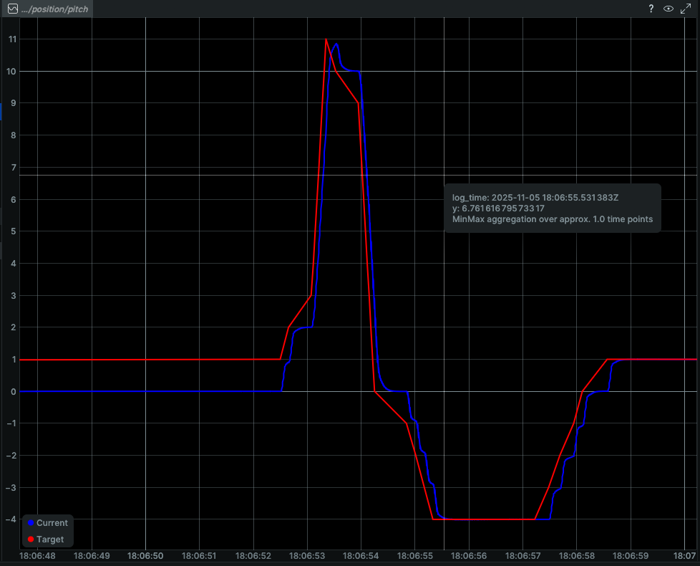
Fig 1: Pitch position current vs target for one movement

A slightly larger movement at 18:07:36 (from 11 to −7) has a lower but similar latency of ~80 ms.
There are some instances where the target drifts up linearly but the current value remains constant for a while before jumping up to meet it. From 19:12:01 to 19:12:24 the target increases from 8.25 to 10 while the current stays constant. It then jumps to 10.3 while the target is even higher. They oscillate together for a bit before the target changes drastically.
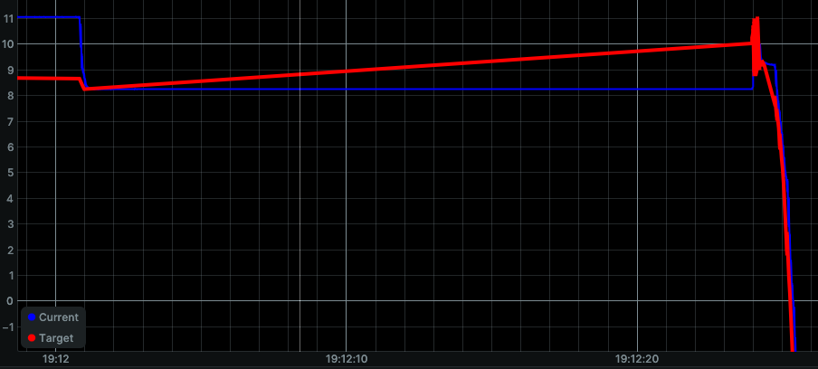
Fig 2: Target rises by 1.75 while the current position does not change
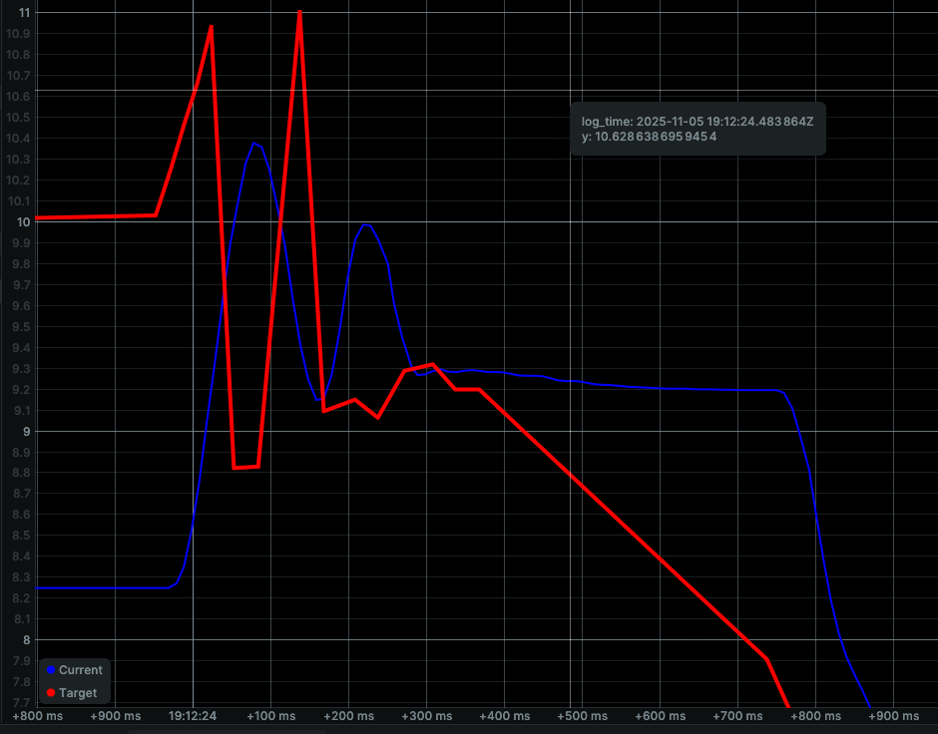
Fig 3: Zoomed in on the end of the movement from fig 2, current position is rising even after the target has begun to decrease and likewise begins to decrease after the target has begun to rise. This bouncing implies the motor may not have enough gain, as it’s not reaching the target fast enough and the target has changed by the time it gets there.
Conclusion: Latency is consistently between 80 ms and 100 ms in the locations measured, and this does not seem to be notably dependent on the magnitude of change in position.

Pitch vs. Yaw Comparison
Looking at that same movement at 19:12:01–19:12:24, there is very similar behavior on the yaw axis where the current position has a delayed response before oscillating a bit and then moving on to a newly targeted position. This is the exact same time interval between target given and current position reflecting this command.

The oscillation in the pitch resolves at 19:12:24.367 but at 19:12:24.498 in yaw. I wonder if the fact that pitch must counteract gravity while yaw is normal to the gravitational force has an effect here.
The overall latency is similar in scale, but the yaw motor takes anywhere from 2–6 seconds to respond to a command where the pitch does not. During movement it lags a similar amount to pitch, but only once it has initially caught up. Perhaps on the PCB the signal from the MCU has to travel further to the yaw motor than to the pitch motor and the reader/header.
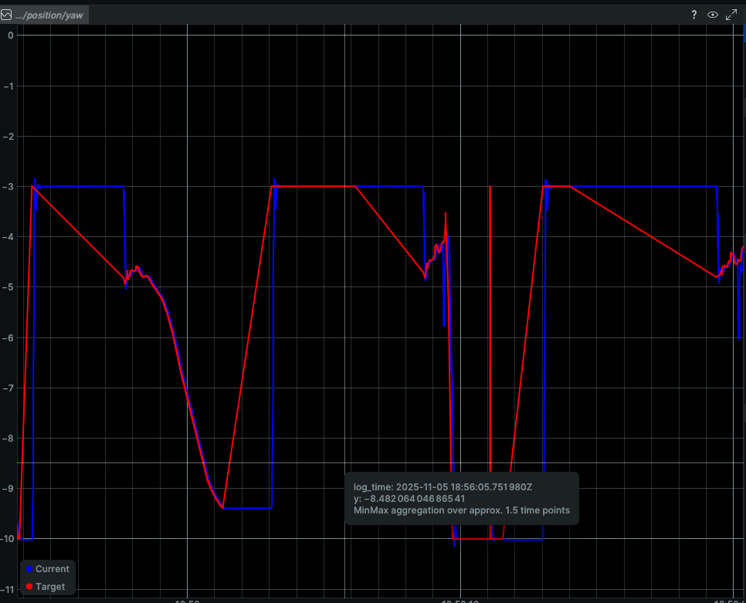
Fig 4: Showing the delay in response with the yaw motor

April 23 — Shooting Impact Analysis

Confirmed Shot Disturbance at 18:16:31
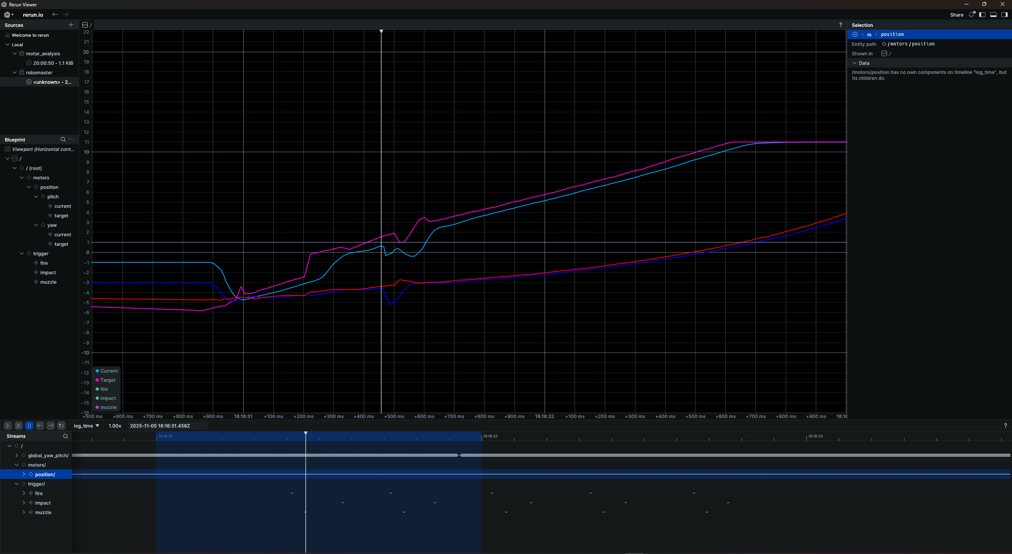
Fig 5: Analyzing the moment of a muzzle fire

Looking at the data streams, there was a muzzle fire in trigger/muzzle at 18:16:31.453. The targets were flat (turret holding still), confirming this is a pure mechanical disturbance from the shot.
- Yaw deflects from −3.571 to −5.189 (−1.618° deflection)
- Pitch deflects from 0.585 to −0.329 to 0.383 (−0.914° deflection)
- Yaw recovered by 18:16:31.573 (~120 ms recovery)
- Pitch recovered by 18:16:31.644 (~191 ms recovery)
Interesting observation: Yaw had one deflection and pitch had two deflections from the same singular muzzle fire. Pitch took 59% longer to recover from its set of deflections.
Primary disturbance axis: Yaw showed larger absolute deflection (~1.6° vs ~0.9°), suggesting the recoil force has a stronger lateral than vertical component in this configuration. I continue to contemplate the effect of gravity on these deflection magnitudes.

Summary of Findings
- Control loop latency (pitch): 80–100 ms consistently; not strongly dependent on movement magnitude.
- Yaw vs. pitch latency: Similar scale during active movement, but yaw shows an additional 2–6 s initial response delay not present in pitch. Possible PCB routing or firmware acceleration difference.
- Shot deflection: Yaw ~1.6°, Pitch ~0.9°. Yaw is the dominant disturbed axis.
- Recovery time: Yaw ~120 ms, Pitch ~191 ms. Both axes recover quickly but pitch unexpectedly takes longer despite smaller deflection.

