Name: Amanpreet Kaur Josan
Course: BDA400 - Data Science Tools and Techniques
Assignment: Assignment 2 - Technical Analysis using R, Preliminary Stage
GitHub Repository Link: https://github.com/awammy/TechnicalAnalysis

# Step 1: GitHub Account and Repository Setup
* Process: I created a GitHub account and set up a new repository named 'TechnicalAnalysis' to store my assignment files.
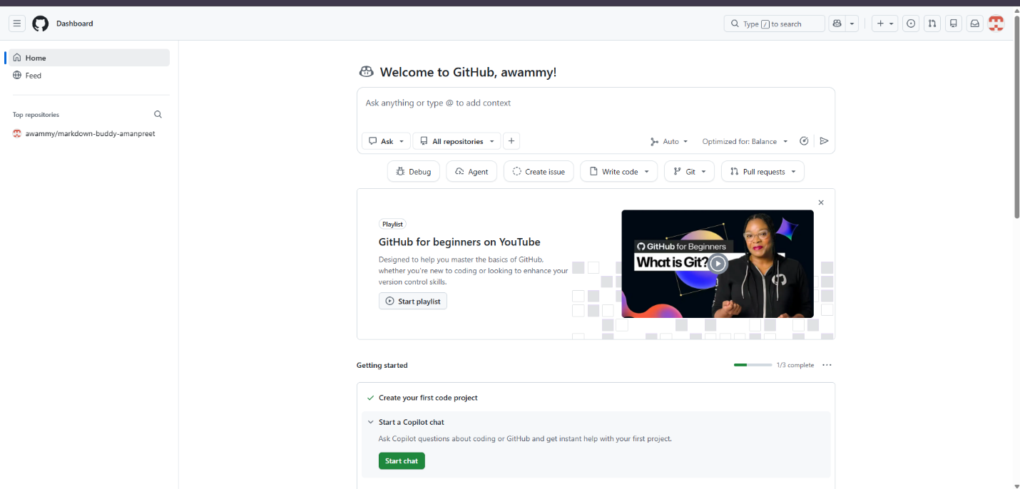
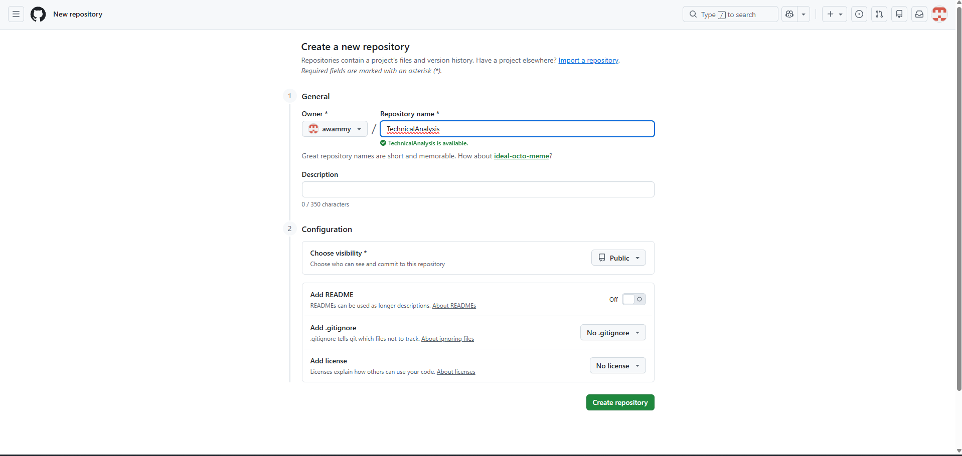
# Step 2: Installing and Configuring R and RStudio
* Process: I downloaded the latest versions of R and RStudio for my operating system and completed the installation process.
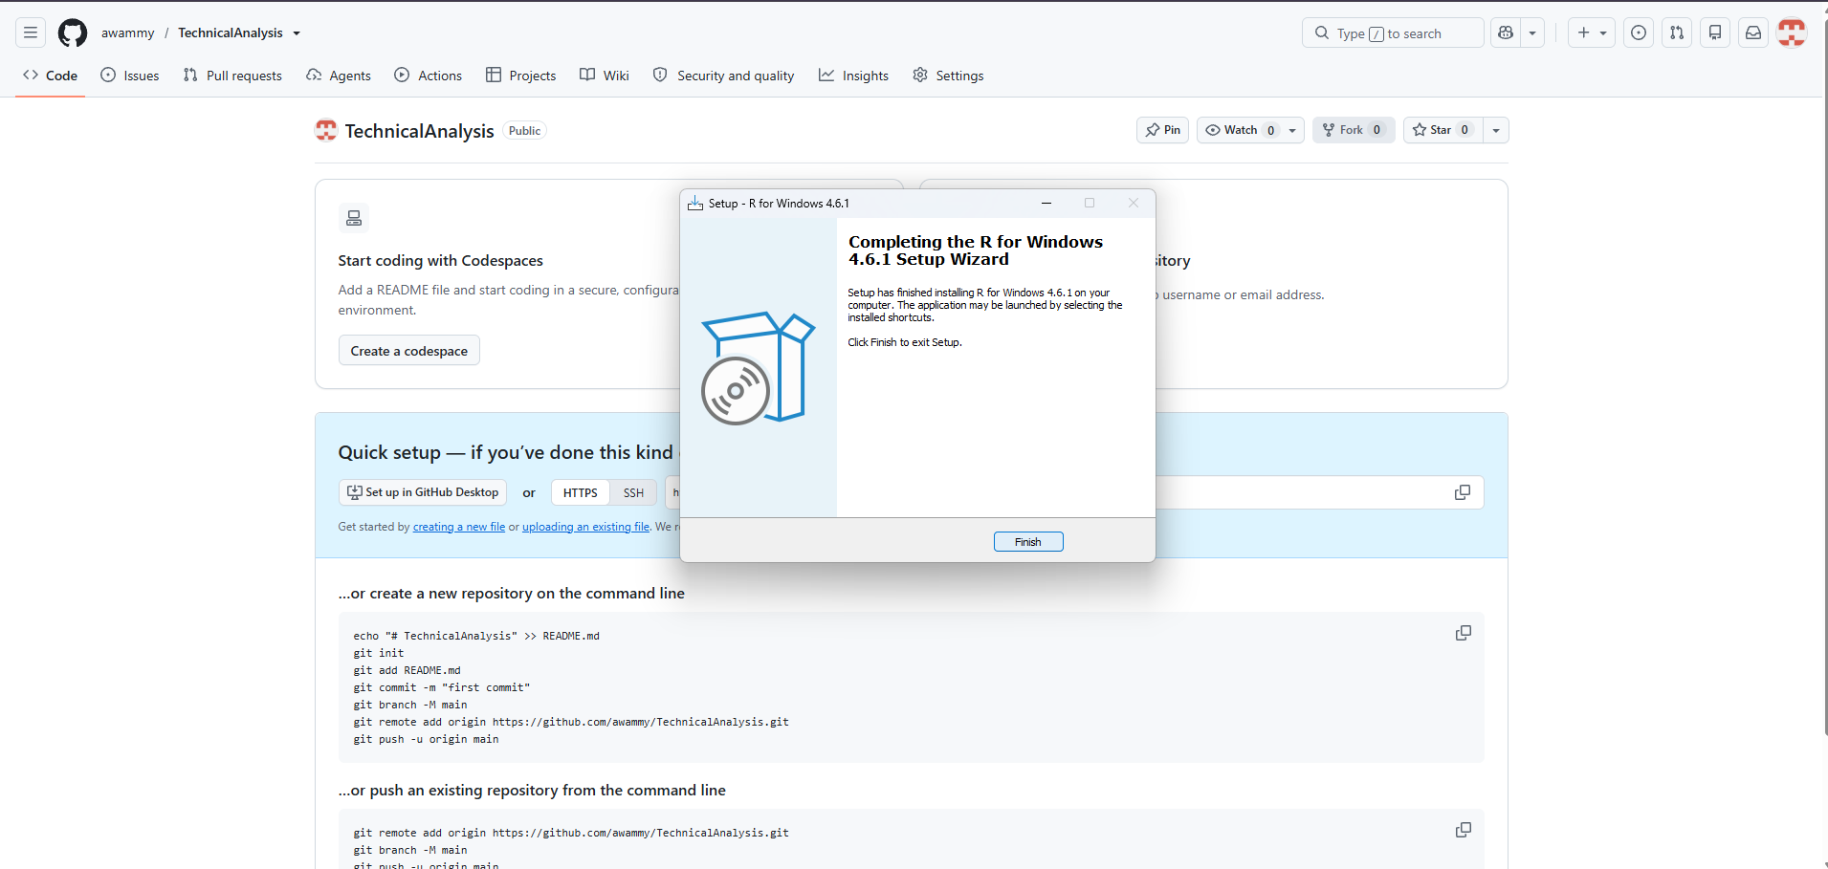

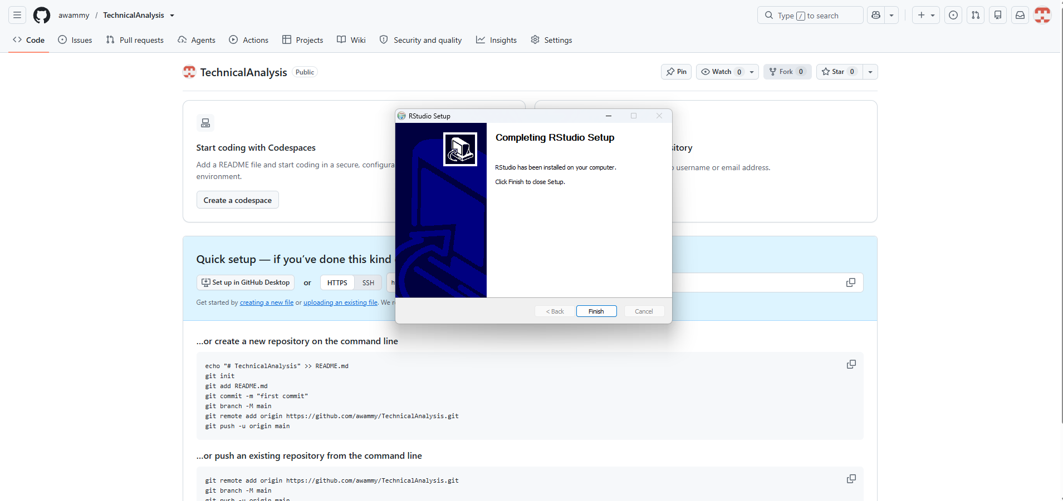

# Step 3: Downloading and Installing R Packages
* Process: I used the install.packages() command in RStudio to download and install the 'quantmod' and 'TTR' packages required for technical analysis.
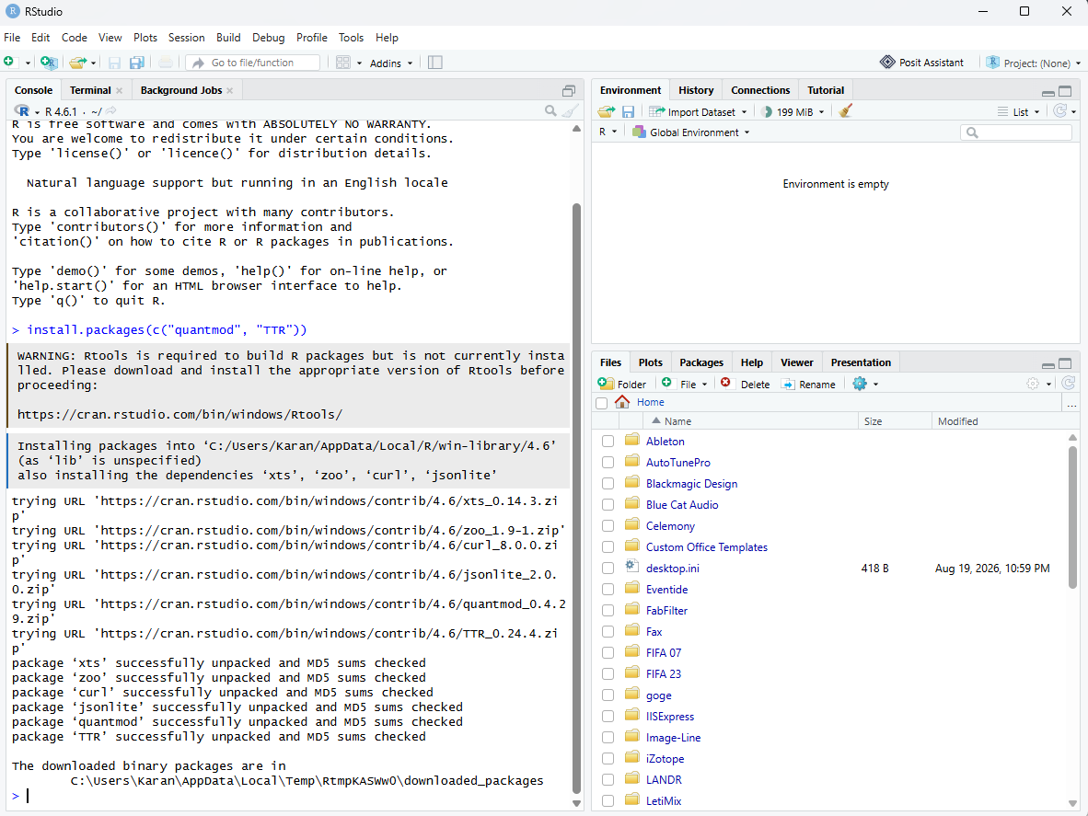

# Step 4, 5, 6, & 7: Configuration, Initialization, and Script Execution
* Process: I created the 'portfolio.txt' file with my stock symbols and wrote the R script to load the data, calculate the moving average, mean, mode, median, and standard deviation, and display the output.
