SMART IMPACT CONSULT
smartimpactconsult.com

Sector Investability Assessment

Sierra Leone — Sector 1: AgTech and post-harvest value chains (re-run)
Workstream: B.1 — WS1 Market and Sector Validation (Priority · Sprint 1)
Prompt: WS1-v1.0 — Sector Investability, Sierra Leone
Stage / round: Stage 1 desk research · Round 2 (re-run), formatted for Stage 2 review
Prepared by: Investment Operations, Smart Impact Consult (smartimpactconsult.com)
Date: 23 September 2026
Why this sector was re-run. Sector 1 was completed before the deeper, multi-round research pattern used for Sectors 2–8 was established, and its evidence base — two named agribusinesses (Miro Forestry, Planting Naturals), one contested GDP-share figure, and a single unverified post-harvest-loss estimate — is thin relative to what a second, more intensive pass surfaces. This document supersedes the existing Sector 1 section in claude_B1.docx and should replace it on merge, not sit alongside it.
Desk research only. Every factual claim below carries a named source and, where available, the year it refers to; sources are embedded as clickable links. Where Sierra Leone-specific data does not exist, this is stated explicitly and regional or continental data used as a proxy is labelled as such. Where a search could not evidence a figure at all, the document states “no reliable data identified” rather than estimating.
Environment limitation — read before using this output. In this session, the WebFetch tool used to open and read primary sources directly was blocked by network egress policy for every domain tested. WebSearch (titled snippets and source URLs, not full page content) remained the sole basis for every finding below. Every source is therefore carried at the same status as the “†” markers in the existing claude_B1.docx: a named, dated, linked lead, not yet opened and read in full. Nothing here should enter a gate pack or the Source Register as “Verified” until someone opens each link directly, per Stage 4 of the AI-Assisted Research Methodology.

Sector 1 — AgTech and post-harvest value chains

Part 1 — Market structure and size
- Agriculture’s share of GDP remains genuinely unresolved, and this pass adds a third data point rather than settling it. World Bank WDI value-added data put agriculture near 29% of GDP (2024). The World Bank’s own Agricultural Sector Risk Assessment, as reported at its 2025 launch, put it at more than 57%. Statistics Sierra Leone’s current-price series shows 64.4% (2023). No methodology reconciles these three figures — see Figure 1 below. World Bank WDI; World Bank Agricultural Sector Risk Assessment — †, not opened.
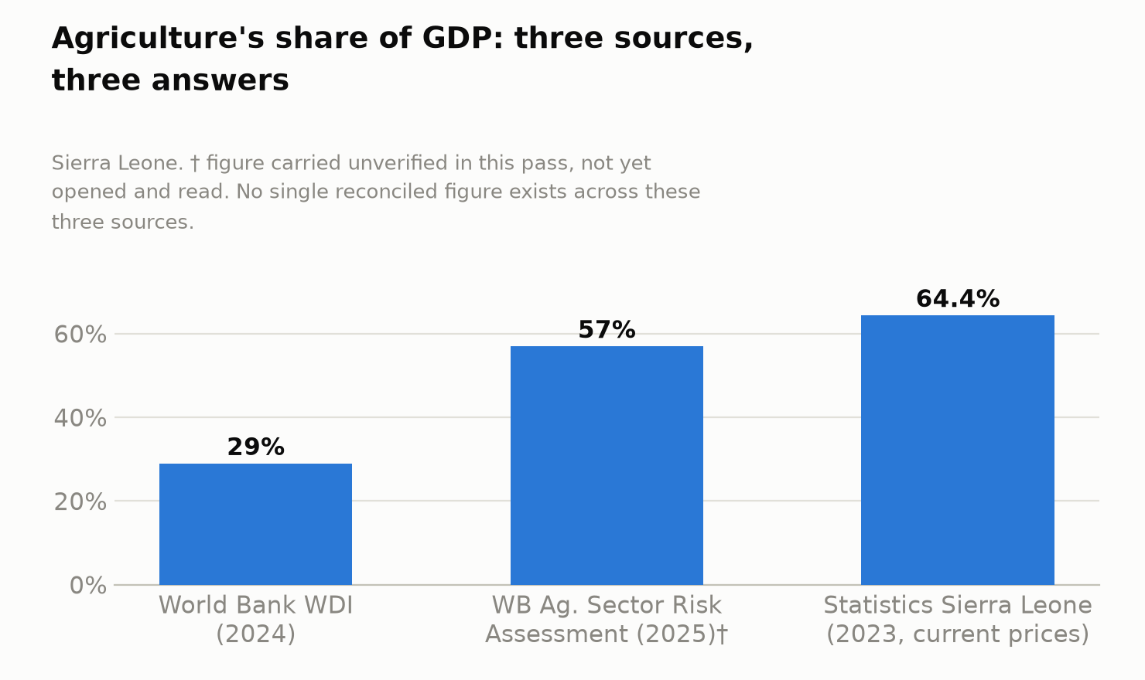
Figure 1. Agriculture’s share of GDP — three sources, three answers
- Employment: the World Bank describes agriculture as providing nearly 60% of employment (already carried in the prior draft). This pass adds precision on who within that workforce: roughly 80% of employed women work in the agrifood sector overall, and about 50% of working women work specifically in subsistence farming. FAO, “Gender and Work in Agrifood Systems” — †, not opened.
- Rural/smallholder structure, quantified for the first time in this assessment: more than 58% of Sierra Leone’s population lives in rural areas, and 86.1% of that rural population is engaged in smallholder subsistence agricultural production. [via search] — †, not opened. This is the denominator against which every “AgTech” business model in this sector has to work — the addressable population is overwhelmingly subsistence-scale, not commercial-scale, farmers.
- “AgTech” as a discrete, measured sub-sector still does not exist in Sierra Leonean statistics — Statistics Sierra Leone does not report it separately, consistent with the prior draft. But this pass identifies real companies operating in the space that the prior draft did not find — see Part 3.
- Land use, carried from the prior draft and reconfirmed: of 7.22 million hectares, 74% is suitable for farming but only about 10% is cultivated. [World Bank Agricultural Sector Risk Assessment, via Awoko] — †.

Part 2 — The structural problem
- Import dependence, updated with more precise, more current figures than the prior draft carried. Rice import volume fell from 386,437 MT (2021) to 361,322 MT (2024) — now about 30% of national requirement, down from roughly a third previously. Rice import value fell from US$166.5 million (2023) to US$159.1 million (2024). CARD / riceforafrica.net, May 2026 — †, not opened. Rice self-sufficiency rose from 56.3% (2019) to about 72% (2024), with the government targeting near-zero rice imports by 2028 — see Figure 2. Ministry of Information and Civic Education — †, not opened.
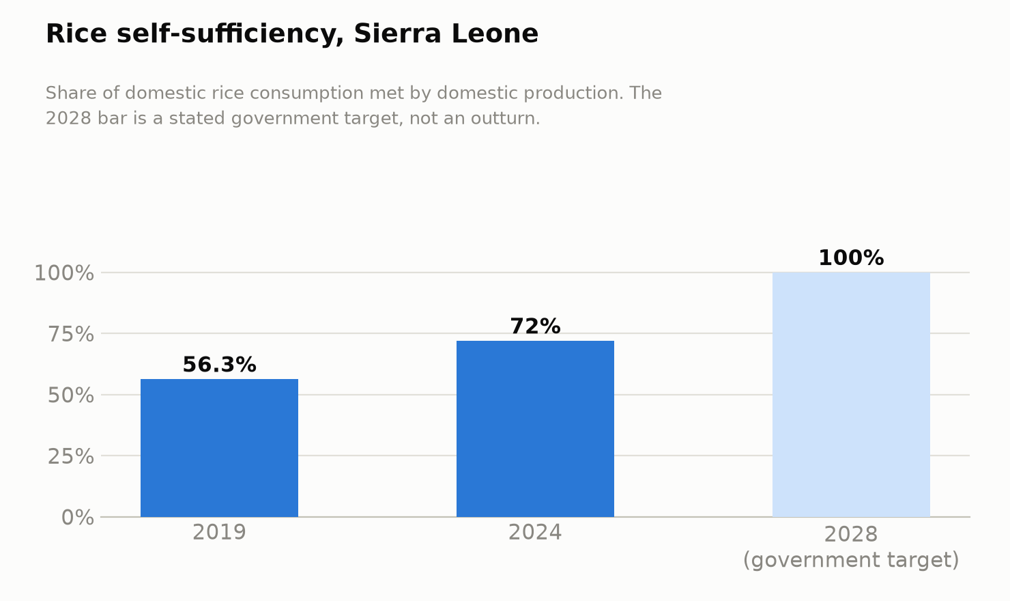
Figure 2. Rice self-sufficiency, Sierra Leone
- Post-harvest losses: the prior draft’s figures are carried forward, still unverified — losses around 40% (National Sustainable Agriculture Development Plan) and an estimated US$128 million/year (3.5% of GDP) from unmanaged production risk (World Bank Agricultural Sector Risk Assessment, 2025). This pass could not independently verify the $128m figure or locate its exact page reference either — it remains a † figure carried from the prior round, not newly confirmed. The Risk Assessment does confirm it prioritises risk by commodity — rice (flooding, pests, disease, wildfire as top risks), cassava, groundnut, oil palm, cocoa and livestock. World Bank Agricultural Sector Risk Assessment — †, not opened.
- A sharper, newly evidenced input-side constraint: Sierra Leone’s fertiliser use averages just 12.8 kg per hectare — a fraction of the 131 kg/ha recommended under the Nairobi Declaration. AfDB FOSTER project — †, not opened. This is a specific, quantified driver of low yields that the prior draft did not carry, and it is directly addressed by a new financing instrument (Part 6).
- Why the problem has persisted, and where value leaks: the prior draft’s framing (feeder-road gaps, no cold chain, thin extension services, scarce processing capital) stands and is reinforced by this pass’s finding that fertiliser access is itself a binding, quantified constraint, not just an assumed one.

Part 3 — Is this sector investable now?
This is where the re-run changes the picture most. The prior draft found two named companies — both agribusiness/forestry, neither “AgTech” in the digital-platform sense the sector name implies. This pass finds at least six named, operating companies, and — critically — two of them are genuine digital-AgTech platforms actively building Sierra Leone-specific product, which the prior draft stated did not exist.
Established agribusiness and processing (carried forward and expanded):
- Miro Forestry — unchanged from the prior draft: DFC US$24m equity (2023), CDC US$15m equity (2015), ~1,400 Sierra Leone staff, plywood mill under construction. DFC — †.
- Planting Naturals — unchanged: AgDevCo US$7m (September 2025), 1,500+ employees, ~8,000 smallholder suppliers. AgDevCo — †.
- Pee Cee Agriculture (PCA) — new to this pass. The agribusiness arm of Pee Cee Holding Ltd, one of Sierra Leone’s leading consumer-goods and agribusiness enterprises. IFC committed a US$12 million loan in April 2025 to develop a fully irrigated, mechanised 500-hectare farm near Freetown — Sierra Leone’s first large-scale, local-market-focused onion farm, targeting more than 40,000 tonnes of onions annually, alongside maize, rice and potatoes. The financing followed a four-year IFC advisory partnership during which Pee Cee raised onion yields to ten times the national average. Pee Cee is separately opening a logistics hub in Cline Town for its private-label brand, Padi. IFC; Trendtype Africa — †, both blocked, not opened.
- Capitol Foods — Sierra Leone’s first cocoa processing factory, at Tissor Village, Kenema District, commissioned 23 October 2021, with capacity for 4,000 tonnes/year of cocoa beans — roughly a quarter of the country’s annual output. Older than the 2024–25 window this pass targeted, but still operating and still the only named domestic cocoa processor. African Business — †, not opened.
- Green Roots Agro — Sierra Leone’s first cashew processing and export company, described as taking cashew “from seed to shelf” with traceable export product. Green Roots Agro — †, not opened.
- Newton cashew processing factory (Western Rural District) — EU-funded under the Boosting Agriculture and Food Security project, inaugurated March 2024, capacity of over 800 kg/day (~200 tonnes/year) of raw cashew, employing more than 300 women and youth from the Waterloo Cashew Processors and Sellers Association. Red River Foods (US-based) is named as a leading buyer/exporter of West African cashew kernels, including from Sierra Leone. With 85% of Sierra Leone’s cashew orchards reaching maturity by 2025, this is a sector with real, near-term export volume upside. Solidaridad Network; Invest Salone / Red River Foods — †, both blocked, not opened.
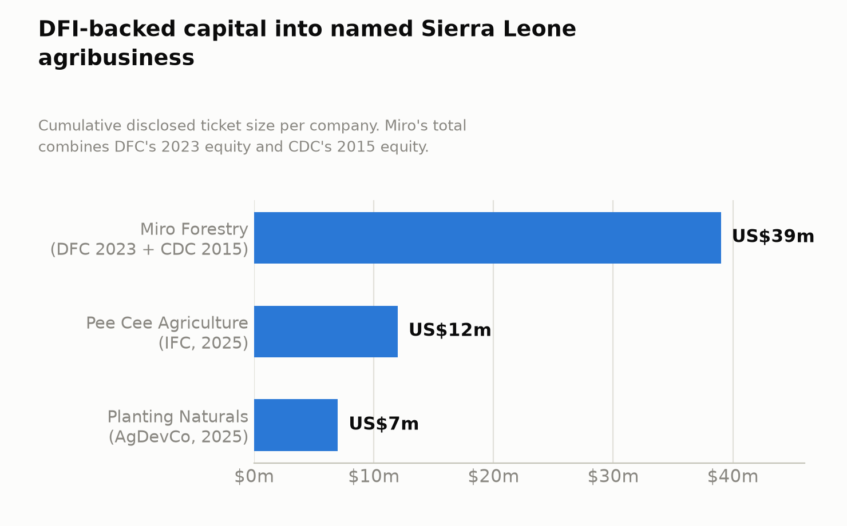
Figure 3. DFI-backed capital into named Sierra Leone agribusiness
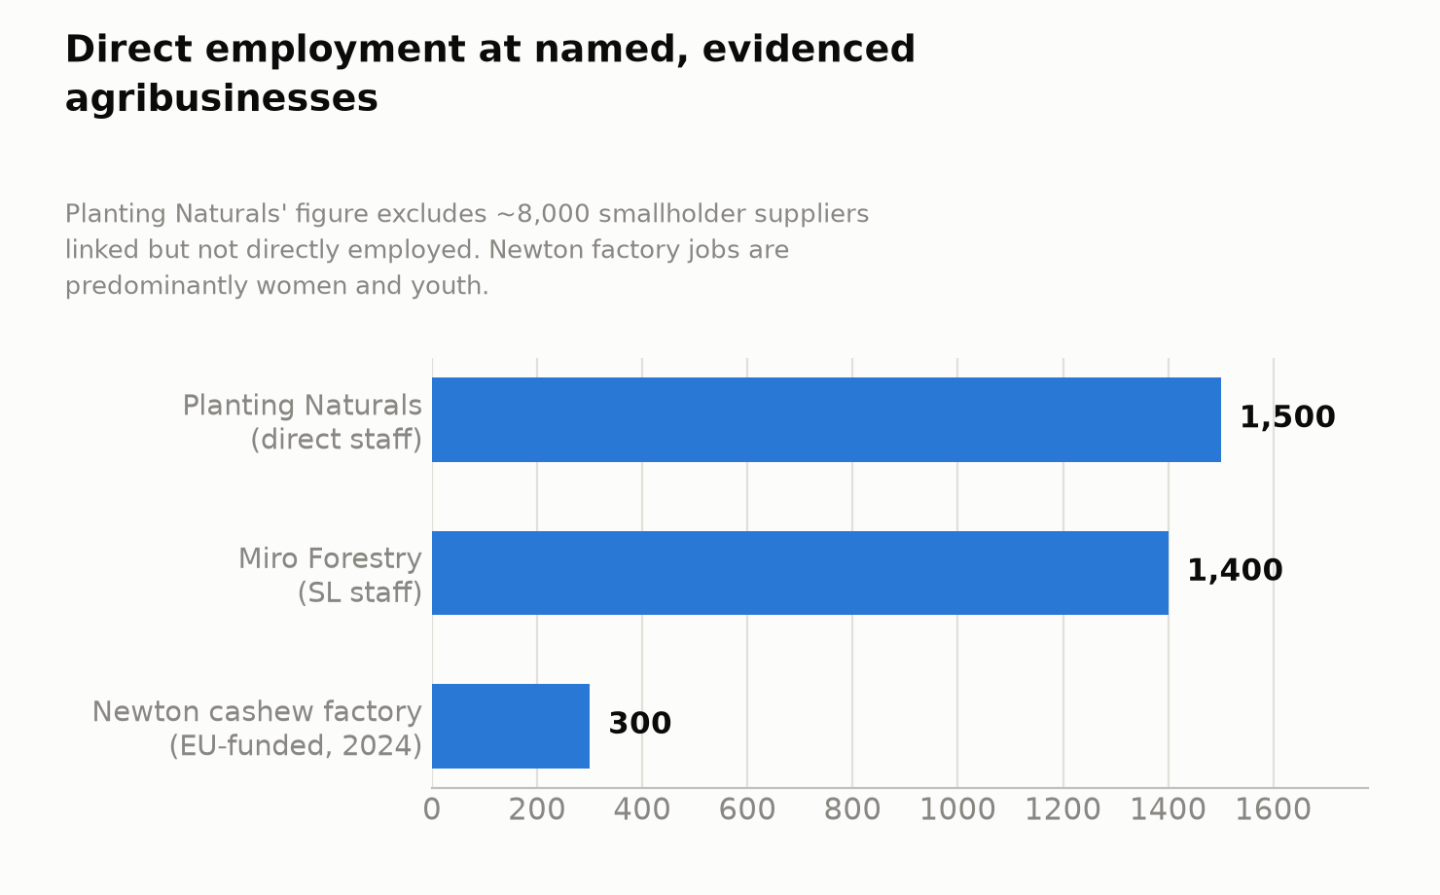
Figure 4. Direct employment at named, evidenced agribusinesses
Digital AgTech — genuinely new to this assessment, with an important caveat.
- WARC Group — founded 2011, headquartered in Accra, operating a “Trading Hub” model (bundled inputs, training and market-access support for smallholders) across Ghana, Sierra Leone and Uganda. Acumen became WARC’s first institutional investor in 2019, specifically to build out Sierra Leone operations for subsistence farmers earning under US$1.50/day. WARC raised a US$7.5 million Series B in 2024 — a regional round, not a Sierra Leone-specific allocation. Its evidenced Sierra Leone-specific reach is roughly 600 farmers — far smaller than the pan-regional “20,000+ farmers across trading hubs” headline figure, which spans all three countries. Acumen; Crunchbase — †, both blocked, not opened.
- Farmerline — Ghana-based, founded 2013, operating in Ghana, Sierra Leone and Côte d’Ivoire, with US$15.3 million raised cumulatively (regional, not Sierra Leone-specific). In March 2024, Farmerline launched two new services specifically for Sierra Leone: Darli AI (a conversational IVR tool) and a Krio AI Agronomist, developed under a direct partnership with Sierra Leone’s Ministry of Communication, Technology and Innovation (MoCTI) to build language and speech models tailored to the country’s agricultural sector. Since March 2024, Darli has been used by 110,000 farmers across 27 languages including Twi, Swahili and Yoruba — a pan-African figure, not Sierra Leone-specific; Farmerline overall supports 2.2 million farmers across Africa. Darli AI was named to TIME’s Best Inventions of 2024. TIME; Farmerline — †, both blocked, not opened. No Sierra Leone-specific Darli user count was identified in this pass — this is a specific, answerable gap for Stage 2.
What this means for the sector’s core verdict. The prior draft’s statement that “no reliable data identified on AgTech sub-sector revenue, growth or registered-enterprise count” and the ranking table’s “no evidenced venture-scale AgTech” line are no longer accurate as stated. Two real, regionally-funded digital-AgTech companies are building Sierra Leone-specific product today. What remains true is that their evidenced Sierra Leone-specific footprint is still small (WARC: ~600 farmers; Farmerline: partnership confirmed, user count not evidenced) relative to their pan-African scale — so the correction is to the existence finding, not yet to the scale finding.
- Minimum viable business model: established agribusiness (Miro, Planting Naturals, Pee Cee, Capitol Foods, Green Roots Agro, Newton) requires physical processing assets, secured offtake, and DFI-scale capital — confirmed from the prior draft. Digital AgTech’s viable model in Sierra Leone specifically appears to be a regional platform extending into Sierra Leone as an additional market, not a Sierra Leone-native start-up building from zero — both evidenced examples (WARC, Farmerline) are Ghana-founded companies expanding in.
- Venture-scale potential: still capped for the reasons the prior draft identified (market size, purchasing power, infrastructure), but the evidence base for any commercial AgTech activity in-market is now real rather than absent.
- What a company needs to reach US$1M revenue: for established agribusiness, unchanged from the prior draft — physical processing assets and secured offtake. For digital AgTech, no reliable Sierra Leone-specific revenue or monetisation data was identified for either WARC or Farmerline’s Sierra Leone operations — a clear Stage 2 gap.
- Exit environment: no new evidence found. The prior draft’s comparator (Ghana, where Miro also operates) stands, now reinforced by the fact that WARC and Farmerline are also Ghana-headquartered companies using Sierra Leone as a secondary market — Ghana is not just a comparator market, it is the actual home base of two of the six companies evidenced here.

Part 4 — Capital and instrument fit
- A concrete, Sierra Leone-specific blended-finance mechanism not in the prior draft. UNCDF, with European Union funding, launched a €6 million Agricultural Financing Facility under the Salone Access to Finance Project, going live in 2025, combining grants and loans to help agribusinesses access financing matched to seasonal cash flow and growth needs, with UNCDF absorbing part of the risk financial institutions cannot take alone. The facility drew more than 500 applications in its initial phase. UNCDF — †, not opened. This is the clearest evidenced “missing middle” financing instrument found anywhere in this sector — sized for agribusinesses too large for microfinance and too small/early for DFI-scale debt.
- A second concrete instrument: AfDB’s FOSTER project — US$2.25 million total, comprising a US$1.5 million Partial Credit Guarantee from the Africa Fertilizer Financing Mechanism (AFFM), a US$700,000 grant for soil-health management, and US$50,000 in-kind support from Welthungerhilfe (the implementing partner). A three-year project, December 2025 to November 2028, aimed directly at the fertiliser-access gap identified in Part 2. AfDB — †, not opened.
- Ticket sizes, now with a clearer distribution across the capital stack — see Figure 3: DFI-scale equity/debt of US$7–39 million for established agribusiness (Miro, Pee Cee, Planting Naturals); blended micro-to-SME finance via the €6m UNCDF/EU facility (hundreds of smaller applications, individual ticket size not disclosed); and a targeted US$1.5m guarantee instrument (AfDB FOSTER) for the input-supply layer specifically. No reliable data identified on a venture-equity ticket sized for a digital-AgTech company’s Sierra Leone-specific operations (WARC’s and Farmerline’s capital is raised and allocated regionally, not disclosed at the Sierra Leone-country level).
- Financing gap: still not precisely quantified for AgTech specifically, but the >500 applications to the UNCDF/EU facility in its initial phase is itself a strong revealed-demand signal that a funding gap exists at the agribusiness-SME scale.

Part 5 — Employment and job readiness
- Scale, per Figure 4: Planting Naturals (1,500 direct staff, plus ~8,000 smallholder suppliers not directly employed), Miro Forestry (~1,400 Sierra Leone staff), and the Newton cashew factory (300+, predominantly women and youth) are the three largest evidenced direct-employment figures in the sector.
- Gender, substantially more evidenced than the prior draft: roughly 80% of employed women work in the agrifood sector overall, and about 50% of working women work in subsistence farming specifically (Part 1). AgDevCo’s existing 15% female-smallholder target for Planting Naturals (prior draft) sits well below this economy-wide female-participation rate, suggesting real headroom for gender-lens investment design. A separate IFAD-backed livestock project requires at least 40% of its 62,500 targeted smallholder beneficiaries to be women. [via search] — †, not opened.
- Skills base: unchanged from the prior draft for physical agribusiness (labour-intensive, low formal-skill barrier to entry). For digital AgTech specifically, talent remains a binding constraint, though Farmerline’s Krio-language-model partnership with MoCTI suggests at least some domestic technical capacity is being built through direct government partnership, not purely imported.

Part 6 — Investment innovation and de-risking
- Two real, named, Sierra Leone-specific de-risking instruments were found in this pass — a material upgrade from the prior draft, which had only AgDevCo’s TA pairing and an unverified government credit-facility claim. The UNCDF/EU €6m blended Agricultural Financing Facility (Part 4) is a genuine risk-absorption mechanism purpose-built for this sector. AfDB’s FOSTER Partial Credit Guarantee (US$1.5m via AFFM) is a second, more narrowly targeted instrument aimed at fertiliser-value-chain financing specifically.
- A demonstrated TA-then-capital sequencing model: IFC’s relationship with Pee Cee shows a specific, evidenced pattern — four years of advisory support (which delivered a 10x onion-yield improvement) preceded, and appears to have justified, the subsequent US$12 million loan commitment. This is a concrete, Sierra Leone-specific example of technical assistance functioning as a de-risking mechanism ahead of capital deployment, more specific than the prior draft’s general reference to AgDevCo’s TA pairing.
- Government claims carried from the prior draft remain unverified: the reported US$10 million equipment credit facility and first national crop-insurance scheme (Presidential address, August 2025) were not independently corroborated in this pass either — still flagged † — government claim, unverified.
- Regional-scale de-risking capital exists but is not confirmed as Sierra Leone-specific: GAFSP’s US$14 million allocation to AfDB Group aims to unlock US$200 million in private-sector agriculture investment — this is an AfDB Group-wide facility; no Sierra Leone-specific allocation was identified in this pass, and it should not be cited as Sierra Leone-specific evidence without that confirmation.

Part 7 — Enabling environment
- Feed Salone, updated with materially more current and more precise figures than the prior draft. In 2024, over 600,000 hectares of rice were cultivated through combined government/private-sector effort, and more than 90,000 farmers received inputs and machinery. The Minister of Agriculture has estimated the full Feed Salone strategy requires US$2.8 billion to implement — a sharper, more current figure than the prior draft’s “over US$1 billion secured” claim, and one that puts the scale of the remaining financing gap in context. Ministry of Information and Civic Education — †, not opened.
- Cold-chain and storage infrastructure, newly evidenced: the Sierra Leone Agro-Processing Competitiveness Project, financed through the International Development Association (IDA) and implemented by the Ministry of Trade and Industry, includes construction of solar-powered cold storage containers for agricultural products. Separately, IFAD’s Agricultural Value Chain Development Project (AVDP) is rehabilitating feeder roads and warehouses specifically to improve drying and storage capacity. UNDP SDG Private Finance; IFAD — both †, not opened. This is the first concrete evidence found (across this pass and the prior draft) that the cold-chain gap identified as a structural constraint is being directly, physically addressed, not merely flagged.
- Policy anchor: unchanged — the MTNDP’s Feed Salone pillar remains the flagship policy vehicle, consistent with the prior draft.

Part 8 — Comparative evidence
- Ghana is not merely a comparator — it is now shown to be the direct commercial parent market for two of the six companies evidenced in this sector. WARC Group and Farmerline are both Ghana-headquartered and expanded into Sierra Leone as a secondary market. This is materially different from a comparator relationship — it means Sierra Leone’s digital-AgTech activity is currently entirely derivative of Ghanaian company decisions, not domestically generated. Ghana’s own AgTech market includes Complete Farmer, which secured a US$9–10 million Series A in 2024 for an end-to-end, middleman-bypassing digital sourcing platform — a scale of round no Sierra Leone-specific AgTech company has approached.
- Kenya (Twiga Foods) illustrates the ceiling this sector could reach at true scale: over US$100 million raised since 2014, including a US$35 million round (December 2023) and a US$29.4 million IFC debt facility, serving 140,000+ vendors and 1,000+ farmers. The contrast with WARC’s evidenced ~600-farmer Sierra Leone footprint illustrates how far Sierra Leone’s AgTech activity sits from continental frontier examples.
- Nigeria (Releaf) — Y Combinator and Sam Altman-backed, US$4.2 million seed round (2021) — represents a hardware-plus-software processing model not yet evidenced anywhere in Sierra Leone, a potential future entrant category worth monitoring.
- Macro context (regional proxy): African agrifoodtech investment peaked at US$776 million in 2022 and has since fallen to US$192 million in 2024 — a sector-wide funding contraction across the continent that likely reduces, not increases, the near-term probability of new regional AgTech entrants choosing Sierra Leone as a next market. [AgFunderNews] — †, not opened.
Verdict. Materially upgraded from the existing draft’s “no evidenced venture-scale AgTech” finding, though still not investable as stand-alone venture-scale digital AgTech today. Six named, operating companies were evidenced in this pass (up from two), two of them genuine digital-AgTech platforms building Sierra Leone-specific product (Farmerline’s Krio-language MoCTI partnership is a particularly concrete signal). The sector also now has a real, Sierra Leone-specific blended-finance de-risking architecture (UNCDF/EU’s €6m facility; AfDB’s FOSTER guarantee) that did not appear at all in the prior draft. On processing/export agribusiness specifically, the sector is investable now through DFI-scale debt and equity with secured offtake, as the prior draft concluded — and that conclusion is now backed by five named companies instead of two. What must change for digital AgTech specifically: Sierra Leone-specific revenue or user data from WARC or Farmerline (neither currently disclosed); a domestically-founded (not Ghana-expanding) AgTech entrant; and continued build-out of cold chain and feeder-road infrastructure, now visibly underway (IDA-financed cold storage, IFAD-financed road/warehouse rehabilitation) rather than merely proposed.

Additions required to the master tracker / claude_B1.docx on merge
- This document replaces, not supplements, the existing Sector 1 section in claude_B1.docx. The existing section’s “no evidenced venture-scale AgTech” language and its two-company evidence base should be removed and replaced with the content above.
- Ranking table / Executive summary: AgTech’s “Deciding evidence” cell should be rewritten to reflect six named companies, two of them genuine digital-AgTech entrants, and the two new de-risking instruments (UNCDF/EU facility; AfDB FOSTER guarantee). Per the cross-sector synthesis note already delivered, AgTech sits at #4 in the updated eight-sector ranking, behind Blue economy — this re-run does not change that relative position, since Blue economy’s MIGA/ManoCap precedent remains the stronger, older, more directly comparable DFI-PE transaction — but it does narrow the evidentiary gap between the two considerably.
- Figure 2 (companies evidenced per sector) in the master tracker: AgTech count should move from 2 to 6 (Miro Forestry, Planting Naturals, Pee Cee Agriculture, Capitol Foods, Green Roots Agro, plus WARC Group and Farmerline operating Sierra Leone-specific activity — 7 if WARC and Farmerline are both counted individually).
- Figure 3 (ticket sizes) in the master tracker: add Pee Cee Agriculture’s US$12m IFC loan (2025), the €6m UNCDF/EU blended facility, and the US$1.5m AfDB FOSTER guarantee.
- Contradiction log: the agriculture GDP-share contradiction (Part 1) now has a full three-point spread (29% / 57% / 64.4%) confirmed unreconciled across two research passes.
- Negative-results log: add “no Sierra Leone-specific revenue or user-count data identified for WARC Group or Farmerline’s Sierra Leone operations, despite confirmed operating activity” and “no domestically-founded (non-Ghana-origin) digital AgTech company identified.”

Verification queue for Stage 2/4 (nothing above may enter the Source Register as “Verified” until this is done)
- Open the World Bank Agricultural Sector Risk Assessment (2025) directly to locate and confirm the US$128m/3.5% GDP post-harvest loss figure and its exact page reference — unresolved across two research passes now.
- Open IFC’s Pee Cee Holding press release directly to confirm the US$12m loan’s exact terms and the 500-hectare farm’s current construction status.
- Directly request Sierra Leone-specific user, farmer-reach or revenue data from WARC Group and Farmerline — desk research has now confirmed both companies’ Sierra Leone activity exists but cannot establish its scale.
- Confirm the UNCDF/EU €6m Agricultural Financing Facility’s disbursement status and average ticket size from the 500+ initial-phase applications.
- Confirm AfDB’s FOSTER project’s current implementation status against its December 2025 start date.
- Directly verify the government’s claimed US$10m equipment credit facility and national crop-insurance scheme (Presidential address, August 2025) — still unverified after two passes.
- Confirm Green Roots Agro’s and Capitol Foods’ current production volumes and export status directly.

