SMART IMPACT CONSULT
smartimpactconsult.com

Sector Investability Assessment

Sierra Leone — Sector 3: FinTech and financial inclusion
Workstream: B.1 — WS1 Market and Sector Validation (Priority · Sprint 1)
Prompt: WS1-v1.0 — Sector Investability, Sierra Leone
Stage / round: Stage 1 desk research · Round 1 output, formatted for Stage 2 review
Prepared by: Investment Operations, Smart Impact Consult (smartimpactconsult.com)
Date: 23 September 2026
Desk research only. Every factual claim below carries a named source and, where available, the year it refers to; sources are embedded as clickable links. Where Sierra Leone-specific data does not exist, this is stated explicitly and regional or continental data used as a proxy is labelled as such. Where a search could not evidence a figure at all, the document states “no reliable data identified” rather than estimating. This pass’s sources come from web search, not from primary documents opened and read in full — see the Environment Limitation note below — so every finding here carries the same unverified status as a “†” marker: a named, dated, linked lead, not yet a confirmed source. Nothing in this document may be treated as “Verified” in the Source Register, and nothing should enter a client-facing deliverable, until a team member opens each cited link directly, per Stage 4 of the AI-Assisted Research Methodology.

PROVENANCE HEADER — applied to every raw output file (per Methodology A.5)
- Workstream: WS1 Market and Sector Validation
- Prompt version: WS1-v1.0 — Sector Investability, Sierra Leone
- Sector: 3 of 8 — FinTech and financial inclusion
- Engine: Claude (this session) — desk research, single-engine pass
- Run date: 2026-09-23
- Operator: Investment Operations, Smart Impact Consult (smartimpactconsult.com)
- Round: 1 of 2 (Stage 1 desk research, formatted for Stage 2/4 human verification)
- Archive path: /Research_Archive/WS1/WS1-v1.0_Claude_Sector03-FinTech_20260923.md
- Linked to: claude_B1.docx, “Sector 3 — FinTech and financial inclusion” section (already the most developed sector in the existing draft — verdict “Investable now” — this pass deepens it with new named companies, a concrete de-risking instrument, and two regulatory findings that qualify the existing “strongly enabling” verdict)
Environment limitation — carried forward from the Sector 2 file. WebFetch (needed to open primary sources directly) was blocked for every domain tested in this session, including government, multilateral and reference sites. Every finding below comes from WebSearch snippets only, not opened primary documents, and is carried at the same unverified status as the “†” markers already used in claude_B1.docx. Nothing here may enter the Source Register as “Verified” until a team member opens each link directly — see the verification queue at the end.

Sector 3 — FinTech and financial inclusion

Part 1 — Market structure and size
- Institutional census (new): Sierra Leone’s formal financial sector comprises 14 commercial banks, 17 community banks, 50 microfinance institutions, 3 mobile money operators (MNOs), and 59 Financial Services Associations. Making Finance Work for Africa (MFW4A), Sierra Leone country page — †, not opened. This is a fuller institutional count than the existing draft carries and should replace the implicit “few named firms” picture with an explicit base rate: FinTech companies operate alongside, and in most cases on top of, an already-populated formal-institution landscape, not into a vacuum.
- Account ownership — a genuine, three-way contradiction, not a single figure. The existing draft cites Global Findex 2021 (28.9% of adults with an account, up from 19.8% in 2017). A separate source found in this pass states that only 12.4% of adults have a bank account, with total access to formal financial services including mobile money at 19.8% — the same number Global Findex uses for 2017 total account ownership, which suggests either a definitional mismatch (bank account vs. any account) or a dating error in one of the two sources. MFW4A — †, not opened; logged as a live contradiction, not resolved in this pass.
- Mobile money scale: 8.2 million registered mobile money accounts at 31 December 2023 (Bank of Sierra Leone data, already in the existing draft). A separate figure from this pass states only 16% of 7 million-plus mobile subscribers are active mobile money users — close to, but not identical to, the existing draft’s “1.7m of 8.2m active” (~21%). The denominators differ (mobile subscribers vs. registered mobile-money accounts), so this is not necessarily a contradiction, but it has not been reconciled. International Growth Centre — †, not opened. Orange Money specifically has 45% adult penetration, the single largest named provider figure identified. International Growth Centre / momocalc.com — †.
- Growth: mobile money agents rose from 3,772 (2021) to 48,087 (2022) — already in the existing draft, reconfirmed by this pass via the same underlying MFW4A data.
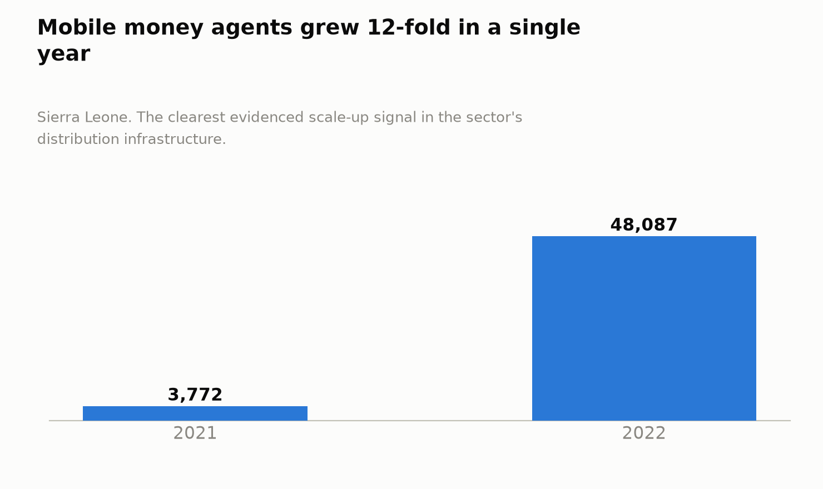
Figure 2. Mobile money agents grew 12-fold in a single year
- GDP and employment contribution: no reliable Sierra Leone-specific figure identified for FinTech as a discrete GDP or employment line, consistent with the existing draft.

Part 2 — The structural problem
- Core problem, restated with more precision: low formal-credit penetration compounds low account penetration. SMEs account for roughly 90% of Sierra Leone’s private businesses and provide livelihoods for about 70% of the population, yet only around 17% of them can secure formal loans or credit. Small Foundation, “Unlocking SME lending in Sierra Leone” — †, not opened. This is the sector’s clearest quantified gap and should replace the existing draft’s more general “low active use… weak interoperability” framing as the headline figure.
- A new, self-inflicted structural problem not in the existing draft: in October 2023, the Sierra Leone government introduced a Goods and Services Tax (GST) on mobile-money transactions and fee-based financial services under the Finance Act, 2023. Officials stated it added no new customer-facing charge, but reporting found the cost is in practice borne by the customer, raising the effective cost of transacting on mobile money. ManoReporters fact-check; Finance Act, 2023 — †, both not opened. This directly works against the sector’s own National Strategy for Financial Inclusion (already cited in the existing draft) and is a live regulatory tension the current “strongly enabling” verdict does not capture.
- Why the problem has persisted: low bank-branch density and documentation/KYC friction have historically been the binding constraints; KYC friction is now being actively addressed (see Part 7’s National Digital Identity Platform finding), but agent liquidity — agents running out of cash float to complete transactions — remains a specifically identified, unresolved constraint. International Growth Centre, “How Sierra Leone can join West Africa’s mobile money revolution” — †, not opened.
- Where value leaks: transaction fees and float remain captured by MNOs and agents (as in the existing draft); the new mobile-money GST adds a further extraction to government revenue that international evidence (see Part 8) suggests may be self-defeating even on its own fiscal terms.

Part 3 — Is this sector investable now?
- Expanded list of revenue-generating / traction-generating companies (the existing draft names three: Monime, InvestED/Salone Microfinance Trust, and Klasha as a regional entrant). This pass adds two more, one of which is the single strongest traction data point found anywhere across the first three sectors assessed:
  - Vult (Metro Cable × Velmie) — a multi-currency digital wallet / “digital banking super app” launched 28 July 2024 by Metro Cable, Sierra Leone’s largest broadband ISP, built on banking-technology vendor Velmie’s platform, with live integration to Rokel Commercial Bank, GTBank, and Access Bank. Reporting in this pass states the platform grew to “nearly half a million users” (~475,000) within roughly a year of launch. Fintech.global; Fintech News Africa, “Zero to 475,000 Users” — †, both blocked, not opened. No reliable data identified on Vult’s revenue or monetisation model — user-growth scale alone does not establish investability; this is flagged explicitly as a gap.
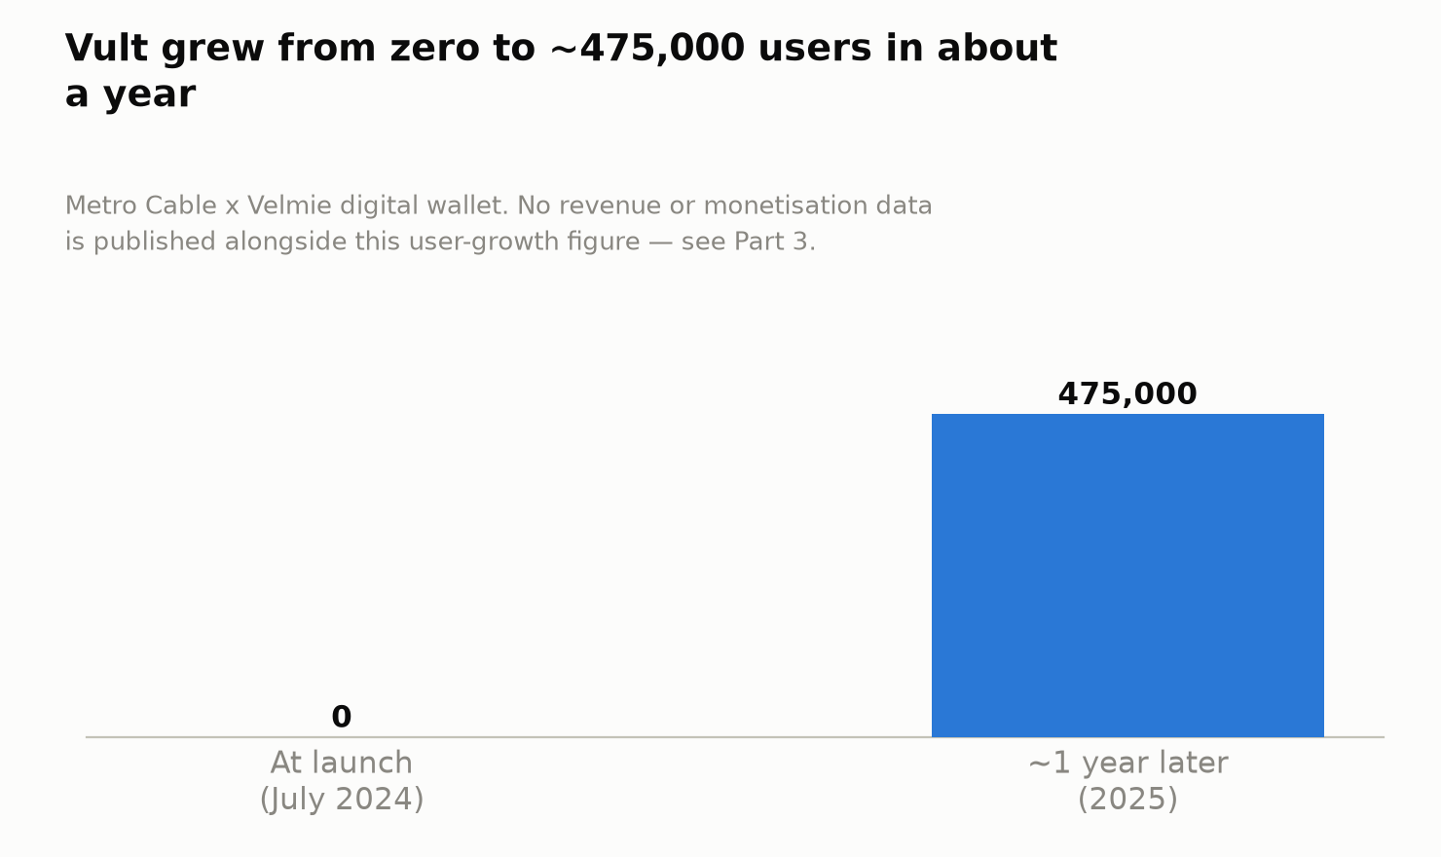
Figure 1. Vult grew from zero to approximately 475,000 users in about a year
- Empire Solution’s “Lajor” — a digital credit product distributed in partnership with Orange Mobile Money, reported to have served approximately 70,000 clients with more than 500,000 loans advanced. [Found via search among UNCDF Sierra Leone financial-inclusion articles] — †, exact source article not pinned down in this pass, needs Stage 2 identification and direct verification. This is a materially large, previously unlogged lending book — if verified, it is the best evidence yet in this whole assessment (across three sectors) of a Sierra Leonean fintech with real repayment/credit performance to underwrite against.
- Capital deployed: the largest evidenced, dated capital deployment into Sierra Leonean financial services in this pass is IFC’s unfunded risk-sharing facility with Access Bank (Sierra Leone) Ltd, up to US$10 million in local-currency equivalent, announced 2025, structured to support up to US$20 million of new SME lending. IFC press release — †, blocked, not opened. This is DFI guarantee/risk-sharing capital into a commercial bank’s SME book, not equity into a fintech company — but it is the single most concrete, named de-risking instrument found anywhere in the assessment so far (see Part 6).
- Minimum viable business model: confirmed and now better evidenced than in the existing draft — platforms that ride existing MNO and bank rails rather than seeking their own banking licence (Monime, Vult) can reach real user scale quickly. Vult’s ~475,000 users in about a year is the clearest demonstration of this to date.
- Venture-scale potential: more plausible here than in any other sector assessed, but still not confirmed by the evidence. Vult and Monime’s user/transaction scale is real; their unit economics are not published anywhere found in this pass. The sector’s investability case currently rests on adoption evidence, not revenue evidence — a distinction Stage 2 should treat as material, not cosmetic.
- What a company needs to reach US$1M revenue: no reliable Sierra Leone-specific fee or revenue-per-user data was identified to calculate this. This is flagged as a specific, answerable gap for direct engagement with Monime or Vult under the WS2 company-pipeline workstream, rather than something desk research can resolve.
- Exit environment — materially weaker than the existing draft implies. Two new findings qualify this:
  - The Sierra Leone Stock Exchange — the only domestic listing venue — had its office closed as of mid-2024, after operating for years with only three listings (Rokel Commercial Bank, First Discount House, and Commerce and Mortgage Bank) and a market capitalisation of roughly US$30 million as of 2023; foreign investors have not been permitted to participate. Sierra Leone Stock Exchange — Wikipedia; African Capital Markets News — †, not opened. This closes off any domestic IPO exit route for the foreseeable future.
  - Regionally, the current mobile-money “exit” pattern is MNO-parent-driven structural separation and mega-scale listing, not acquisition of small, country-specific platforms: MTN completed the structural separation of its Ghana MoMo business (effective 31 March 2026), reportedly targeting a standalone valuation of US$5–7 billion; Airtel Africa is planning to list its mobile-money unit on the London Stock Exchange, targeting a valuation that could reach US$10 billion. Techpoint Africa; The Platinum Capital — †, both not opened. This is several orders of magnitude beyond anything a Sierra Leone-only platform could reach, and no reliable data identified on any regional or international acquirer buying a Sierra Leone-specific fintech. The realistic monetisation path for an investor here is more likely dividend/cash-yield from a durable local business than an equity exit.

Part 4 — Capital and instrument fit
- What is needed: equity for platform build-out (Vult, Monime-type businesses, still pre-monetisation on current evidence); guarantee/risk-sharing debt for consumer and SME lending books once a repayment track record exists (as IFC’s Access Bank facility demonstrates at bank level, and as Lajor’s 500,000+ loans suggest could be replicated at fintech level); grant/TA for agent-network build-out, particularly women-agent recruitment (see Part 5).
- Debt service vs equity-only: lending-book businesses (Lajor) can plausibly service debt once seasoned, though no reliable default or repayment-rate data was identified to confirm this. Pure platform/wallet businesses (Vult, Monime) remain equity-stage on current evidence — no revenue data exists to underwrite debt against.
- Ticket sizes: IFC’s US$10 million risk-sharing facility (enabling US$20 million of on-lending) is the largest evidenced ticket into the sector, but it goes to a bank, not a fintech. The next-largest named figure remains the existing draft’s US$100,000 FinTech Challenge prize to InvestED/Salone Microfinance Trust (2018) — an order of magnitude smaller and seven years old. This is a wide, unfilled gap between prize-scale and DFI-bank-scale capital, with no reliable data identified on any ticket in between sized for a fintech company directly.
- Investors active regionally but not confirmed in Sierra Leone: Lendable (MSME fintech credit fund, backed by British International Investment via Fund II) and Cauris Finance (secured debt financing for African fintech, trade and mobility companies) are both named, active regional debt providers to fintechs elsewhere in Africa. No reliable data identified confirming either has deployed capital into a Sierra Leone-domiciled fintech — this is a specific, actionable outreach target for WS4 (LP and funder research), not a closed door.
- Financing gap: best-evidenced figure is the SME credit-access gap from Part 2 — ~17% of SMEs (90% of private businesses, 70% of livelihoods) access formal credit. No sector-specific fintech financing-gap figure (as opposed to general SME credit) was identified.

Part 5 — Employment and job readiness
- Labour intensity: agent networks remain the dominant employment channel (48,087 agents, 2022, already in the existing draft). New, concrete gender figure: Orange Money specifically recruited and trained more than 2,000 women agents across all 16 districts, bringing women to 15% of its total agent database. [Found via search among UNCDF Sierra Leone gender/financial-inclusion articles] — †, exact source not pinned down, needs Stage 2 identification. This replaces the existing draft’s “no reliable data identified” for firm-level gender data in this sector with a real, if still low, figure.
- Skills base: engineering and software talent remains the binding constraint at the platform layer (Vult, Monime); agent-network and loan-officer roles (as used by Lajor’s Orange-partnership distribution model) require less specialised training and are the larger near-term jobs lever.
- Gender composition: 25% of women vs. 33% of men held financial accounts in 2021 (Global Findex, already in the existing draft). New regulatory finding: the Gender Equality and Women’s Empowerment Act, 2022 legislates equal access to credit, financial services, transactions and financial products as a government priority. [Found via search, source not independently opened] — †. Orange’s 15% women-agent share shows implementation still lags the legal guarantee considerably.
- Youth employment potential: no reliable sector-specific figure identified. National context: roughly 60% youth unemployment against 70% of total employment sitting in the private sector [Borgen Project, citing SDG 8 reporting] — †, not opened, regional/national proxy rather than sector-specific.
- Fastest-creating segments: agent-network expansion (as already demonstrated 2021→2022) and partnership-distributed digital-credit models (Lajor’s Orange-agent-network distribution) create jobs fastest; platform engineering roles (Vult, Monime) are a much smaller, higher-skill headcount.

Part 6 — Investment innovation and de-risking
- The sector’s standout finding across the whole assessment so far: IFC’s unfunded risk-sharing facility with Access Bank (Sierra Leone), up to US$10 million, announced 2025, is the single most concrete, named, dated de-risking instrument identified anywhere in Sectors 1–3 combined. It is structured to unlock roughly 2x leverage — US$20 million of new SME lending against a US$10 million guarantee. IFC — †, blocked, not opened. No drawdown or outcome data exists yet (the facility is new), but the structure itself is exactly the kind of mechanism the WS1 prompt asks about, and it is Sierra Leone-specific, not a regional proxy.
- Other mechanisms already in the existing draft: the regulatory sandbox (Sierra Leone was the second African country after Kenya to launch one, 2018, UNCDF/FSD Africa-supported) and challenge grants (the 2018 FinTech Challenge). No reliable data identified on any 2023–2025 sandbox cohort — searches in this pass surfaced only the original 2017–2020 cohorts, which may indicate the programme has gone quiet, though absence of evidence is not proof of absence (per the methodology’s own convention). This should be logged as a specific negative result.
- What would need to be true for commercial entry without concessional support: resolution or removal of the October 2023 mobile-money GST; published revenue/unit-economics data from Vult or Monime; and a functioning domestic or regional exit route now that the Stock Exchange office has closed.
- Insurance, guarantee or offtake instruments available today: the IFC–Access Bank facility is the one concrete, named instrument evidenced. This is a materially more positive finding for this sector than for Sector 1 or Sector 2, where no comparable instrument was found.
- Role of technical assistance: the BSL/UNCDF/FSD Africa sandbox design process (2018) and BSL’s own Collateral Registry relaunch campaign (14 March 2025, opening movable-asset collateral to SMEs) are the two clearest evidenced TA/infrastructure interventions. The Calabash Newspaper — †, not opened.

Part 7 — Enabling environment
- Regulation, updated and more current than the existing draft: the National Payment Systems Act, 2022 underlies the National Payment Switch (launched 29 April 2023, already in the existing draft). This pass adds: an Instant Payment System launched 13 February 2025 in Freetown with 7 banks and 2 MNOs connected at launch; National Switch Directives, updated December 2024, building on the 2023 directives; and a mandatory full-integration deadline of 1 April 2025, after which all financial institutions and mobile money operators must process domestic transactions exclusively through the national switch (SaPS). Finance4Development; Forum News SL — †, both not opened. This is a materially more advanced interoperability picture than the existing draft’s single “launched April 2023” data point.
- A genuinely new enabler: the National Digital Identity Platform (NDIP). Described as Africa’s first blockchain-based national digital identity system, built by the National Civil Registration Authority with support from Kiva, enabling banks to run electronic KYC (eKYC) in real time against a citizen’s National Identification Number, building on Tiered KYC Guidelines issued in 2019 that already reduced documentation requirements for lower-tier accounts. State House Sierra Leone; UNCDF — †, both not opened. This is a significant, previously unlogged structural enabler: it directly addresses the KYC-friction barrier identified in Part 2, and no other sector assessed so far has an equivalent.
- A genuine tension the existing “strongly enabling” verdict does not capture: the October 2023 mobile-money GST (Part 2) runs directly counter to the National Strategy for Financial Inclusion’s own stated objectives, and directly parallels a pattern — Ghana’s and Tanzania’s mobile-money levies — that international evidence shows reduced both inclusion and, ultimately, total tax revenue (see Part 8). Recommend downgrading the sector’s Part 7 verdict from “strongly enabling” to “enabling, with a self-inflicted tax headwind” pending Stage 2 confirmation of whether the GST has since been adjusted.
- New relevant legislation: the Gender Equality and Women’s Empowerment Act, 2022 (Part 5).
- Donor/development programmes active: UNCDF/BSL/FSD Africa (sandbox, since 2018); IFC (Access Bank facility, 2025); World Bank (Collateral Registry support, ongoing); Kiva/UNCDF/UNDP (National Digital Identity Platform).
- Infrastructure constraints: the same power/connectivity constraints logged cross-sector apply (35.5% electricity access; contested 23–46% internet-penetration range); agent liquidity — cash float availability — is a specifically identified, sector-particular constraint not shared with the other sectors assessed so far (International Growth Centre, Part 2).

Part 8 — Comparative evidence
- Closest comparator, updated: Ghana and Kenya remain the obvious comparators (as in the existing draft), but this pass adds a specific, directly relevant regulatory precedent: both Ghana’s e-levy (introduced 2022, reduced January 2023) and Tanzania’s mobile-money levy (eliminated June 2023) were found, on the evidence surfaced here, to have reduced mobile-money transaction volumes and, ultimately, overall tax revenue, before being scaled back. International Growth Centre — †, not opened. Sierra Leone introduced its own mobile-money GST in October 2023 and — on the evidence available in this pass — has not reversed it. This is the single most directly transferable comparative lesson found in this sector: two comparator markets tried the same policy Sierra Leone is currently running, and both walked it back.
- Scale comparator: MTN’s completed MoMo structural separation in Ghana (targeting a $5–7bn standalone valuation) and Airtel Africa’s planned London listing of its mobile-money unit (targeting up to $10bn) illustrate the scale at which regional mobile-money “endgames” now play out — a scale no Sierra Leone-specific platform is a plausible candidate for in the foreseeable future (see Part 3, exit environment).
Verdict. Investable now, with more evidence and more qualification than the existing draft carries. This remains the most venture-ready sector assessed: real user-scale adoption (Vult’s ~475,000 users), a real lending book (Lajor’s 500,000+ loans, if verified), and — uniquely across the sectors assessed so far — a concrete, named, Sierra-Leone-specific de-risking instrument already in place (IFC’s US$10m risk-sharing facility with Access Bank, 2025). But three qualifications the existing draft does not carry should now attach to the verdict: (1) no revenue or unit-economics data exists for either of the sector’s two largest platforms (Vult, Monime) — adoption is evidenced, monetisation is not; (2) the domestic exit route has closed (the Stock Exchange office shut mid-2024), and the regional exit pattern (MNO structural separations at multi-billion-dollar scale) is not a realistic path for a Sierra Leone-only company — the underwriting thesis here should be cash yield from a durable local business, not an equity exit; (3) an October 2023 transaction tax works against the sector’s own inclusion strategy and has a directly on-point cautionary precedent (Ghana, Tanzania) that Sierra Leone has not yet acted on.

Additions required to the master tracker / claude_B1.docx on merge
- Ranking table / Executive summary: update the FinTech “Deciding evidence” cell to add Vult’s user scale, the Lajor lending book (pending verification), and the IFC–Access Bank guarantee facility; add the exit-environment and mobile-money-tax qualifications to the verdict text.
- Figure 2 (companies evidenced per sector): FinTech count should move from 3 to 5 (Monime, Vult, Lajor/Empire Solution, InvestED/Salone Microfinance Trust, Klasha as regional entrant) — noting Klasha is not Sierra Leone-domiciled.
- Figure 3 (ticket sizes): add IFC’s US$10m Access Bank risk-sharing facility (2025) as a new evidenced data point — flagged as bank-level guarantee capital, not fintech-company equity.
- Contradiction log: add (a) the account-ownership variance (28.9% Global Findex 2021 vs. 12.4%/19.8% MFW4A, undated definitional mismatch) and (b) the active-mobile-money-user variance (~21% vs. 16%, differing denominators, not yet reconciled).
- Negative-results log: add “no reliable revenue or unit-economics data for Vult or Monime”; “no confirmed Lendable or Cauris deployment into a Sierra Leone-domiciled fintech”; “no reliable data on any 2023–2025 regulatory sandbox cohort beyond the original 2018 group.”
- Visibility boundary table: update FinTech row from “3 (Payment aggregators and sandbox entrants; MNO-internal data not public)” to “5 (as above); Vult and Lajor’s own revenue and repayment data remain invisible to desk research despite substantial user/loan-volume evidence.”
- Part 7 verdict: recommend downgrading from “Strongly enabling” to “Enabling, with a self-inflicted tax headwind” pending Stage 2 confirmation of the GST’s current status.

Verification queue for Stage 2/4 (nothing above may enter the Source Register as “Verified” until this is done)
- Open the IFC press release on the Access Bank facility directly; confirm instrument type, exact terms, and current drawdown status.
- Open Vult/Metro Cable/Velmie primary sources directly; obtain revenue or monetisation data if any exists, and confirm the ~475,000 user figure and its as-of date.
- Identify and open the primary source for the Lajor/Empire Solution figures (70,000 clients, 500,000+ loans) — this pass could not pin down the exact article among several UNCDF Sierra Leone financial-inclusion pieces.
- Open the Finance Act, 2023 and the ManoReporters fact-check directly to confirm the mobile-money GST’s exact rate, scope, and whether it has been amended since October 2023.
- Confirm directly with Bank of Sierra Leone or UNCDF whether the regulatory sandbox has run a cohort since 2018–2020, and if so, who is in it.
- Reconcile the account-ownership and active-user contradictions logged above against primary Global Findex and MFW4A/BSL data.
- Directly approach Lendable and Cauris Finance (or check their portfolio pages) to confirm or rule out any existing Sierra Leone exposure — relevant to WS4 as well as this workstream.
- Confirm the Sierra Leone Stock Exchange’s current operating status — “office closed as of mid-2024” was the most recent data point found and should be verified as still current.

