SMART IMPACT CONSULT
smartimpactconsult.com

Sector Investability Assessment

Sierra Leone — Sector 6: HealthTech
Workstream: B.1 — WS1 Market and Sector Validation (Priority · Sprint 1)
Prompt: WS1-v1.0 — Sector Investability, Sierra Leone
Stage / round: Stage 1 desk research · Round 1 output, formatted for Stage 2 review
Prepared by: Investment Operations, Smart Impact Consult (smartimpactconsult.com)
Date: 23 September 2026
Desk research only. Every factual claim below carries a named source and, where available, the year it refers to; sources are embedded as clickable links. Where Sierra Leone-specific data does not exist, this is stated explicitly and regional or continental data used as a proxy is labelled as such. Where a search could not evidence a figure at all, the document states “no reliable data identified” rather than estimating. This pass’s sources come from web search, not from primary documents opened and read in full — see the Environment Limitation note below — so every finding here carries the same unverified status as a “†” marker: a named, dated, linked lead, not yet a confirmed source. Nothing in this document may be treated as “Verified” in the Source Register, and nothing should enter a client-facing deliverable, until a team member opens each cited link directly, per Stage 4 of the AI-Assisted Research Methodology.

PROVENANCE HEADER — applied to every raw output file (per Methodology A.5)
- Workstream: WS1 Market and Sector Validation
- Prompt version: WS1-v1.0 — Sector Investability, Sierra Leone
- Sector: 6 of 8 — HealthTech
- Engine: Claude (this session) — desk research, single-engine pass
- Run date: 2026-09-23
- Operator: Investment Operations, Smart Impact Consult (smartimpactconsult.com)
- Round: 1 of 2 (Stage 1 desk research, formatted for Stage 2/4 human verification)
- Archive path: /Research_Archive/WS1/WS1-v1.0_Claude_Sector06-HealthTech_20260923.md
- Linked to: claude_B1.docx, “Sector 6 — HealthTech” section (existing verdict: “Not investable” — “Pre-commercial and donor-dependent.” This pass confirms the verdict and adds a materially sharper, more current basis for it: a quantified workforce/payroll crisis on the supply side, and a large, dated, ongoing donor-funding contraction on the financing side.)
Environment limitation — carried forward from all prior sector files. WebFetch was blocked for every domain tested in this session. Every finding below comes from WebSearch snippets only, not opened primary documents, and is carried at the same unverified status as the “†” markers already used in claude_B1.docx. Nothing here may enter the Source Register as “Verified” until a team member opens each link directly — see the verification queue at the end.

Sector 6 — HealthTech

Part 1 — Market structure and size
- No reliable data identified on HealthTech sector size, revenue or enterprise count in Sierra Leone — consistent with the existing draft.
- A sharp, quantified capacity gap not in the existing draft: the density of doctors, nurses and midwives in Sierra Leone is estimated at 6.4 per 10,000 population, against a WHO-recommended minimum threshold of 44.5 per 10,000 needed for meaningful progress toward universal health coverage — roughly a seven-fold shortfall. Annals of Global Health / PMC — †, not opened. This is one of the starkest quantified capacity gaps found anywhere across the sectors assessed so far.
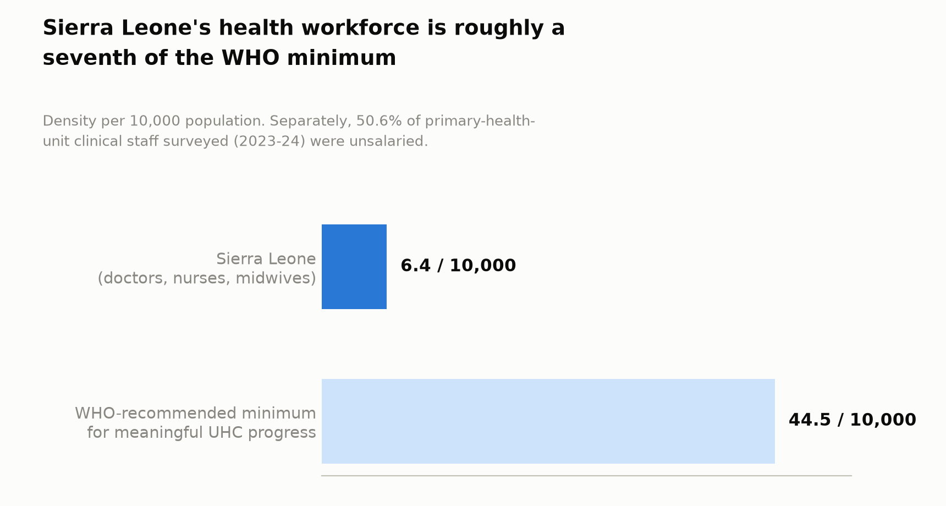
Figure 1. Sierra Leone’s health workforce is roughly a seventh of the WHO minimum
- Financing and coverage baseline: less than 1% of Sierra Leone’s population is covered by any social health protection scheme. Out-of-pocket health expenditure stands at 46% of total health spending, and the government’s own UHC service coverage index score is 41 (out of 100). WHO / Ministry of Health and Sanitation — †, not opened.

Part 2 — The structural problem
- Core problem confirmed, now with a specific, decade-long institutional failure identified as its cause. The Sierra Leone Social Health Insurance Scheme (SLeSHI) — the country’s would-be national health-insurance rail — has been under discussion since 2007 and was formally launched in 2017, but the scheme itself never became operational. WHO/AFRO — †, not opened. This directly explains why no digital-health payer or insurance rail exists for a HealthTech company to build on — it is not merely that inclusion is low, it is that the specific mechanism designed to fix it has sat unused for close to a decade.
- A second, deep structural problem not in the existing draft: the public health workforce is substantially unpaid. A mixed-methods survey across 10 of Sierra Leone’s 16 districts (2023–2024) found that 50.6% of clinical staff at primary health units were unsalaried, operating outside formal payroll systems with limited accountability. Separately, approximately 10,000 auxiliary nurses have been engaged in the public health system since 2010 on an unsalaried “volunteer” basis. PMC, “Improving Sierra Leone’s skilled health-worker-to-population ratio” — †, not opened. This matters directly for HealthTech investability: the “formal” health system any digital-health company would serve is materially smaller, and less financially stable, than headline facility or workforce counts suggest.
- Where value/capacity concentrates: with no functioning domestic insurance rail, financing and delivery capacity has flowed almost entirely through donor and NGO vertical programmes (Gavi, Global Fund, PEPFAR, USAID, UNICEF — see Part 7) rather than through a commercial or even fully functioning public system — this is a more specific answer than the existing draft’s general “donor-dependent” framing.

Part 3 — Is this sector investable now?
- Still no reliable evidence of a revenue-generating Sierra Leonean HealthTech firm — confirmed, not overturned, in this pass. SalCare, already logged in the existing draft as pilot-stage, is confirmed as a mobile micro-health wallet and insurance app that lets families save small amounts, buy affordable micro-insurance, and pay for care from basic phones, co-designed with residents to reach women, youth and people with disabilities specifically. [App Store listing / related coverage] — †, not opened. No user count or revenue data was identified in this pass either — it remains genuinely pilot-stage, not merely under-documented.
- mPharma (Ghana) — the region’s flagship pharmaceutical-supply-chain HealthTech company — is confirmed not operating in Sierra Leone, with fresh 2024–2025 sourcing. mPharma has raised over US$40 million cumulatively, including a US$13.6 million round involving Sanofi’s Global Health Unit Impact Fund, and has taken strategic investment from Growth Investment Partners (GIP) Ghana, a platform established by British International Investment (BII); as of late 2025 it was doubling down on Francophone Africa expansion. It operates in Ghana, Nigeria, Kenya and Zambia — Sierra Leone is not among them, now or in its stated expansion pipeline. Launchbase Africa — †, not opened.
- Reliance Health (Nigeria) raised US$40 million in a Series B round led by General Atlantic (2022) — the largest Series B by an African health-tech startup to date. This is what genuine venture-scale investability looks like in this sector regionally; nothing remotely comparable exists in or near Sierra Leone.
- A genuine, Sierra-Leone-specific innovation exists, but it is infrastructure, not a company — worth distinguishing clearly from the existing draft’s undifferentiated “not investable.” HETA (Health Electrification and Telecommunications Alliance), Power Africa’s flagship health-facility electrification and connectivity initiative, builds on HealthGrid Sierra Leone — a USAID-supported Global Development Alliance with Orange Sierra Leone, World Vision Sierra Leone, Gavi and the Ministry of Health and Sanitation, which installed solar power and internet at 26–27 remote health facilities (pilot completed between September 2024 and January 2025 depending on source — minor date discrepancy, logged, not resolved) — and is now expanding to an additional 60 sites. RESOLVE; Abt Global — both †, not opened. A named commercial solar-energy company, Mopo, partners with HETA to deliver this power. This is not a HealthTech company an investor could back, but it is a real precondition — reliable power and connectivity at the facility level — for any future digital-health venture to operate at all, and should be logged as such rather than folded into a blanket “nothing here” finding.
- Minimum viable business model: unchanged from the existing draft’s conclusion, now with the specific mechanism identified — with SLeSHI non-operational and out-of-pocket expenditure at 46%, there is no functioning payer rail for a digital-health company to plug into today.
- Venture-scale potential: no, confirmed, and now more sharply explained: the formal system any HealthTech company would serve is both smaller (given the workforce/payroll informality finding) and less financially stable (given the aid-cuts finding in Part 7) than headline figures suggest.

Part 4 — Capital and instrument fit
- What is needed: overwhelmingly grant and donor/blended infrastructure finance (as HETA/HealthGrid demonstrates), not equity. Any future digital-health equity company would first need either a functioning payer rail or a viable out-of-pocket/B2B revenue model — neither currently exists at scale.
- Ticket sizes: no reliable Sierra Leone-specific figure identified. Regional comparators, for context only: mPharma’s cumulative >$40m raised (including the $13.6m Sanofi-linked round) and Reliance Health’s $40m Series B (General Atlantic) illustrate that venture-scale outcomes in this sector require markets an order of magnitude larger, more urbanised, and better-insured than Sierra Leone offers today.
- A useful regional funding-pattern signal (proxy, not Sierra Leone-specific): across Africa, pharmaceutical-supply-chain/logistics/embedded-financing HealthTech models (mPharma-like) capture roughly 40% of total sector VC funding, while consumer telemedicine platforms (Reliance Health-like) capture only around 17%. [via search, source not independently opened] — †. This suggests that if Sierra Leone ever attracts HealthTech capital, a pharmaceutical-supply-chain/logistics entry point — building on the existing donor-run RapidPro medicines-tracking and NPPU procurement infrastructure (Part 7) — is more plausible than a consumer telemedicine app, given the near-total absence of a private-pay or insured customer base.
- Financing gap: still no reliable Sierra Leone-specific figure identified.

Part 5 — Employment and job readiness
- Skills base, now quantified: the 6.4-per-10,000 health-worker density against a WHO minimum of 44.5-per-10,000 (Part 1) is a direct, sourced measure of talent constraint, replacing the existing draft’s unsupported general statement.
- Gender — a new, sourced figure replacing the existing draft’s “no reliable data identified”: 64.2% of Sierra Leone’s active health workforce are female. [Search-sourced, PMC-linked reporting] — †, not opened.
- A major structural employment finding not in the existing draft: roughly half of primary-health-unit clinical staff (50.6%, 2023–24 survey) and ~10,000 auxiliary nurses since 2010 are unsalaried — meaning a large share of this sector’s “employment” is unpaid labour outside the formal payroll and accountability system, not jobs a private investment would create or capture value from. This should materially qualify any future employment-multiplier claim made for this sector.
- Youth employment potential: no reliable data identified specific to this sector, consistent with the existing draft.

Part 6 — Investment innovation and de-risking
- This pass corrects the existing draft’s blanket “no mechanisms evidenced” position for this sector. HETA’s “Sustainability Fund” is a real, named, Sierra-Leone-specific innovation: rather than treating solar/connectivity electrification of health facilities as a one-off donor grant, HETA explicitly incorporates market-based revenue-generation mechanisms intended to fund ongoing operations and maintenance after the initial donor-funded build — an attempt to convert a grant-funded infrastructure intervention into something closer to a self-sustaining, quasi-commercial model. Abt Global; SEforALL — †, both not opened. This is genuinely closer to “investment innovation” than anything found in this sector previously, even though it operates at the infrastructure layer rather than the company layer.
- Other evidenced TA/donor mechanisms: UNICEF’s RapidPro SMS-based medicines-tracking system (USAID-supported, since 2015) provides free-to-user, basic-phone-compatible drug-distribution feedback — a real, functioning digital tool, though donor-run rather than a company; Crown Agents was contracted in 2012 to build and manage the National Pharmaceutical Procurement Unit (NPPU) and transfer local capacity over three years — a foreign-contracted national logistics function, not a Sierra Leonean venture, but evidence that a functioning pharma-supply-chain backbone has been built once before with external management.
- What would need to be true for commercial entry without concessional support: SLeSHI or its proposed SLAUHC successor (Part 7) actually becoming operational as a functioning payer; resolved workforce formalisation so a digital tool has a stable, trackable professional user base; and, per Part 4’s funding-pattern signal, a pharma-logistics entry point building on existing donor-run infrastructure (RapidPro, NPPU) is more plausible than a consumer-facing app.

Part 7 — Enabling environment
- New, directly relevant policy development not in the existing draft: a draft Sierra Leone Agency for Universal Health Coverage (SLAUHC) Bill proposes creating a single agency to integrate the country’s two major health-financing mechanisms — the Free Healthcare Initiative (FHCI), in place since 2010 for pregnant/lactating women and under-5s, and the never-operationalised SLeSHI (Part 2) — under one governance structure. A high-level stakeholder engagement (60+ senior leaders) was held 6 May 2025; no reliable data identified confirming the Bill has since passed. WHO/AFRO — †, not opened. The government’s own 2025–2030 UHC targets — raising the service coverage index from 41 to 55, cutting out-of-pocket expenditure from 46% to below 20%, and “mobilising significant private sector investment” — are directly on-point for WS1’s investability question and were entirely absent from the existing draft.
- A major negative shock, not in the existing draft, that materially worsens this sector’s financing picture: at the end of January 2025, the US administration issued a stop-work order halting USAID-funded projects. Sierra Leone’s Ministry of Health reported this represents a US$45 million reduction in projects focused on maternal, child and adolescent health; the US had provided US$3.2 million in 2024 — about 14% of Sierra Leone’s total reproductive-health funding — now cut. Separately, the UK’s “Saving Lives” programme was reduced from roughly £17 million (~US$22.9m) to just £1 million (~US$1.3m) by late 2025. [Human Rights Watch-linked reporting via Fuller Project, Foreign Policy, Rebuild Consortium] — †, all not opened. Reported consequences include a sharp decline in per-capita health expenditure and specific emerging service gaps in rural, donor-dependent districts — Pujehun, Bonthe, Kambia, Karene and Falaba are named specifically. This is a large, dated, quantified funding contraction directly affecting the sector’s dominant financing model (donor/NGO delivery, per Part 2) and should be weighted heavily in any current investability judgement — the existing draft’s single line (“the 2025 reduction in US health aid removed part of it”) substantially understates the scale of what has happened.
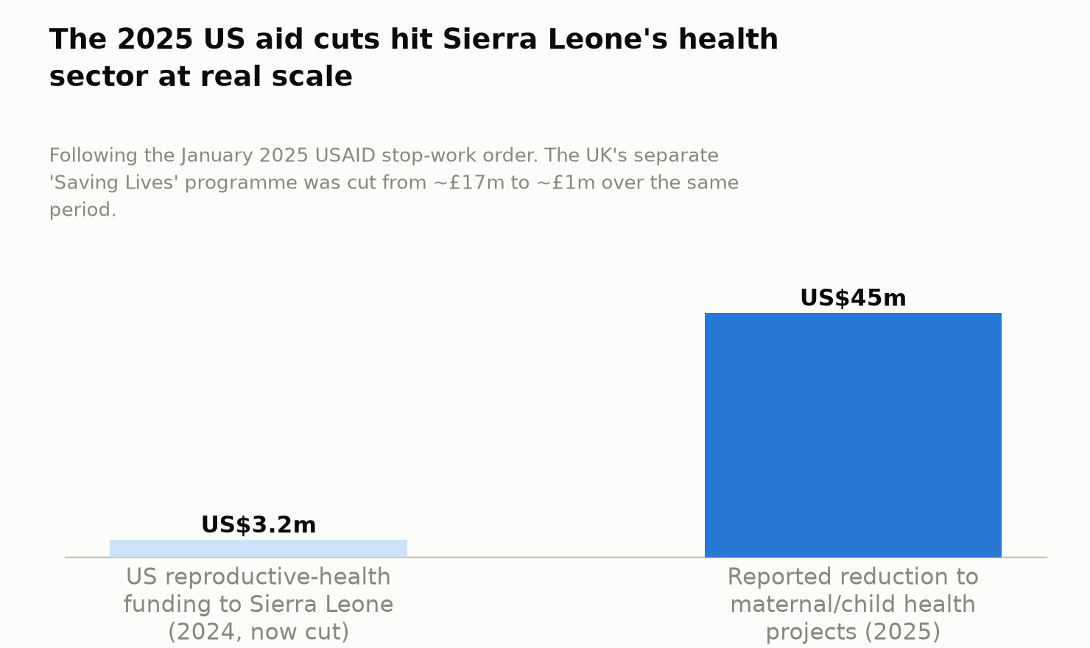
Figure 2. The 2025 US aid cuts hit Sierra Leone’s health sector at real scale
- Donor/development programme ecosystem, now more fully mapped: USAID/Power Africa (HETA/HealthGrid), Gavi, the Global Fund (which procures ARVs jointly with or exclusively for Sierra Leone), PEPFAR, the US President’s Malaria Initiative, UNICEF (RapidPro), and Crown Agents (NPPU) — a dense donor ecosystem that is now visibly contracting per the aid-cuts finding above, not a stable baseline to plan against.
- Infrastructure constraints: HETA/HealthGrid’s own existence — donor intervention was required simply to bring solar power and internet to health facilities — is itself direct evidence of the same power/connectivity constraint logged cross-sector, now with a concrete remediation programme and site count attached.

Part 8 — Comparative evidence
- Ghana (mPharma) and Nigeria (Reliance Health) remain the comparators, now with hard, dated funding figures rather than general statements. Both operate in markets with materially larger populations, higher urbanisation, and — in mPharma’s case — an actual functioning pharmacy-distribution network to build a supply-chain business on top of; Sierra Leone has neither the population scale nor (per Part 2) a functioning insurance rail to offer an equivalent foundation today.
- What failed, reframed for this sector specifically: no Sierra Leone-specific HealthTech venture has failed outright — there has essentially been nothing at venture scale to fail. The closest thing to a “failure” evidenced in this pass is a funding-model failure: the sector’s near-total dependence on donor/NGO delivery has proven fragile, as the 2025 US and UK aid cuts (Part 7) directly demonstrate. This is arguably a more important comparative lesson than any single-company failure would be.
Verdict. Not investable now — confirmed, with a materially sharper and more current basis than the existing draft. This is not a static absence of activity; it is an active double pressure: on the supply side, a formal health workforce that is both critically undersized (6.4 vs. a WHO minimum of 44.5 per 10,000) and roughly half unsalaried; on the financing side, a donor-dependent delivery model now undergoing a large, sudden, dated contraction (US and UK aid cuts through 2025). What would have to change: SLeSHI or its proposed SLAUHC successor actually becoming operational as a functioning payer rail; workforce formalisation; and — the live, unresolved question right now — whether the sector’s donor-funded infrastructure (HETA’s 2024–25 electrification work, RapidPro, NPPU) can survive and adapt to the 2025 aid contraction, or whether it simply loses capacity. Stage 2 should treat this last question as urgent and time-sensitive, not a standing background fact.

Additions required to the master tracker / claude_B1.docx on merge
- Ranking table / Executive summary: update HealthTech’s “Deciding evidence” cell to add the workforce-density gap (6.4 vs. 44.5 per 10,000), the SLeSHI non-operational finding, and — critically — the 2025 US/UK aid-cut figures, which the existing draft only gestures at in one clause.
- Figure 2 (companies evidenced per sector): HealthTech count should remain effectively 0 revenue-generating (SalCare remains pilot-stage, as in the existing draft), but the tracker should now separately note HETA/HealthGrid as a real, named, Sierra-Leone-specific infrastructure and sustainability-financing innovation distinct from a company-level finding.
- Negative-results log: retain “no revenue-generating Sierra Leonean HealthTech firm evidenced”; add “mPharma and Reliance Health, the region’s two flagship HealthTech companies, both confirmed not operating in or expanding toward Sierra Leone as of late 2025.”
- Contradiction log: add the HealthGrid pilot-completion date discrepancy (September 2024 vs. January 2025, depending on source).
- Cross-cutting flag for the Advisory Group: the 2025 US/UK aid-cut figures found here (US$45m US maternal/child health reduction; UK Saving Lives cut from ~£17m to ~£1m) are large enough, and recent enough, that they likely warrant a dedicated line in the Sprint 1 cross-cutting risk summary, not just a sector-level footnote — donor-dependent sectors elsewhere in this assessment (EdTech, GovTech) may be exposed to the same or parallel cuts and should be checked for an equivalent finding when those sectors are run.

Verification queue for Stage 2/4 (nothing above may enter the Source Register as “Verified” until this is done)
- Open Human Rights Watch, Fuller Project, and Rebuild Consortium reporting directly to confirm the exact US$45m and UK Saving Lives figures, their scope, and whether any restoration of funding has occurred since this pass’s search date.
- Confirm whether the SLAUHC Bill has passed since the 6 May 2025 stakeholder engagement.
- Open SalCare’s own materials directly to obtain any user or transaction-volume data.
- Confirm mPharma’s and Reliance Health’s current market footprints directly (company sites/investor updates) to verify continued non-presence in Sierra Leone as of the Stage 2 date.
- Resolve the HealthGrid pilot-completion date discrepancy (26 vs. 27 facilities; September 2024 vs. January 2025) directly against RESOLVE/Abt Global/HETA primary reporting.
- Confirm the current operational status of HETA’s expansion to the additional 60 sites.
- Directly verify the 50.6% unsalaried clinical-staff figure and its district coverage (10 of 16 districts) against the original 2023–24 survey.

