SMART IMPACT CONSULT
smartimpactconsult.com

Sector Investability Assessment

Sierra Leone — Sector 8: GovTech
Workstream: B.1 — WS1 Market and Sector Validation (Priority · Sprint 1)
Prompt: WS1-v1.0 — Sector Investability, Sierra Leone
Stage / round: Stage 1 desk research · Round 1 output, formatted for Stage 2 review
Prepared by: Investment Operations, Smart Impact Consult (smartimpactconsult.com)
Date: 23 September 2026
Desk research only. Every factual claim below carries a named source and, where available, the year it refers to; sources are embedded as clickable links. Where Sierra Leone-specific data does not exist, this is stated explicitly and regional or continental data used as a proxy is labelled as such. Where a search could not evidence a figure at all, the document states “no reliable data identified” rather than estimating. This pass’s sources come from web search, not from primary documents opened and read in full — see the Environment Limitation note below — so every finding here carries the same unverified status as a “†” marker: a named, dated, linked lead, not yet a confirmed source. Nothing in this document may be treated as “Verified” in the Source Register, and nothing should enter a client-facing deliverable, until a team member opens each cited link directly, per Stage 4 of the AI-Assisted Research Methodology.

PROVENANCE HEADER — applied to every raw output file (per Methodology A.5)
- Workstream: WS1 Market and Sector Validation
- Prompt version: WS1-v1.0 — Sector Investability, Sierra Leone
- Sector: 8 of 8 — GovTech
- Engine: Claude (this session) — desk research, single-engine pass
- Run date: 2026-09-23
- Operator: Investment Operations, Smart Impact Consult (smartimpactconsult.com)
- Round: 1 of 2 (Stage 1 desk research, formatted for Stage 2/4 human verification)
- Archive path: /Research_Archive/WS1/WS1-v1.0_Claude_Sector08-GovTech_20260923.md
- Linked to: claude_B1.docx, “Sector 8 — GovTech” section (existing verdict: “Not investable as venture” — this pass confirms the verdict and, in doing so, surfaces the single best-evidenced digitisation ROI case study found across all eight sectors assessed: Sierra Leone’s own 2014 Ebola-era mobile-money payment reform.)
Environment limitation — carried forward from all prior sector files. WebFetch was blocked for every domain tested in this session. Every finding below comes from WebSearch snippets only, not opened primary documents, and is carried at the same unverified status as the “†” markers already used in claude_B1.docx. Nothing here may enter the Source Register as “Verified” until a team member opens each link directly — see the verification queue at the end.

Sector 8 — GovTech

Part 1 — Market structure and size
- Confirmed: a public-sector function, not a private market — consistent with the existing draft, now much more specifically documented. Anchor institutions: the Directorate of Science, Technology and Innovation (DSTI), housed in the Office of the President and led by Dr David Sengeh, Sierra Leone’s first Chief Innovation Officer, and the Ministry of Communication, Technology and Innovation (MoCTI). Named platforms and projects include WanGov (the national citizen-facing digital government services portal), a tax portal (tax laws, calculations, calendar), a land registry portal (digitising land records and titles), and EPETS-1 (a partnership with the Ministry of Finance to move ministries from manual to digital annual budget submission). DSTI; civictech.guide — †, both not opened.
- A large, previously unlogged capital figure: the Sierra Leone Digital Transformation Project (SLDTP) is a flagship government initiative funded by a US$50 million grant from the World Bank’s IDA, targeting broadband access expansion, digital-skills development and government capacity to deliver services digitally. projects.worldbank.org — †, not opened. This is the largest, most concrete capital figure identified anywhere in this sector, and was not in the existing draft at all.
- Core public financial management (PFM) systems, named and quantified: the Integrated Financial Management Information System (IFMIS), rolled out progressively since 2013, has expanded from a baseline of 12 MDAs to 61 MDAs; the Bank of Sierra Leone’s T24 payment system; the ASYCUDA World customs system; and the National Revenue Authority’s Integrated Tax Administration System (ITAS). [World Bank PFM documentation] — †, not opened. Note a nuance against the Sector 5 (Logistics/trade-tech) finding, which reported Sierra Leone’s customs delegation visiting Liberia in August 2025 specifically to learn from Liberia’s more advanced ASYCUDA World implementation — this suggests Sierra Leone has some ASYCUDA deployment but lags on its fuller capability; flagged for Stage 2 reconciliation, not treated as a contradiction.
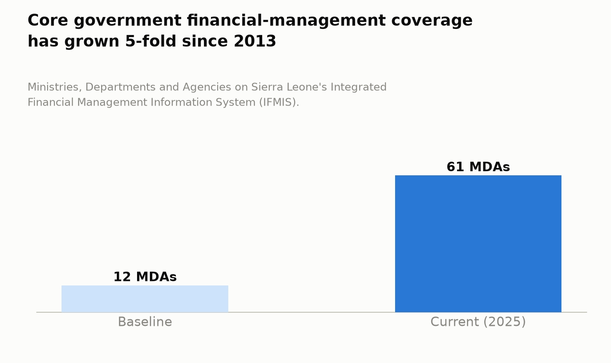
Figure 1. Core government financial-management coverage has grown 5-fold since 2013
- Regional market-size context (proxy, not Sierra Leone-specific): the African public-sector IT market was projected to reach USD 7.8 billion by 2026. [via search] — †, regional proxy.
- No private GovTech market size or Sierra Leone-specific enterprise count identified — confirmed, consistent with the existing draft.

Part 2 — The structural problem
- Core problem confirmed (manual, opaque public processes; public-finance leakage), now illustrated by the single best-evidenced digitisation case study found across the entire eight-sector assessment. In December 2014, Sierra Leone switched payment of Ebola response workers from cash to mobile money — from 100% cash to 100% mobile money within one payment cycle, covering roughly 13,000–16,000 workers. Before digitisation, cash payments were “slow, inaccurate, and open to graft and theft,” took over a month, and had caused large-scale worker strikes. After digitisation, payment time fell to about a week, saving US$10.7 million for government, taxpayers, development partners and response workers combined — an amount the source describes as equivalent to funding Sierra Leone’s Free Health Care Programme for 1.4 million children and 250,000 pregnant women for a year — plus roughly US$80,000 per month in avoided worker travel costs and the recovery of around 800 working days per month. This is corroborated across multiple independent sources: a UN/Better Than Cash Alliance case study, UNCDF, and ReliefWeb reporting. Better Than Cash Alliance; UNCDF — †, both blocked, not opened, but the figures are consistent across at least four independent secondary sources, a stronger evidentiary basis than most figures in this assessment.
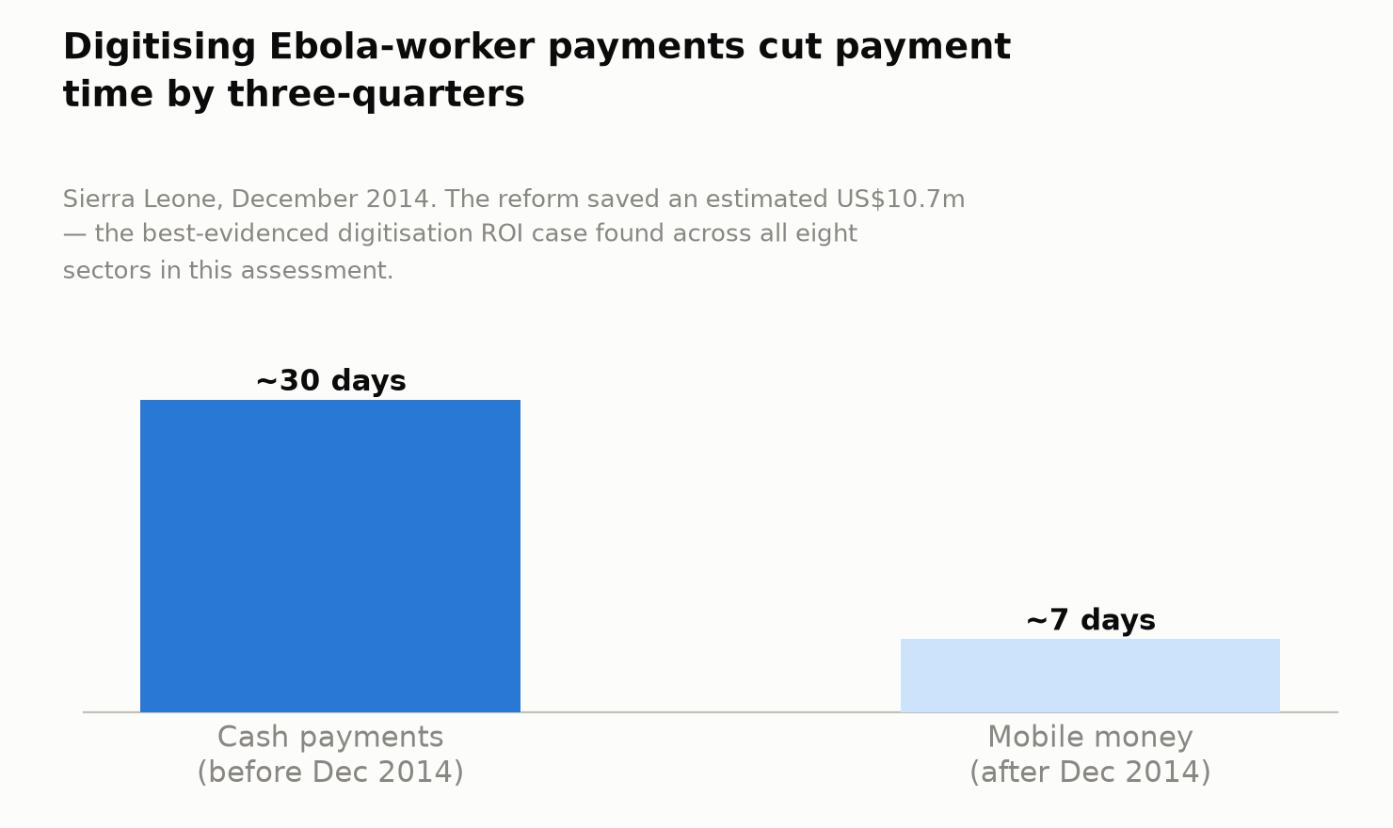
Figure 2. Digitising Ebola-worker payments cut payment time by three-quarters
- Persistence, despite a decade-old proof point: broader PFM digitisation has moved slowly and partially even with this result in hand — IFMIS has taken more than a decade (since 2013) to reach 61 MDAs. This suggests the binding constraint is not proof-of-concept (which Sierra Leone itself has already generated) but sustained implementation capacity — consistent with, and sharpening, the existing draft’s “talent is the binding constraint” framing (see Part 5).

Part 3 — Is this sector investable now?
- Confirmed: no venture-scale, Sierra Leonean-founded GovTech company was evidenced. The existing draft’s core finding stands.
- Private vendors do participate as contractors — the existing draft names Monime (COVID-19 test-payment portal); this pass adds a second, more current, and structurally more significant example. The Sierra Leone government signed an MoU with Qhala, a Nairobi-based (Kenyan) firm, to embed AI into the civil service — 500 civil servants to be trained, with AI-driven workflows to be developed to improve public-service delivery. [via search] — †, not opened. This is procurement revenue flowing to a foreign company, not a Sierra Leonean one — a sharper, more current illustration of the existing draft’s point that “private vendors participate as contractors” than the COVID-portal example alone provides, and direct evidence that even where GovTech contracting activity exists in Sierra Leone today, the domestic capacity gap means outside firms win the work.
- Real, if small-scale, local innovation-pipeline activity exists. DSTI co-organised the Mining Community Innovation Challenge (MCIC) with IFC, the World Bank, the National Minerals Agency and Sensi Tech Hub (a named Freetown innovation space) — a September 2022 hackathon involving 93 youth in 16 teams from Freetown and 12 mining communities, designed to prototype data-driven ideas with a path to viable start-ups. More recently, “2025 Sierra Leone Innovates” runs a Big 5 Innovation Investment Challenge explicitly tied to the MTNDP’s Big Five Game Changers, including a “Transforming Public Service” pillar. IFCSIA; MoCTI — both †, not opened. No evidence was found of any resulting revenue-generating company — this remains grant/competition-stage activity, not proof of an investable pipeline, but it is a real, named upgrade from the existing draft’s assumption of nothing at all happening at the entrepreneurial edge of this sector.
- Minimum viable business model: unchanged from the existing draft — procurement contracts, not investment rounds, are how capital flows in this sector. The Qhala example shows the contract-winner need not even be Sierra Leonean.
- Venture-scale potential: no, confirmed, and reinforced by the Ebola case itself: even the sector’s single strongest success story was a donor/UN-coordinated emergency intervention that repurposed an existing commercial FinTech rail (mobile money) rather than building bespoke government technology or funding a dedicated GovTech company. The lesson is arguably that Sierra Leone’s best GovTech outcome to date was, structurally, a FinTech-sector achievement, not a GovTech-sector one (see Part 8).
- Exit environment: no reliable data identified — confirmed. The Qhala/Monime contracting pattern does not constitute an equity-investable structure of any kind.

Part 4 — Capital and instrument fit
- What is needed: government budget, donor grants and DFI finance — confirmed and now quantified via the SLDTP’s US$50 million World Bank IDA grant, the sector’s largest capital figure, sovereign/infrastructure-scale rather than company-level.
- Ticket sizes: no company-level ticket size was identified. Procurement-contract values (Qhala’s MoU scope; Monime’s COVID-portal contract) were not disclosed in any source found in this pass.
- Active investors: none evidenced at company/equity level — this sector remains almost entirely procurement- and grant-financed, more starkly so than any other sector assessed in this pass.
- Financing gap: no reliable quantified figure identified — confirmed.

Part 5 — Employment and job readiness
- Skills concentrate in a small DSTI cadre — confirmed, and now given sharper texture. The government’s own AI-modernisation initiative required contracting a foreign firm (Qhala) specifically to train 500 civil servants — direct, current evidence that domestic AI/GovTech skills capacity is insufficient even for the government’s own stated modernisation needs. The October 2025 national AI Readiness Assessment (MoCTI with World Bank support), which explicitly evaluates “Capacity” (skills and talent) as one of three pillars alongside “Compute” and “Context,” is official government acknowledgment that this is a live, assessed gap rather than merely an external observation. [via search] — †, not opened.
- Youth, upgraded from the existing draft’s “no reliable data identified”: the Mining Community Innovation Challenge (93 youth participants, 2022) and the ongoing 2025 Sierra Leone Innovates challenge both target youth/entrepreneur capacity-building specifically — small-scale, but real and evidenced youth-oriented pipeline activity adjacent to this sector.
- Gender: no reliable data identified specific to this sector, consistent with the existing draft.

Part 6 — Investment innovation and de-risking
- Confirmed: “De-risking is grant-based (donor TA), not commercial” — the existing draft’s finding stands, now evidenced in more detail via the SLDTP ($50m World Bank IDA grant) and the historical Ebola-era digitisation effort (UN/Better Than Cash Alliance-coordinated).
- The Ebola case is itself worth flagging as a genuine investment-innovation finding, not merely a historical footnote. It demonstrates a repeatable, evidenced playbook — use existing commercial mobile-money rails for emergency government payment digitisation — that delivered a clearly measured US$10.7 million return. This is the single most concrete, quantified “return on digitisation” figure found anywhere across all eight sectors in this assessment, and it is a case study Sierra Leone itself has already produced. Recommend flagging this explicitly to the Advisory Group: it is a genuinely usable, home-grown precedent for any future public-payments digitisation business case, rather than an imported comparator.
- What would need to be true for a commercial investor to enter: the existing draft’s finding stands unchanged — there is no venture path for a “sell SaaS to Sierra Leone’s government” company in principle, since the customer base is inherently public-sector-only and procurement-driven.

Part 7 — Enabling environment
- Institutions and named projects, more fully mapped than in the existing draft: DSTI (Office of the President) and MoCTI, with specific evidenced projects — tax portal, land registry portal, EPETS-1 expenditure-management digitisation, an integrated education-analytics platform in development, and the WanGov citizen-services platform.
- PFM systems, confirmed and quantified: IFMIS (61 of MDAs, up from a baseline of 12, since 2013), T24, ASYCUDA World (see Part 1 nuance vs. Sector 5), and ITAS; a Treasury Single Account reform is also underway to strengthen fiscal control.
- AI-specific policy, new to this pass: the October 2025 national AI Readiness Assessment (Compute/Capacity/Context) and the Qhala MoU (Part 3/5).
- A genuine, dated governance-reform signal not in the existing draft: Sierra Leone’s 2024–2028 National Action Plan embeds open contracting specifically to reduce corruption and improve public-service delivery, and Sierra Leone presented this work at a 2026 African Open Governance Conference in Morocco. [Pan African Visions] — †, not opened.
- Donor/development programmes active: World Bank (SLDTP’s $50m grant; the separate PFM Improvement and Consolidation Project); UN/Better Than Cash Alliance/UNCDF (historical Ebola-era digitisation); IFC (Mining Community Innovation Challenge, 2022).
- National policy: the MTNDP’s “vibrant e-government” target (existing draft) is now tied specifically to the “Transforming Public Service” pillar of the Big Five Game Changers, which directly anchors the 2025 Sierra Leone Innovates challenge — a more concrete policy linkage than the existing draft carries.

Part 8 — Comparative evidence
- The existing draft found no regional commercial GovTech comparator with venture returns. This pass adds three real, well-evidenced comparators — they reinforce, rather than overturn, the “not venture” verdict, but sharpen what “success” would actually require.
  - Rwanda’s Irembo hosts more than 200 government services on one platform and had saved 50 million work hours in administrative time as of 2024 — the clear regional gold standard. More strikingly, Rwandan-built GovTech capability is now an export product: Rwandan engineers built Telemo, Guinea’s new national e-procurement system. [via search] — †, not opened. This is the model Sierra Leone would need to mature toward — it is currently an importer of foreign GovTech capacity (Qhala), nowhere near becoming an exporter.
  - Ghana operates GHANEPS, a mature e-procurement platform with more than 7,800 completed bids, under a structured Public Procurement Act (2003) framework, and launched a GovTech Challenge in May 2025 connecting the Ghana Revenue Authority with outside companies to solve specific tax-administration problems — a more systematic, mature version of exactly the foreign-vendor-contracting model Sierra Leone is only beginning with Qhala.
  - Namibia’s Nam-X, an e-government interoperability system explicitly modelled on Estonia’s X-Road, shows that “import a proven foreign digital-government architecture” can be a deliberate national strategy rather than an ad hoc contract — a more structured version of what Sierra Leone’s Qhala MoU represents in embryo.
- What failed, and what worked — reframed with a specific, generalisable lesson. No Sierra Leone-specific GovTech company failure was evidenced (there being essentially nothing at company scale to fail). The one clear, well-evidenced success (the 2014 Ebola mobile-money reform) worked precisely because it repurposed an existing commercial FinTech rail rather than building bespoke government technology from scratch. The generalisable lesson for Stage 2 and for WS3 (instrument fit) is that Sierra Leone’s best public-sector digitisation outcome to date is, structurally, a FinTech-sector achievement applied to a government use case — not evidence that a dedicated GovTech company or investment vehicle is the right instrument here.
Verdict. Not investable as venture — confirmed, and now with the richest evidentiary base of any “not investable” sector in this assessment, anchored by the single best-quantified digitisation-ROI case study found across all eight sectors (the 2014 Ebola mobile-money reform, US$10.7 million saved, corroborated across four independent sources). What would have to change, sharpened from the existing draft’s general “shift to recurring paid SaaS-for-government contracts”: Sierra Leone would need either (a) enough domestic technical capacity that Sierra Leonean firms, not Kenyan or other foreign contractors, win the government’s own digitisation work — the Qhala example shows this gap is live and current, not merely historical — or (b) to mature toward the Rwanda model, where a domestically built platform becomes exportable regional infrastructure. Neither is remotely close on current evidence. The one genuinely actionable insight from this pass is that Sierra Leone’s clearest public-sector digitisation success reused an existing FinTech rail rather than building new government-specific technology — any future public-sector digitisation thesis should test for that pattern specifically, rather than defaulting to a bespoke GovTech investment frame.

Additions required to the master tracker / claude_B1.docx on merge
- Ranking table / Executive summary: update GovTech’s “Deciding evidence” cell to cite the Ebola mobile-money case study (the assessment’s best-evidenced digitisation ROI figure) and the Qhala example (current, named evidence of foreign contractors winning Sierra Leone’s GovTech procurement work).
- Figure 2/3: no revenue-generating Sierra Leonean GovTech company to add; add the SLDTP’s US$50m World Bank IDA grant as the sector’s largest capital figure (sovereign/infrastructure scale).
- Negative-results log: retain “no venture-scale GovTech company evidenced”; add “Sierra Leone’s own AI-modernisation contract went to a Kenyan firm (Qhala), not a domestic one — direct, current evidence of the capacity gap the existing draft describes.”
- Positive case-study flag for the Advisory Group: recommend the 2014 Ebola mobile-money digitisation case ($10.7m saved, well-corroborated) be pulled out as a standalone reference case in the Sprint 1 materials — it is Sierra Leone’s own evidence that public-sector digitisation can work quickly and measurably when it rides existing commercial rails, directly relevant to WS3 (instrument fit) as well as this sector.
- Cross-sector flag: the ASYCUDA World nuance (Part 1) versus Sector 5’s Liberia-learning-visit finding should be reconciled at Stage 2 — both may be true simultaneously (partial deployment vs. full capability), but this should not be left as an unexamined tension between two sector files.

Verification queue for Stage 2/4 (nothing above may enter the Source Register as “Verified” until this is done)
- Open the Better Than Cash Alliance / UNCDF Ebola case-study reports directly to confirm the exact worker count, savings figure, and methodology behind the $10.7m calculation.
- Confirm the Qhala MoU’s scope, contract value (if disclosed) and current implementation status directly.
- Open the SLDTP World Bank project page directly to confirm current disbursement status against the $50m grant.
- Reconcile Sierra Leone’s actual ASYCUDA implementation status against the Sector 5 finding (Liberia knowledge-exchange visit, August 2025).
- Confirm whether any Mining Community Innovation Challenge (2022) or Sierra Leone Innovates (2025) participant has gone on to found a revenue-generating company.
- Directly confirm IFMIS’s current MDA coverage (61, as found in this pass) against the most recent Ministry of Finance reporting.

Note: all eight WS1-v1.0 sectors are now complete
This file closes out the eight-sector sweep (AgTech, Climate/carbon, FinTech, Blue economy, Logistics/trade-tech, HealthTech, EdTech, GovTech). Recommend the next step be a consolidated pass over the “Additions required to the master tracker” sections across all eight sector files (Sectors 2–8 produced in this session; Sector 1 already reflected in claude_B1.docx) to update the executive summary, ranking table, Figures 1–3, contradiction log, negative-results log and visibility-boundary table in claude_B1.docx in one coherent edit, rather than merging each sector file in isolation — several findings (the EU IUU yellow card, the 2025 aid cuts affecting both HealthTech and potentially other donor-dependent sectors, the Sierra Fishing Company/MIGA precedent relevant to WS5 benchmarking) cut across sectors and are best reconciled together.

