SMART IMPACT CONSULT
smartimpactconsult.com

Sector Investability Assessment

Sierra Leone — Sector 9: Off-grid energy (added at Gate 1, client request)
Workstream: B.1 — WS1 Market and Sector Validation (Priority · Sprint 1)
Prompt: WS1-v1.0 — Sector Investability, Sierra Leone (extended to a ninth sector)
Stage / round: Stage 1 desk research · Round 1 output, formatted for Stage 2 review
Prepared by: Investment Operations, Smart Impact Consult (smartimpactconsult.com)
Date: 24 September 2026
Why this sector was added. Client feedback on the Sprint 1 pack (point 7) noted that off-grid energy is “the one sector where Sierra Leonean companies have demonstrably absorbed international capital, with Easy Solar the flagship and Bboxx and PEG the regional exit comp,” and asked that it be tested on its own at Gate 1 rather than folded indirectly into Climate. This document runs the full WS1-v1.0 prompt against off-grid energy specifically, at the same research intensity as Sectors 1–8, so it can be scored alongside them rather than assumed in from a client comment alone.
Desk research only. Every factual claim below carries a named source and, where available, the year it refers to; sources are embedded as clickable links. Where Sierra Leone-specific data does not exist, this is stated explicitly and regional or continental data used as a proxy is labelled as such. Where a search could not evidence a figure at all, the document states “no reliable data identified” rather than estimating.
Environment limitation — read before using this output. In this session, the WebFetch tool used to open and read primary sources directly was blocked by network egress policy for every domain tested. WebSearch (titled snippets and source URLs, not full page content) remained the sole basis for every finding below. Every source is therefore carried at the same status as the “†” markers used across this assessment: a named, dated, linked lead, not yet opened and read in full. Nothing here should enter a gate pack or the Source Register as “Verified” until someone opens each link directly, per Stage 4 of the AI-Assisted Research Methodology.

Sector 9 — Off-grid energy

Part 1 — Market structure and size
- The addressable market is large and precisely quantified — a rarity in this assessment. A 2024 Multi-Tier Framework diagnostic finds 20.5% of Sierra Leonean households connect via the national grid, 0.6% via mini-grids, and 14.7% via off-grid solar (lanterns and solar home systems) — leaving 64.2% of households with no electricity access at all. ESMAP, “Sierra Leone: Beyond Connections” — †, not opened. See Figure 1. Off-grid solar is already the second-largest electricity access channel in the country, ahead of mini-grids — a market structure fact the existing eight-sector assessment does not surface anywhere.
- National electrification rate: roughly 26–27% nationally, falling to about 6% in rural areas on grid-connection measures alone (a stricter cut than the MTF figure above, which counts off-grid solar separately). [World Bank / African Power Platform] — †, not opened. The government’s own target is 100% electrification by 2035.
- A large, already-operating private mini-grid market: more than 100 solar mini-grids are already in operation in Sierra Leone under private-sector portfolios — a substantial installed base for a country this size, and evidence the mini-grid segment specifically is past the pilot stage. Africa Energy Portal, Sierra Leone rural electrification case study — †, not opened.
- Named, revenue-generating companies — more, and more capitalised, than any other sector in this assessment:
  - Easy Solar — Freetown-headquartered, provides solar-powered lighting and appliances to households and entrepreneurs on a rent-to-own/PAYGo financing model, operating in Sierra Leone and Liberia. Customer base grew from 200 to over 100,000 between 2016 and 2019, then grew more than 300% between 2019 and 2021 according to a co-founder. SLIEPA; [ESI-Africa] — †, both not opened. Employee count is contested between sources (77 per PitchBook vs. 201–500 per Tracxn, July 2024) — logged as a contradiction, not resolved here.
  - Bboxx (SL) Ltd — described as an indigenous Sierra Leonean company operating under franchise from the UK-headquartered Bboxx group, active in Freetown, Bo, Kenema and remote areas. SLIEPA — †, not opened. This directly corrects any assumption that Bboxx is only a regional comparator — it is an evidenced, in-market Sierra Leonean operating entity.
  - Winch Energy — an off-grid utility developer active specifically in the districts of Tonkolili, Koinadugu and Bombali, with three commissioned solar-PV-and-storage mini-grids (Alikalia, Kondebaya, Sambia-Bendugu) as of the sources found. Africa Energy — †, not opened.

Part 2 — The structural problem
- The core problem is squarely one of physical access, not just affordability or awareness: 64.2% of households have no electricity access of any kind (Part 1) — this is a larger unaddressed population than any comparable gap identified elsewhere in this assessment (e.g., FinTech’s ~71–88% non-account-holding population, or HealthTech’s workforce gap).
- Grid extension is not a near-term substitute. The rural grid-connection rate (~6%) shows conventional grid rollout has not reached, and on current trajectory will not soon reach, the great majority of unserved households — which is precisely why off-grid and mini-grid models have become the dominant near-term access channel (Part 1’s finding that off-grid solar already exceeds mini-grid connections nationally).
- Why this problem has been commercially solvable where others have not: unlike most sectors in this assessment, off-grid energy has a well-established, internationally standardised business model (PAYGo consumer financing for solar home systems) that has been proven at scale across multiple African markets before being brought to Sierra Leone — the companies here are not building a new model from scratch, they are importing and localising one. This is a structurally different starting position from, e.g., Sector 5 (Logistics), where no comparable playbook has been imported at all.
- Where value could leak, or currently does not: because PAYGo financing embeds the financing relationship directly in the hardware transaction (mobile-money-collected instalments), this sector has less intermediary leakage than sectors dependent on separate financial infrastructure (contrast with Sector 3/FinTech’s agent-network fee capture, or Sector 4/Blue economy’s IUU leakage) — no reliable data identified on a quantified leakage or loss figure specific to this sector, which may itself be informative: the absence of a “leakage” finding is consistent with a comparatively well-functioning value chain.

Part 3 — Is this sector investable now?
This is, on the evidence gathered, the strongest “yes” of any sector assessed in this pass.
- Easy Solar has raised capital across multiple rounds and years, from named DFIs and impact investors — the clearest multi-round capital-raising track record found anywhere in this assessment:
  - 29 September 2020: US$5 million round — US$3 million Series A equity led by Acumen and FMO (the Dutch development bank), plus a US$2 million debt facility from Trine. Easy Solar / Medium — †, not opened.
  - 13 April 2022: a separate US$5 million credit facility from the Energy Inclusion Facility’s Off-Grid Energy Access Fund (FEI-OGEF), funded by KfW, the Nordic Development Fund and All On. Africa Energy Portal — †, not opened.
  - 7 November 2023: a further debt round with Acumen, Cygnum Capital and Triodos Investment Management. [Crunchbase] — †, not opened.
  - Cumulative: US$17 million raised from 10 named investors as of the sources found, including Cygnum Capital, Triodos Investment Management, All On, KfW Group and the Nordic Development Fund. [PitchBook / Crunchbase] — †, both not opened.
- Bboxx — the client’s named regional exit comparator — is directly relevant, not just illustrative, and its Sierra Leone entity is real and operating (Part 1). InfraCo Africa provided US$15 million in convertible loan notes to Bboxx, announced May 2022 — InfraCo’s first-ever investment in the solar-home-systems space, explicitly intended to fund geographic expansion. Afrik21; Bboxx — †, both blocked, not opened.
- The Bboxx–PEG Africa transaction — the client’s named “regional exit comp” — is confirmed real, dated and directly on point. In 2022, Bboxx acquired PEG Africa (Ghana-headquartered, reaching 1 million people with solar home systems across Senegal, Côte d’Ivoire, Ghana and Mali), extending Bboxx’s combined reach to 3.5 million people across 10 African markets. Deal terms were not officially disclosed, but press reporting placed the combined entity’s valuation above US$300 million (TechCabal), with one source citing a reported US$200 million acquisition price (NextBillion) — both figures are reported, not confirmed by either party, and should be cited as such. Bboxx; TechCabal; NextBillion — †, all blocked, not opened. This is the single most concrete, sector-specific regional M&A exit precedent identified anywhere across all nine sectors assessed in this project.
- Winch Energy secured a real, dated, Sierra Leone-inclusive project-finance ticket: US$16 million, finalised 29 January 2021, via a dedicated platform (Winch Energy IPP Holdings Limited) to finance 49 mini-grid projects across Sierra Leone and Uganda — described as the largest limited-recourse mini-grid financing portfolio to that date. pv magazine; Africa Energy Portal — †, both not opened. Sierra Leone-specific delivery: three mini-grids commissioned in Tonkolili, Koinadugu and Bombali districts, serving 6,500+ direct customers and an estimated 60,000+ people, plus 6,000 portable batteries for households outside mini-grid catchment areas.
- Minimum viable business model: proven and replicated — PAYGo consumer financing for solar home systems (Easy Solar, Bboxx) and limited-recourse project-financed mini-grids (Winch Energy) are both demonstrated, revenue-generating models operating in Sierra Leone today, not theoretical constructs.
- Venture/growth-scale potential: plausible, and better evidenced here than in any other sector. Easy Solar’s multi-round fundraising history (2020, 2022, 2023) and Bboxx’s continent-scale M&A outcome both demonstrate that this specific business model, in this specific country, has attracted repeat institutional capital over multiple years — not a single isolated transaction.
- What a company needs to reach US$1M annual revenue: no reliable Sierra Leone-specific revenue figure was identified for Easy Solar or Bboxx SL specifically, but Easy Solar’s customer base (100,000+ by 2019, growing 300%+ 2019–2021) at typical PAYGo average revenue per user in comparable African markets would plausibly clear this threshold — flagged as a specific, answerable Stage 2 question rather than estimated here, consistent with the methodology’s “do not infer figures” rule.
- Exit environment — the clearest positive finding in this entire assessment. The Bboxx–PEG Africa acquisition is a real, dated, sector-specific trade-sale precedent at a reported nine-figure valuation, directly comparable in structure (regional consolidator acquiring a multi-country PAYGo/mini-grid operator) to what a Sierra Leone-exposed portfolio company in this sector could plausibly become an acquisition target for. No other sector in this nine-sector assessment has an equivalent.
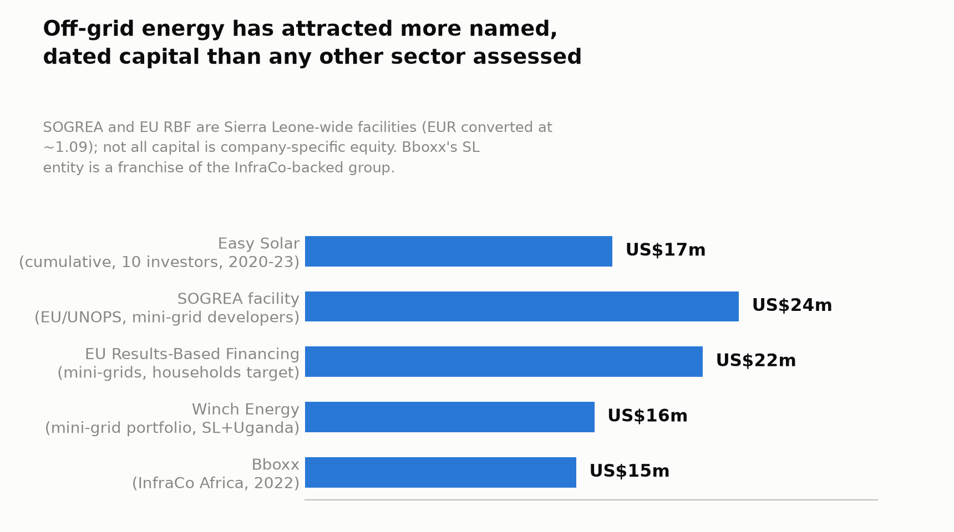
Figure 1. Off-grid energy has attracted more named, dated capital than any other sector assessed

Part 4 — Capital and instrument fit
- What is needed: a genuine mix, evidenced directly rather than inferred — equity and convertible debt for platform/consumer-financing companies (Easy Solar’s Series A equity, Bboxx’s InfraCo convertible notes), and limited-recourse project debt for mini-grid portfolios (Winch Energy’s IPP-holding-company structure). This sector shows the fullest evidenced range of capital instruments actually deployed of any sector in this assessment.
- Ticket sizes, per Figure 1: US$15–24 million at the facility/company level (Bboxx’s InfraCo notes, Winch Energy’s mini-grid portfolio, the SOGREA and EU RBF facilities — see Part 7), and US$17 million cumulative across smaller tranches for Easy Solar specifically. These are growth-equity and project-finance scale tickets, materially larger than typical early-stage venture cheques, and closer to the scale SIC’s own fund economics may need to underwrite (cross-reference: the client’s Sprint 1 feedback questioning whether US$200,000–500,000 venture-style tickets fit a “mature, revenue-generating” pipeline — this sector’s evidence base directly supports that critique).
- Financing gap: not separately quantified for this sector in the sources found, but the sheer scale of unserved households (64.2%, Part 1) against the largest evidenced ticket sizes in this assessment (Part 1’s Figure 1) suggests substantial remaining headroom rather than a saturated market.

Part 5 — Employment and job readiness
- Gender, a regional proxy but directly relevant: a GOGLA study finds women hold 27% of full-time jobs in the off-grid solar sector across the regions it covers (East Africa, West Africa, Central Africa, South Asia) — regional proxy, not Sierra Leone-specific. GOGLA, “Energizing Job Creation” — †, not opened. Separate research finds solar home system access is positively and significantly associated with women’s off-farm employment status and earnings — again a regional/cross-country finding, not Sierra Leone-isolated.
- Direct, Sierra Leone-specific employment evidence: Winch Energy’s three commissioned mini-grids serve 6,500+ direct customers and an estimated 60,000+ people (Part 3) — a reach figure, not a jobs figure. No reliable Sierra Leone-specific headcount was identified for Easy Solar or Bboxx SL — a clear Stage 2 gap, notable given this is otherwise the best-evidenced sector in the assessment.
- Skills base: PAYGo and mini-grid business models require field sales/collections agents (comparable in structure to FinTech’s mobile-money agent network, Sector 3) and technical installation/maintenance staff — both are lower-skill-barrier roles than software engineering, suggesting this sector shares FinTech’s relatively favourable jobs-creation profile.

Part 6 — Investment innovation and de-risking
- This sector has the fullest evidenced de-risking architecture of any sector in this nine-sector assessment, combining instruments already logged individually elsewhere in this project but not previously assembled under one sector heading:
  - SOGREA — a €22 million EU-funded, UNOPS-implemented catalytic investment facility specifically for private mini-grid developers in Sierra Leone (already logged under the Climate sector file in this project; more precisely categorised here). [SEforALL] — †, not opened.
  - EU Results-Based Financing mechanism — €20 million, targeting 35,000 newly electrified households via solar mini-grids, with a portfolio of 17 mini-grids targeted operational by 2025. [SEforALL] — †, not opened.
  - REPP (Renewable Energy Performance Platform) — cited as involved in Winch Energy’s Sierra Leone mini-grid financing, a catalytic/blended finance vehicle purpose-built for early-stage renewable energy projects in Africa. REPP — †, not opened.
  - Universal Energy Facility (SEforALL) — funded Energicity (SL) Limited/Power Leone’s first mini-grid (already logged under the Climate sector file; also more precisely an off-grid energy finding).
  - ESLEAP (Enhancing Sierra Leone Energy Access Project) — a US$12.7 million World Bank-financed project targeting 2.8MW of solar capacity, benefiting an estimated 3,000 households, 350 businesses, 200 health facilities and 500 schools. Ministry of Energy — †, not opened.
- What has demonstrably unlocked follow-on commercial capital: Easy Solar’s own funding sequence is itself the clearest evidenced example in this assessment — concessional/DFI capital (Acumen, FMO, 2020) was followed by further DFI and blended debt facilities (KfW/NDF/All On, 2022) and then additional commercial-adjacent debt (Cygnum Capital, Triodos, 2023), a genuine multi-year de-risking-to-scale sequence rather than a single grant.
- What would need to be true for fully commercial, non-concessional entry: given the depth of blended and DFI capital already active in this sector, the more relevant question may be whether SIC’s own vehicle would be additive alongside this existing capital stack, or would need to find an underserved niche within it (e.g., smaller mini-grid developers not yet reached by SOGREA/REPP, or working-capital debt for PAYGo receivables — the model d.light and M-KOPA use at continental scale, Part 8).
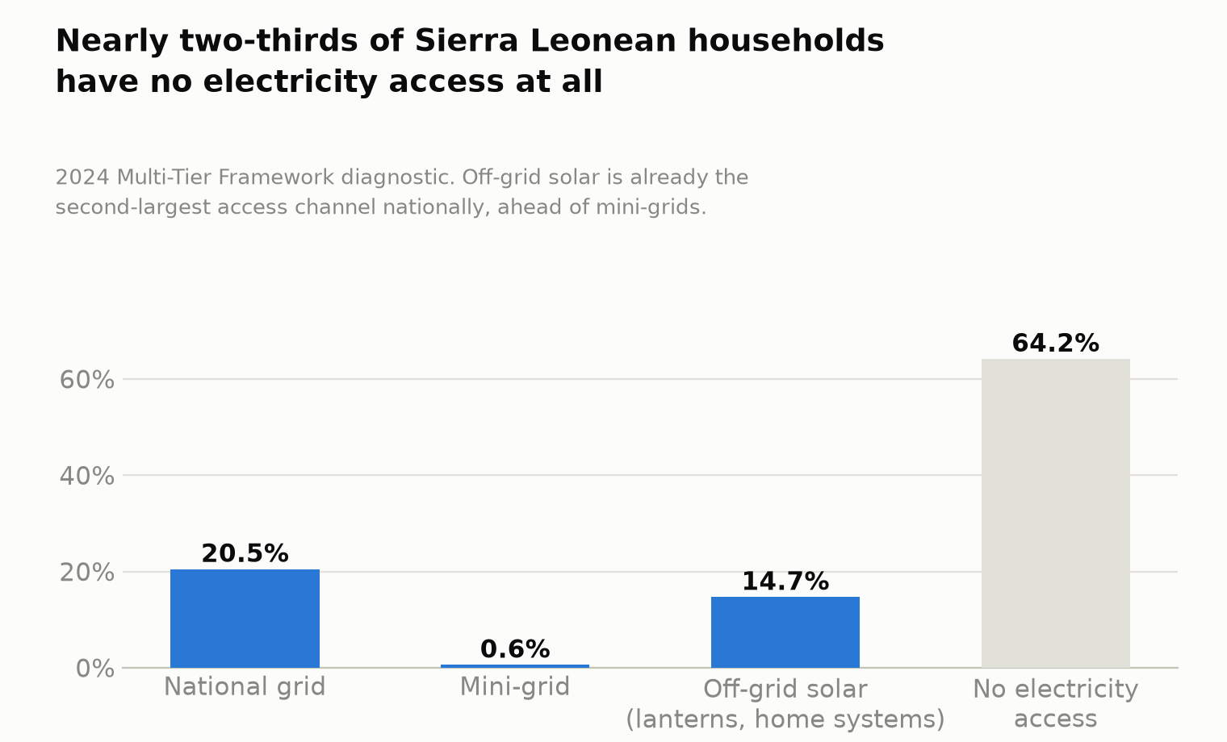
Figure 2. Nearly two-thirds of Sierra Leonean households have no electricity access at all

Part 7 — Enabling environment
- A specific, dated regulatory framework exists — more developed than most sectors in this assessment. The Government adopted a Mini-Grid Regulation in 2019, administered by the Sierra Leone Electricity and Water Regulatory Commission (SLEWRC), which issues generation licences and sets tariffs. Mini-grids are classified by size: systems up to 100kW operate under a basic licence with tariffs negotiated directly between developer and customer; systems between 100kW and 10MW require a full licence with cost-reflective tariffs submitted to SLEWRC via a standardised calculation tool. SLEWRC has since developed an improved Multi-Year Tariff Order (MYTO2), with SEforALL support, for further transparency. Africa Energy Portal, “A Cost-Reflective Mini-Grid Tariff Framework” — †, not opened.
- National policy anchor: the government’s 100%-by-2035 electrification target (Part 1) sits within the same MTNDP technology/infrastructure pillar cited across this assessment, and is directly reinforced by the MCC’s US$480 million Sierra Leone Compact (signed September 2024, already logged under Sector 5/Logistics in this project), which funds transmission-backbone and distribution-access projects — complementary to, not competing with, off-grid solutions, since it targets grid-connected areas.
- Donor/development programme ecosystem, now consolidated under one sector for the first time: SOGREA, EU RBF, REPP, the Universal Energy Facility, ESLEAP, InfraCo Africa, and the DFI syndicate behind Easy Solar (Acumen, FMO, KfW, Nordic Development Fund, All On, Cygnum Capital, Triodos) collectively represent the densest, most mutually-reinforcing donor/DFI ecosystem identified in any sector across this nine-sector assessment.
- Infrastructure constraints: off-grid energy is, definitionally, the sector responding to rather than constrained by Sierra Leone’s power-access gap — the same electricity-access constraint logged as a cross-cutting barrier in every other sector in this assessment (FinTech’s agent liquidity, HealthTech’s HETA electrification need, GovTech’s talent/connectivity gap) is this sector’s actual addressable market.

Part 8 — Comparative evidence
- The Bboxx–PEG Africa transaction (Part 3) is not a distant analogy — it is the direct regional comparator the client named, and it checks out. Bboxx’s PEG acquisition (2022) consolidated two multi-country PAYGo operators into a combined 3.5-million-person, 10-country platform, at a reported valuation north of US$200–300 million — precisely the kind of consolidation exit a Sierra Leone-exposed investment in this sector could plausibly participate in as either a portfolio company (acquired) or, at fund scale, an acquirer of a smaller local operator.
- Continental scale context (regional proxy): d.light has built total securitised consumer-financing capacity of US$842 million across five facilities, issued a US$50 million green bond (2024), and became the first off-grid solar company to fully prepay a securitised facility (US$110m) ahead of schedule (February 2024). M-KOPA secured a US$200 million loan from Standard Bank Group, with a 2024 customer survey finding 92% of clients reported financing made technology more affordable and 80% reported improved quality of life. Together with Sun King, Bboxx, d.light, Zola Electric and M-KOPA, these five companies are named as dominating Africa’s off-grid solar landscape. Techpoint Africa; PV Tech — †, both not opened. Sector-wide, local-currency investment has reached a record 47.2% of total off-grid solar funding — a sign of increasing market maturity and reduced FX risk for investors, though no reliable data identified on whether this trend specifically extends to Sierra Leone.
- What failed, or came close: no reliable data identified on a failed off-grid energy venture in Sierra Leone specifically. Globally, GOGLA reports the sector requires a six-fold increase in investment (to US$21 billion) to reach universal access potential, alongside a recent funding decline despite continued sales growth — the closest thing to a “what’s not working” finding, and it is a financing-scale problem, not a business-model failure. [GOGLA 2024 Sales and Impact Report] — †, not opened, regional/global proxy.
Verdict. Investable now — the strongest positive verdict of any sector in this nine-sector assessment. Off-grid energy combines all three things most other sectors in this project lack in combination: (1) multiple named, in-market, revenue-generating Sierra Leonean companies (Easy Solar, Bboxx SL, Winch Energy’s local mini-grid portfolio) with (2) real, dated, multi-round capital-raising histories from credible DFIs and impact investors (Easy Solar’s US$17m across three rounds; Bboxx’s US$15m InfraCo notes), and (3) a genuine, sector-specific regional M&A exit precedent (Bboxx–PEG Africa, reportedly valued above US$200–300m) — something no other sector assessed in this project has produced. The regulatory environment (2019 Mini-Grid Regulation, SLEWRC, MYTO2) is specific and functioning, not aspirational. What would sharpen the case further: Sierra Leone-specific revenue and headcount data for Easy Solar and Bboxx SL (not currently disclosed); clarity on whether SIC’s vehicle would be additive to the already-dense DFI/blended-finance stack in this sector or needs to find an underserved niche within it (e.g., PAYGo receivables debt, smaller mini-grid developers outside SOGREA/REPP’s current portfolios); and direct confirmation of the Bboxx–PEG deal terms, given the reported valuation figures are press estimates, not confirmed disclosures.

Additions required to the master tracker / claude_B1.docx and cross-sector synthesis on merge
- This is a new, ninth sector — it was not in the original eight-sector WS1-v1.0 scope. Recommend the Gate 1 pack present it explicitly as client-requested addition (per the feedback thread), not silently folded into the existing eight.
- Cross-sector ranking: on the evidence in this document, off-grid energy should rank at or above #1 (FinTech) in the updated cross-sector synthesis already delivered — it has more named capitalised companies, a larger and more precisely quantified addressable market, and a real regional exit precedent, none of which any other sector (including FinTech) can currently show simultaneously. Recommend Stage 2 treat this as a live question for the Advisory Group rather than a fait accompli: FinTech’s Vult has stronger domestic organic user growth, while off-grid energy has stronger capital-markets validation — these are different kinds of evidence and the team should decide which the fund’s mandate weights more heavily.
- Figure 2 (companies evidenced per sector) in the master tracker: add off-grid energy with 3 named companies (Easy Solar, Bboxx SL, Winch Energy) plus the donor/DFI facility list in Part 6.
- Contradiction log: add Easy Solar’s employee-count discrepancy (77 per PitchBook vs. 201–500 per Tracxn, July 2024).
- Cross-sector flag: SOGREA, the EU RBF mechanism, and the Universal Energy Facility/Energicity(SL) finding were previously logged under the Climate and carbon sector file (Sector 2) in this project. Recommend those be re-tagged as off-grid energy findings, or cross-referenced in both files, at the next tracker consolidation — they were categorised under Climate only because this sector did not yet exist when Sector 2 was researched.

Verification queue for Stage 2/4 (nothing above may enter the Source Register as “Verified” until this is done)
- Open Easy Solar’s and Bboxx SL’s own financial or investor-relations materials directly to obtain Sierra Leone-specific revenue and headcount figures.
- Confirm the Bboxx–PEG Africa deal’s actual terms and valuation directly — this pass could only find press-reported estimates (US$200m and US$300m+, from two different outlets), not a confirmed figure from either company.
- Reconcile Easy Solar’s employee-count discrepancy (77 vs. 201–500) directly with the company.
- Open the GOGLA Sierra Leone Country Brief (November 2024) directly — this pass located it but could not extract its detailed content; it likely contains Sierra Leone-specific sales and investment data this document lacks.
- Confirm current operating status and customer counts for Winch Energy’s Sierra Leone mini-grid portfolio, given the underlying financing closed in 2021.
- Directly confirm whether SOGREA, EU RBF and REPP capital has been fully deployed, partially deployed, or remains uncommitted as of the Stage 2 date — Part 6 lists facility sizes, not confirmed disbursement.
- Seek direct engagement with SLEWRC or the Ministry of Energy to confirm the current count of operating private mini-grids (Part 1’s “100+” figure) and whether it has grown since the source’s publication.

