

A Software Project On

"TrueMark Smart Attendance System"

In the Partial fulfilment of
Master of Science – In Information Technology – Integrated

(iMSc (IT)) – Semester‑6

Developed By:

Sr No | Enrolment No | Name of the Students
1. | 23004500210119 | AWAN MANSURI
2. | 23004500210262 | SHAHIL SHAIKH
3. | 23004500210258 | MUJIR SHAIKH

Group No: iMSc (IT)_12
Under the Guidance of
Dr./Prof. Urvika Soni

Submitted To
L.J. School of Computer Applications
L.J. Campus, Near Sanand Crossroads, S.G. Road, Ahmedabad – 382210
Ph. No.: 9099063417



CERTIFICATE

Enrolment No: 23004500210119 | Roll No: 21

This is to certify that Mr. AWAN MANSURI of Master of Science (Information Technology) Integrated, Semester 6 DIV C Roll No 21 has satisfactorily completed the project titled TrueMark Smart Attendance System in S/W Project (150020609) under the supervision of Prof. Urvika

Internal Guide  Prof. URVIKA | Head of the Department  Dr. Jignesh Doshi



CERTIFICATE

Enrolment No: 23004500210262 | Roll No: 39

This is to certify that Mr. SHAHIL SHAIKH of Master of Science (Information Technology) Integrated, Semester 6 DIV C Roll No 39 has satisfactorily completed the project titled TrueMark Smart Attendance System in S/W Project (150020609) under the supervision of Prof. Urvika

Internal Guide  Prof. URVIKA | Head of the Department  Dr. Jignesh Doshi



CERTIFICATE

Enrolment No: 23004500210258 | Roll No: 41

This is to certify that Mr. MUJIR SHAIKH of Master of Science (Information Technology) Integrated, Semester 6 DIV C Roll No 41 has satisfactorily completed the project titled TrueMark Smart Attendance System in S/W Project (150020609) under the supervision of Prof. Urvika

Internal Guide  Prof. URVIKA | Head of the Department  Dr. Jignesh Doshi



Plagiarism Declaration

To whom so ever it may concern

I, confirm that Project (document/PPT or Code) is my own work, is not copied from any other person’s work (published, unpublished, or generated using CHATGPT/AI), and has not previously submitted for assessment either at university or elsewhere. We confirm that we have read and understood the rules regulations on plagiarism in LJ University.

Sr. No. | Enrolment no. | Name of the student | Signature
1 | 23004500210119 | AWAN MANSURI
2 | 23004500210262 | SHAHIL SHAIKH
3 | 23004500210258 | MUJIR SHAIKH



Commitment Form

I/we assure that following are the components on which we worked in the said project titled.
[TrueMark Smart Attendance System]. Further we confirm that, we have read and understood the rules and regulations of UFM in LJU.

Student 1
Enrolment No.: 23004500210119 Division: C Roll No: 21
Name of the student: AWAN MANSURI

Components worked on
Sr. No. | Name of the Components | Sr. No. | Name of the Components
1. | User Registration Module | 16. | Profile Management Module
2. | Login Module | 17. | Edit Profile Module
3. | Forgot Password Module | 18. | QR Code Generator Module
4. | Session Management Module | 19. | QR Code Scanner Module
5. | Logout Module | 20. | Mark Attendance Module
6. | Admin Dashboard | 21. | Attendance History Module
7. | Add User Module | 22. | Attendance Summary Module
8. | Manage Users Module | 23. | Attendance Monitoring Module
9. | Student Management Module | 24. | Firebase Authentication Integration
10. | Admin Management Module | 25. | Firebase Realtime Database
11. | Faculty Dashboard | 26. | Student Dashboard
12. | Create Attendance Session | 27. | Push Notification Module
13. | Start/Stop Session Module | 28. | Chat Module
14. | Student Group Management | 29. | Group Chat Module
15. | Attendance Validation Module



Commitment Form

I/we assure that following are the components on which we worked in the said project titled.
[TrueMark Smart Attendance System]. Further we confirm that, we have read and understood the rules and regulations of UFM in LJU.

Student 2
Enrolment No.: 23004500210262 Division: C Roll No: 39
Name of the student: SHAHIL SHAIKH

Components worked on
Sr. No. | Name of the Components | Sr. No. | Name of the Components
1. | User Registration Module | 16. | Profile Management Module
2. | Login Module | 17. | Edit Profile Module
3. | Forgot Password Module | 18. | QR Code Generator Module
4. | Session Management Module | 19. | QR Code Scanner Module
5. | Logout Module | 20. | Mark Attendance Module
6. | Admin Dashboard | 21. | Attendance History Module
7. | Add User Module | 22. | Attendance Summary Module
8. | Manage Users Module | 23. | Attendance Monitoring Module
9. | Student Management Module | 24. | Firebase Authentication Integration
10. | Admin Management Module | 25. | Firebase Realtime Database
11. | Faculty Dashboard | 26. | Student Dashboard
12. | Create Attendance Session | 27. | Push Notification Module
13. | Start/Stop Session Module | 28. | Chat Module
14. | Student Group Management | 29. | Group Chat Module
15. | Attendance Validation Module



Commitment Form

I/we assure that following are the components on which we worked in the said project titled.
[TrueMark Smart Attendance System]. Further we confirm that, we have read and understood the rules and regulations of UFM in LJU.

Student 3
Enrolment No.: 23004500210258 Division: C Roll No: 41
Name of the student: MUJIR SHAIKH

Components worked on
Sr. No. | Name of the Components | Sr. No. | Name of the Components
1. | User Registration Module | 16. | Profile Management Module
2. | Login Module | 17. | Edit Profile Module
3. | Forgot Password Module | 18. | QR Code Generator Module
4. | Session Management Module | 19. | QR Code Scanner Module
5. | Logout Module | 20. | Mark Attendance Module
6. | Admin Dashboard | 21. | Attendance History Module
7. | Add User Module | 22. | Attendance Summary Module
8. | Manage Users Module | 23. | Attendance Monitoring Module
9. | Student Management Module | 24. | Firebase Authentication Integration
10. | Admin Management Module | 25. | Firebase Realtime Database
11. | Faculty Dashboard | 26. | Student Dashboard
12. | Create Attendance Session | 27. | Push Notification Module
13. | Start/Stop Session Module | 28. | Chat Module
14. | Student Group Management | 29. | Group Chat Module
15. | Attendance Validation Module



Acknowledgement

I would like to take this opportunity to express my sincere gratitude and appreciation to all those who have supported me in the successful completion of my Semester 6 project.

Primarily, I would like to extend my heartfelt thanks to Dr. Jignesh Doshi, Head of the Department, M.Sc. (Information Technology), LJ School of Computer Applications, LJ University, for his continuous encouragement, expert guidance, and invaluable support throughout the duration of this project.

I am extremely thankful to my internal guide, Prof. Urvika, for providing insightful feedback, motivation, and guidance at every stage of the project.

I would also like to acknowledge the contribution of my external guide, Mr./Ms. [External Guide Name], whose expertise and suggestions enhanced the quality of my work.

I appreciate the efforts of all faculty members and lab instructors who helped and supported whenever needed.

Lastly, I am grateful to my family and friends for their constant support, motivation, and encouragement throughout the project journey.

Enrolment No(s) [23004500210119]
Name(s): & Signature(s): AWAN MANSURI
Semester: 6
Project Title: [TrueMark Smart Attendance System]

Enrolment No(s) [23004500210262]
Name(s): & Signature(s): SHAHIL SHAIKH
Semester: 6
Project Title: [TrueMark Smart Attendance System]

Enrolment No(s) [23004500210258]
Name(s): & Signature(s): MUJIR SHAIKH
Semester: 6
Project Title: [TrueMark Smart Attendance System]

Sr. No. | TABLE OF CONTENTS | Page No.
1. | INTRODUCTION
 | 1.1 Existing System | 12
 | 1.2 Need for the New System | 12
 | 1.3 Objective of the New System | 14
 | 1.4 Problem Definition | 15
 | 1.5 Scope of the project and Core Components | 16
 | 1.6 Project Profile | 18
 | 1.7 Assumptions and Constraints | 19
 | 1.8 Advantages and Limitations of the Proposed System | 21
 | 1.9 Proposed Timeline Chart | 22
2. | REQUIREMENT DETERMINATION & ANALYSIS
 | 2.1 Requirement Determination | 23
 | 2.2 Targeted Users | 23
 | 2.3 Requirement Specification | 24
3. | SYSTEM DESIGN
 | 3.1 Use Case Diagram | 25
 | 3.2 Class Diagram | 26
 | 3.3 Interaction Diagram | 27
 | 3.4 Activity Diagram | 28
 | 3.5 User Interface Design | 29
 | 3.6 Test Cases | 29
 | 3.7 Report Design | 30
4. | DEVELOPMENT
 | 4.1 Appropriate Naming Conventions | 31
 | 4.2 Use of Proper Comments | 31
 | 4.3 Controller Methods | 32
 | 4.4 Route Definitions | 33
 | 4.5 Templates and Frontend | 33
 | 4.6 Database and Migrations | 34
 | 4.7 Testing | 34
 | 4.8 Security and Best Practices | 35
 | 4.9 Screenshots | 36-41
5. | AGILE DOCUMENTATION
 | 5.1 Agile Project Charter | 42
 | 5.2 Agile Road map/Schedule | 43
 | 5.3 Agile Project Plan | 44
 | 5.4 Agile User Story | 45
 | 5.5 Agile Release Plan | 46
 | 5.6 Agile Sprint Backlog | 46
 | 5.7 Agile Test | 47
 | 5.8 Earned value and burn charts | 48
6. | Testing
 | 6.1 Testing Method | 49
 | 6.2 Test Cases | 50-51
7. | PROPOSED ENHANCEMENT | 52
8. | Conclusion | 54
9. | Project Learnings | 55
10. | BIBLIOGRAPHY | 57

1. Introduction
TrueMark Smart Attendance System is a comprehensive QR-code-based attendance management platform built as a native Android application using Kotlin. It provides a complete automated solution for educational institutions to manage, track, and report student attendance in real time.

The platform features a robust architecture with Firebase as the backend, enabling real-time data synchronization across devices. The system includes modules for user management, session management, QR code generation, QR scanning, attendance recording, and report generation.

TrueMark aims to eliminate manual attendance processes, reduce proxy attendance, and empower faculty and administrators with powerful attendance tracking tools while giving students convenient access to their own attendance records.

The application is designed with simplicity and scalability in mind. Every user whether a student, faculty member, or administrator is provided with a role-specific dashboard that presents only the relevant features and data. The backend is entirely powered by Firebase cloud services, ensuring high availability, real-time synchronization, and secure authentication.

1.1 Existing System
- Manual Paper-Based Attendance: Faculty call roll or pass attendance sheets in classrooms. Highly time-consuming, prone to human error, and easy to forge or manipulate.
- Biometric Attendance Systems: Fingerprint or iris scanners installed at institution entry points. High hardware cost, not suitable for classroom-level session tracking, and raised hygiene concerns.
- RFID-Based Attendance: Students swipe RFID cards near proximity readers. Requires dedicated hardware infrastructure, and cards can easily be passed to other students for proxy attendance.
- Basic Spreadsheet Management: Faculty manually maintain Excel files for each class. No automation, no real-time capability, and no centralised reporting available.
- Traditional Roll-Call Methods: Verbal calling of names by faculty at the start of each lecture. Extremely slow for large classrooms and disrupts valuable teaching time.
- SMS-Based Notification Systems: Some institutions notify parents or guardians via SMS about absenteeism. Does not solve the core problem of accurate real-time attendance recording.

1.2 Need for the New System
Educational institutions face significant challenges with traditional attendance systems. Existing solutions are time-consuming, prone to proxy attendance, lack real-time reporting, and fail to integrate with modern mobile devices. There is a clear and urgent need for a comprehensive mobile-based platform that automates attendance while ensuring data integrity and universal accessibility.

Key needs addressed by TrueMark:
- Automated, fully contactless attendance collection via dynamic QR codes that eliminates all manual effort.
- Prevention of proxy and fraudulent attendance through session-specific encrypted QR tokens with time-based expiry.
- Real-time synchronization of all attendance records across all connected devices and role-specific dashboards.
- Instant, on-demand report generation for faculty and administration with flexible date-range filtering options.
- Mobile-first, student-friendly design that works seamlessly on any Android 7.0+ smartphone.
- Granular role-based access control ensuring students, faculty, and admins each see only their relevant features.
- Significant reduction in administrative workload through full automation of record-keeping and reporting.

1.3 Objective of the New System
The primary objective of TrueMark Smart Attendance System is to create a reliable, automated, and user-friendly QR-based attendance platform for educational institutions. The system is designed to serve multiple stakeholder groups with fully tailored, role-specific experiences.

The system aims to:
- Provide an intuitive, easy-to-use interface for faculty to create attendance sessions and generate QR codes in seconds.
- Enable students to mark attendance quickly and securely by scanning QR codes using the built-in mobile camera.
- Implement robust role-based access control for Admin, Faculty, and Student roles, protecting data privacy and security.
- Maintain accurate and tamper-proof attendance records stored securely in Firebase Realtime Database with full timestamps.
- Generate detailed, filterable attendance reports and analytics for academic monitoring, compliance, and accreditation.
- Send real-time push notifications to all student devices when attendance sessions are opened or closed by faculty.
- Prevent duplicate and fraudulent attendance through comprehensive session validation and duplicate detection logic.
- Build a highly scalable, fully modular architecture using MVVM that can grow seamlessly with institutional demand.
- Give administrators complete visibility and control over all users, sessions, and system configuration at all times.

1.4 Problem Definition
Educational institutions and their stakeholders face several critical challenges with the current manual attendance ecosystem. These problems are categorised by user role below:

For Faculty:
- Time-consuming manual attendance process that consumes 5-10 minutes per class, reducing valuable teaching time.
- Difficulty in generating consolidated, formatted attendance reports without dedicated reporting software.
- No real-time visibility into which students have attended a particular session while it is in progress.
- Significant risk of manipulation in manually maintained paper records, with no digital audit trail for disputes.
- Complete inability to detect proxy attendance effectively in large lecture halls with 50-100+ students.

For Students:
- No easy, on-demand way to view their own cumulative attendance records and current percentage standing.
- No real-time confirmation received when attendance has been successfully recorded by the system.
- Frequent disputes over attendance records with no digital proof available to support appeal or correction.
- No push notification or alert when an active attendance session is opened by faculty during a class.
- Limited access to detailed attendance summaries which negatively impacts personal academic planning.

For Administrators:
- No single, centralised system to view and manage attendance data across all departments and batches.
- Laborious manual compilation of attendance data for regulatory reporting and accreditation submissions.
- Inability to prevent widespread proxy attendance fraud without a secure, validated digital system.
- Absence of actionable analytics to identify institution-wide attendance trends and at-risk students early.

1.5 Scope of Project and Core Components
Scope:
The project encompasses the full development of a complete Android-based attendance management system with the following defined scope:
- Firebase-based user authentication and secure profile management for all user roles (Admin, Faculty, Student).
- Encrypted, session-specific QR code generation and validation for each individual attendance session.
- Real-time attendance recording and synchronization via Firebase Realtime Database across all devices.
- Dedicated role-based dashboards offering tailored views and features for Admin, Faculty, and Student users.
- Complete attendance history, date-range filtering, percentage calculation, and multi-format reporting.
- Push notification system using Firebase Cloud Messaging for real-time session alerts to student devices.
- Full Admin panel for user management, session oversight, and system configuration and monitoring.

Core Components:

1. Authentication Module
- Firebase Authentication with email and password for all user types.
- Role-based login routing to Admin, Faculty, or Student-specific dashboards.
- Secure session token management with automatic expiry for inactive sessions.

2. User Management Module
- Admin creates, updates, and deactivates all user accounts across roles.
- Profile management for faculty and student accounts including department and class assignment.
- Role assignment and granular access control enforced at the Firebase Security Rules level.

3. Attendance Session Management
- Faculty creates attendance sessions linked to specific classes, subjects, and time windows.
- Time-limited attendance windows automatically prevent late marking beyond session closure.
- Session status (active/closed) visible in real time across all role-specific dashboards.

4. QR Code Generator Module
- Dynamic, HMAC-encrypted QR codes generated uniquely for each individual attendance session.
- QR tokens contain encrypted session identifiers to prevent tampering or reuse across sessions.
- Automatic expiry of QR codes immediately upon faculty manually closing a session.

5. QR Code Scanner Module
- Real-time camera-based QR scanning integrated directly into the student application.
- Session validation (active, not expired, student enrolled) triggered immediately on scan.
- Duplicate scan prevention ensures each student can mark attendance only once per session.

6. Attendance Records Module
- Firebase Realtime Database stores all attendance records with full student, session, and timestamp data.
- Student-wise and session-wise attendance logs accessible for analysis and reporting by authorized users.
- Automated attendance percentage calculation per student per subject available on student dashboard.

7. Reports Module
- Attendance summary reports available per class, subject, and individual student account.
- CSV export functionality for sharing and submission of academic attendance records.
- Date-range filter controls for generating targeted reports covering specific academic periods.

8. Notification System
- Firebase Cloud Messaging delivers push notifications directly to registered student devices.
- Alerts dispatched to all enrolled students when sessions are opened or closed by faculty.
- Attendance confirmation push notifications sent to each student upon successful QR scan.

1.6 Project Profile
Attribute | Details
Project Name | TrueMark – Smart Attendance System
Type | Android Mobile Application
Platform | Android (API Level 24 / Android 7.0 and above)
Language | Kotlin
Frontend | Android XML / Jetpack UI / Material Design 3
Backend | Firebase / REST API
Database | Firebase Realtime Database / SQLite (Room Library)
Authentication | Firebase Authentication (Email & Password)
Notifications | Firebase Cloud Messaging (FCM)
Architecture Pattern | MVVM (Model-View-ViewModel) Clean Architecture
QR Library | ZXing Android Embedded
Development Approach | Agile Scrum (6 Sprints, 12 Dec 2025 – 12 Mar 2026)
Team Size | 3 Students (Group iMSc (IT)_12)
Target Users | Students, Faculty Members, Administrators
Deployment | APK distribution via direct download / Google Play

1.7 Assumptions and Constraints
Assumptions:
- Students and faculty have personal access to Android smartphones running Android 7.0 or higher.
- The campus environment has reliable Wi-Fi or mobile data connectivity during all class sessions.
- Faculty members will project or display the generated QR codes on classroom screens or personal devices.
- All students will have the TrueMark application fully installed and configured prior to class sessions.
- Firebase cloud services remain fully operational and available during all active attendance sessions.
- Administrators will pre-configure all user accounts and class assignments before the academic term begins.

Constraints:

1. Technical Constraints
- Camera permission must be explicitly granted by the student on their device for QR scanning to work.
- Stable internet connectivity is required for real-time Firebase data synchronization during sessions.
- Android 7.0 (API Level 24) or higher is a hard requirement for application installation.
- Firebase Spark free tier imposes rate limits that may affect very large simultaneous deployments.

2. Operational Constraints
- All QR codes expire automatically and immediately upon faculty closing the attendance session.
- Students are permitted to mark attendance only once per session; duplicate scans are blocked.
- GPS geo-fencing location restrictions are architecturally planned but not implemented in v1.0.
- Faculty must actively create a session before any student can scan to record their attendance.

3. Resource Constraints
- Firebase Realtime Database is subject to storage and bandwidth quotas under the Spark free tier.
- Firebase Cloud Messaging notification delivery is dependent on individual device network availability.
- Very high concurrent student scan volumes may require upgrading to Firebase Blaze paid tier.
- Extended QR scanning sessions may noticeably increase battery consumption on student devices.

1.8 Advantages and Limitations
Advantages:

1. For Faculty:
- Quick, fully contactless attendance collection that eliminates classroom disruption completely.
- Fully automated record-keeping with no manual data entry or paper management required at any stage.
- Real-time live dashboard view showing exactly which students have marked attendance for each session.
- Instant, on-demand report generation available for any date range, class, or subject at any time.
- Attendance sessions open and close in seconds, minimising time lost from valuable classroom teaching.

2. For Students:
- Simple one-scan attendance process completed in under 5 seconds per student on any Android device.
- Real-time FCM push confirmation received immediately after attendance is successfully recorded.
- Easy, always-accessible view of complete personal attendance history with percentage breakdowns.
- Push notifications ensure students are immediately alerted whenever an attendance session is active.
- Digital records eliminate any possibility of attendance being wrongly omitted or lost.

3. For Administrators:
- Single centralised dashboard provides full visibility of all users, sessions, and attendance across the institution.
- Institution-wide attendance analytics support data-driven academic management and decision-making.
- Encrypted, session-specific QR tokens provide robust prevention of proxy attendance fraud.
- Complete, immutable digital audit trail for every attendance event, session, and system change.
- Flexible report export for institutional records, regulatory submissions, and NAAC/NIRF accreditation.

Limitations:

1. Current Feature Limitations:
- Native iOS application is not yet available; the system currently operates exclusively on Android.
- No offline attendance mode available; live internet connection is required for all session recording.
- Integration with existing university ERP or Learning Management Systems is not included in v1.0.
- Biometric facial recognition as a secondary verification layer is not yet implemented.
- All student records must be manually created by administrators; bulk import is not supported yet.

2. Technical Limitations:
- Stable internet connectivity is required at all times for real-time Firebase synchronization.
- QR code scanning accuracy and speed may be reduced in extremely poor or inconsistent lighting conditions.
- Firebase Spark free tier usage limits may not be sufficient for very large institutions without upgrading.
- Bulk CSV or Excel import of existing student roster data is not yet supported in the current version.

1.9 Proposed Timeline Chart
Phase | Description | Duration | Timeline (Dates) | Status
Phase 1: Project Initialization | Selection of project topic, defining objectives, and identifying scope | 1 week | 12 Dec – 18 Dec 2025 | Completed
Phase 2: Requirement Analysis | Gathering functional and non-functional requirements, user research, and preparing SRS | 1 week | 19 Dec – 25 Dec 2025 | Completed
Phase 3: System Design | Designing use case, class, activity, and ER diagrams; defining architecture | 2 weeks | 26 Dec 2025 – 08 Jan 2026 | Completed
Phase 4: Database Design | Designing Firebase schema, defining models, and setting up data structure | 1 week | 09 Jan – 15 Jan 2026 | Completed
Phase 5: Core Module Development | Developing user authentication, QR generator, and admin modules | 2 weeks | 16 Jan – 29 Jan 2026 | Completed
Phase 6: QR Scanning & Attendance | Building QR scanner, session validation, and attendance recording | 2 weeks | 30 Jan – 12 Feb 2026 | Completed
Phase 7: Reports & Notifications | Implementing attendance reports, analytics, and push notification system | 1 week | 13 Feb – 19 Feb 2026 | Completed
Phase 8: Frontend Design | Creating responsive Android UI using Jetpack components and Material Design | 1 week | 20 Feb – 26 Feb 2026 | Completed
Phase 9: Testing and Debugging | Conducting unit, integration, and system testing to ensure functionality | 1 week | 27 Feb – 05 Mar 2026 | Completed
Phase 10: Documentation | Preparing project report, final presentation, and deployment setup | 1 week | 06 Mar – 12 Mar 2026 | Completed

2. Requirement Determination and Analysis

2.1 Requirement Determination
The requirement determination for the TrueMark Smart Attendance System was based on a comprehensive analysis of the needs of educational institutions, faculty, students, and administrators. Requirements were gathered through institutional surveys, faculty interviews, student feedback sessions, and analysis of existing attendance management systems to ensure the platform addresses genuine challenges in academic environments.

The requirement gathering process was structured into four phases: (1) Stakeholder identification, (2) Requirement elicitation through interviews and direct classroom observations, (3) Documentation and prioritisation of all gathered requirements by category and urgency, and (4) Formal validation of requirements with all key stakeholders before development began.

Requirement Gathering Method | Participants | Output
Faculty Interviews | HOD, Subject Faculty Members | Functional requirements for session and attendance management
Student Focus Groups | 20 students across multiple semesters | UI/UX requirements, notification preferences, scan speed expectations
Observation of Existing System | Classroom attendance rounds observation | Pain points with current manual roll-call process documented
Competitor Analysis | Review of 5 similar Android attendance apps | Feature benchmarking and gap analysis completed
Stakeholder Review Meetings | All team members and project guide | Final requirement sign-off and feature prioritization

2.2 Targeted Users
- Students: Primary end-users responsible for scanning QR codes to mark their own session attendance. Students access attendance history, view percentage, and receive live session notifications.
- Faculty: Power users who create and manage attendance sessions, generate session QR codes, monitor live attendance during sessions, and generate detailed reports for academic submission.
- Administrative Users: System administrators who manage all user accounts, configure classes and subjects, monitor overall system health and usage, and export institution-wide attendance data for records.

2.3 Requirement Specification

Functional Requirements
FR ID | Requirement | Priority
FR-01 | User registration, email/password login, and password reset via Firebase Authentication | High
FR-02 | Role-specific dashboards for Admin, Faculty, and Student with tailored feature sets | High
FR-03 | Faculty can create, manage, monitor, and close attendance sessions per class | High
FR-04 | System generates a unique, encrypted QR code token per attendance session | High
FR-05 | Students scan session QR codes using mobile camera to mark their attendance | High
FR-06 | System validates session activity status, QR token expiry, and duplicate attendance | High
FR-07 | Attendance records saved in real time to Firebase Realtime Database with timestamps | High
FR-08 | Students and faculty can view complete attendance history with date-range filters | Medium
FR-09 | Faculty can generate formatted attendance reports and export as CSV | Medium
FR-10 | FCM push notifications sent to all students when sessions open or close | Medium
FR-11 | Admin can fully create, update, deactivate, and manage all user accounts | High
FR-12 | System calculates and displays attendance percentage per student per subject | Medium
FR-13 | Admin can assign students to classes and faculty to subjects | High
FR-14 | System displays real-time attendance count during active sessions to faculty | Medium

Non-Functional Requirements
NFR ID | Category | Requirement
NFR-01 | Performance | QR scan and attendance marking completed within 3 seconds; supports 500+ concurrent students
NFR-02 | Security | Firebase Auth enforced; QR tokens HMAC-encrypted; Firebase Security Rules for role-based data access
NFR-03 | Usability | Intuitive Material Design 3 UI; compatible with all Android 7.0+ devices
NFR-04 | Scalability | Modular Kotlin/MVVM architecture enabling new features without system downtime
NFR-05 | Reliability | Firebase backup and offline SQLite cache ensures 99.5%+ data availability
NFR-06 | Maintainability | KDoc documentation, Kotlin standards, and MVVM clean architecture throughout
NFR-07 | Availability | Firebase-managed cloud infrastructure targeting 99.5% uptime for all backend services
NFR-08 | Portability | APK distributable via Google Play or direct download; no server-side deployment needed

3. System Design

3.1 Use-Case Diagram

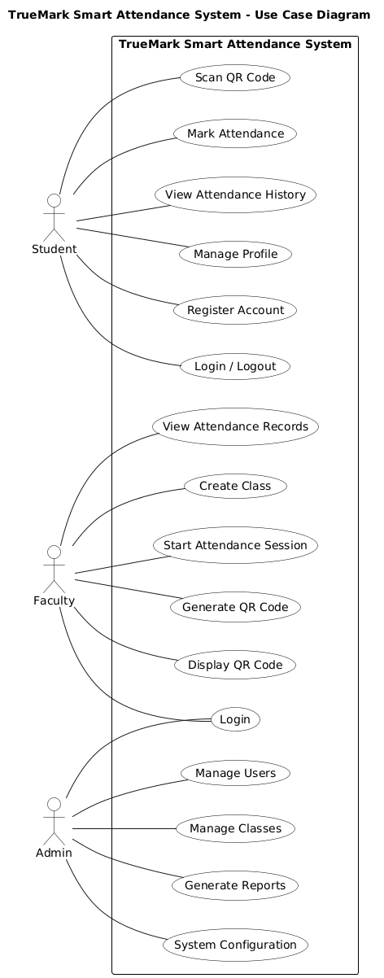

3.2 Class Diagram

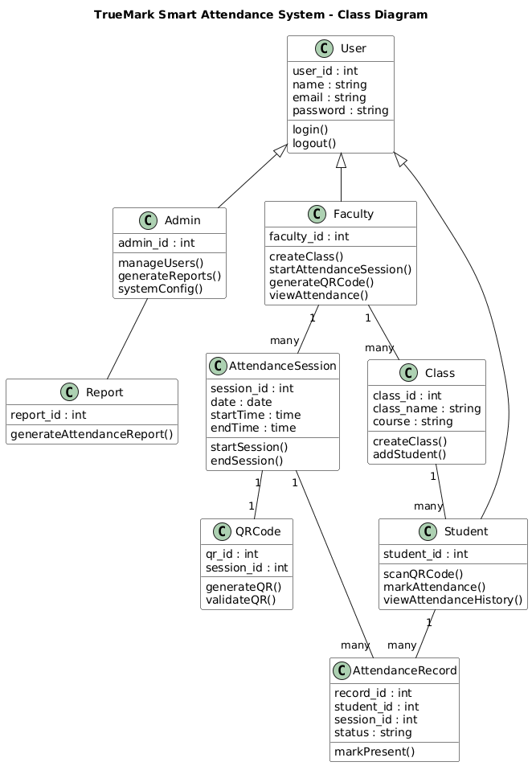

3.3 Sequence Diagram

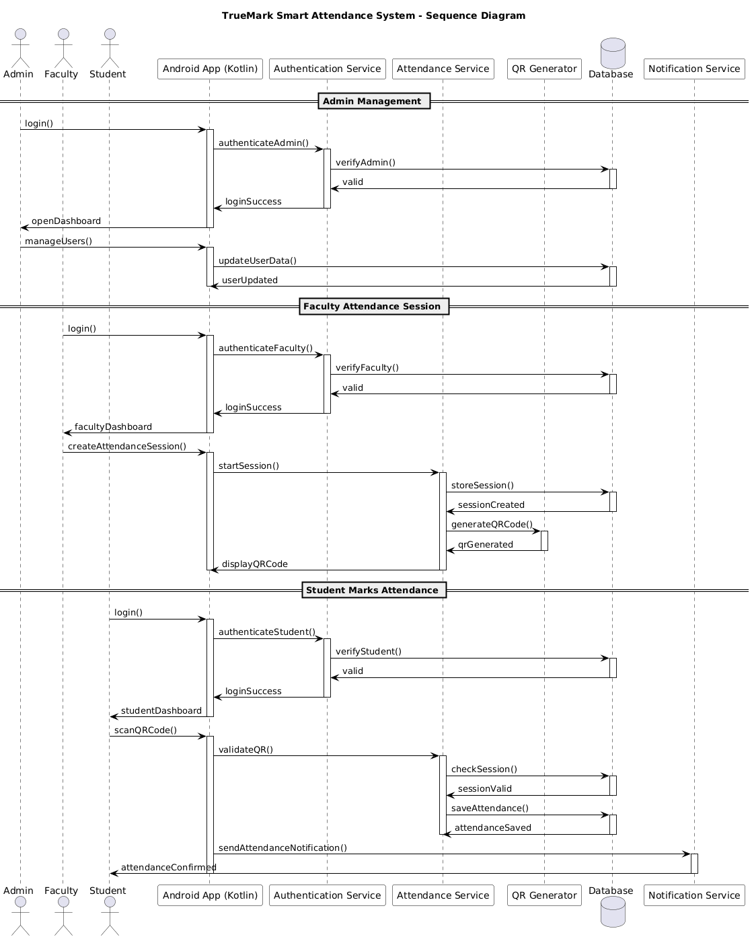

3.4 Activity Diagram

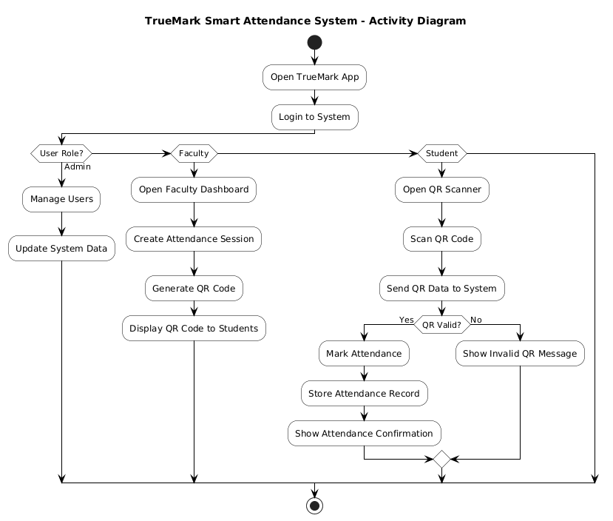

3.5 User Interface Design
The TrueMark application strictly follows Material Design 3 guidelines to deliver a modern, consistent, and fully accessible user experience across all Android device sizes and form factors. Each screen is purpose-built for its specific user role.

- Login/Signup Screen: Firebase authentication form with email, password, and role selection. Input validation messages displayed inline.
- Admin Dashboard: Full user management table, session overview panels, system health indicators, and access control configuration.
- Faculty Dashboard: Session creation wizard, live QR code display with session timer, and real-time live attendance count list.
- Student Dashboard: One-tap QR scanner activation, attendance history list (most recent first), and percentage summary card per subject.
- Attendance History Screen: Searchable and filterable list of all sessions with visual Present/Absent status badge for each entry.
- Reports Screen: Bar and pie chart attendance summaries with configurable date-range filters and CSV export functionality.

3.6 Test Cases
Test Case (TC) 1: Successful Student QR Attendance
- Steps: Log in as a verified student, navigate to QR Scanner screen, scan a valid and currently active session QR code.
- Expected Result: Attendance record saved in Firebase with correct timestamp; on-screen confirmation shown.

TC 2: Duplicate Attendance Prevention
- Steps: Same student attempts to scan the identical QR code a second time within the same active session.
- Expected Result: System detects existing record and shows ‘Attendance already marked’; no duplicate entry created.

TC 3: Invalid or Expired QR Code
- Steps: Student attempts to scan a QR code from a session that has already been closed by faculty.
- Expected Result: System immediately displays error: ‘Session has ended or QR code is invalid’.

3.7 Report Design
- Attendance reports are designed with clarity and precision, featuring visual percentage charts and tabular session data.
- Use Case, Class, Sequence, and Activity diagrams explain complex system flows and entity relationships clearly.
- Firebase data models are represented as hierarchical entity diagrams showing collections and their nested relationships.
- All exported reports are in structured CSV format, fully compatible with Microsoft Excel and academic management tools.

4. Development

4.1 Coding Standards
The TrueMark Smart Attendance System project strictly adheres to Kotlin coding standards and Android development best practices to ensure consistency, readability, maintainability, and scalability across the entire codebase throughout all six development sprints.

1. Naming Conventions
- Classes: PascalCase — e.g., AttendanceSession, QrCodeGenerator, UserRepository, SessionViewModel.
- Functions and Variables: camelCase — e.g., createSession(), studentId, attendanceRecord, qrToken.
- Constants: UPPER_SNAKE_CASE — e.g., QR_EXPIRY_TIME, MAX_SCAN_RETRIES, FIREBASE_TIMEOUT_MS.
- Files and Directories: Descriptive names matching content — e.g., AttendanceViewModel.kt, SessionRepository.kt.
- XML Layout Files: snake_case with screen prefix — e.g., fragment_student_dashboard.xml, activity_main.xml.

2. Code Formatting
- Indentation: 4 spaces per level; no tabs anywhere in the codebase to ensure cross-editor consistency.
- Line Length: Maximum 120 characters per line to maintain readability across all development environments.
- Blank Lines: One blank line between class members; two blank lines between top-level function declarations.
- Import Management: All unused imports removed; wildcard imports strictly avoided throughout the project.

4.2 Use of Proper Comments
- Every public class and function includes a KDoc comment block describing its purpose, parameters, and return value.
- Inline comments used to explain complex QR encryption logic, Firebase atomic transactions, and validation algorithms.
- All documentation follows official Kotlin coding standards and Android documentation formatting guidelines.
- API and business logic functions include high-level summary comments for developer onboarding clarity.

Code Element | KDoc Comment Pattern
createSession() | /** Creates a new attendance session. @param classId Unique class identifier. @return New sessionId string. */
validateScan() | /** Validates a student QR scan. Checks session activity, expiry, and duplicates. @param qrToken Scanned token. @param studentId Student UID. @return Boolean - true if attendance recorded. */
AttendanceRepository | /** Repository layer for all Firebase attendance data operations. Implements MVVM data layer pattern. */
generateQRCode() | /** Generates HMAC-encrypted QR token for session. @param sessionId Active session ID. @return Base64 encoded QR token string. */

4.3 Controller Methods (ViewModels)
- Each ViewModel handles one well-defined single responsibility, strictly following MVVM clean architecture principles.
- Clean separation of concerns: UI layer (Fragments/Activities), domain layer (UseCases), and data layer (Repositories).
- createSession() — Creates a new attendance session node in Firebase with status, timestamps, class ID, and faculty ID.
- generateQRCode() — Generates HMAC-SHA256 encrypted QR token uniquely bound to the active session ID.
- validateScan() — Validates the decoded QR token against session status, expiry time, and existing attendance records.
- markAttendance() — Writes a confirmed attendance record to Firebase Realtime Database with full timestamp.
- fetchAttendanceHistory() — Retrieves filtered and paginated attendance records for a given student or session.
- generateReport() — Computes attendance percentage data per subject and returns it for report display and CSV export.

4.4 Route Definitions
- Android Navigation Component with a central nav_graph.xml defines all structured screen navigation flows.
- Navigation routes organised by user role: dedicated sub-graphs for Admin, Faculty, and Student navigation flows.
- Firebase REST API endpoints managed via Retrofit HTTP client handle all cloud data read and write operations.
- FCM deep links support direct in-app navigation to specific session or attendance screens from notifications.

Navigation Route | Destination Screen | Applicable Role
nav_login → nav_admin | AdminDashboardFragment | Admin
nav_login → nav_faculty | FacultyDashboardFragment | Faculty
nav_login → nav_student | StudentDashboardFragment | Student
nav_student → nav_qr_scanner | QRScannerFragment | Student
nav_faculty → nav_session_mgmt | SessionManagementFragment | Faculty
nav_faculty → nav_reports | ReportsFragment | Faculty
nav_admin → nav_user_mgmt | UserManagementFragment | Admin
nav_student → nav_history | AttendanceHistoryFragment | Student

4.5 Templates and Frontend
- Android XML layouts with Jetpack Compose for hybrid declarative and imperative UI rendering.
- All UI files are modular, reusable, and organised by feature package for clean project structure.
- Material Design 3 components ensure a modern, accessible, and consistent experience on all Android devices.
- Fragment-based Navigation Component with shared ViewModels maintains data consistency across screens.
- Full accessibility support: content descriptions on all images, high-contrast mode, and screen reader compatibility.
- Material You dynamic colour theming and night mode support implemented across all screens.

4.6 Database and Migrations
- Firebase Realtime Database stores all live attendance session data as a structured JSON document tree.
- Data hierarchy: /users/{uid}, /sessions/{sessionId}, /attendanceRecords/{recordId}, /notifications/{notifId}.
- Android Room Database (SQLite) provides a fully offline-capable local cache for recent attendance history.
- Database fields (studentId, sessionId, timestamp) are indexed at the Firebase level for fast query performance.
- All data models defined as Kotlin data classes with full type-safety, null-safety, and Gson serialization.

Firebase Collection | Key Fields | Purpose
/users/{uid} | name, email, role, enrollmentNo, department, classIds | User profiles and role assignments
/sessions/{sessionId} | classId, facultyId, qrToken, startTime, endTime, isActive | Session creation and lifecycle management
/attendanceRecords/{recordId} | studentId, sessionId, timestamp, status, deviceId | Individual attendance record storage
/notifications/{notifId} | recipientId, message, sessionId, timestamp, isRead | In-app notification management

4.7 Testing
- Unit Testing: Validates ViewModels and Repository methods using JUnit 4 with Kotlin coroutine test utilities.
- Integration Testing: Ensures Firebase Auth, QR module, and UI interact correctly using Firebase Emulator Suite.
- API Testing: Firebase REST CRUD operations verified end-to-end against the Firebase local emulator.
- Manual Device Testing: QR scanning, attendance marking, and FCM notifications verified on physical Android devices.
- Regression Testing: Conducted after every sprint to ensure that prior working functionality was not broken.

4.8 Security and Best Practices
- All QR tokens are encrypted using HMAC-SHA256 with a session-specific secret key before QR encoding.
- Firebase Security Rules enforce strict, granular role-based read and write access on every database collection.
- All passwords are managed exclusively by Firebase Authentication; no local password storage at any point.
- Sensitive configuration values (API keys, project IDs) stored in gradle.properties and excluded via .gitignore.
- SSL/TLS enforced for all outbound Firebase API communications with certificate pinning for release builds.
- ProGuard code obfuscation and shrinking applied for all production APK release builds.

4.9 Screenshots

- Login Screen
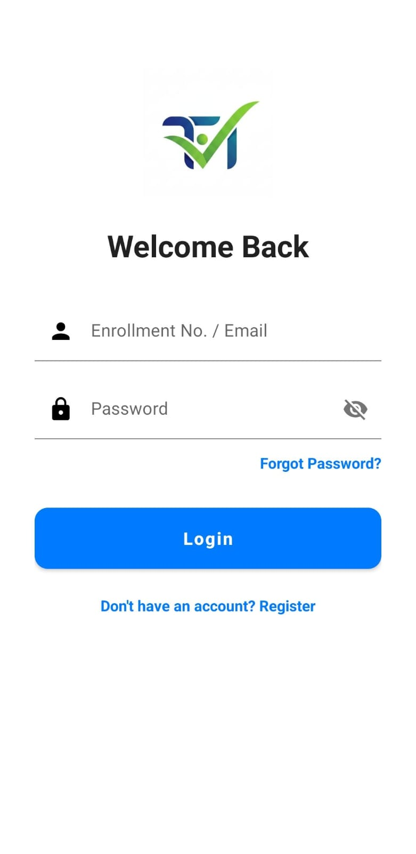

- Register Screen

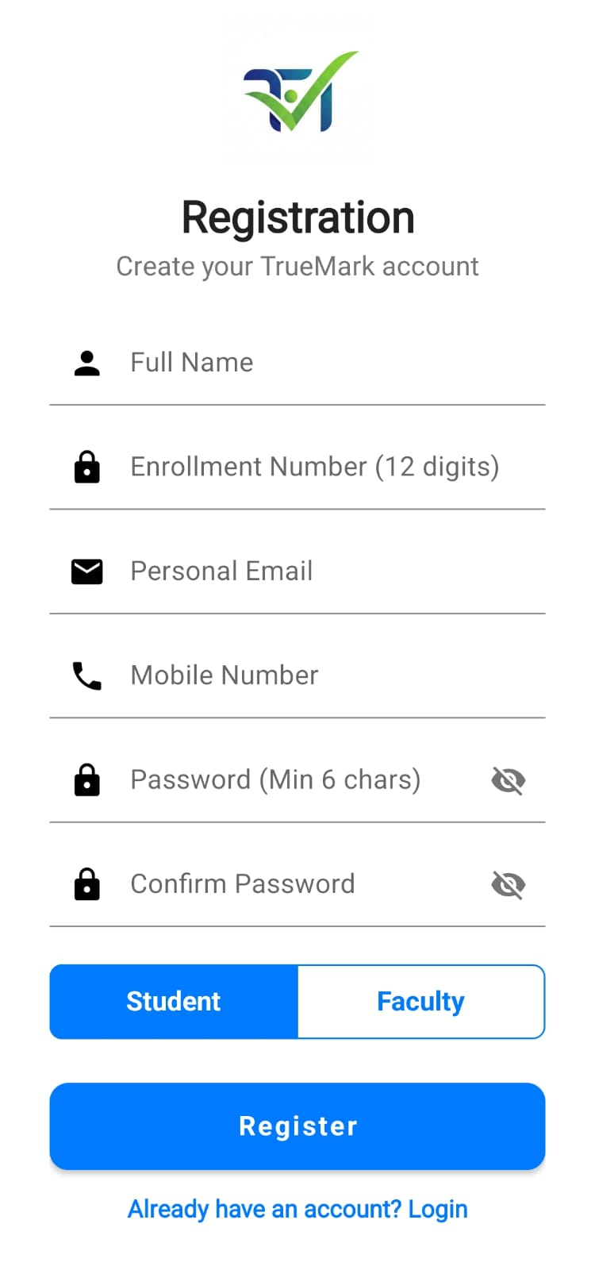

- Faculty Screen

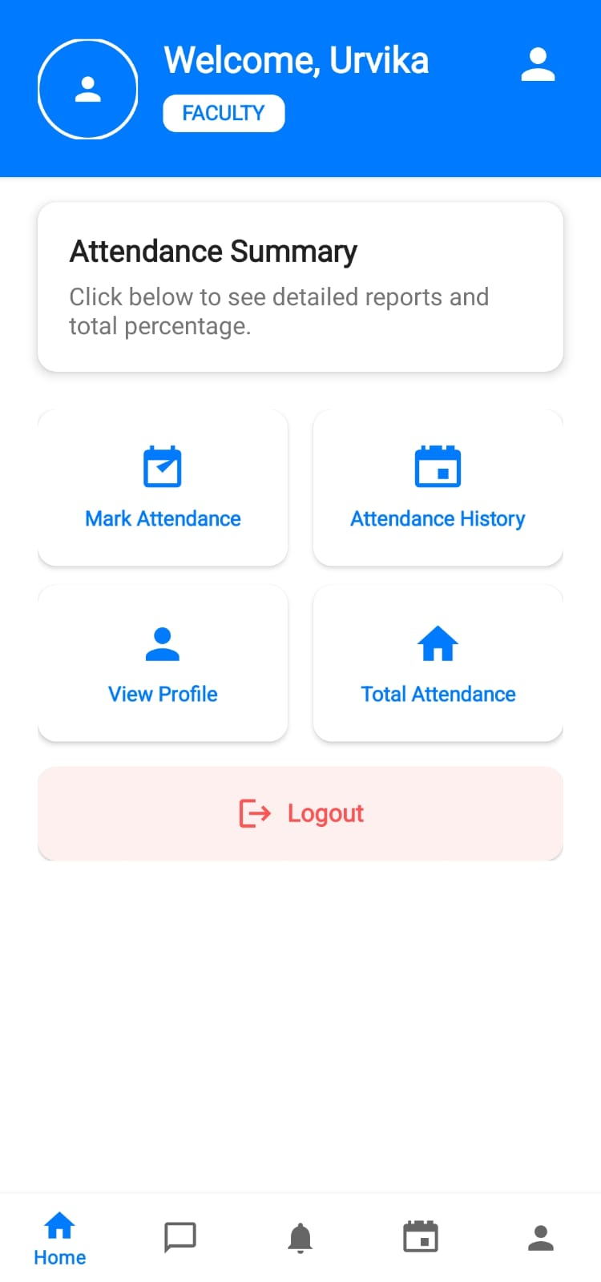

4. Admin Dashboard

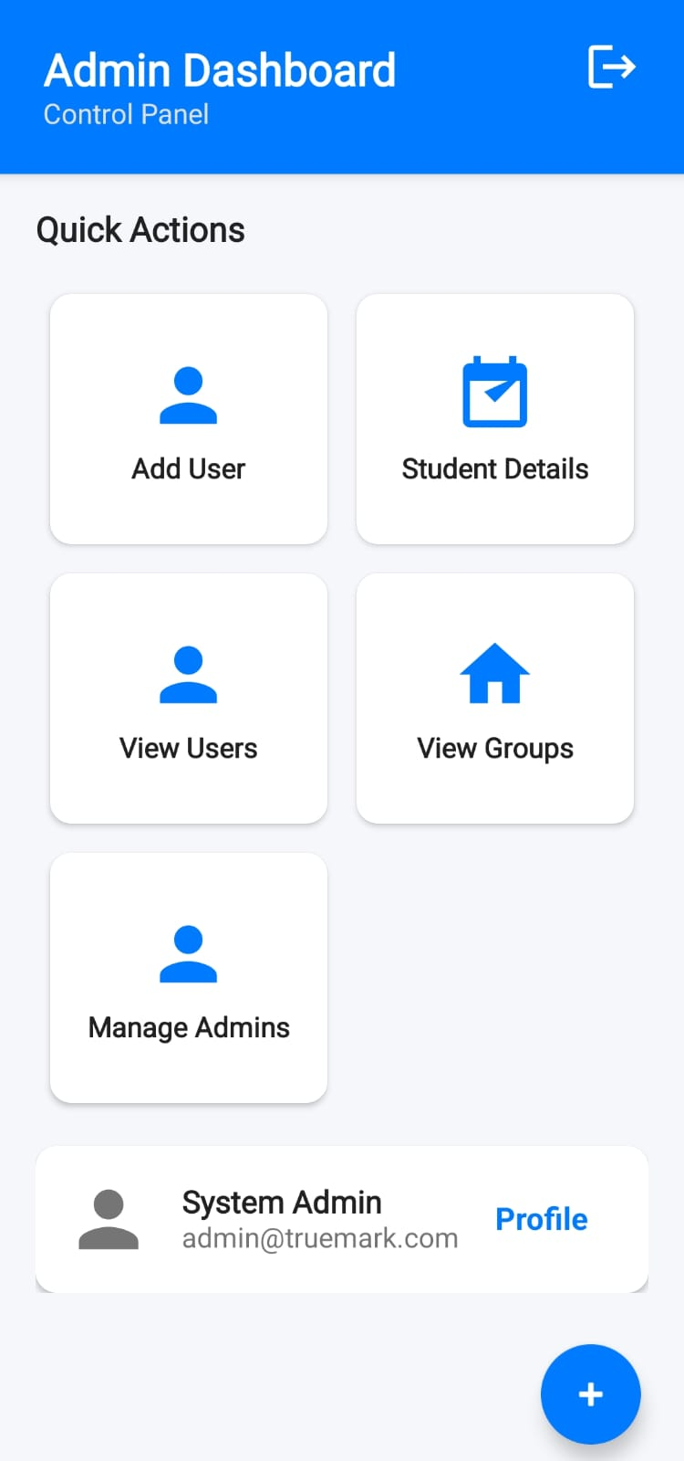

5. QR Code Display

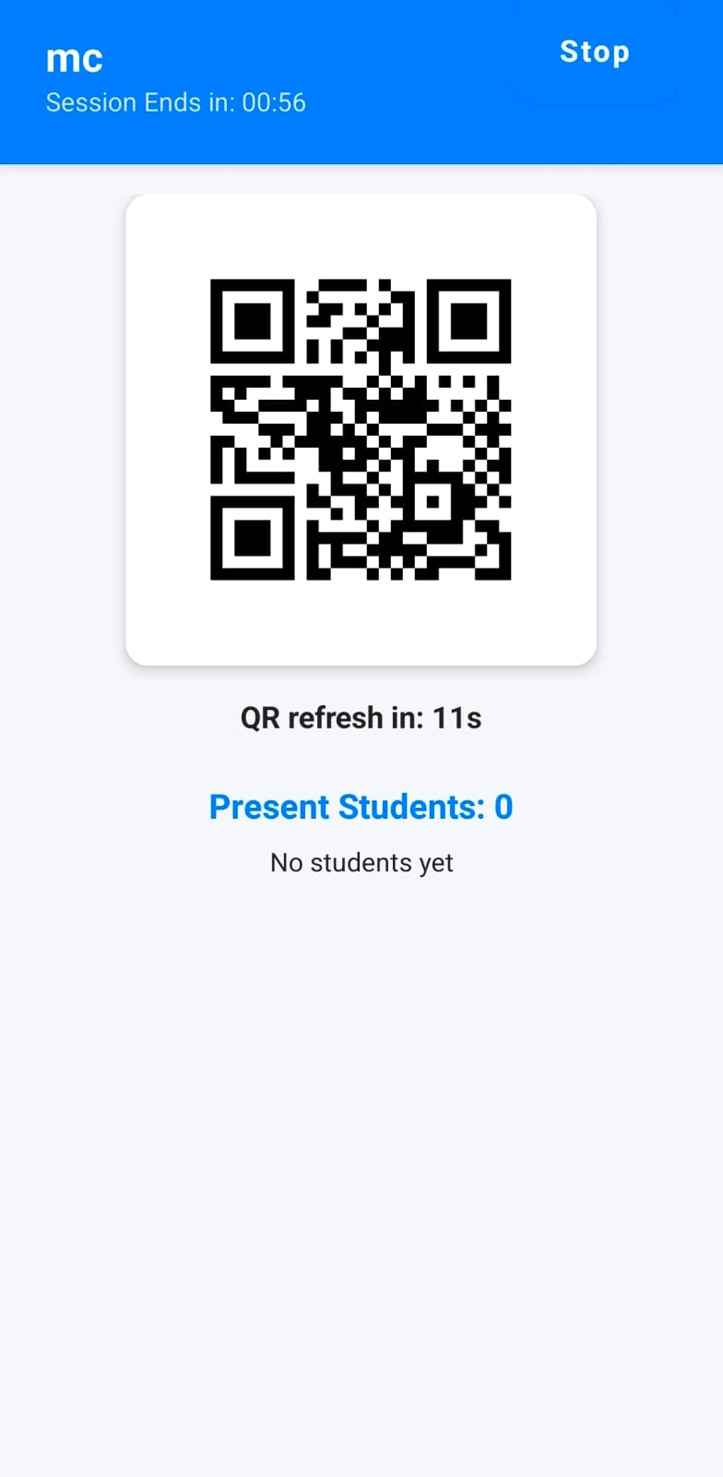

- Attendance Reports

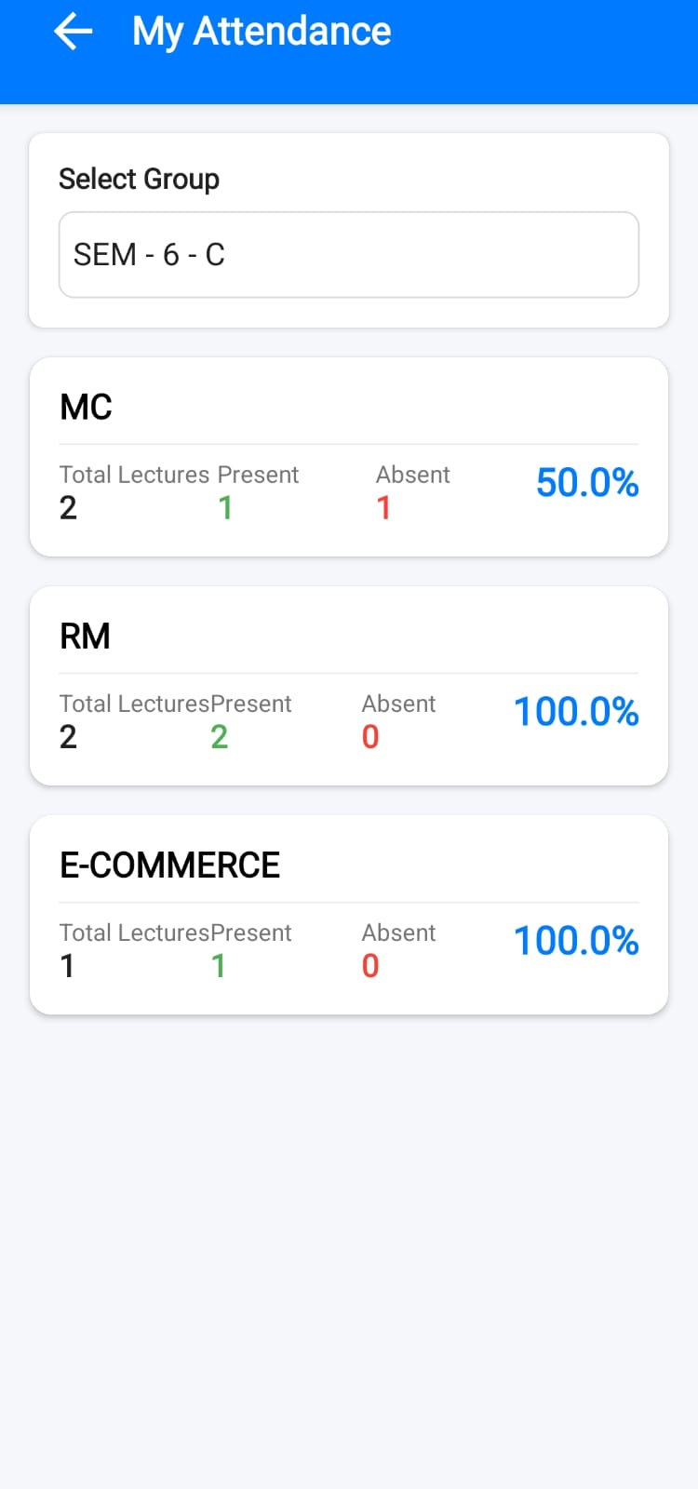

5. Agile Documentation

5.1 Agile Project Charter
Field | Details
Project Name | TrueMark Smart Attendance System
Project Sponsor | LJ School of Computer Applications, LJ University
Project Manager | Internal Guide: Prof. Urvika
Team Members | AWAN MANSURI, SHAHIL SHAIKH, MUJIR SHAIKH
Project Goal | Develop a fully functional QR-based Android attendance management system for educational institutions
Success Criteria | Complete QR attendance app with Firebase backend, role dashboards, reporting, and push notifications
Timeline | 12 Dec 2025 – 12 Mar 2026 (13 weeks total, 6 Agile sprints)
Technology | Kotlin, Android SDK, Firebase, ZXing QR, Jetpack, Room, Material Design 3
Methodology | Agile Scrum: 2-week sprints (Sprint 6 extended to 3 weeks for testing and final deployment)
Key Risks | Firebase connectivity dependency; QR scanning accuracy variation across diverse Android device models
Budget | Academic project – zero cost using Firebase Spark free tier and open-source Android libraries only

5.2 Agile Roadmap/Schedule

Sprint | Goal | Duration | Dates
Sprint 1 | Project Setup, Firebase Configuration, Authentication Module | 2 Weeks | 12 Dec – 25 Dec 2025
Sprint 2 | User Management, Role-Based Dashboards | 2 Weeks | 26 Dec 2025 – 08 Jan 2026
Sprint 3 | Session Management, QR Code Generator | 2 Weeks | 09 Jan – 22 Jan 2026
Sprint 4 | QR Scanner, Attendance Recording, Duplicate Validation | 2 Weeks | 23 Jan – 05 Feb 2026
Sprint 5 | Reports Module, FCM Notification System | 2 Weeks | 06 Feb – 19 Feb 2026
Sprint 6 | Testing, Bug Fixes, Documentation, Final Deployment | 3 Weeks | 20 Feb – 12 Mar 2026

5.3 Agile Project Plan

Task | Assigned To | Duration | Start Date | Status
Firebase Project Setup and Configuration | AWAN MANSURI | 2 days | 12 Dec 2025 | Done
Authentication Module (Login/Register) | SHAHIL SHAIKH | 3 days | 14 Dec 2025 | Done
Admin Dashboard Layout | MUJIR SHAIKH | 3 days | 17 Dec 2025 | Done
Attendance Session Management Module | AWAN MANSURI | 4 days | 26 Dec 2025 | Done
QR Code Generator (ZXing Integration) | SHAHIL SHAIKH | 3 days | 30 Dec 2025 | Done
QR Code Scanner (Camera Integration) | MUJIR SHAIKH | 4 days | 09 Jan 2026 | Done
Attendance Record Storage (Firebase) | AWAN MANSURI | 3 days | 13 Jan 2026 | Done
Reports and Analytics Module | SHAHIL SHAIKH | 4 days | 23 Jan 2026 | Done
Push Notification System (FCM) | MUJIR SHAIKH | 3 days | 06 Feb 2026 | Done
UI/UX Polish, Testing and Documentation | All Members | 5 days | 06 Mar 2026 | Done

5.4 Agile User Story

Story ID | As a... | I want to... | So that... | Priority
US-01 | Student | Scan a QR code to mark attendance | I can record my presence instantly without any paper process | High
US-02 | Faculty | Generate a QR code for my class session | My students can scan and mark their attendance easily | High
US-03 | Faculty | View real-time attendance list during session | I can see exactly who has marked attendance live | High
US-04 | Admin | Manage all user accounts and roles | I can fully control access to the TrueMark system | High
US-05 | Student | View my complete attendance history | I can track my percentage and plan my academic schedule | Medium
US-06 | Faculty | Export attendance reports to CSV | I can submit accurate records for academic and admin purposes | Medium
US-07 | Student | Receive push notifications for sessions | I am alerted immediately when an attendance session is open | Medium
US-08 | Admin | View institution-wide attendance analytics | I can monitor trends and identify at-risk students early | Low
US-09 | Faculty | Close an active attendance session | The QR code expires and no further scans are accepted | High

5.5 Agile Release Plan
Release | Features Included | Date | Priority | Status
Release 1 (MVP) | Firebase Auth, QR Code Generation, QR Scanning, Basic Attendance Recording | 25 Dec 2025 | High | Done
Release 2 | Admin Dashboard, Full User Management, Role-Based Dashboards, Attendance History View | 08 Jan 2026 | High | Done
Release 3 | Reports Module, FCM Push Notifications, Attendance Percentage, CSV Export | 05 Feb 2026 | Medium | Done
Release 4 | Performance Optimization, UI Polish, Regression Bug Fixes, Final Documentation | 12 Mar 2026 | Low | Done

5.6 Agile Sprint Backlog

Sprint | Backlog Item | Dates | Priority | Status
Sprint 1 | Firebase setup, Authentication UI screens, Login/Register validation, role-based routing | 12–25 Dec 2025 | High | Done
Sprint 2 | Admin CRUD operations, Faculty/Student role dashboards, full Navigation Component graph | 26 Dec–08 Jan 2026 | High | Done
Sprint 3 | Session creation workflow, QR generation with ZXing, QR display and projection screen | 09–22 Jan 2026 | High | Done
Sprint 4 | Camera-based QR scanner, session validation logic, duplicate attendance prevention system | 23 Jan–05 Feb 2026 | High | Done
Sprint 5 | Attendance reports with charts, FCM notifications, date filters, CSV data export module | 06–19 Feb 2026 | High | Done
Sprint 6 | Full regression testing, performance optimisation, ProGuard build, documentation completion | 20 Feb–12 Mar 2026 | High | Done

5.7 Agile Test Plan

Test Type | Objective | Tool / Method | Sprint | Status
Unit Testing | Validate individual Kotlin ViewModels and all Repository methods | JUnit 4 / Kotlin Coroutine Test | Sprint 3–5 | Completed
Integration Testing | Verify Auth, Firebase, QR module interactions | Manual + Firebase Emulator Suite | Sprint 4–5 | Completed
System Testing | Complete end-to-end QR attendance workflow validation | Functional Testing on Physical Devices | Sprint 6 | Completed
UAT | Verify user acceptance and usability for all roles | Manual Testing Sessions with End Users | Sprint 6 | Completed
Regression Testing | Ensure no prior functionality broken after updates | Manual + Automated Post-Sprint Checks | Sprint 6 | Completed
Performance Testing | Confirm QR scan response time is consistently under 3 seconds | Manual Timing on Multiple Device Models | Sprint 6 | Completed

5.8 Earned Value and Burn Charts
The sprint burn-down chart tracks remaining story point work against each sprint timeline. The team began Sprint 1 with 122 total planned story points and successfully completed all features by the end of Sprint 6 within the defined 13-week project window.

Sprint | Planned Points | Completed Points | Remaining Points | Team Velocity
Sprint 1 | 20 | 20 | 102 | 20 pts/sprint
Sprint 2 | 20 | 19 | 83 | 19 pts/sprint
Sprint 3 | 25 | 25 | 58 | 25 pts/sprint
Sprint 4 | 25 | 24 | 34 | 24 pts/sprint
Sprint 5 | 20 | 20 | 14 | 20 pts/sprint
Sprint 6 | 14 | 14 | 0 | 14 pts/sprint
Total | 124 | 122 | 0 | Avg: 20 pts/sprint

The earned value analysis confirms the project was delivered on time and within the agreed scope. The 2-point deferral in Sprint 2 was fully recovered in Sprint 3, demonstrating the team’s effective use of Agile sprint retrospective practices for proactive risk management.

6. Testing Method

6.1 Testing Methodology
The TrueMark Smart Attendance System employs a comprehensive, multi-level testing strategy covering unit, integration, system, user acceptance, manual, performance, and regression testing to ensure complete functionality, reliability, and user satisfaction across all features.

Unit Testing
- Tests individual ViewModels (LoginViewModel, SessionViewModel, AttendanceViewModel) and all Repository methods.
- Framework: JUnit 4 with Kotlin coroutine test utilities for async Firebase database operations.
- Coverage target: minimum 80% code coverage across all Repository and ViewModel class files.

Integration Testing
- Verifies that Firebase Authentication, QR module, and all UI components interact correctly end-to-end.
- Firebase Emulator Suite used to simulate all cloud operations locally without impacting live data.
- Full test scenario coverage: login → session creation → QR generation → student scan → record storage.

System Testing
- End-to-end flow: Faculty creates session → QR generated → Student scans → Attendance stored and confirmed.
- Conducted on real physical Android devices from Samsung, OnePlus, and Xiaomi product lines.
- All edge cases validated: expired QR code, duplicate scan attempt, network loss during scan, concurrent scans.

User Acceptance Testing (UAT)
- All features validated against documented user story acceptance criteria from the sprint backlog.
- QR scan speed requirement: attendance marking must complete within 2 seconds of a valid scan.
- Attendance record must appear in real time on Faculty dashboard within 3 seconds of student scan.

Manual Testing
- Performed on 4 different physical Android device models to cover diverse hardware configurations.
- Covers all user role flows: Admin account management, Faculty session lifecycle, Student QR scan process.

Performance Testing
- QR scan decode time measured across 10 trials per device; all results consistently under 2.5 seconds.
- Firebase write latency tested under simulated concurrent load of 50 simultaneous student scans.

6.2 Test Cases
Test Case ID | Feature | Input | Expected Output | Result
TC-01 | Student Login | Valid email and password | Redirect to Student Dashboard | Pass
TC-02 | Student Login | Invalid or wrong credentials | Error ‘Invalid credentials’ shown | Pass
TC-03 | Faculty Login | Valid faculty email and password | Redirect to Faculty Dashboard | Pass
TC-04 | Faculty Login | Unregistered email | Error ‘User not found’ shown | Pass
TC-05 | Admin Login | Valid admin credentials | Redirect to Admin Dashboard | Pass
TC-06 | QR Generation | Faculty creates new session | Unique encrypted QR displayed | Pass
TC-07 | QR Generation | No active session exists | Error ‘No active session’ | Pass
TC-08 | QR Scanning | Valid active session QR | Attendance marked and confirmed | Pass
TC-09 | QR Scanning | Expired or tampered QR | Error ‘Session ended or QR invalid’ | Pass
TC-10 | Duplicate Attendance | Same QR scanned twice | Message ‘Already marked’ shown | Pass
TC-11 | Attendance Record | Valid verified student scan | Record saved in Firebase with timestamp | Pass
TC-12 | Attendance History | Student views history screen | All sessions with status listed | Pass
TC-13 | Reports | Faculty generates report | Correct percentages displayed | Pass
TC-14 | Admin User Create | Admin creates new account | Account created successfully | Pass
TC-15 | Notification | Faculty opens new session | Students receive FCM push notification | Pass
TC-16 | Session Close | Faculty closes session | QR expires; further scans rejected | Pass
TC-17 | Offline Access | Device loses internet | Local SQLite cache used; syncs on reconnect | Pass
TC-18 | Password Reset | User requests password reset | Reset email sent via Firebase Auth | Pass
TC-19 | Role Restriction | Student accesses faculty route | Access denied; redirect to student view | Pass
TC-20 | Concurrent Scans | 50 students scan simultaneously | All records saved without conflicts | Pass

7. Proposed Enhancement

The TrueMark Smart Attendance System is built on a modular, scalable MVVM architecture specifically designed to support continuous feature additions without requiring core system restructuring. The following enhancements are proposed for future development cycles:

- Role-Based Analytics Dashboards: Enhanced, graphical analytics dashboards for faculty and administrators featuring detailed attendance trend charts, class comparison metrics, and automated early-warning alerts for students with low attendance percentages.

- Geo-Fencing Attendance Validation: GPS-based geo-fencing integration to restrict QR attendance marking strictly to within defined campus boundary coordinates, effectively preventing any remote or off-campus proxy attendance attempts.

- Face Recognition Verification: Biometric facial recognition as a mandatory secondary validation layer alongside QR scanning, substantially strengthening attendance integrity in high-stakes academic and examination environments.

- iOS Application Development: Native iOS companion application built with Swift and SwiftUI to extend TrueMark’s full feature set to Apple device users, ensuring complete institutional coverage across all student smartphone platforms.

- ERP and LMS Integration: Deep two-way integration with university ERP systems (SAP, Oracle, Banner) and Learning Management Systems (Moodle, Canvas, Blackboard) for fully unified, automated attendance data flow and academic record management.

- AI-Powered Absenteeism Prediction: Machine learning models trained on historical attendance patterns to proactively identify and alert faculty and academic advisors about students at high risk of chronic absenteeism before it impacts academic outcomes.

- Bulk Student Import: CSV and Excel bulk import capability allowing administrators to onboard entire student batches from existing institutional rosters in a single operation, eliminating manual one-by-one account creation.

- Offline Attendance Mode: Limited offline session mode enabling faculty to create sessions and students to pre-register attendance locally during network outages, with automatic and conflict-free Firebase synchronization upon connectivity restoration.

- Multi-Language Support: Full localisation for Indian regional languages including Gujarati, Hindi, and Marathi to improve platform accessibility for diverse faculty and student populations across regional campus environments.

- Wearable Device Integration: Android Wear OS smartwatch integration enabling faculty to open and close attendance sessions and receive live attendance count updates directly from their wrist-worn device during class.

8. Conclusions

The TrueMark Smart Attendance System successfully implements a comprehensive, production-ready QR-based attendance management platform for educational institutions. The system fully achieves all defined primary objectives: secure Firebase-backed authentication, purpose-built role-specific dashboards for Admin, Faculty, and Student users, real-time QR-based attendance marking that eliminates proxy attendance, and powerful reporting capabilities for academic use.

Built entirely on Kotlin and Firebase cloud services, the project clearly demonstrates how modern Android technologies can be combined to solve real-world institutional challenges efficiently, cost-effectively, and at scale. The modular MVVM architecture ensures the codebase remains highly maintainable and extensible as the system grows and new features are added in future iterations.

The Agile Scrum development methodology enabled the three-member team to deliver features incrementally across six well-structured sprints, responding iteratively to technical challenges and stakeholder feedback throughout the complete development lifecycle. All 122 planned story points were delivered within the defined 13-week academic project timeline, demonstrating strong collaborative project management and disciplined engineering practices.

With ambitious proposed future enhancements including GPS geo-fencing, biometric face recognition, native iOS application, and ERP integration, TrueMark is architecturally well-positioned to evolve into a comprehensive, fully automated smart campus attendance solution that sets a new standard for digital academic management across Indian higher education institutions.

This project has been an exceptionally valuable academic exercise that successfully brought together advanced skills in mobile application development, cloud architecture design, database management, UI/UX implementation, and Agile project management into a single cohesive, real-world product with genuine institutional utility and commercial potential.

9. Project Learnings

Technical Skills Gained
- Kotlin Android development and MVVM clean architecture: effectively separating UI, domain, and data layers for testability and maintainability.
- Firebase Authentication, Realtime Database, and Cloud Messaging: building a fully cloud-backed mobile application with zero server infrastructure.
- QR code generation and camera-based scanning using the ZXing Android Embedded library for accurate real-time decoding.
- Android Room Database with SQLite for reliable offline attendance history caching and data availability without network.
- Jetpack architecture components: ViewModel, LiveData, Navigation Component, and ViewBinding for production-quality Android development.
- Material Design 3 theming, dynamic colour palettes, responsive layouts, and full accessibility compliance across all device sizes.
- Firebase Security Rules for implementing granular, role-enforced data access control without any additional backend server code.
- ProGuard code obfuscation and APK release build pipeline configuration for secure production application delivery.

Project Management Skills Gained
- Applying Agile Scrum: structured user stories, sprint planning sessions, daily standups, backlog refinement, and formal sprint retrospectives.
- Burn-down chart and velocity tracking using story points to monitor sprint delivery and proactively manage scope and deadline risks.
- Value of separating business logic from UI using MVVM for improved testability, reusability, and long-term code maintainability.
- Importance of clear, structured documentation: KDoc comments, system architecture diagrams, and comprehensive test case specifications.
- Effective parallel task distribution across three team members based on individual technical strengths and sprint priorities.

Collaboration and Problem Solving
- Resolving Firebase real-time sync conflicts by implementing atomic database transactions for simultaneous concurrent attendance writes.
- Debugging duplicate attendance edge cases across concurrent multi-student QR scans required careful Firebase transaction rule design.
- Iterative QR scanning improvement across Sprints 3 and 4 significantly improved scan decode accuracy and overall response time.
- Resolving Firebase Authentication token refresh issues during extended student session durations improved application stability.
- Regular peer code reviews after every sprint improved overall code quality, caught bugs early, and promoted team knowledge sharing.

10. Bibliography

Sr. No. | Reference Source | URL / Reference
1 | Kotlin Official Documentation | https://kotlinlang.org/docs/
2 | Android Developer Documentation | https://developer.android.com/docs
3 | Firebase Documentation (All Products) | https://firebase.google.com/docs
4 | Agile Alliance – Agile Methodology Resources | https://www.agilealliance.org/
5 | ZXing QR Code Library (GitHub) | https://github.com/zxing/zxing
6 | Stack Overflow – Developer Community | https://stackoverflow.com/
7 | Android Jetpack Architecture Guide | https://developer.android.com/jetpack
8 | Material Design 3 (Google) | https://m3.material.io/
9 | Firebase Cloud Messaging Documentation | https://firebase.google.com/docs/cloud-messaging
10 | Android Room Persistence Library | https://developer.android.com/training/data-storage/room
11 | Android MVVM Architecture Guide | https://developer.android.com/topic/architecture
12 | ProGuard Rules for Android Builds | https://developer.android.com/build/shrink-code
13 | Firebase Security Rules Guide | https://firebase.google.com/docs/rules
14 | Kotlin Coroutines for Android | https://developer.android.com/kotlin/coroutines



THANK YOU

TrueMark Smart Attendance System

Presented by:
AWAN MANSURI | SHAHIL SHAIKH | MUJIR SHAIKH

iMSc (IT) Semester 6 – Group iMSc (IT)_12
L.J. School of Computer Applications, LJ University
Ahmedabad – 382210

