PCB has 2 errors, one error - varactors D1 and D2 drawn opposite. C27 need to go to ground, place it to another leg of R22.

Here is photo attached.

More notes on assembly:

I have provided you with coils:

4+1

1 red is for first oscillator. You need to wind 44 turns.

2 out of 4 others used in RF and you need to remove built in capacitors from them. One used for sense tuning, another one in input circuit.

Sense coil need to be rewind completely with 62-65 turns.

Another one in RF - remove cap and wind secondary.

Two others are for IF - only need to wind secondary and leave caps in place.

Start assembly from AF and move to RF, check signal as you go.

Schematic is good, you do NOT need: IC4, C37, C41, C42, C50, C51

R41 - use 3k, you can adjust it, it affects main volume level

C5 - dont need it also

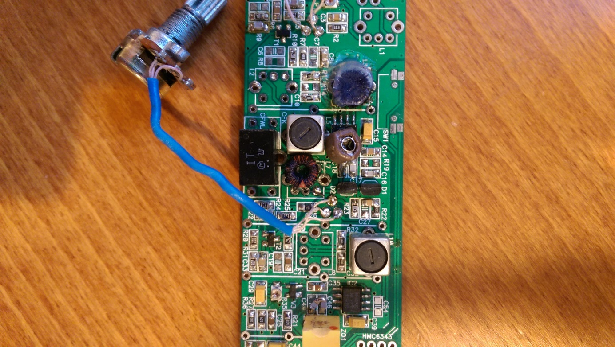

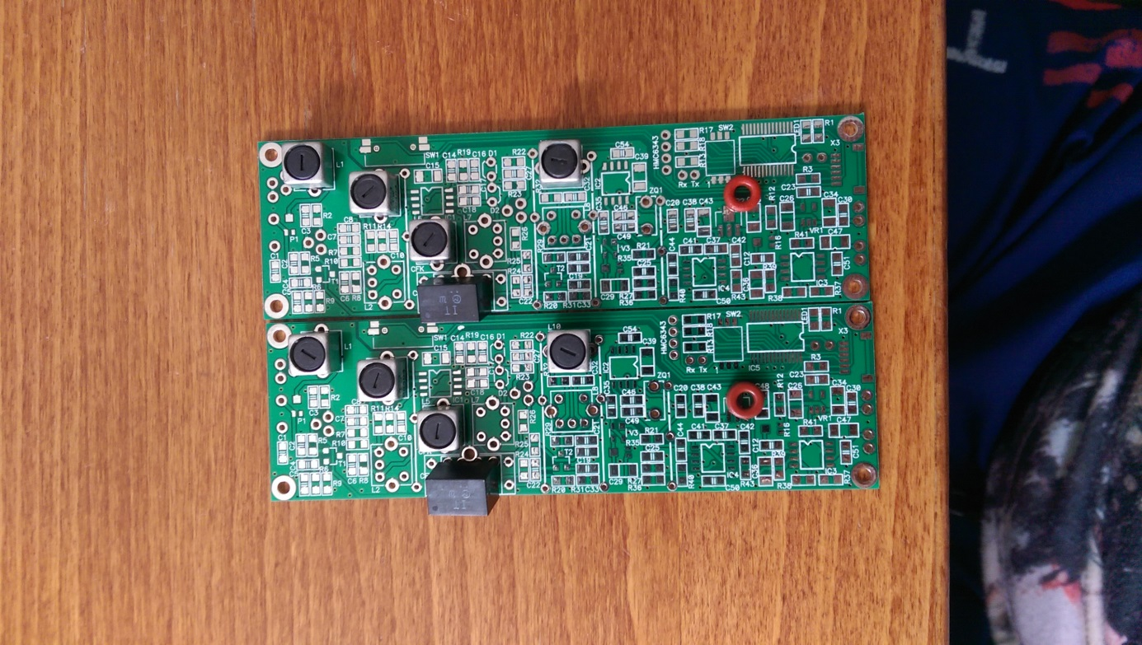

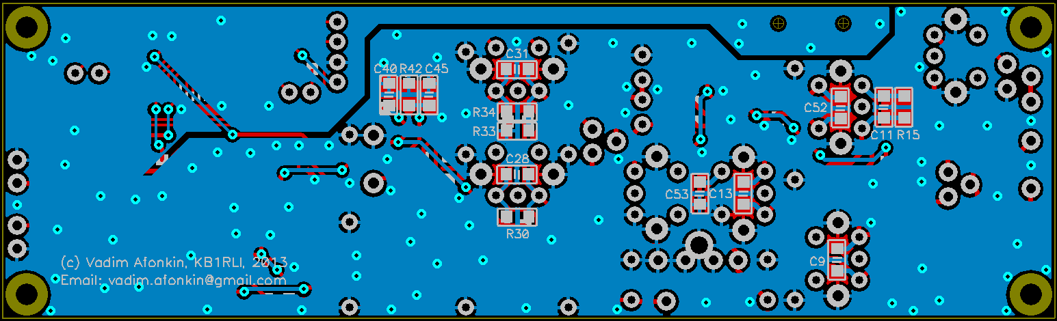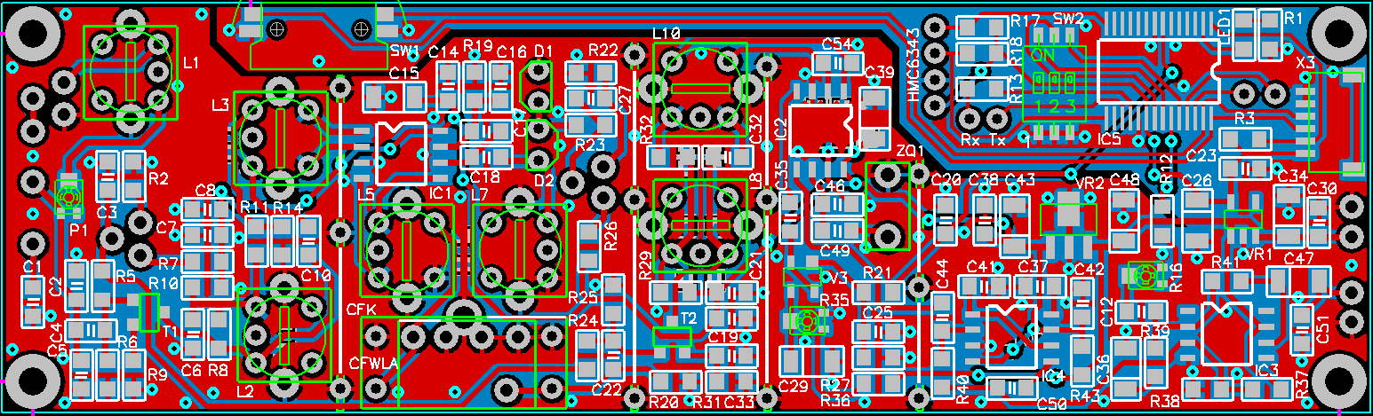

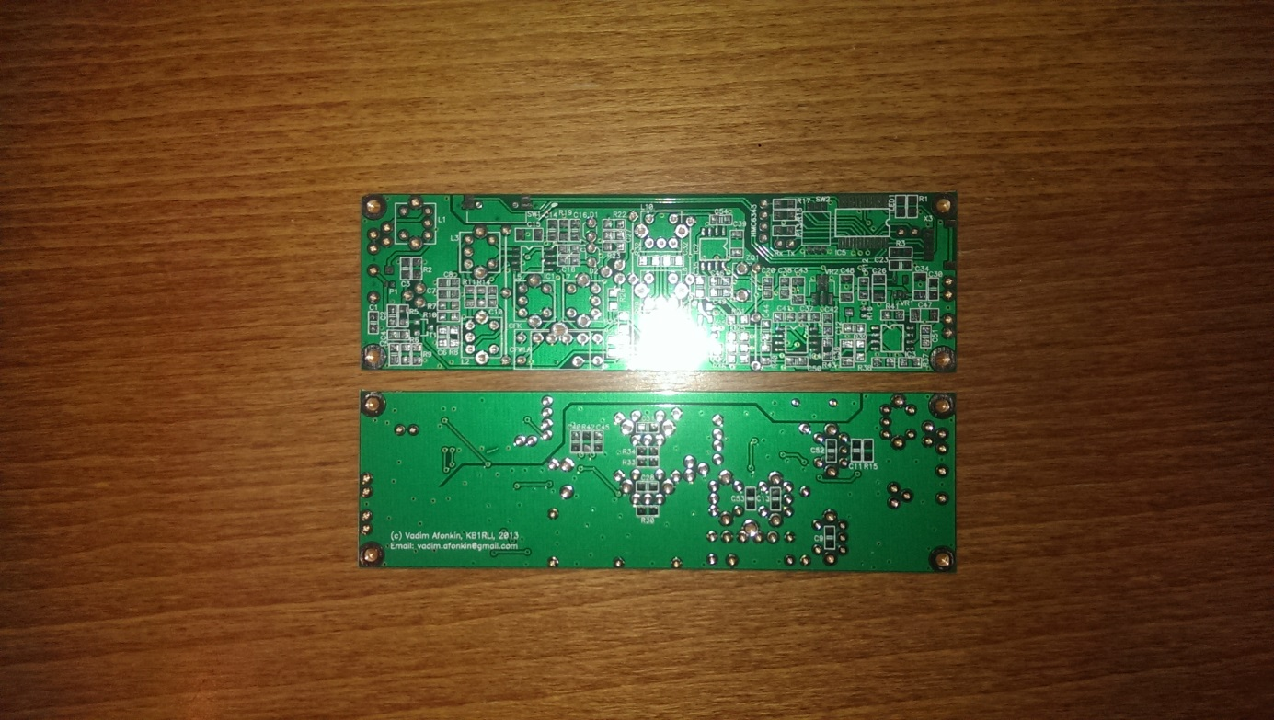

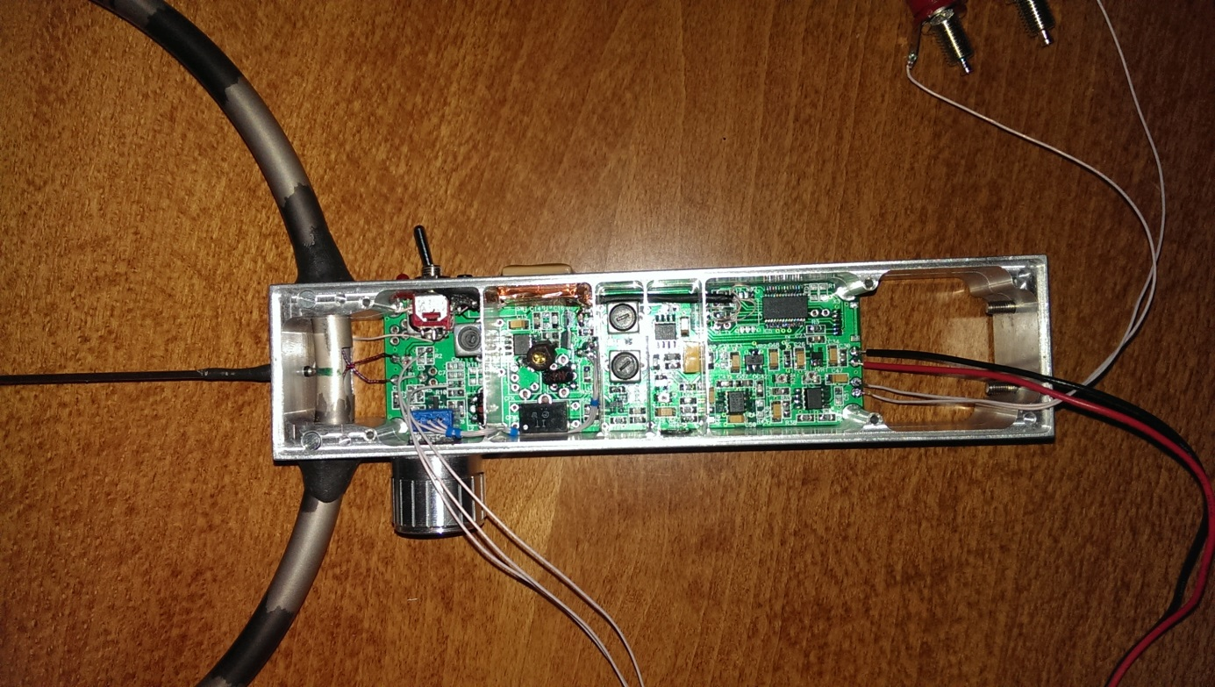

Parts to be installed at factory:

IC1,IC2 SA602

IC3 UA741C

IC5 PIC16F886

VR1 LP2981 3.3v

VR2 MC78L06 6v

T1,T2 BC850C

D1,D2 NTE618

D3,D4 BAT74 uses only one part because case has 2 diodes inside

C2 6-30p

C5 100p\*

C47,C34,C26,C29,C39,C48,C43,C15 10uF electrolitic

C36 1uF electrolitic

C35,C44,C12 1uF

C4,C33 1500p

C3,C14,C27 10n

C16,C17,C18 470p

C55 5-60p\*

C22,C38,C40,C20,C25 100n

C45 940p

C46 830p

C49 120p

C23,C30 1n

C11 12p

P1 2k\*

R2,R13,R39 1k\*

R7 15k\*

R5 220k

R6,R27,R21,R37,R38 100k

R10,R12 3k

R9 1.1k

R22 360k

R23 1M

R26 750k

R20,R31 R36 2k

R24 75k

R25 82k

R29 2.4k

R40,R11,C10,R32,C32,C1 0

R3,R17,R18,R41 10k

R35,R16 20k Pot

Parts needs to be installed manually:

R4,R28 100k Pot

L1 120uH\* (60 turns on TOKO S7AG-A033HM)

L3 53 turns for secondary on TOKO S7AG-A033HM, remove capacitor from contour

L5 44 turns for secondary on TOKO S7AG-A033HM

L10 59 turns for secondary on TOKO S7AG-A033HM

L7 44 turns on T-25-2

ZQ1 455kHz

CFWLA CFK455J or similar

C7 10n

C21 100n

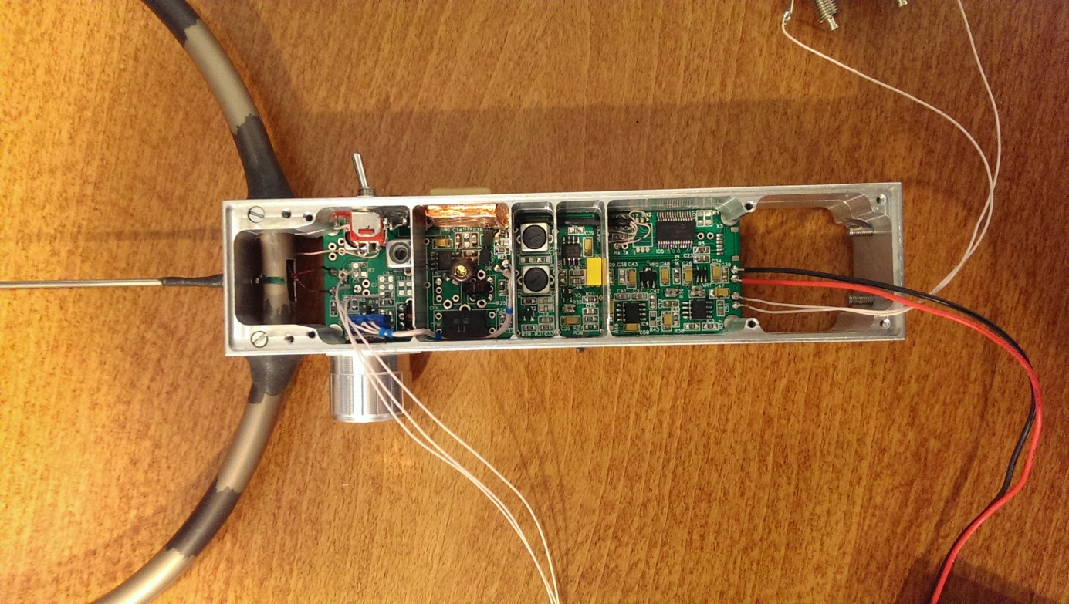

\*\*\*\*\*\*\*\*\*\*\*\*\*\*\*\*\*\*\*\*\*\*\*\*\*\*\*\*\*\*\*\*\*\*\*\*\*\*\*\*\*\*\*\*\*\*\*\*\*\*\*\*\*\*\*\*\*\*\*\*\*\*\*\*\*\*\*\*\*\*\*\*\*\*\*\*\*\*\*

\*\*\*\*\*\*\*\*\*\*\*\*\* This is open source project \*\*\*\*\*\*\*\*\*\*\*\*\*\*\*

\*\*\*\*\*\*\*\*\*\*\*\*\* 80 Meters FoxFinder receiver by KB1RLI \*\*\*\*\*\*\*\*\*\*\*\*\*\*\*

\*\*\*\*\*\*\*\*\*\*\*\*\* email all questions to vadim.afonkin@gmail.com \*\*\*\*\*\*\*\*\*\*\*\*\*\*\*

\*\*\*\*\*\*\*\*\*\*\*\*\*\*\*\*\*\*\*\*\*\*\*\*\*\*\*\*\*\*\*\*\*\*\*\*\*\*\*\*\*\*\*\*\*\*\*\*\*\*\*\*\*\*\*\*\*\*\*\*\*\*\*\*\*\*\*\*\*\*\*\*\*\*\*\*\*\*\*

Folders content:

1. Schematics - most recent version of receiver

2. Enclosures - drawings to manufacture receiver enclosure. Use PDF files - they are most accurate. Autocad files does not have measurments. All sizes are in inches, not in millimeters

3. FRMWR - most recent firmware for receiver

4. Parts list - parts list/BOM

5. PCB - Gerber files for PCB manufacturing

6. Photo - photos of assembled receiver, pcb, etc.

Other notes:

main.hex - firmware for MCU - PIC16F886

Current firware supports following functions:

1. AutoTone - tone will turn on based on signal level, on standard 3W TX from about 900-1k. Tone attached to signal and controlled by volume.

2. Tone pitch - attached to signal level

3. GPS/Display/Distance calculation

No changes needed if no GPS/Display used.

73!

Vadim

KB1RLI