WORKING ONE-PAGER · UPDATED NOVEMBER 3, 2026
NYC Policy Implementation Observatory
A validated, season-matched read of NYC 311 service demand and administrative performance — built to surface where to ask the next question, not to answer it.
Study period Oct 2025–Sep 2026 · Seasonal baseline Oct 2024–Sep 2025 · Author Anruo Wang

3,963,901  study-period 311 requests, up 10.2% from baseline | 90.35%  weighted 30-day administrative closure rate, down from 91.00% | 50  agency–service–district combinations flagged for investigation | 24 mo  of reconciled, monthly-validated 311 data, Oct 2024–Sep 2026

What it does
Two live dashboard pages, built on a validated pipeline and reconciled to independent SQL checks.
NEIGHBORHOOD EQUITY  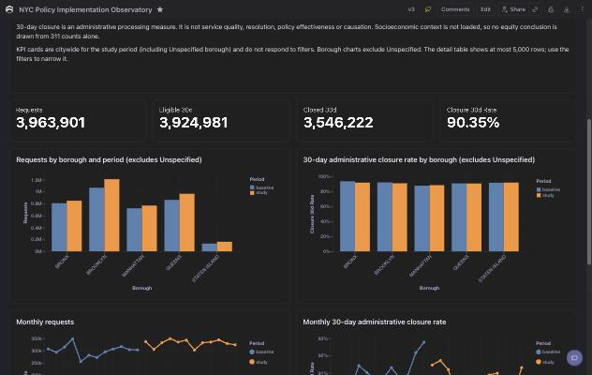  Citywide demand and closure-rate KPIs, by borough and month, baseline vs. study period. Bronx and Brooklyn show the largest closure-rate declines. | OPERATIONAL PRIORITIES  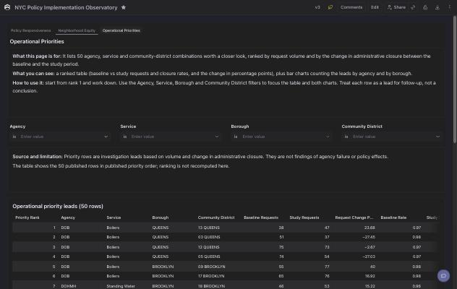  50 agency–service–district cells ranked by volume and closure-rate change. Top ranks are dominated by DOB boiler complaints across multiple districts — still being checked against classification/routing changes.

What it deliberately doesn't do
Discipline over coverage. Every number below is a design choice, not an oversight.
— Compares the same calendar months one year apart, so no seasonal swing is mistaken for a trend.
— Defines “closed” as an administrative event recorded within 30 days — not service quality, resolution, or satisfaction.
— Treats the 50 ranked rows as leads for follow-up, never as findings of agency failure or policy effect.
— Estimates no causal effects and infers no socioeconomic equity conclusion from 311 counts alone.
— Does not track or verify policy or legislative implementation. For that layer, see the NYC Council Legislative Calendar or the NYC Mayor's Management Report.

Where it could go
The current scope is deliberately narrow. Here's what extending it would take.
NEXT STEP
This project already measures the second half of the implementation chain: administrative performance and neighborhood heterogeneity, reconciled monthly against the source data. The missing first half is a verified record of what an agency was obligated to do, and by when — sourced from primary records, not estimated.
Closing that gap for one well-chosen case, end to end, is the next extension of this project's scope: a verified obligation, the agency action that followed, the measurable change in the service responsible for it, and where across the city that change was and wasn't felt.

CONTACT  Anruo Wang  anruowang1211@outlook.com | LIVE DASHBOARD  Cube Cloud — shared by invitation, ask for access | DATA WINDOW  311 reconciled through Sep 2026

