GENERAL PROJECT OVERVIEW · NOVEMBER 2026
NYC Policy Implementation Observatory
A validated, season-matched read of NYC 311 service demand and administrative closure performance, down to the community-district level.
Study period Oct 2025–Sep 2026 · Seasonal baseline Oct 2024–Sep 2025 · Author Anruo Wang

Where this sits in the bigger picture
A city policy's path from commitment to felt outcome has eight links. Each one below is tagged with what this project currently does with it.
Policy commitment / enacted law | NOT COVERED
↓
Legal / administrative obligation | NOT COVERED
↓
Agency action | NOT COVERED
↓
Operational output | BUILT
↓
Resident outcome | PARTIAL
↓
Neighborhood disparity | BUILT
↓
Resident feedback | NOT COVERED
↓
Implementation diagnosis | NEXT STEP

WHAT THIS FILLS TODAY
A single validated dataset connecting NYC 311 demand and administrative closure across a full 24-month, season-matched window, down to agency–service–community-district granularity, reconciled against independent checks, with a ranked queue showing where performance moved most.
Everything to the left of “Operational output” (what was committed, and what it obligated agencies to do) and the two steps after “Neighborhood disparity” are not part of this tool today.

What exists today
Core question | How did NYC 311 service demand and administrative closure performance differ between the study year and the year before it, and which agency–service–district combinations are worth a closer look?
Primary data | NYC 311 service requests — complete and validated. Community-district geography — identified, not yet integrated. Socioeconomic context and policy/implementation records — not yet loaded.
Current infrastructure | A PostgreSQL/SQL pipeline with independent reconciliation, a Cube semantic layer, and a two-page live dashboard.
Current modules | Neighborhood Equity (citywide, borough and district demand/closure trends) and Operational Priorities (a 50-row ranked investigation queue).
Current analytical direction | Compare the study year to a seasonally matched baseline, find where demand and closure performance moved most, and flag agency–service–district cells for manual follow-up.
Current limitation | The dashboard shows where to look. It does not yet verify why performance changed, whether a specific policy caused it, or what residents experienced beyond what they reported to 311.

3,963,901  study-period 311 requests, up 10.2% from baseline | 90.35%  weighted 30-day administrative closure rate, down from 91.00% | 50  agency–service–district combinations flagged for investigation | 24 mo  of reconciled, monthly-validated 311 data, Oct 2024–Sep 2026

IMPORTANT ANALYTICAL DISCIPLINE
A change in the data after a policy date is not evidence that the policy caused it. This project keeps three things separate — descriptive trends, associations, and causal estimates — and today only produces the first two.
“Closed within 30 days” is an administrative processing measure, not service quality or resolution. The 50 ranked rows are leads for follow-up, not findings of agency failure. No socioeconomic equity conclusion is drawn from 311 counts alone.

What it looks like
Two live dashboard pages, reconciled to independent SQL checks.
NEIGHBORHOOD EQUITY  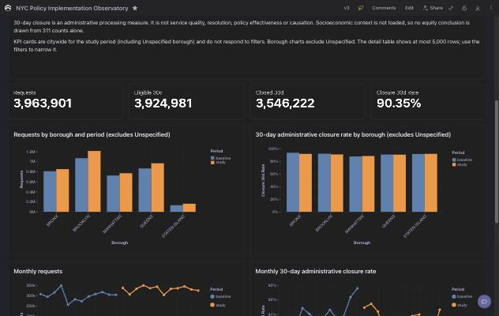  Citywide demand and closure-rate KPIs, by borough and month, baseline vs. study period. | OPERATIONAL PRIORITIES  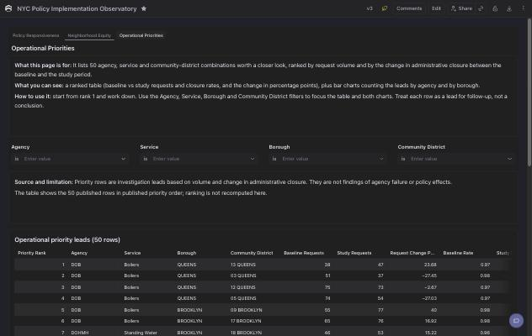  50 agency–service–district cells ranked by volume and closure-rate change, for manual follow-up.

Practical value: who this could help
What the data could support today — not yet confirmed by outside user feedback.
POTENTIAL USER | WHAT THIS COULD OFFER TODAY
City agencies | A citywide and district-level view of where reported demand and closure performance moved, to compare against internal records.
City Council / oversight | A ranked list of agency–service–district combinations worth a follow-up question, with the underlying numbers shown.
Mayor's Office | A cross-agency view of where performance patterns diverge from the citywide trend.
Community organizations | A sourced starting point for which service issues, in which districts, moved most — to pair with lived experience.
Researchers / journalists | A validated, reconciled 311 dataset and methodology, instead of reconstructing one from raw Open Data.
Funders / civic-tech | A concrete example of where a small, well-scoped data project surfaces decision-relevant questions.

Next step: one narrow, end-to-end case
Not a wider dashboard. One case, followed all the way through.
Can this project take one already-implemented NYC policy or operational intervention and reconstruct the full chain — commitment, implementation, service change, resident outcome, neighborhood heterogeneity — while keeping descriptive evidence and causal claims clearly separate?
That means picking one case where an intervention, its implementation date, and a matching operational metric all exist, and following it end to end — including the honest possibility that, for most candidates, the data shows something changed but not yet why.

CONTACT  Anruo Wang  anruowang1211@outlook.com | LIVE DASHBOARD  Cube Cloud — shared by invitation, ask for access | DATA WINDOW  311 reconciled through Sep 2026

