Data (1.):

-Our data for this project is the Yosemite sequence, a rather famous dataset for optical flow problems. It consists of 15 simulated images of Yosemite national park “taken” by an aerial camera moving in a straight line.

-It was originally generated by Lynn Quam at SRI, by taking a topdown image and texture mapping it to a depth map to create a 3d model, with the images generated from a similar camera

-Subsequent images are only marginally different. (img1 vs img15 below)
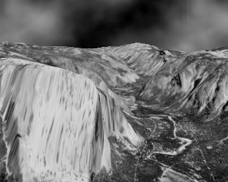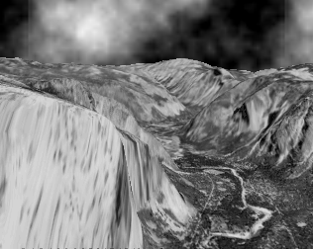

-The clouds were randomly simulated, (brownian motion) and the assumption of brightness constancy doesn’t hold for that region
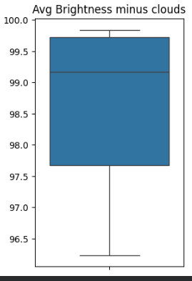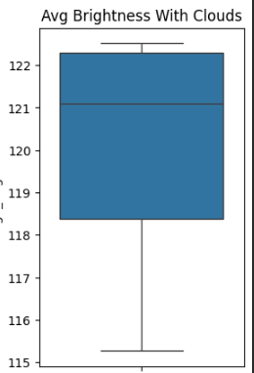

Question (2.):

-We seek to uncover that optical flow can be represented accurately by a Gaussian process with gaussian noise.

Literature (3.):

-Horn and Schunk (1984), Lucas and Kanade have both created algorithms to measure optical flow. The former uses the gradient constraints and regularizes with a smoothness term, and the latter uses least-squares on a moving window

-Barron et. al (1994) was the first to test these on the Yosemite dataset, with the conclusion L-K was more effective.

-Heeger et. al (1991) was the first to experiment with making a probabilistic model for optical flow with gaussian error, but used a different dataset

-More recently, several methods have emerged using probabilistic models for optical flow problems, such as ProbFlow (2015) which jointly estimates optical flow and its uncertainty

-Gaussian Processes and GPR have been used to solve similar problems in ML for a while, but not frequently used for optical flow. (Rasmussen 2006)

