BABU BANARASI DAS
UNIVERSITY
2026-2027
SCHOOL OF COMPUTER APPLICATIONS

NoSQL Project On
Employee Management System Using MongoDB
Submitted to: Submitted by:
Mr. Harendra Singh Student's name: Awan Sheeka
Department: BCA (DS & AI)22 Roll no: (69)
Date: 25th September University roll no:1250258157

ACKNOWLEDGEMENT
I sincerely express my gratitude to my teacher Mr. Harendra Singh for giving me the opportunity to work on this NoSQL project titled “Employee Management System Using MongoDB”.
This project helped me understand the basic concepts of NoSQL databases and learn how MongoDB is used to create, retrieve, update, sort and delete data. I also learned how different query operators such as greater than, less than, equal to, AND, and OR are used in MongoDB.
I am thankful to my teacher for the guidance and support provided throughout the completion of this project.

INTRODUCTION
MongoDB is a popular NoSQL database management system that stores data in the form of documents. Unlike traditional relational databases, MongoDB does not require data to be stored in fixed rows and columns.
In this project, an Employee Management System has been created using MongoDB. The database contains information about 50 employees, including their employee ID, name, age, salary, and department.
Different MongoDB operations have been performed on the employee data, such as inserting, displaying, updating, deleting, sorting, counting, and searching records. Comparison operators such as $eq, $gt, $lt, $gte, and $lte have also been demonstrated.

OBJECTIVES
• To understand the concept of NoSQL databases.
• To learn the basic features of MongoDB.
• To create a database and collection.
• To insert 50 employee records.
• To perform CRUD operations.
• To use comparison operators.
• To perform sorting and filtering.
• To understand AND and OR operations.

1. CREATE DATABASE
MongoDB Query:
use Company
Explanation: Creates or switches to the Company database.
Output Screenshot:
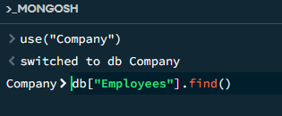

2. CREATE COLLECTION
MongoDB Query:
db.createCollection("employees")
Explanation: Creates a collection named employees.
Output Screenshot:
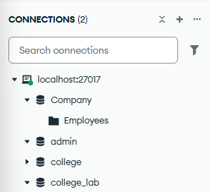

3. INSERT 50 EMPLOYEES
MongoDB Query:
db.employees.insertMany([
{empId:1, name:"Aarav", age:23, salary:62000, department:"IT"},
{empId:2, name:"Riya", age:26, salary:44628, department:"HR"},
{empId:3, name:"Vihaan", age:24, salary:36717, department:"Operations"},
{empId:4, name:"Sneha", age:30, salary:68698, department:"IT"},
{empId:5, name:"Kabir", age:28, salary:78000, department:"IT"},
{empId:6, name:"Diya", age:23, salary:45247, department:"HR"},
{empId:7, name:"Reyansh", age:30, salary:31739, department:"Sales"},
{empId:8, name:"Isha", age:30, salary:76925, department:"HR"},
{empId:9, name:"Arjun", age:30, salary:44446, department:"Marketing"},
{empId:10, name:"Meera", age:29, salary:48231, department:"HR"},
{empId:11, name:"Aditya", age:22, salary:75753, department:"HR"},
{empId:12, name:"Kavya", age:28, salary:48210, department:"Finance"},
{empId:13, name:"Rohan", age:24, salary:92731, department:"HR"},
{empId:14, name:"Tanya", age:27, salary:36078, department:"IT"},
{empId:15, name:"Yash", age:28, salary:53526, department:"IT"},
{empId:16, name:"Pooja", age:27, salary:47335, department:"Sales"},
{empId:17, name:"Karan", age:22, salary:60108, department:"Operations"},
{empId:18, name:"Neha", age:30, salary:93774, department:"IT"},
{empId:19, name:"Siddharth", age:28, salary:66178, department:"IT"},
{empId:20, name:"Divya", age:26, salary:91000, department:"Operations"},
{empId:21, name:"Manav", age:27, salary:42601, department:"Sales"},
{empId:22, name:"Simran", age:23, salary:73336, department:"IT"},
{empId:23, name:"Rahul", age:25, salary:94567, department:"Finance"},
{empId:24, name:"Ananya", age:23, salary:86785, department:"HR"},
{empId:25, name:"Varun", age:26, salary:88000, department:"Marketing"},
{empId:26, name:"Shreya", age:29, salary:84664, department:"Operations"},
{empId:27, name:"Nikhil", age:27, salary:54260, department:"HR"},
{empId:28, name:"Priya", age:27, salary:73920, department:"HR"},
{empId:29, name:"Aryan", age:26, salary:91384, department:"Operations"},
{empId:30, name:"Pallavi", age:23, salary:71613, department:"IT"},
{empId:31, name:"Dev", age:24, salary:77784, department:"HR"},
{empId:32, name:"Ritika", age:25, salary:60294, department:"HR"},
{empId:33, name:"Sahil", age:28, salary:94849, department:"Finance"},
{empId:34, name:"Anjali", age:30, salary:74866, department:"HR"},
{empId:35, name:"Vivek", age:27, salary:45010, department:"IT"},
{empId:36, name:"Kritika", age:22, salary:56290, department:"Finance"},
{empId:37, name:"Harsh", age:26, salary:43826, department:"IT"},
{empId:38, name:"Swati", age:27, salary:72954, department:"HR"},
{empId:39, name:"Gaurav", age:29, salary:87978, department:"Marketing"},
{empId:40, name:"Nidhi", age:29, salary:47359, department:"HR"},
{empId:41, name:"Ishaan", age:24, salary:78823, department:"HR"},
{empId:42, name:"Bhavna", age:30, salary:47219, department:"Sales"},
{empId:43, name:"Suraj", age:28, salary:56175, department:"Sales"},
{empId:44, name:"Payal", age:27, salary:39065, department:"HR"},
{empId:45, name:"Akash", age:30, salary:35957, department:"Marketing"},
{empId:46, name:"Sonal", age:22, salary:40016, department:"IT"},
{empId:47, name:"Raghav", age:24, salary:57666, department:"Operations"},
{empId:48, name:"Tanvi", age:23, salary:55009, department:"Marketing"},
{empId:49, name:"Devansh", age:29, salary:46476, department:"Sales"},
{empId:50, name:"Kirti", age:30, salary:74583, department:"IT"}
])
Explanation: Inserts multiple employee documents into the collection.
Output Screenshot:
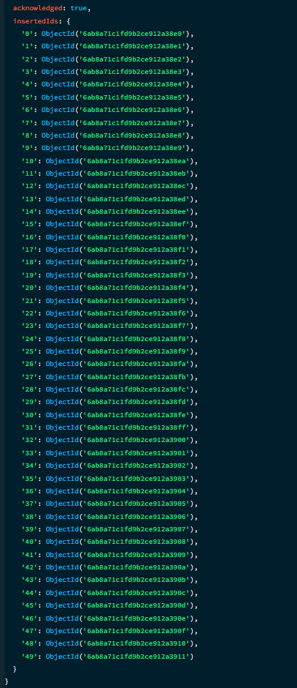

4. DISPLAY ALL EMPLOYEES
MongoDB Query:
db.employees.find()
Explanation: Retrieves all documents from the employees collection.
Output Screenshot:
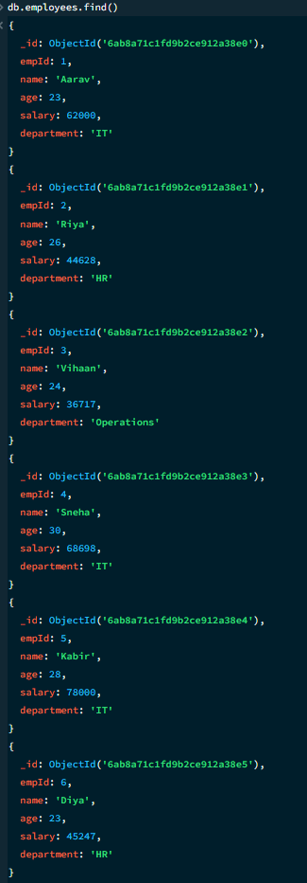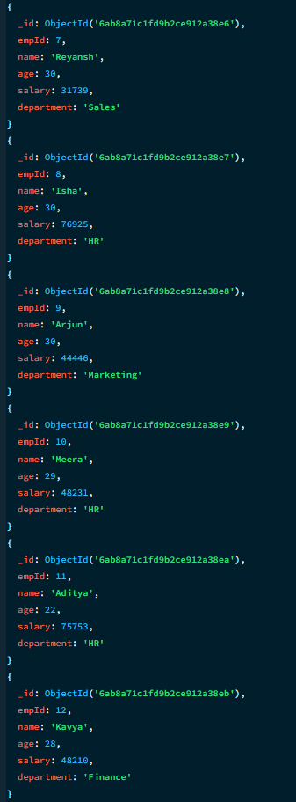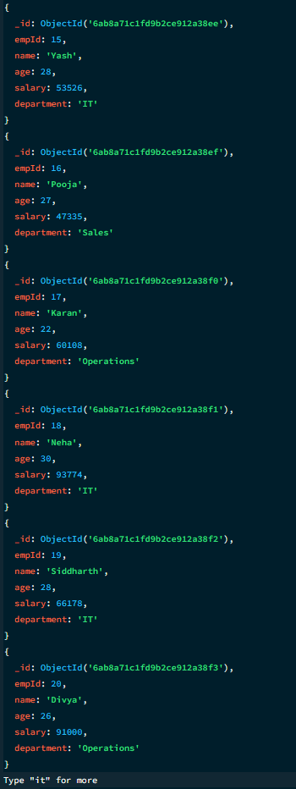

5. EQUAL TO — $eq
MongoDB Query:
db.employees.find({salary: {$eq: 62000}})
Explanation: Finds employees whose salary is exactly 62000.
Output Screenshot:
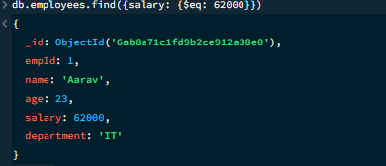

6. GREATER THAN — $gt
MongoDB Query:
db.employees.find({salary: {$gt: 85000}})
Explanation: Finds employees whose salary is greater than 85000.
Output Screenshot:
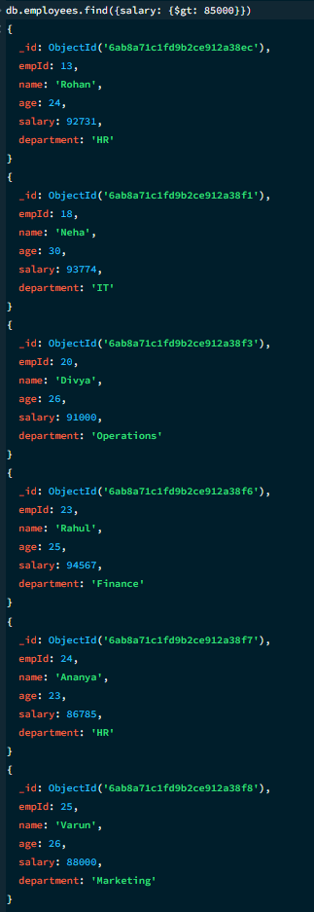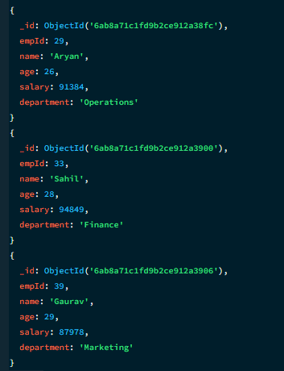

7. LESS THAN — $lt
MongoDB Query:
db.employees.find({salary: {$lt: 35000}})
Explanation: Finds employees whose salary is less than 35000.
Output Screenshot:
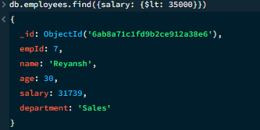

8. GREATER THAN OR EQUAL TO — $gte
MongoDB Query:
db.employees.find({salary: {$gte: 90000}})
Explanation: Finds employees whose salary is 90000 or above.
Output Screenshot:
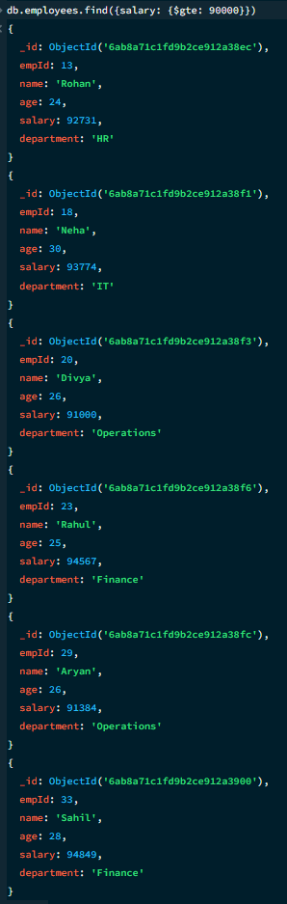

9. LESS THAN OR EQUAL TO — $lte
MongoDB Query:
db.employees.find({salary: {$lte: 40000}})
Explanation: Finds employees whose salary is 40000 or below.
Output Screenshot:
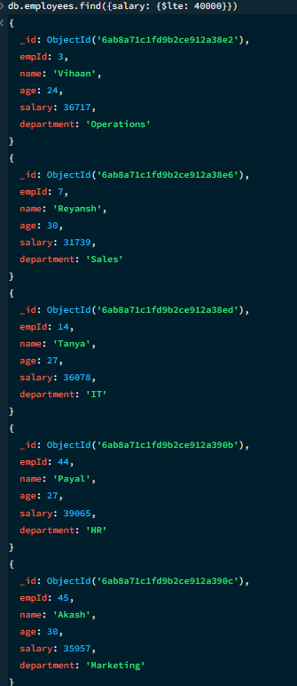

10. UPDATE OPERATION
MongoDB Query:
db.employees.updateOne(
{empId:5},
{$set:{salary:95000}}
)
Explanation: Updates the salary to 95000 of the employee with empId 5.
Output Screenshot:
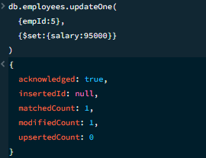

11. DELETE ONE OPERATION
MongoDB Query:
db.employees.deleteOne({empId:10})
Explanation: Deletes one document matching empId 10.
Output Screenshot:
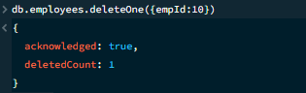

12. DELETE MANY OPERATION
MongoDB Query:
db.employees.deleteMany({
salary: {$lt:35000}
})
Explanation: Deletes all employees having a salary below 35000.
Output Screenshot:
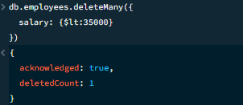

13. AND OPERATION — $and
MongoDB Query:
db.employees.find({
$and:[
{salary:{$gt:80000}},
{age:26}
]
})
Explanation: Finds employees satisfying both conditions.
Output Screenshot:
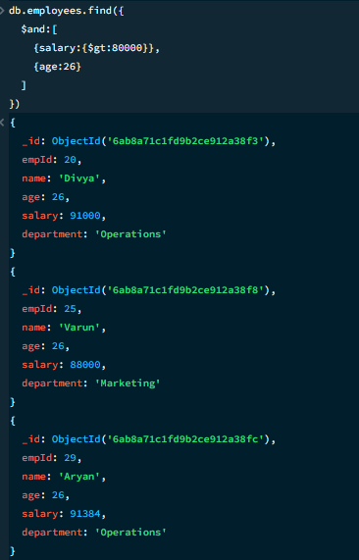

14. OR OPERATION — $or
MongoDB Query:
db.employees.find({
$or:[
{department:"IT"},
{department:"HR"}
]
})
Explanation: Finds employees who work in the IT or HR department.
Output Screenshot:
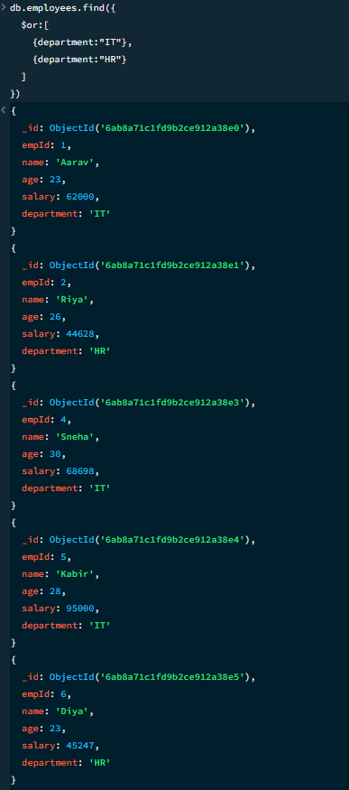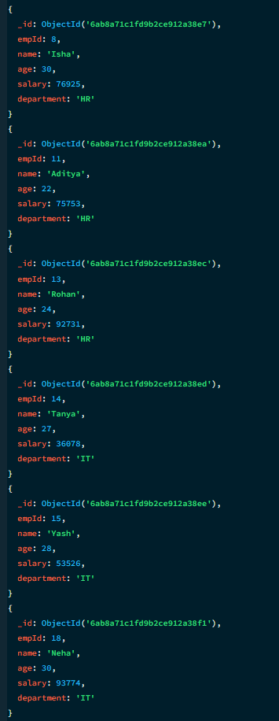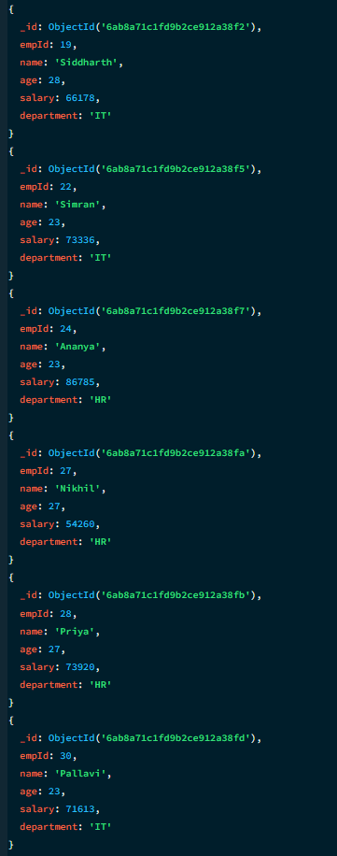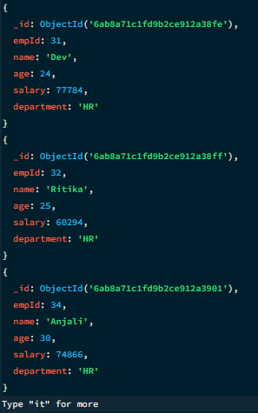

15. SORT OPERATION
A. MongoDB Query:
db.employees.find().sort({salary: 1})
Explanation: Sorts employees by salary from lowest to highest. Use 1 for ascending order.
Output Screenshot:
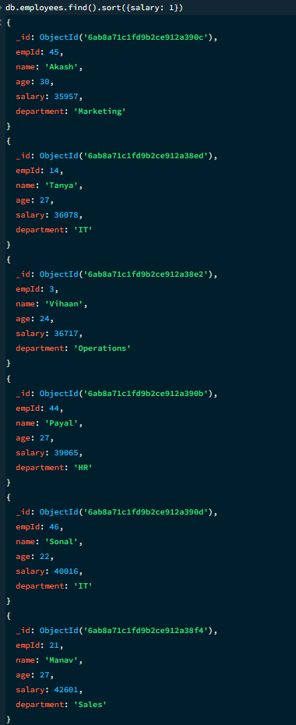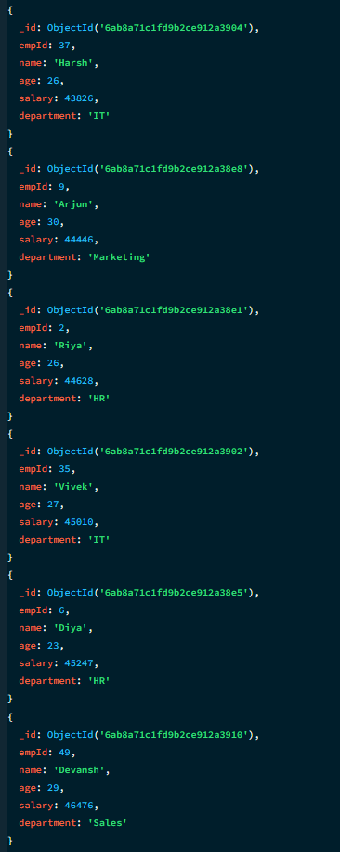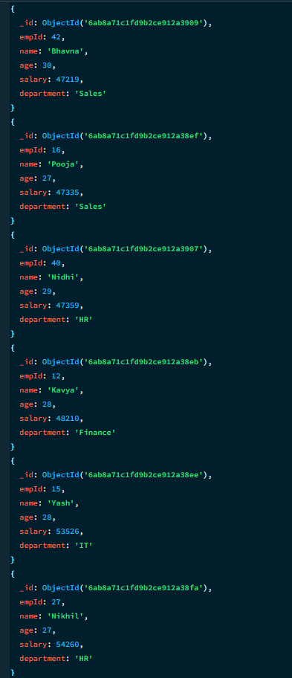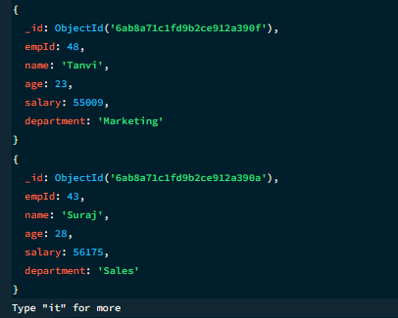
B. MongoDB Query:
db.employees.find().sort({salary: -1})
Explanation: Sorts employees by salary from highest to lowest. Use -1 for descending order.
Output Screenshot:
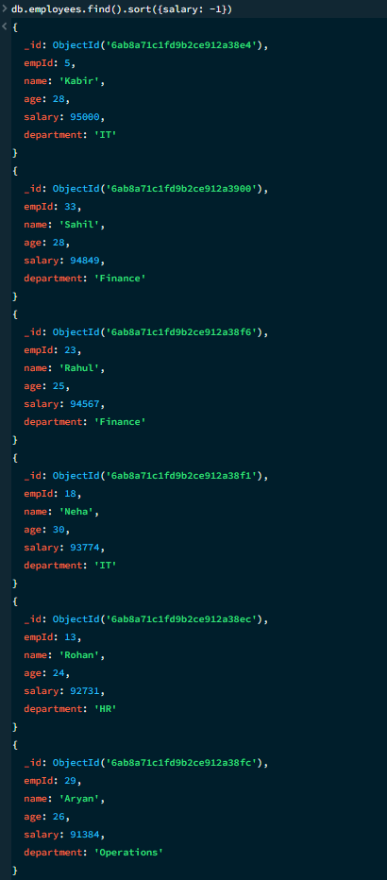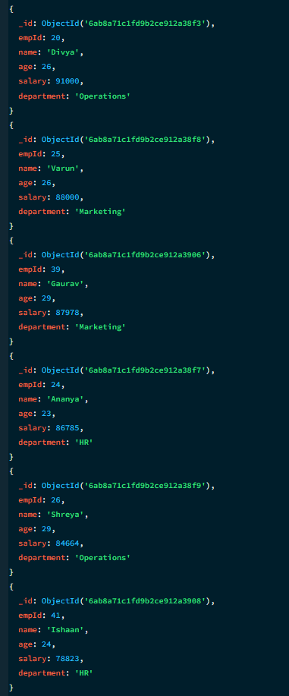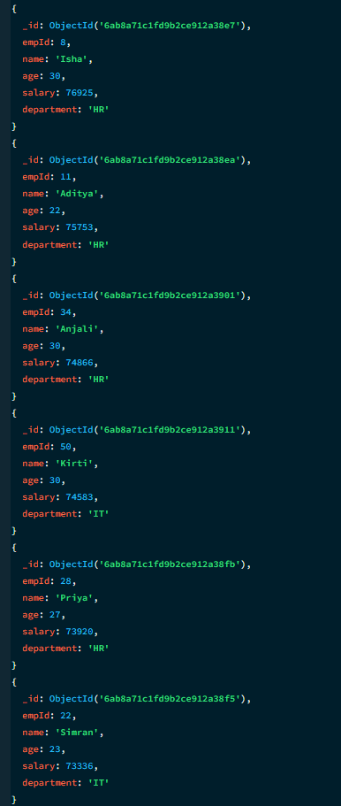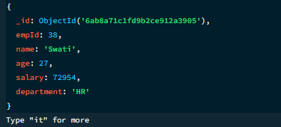

16. LIMIT OPERATION
MongoDB Query:
db.employees.find().limit(5)
Explanation: Displays only the first five documents.
Output Screenshot:
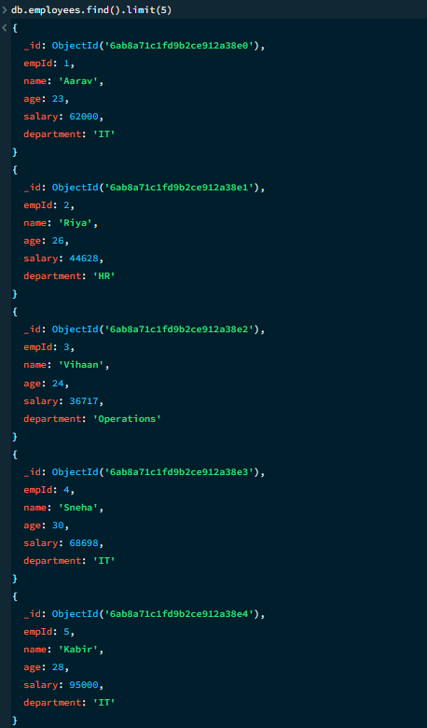

17. SEARCH BY DEPARTMENT
MongoDB Query:
db.employees.find({department:"IT"})
Explanation: Finds all employees who work in the IT department.
Output Screenshot:
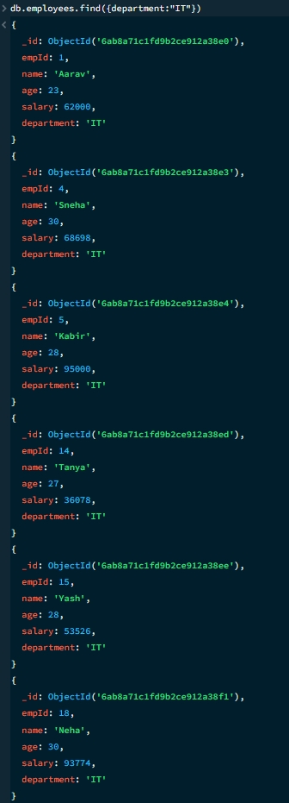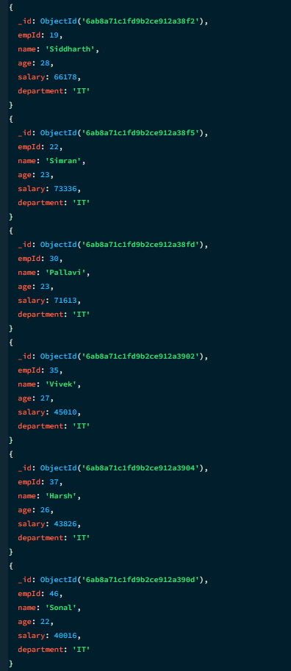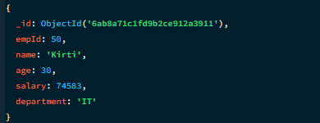

18. COUNT DOCUMENTS
MongoDB Query:
db.employees.countDocuments()
Explanation: Counts documents currently present in the collection (performed after the delete operations).
Output Screenshot:
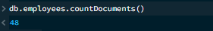

MONGODB OPERATORS USED
Operator | Meaning | Example
$eq | Equal to | salary: {$eq:62000}
$gt | Greater than | salary: {$gt:85000}
$lt | Less than | salary: {$lt:35000}
$gte | Greater than or equal to | salary: {$gte:90000}
$lte | Less than or equal to | salary: {$lte:40000}
$and | All conditions true | $and:[...]
$or | At least one condition true | $or:[...]

CONCLUSION
This project provided practical knowledge of NoSQL databases using MongoDB. An Employee Management System containing employee information was created and different MongoDB operations were performed on the data.
Through this project, I learned how to insert, retrieve, update, and delete documents. I also learned how to arrange data in ascending and descending order, how comparison operators such as $eq, $gt, $lt, $gte, and $lte work, along with logical operators such as $and and $or.
Overall, this project helped me understand how MongoDB can be used to manage and query employee data efficiently.

