

Machine Learning Techniques Lab manual
Course Type: DSH | Machine Learning Techniques Lab manual
Course Code:  230GAIB83_06 | Teaching Scheme: (Hrs./Week): 2 | Examination Scheme: CIE & ESE
Credits: 2 | Lecture (L): 0  Tutorial (T): 0  Practical (P): 2  Experiential Learning (EL): 0 | Practical (Pr): 50 Marks

1.Introduction to Scikit-learn for Supervised Learning
Aim: To gain hands-on experience with implementing supervised learning algorithms.
Technology: Scikit-learn library in Python
Solution
Linear Regression
import numpy as np
from sklearn.linear_model import LinearRegression
import matplotlib.pyplot as plt
# Generate synthetic data
X = np.array([1, 2, 3, 4, 5]).reshape(-1, 1)
y = np.array([1.1, 2.3, 2.9, 4.2, 5.1])
# Create and train the model
model = LinearRegression()
model.fit(X, y)
# Make predictions
y_pred = model.predict(X)
# Plot results
plt.scatter(X, y, color="blue", label="Actual")
plt.plot(X, y_pred, color="red", label="Predicted")
plt.title("Linear Regression")
plt.xlabel("X")
plt.ylabel("y")
plt.legend()
plt.show()
Logistic Regression
from sklearn.linear_model import LogisticRegression
from sklearn.datasets import make_classification
from sklearn.model_selection import train_test_split
from sklearn.metrics import accuracy_score
# Generate synthetic data
X, y = make_classification(n_samples=100, n_features=2, n_classes=2,
random_state=42)
X_train, X_test, y_train, y_test = train_test_split(X, y, test_size=0.3, random_state=42)
# Create and train the model
model = LogisticRegression()
model.fit(X_train, y_train)
# Make predictions
y_pred = model.predict(X_test)
# Evaluate the model
print("Logistic Regression Accuracy:", accuracy_score(y_test, y_pred))
Support Vector Machine
from sklearn.svm import SVC
from sklearn.datasets import make_blobs
from sklearn.model_selection import train_test_split
from sklearn.metrics import classification_report
# Generate synthetic data
X, y = make_blobs(n_samples=100, centers=2, random_state=42)
X_train, X_test, y_train, y_test = train_test_split(X, y, test_size=0.3, random_state=42)
# Create and train the model
model = SVC(kernel='linear')
model.fit(X_train, y_train)
# Make predictions
y_pred = model.predict(X_test)
# Evaluate the model
print("SVM Classification Report:")
print(classification_report(y_test, y_pred))
Decision Tree
from sklearn.tree import DecisionTreeClassifier, plot_tree
from sklearn.datasets import make_classification
from sklearn.model_selection import train_test_split
from sklearn.metrics import accuracy_score
# Generate synthetic data
X, y = make_classification(n_samples=100, n_features=4, random_state=42)
X_train, X_test, y_train, y_test = train_test_split(X, y, test_size=0.3, random_state=42)
# Create and train the model
model = DecisionTreeClassifier()
model.fit(X_train, y_train)
# Make predictions
y_pred = model.predict(X_test)
# Evaluate the model
print("Decision Tree Accuracy:", accuracy_score(y_test, y_pred))
# Plot the decision tree
plot_tree(model, filled=True)
plt.show()

Criterian | Fair | Good | Excellent | CO Wise weight
Experiment 1 | Understanding of supervised Learning  CO3 | Implementing a code  CO6 | Result Evaluation  CO5 | CO3=20%  CO5=20%  CO6=40%

Experiment 2: Exploring Unsupervised Learning with K-Means Clustering.
Aim: To explore the concepts of unsupervised learning and clustering using the K-Means algorithm.
Code:
import numpy as np
import pandas as pd
df= pd.read_csv('student_clustering.csv')
print("shape of data is", df.shape)
print(df)

from sklearn.cluster import KMeans
wcss= []
for i in range (1,11):
km=KMeans(n_clusters=i)
km.fit(df)
wcss.append(km.inertia_)

import matplotlib.pyplot as plt
plt.plot(range(1,11),wcss)
from sklearn.cluster import KMeans
km=KMeans(n_clusters=4)
km.fit(df)
pred=km.predict(df)
pred

df['cluster']=pd.DataFrame(pred,columns=['cluster'])
df

import seaborn as seb
seb.lmplot(x='cgpa',y='iq',data=df,hue='cluster')
plt.show()

import seaborn as seb#
seb.lmplot(x='cgpa',y='iq',data=df,hue='cluster')
plt.title('CLUSTER FORMATION for CGPA & IQ Using KMeans')
plt.xlabel('CGPA')
plt.ylabel('IQ')
plt.show()

Output: dataset
shape of data is (200, 2)
cgpa iq
0 5.13 88
1 5.90 113
2 8.36 93
3 8.27 97
4 5.45 110
.. ... ...
195 4.68 89
196 8.57 118
197 5.85 112
198 6.23 108
199 8.82 117
[200 rows x 2 columns]
b) Elbow Curve and Point
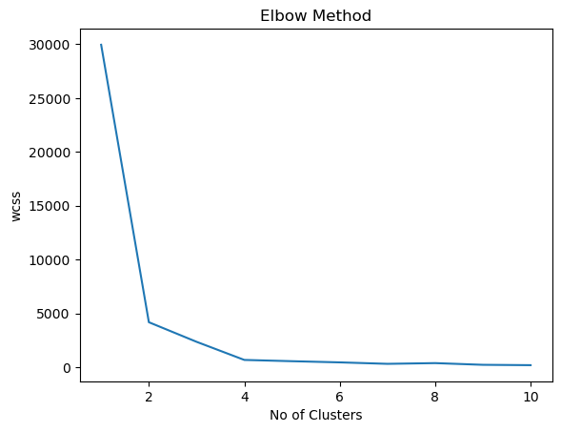
c) Cluster Allocation in wcss
array([1, 2, 3, 3, 2, 2, 3, 0, 2, 3, 1, 2, 3, 1, 2, 3, 2, 3, 2, 2, 3, 1,
3, 1, 1, 3, 1, 0, 3, 2, 0, 2, 0, 2, 3, 3, 0, 2, 1, 2, 1, 3, 3, 1,
0, 0, 3, 2, 0, 2, 1, 1, 0, 3, 0, 2, 2, 0, 2, 0, 2, 3, 3, 0, 1, 0,
3, 1, 2, 3, 2, 0, 3, 1, 2, 0, 2, 0, 1, 3, 3, 0, 2, 1, 0, 1, 0, 2,
0, 2, 0, 0, 3, 1, 3, 3, 0, 3, 1, 0, 2, 1, 1, 0, 1, 1, 3, 1, 0, 0,
3, 0, 2, 2, 3, 0, 3, 2, 0, 1, 1, 2, 3, 0, 3, 1, 3, 2, 1, 3, 3, 2,
1, 1, 2, 0, 2, 1, 3, 3, 3, 1, 2, 1, 1, 0, 1, 0, 2, 1, 0, 1, 0, 0,
1, 3, 2, 0, 2, 3, 1, 0, 2, 3, 0, 1, 2, 1, 1, 0, 0, 2, 0, 1, 1, 3,
0, 2, 1, 0, 0, 2, 2, 2, 3, 1, 3, 3, 0, 2, 3, 3, 1, 1, 3, 1, 0, 2,
2, 0])
d) Creating Cluster column in df
 | cgpa | iq | Cluster
0 | 5.13 | 88 | 1
-1 | 5.90 | 113 | 2
2 | 8.36 | 93 | 3
3 | 8.27 | 97 | 3
4 | 5.45 | 110 | 2
... | ... | ... | ...
195 | 4.68 | 89 | 1
196 | 8.57 | 118 | 0
197 | 5.85 | 112 | 2
198 | 6.23 | 108 | 2
199 | 8.82 | 117 | 0
200 rows × 3 columns

e) Output
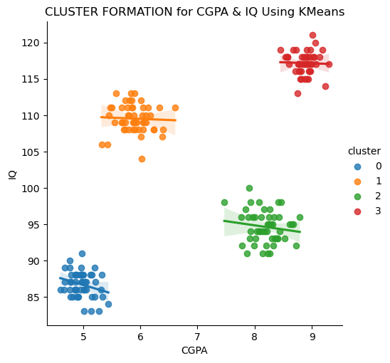

Interpret the Predictions
Red colored cluster 3, students’ data indicates that the students are intelligent and their CGPA is also good. So, placement officer need not make many efforts to place them. Much guidance is not required for such students. Such students get placed with the least effort.
If we focus on the green colored cluster 2, it indicates that these students are hard workers. These students are not very intelligent, but they have more CGPA due to their sincere nature. Such students also do not require much guidance while making their placement.
Orange colored cluster 1 includes the students whose IQ is more than enough but their CGPA is less. Such students are not sincere. They just chill out. They are in a relaxed mood. So, placement officer has to motivate them before their examination. They are not sincere. Some assessment type of efforts must be get done from such students. They may be asked to attempt extra assignments, tutorials, presentations, group discussions, so that their interest in studies can be increased.
Blue colored cluster 0o, includes students’ data whose ‘cgpa’ and ‘iq’ both are less. So, placement officer has to make many efforts on these students to increase CGPA also to increase their course related knowledge. Extra efforts like couching classes, notes, practice tests can be conducted for such students to bring them into the mainstream of placement

Experiment 3 Linear Regression from Scratch
Aim: To gain a deeper understanding of linear regression by implementing it from scratch using Python.
Code: # importing libraries
import pandas as pd
import numpy as np
import matplotlib.pyplot as plt
import seaborn as sns

#Reading the dataset
dataset = pd.read_csv("advertising.csv")
dataset.head()
Output:
 | TV | Radio | Newspaper | Sales
0 | 230.1 | 37.8 | 69.2 | 22.1
1 | 44.5 | 39.3 | 45.1 | 10.4
2 | 17.2 | 45.9 | 69.3 | 12.0
3 | 151.5 | 41.3 | 58.5 | 16.5
4 | 180.8 | 10.8 | 58.4 | 17.9

#Extracting Independent and dependent Variable
#Setting the value for X and Y
x = dataset[['TV', 'Radio', 'Newspaper']]
y = dataset['Sales']

from sklearn.model_selection import train_test_split
x_train, x_test, y_train, y_test = train_test_split(x, y, test_size = 0.2, random_state = 100)
#Fitting the Multiple Linear Regression model
mlr = LinearRegression()
mlr.fit(x_train, y_train)
#Intercept and Coefficient
print("Intercept: ", mlr.intercept_)
print("Coefficients:")
list(zip(x, mlr.coef_))
[(array([1.2]), 9361.116390321691)]

[(array([1.2]), 9361.116390321691)]
#Prediction of test set
y_pred_mlr= mlr.predict(x_test)
#Predicted values
print("Prediction for test set: {}".format(y_pred_mlr))
#Actual value and the predicted value
mlr_diff = pd.DataFrame({'Actual value': y_test, 'Predicted value': y_pred_mlr})
mlr_diff.head()
Output:
 | Actual value | Predicted value
0 | 57190.0 | 61456.195763
1 | 116970.0 | 115750.670827
2 | 122392.0 | 123239.563939
3 | 57082.0 | 65200.642319
4 | 56643.0 | 53967.302651

#Model Evaluation
from sklearn import metrics
meanAbErr = metrics.mean_absolute_error(y_test, y_pred_mlr)
meanSqErr = metrics.mean_squared_error(y_test, y_pred_mlr)
rootMeanSqErr = np.sqrt(metrics.mean_squared_error(y_test, y_pred_mlr))
print('R squared: {:.2f}'.format(mlr.score(x,y)*100))
print('Mean Absolute Error:', meanAbErr)
print('Mean Square Error:', meanSqErr)
print('Root Mean Square Error:', rootMeanSqErr)
Output:
R squared: 95.64
Mean Absolute Error: 4072.326537253693
Mean Square Error: 24477109.089655716
Root Mean Square Error: 4947.434596804259

Experiment 4: Binary Classification with Logistic Regression.
Aim: To implement logistic regression for binary classification tasks and understand its application in real-world scenarios
Solution:
from sklearn.linear_model import LogisticRegression
from sklearn.datasets import make_classification
from sklearn.model_selection import train_test_split
from sklearn.metrics import accuracy_score
# Generate synthetic data
X, y = make_classification(n_samples=100, n_features=4, n_classes=2,
random_state=42)
Output:
[[-1.05383855 -1.02754411 -0.32929388 0.82600732]
[ 1.56931739 1.306542 -0.23938468 -0.3313761 ]
[-0.35885569 -0.69102126 -1.22532865 1.65214494]
[-0.1368559 0.46093758 1.89691056 -2.2813861 ]
[-0.04862909 0.50230075 1.77872961 -2.17105282]
[ 2.30450019 1.33970234 -2.24075406 1.83991037]
[-0.40925706 0.32423734 2.23245441 -2.58590856]
[-0.7173148 -0.88602706 -0.83311649 1.31217492]
[ 1.06173727 1.05688647 0.40238353 -0.91916686]
[ 1.48052803 1.28131775 -0.06692233 -0.50833095]
[ 0.53479393 0.21164583 -0.84389686 0.82584805]
[ 1.38991764 1.22541983 0.01066604 -0.56772453]
[-1.79532002 -1.46361184 0.37531604 0.25415746]
[-1.26898369 -0.68933585 1.39175475 -1.20757158]
[-1.56826626 -0.87306613 1.65095783 -1.40735658]
[-0.42795824 -0.72216846 -1.12868571 1.56070438]
[ 0.73644435 0.28247903 -1.19137182 1.17329352]
[-1.42922002 -1.29267194 -0.1173572 0.71479373]
[ 0.49429823 0.36783185 -0.21800395 0.07123641]
[-1.32933233 -1.19300559 -0.07873421 0.6273745 ]
[ 2.25661188 1.17077461 -2.65461268 2.36867367]
[-2.25553963 -1.69200458 0.95057302 -0.27062383]
[-1.92487377 -1.11327862 1.89033108 -1.5598485 ]
[-1.20592943 -0.64760425 1.34700796 -1.17762637]
[-0.6795874 -0.32683618 0.8834691 -0.81680628]
[ 0.13979096 0.04668349 -0.24878048 0.25058844]
[ 1.15509316 0.56372286 -1.47487037 1.35536951]
[-2.52343407 -1.45612516 2.48904785 -2.05832072]
[-0.17593681 0.44205183 1.94742094 -2.3279946 ]
[-1.5332749 -0.84467713 1.6431949 -1.4117586 ]
[-0.38919817 -0.67826129 -1.09662143 1.50575249]
[-1.00544254 -1.05463759 -0.55658056 1.08659413]
[-1.14658127 -1.10644979 -0.32066954 0.85239186]
[ 0.08896214 0.08714206 0.0291022 -0.07133524]
[-0.43131517 -0.74920203 -1.20727346 1.65882246]
[ 2.38869353 1.7240021 -1.22823431 0.55942643]
[ 0.88629356 0.52576893 -0.82741596 0.66530077]
[-1.57127256 -0.81296687 1.85571007 -1.65830375]
[ 0.24472415 -0.45390127 -2.18347304 2.59123946]
[ 0.55448398 0.17593 -1.01695056 1.03110238]
[ 1.07954187 0.50047696 -1.46447269 1.3727107 ]
[ 1.19664076 1.13446163 0.26843823 -0.80804463]
[ 0.23085877 0.64701888 1.44901594 -1.87653774]
[-0.86023823 -0.39769634 1.17059844 -1.09831681]
[ 0.01722979 0.1094067 0.30759353 -0.38566776]
[-1.08324727 -1.09939128 -0.47936995 1.02255619]
[-0.95548162 -1.03260487 -0.62804104 1.15466088]
[ 1.85605469 1.46098002 -0.55818081 -0.05319823]
[-1.50077611 -1.2827436 0.12037048 0.4505902 ]
[-1.14054824 -0.63922566 1.18674111 -1.00634985]
[-0.98021491 -1.03398089 -0.56156012 1.08266027]
[-1.72067112 -0.99325144 1.69607038 -1.40210053]
[ 0.86561977 0.96335953 0.65992405 -1.15806823]
[-1.73597973 -1.37111696 0.50688537 0.06845616]
[-0.11708689 -0.05396947 0.15985512 -0.15013844]
[-0.53355799 -0.79864786 -1.07525068 1.53703587]
[-1.20946429 -1.13714057 -0.24038388 0.77861318]
[ 1.10009583 1.09267506 0.40910605 -0.94275087]
[ 0.36016958 0.71768635 1.30857636 -1.75518644]
[ 1.94087643 0.88439534 -2.68317954 2.52983424]
[ 0.89075877 0.97650004 0.63067073 -1.13207427]
[ 1.02703224 0.63174629 -0.88541844 0.68057323]
[ 1.25896077 0.6635226 -1.44723231 1.2798899 ]
[ 0.68811892 0.30446853 -0.9809438 0.93343952]
[ 0.4176729 0.73594772 1.2031659 -1.64832073]
[-1.43534875 -0.73426524 1.72251306 -1.54851014]
[ 0.06194498 0.55253544 1.6253749 -2.02632079]
[-0.72427983 -0.43066755 0.67287309 -0.53963044]
[ 0.73019848 0.88948365 0.80742726 -1.28568005]
[-0.71352532 -0.84321213 -0.70426956 1.15199146]
[-1.64060704 -0.94116325 1.63631177 -1.36045573]
[ 1.28938375 0.68720469 -1.45724683 1.28008347]
[ 1.56010259 1.30373602 -0.22210005 -0.34898484]
[ 0.54914434 0.30877317 -0.56811307 0.480502 ]
[ 0.55600276 0.19375402 -0.96314239 0.96423311]
[-1.61453273 -0.83806958 1.89792447 -1.69302842]
[ 0.94800532 0.99630897 0.53104737 -1.03223274]
[ 1.74147706 0.97687358 -1.80921926 1.53313849]
[ 1.09180466 0.55831966 -1.31089865 1.17869556]
[-1.42695838 -0.756006 1.62748917 -1.43483867]
[-0.48949935 -0.74717988 -1.03371682 1.46830827]
[ 1.4991983 0.77813969 -1.76254901 1.57233676]
[-1.36716377 -0.7635164 1.43140126 -1.21722043]
[ 1.18739045 1.12210055 0.254643 -0.78736523]
[-1.51042899 -0.79383636 1.74355119 -1.54446032]
[-0.02185231 -0.51103632 -1.60499282 1.98522348]
[ 1.99805321 1.51990078 -0.77336118 0.15513175]
[-2.39955005 -1.3731412 2.40437346 -2.00347738]
[ 1.25291095 0.70385192 -1.29826331 1.09885263]
[ 1.35970566 0.84609208 -1.14052601 0.86199147]
[ 0.62453032 0.4057089 -0.46809422 0.32725188]
[-0.92169432 -0.97763681 -0.54561186 1.03967019]
[ 0.25995672 0.65574086 1.3939833 -1.82037691]
[-0.9311259 -0.52878508 0.94621814 -0.79371387]
[ 1.20852705 1.1374615 0.24412056 -0.78284083]
[-2.24181979 -1.24868955 2.35790248 -2.00918545]
[ 0.57304248 0.36205368 -0.46281432 0.34129395]
[-0.3751207 -0.14951801 0.58846525 -0.57500215]
[ 1.59488828 0.78025563 -2.0302233 1.86378908]
[-0.14994102 -0.56603681 -1.41693293 1.80474148]]

5) Implementing Decision Tree Classifier for Multiclass Classification Objective: To understand the working of decision tree classifiers and their application in multiclass classification problems
import numpy as np
import pandas as pd
from sklearn.datasets import load_iris
from sklearn.model_selection import train_test_split
from sklearn.tree import DecisionTreeClassifier
from sklearn.metrics import accuracy_score, classification_report, confusion_matrix
import matplotlib.pyplot as plt
from sklearn import tree

# Load the Iris dataset
iris = load_iris()
X = iris.data # Features
y = iris.target # Labels

# Convert to DataFrame for better visualization (optional)
df = pd.DataFrame(X, columns=iris.feature_names)
df['species'] = y
df.head()

# Split the dataset into training and testing sets
X_train, X_test, y_train, y_test = train_test_split(X, y, test_size=0.3, random_state=42)

# Initialize the Decision Tree Classifier
clf = DecisionTreeClassifier(random_state=42)

# Train the classifier
clf.fit(X_train, y_train)

# Make predictions on the test set
y_pred = clf.predict(X_test)

# Calculate accuracy
accuracy = accuracy_score(y_test, y_pred)
print(f"Accuracy: {accuracy:.2f}")

# Print classification report
print("\nClassification Report:")
print(classification_report(y_test, y_pred, target_names=iris.target_names))

# Print confusion matrix
print("\nConfusion Matrix:")
print(confusion_matrix(y_test, y_pred))

# Plot the decision tree
plt.figure(figsize=(12,8))
tree.plot_tree(clf, filled=True, feature_names=iris.feature_names, class_names=iris.target_names)
plt.show()

Output:
Accuracy: 1.00
Classification Report:
precision recall f1-score support
setosa 1.00 1.00 1.00 19
versicolor 1.00 1.00 1.00 13
virginica 1.00 1.00 1.00 13

accuracy 1.00 45
macro avg 1.00 1.00 1.00 45
weighted avg 1.00 1.00 1.00 45

Confusion Matrix:
[[19 0 0]
[ 0 13 0]
[ 0 0 13]]

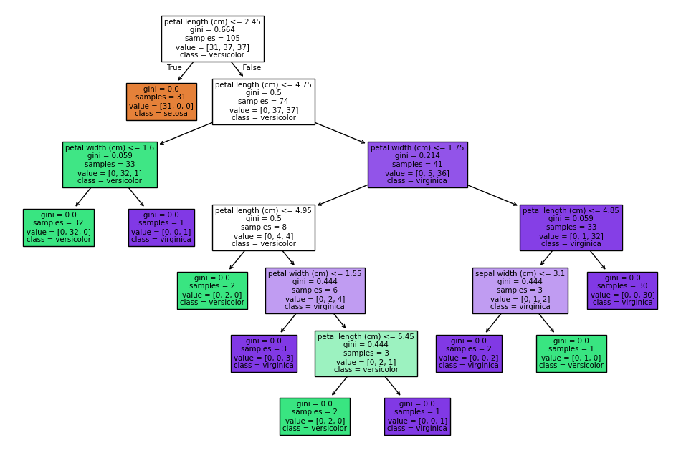
6) Implement Support Vector Machine (SVM) for Classification Objective: To implement support vector machine (SVM) classifiers for binary and multiclass classification tasks and understand their kernel trick.
SOLUTION
- Linear Kernel: Works well when the data is linearly separable.
- Polynomial Kernel: Can capture more complex relationships by considering polynomial combinations of features.
- RBF Kernel: Highly flexible and can model complex, non-linear decision boundaries.
Code:
import numpy as np
import matplotlib.pyplot as plt
from sklearn import datasets
from sklearn.model_selection import train_test_split
from sklearn.svm import SVC
from sklearn.metrics import accuracy_score, classification_report, confusion_matrix
from sklearn.preprocessing import StandardScaler

# Load the Iris dataset
iris = datasets.load_iris()
X = iris.data
y = iris.target

# Split the dataset into training and testing sets
X_train, X_test, y_train, y_test = train_test_split(X, y, test_size=0.3, random_state=42)

# Standardize the features (important for SVM)
scaler = StandardScaler()
X_train = scaler.fit_transform(X_train)
X_test = scaler.transform(X_test)

# Linear Kernel
svm_linear = SVC(kernel='linear', C=1.0)
svm_linear.fit(X_train, y_train)
y_pred_linear = svm_linear.predict(X_test)

# Polynomial Kernel
svm_poly = SVC(kernel='poly', degree=3, C=1.0)
svm_poly.fit(X_train, y_train)
y_pred_poly = svm_poly.predict(X_test)

# RBF Kernel
svm_rbf = SVC(kernel='rbf', gamma='scale', C=1.0)
svm_rbf.fit(X_train, y_train)
y_pred_rbf = svm_rbf.predict(X_test)

# Linear Kernel
svm_linear = SVC(kernel='linear', C=1.0)
svm_linear.fit(X_train, y_train)
y_pred_linear = svm_linear.predict(X_test)

# Polynomial Kernel
svm_poly = SVC(kernel='poly', degree=3, C=1.0)
svm_poly.fit(X_train, y_train)
y_pred_poly = svm_poly.predict(X_test)

# RBF Kernel
svm_rbf = SVC(kernel='rbf', gamma='scale', C=1.0)
svm_rbf.fit(X_train, y_train)
y_pred_rbf = svm_rbf.predict(X_test)

def evaluate_model(y_true, y_pred, kernel_name):
print(f"Evaluation for {kernel_name} kernel:")
print(f"Accuracy: {accuracy_score(y_true, y_pred):.2f}")
print("Classification Report:")
print(classification_report(y_true, y_pred))
print("Confusion Matrix:")
print(confusion_matrix(y_true, y_pred))
print("\n")

# Evaluate Linear Kernel
evaluate_model(y_test, y_pred_linear, "Linear")

# Evaluate Polynomial Kernel
evaluate_model(y_test, y_pred_poly, "Polynomial")

# Evaluate RBF Kernel
evaluate_model(y_test, y_pred_rbf, "RBF")
Output:
def evaluate_model(y_true, y_pred, kernel_name):
print(f"Evaluation for {kernel_name} kernel:")
print(f"Accuracy: {accuracy_score(y_true, y_pred):.2f}")
print("Classification Report:")
print(classification_report(y_true, y_pred))
print("Confusion Matrix:")
print(confusion_matrix(y_true, y_pred))
print("\n")

# Evaluate Linear Kernel
evaluate_model(y_test, y_pred_linear, "Linear")

# Evaluate Polynomial Kernel
evaluate_model(y_test, y_pred_poly, "Polynomial")

# Evaluate RBF Kernel
evaluate_model(y_test, y_pred_rbf, "RBF")
Output:
Evaluation for Linear kernel:
Accuracy: 0.98
Classification Report:
precision recall f1-score support

0 1.00 1.00 1.00 19
1 1.00 0.92 0.96 13
2 0.93 1.00 0.96 13

accuracy 0.98 45
macro avg 0.98 0.97 0.97 45
weighted avg 0.98 0.98 0.98 45

Confusion Matrix:
[[19 0 0]
[ 0 12 1]
[ 0 0 13]]

Evaluation for Polynomial kernel:
Accuracy: 0.96
Classification Report:
precision recall f1-score support

0 1.00 1.00 1.00 19
1 0.87 1.00 0.93 13
2 1.00 0.85 0.92 13

accuracy 0.96 45
macro avg 0.96 0.95 0.95 45
weighted avg 0.96 0.96 0.96 45

Confusion Matrix:
[[19 0 0]
[ 0 13 0]
[ 0 2 11]]

Evaluation for RBF kernel:
Accuracy: 1.00
Classification Report:
precision recall f1-score support

0 1.00 1.00 1.00 19
1 1.00 1.00 1.00 13
2 1.00 1.00 1.00 13

accuracy 1.00 45
macro avg 1.00 1.00 1.00 45
weighted avg 1.00 1.00 1.00 45

Confusion Matrix:
[[19 0 0]
[ 0 13 0]
[ 0 0 13]]

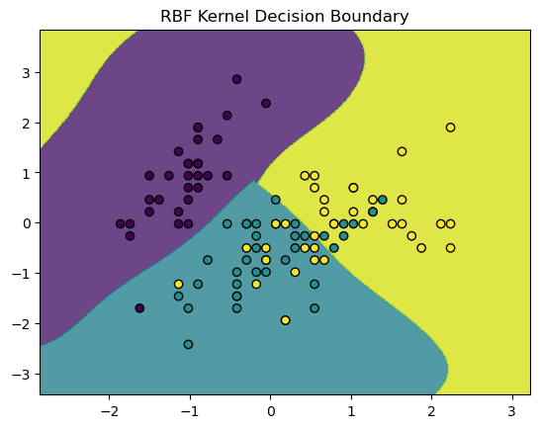
7) Ensemble Learning with Random Forests Objective: To implement random forests, an ensemble learning method, and understand their advantages in improving model performance and generalization.
Solution;
import numpy as np
import pandas as pd
from sklearn.datasets import load_iris
from sklearn.model_selection import train_test_split
from sklearn.ensemble import RandomForestClassifier
from sklearn.metrics import accuracy_score, classification_report, confusion_matrix

# Load the Iris dataset
data = load_iris()
X = data.data # Features
y = data.target # Labels

# Split the data
X_train, X_test, y_train, y_test = train_test_split(X, y, test_size=0.3, random_state=42)

# Initialize and train the Random Forest classifier
rf_classifier = RandomForestClassifier(n_estimators=100, random_state=42)
rf_classifier.fit(X_train, y_train)

# Make predictions
y_pred = rf_classifier.predict(X_test)

# Evaluate the model
accuracy = accuracy_score(y_test, y_pred)
print(f"Accuracy: {accuracy:.2f}")

print("Classification Report:")
print(classification_report(y_test, y_pred, target_names=data.target_names))

print("Confusion Matrix:")
print(confusion_matrix(y_test, y_pred))
Accuracy: 1.00
Classification Report:
precision recall f1-score support

setosa 1.00 1.00 1.00 16
versicolor 1.00 1.00 1.00 14
virginica 1.00 1.00 1.00 15

accuracy 1.00 45
macro avg 1.00 1.00 1.00 45
weighted avg 1.00 1.00 1.00 45

Confusion Matrix:
[[16 0 0]
[ 0 14 0]
[ 0 0 15]]

8)
from sklearn.metrics import accuracy_score
y_true = [0, 1, 1, 0, 1]
y_pred = [0, 1, 0, 0, 1]
accuracy = accuracy_score(y_true, y_pred)
print("Accuracy:", accuracy)
precision
from sklearn.metrics import recall_score
recall = recall_score(y_true, y_pred)
print("Recall:", recall)
Recall
from sklearn.metrics import recall_score
recall = recall_score(y_true, y_pred)
print("Recall:", recall)
from sklearn.metrics import roc_auc_score
y_true = [0, 1, 1, 0, 1]
y_scores = [0.1, 0.9, 0.8, 0.2, 0.7] # Predicted probabilities
roc_auc = roc_auc_score(y_true, y_scores)
print("ROC-AUC Score:", roc_auc)from sklearn.metrics import f1_score
f1 = f1_score(y_true, y_pred)
print("F1-Score:", f1)

LAB ASSESSMENT RUBRICS
1. Use a Rubric Format
A structured rubric typically has levels (e.g., Excellent, Good, Fair, Needs Improvement). Here's an example:
Criteria | Excellent (4) | Good (3) | Fair (2) | Needs Improvement (1)
Code Implementation | Code is correct, efficient, and well-structured  100% | Minor inefficiencies or small errors  80% | Some errors, inefficient, or lacks modularity  60% | Major errors, does not work correctly  30%
Understanding of Concepts | ML concepts applied correctly | Minor misunderstandings | Significant misunderstandings | Incorrect or missing concepts
Results & Evaluation | Proper validation, correct metrics, meaningful insights | Minor mistakes in evaluation | Incorrect or incomplete evaluation | No evaluation or incorrect approach
Report & Documentation | Clear explanations, well-organized | Some details missing | Lacks clarity or structure | Poor or missing documentation
Code Readability | Well-commented, modular, easy to follow | Some comments missing, minor readability issues | Difficult to follow, lacks documentation | Unstructured, no comments, hard to read

