

**MICROWAVE ENGINEERING(ECE3011)**

**LAB TASK-2**

**NAME:RAHUL MAHESH AWARI**

**REG NO:-18BEC2014**

**SLOT:-L27+L28**

Task 2 (A)-- Design a Wilkinson power divider with a power division ratio of 1/2 and a system impedance of 50 Ω using microstrip substrate (Permittivity: εr=4.4, Height of the substrate H=1.6mm, Conductor Thickness T=0.05mm, Loss tangent tan δ = 0.001) for the given frequency**(FREQUENCY-2GHz)**

**Circuit Diagram:-**

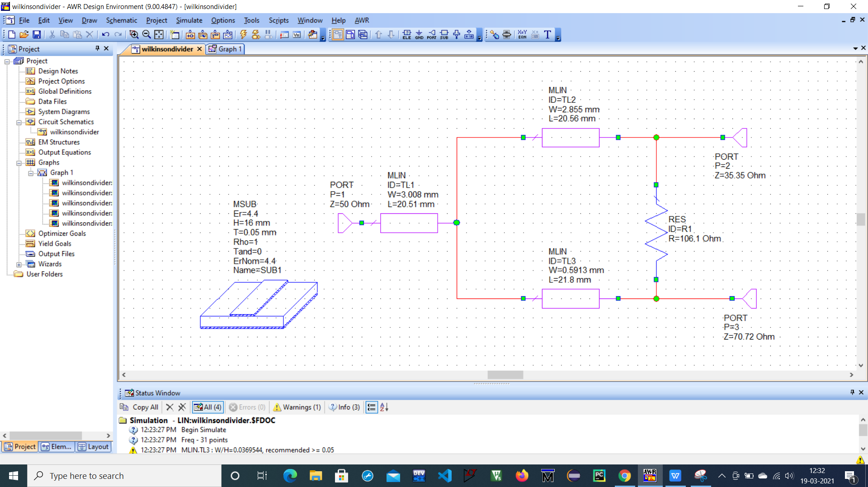

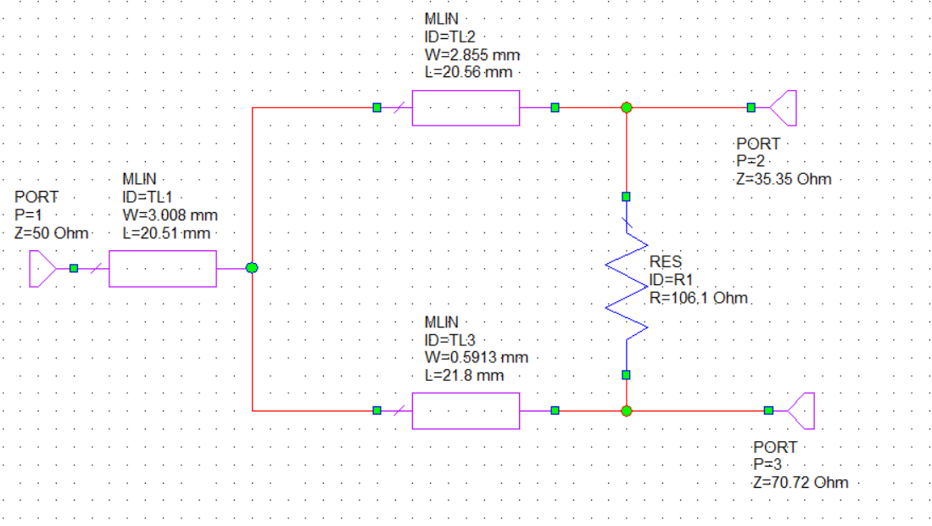

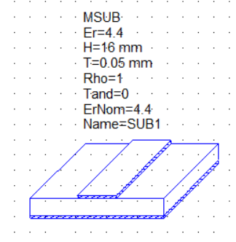

**Calculations:-**

P3/P2=0.5

K^2=P3/P2 k=0.707

Z03=Z0*sqrt((1+k^2)/k^3) = 103ohm

Z02=Z03*K^2 = 51.5ohm

R=Z0(k+1/k)=106.1ohm

R2=Z0*K=35.35ohm

R3=Z0/K=70.72ohm

**Port -1**

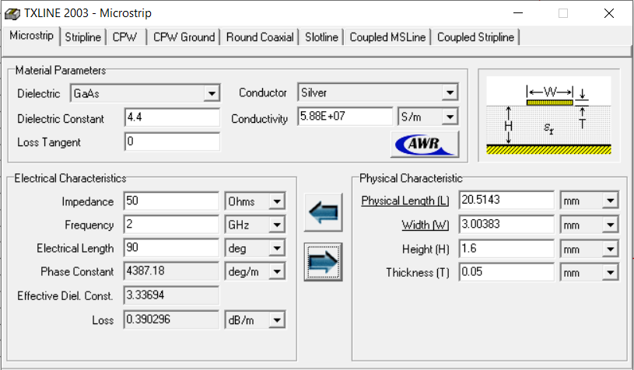

**Port-2**

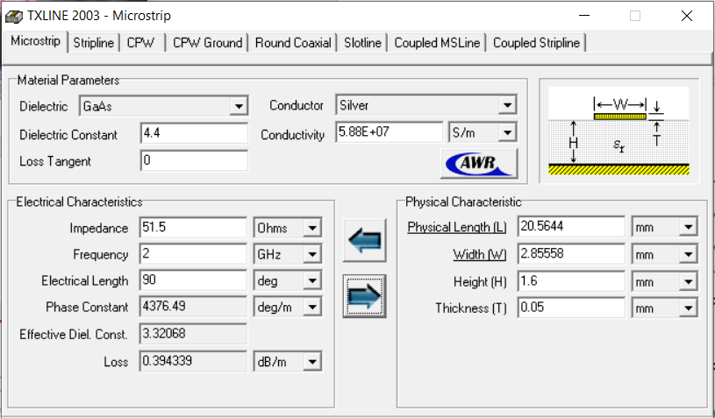

**Port-3**

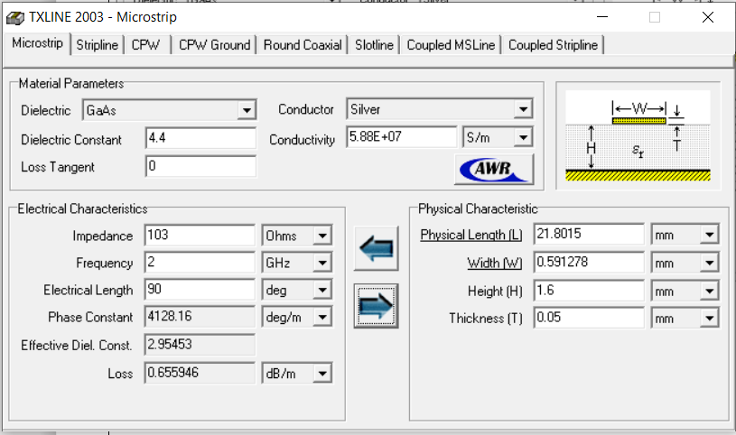

**OUTPUT WAVEFORM:-**

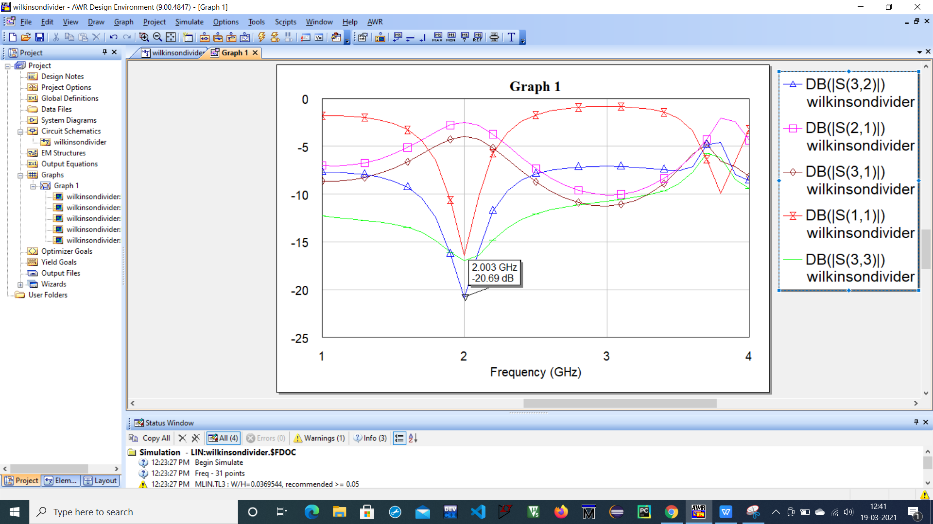

**TABULAR FORMAT RESULT:-**

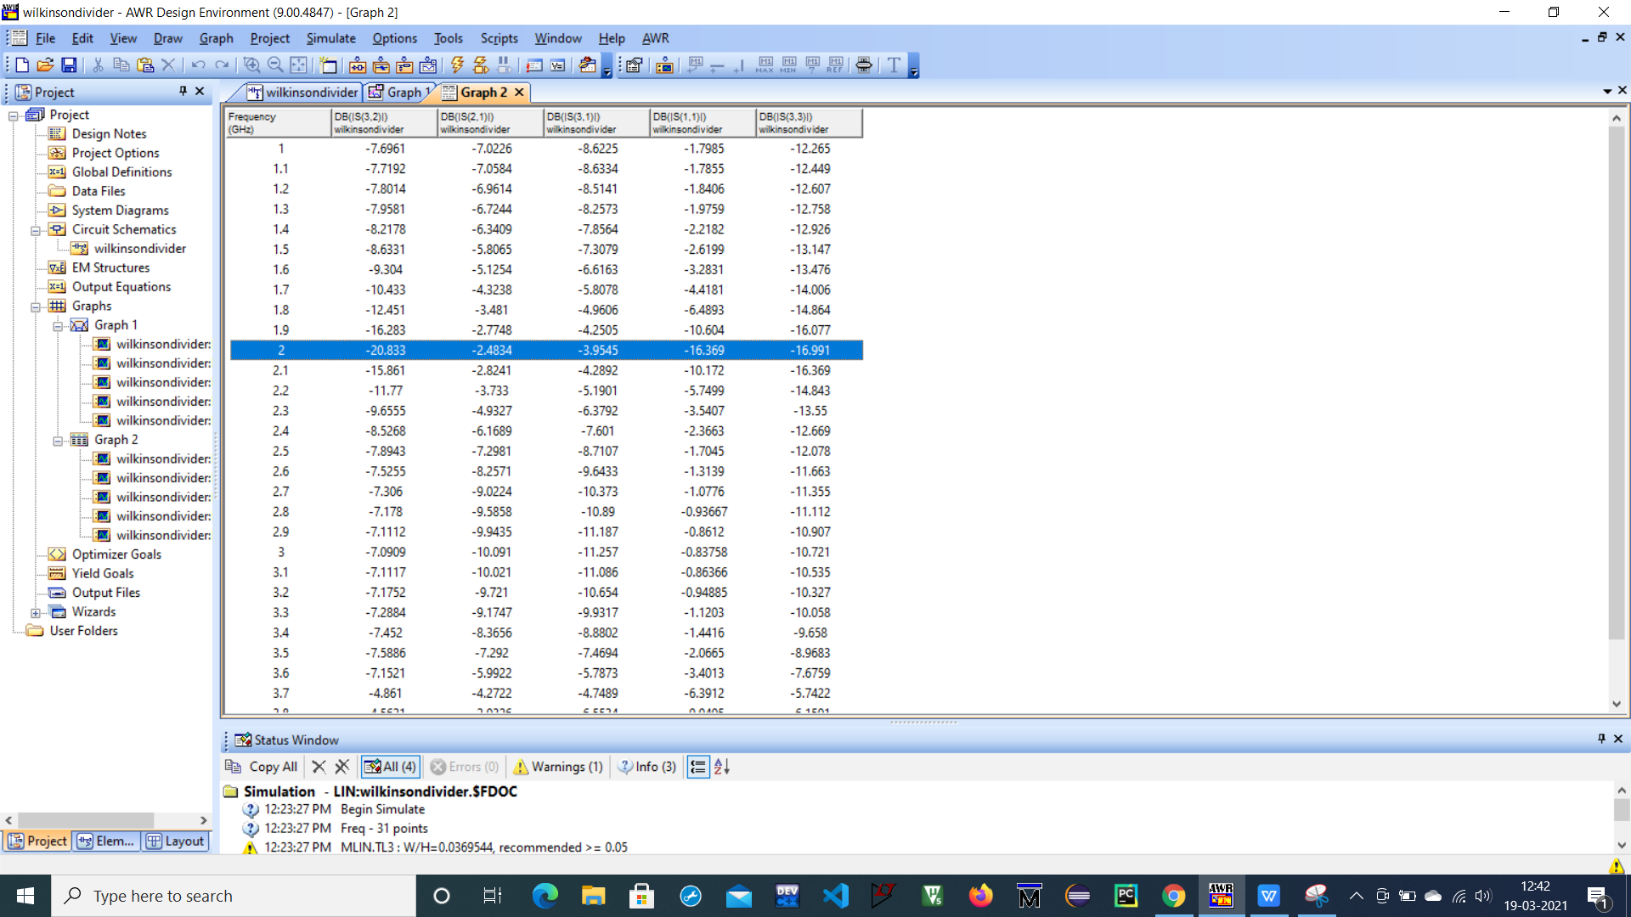

**RESULT AND INFERENCE:-**

Task 2 (B)-- Design a Wilkinson power divider with a power division ratio of 1/3 and a system impedance of 50 Ω using microstrip substrate (Permittivity: εr=4.4, Height of the substrate H=1.6mm, Conductor Thickness T=0.05mm, Loss tangent tan δ = 0.001) for the given frequency.(Frequency- 3GHz)

**Circuit Diagram:-**

**CALCULATIONS:-**

P3/P2=1/3

K^2=P3/P2 k=0.577

Z03=Z0*sqrt((1+k^2)/k^3) = 135.60ohm

Z02=Z03*K^2 = 44.056 ohm

R=Z0(k+1/k)=116.21ohm

R2=Z0*K=28.85ohm

R3=Z0/K=86.6551ohm