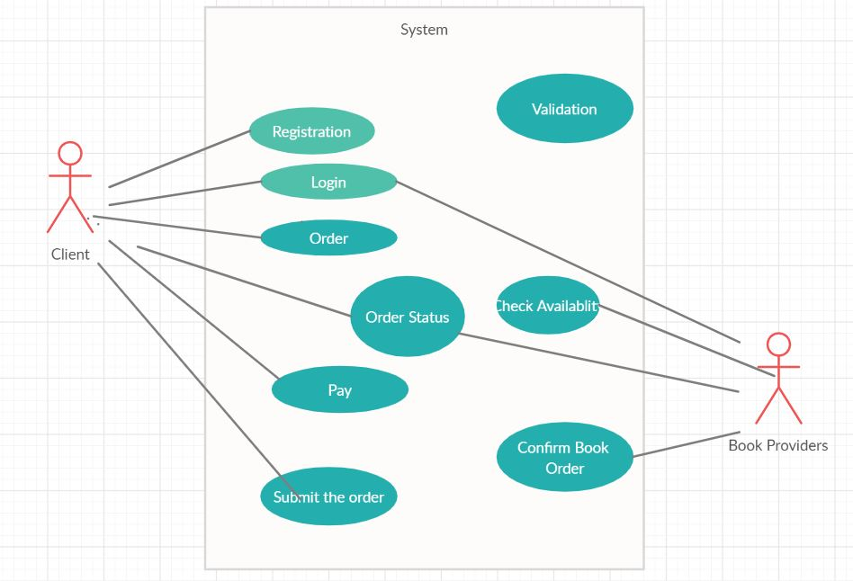

Design:

Sign in and Sign up. User can sign up a new account or sign in as an exist account. All user account data will be stored in firebase.

In Category, book detail we divide the book in respective categories: For eg –Physics , Computers,Novels. When click on each one, the book list will show on the screen. Click on every book item, user can see all details and add it to chart. All these information will be synchronized on the firebase.

# ⬇

Define Service thread and running in Cart.java, the thread keep managing the synchronized order list. Define another thread: ReadInventory thread, responsible for updating local inventory list from data source of Firebase every hour. Once the Place Order button clicked, update the Inventory list immediately

# ⬇

Create CheckAvailability method to check order

availability by comparing the availability FLAG of the books between local inventory list and order.

# ⬇

After “place order” button clicked, call the Check

Availability method and collect unavailable book information for later use.

Send notification and options(partial order or cancel order) to user

# ⬇

According to feedback from user, if this order is

partial, add to head of order list; If it is complete order, add to the end of order list

When the head order in order list cooked

complete (180-300 secs), cook next order, and show the finished order in order status activity for cashier

# ⬇

Generate receipt; send “Pick up” notification to

User, and change the order status from “placed” to “preparing” to “packaged” to “Book Read.