DATA PRIVACY
Micro-aggregation in Income and Tax Data Publication – Implementation
Project Report

Submitted by | Prashast Awasthi
Roll / Registration No. | 23BCE0071
Course | Data Privacy

Table of Contents
Abstract 3
1. Introduction 3
2. Problem statement 3
3. Objectives 4
4. Literature and conceptual background 4
5. Methodology 4
6. The MDAV algorithm 5
7. Implementation 6
8. Experimental setup 6
9. Dataset 7
10. Results 7
10.1 Utility 7
10.2 Privacy 10
10.3 Comparison of original and anonymised records 12
10.4 Ablation: design of the distance space (MDAV, k = 5) 12
11. Privacy analysis 12
12. Utility analysis 13
13. Privacy–utility trade-off 14
14. Limitations 15
15. Conclusion 15
16. Future scope 16
References 16

Every number in this report was produced by run_experiments.py (Python 3.11.9, NumPy 1.26.4, pandas 3.0.5) and inserted automatically. Re-running the script with the same seed reproduces them exactly; a different seed or dataset regenerates the report.

Abstract
Tax administrations and statistical offices are asked to publish income and tax microdata for research and policy analysis, but such records are among the most sensitive personal data. This project implements micro-aggregation with the MDAV (Maximum Distance to Average Vector) heuristic as a statistical disclosure control method for an income/tax dataset, together with an end-to-end pipeline: synthetic data generation, validation and imputation, anonymisation, a release guard, utility and disclosure-risk evaluation, attack simulations and an interactive Streamlit dashboard. On 5000 synthetic taxpayers, MDAV with k = 3, 5, 10, 20 yields k-anonymous releases whose record-linkage success falls from 26.5 % to 2.6 % while information loss (log scale) rises from 4.3 % to 12.1 % and means and totals (e.g. total tax revenue) are preserved exactly. The experiments also show the limits of the method: even at k = 20, 40.8 % of taxpayers have their published income within ±10 % of the truth, and an attacker who knows the incomes of 90 % of the population recovers 14.0 % of the remaining incomes exactly. Micro-aggregation substantially reduces, but does not eliminate, disclosure risk.

1. Introduction
Income-tax microdata – one record per taxpayer with demographics, income components, deductions and tax – are invaluable for evaluating tax reforms, measuring inequality and forecasting revenue. Releasing them as-is, even without names, is unsafe: a combination of age, region, occupation and family situation is often unique, and anyone who can single a person out learns their income and tax. Statistical disclosure control (SDC) offers masking methods that perturb the data so that individuals are protected while aggregate statistics remain useful.
Micro-aggregation is a masking method designed for continuous data. It groups similar records into clusters of at least k records and publishes the cluster averages instead of the individual values. It is used by statistical agencies (it is implemented in μ-ARGUS and sdcMicro) and, with a joint partition, it yields k-anonymity for numerical data (Domingo-Ferrer & Torra, 2005).

2. Problem statement
Given a microdata file of taxpayers with direct identifiers, quasi-identifiers (QIs) and confidential financial attributes, produce a releasable file such that
1. no released record can be linked to a specific taxpayer with probability above 1/k,
2. original confidential values are not exposed – neither in the released file nor in the tools used to produce it,
3. the released file supports the analyses tax researchers actually run (means, totals, distributions, inequality, effective tax rates, regression), and
4. the residual disclosure risk is measured and reported honestly.

3. Objectives
- Implement MDAV micro-aggregation, cleanly and reproducibly, with documented complexity.
- Build a realistic synthetic income/tax population with correlated attributes and heavy tails.
- Validate input data and handle missing and invalid values.
- Quantify utility (information loss, distributional and analytical validity) and risk (identity and attribute disclosure, attack simulations) for k = 3, 5, 10, 20.
- Compare MDAV with univariate (individual ranking) and random-partition baselines.
- Provide an interactive dashboard and an export path that cannot leak original values.
- Discuss limitations and attacks explicitly.

4. Literature and conceptual background
Statistical disclosure control. SDC distinguishes identity disclosure (a released record is linked to a person) from attribute disclosure (something is learnt about a person, whether or not their record is found) (Hundepool et al., 2012). Masking methods are either non-perturbative (suppression, generalisation) or perturbative (noise, swapping, micro-aggregation).
k-anonymity (Sweeney, 2002) requires every combination of QI values to be shared by at least k records. It bounds identity disclosure but is vulnerable to the homogeneity and background-knowledge attacks, which motivated l-diversity (Machanavajjhala et al., 2007) and t-closeness (Li et al., 2007).
Micro-aggregation. Defay & Nanopoulos (1992) introduced fixed-size micro-aggregation; Domingo-Ferrer & Mateo-Sanz (2002) formalised it as minimising the within-group sum of squares subject to a minimum group size, showed that optimal groups have between k and 2k−1 records, and proposed MDAV. Optimal multivariate micro-aggregation is NP-hard (Oganian & Domingo-Ferrer, 2001); the univariate case has a polynomial optimum (Hansen & Mukherjee, 2003). Domingo-Ferrer & Torra (2005) showed that micro-aggregating all QIs with a joint partition achieves k-anonymity for continuous data. Variants include V-MDAV (variable group sizes) and MD-MHM.
Tabular confidentiality rules. Tax agencies protect published cells with the (n, k)-dominance and p %-rule, which flag cells where one or two contributors dominate the total; the same logic applies to a micro-aggregated group mean.
Differential privacy (Dwork, 2006) offers a formal guarantee against arbitrary auxiliary information, at the price of calibrated noise; micro-aggregation offers no such guarantee.

5. Methodology
raw CSV ──► validation & cleaning ──► distance-space encoding ──► partition (MDAV | IR | random)
│
release guard ◄── shuffle & drop ids ◄── aggregation (mean / mode, one partition)
│
└──► released CSV + metadata utility & risk metrics ◄── (internal only)

1. Data. A synthetic population generated with a fixed seed (Section 9).
2. Validation and cleaning (preprocessing.py): schema check, label normalisation, de-duplication, numeric coercion, domain ranges, edit rules (deductions ≤ gross income), deductive repair with the identity taxable = gross − deductions, removal of mostly-empty rows, median imputation within occupation (numeric) and mode imputation (categorical), recomputation of tax when missing.
3. Encoding (features.py): z-scores, log1p for monetary attributes, weighted one-hot encoding for categories (weight 1/√2).
4. Partitioning with MDAV; baselines: individual ranking and random partition.
5. Aggregation with a single partition for all attributes: mean (numeric), mode (categorical).
6. Release (release.py): whitelist of aggregated attributes, rounding, seeded shuffle, fresh release_id, and blocking checks (k-anonymity, completeness, id hygiene).
7. Evaluation (utility.py, privacy.py) on the internal, row-aligned original/anonymised pair – never exported.

6. The MDAV algorithm
MDAV repeatedly takes the record r farthest from the centroid of the unassigned records and the record s farthest from r, and forms a group from each of them with their k−1 nearest neighbours, until fewer than 3k records remain; then it forms one or two final groups so that every group has between k and 2k−1 records. Each record is replaced by its group centroid.
Intuition. Extreme records are the hardest to hide, so they are grouped first, while they still have the largest choice of neighbours; r and s lie at opposite ends of the cloud, so the two groups formed in each round do not compete for the same neighbours.
Complexity. An iteration over m remaining records computes three distance vectors (O(md)) and two linear-time k-selections, and removes 2k records. Over n/(2k) iterations:
T(n) = Σᵢ O(d·(n − 2ki)) ≈ O(n²·d / 4k) = O(n² d / k) time, O(n d) memory.
Measured on 34-dimensional encodings, the log–log slope of runtime is 2.03 in n and -0.98 in k, matching the predicted exponents 2 and −1.
Sweep | n | k | d | Seconds
n | 1000 | 5 | 34 | 0.040
n | 2000 | 5 | 34 | 0.130
n | 4000 | 5 | 34 | 0.425
n | 8000 | 5 | 34 | 2.496
n | 16000 | 5 | 34 | 10.100
k | 8000 | 3 | 34 | 3.922
k | 8000 | 5 | 34 | 2.400
k | 8000 | 10 | 34 | 1.217
k | 8000 | 20 | 34 | 0.615

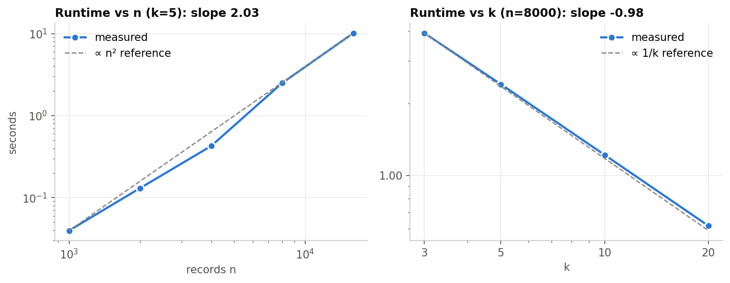
Figure 1. MDAV runtime against the number of records n (left) and the group size k (right), log–log scale
Full derivations, a worked example and proofs are in `docs/ALGORITHM.md`.

7. Implementation
Module | Responsibility
microagg/config.py | attribute roles, valid ranges, AnonymizationConfig
microagg/tax.py | stylised progressive tax schedule (slabs, rebate, surcharge, cess)
microagg/data_generator.py | reproducible synthetic population + injected dirt
microagg/preprocessing.py | validation, edit rules, deductive repair, imputation
microagg/features.py | distance-space encoder
microagg/mdav.py | MDAV, individual ranking, random partition, aggregation
microagg/anonymizer.py | pipeline returning an internal AnonymizationResult
microagg/release.py | release builder and release guard
microagg/utility.py, privacy.py | utility metrics, risk metrics, attacks
microagg/safe_display.py | banding / safe summaries for anything shown on screen
microagg/experiments.py, plotting.py, report_builder.py | experiments, figures, this report
app.py | Streamlit dashboard
tests/test_microagg.py | unit tests (group-size invariants, determinism, k-anonymity, guard, validation)

Safeguards against accidental exposure. (i) The release is built from a whitelist of aggregated attributes; taxpayer_id and the derived tax_bracket can never be exported. (ii) Rows are shuffled with a seeded permutation and re-numbered, so row order cannot be joined back to the source. (iii) The release guard blocks any file that is not k-anonymous – in the experiments it blocked: individual_ranking_k3, individual_ranking_k5, individual_ranking_k10, individual_ranking_k20. (iv) The dashboard shows original monetary values only as bands, never shows per-record errors (released value + error = original), never shows the minimum or maximum of an original attribute, trims distribution plots to P1–P99, and keeps exact originals behind an explicit, off-by-default custodian view. (v) All randomness is seeded.

8. Experimental setup
- Data: 5010 raw rows → 5000 clean records after removing 10 duplicates; 263 cells repaired exactly through the accounting identity and 1010 cells imputed; 0 rows dropped.
- Released attributes: age, dependents, gross income, deductions, taxable income, capital gains, tax paid (numeric); gender, marital status, education, occupation, region, city tier (categorical). All are micro-aggregated with one partition.
- Methods: MDAV; individual ranking (IR); random partition. k ∈ { 3, 5, 10, 20 }.
- Attacker models: (a) worst case – the attacker holds the original records (DBRL on all attributes); (b) the attacker knows the QIs only; (c) the attacker knows the true incomes of a share f of the population (collusion).
- Validation of cleaning:
Column | Missing | Non-numeric | Out of range | Rule violations | Repaired (identity) | Imputed
age | 159 | 9 | 23 | 0 | 0 | 191
capital_gains | 165 | 0 | 0 | 0 | 0 | 165
city_tier | 167 | 0 | 0 | 0 | 0 | 167
deductions | 142 | 0 | 0 | 0 | 136 | 6
education | 141 | 0 | 0 | 0 | 0 | 141
gender | 0 | 0 | 0 | 0 | 0 | 0
gross_income | 59 | 0 | 19 | 0 | 76 | 2
marital_status | 154 | 0 | 0 | 0 | 0 | 154
num_dependents | 161 | 0 | 18 | 0 | 0 | 179
occupation | 0 | 0 | 0 | 0 | 0 | 0
region | 0 | 0 | 0 | 0 | 0 | 0
tax_paid | 0 | 0 | 0 | 0 | 0 | 0
taxable_income | 56 | 0 | 0 | 0 | 51 | 5

9. Dataset
The synthetic population mimics the structure of personal income-tax returns: age-dependent marital status and retirement, dependents driven by family status, education- and occupation-dependent log-normal incomes with an experience curve and a city-tier premium, a Pareto tail for business owners and professionals, deductions whose take-up grows with income, capital gains for a minority, and tax computed with a stylised progressive schedule (rebate up to ₹7 L, slabs 0–30 %, surcharge, 4 % cess; illustrative only, not tax law). About 3 % of cells are deliberately made missing and ~0.4 % invalid, and a few rows are duplicated.

10. Results

10.1 Utility
Method | k | IL raw (%) | IL log (%) | Cat. changed (%) | Corr. distortion | Var. ratio | CI overlap | Tax-rule violations (%)
MDAV (multivariate) | 3 | 19.56 | 4.28 | 13.47 | 0.03 | 0.80 | 0.59 | 14.52
MDAV (multivariate) | 5 | 27.04 | 6.16 | 19.83 | 0.04 | 0.73 | 0.55 | 18.90
MDAV (multivariate) | 10 | 33.40 | 8.68 | 27.33 | 0.06 | 0.67 | 0.49 | 26.20
MDAV (multivariate) | 20 | 39.45 | 12.13 | 34.09 | 0.07 | 0.61 | 0.23 | 29.20
Individual ranking (univariate) | 3 | 5.92 | 0.10 | 0.05 | 0.01 | 0.94 | 0.97 | 0.52
Individual ranking (univariate) | 5 | 6.00 | 0.16 | 0.11 | 0.01 | 0.94 | 0.95 | 0.76
Individual ranking (univariate) | 10 | 10.55 | 0.33 | 0.21 | 0.01 | 0.89 | 0.93 | 1.82
Individual ranking (univariate) | 20 | 15.99 | 0.56 | 0.40 | 0.02 | 0.84 | 0.89 | 4.06
Random partition (baseline) | 3 | 62.14 | 94.24 | 35.19 | 0.02 | 0.38 | 0.16 | 84.94
Random partition (baseline) | 5 | 80.06 | 117.33 | 40.39 | 0.02 | 0.20 | 0.13 | 95.40
Random partition (baseline) | 10 | 89.86 | 139.25 | 45.47 | 0.03 | 0.10 | 0.06 | 99.80
Random partition (baseline) | 20 | 94.89 | 149.96 | 48.44 | 0.05 | 0.05 | 0.00 | 100.00

IL raw is the classic 100·SSE/SST on z-scored values; IL log uses log1p for money; Var. ratio is the mean released/original variance ratio; CI overlap is the mean 95 % confidence-interval overlap of the regression coefficients.
Income and tax statistics on the MDAV releases:
Dataset | Gini (gross income) | Top-10% share (%) | Total tax (₹ crore) | Zero-tax filers (%)
Original | 0.390 | 30.476 | 65.579 | 40.940
MDAV k=3 | 0.384 | 30.010 | 65.579 | 40.740
MDAV k=5 | 0.381 | 29.771 | 65.579 | 40.000
MDAV k=10 | 0.379 | 29.735 | 65.579 | 38.600
MDAV k=20 | 0.377 | 29.510 | 65.579 | 35.200

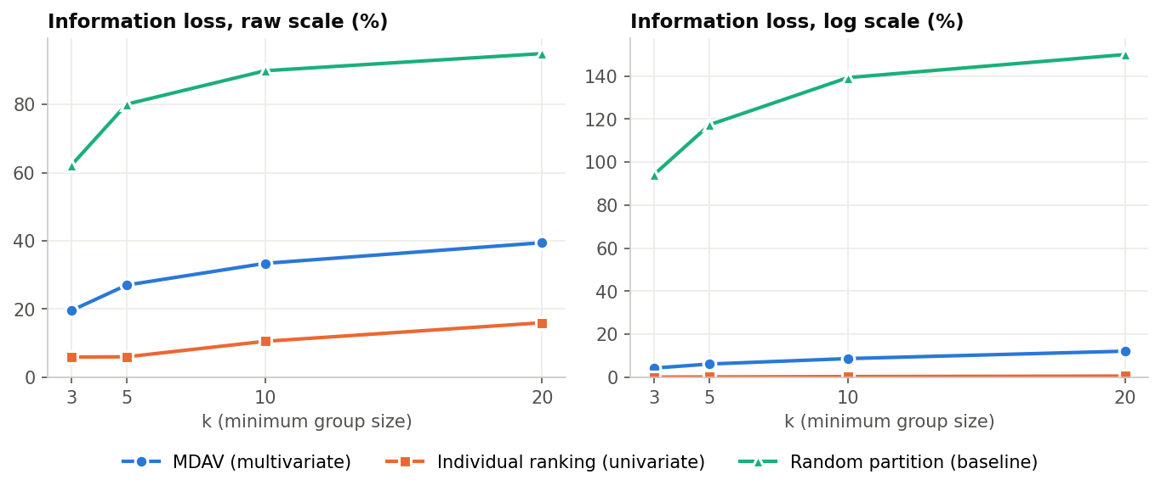
Figure 2. Information loss against k for the three methods, raw scale (left) and log scale (right)
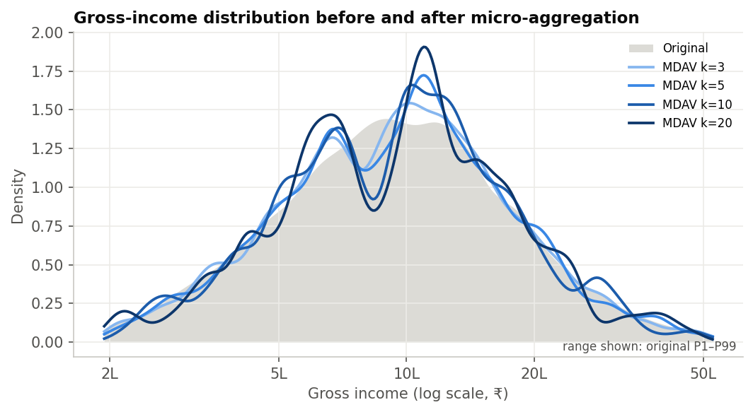
Figure 3. Gross-income distribution of the original data and of the MDAV releases
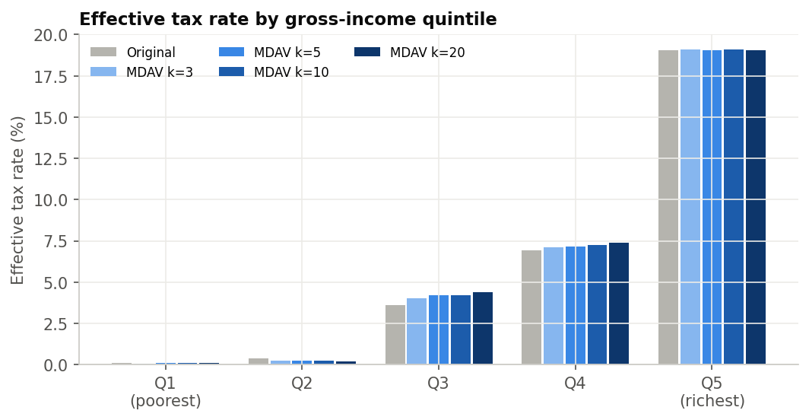
Figure 4. Effective tax rate by gross-income quintile, original data and MDAV releases
Per-attribute statistics, MDAV k = 5:
Attribute | Mean (original) | Mean (released) | Mean diff. (%) | Variance ratio | KS statistic | Median abs. rel. error (%)
age | 41.09 | 41.09 | 0.00 | 0.89 | 0.07 | 6.67
num_dependents | 1.30 | 1.30 | 0.00 | 0.89 | 0.19 | 20.00
gross_income | 1213965.34 | 1213965.34 | 0.00 | 0.79 | 0.03 | 10.75
deductions | 148649.70 | 148649.70 | 0.00 | 0.53 | 0.11 | 29.31
taxable_income | 1065315.64 | 1065315.64 | 0.00 | 0.79 | 0.04 | 11.51
capital_gains | 65496.02 | 65496.02 | 0.00 | 0.46 | 0.04 | 49.58
tax_paid | 131158.30 | 131158.30 | 0.00 | 0.76 | 0.04 | 27.36

Regression of log(1 + gross income) on demographics, MDAV k = 5:
Term | Coef. (original) | Coef. (released) | CI overlap
intercept | 12.654 | 12.080 | 0.000
age | 0.058 | 0.086 | 0.000
age_sq/100 | -0.056 | -0.089 | 0.000
num_dependents | 0.003 | -0.013 | 0.379
education=Graduate | -0.408 | -0.333 | 0.524
education=Higher Secondary | -0.618 | -0.569 | 0.713
education=Postgraduate | -0.148 | -0.046 | 0.373
education=Secondary | -0.742 | -0.701 | 0.768
occupation=Professional | 0.931 | 0.955 | 0.842
occupation=Retired | -0.545 | -0.435 | 0.458
occupation=Salaried-Government | 0.512 | 0.478 | 0.715
occupation=Salaried-Private | 0.354 | 0.307 | 0.543
occupation=Self-Employed | 0.324 | 0.271 | 0.522
city_tier=Tier-2 | -0.239 | -0.244 | 0.931
city_tier=Tier-3 | -0.429 | -0.436 | 0.909

10.2 Privacy
Method | k | Min. class | DBRL all (%) | DBRL QI (%) | Income ±10% (%) | QI inference (%) | Bracket homog. (%) | Mean l | p%-rule (%) | Collusion f=0.5 (%)
MDAV (multivariate) | 3 | 3 | 26.47 | 14.94 | 53.48 | 27.16 | 43.38 | 1.62 | 0.00 | 26.27
MDAV (multivariate) | 5 | 5 | 13.80 | 6.70 | 46.84 | 18.24 | 27.70 | 1.91 | 0.00 | 6.68
MDAV (multivariate) | 10 | 10 | 5.86 | 2.46 | 41.68 | 15.60 | 15.20 | 2.27 | 0.00 | 0.12
MDAV (multivariate) | 20 | 20 | 2.65 | 1.00 | 40.84 | 12.94 | 10.40 | 2.54 | 0.00 | 0.00
Individual ranking (univariate) | 3 | 1 | 99.86 | 94.48 | 99.94 | 92.12 | – | – | 0.00 | 26.92
Individual ranking (univariate) | 5 | 1 | 99.76 | 94.32 | 99.84 | 91.92 | – | – | 0.00 | 6.84
Individual ranking (univariate) | 10 | 1 | 99.38 | 93.99 | 99.68 | 91.68 | – | – | 0.00 | 0.20
Individual ranking (univariate) | 20 | 1 | 98.98 | 93.41 | 99.48 | 91.20 | – | – | 0.00 | 0.00
Random partition (baseline) | 3 | 3 | 1.79 | 1.73 | 15.08 | 12.02 | 3.48 | 2.48 | 5.16 | 26.19
Random partition (baseline) | 5 | 5 | 0.51 | 0.53 | 13.50 | 11.14 | 0.10 | 3.47 | 0.30 | 6.40
Random partition (baseline) | 10 | 10 | 0.15 | 0.17 | 12.52 | 10.82 | 0.00 | 4.88 | 0.00 | 0.20
Random partition (baseline) | 20 | 20 | 0.08 | 0.08 | 11.90 | 11.32 | 0.00 | 5.68 | 0.00 | 0.00

Min. class = smallest equivalence class over all released attributes; DBRL = expected success of distance-based record linkage; Income ±10 % = interval disclosure of gross income; QI inference = success of the QI-based income-inference attack (baseline without the release: 12.3 %); Bracket homog. = records in groups whose members all share one tax bracket; Mean l = mean distinct tax brackets per group; p %-rule = records in groups failing the p %-rule (p = 10); Collusion f = 0.5 = targets recovered exactly when the attacker knows half of all incomes.
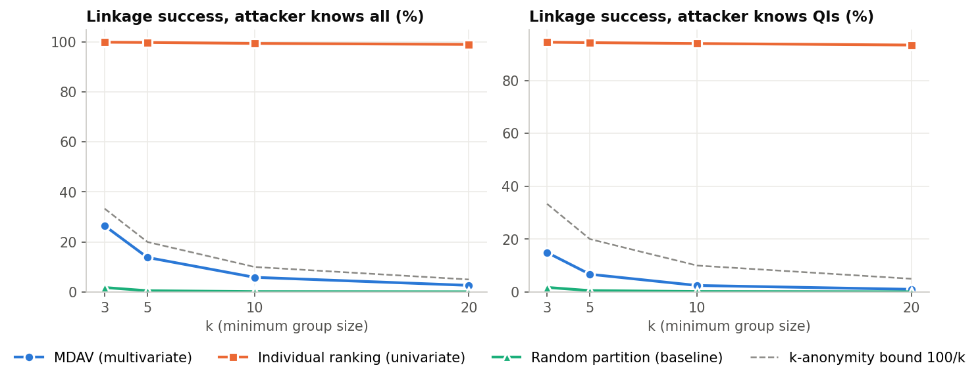
Figure 5. Record-linkage success against k; the dashed line is the k-anonymity bound 100/k
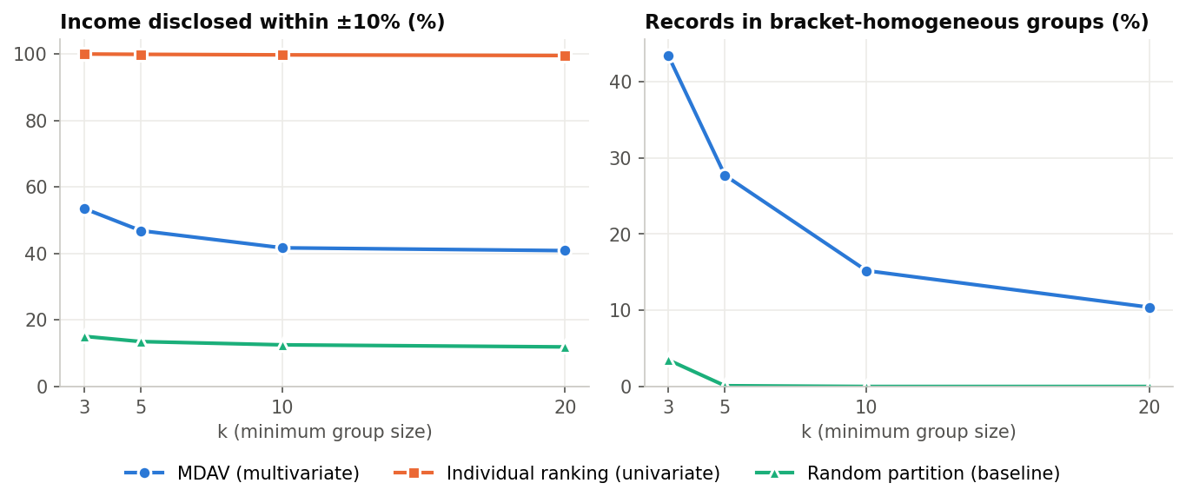
Figure 6. Attribute disclosure against k: income within ±10 % (left) and bracket-homogeneous groups (right)
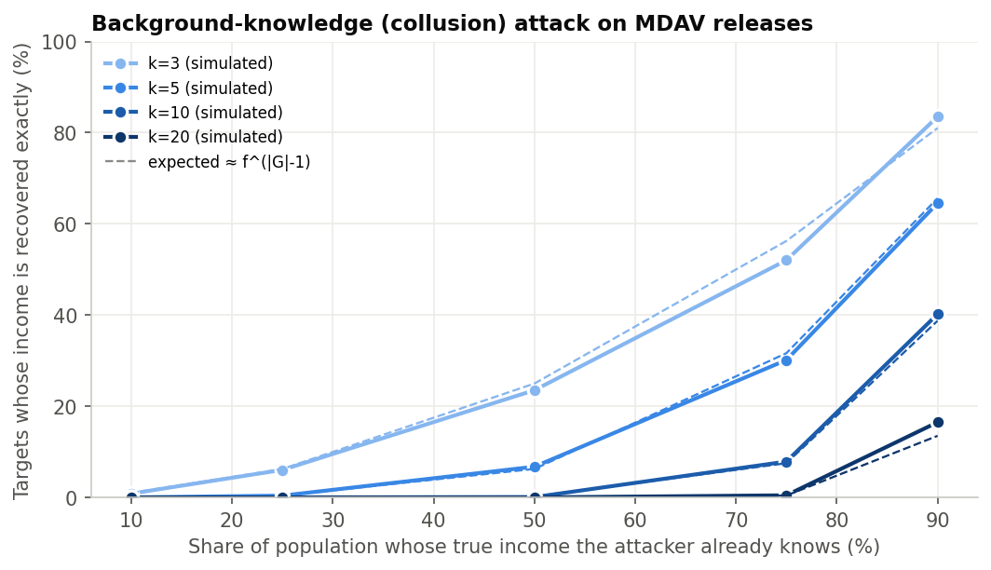
Figure 7. Background-knowledge (collusion) attack: simulated success and expected value f^(G−1)

10.3 Comparison of original and anonymised records
Eight random records, MDAV k = 5. In line with the project's exposure rules, original monetary values are shown as bands and ages as decades; per-record errors are deliberately not shown.
Record | Age (orig.) | Age (rel.) | Gross income (orig.) | Gross income (rel.) | Taxable income (orig.) | Taxable income (rel.) | Tax paid (orig.) | Tax paid (rel.) | Gender (orig.) | Gender (rel.) | Occupation (orig.) | Occupation (rel.) | Group size
Sample 1 | 30–39 | 33.00 | ₹2.5L–5L | ₹2.72L | ₹0–2.5L | ₹1.67L | ₹0 | ₹0 | Female | Female | Freelancer | Freelancer | 5
Sample 2 | 50–59 | 46.20 | ₹2.5L–5L | ₹5.56L | ₹2.5L–5L | ₹3.76L | ₹0 | ₹0 | Female | Female | Self-Employed | Self-Employed | 5
Sample 3 | 50–59 | 47.40 | ₹7.5L–10L | ₹7.43L | ₹5L–7.5L | ₹6.48L | ₹0 | ₹0 | Female | Female | Salaried-Private | Salaried-Private | 5
Sample 4 | 50–59 | 47.20 | ₹15L–25L | ₹14.57L | ₹10L–15L | ₹12.15L | ₹0–2.5L | ₹99,170 | Female | Female | Salaried-Private | Salaried-Private | 5
Sample 5 | 20–29 | 27.60 | ₹10L–15L | ₹13.35L | ₹10L–15L | ₹13.35L | ₹0–2.5L | ₹1.33L | Male | Female | Self-Employed | Self-Employed | 5
Sample 6 | 40–49 | 44.40 | ₹5L–7.5L | ₹7.00L | ₹5L–7.5L | ₹6.38L | ₹0 | ₹0 | Female | Female | Salaried-Private | Self-Employed | 5
Sample 7 | 40–49 | 47.40 | ₹7.5L–10L | ₹7.45L | ₹5L–7.5L | ₹6.22L | ₹0 | ₹0 | Male | Male | Self-Employed | Self-Employed | 5
Sample 8 | 30–39 | 38.60 | ₹5L–7.5L | ₹7.51L | ₹5L–7.5L | ₹6.36L | ₹0 | ₹0 | Female | Male | Salaried-Private | Freelancer | 5

10.4 Ablation: design of the distance space (MDAV, k = 5)
Distance space | IL raw (%) | IL log (%) | Cat. changed (%) | Income median rel. error (%) | Income ±10% (%) | Bracket homog. (%) | DBRL all (%)
log + categorical (default) | 27.04 | 6.16 | 19.83 | 10.75 | 46.84 | 27.70 | 13.80
log, numeric only in distance | 20.28 | 2.27 | 36.89 | 4.98 | 78.46 | 57.30 | 16.22
raw scale + categorical | 13.49 | 51.92 | 17.29 | 19.36 | 27.42 | 10.70 | 13.36
raw scale, numeric only | 9.53 | 28.21 | 36.40 | 9.88 | 50.44 | 26.70 | 16.25

11. Privacy analysis
- Identity disclosure is bounded as promised. Every MDAV and random-partition release is k-anonymous (minimum class = k), and no record's linkage probability exceeds 1/k (max. per-record risk 0.333 at k = 3, 0.050 at k = 20). Even for the worst-case attacker holding the original file, expected linkage success falls from 26.5 % (k = 3) to 2.6 % (k = 20); with QIs only, from 14.9 % to 1.0 %. Individual ranking, in contrast, leaves records essentially unique: linkage succeeds for 99.9 % of records at k = 3 and still 99.0 % at k = 20, which is why the release guard blocks it.
- Attribute disclosure is NOT bounded by k. Because MDAV groups similar taxpayers, the published income is within ±10 % of the true income for 53.5 % of taxpayers at k = 3 and still 40.8 % at k = 20 (random grouping: 11.9 %). An attacker who only knows a target's QIs estimates the income within ±10 % for 27.2 % of targets at k = 3 versus a 12.3 % baseline without the release; the gain shrinks to 0.7 percentage points at k = 20.
- Homogeneity. 43.4 % of records (k = 3) and 10.4 % (k = 20) sit in groups whose members all share one tax bracket – an attacker who identifies the group learns the bracket with certainty. The minimum distinct l-diversity is 1 even at k = 20, and the worst group's t-closeness distance is 0.52.
- Dominance. Groups failing the (1, 50 %) dominance rule: 0.42 % at k = 3, 0.00 % at k = 5; p %-rule failures: 0.00 %. MDAV's similarity grouping keeps very high earners together, so a single outlier rarely dominates; random grouping is far worse (50.2 % of groups at k = 3).
- Background knowledge. If the attacker already knows half of all incomes, they recover 26.3 % of the other incomes exactly at k = 3, 6.7 % at k = 5 and 0.12 % at k = 10. With 90 % known, the figures are 79.1 %, 63.8 %, 41.5 % and 14.0 % for k = 3, 5, 10, 20. Simulations match the f^(|G|−1) prediction.

12. Utility analysis
- First moments are exact. Means of every attribute and the total tax revenue are preserved for every k (largest relative deviation of any attribute mean at k = 20: 0.000000 %).
- Information loss grows with k. For MDAV, IL raw rises from 19.6 % (k = 3) to 39.5 % (k = 20) and IL log from 4.3 % to 12.1 %. The raw figure looks high because incomes are heavy-tailed: the top 1 % of earners account for 76.9 % of the total sum of squares of gross income, so raw IL mainly measures how well a handful of very rich taxpayers are grouped. Random grouping, with the same k-anonymity, loses 62.1–94.9 % – MDAV's similarity search is what makes the release useful.
- Distributions and inequality. The Gini coefficient of gross income moves from 0.390 to 0.384 (k = 3) and 0.377 (k = 20); the top-10 % income share from 30.5 % to 29.5 % at k = 20. Averaging compresses variance (mean variance ratio 0.80 at k = 3, 0.61 at k = 20), so dispersion and inequality are slightly understated.
- Non-linear rules break. The share of zero-tax filers falls from 40.9 % to 35.2 % at k = 20 because groups straddling the rebate threshold get a positive mean tax, and 14.5 % (k = 3) to 29.2 % (k = 20) of released records carry a tax that differs from the schedule applied to their released income. Linear identities hold exactly (identity violations 0.0 %), whereas individual ranking breaks taxable = gross − deductions for 97.5 % of records.
- Regression. The R² of the income regression rises from 0.376 to 0.522 at k = 20 – an artefact of averaging out noise, not better data – while the mean confidence-interval overlap of the coefficients falls from 0.59 (k = 3) to 0.23 (k = 20). In the k = 5 table, coefficients of categorical attributes used in the grouping (city tier, education, occupation) survive comparatively well, whereas the age profile is biased, because ages are averaged within groups formed mostly on income and categories.
- Categories. Mode replacement changes 13.5 % of categorical cells at k = 3 and 34.1 % at k = 20. Rare levels are absorbed by the group mode: the gender level "Other" (32 taxpayers) survives in 18 released records at k = 3 and 0 at k = 5 – a utility loss for minority analysis, but also a privacy gain for a very small, easily identifiable group.

13. Privacy–utility trade-off
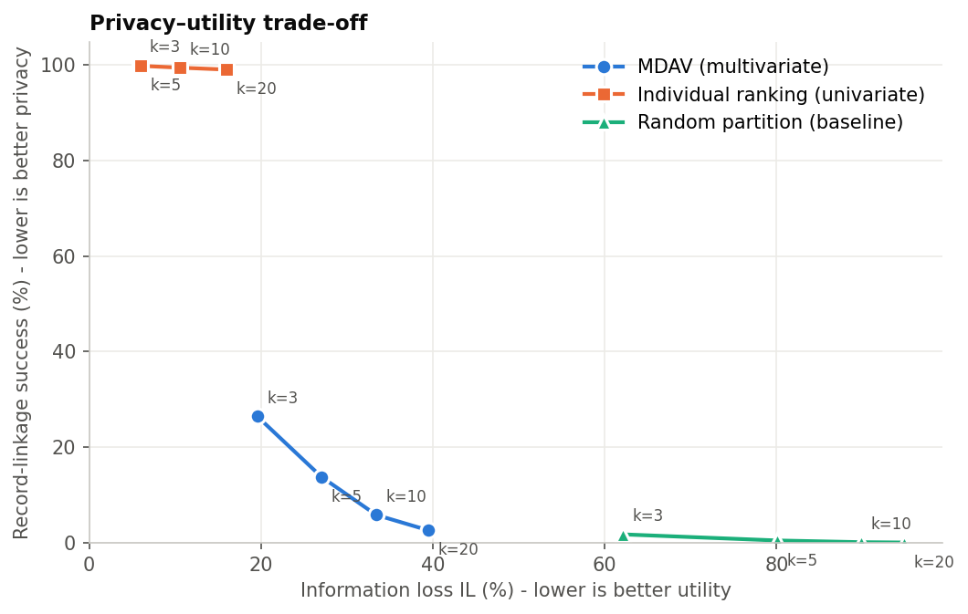
Figure 8. Privacy–utility trade-off: information loss against record-linkage success
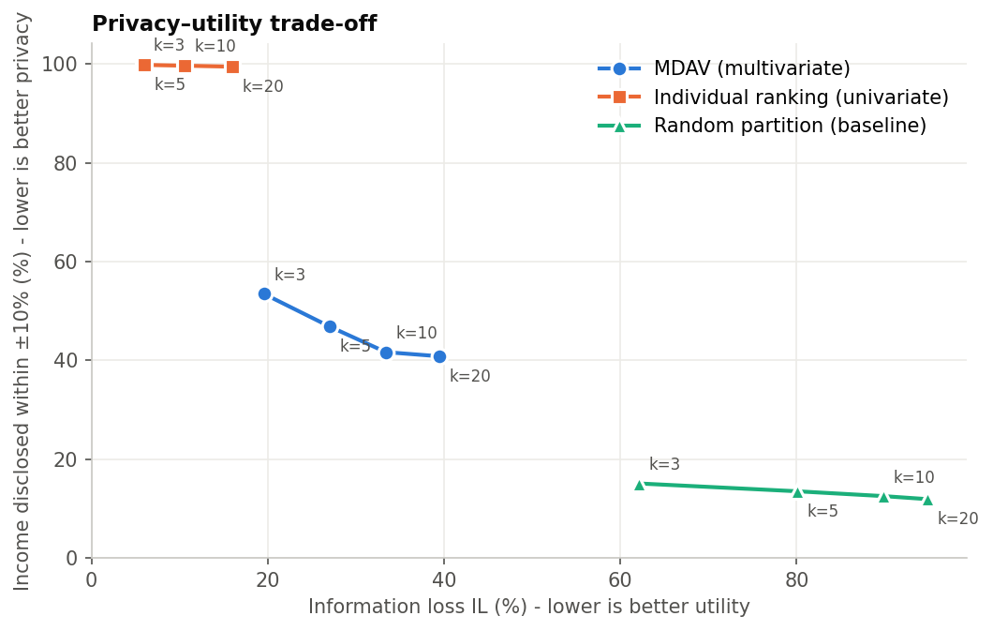
Figure 9. Privacy–utility trade-off: information loss against attribute disclosure
- MDAV dominates random grouping on utility at equal k-anonymity: at k = 3 MDAV's IL is 19.6 % against 62.1 %.
- Individual ranking is the opposite corner: excellent utility (IL 5.9 %) but almost no protection against linkage (99.9 %).
- Along the MDAV curve, k = 5 → 10 roughly halves linkage risk (13.8 % → 5.9 %) for an IL increase of 27.0 % → 33.4 %. Attribute disclosure, however, decreases much more slowly (46.8 % → 41.7 %), so raising k is an inefficient tool against it.
- The distance space is a privacy–utility knob too (ablation, Section 10.4): grouping on raw rupees lowers raw IL but sharply raises log-scale IL, i.e. it serves the few richest taxpayers at the expense of relative accuracy for everyone else; dropping categories from the distance makes incomes very precise – and therefore raises interval disclosure and bracket homogeneity – while changing many more categorical values. No single setting is best for both utility measures and for privacy.
- Recommendation for this dataset: MDAV with k = 5 or 10 and the default (log + categorical) distance space, released together with documentation of the residual risks, and ideally combined with an attribute-disclosure control (Section 16).

14. Limitations
1. No absolute anonymity. k-anonymity bounds identity disclosure only; attribute disclosure (similarity, homogeneity) remains substantial, as Section 11 shows.
2. Background knowledge. Knowing the other members of a group reveals the remaining member exactly; risk decays as f^(k−1) but never vanishes. Insiders (employers, colleagues, family) are realistic sources of such knowledge.
3. Multiple releases. Publishing the same population at different k, or with different attribute sets, enables differencing attacks. One release per population is advised.
4. Outliers. The top earners are few and far apart; their groups are heterogeneous and their group means still reveal that a very rich person exists in a given region/occupation.
5. Heuristic, not optimal. MDAV is a fixed-size heuristic; the last group can be poor and optimal partitions are NP-hard to find.
6. Utility distortions. Variances, inequality and non-linear relationships (tax schedule, zero-tax mass) are distorted; averaged ages and dependents are fractional; rare categories may disappear; regression R² is inflated.
7. Quadratic cost. O(n²) time makes plain MDAV slow for millions of returns (blocking or approximate nearest neighbours would be needed).
8. Synthetic data. Results come from a synthetic population with a stylised tax schedule; real data will have different tails, correlations and edit rules.
9. Guarantees are attribute-specific. Only the released (aggregated) attributes are covered; adding any other attribute to the release voids the k-anonymity argument.

15. Conclusion
MDAV micro-aggregation turns a highly sensitive income/tax file into a k-anonymous release that preserves totals and means exactly and keeps most distributional and policy statistics close to the original. Compared with univariate micro-aggregation it actually protects against record linkage, and compared with random grouping it retains far more information. Its O(n²d/k) cost was confirmed empirically. The experiments also show clearly why micro-aggregation must not be presented as absolute anonymity: grouping similar taxpayers makes their published incomes close to their true incomes, homogeneous groups reveal tax brackets, and an attacker with background knowledge can recover incomes exactly. A responsible release therefore pairs micro-aggregation with measured risk, conservative k, documented limitations and controlled access.

16. Future scope
- Attribute-disclosure-aware micro-aggregation: enforce l-diversity / t-closeness of the tax bracket or a minimum within-group income spread (e.g. t-closeness-first micro-aggregation, Soria-Comas et al., 2015).
- Variable group sizes (V-MDAV) and optimal univariate projections to reduce information loss.
- Hybrid methods: micro-aggregation followed by calibrated noise, or differentially private micro-aggregation, to obtain formal guarantees against background knowledge.
- Scalability: blocking by region/occupation, KD-trees or approximate nearest neighbours for millions of records.
- Consistency-preserving post-processing: recompute tax from released income, or constrained aggregation that respects the tax schedule.
- Evaluation on real administrative data in a secure environment, and user studies with tax analysts on which statistics matter most.

References
Defay, D. & Nanopoulos, P. (1992). Panels of enterprises and confidentiality: the small aggregates method. Proc. Statistics Canada Symposium; Soria-Comas, J., Domingo-Ferrer, J., Sánchez, D. & Martínez, S. (2015). t-closeness through microaggregation. IEEE TKDE 27(11).

