
Production traceability system
SpecAPP · SpecManagment · SpecInstall
User and deployment documentation
Document version 1.0 · November 2026

spec-electronic.pl
by P.R. 2026
Contents
1. Purpose and scope 4
2. System architecture 4
3. Hardware and software requirements 5
3.1. Software requirements 5
3.2. Hardware requirements (recommendations) 5
3.3. Files in the program folder 6
4. Roles and permissions 6
5. Glossary and field reference 7
5.1. Serial number and product definition 7
5.2. Production order 8
5.3. Routing and step 8
5.4. Material 9
5.5. Tool (measuring device) 10
5.6. Unit and its states 10
6. Installation – SpecInstall 10
7. Preparing production step by step 11
Steps 1–2. Installation and distribution 13
Step 3. First login 13
Step 4. Users ("Users" tab, MasterDATA role) 13
Step 5. Tools ("Tools" tab, technologist or quality) 13
Step 6. Materials ("Materials" tab, planner or technologist) 13
Step 7. Product ("Products" tab, planner) 13
Step 8. Routing ("Routings" tab, technologist) 13
Step 9. Prepare the stations 13
Step 10. Order ("Orders" tab, planner) 14
Step 11. Labels 14
Step 12. Start production 14
8. Working at the station – SpecAPP 14
8.1. Keyboard and scanner operation 14
8.2. Flow of a single step 15
9. Automatic measurement and the current.csv file 16
9.1. Measurement program contract 17
10. Connection loss and the local buffer 19
11. Quality module 20
12. KPI dashboard and data export 20
12.1. Order indicators 20
12.2. Export 21
13. Security 21
14. Data model 21
15. Messages and error codes 23
15.1. Codes stored with a NOK result 23
15.2. Most common station messages 23
16. Checklists 23
16.1. Before the first system start 23
16.2. Before starting each order 24
16.3. At the start of a shift (operator) 24

This document describes the system as implemented in the source code of this repository.

1. Purpose and scope
The system records the production history of every unit of a product (traceability): who performed each process step, when, at which station, with which tool and with what result; which materials and components were used; and which decisions the quality department made.
The system consists of three programs:
Program | For whom | Purpose
SpecInstall | administrator | one-time creation of the database structure and generation of the setup.ini configuration files
SpecManagment | planner, technologist, quality, master-data administrator | defining products, routings, orders, materials, tools and users; quality decisions; KPI; export
SpecAPP | production operator | station work: scan a serial number, perform the step, store the OK/NOK result

Out of scope: printing serial-number labels, the measurement program itself (e.g. pomiar.exe – supplied by the user) and ERP integration (the "ERP VALUE" field is typed in manually).

2. System architecture
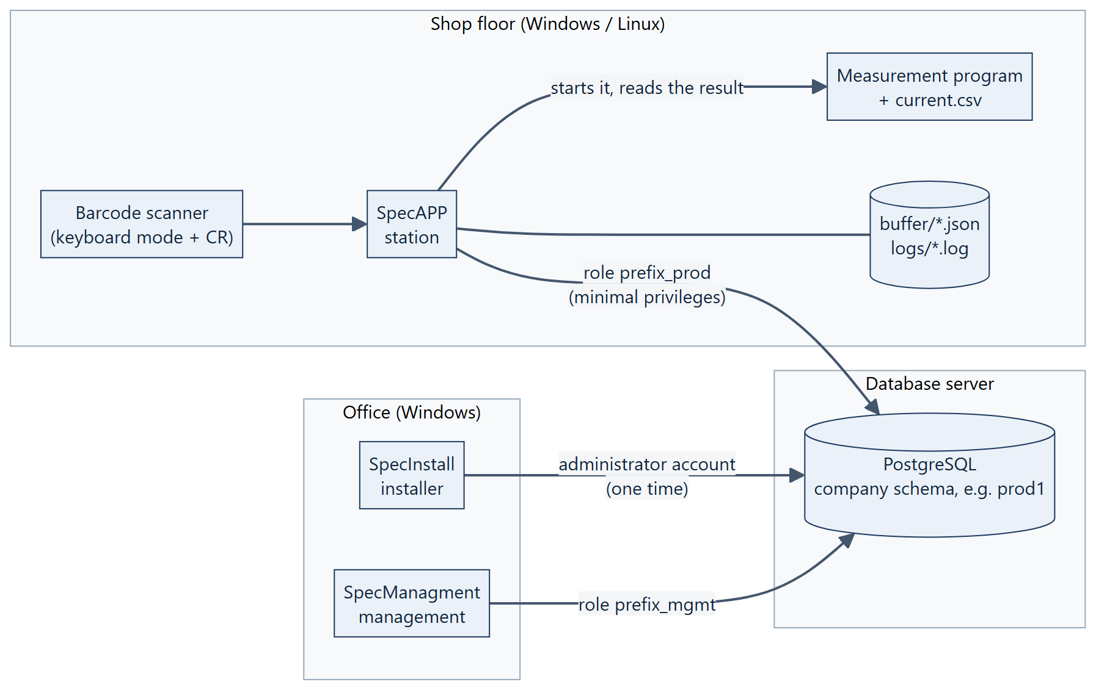
Figure 1. System architecture
Key principles:
• One database, one schema per company. Each installation creates a separate schema with a 5-character name (e.g. prod1) in a PostgreSQL database. Several independent installations can share one server.
• Three database roles. <prefix>_owner (owns the tables, cannot log in), <prefix>_mgmt (SpecManagment) and <prefix>_prod (SpecAPP – reads configuration, appends results and changes unit state only).
• The routing is frozen when the order starts. At "Start production" the current product routing is copied into the order. Later routing changes apply to subsequent orders only.
• The station form is built from the step configuration. SpecAPP has no hard-coded screens – material, measurement and component fields appear according to the step definition.
• Results are append-only. A step result or an audit entry can never be changed or deleted; a correction is always a new entry.

3. Hardware and software requirements

3.1. Software requirements
Item | Requirement
Database server | PostgreSQL 14 or newer (the system has been run on version 14). TCP network access, port 5432 by default.
Installation account | A PostgreSQL account allowed to create roles and schemas in the chosen database (e.g. a superuser, or an account with CREATEROLE and the CREATE privilege on the database). Needed only while SpecInstall runs.
SpecInstall, SpecManagment | Windows 10/11 x64 with .NET Desktop Runtime 8 (or newer).
SpecAPP – Windows | Windows 10/11 x64 with .NET Desktop Runtime 8 (or newer).
SpecAPP – Linux | An x64 distribution with GTK 3 libraries and a graphical session (X11). The package is self-contained – no .NET installation is required.
Network | Permanent connection between stations and the database server. The server firewall and pg_hba.conf must allow the PostgreSQL port from the station addresses.
Connection limit | Each SpecAPP station uses at most 2 connections, each SpecManagment at most 4. The server max_connections should exceed 2 × stations + 4 × management seats, with a margin.
Time | Result timestamps and tool validity are evaluated by the database server – its clock must be correct.

Verification status: the Windows versions were tested on Windows 11; the Linux version has been started on Ubuntu (login screen and database connection). On Linux the window icon may be the system default.

3.2. Hardware requirements (recommendations)
The values below are design recommendations – they do not come from performance measurements.
Item | Recommendation
Production station | x64 CPU (2 cores), 4 GB RAM, 500 MB free disk space for the program, logs and buffer; display at least 1280 × 800
Management seat | x64 CPU (2 cores), 8 GB RAM, display at least 1366 × 768 (the window opens at 1280 × 800)
Database server | 2–4 cores, 4–8 GB RAM, SSD storage, regular database backup
Keyboard | with function keys F1, F5, F8 and Esc
Barcode scanner | keyboard (HID) mode with a trailing CR (Enter); the scanner must not trim spaces or change letter case

3.3. Files in the program folder
File / folder | Program | Meaning
setup.ini | SpecAPP, SpecManagment | server address, port, database, schema and the encrypted login and password of the database role. The program does not start without this file.
language.txt | all | remembered interface language (pl / en)
logs/YYYY-MM-DD.log | SpecAPP, SpecManagment | local log, kept for 30 days
buffer/*.json | SpecAPP | results waiting to be sent after a connection loss
buffer/failed/ | SpecAPP | buffered results rejected by the database (to be clarified with quality)

The program folder must be writable for the operating-system user.

4. Roles and permissions
Every user has exactly one role. The role determines which program the user can log in to and which SpecManagment tabs are visible.
Module | Production | Planner | Technologist | Quality | MasterDATA
SpecAPP (station) | ✔ | – | – | – | ✔
Products | – | write | read-only | read-only | write
Routings | – | read-only | write | read-only | write
Orders | – | write | read-only | read-only | write
KPI Dashboard | – | ✔ | ✔ | ✔ | ✔
Quality | – | – | – | write | write
Export | – | ✔ | ✔ | ✔ | ✔
Materials | – | write | write | read-only | write
Tools | – | read-only | write | write | write
Users | – | – | – | – | write

"Read-only" means the tab is visible (marked "(read-only)") but its save buttons are disabled. "–" means the tab is not shown.
Login rules:
• After 5 failed attempts the account is locked for 5 minutes. Saving the user in the "Users" tab clears the lock.
• A new or reset password forces a change at first login. A password must have at least 4 characters and differ from the previous one.
• At least one active MasterDATA user must always remain in the system.

5. Glossary and field reference

5.1. Serial number and product definition
Every product has its own serial-number pattern:
[PREFIX][ERP VALUE][Num++][SUFFIX]
Field | Required | Length | Description
PREFIX | yes | 1–50 characters | The fixed leading part of the number, usually the product family name including its separator, e.g. TELEFON/ or TELEFON-. The separator (slash, hyphen) is part of the PREFIX – the system adds nothing by itself.
ERP VALUE | no | 0–50 characters | The fixed middle part, usually an item code or variant designation from the ERP system, e.g. NOKIA10/. Typed in manually.
Num++ | yes | 3–6 digits | The unit counter. Only the number of digits is specified; the number is left-padded with zeros (0001). The counter starts at 1 and increases by 1 for each unit.
SUFFIX | no | 0–50 characters | The fixed trailing part, e.g. a firmware version FW1.00. Spaces are allowed and are part of the number.

Examples:
PREFIX | ERP VALUE | Num++ | SUFFIX | First number
TELEFON/ | NOKIA10/ | 4 | FW1.00 | TELEFON/NOKIA10/0001 FW1.00
TELEFON- | (empty) | 4 | (empty) | TELEFON-0001

Rules to keep in mind:
• Forbidden characters in all text fields: $ % ^ & ; # and control characters.
• Counter capacity is 10^n − 1 units: 3 digits = 999, 4 digits = 9,999, 5 digits = 99,999, 6 digits = 999,999. The counter is shared by all orders of the product and never goes back. The system refuses to create an order that would exceed the capacity – a new product must be defined (e.g. with another PREFIX or a longer Num++).
• A product cannot be changed or deleted. Selecting a product in the list copies its data into the form; after changing it you save it as a new product. The combination PREFIX + ERP VALUE + SUFFIX + Num++ length must be unique.
• A serial number is unique across the whole system. If two products would produce the same number, the order is not created.
• Scanning at the station strips trailing CR/LF only. Spaces – including trailing ones – are part of the number, so the label must reproduce the number character for character.

5.2. Production order
Field | Description
Order number | Assigned automatically: ZP-YYYYMMDD-NNN (creation date and a sequence number within that day), e.g. ZP-20261110-001.
Product | Only products with a defined routing are listed.
BOM version | Required, up to 25 characters. Descriptive information about the bill-of-materials version, stored with the order and shown at the station and in exports.
Quantity to produce | Number of units > 0. That many serial numbers are generated immediately when the order is created.
Planned start / end date | Informational; the start date must not be later than the end date.
Notes | Up to 1000 characters.

Order states:
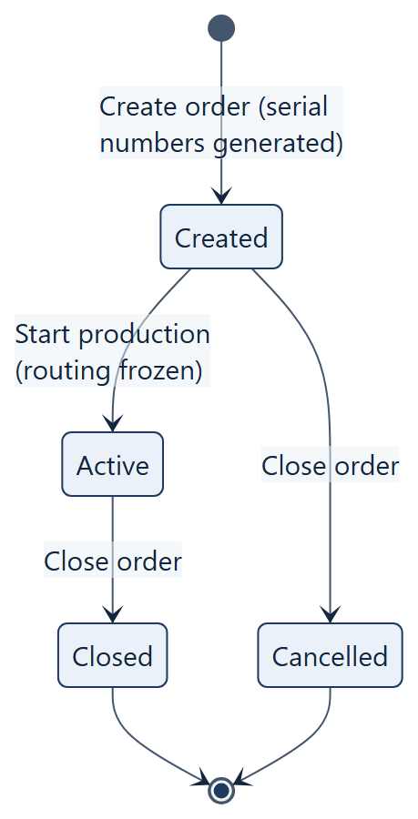
Figure 2. Production order states
• Created – the serial numbers exist, but stations reject them ("order has not been started yet").
• Active – the only state in which units can be processed and quality decisions made.
• Closed / Cancelled – irreversible. Unfinished units of a closed order are blocked permanently.

5.3. Routing and step
A routing is the ordered list of steps of a product. Steps are performed in step-number order; there is no branching.
Step field | Description
Step number | A number > 0. Multiples of 10 (10, 20, 30 …) are recommended so that a step can be inserted in between; the "New step – suggest number" button proposes the next multiple of ten.
Step title | Required, up to 50 characters.
Step body | The operator instruction shown at the station, up to 500 characters.
Step duration [s] | Planned step time in seconds. Used only for the planned-versus-actual comparison in KPI.
Work Instructions | Path to the instruction file as seen from the station (up to 500 characters). The station shows a "Work instruction…" button that opens the file with the system default application.
Manual measurement | Manual measurement of one value. Requires LSL ≤ USL and a tool; the unit is up to 10 characters. The operator scans the meter number and types the value.
Automatic Measurement | A measurement performed by an external program (section 9). Requires the program path, a timeout > 0 s, a tool and 1–10 defined results. Excludes manual measurement, materials and Consumes.
Tool | For manual measurement – the meter whose number the operator must scan. For automatic measurement – the ToolID that the measurement program must return.
Results 1–10 | Automatic measurement only, filled consecutively from 1 with no gaps. Type "Number": LSL ≤ USL required. Type "Text": an expected text is required; the comparison is exact and case-sensitive.
Material declaration | Up to 10 materials per step: tick "Is used?", choose the material, enter a quantity > 0.
Consumes | The operator scans the number of a component built into the unit (e.g. a PCB number).
Repeatable Step? | A NOK result does not block the unit; the operator repeats the step immediately.
Final Step? | An OK result finishes production of the unit. A routing must have exactly one final step, and it must have the highest number.

Constraints: LSL/USL limits are inclusive (a value equal to a limit passes). The total number of actions in a step (materials + manual measurement + Consumes) must not exceed 10.
Buttons: Add creates a new step (the number must not exist yet), Update updates the existing step with the given number, Delete step removes it from the current routing. The final step cannot be deleted until another step is marked as final.

5.4. Material
Field | Description
Name | Required, unique, up to 100 characters.
Unit of measure | Up to 10 characters, e.g. g, pcs.
Default quantity | Suggested when the material is added to a step.
Batch pattern | Optional batch-number pattern: * stands for any sequence of characters, ? for one character. Example: KLEJ* accepts KLEJ-2026-11 and rejects SR-4471. An empty pattern accepts any batch number. Matching is case-sensitive.

5.5. Tool (measuring device)
Field | Description
Serial number (ToolID) | Required, unique, up to 100 characters. Exactly this string is scanned from the meter or returned by the measurement program.
Name | Description, up to 100 characters.
Valid from / Valid to | Validity period, e.g. of the calibration certificate. Ticking "no date" disables the respective bound.
Active | Unticking it invalidates the tool immediately.
Attachments | Files up to 10 MB each (e.g. a calibration certificate), stored in the database.

A tool is valid when it is active and the server date falls within the validity period. An invalid tool cannot be used for a measurement; validity is checked again at the moment the result is saved.

5.6. Unit and its states
A unit is one item of a product with its own serial number. At any time it has one current step and one state.
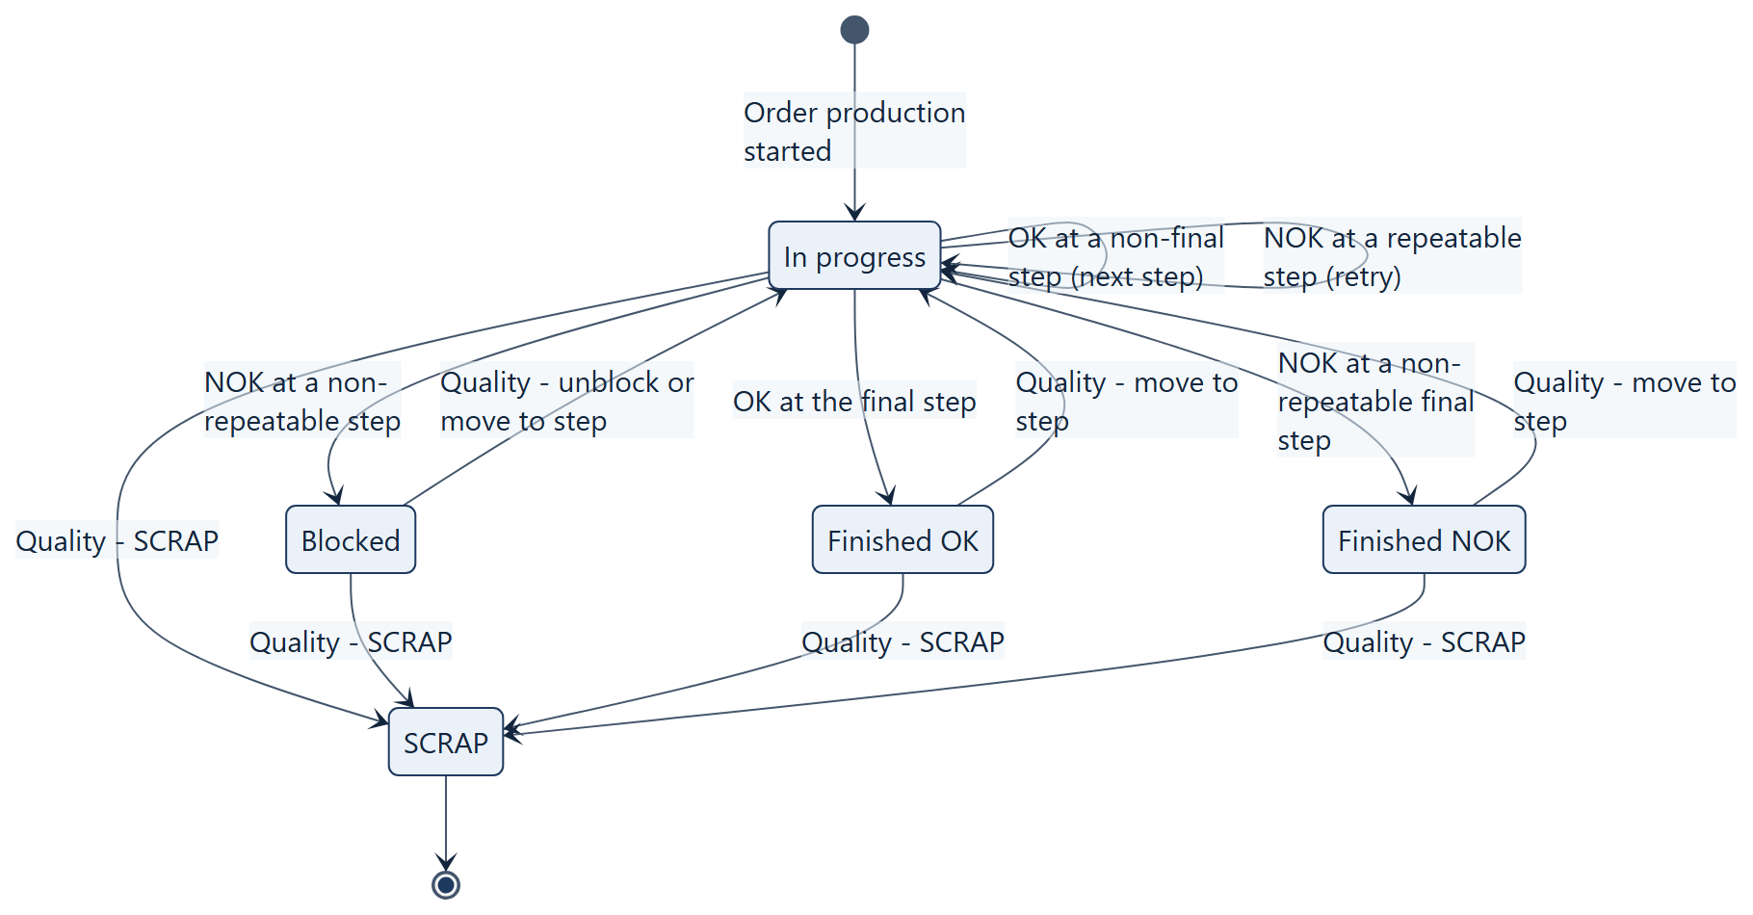
Figure 3. Unit states
"In work" lock. Scanning a unit reserves it for the station for 30 minutes – another station gets the message "The unit is in work at station …". The lock is removed when the result is saved, when the unit is cancelled (Esc), after 30 minutes, or manually in the quality module.

6. Installation – SpecInstall
Installation is performed once per company (schema).
1. Start SpecInstall.exe on a computer that can reach the database server.
2. In the PostgreSQL server group enter the IP address or host name, the port (5432 by default), the database name and the administrator login and password.
3. Click Test connection and make sure the connection works.
4. In the Installation group set:
• Database prefix – exactly 5 characters: a lowercase letter followed by lowercase letters or digits (e.g. prod1). This is the schema name.
• DB user – production / management – suggested as <prefix>_prod and <prefix>_mgmt.
• Passwords of these users – generated randomly; they can be changed (at least 8 characters).
• Folder for setup.ini files – by default setup-output next to the installer.
5. Click Install. In a single transaction the installer creates the roles, schema, tables, privileges and the MasterDATA application account. If anything fails, no object is left in the database.
6. Afterwards the output folder contains two files:
• SpecAPP\setup.ini – copy it to the SpecAPP program folder on every production station,
• SpecManagment\setup.ini – copy it to the SpecManagment program folder.
The installer never overwrites an existing schema or existing roles – in that case it stops with a message.
The setup.ini files contain (encrypted) database credentials. Hand them over through a separate, trusted channel and never place them in repositories or on public shares.

7. Preparing production step by step
The following sequence must be completed before an operator scans the first unit.
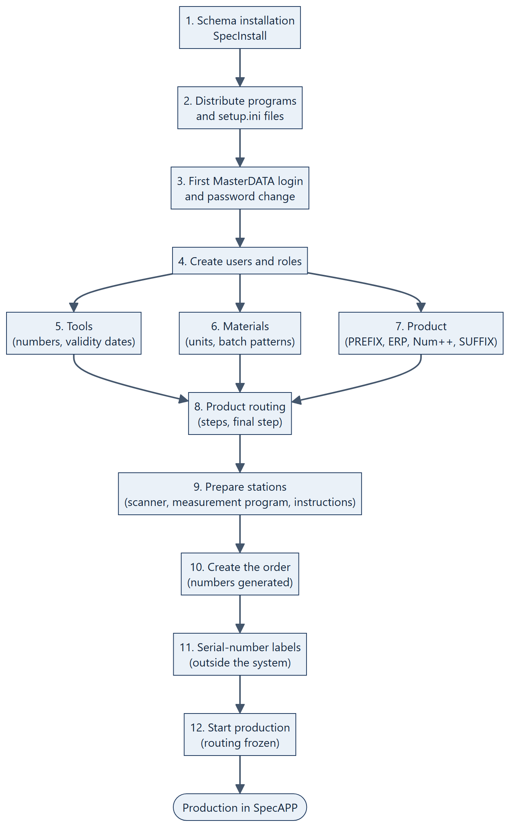
Figure 4. Preparing production – sequence of activities

Steps 1–2. Installation and distribution
Install according to section 6. Place the program folder with the correct setup.ini file on every computer. Without the file the program shows "File setup.ini is missing in the application folder" and exits.

Step 3. First login
Start SpecManagment and log in with the initial MasterDATA account and the initial password shown in the installer's final message. The system immediately forces you to set your own password. The initial password is the same in every installation, so change it before giving anyone else access to the system.

Step 4. Users ("Users" tab, MasterDATA role)
For each person: New → Login (UserID), Full name, Role, Password → Save. Every user sets their own password at first login. Create at least one operator (Production role), a planner, a technologist and a quality user. A second MasterDATA account is recommended as a spare.

Step 5. Tools ("Tools" tab, technologist or quality)
For each meter and tester: New → Serial number (exactly as encoded on the meter label or returned by the measurement program), Name, validity dates, "Active" → Save. After saving you can attach the calibration certificate.

Step 6. Materials ("Materials" tab, planner or technologist)
For each material consumed in the process: New → Name, Unit of measure, Default quantity, Batch pattern → Save.

Step 7. Product ("Products" tab, planner)
1. Fill in PREFIX, ERP VALUE, Num++ length and SUFFIX (see section 5.1).
2. Check the First number field – it shows exactly the number the first unit will receive.
3. Click Save as NEW product. After saving you can add attachments (e.g. a drawing).
Before saving, make sure the Num++ length covers the whole planned volume of the product – it cannot be changed afterwards.

Step 8. Routing ("Routings" tab, technologist)
1. Choose the product.
2. For each step: New step – suggest number → fill in the fields (section 5.3) → Add.
3. Mark the last step as Final Step?.
4. Review the step list at the top: order, kind, tool, "Repeatable" and "Final" marks.
Conditions checked by the system when the order is started: at least one step, exactly one final step with the highest number, every step valid.

Step 9. Prepare the stations
• Barcode scanner: keyboard mode, CR suffix, no space trimming; the scanner keyboard layout must match the system (characters such as / and - must arrive correctly).
• Measurement program: on every station performing an automatic step the program must be located exactly at the path entered in the step, and its folder must be writable (current.csv is created there).
• Work instructions: the file must be reachable at the path from the Work Instructions field.
• Check: start SpecAPP, log the operator in and verify the green "● Connected" status in the top-right corner.

Step 10. Order ("Orders" tab, planner)
Choose the product, enter the BOM version, quantity, dates and notes → Create order. The system assigns the order number and generates the serial numbers at once; the message shows the first and last number.

Step 11. Labels
The system does not print labels. The number range (first–last) is shown in the message after order creation and in the order statistics; the full list is available through "Order export" to CSV (column serial_no). Print the labels with an external tool and attach them to the units.

Step 12. Start production
Select the order in the list → ▶ Start production (start order) → confirm. From this moment the order routing is frozen, all units stand at the first step and stations accept their numbers.

8. Working at the station – SpecAPP

8.1. Keyboard and scanner operation
Key | Action
Enter (CR from the scanner) / TAB | move to the next field
F1 | automatic measurement
F5 | confirm result OK
F8 | confirm result NOK (a comment is required)
Esc | cancel the current unit and return to the scan field

The whole cycle can be done without a mouse: scan the number → scan/type into the following fields (each ended with Enter) → F5 or F8.

8.2. Flow of a single step
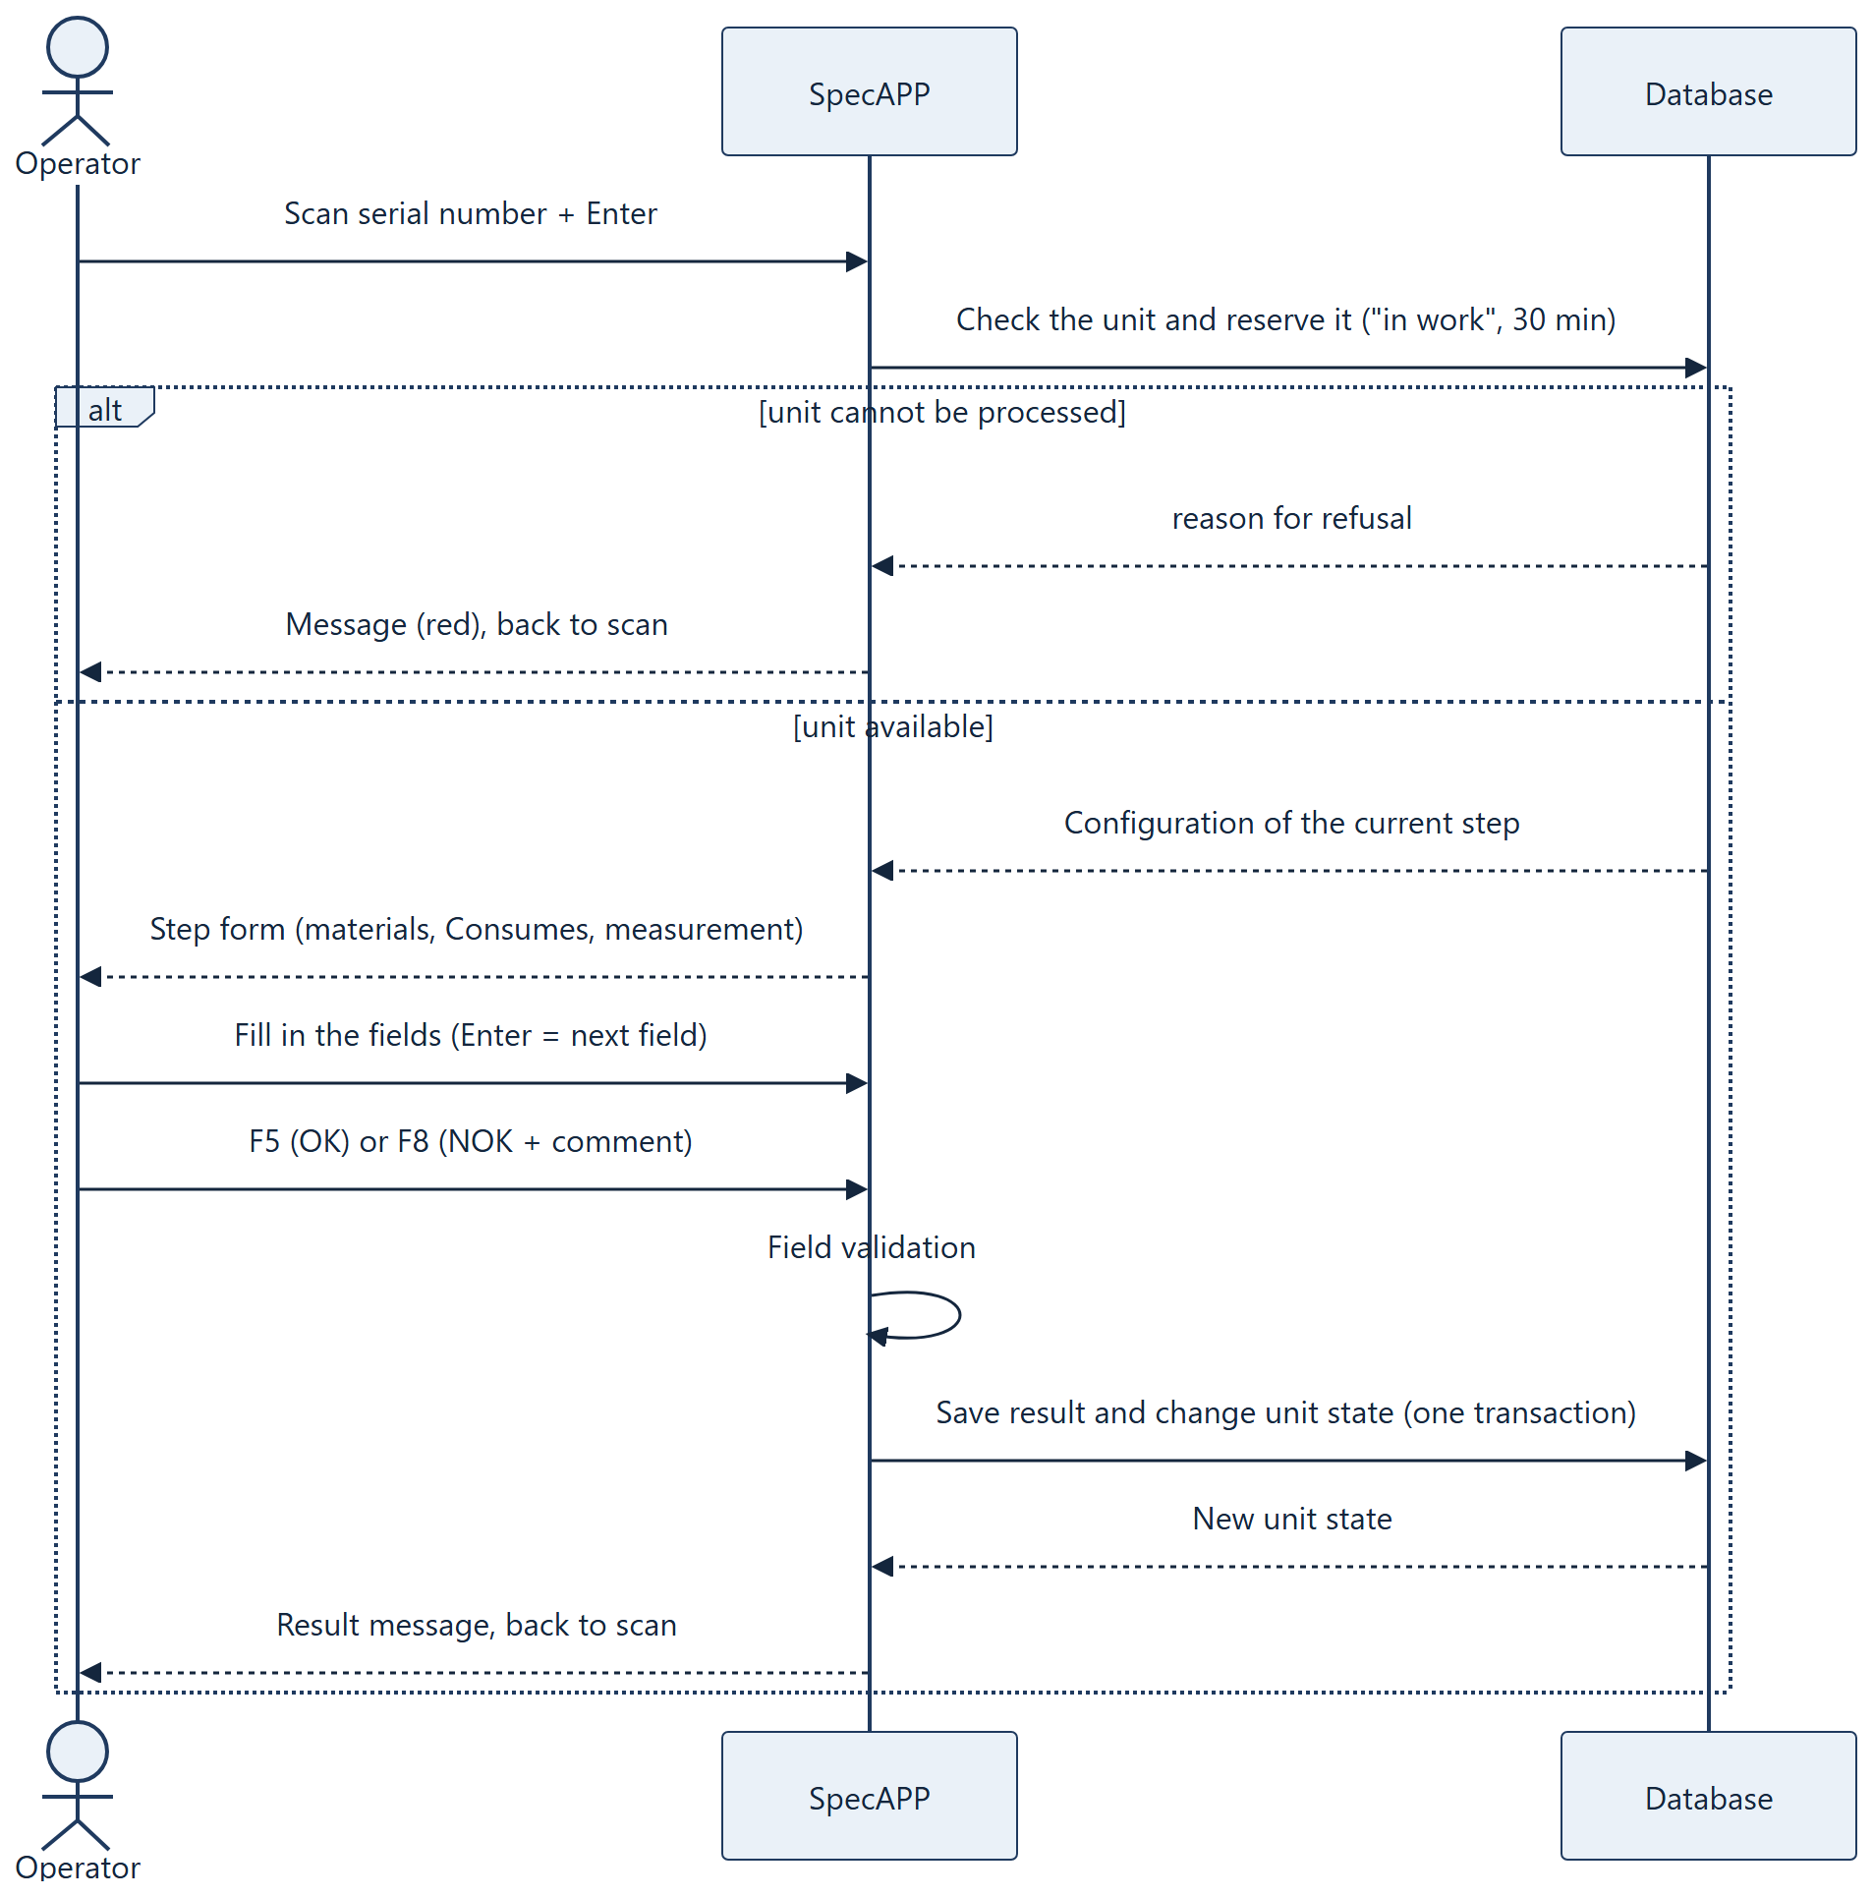
Figure 5. Flow of a single step at the station
Description of activities:
1. Login. The operator enters the UserID and password. The Production and MasterDATA roles can log in.
2. Scan the serial number. The cursor is in the "Serial number" field. After the scan the system checks the unit. The scan is rejected with a message when: the number does not exist; the order is not started or is closed; the unit is blocked, finished or scrapped; the unit is in work at another station.
3. Step form. The form shows the step number and title, the order and BOM version, the instruction text, a "Step X of Y" progress bar and the fields resulting from the configuration:
• Materials – for each: quantity used (pre-filled with the declared quantity) and batch number (scan). The batch must match the material pattern.
• Consumes – scan of the component number.
• Manual measurement – scan the meter number, then type the measured value. The meter must be exactly the tool assigned to the step and must be valid. A decimal comma or point is accepted.
• Automatic measurement – the MEASURE button (F1); see section 9.
• Comment – always available, required for NOK.
4. Decision.
• F5 – OK. All fields must be filled in correctly and the measured value must be within limits. Otherwise the system points to the faulty field and does not save the result.
• F8 – NOK. A comment with the reason is required. The data that was entered correctly is saved.
5. Outcome. A message states the effect:
Result | Step | Effect on the unit
OK | non-final | moves to the next step
OK | final | Finished OK
NOK | repeatable | stays at the step; the form reopens for a retry
NOK | non-repeatable | Blocked – a quality decision is required
NOK | final, non-repeatable | Finished NOK

A unit can be processed at any station – the step to be performed is determined by the unit state, not by the station. The station name is the computer name, registered automatically.

9. Automatic measurement and the current.csv file
A step with Automatic Measurement ticked has no OK/NOK buttons – the result is computed by the system.
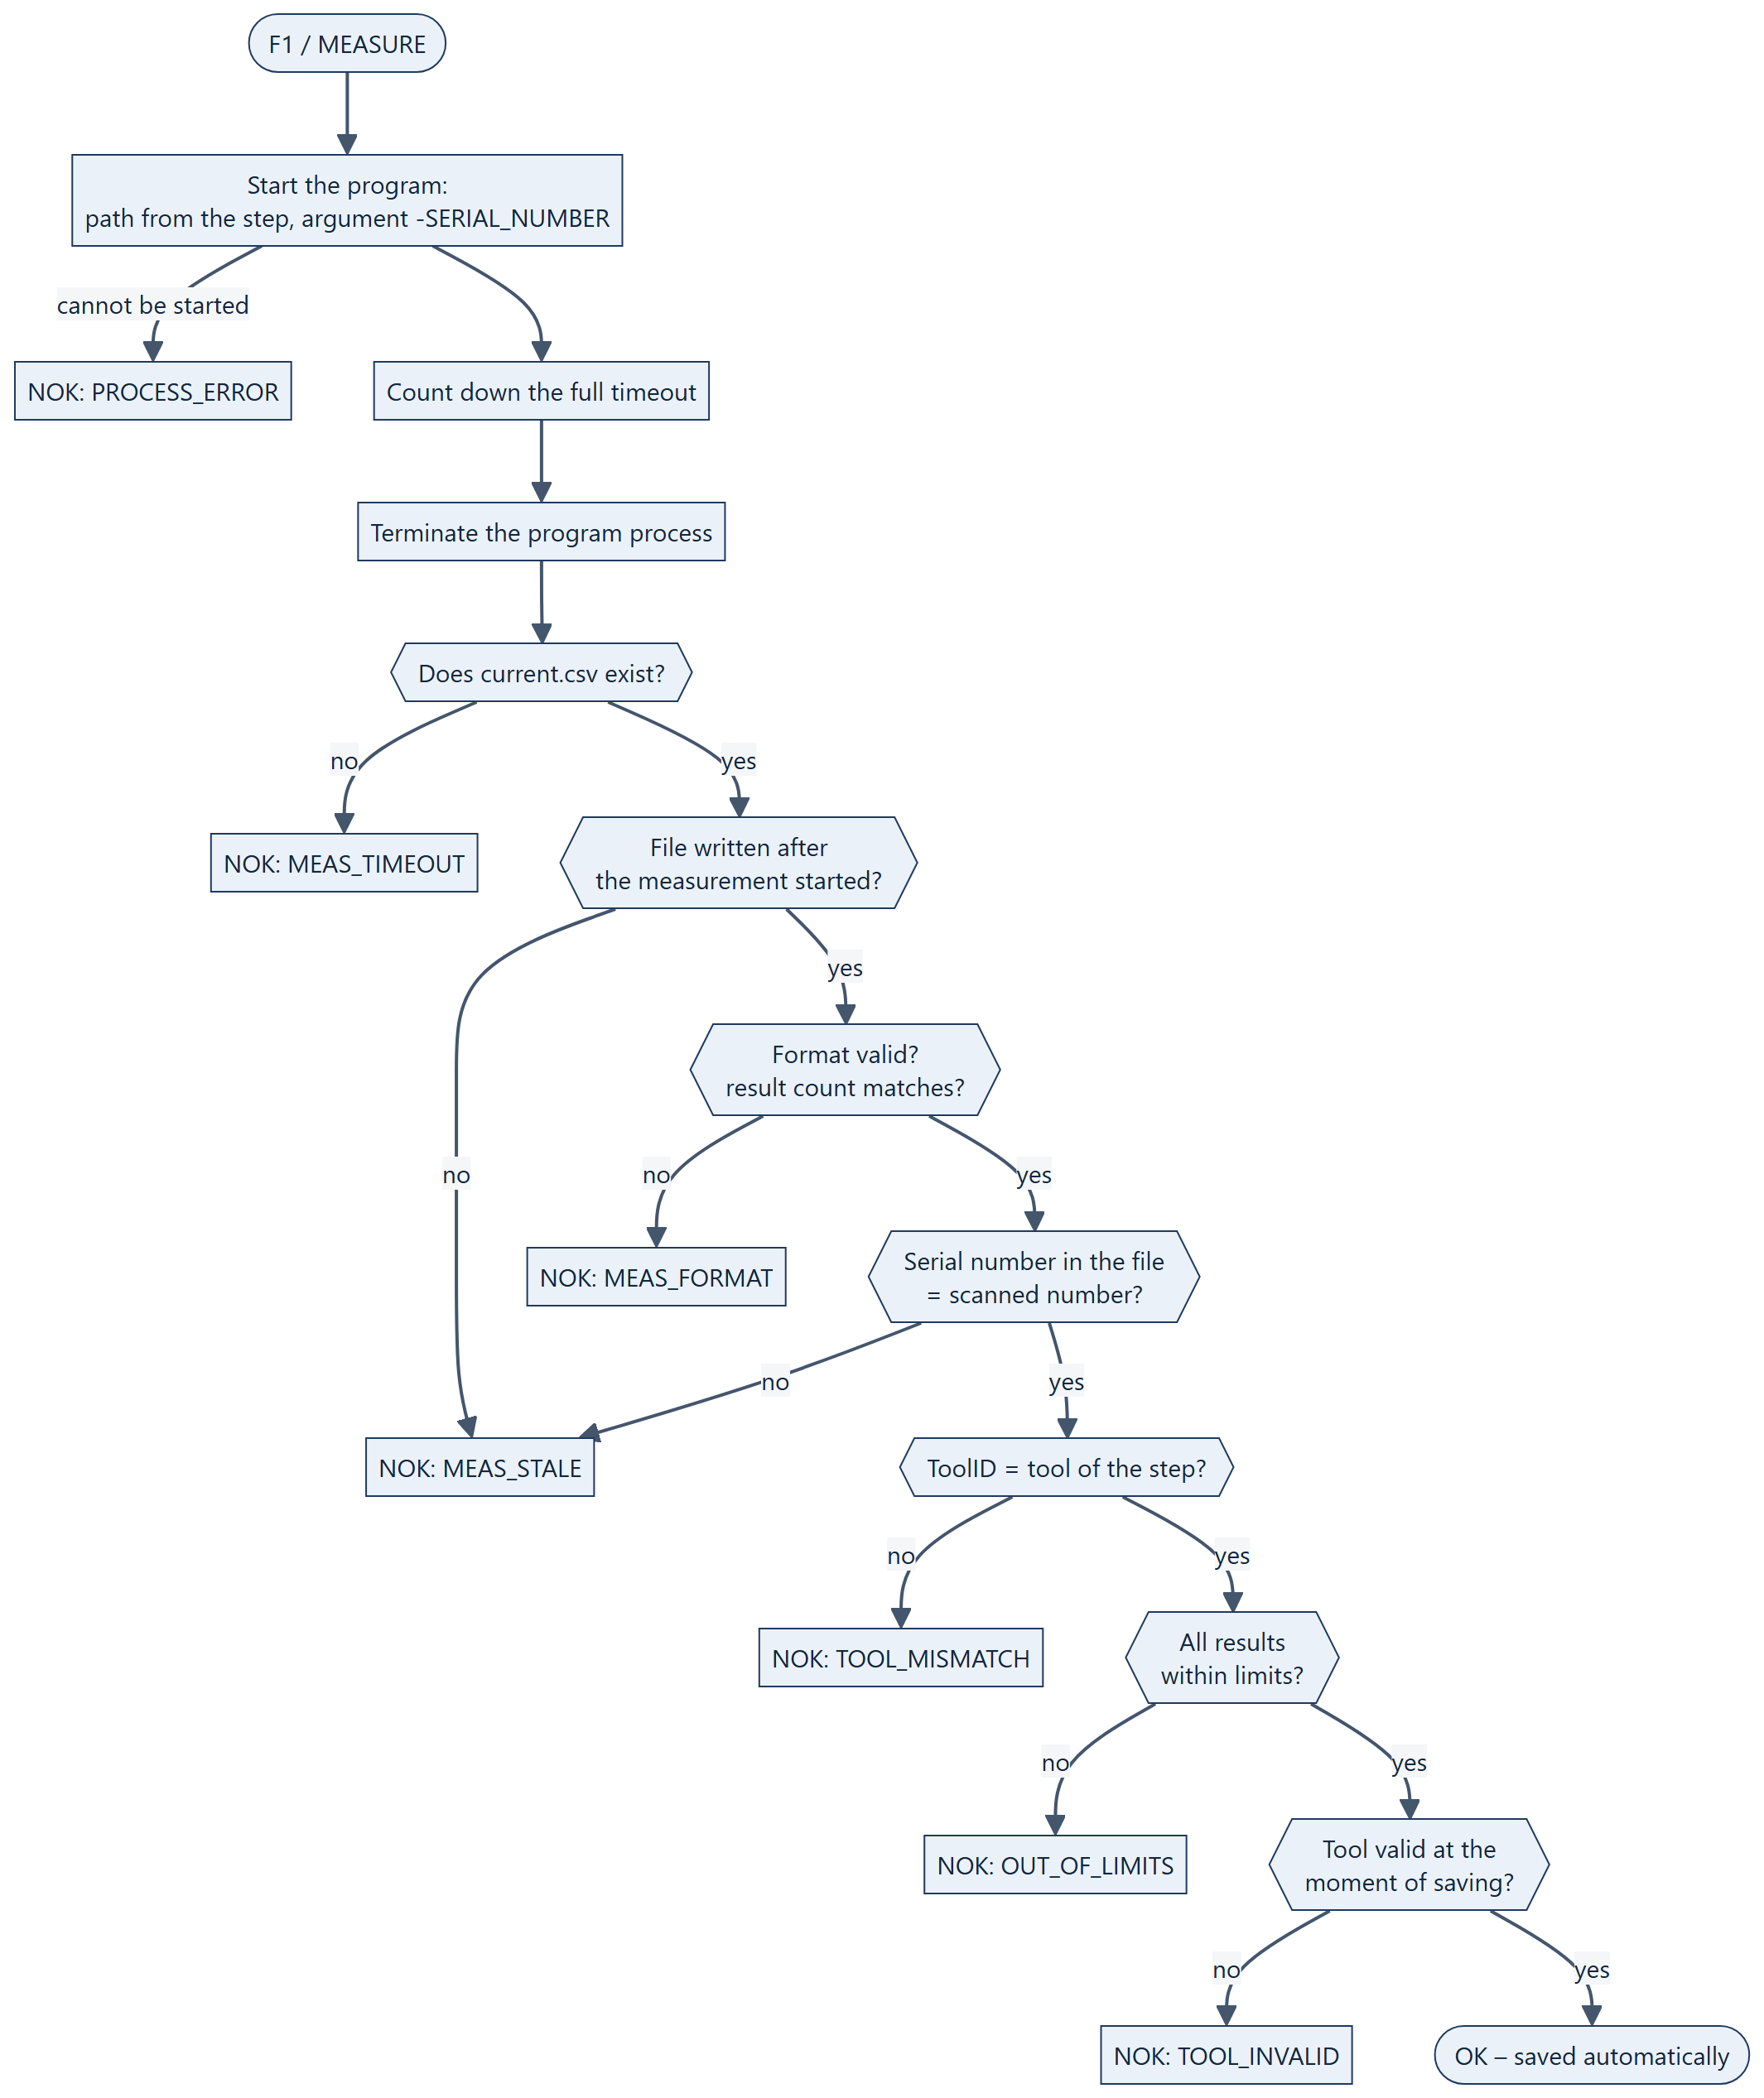
Figure 6. Automatic measurement – result evaluation

9.1. Measurement program contract
Item | Requirement
Start | SpecAPP starts the program from the path entered in the step, with the working directory set to the program folder.
Argument | A single argument: the character - followed by the serial number, e.g. -TELEFON/NOKIA10/0001 FW1.00 (spaces in the number are passed correctly).
Result file | current.csv in the same folder as the program, UTF-8 encoded.
First-line format | SERIAL_NUMBER;DEVICE_NUMBER;RESULT1;…;RESULTn;# terminated by a newline (CR, LF or CRLF).
Number of results | Exactly as many as defined in the step (1–10).
Timing | The file must be written before the timeout elapses. The system always waits the full timeout and then terminates the process – the timeout is therefore the measurement cycle time.

Example for a step with two results (voltage 4.9–5.1 V and the text OK):
TELEFON/NOKIA10/0001 FW1.00;TESTER-7;5.02;OK;#
Numeric results must use a decimal point. The trailing ;# and the newline confirm that the file was written completely – without them the file is treated as a format error.

10. Connection loss and the local buffer
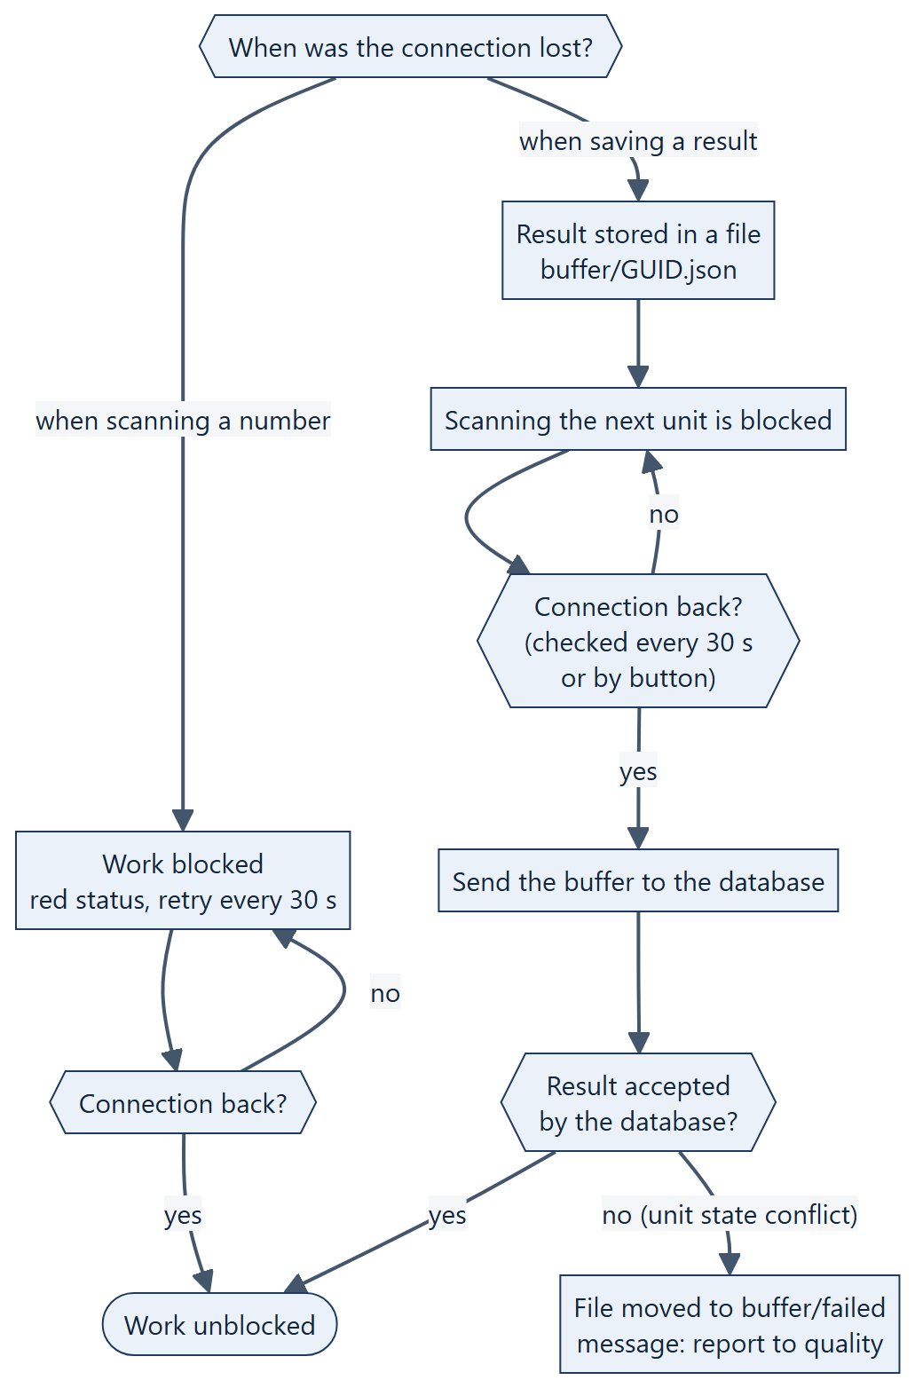
Figure 7. Handling a connection loss
• The connection status is shown in the top-right corner: green "● Connected", amber "● Buffer: N – sending", red "● NO CONNECTION – retrying every 30 s". The Check connection button forces an immediate attempt.
• A buffered result keeps its real execution time and is marked as "Buffered" in the history.
• Every result has a unique identifier, so sending the same result again never creates a duplicate.
• If the result can be stored neither in the database nor in the buffer, a "CRITICAL ERROR" message appears – the unit must not be put aside; repeat F5/F8.
• All events (scans, results, rejections, errors) are written to the station log logs/YYYY-MM-DD.log.

11. Quality module
The Quality tab in SpecManagment (Quality and MasterDATA roles).
1. Scan or type the serial number and press Enter. The Where it is now field shows the unit state, current step, order, BOM version and an "IN WORK at …" mark if present.
2. The Result history table lists all results of the unit (latest on top): time, step, result, reason, comment, user, station, tool, duration and the buffered mark. Selecting a row shows measurement values, materials with batches and the component on the right.
3. Enter a comment (required, up to 500 characters) and choose a decision:
Decision | When | Effect
Unblock (retry step) | unit is blocked | returns to "In progress" at the same step
Move to step | any unit except SCRAP | moves the unit back to the selected earlier step (for a finished unit – the final step as well); the result history is kept
SCRAP | any unit except SCRAP | final, irreversible state; requires an additional confirmation
Release "in work" lock | unit reserved by a station | releases the reservation immediately; no comment required

Every decision is stored in the audit log with the user, time and comment. Decisions are possible only for units of an active order.

12. KPI dashboard and data export

12.1. Order indicators
Indicator | Definition
OK / NOK / SCRAP / In progress / Blocked | number of units of the order in each state; NOK is shown together with SCRAP
Takt time | average interval between consecutive OK results in the order
Order open time | from the first operation until the order is closed (or until now)
Avg unit production time | from the first to the last operation, finished units only
Avg transition time between operations | from the end of a step with result OK to the start of the next step
Total retries | number of results beyond the first for each unit–step pair
Product defect rate | share of NOK, SCRAP and blocked units across all orders of the product

Charts: unit states in the order, OK/NOK results per step, planned versus actual step time, average transition time into each step.

12.2. Export
Export | Content | Format
Order export – CSV | one row per step result of every unit: order, serial number, state, step, result, error code, comment, user, station, tool, times, values 1–10, materials with batches, component | UTF-8 with BOM, separator ;, decimal point
Excel report | sheets: KPI, Steps (planned / actual / OK / NOK), Data (same as CSV) | .xlsx
Serial number export – CSV | all results of one unit plus the quality decisions from the audit log | as above

13. Security
• Minimal station privileges. The production database role can read the order configuration, append results and change only the unit-state columns. It cannot delete data and has no access to the user table.
• User passwords are stored as salted PBKDF2-SHA256 hashes. Login goes through database functions; the application never reads the user table directly.
• The setup.ini file holds the database role login and password encrypted with AES-256-GCM. The key is built into the program, so protect the file like a password: do not share it with outsiders or keep it in repositories.
• Immutability. Step results, material usage, consumed parts and the audit log are append-only. A product cannot be changed or deleted.
• Audit. Recorded events include order creation, start and closing, routing step changes, quality decisions and critical station errors.
• Operational recommendations: change the initial MasterDATA password right after installation; restrict network access to the PostgreSQL port to station addresses; back up the database regularly; install with an administrator account whose password is not known to system users.

14. Data model
Simplified relationship diagram of the schema tables (22 tables; schema_version omitted).

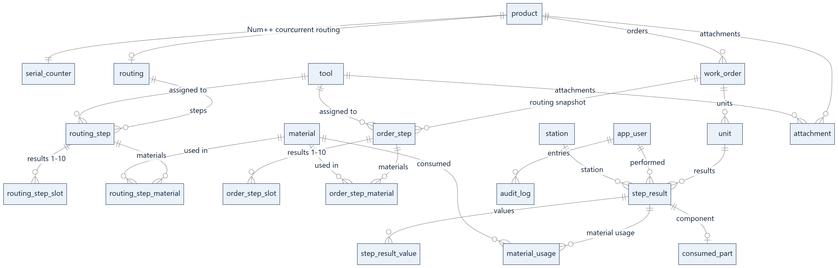
Figure 8. Data model – table relationships

15. Messages and error codes

15.1. Codes stored with a NOK result
Code | Meaning | Typical cause and action
OUT_OF_LIMITS | result out of limits | value outside LSL/USL or text different from the expected one
MEAS_TIMEOUT | no current.csv after the timeout | the measurement program was too slow or hung; check the step timeout and the program
MEAS_FORMAT | bad current.csv format | missing ;# or newline, wrong number of results
MEAS_STALE | stale or foreign current.csv | the file comes from a previous measurement or belongs to another serial number
TOOL_MISMATCH | tool does not match the routing | the program returned a ToolID other than the one assigned to the step
TOOL_INVALID | tool invalid | tool inactive or outside its validity dates; update the tool data
PROCESS_ERROR | measurement program cannot be started | wrong path in the step or program missing on the station

15.2. Most common station messages
Message | What to do
Serial number … does not exist in the system | check the label and scanner settings (spaces, keyboard layout)
Order … has not been started by the planner yet | the planner must click "Start production"
Order … is closed – work on this unit is blocked | an order cannot be reopened; decision lies with the planner and quality
Unit BLOCKED after NOK … | hand the unit over to the quality department
The unit is in work at station … | finish or cancel the work there, wait 30 minutes, or ask quality to release the lock
Conflict: the unit state has changed since the scan | scan the number again
The local buffer has not been sent to the database yet | wait for the connection or click "Check connection"
File setup.ini is missing in the application folder | copy the correct setup.ini produced by the installer

16. Checklists

16.1. Before the first system start
☐ The PostgreSQL server is running and reachable from all stations.
☐ SpecInstall finished the installation without an error.
☐ setup.ini files copied: SpecAPP to every station, SpecManagment to office seats.
☐ Initial MasterDATA password changed.
☐ Users created with the correct roles.
☐ Database backup configured.

16.2. Before starting each order
☐ Product defined; "First number" is as expected.
☐ All tools used in the routing are active and within their validity period.
☐ Materials defined; batch patterns match the real batch markings.
☐ Routing complete; the last step is marked as final.
☐ Measurement program and work instructions available at the routing paths on the relevant stations.
☐ Order created; serial-number labels printed.
☐ "Start production" clicked.
☐ A trial scan of the first unit opens the first step.

16.3. At the start of a shift (operator)
☐ SpecAPP running, the correct operator logged in.
☐ Status "● Connected".
☐ The barcode scanner types the number and moves on automatically (CR).
☐ Meters at the station carry readable number labels.

