**CS323 Assignment Documentation**

***<should consists of about 2-3 pages>***

1. **Problem Statement**

How do we write a lexical scanner for the programming language Rat17F, using a fsm?

1. **How to use your program** 
   1. First completely unzip file onto desktop.
   2. Once unzipped follow path in folder provided (Assignment1\Rat17F\Debug\ )
   3. Add Rat17F source code text file in current directory.
      1. By default there will already be one called “Rat17F.txt”
      2. If adding a new source file make sure to name it Rat17F.txt
   4. Once file is added or using default file, right click on “Rat17F.exe” (first file on top) and click “run as administrator” and if warning pops up click “run anyway”.
   5. Application will now run.
2. **Design of your program**

Used regex library to extract would be tokens from Rat17F source code file, then used a switch statement that’s argument was a string and depending on the case that executed that certain current state was returned and this process continued until the end of the string. Once reach at the end of the string a function will be called to determine whether the string of characters or character is accepted or rejected. 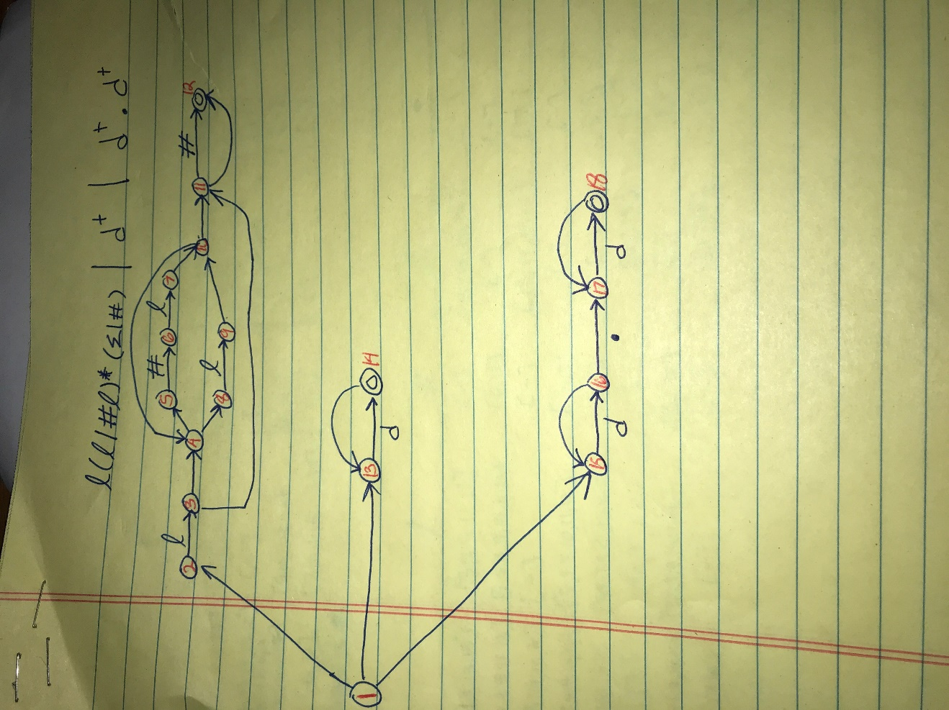

1. **Any Limitation**

*None that we are aware of.*

1. **Any shortcomings**

*None.*