Table of Contents
AwayExtensions3dsmax 2
Installation 2
Installation / Update: 2
UnInstallation: 2
The AWDExporter 3
What will be exported ? 3
ObjectContainer3d (SceneObject-Base) 4
Mesh 4
Geometries 4
Vertexnormals / Shading-Groups 5
UVMaps (SecondaryUV) 5
Mesh-Instances 5
Primitves 6
Cameras (AWDCamera-modifer) 6
Lights (LightPicker / AWD-Light-modifer / Shadows) 7
AWDSkyBox 8
Materials 8
Textures 9
AWDCubeMaterials 9
AWDEffectMethod-Modifier 9
AWDExport Settings 11
1. General Settings 11
Presets (*.awdPreset) 11
Compression 11
Scale 11
Storage Precision 12
Custom-Attributes 12
2. Scene & Geometry 12
Scenegraph 12
Geometry 13
3. Materials & Lights 13
Materials 14
Lights 15
4. Animations 15
5. Preview Options 16
The AWDToolBar and the AWDCommands 16
1. GotoAway3dForum 16
2. CheckForUpdate 16
3. OpenAWDHelp 17
4. OpenAWDAbout 17
5. ImportAWD 17
6. ExportAWD 17
7. OpenAWDHelperMenu 17
8. IncludeSelectedObjects 17
9. ExcludeSelectedObjects 17
10. AddAWDMaterialSettings 17
11. AddAWDTextureSettings 18
12. AddAWDCubeTexture 18
13. AddAWDEffectMethod 18
14. AddAWDSkyBox 18
15. AddAWDVertexAnimSource 18
16. AddAWDSkeleton 19
17. AddAWDAnimationSet 19
18. AddAWDAnimator 19
19. AddAWDLight 19
20. AddAWDCamera 20
The AWDCustomSettings 20
1. AWDObjectSettings 20
2. AWDMaterialSettings 21
3. AWDTextureSettings 24
The AWDModifier 24
1. AWDSkeleton - / AWDSkeletonClone - modifier 25
2. AWDVertexAnimSource - / AWDVertexAnimSourceClone - modifier 27

AwayExtensions3dsmax

Installation

Installation / Update:
- Open the unzipped installation-package in the explorer.
- Find and run the setup-file for your 3dsmax version.
Setup files:
- 3dsmax 2011 x32: "setup_2011_x32.cmd"
- 3dsmax 2011 x64: "setup_2011_x64.cmd"
- 3dsmax 2012 x32: "setup_2012_x32.cmd"
- 3dsmax 2012 x64: "setup_2012_x64.cmd"
- 3dsmax 2013 x32:: "setup_2013_x32.cmd"
- 3dsmax 2013 x64: "setup_2013_x64.cmd"
- 3dsmax 2014 x64: "setup_2014_x64.cmd"
- Follow the instructions in the command-line window.
- When installation is complete, 3dsmax should start automaticly.

Install the AWDToolBar:
- In 3dsmax go to "Customize"->"Customize User Interface"
- Open the "Toolbar"-Panel
- If you have allready had AwayExtensions3dsmax installed, than remove the AWD Toolbar from the tool-bars list (select "AWD" in the list and press delete)
- Load the AWDToolBar-file for your 3dsmax version.
AWDToolBar-files:
- 3dsmax 2011/2012: "AWDToolBar_2011_2012.CUI"
- 3dsmax 2013/2014: "AWDToolBar_2013_2014.cuix"

UnInstallation:
In case you want to remove AwayExtensions3dsmax, you can just run the setup file again, and, when prompted for input, choose "r" for "remove".
In case you dont have the setup-file anymore, a uninstaller can be found here:
3dsmax-plugin-folder/AwayExtensions3dsmax/
For a clean uninstallation, make shure to copy the uninstaller-file into another location, thats not part of the 3dsmax-program-directory.

Uninstall the AWDToolBar:
- In 3dsmax go to "Customize"->"Customize User Interface"
- Open the "Toolbar"-Panel
- Remove the AWD Toolbar from the tool-bars list (select "AWD" in the list and press delete)

The AWDExporter

The AWDExporter is the core of the AwayExtensions3dsmax. It is a exporter-plugin, that allows to export 3dsmax scenes as AWD-files, ready to use in Away3d (as3/ts).

The AWDExporter can work with the normal "export" function, and with the "export selected" function.
When working with the "export selected"- function, please notice that the exporter will still export dependencies for selected objects, no matter if the dependency is selected or not. (e.g. A light that is used on a selected object is exported, even if the light wasnt selected).

What will be exported ?

Basically the exporter will traverse the scenegraph, and export all supported objects and their dependencies, as long as the objects are not set to be excluded from export.
Objects can be exluded from export for one of these reasons:

- Excluded because the export mode is "export selected", and the object is not selected.
- Excluded because of AWDExporter Settings (see AWDExporter Settings)
- Excluded because of AWDObjectSettings
- Excluded because the object is used as bone, or child of a object that is used as bone
- Excluded because object is of unsupported type, and contains no children

A unsupported object that contains children, will be exported as mesh / geometry (if they contain any geometry) or as ObjectContainer3d (if they dont contain any geometry).

Supported Scenegraph-Objects are:

- Helper/Container = > ObjectContainer3D
- Meshes = > Mesh / Geometry
- Some of the 3dsmax standart primitves = > Primitive
- Cameras = > Camera3d
- Camera with AWD-Camera-Modifier = > TextureProjector
- Lights = > PointLight / DirectionalLight
- AWDSkyBox (Custom AWD-Object) = > SkyBox

Supported Non Scenegraph-Objects are:

- StandartMaterial = > material
- MultiMaterial = > multiple materials
- Bitmap-Textures = > textures
- AWDCubeMaterial = > cubetextures

ObjectContainer3d (SceneObject-Base)

All properties of a ObjectContainer3d are also contained in all other supported-scenegraph-objects.

All Scenegraph objects will be exported with a name, a parent, and a local transformation matrix.

In Away3d, a scenegraph object can also have a custom pivot point set, but custom pivot points will not be exporter from 3dsmax.

For all scene-graph-objects, custom attributes can be exported as a list of user-attributes (extra-attributes). You can add and edit Custom-Attributes of a 3dsmax-object by selecting the object and going to "Animation->Parameter-Editor".

Mesh

A 3dsmax-mesh is exported as a mesh-instance, that is referencing a geometry.
The Mesh-Instance is the scene-object, that includes all properties of the ObjectContainer3D.

The mesh-instance also contains a list of materials, that will be applied to the subgeometries of the geometry.

Another exported property of the mesh-instance is the "cast-shadows"-property, that only will have any affect when working with shadows.
To change the "cast shadows"-property in 3dsmax, right-click the object, choose "Object properties", and find the "cast-shadow"-checkbox.

Geometries

In 3dsmax a mesh can be though of as a collection of faces.
Meshes that have a Standart-Material applied will render all faces with this material.
Meshes that have a MultiMaterial applied, will assign the SubMaterials of the Multimaterials to the faces, using the material-id, that can be set per face.

In Away3d a Geometry can be though of as a group of SubGeometries.
Each SubGeometry can be though of as a collection of faces. All face of one subgeometry will allways be rendered with the same material.

3dsmax-meshes that have a Standart-Material applied will be exported as a Geometry-object that contains only one Subgeometry (there will be multiple Subgeometries, if the list of faces is to long to store into one Subgeometry).
3dsmax-meshes that have a MultiMaterial applied, will be exported as a Geometry-object, containing SubGeometries for each material that are used by the faces.

In other words: For the usage in away3d, the 3dsmax face-list will be reordered by the materials they have assigned.

In 3dsmax we can set up faces to use different materials-ids, but use the same material for each of this material-ids (e.g. Connect the same material to multiple slots of a Mutli-Material).
The AWDExporter has an option to merge those faces into one SubGeometry (e.g. merge faces with same materials), or to strictly export one SubGeometry per material-id that is used by a face.

Vertexnormals / Shading-Groups

When rendering an object with light, the vertexnormals are used to calculate the angle of the reflection of the light.
In 3dsmax, faces can be assigned to shading-groups.
If two 2 neightboured faces, are both assigned to the same shading group, there will be no hard edge rendered between them. If the they dont share any shading group, the border between them will be rendered as hard-edge.
The behaviour of the Shading-groups is baked into the vertex-normals on export, so the exported mesh should look the same in away3d as it did in 3dsmax.
Using the materials-facett settings, we can force the exporter, to export hard edges for all the faces.

UVMaps (SecondaryUV)

In 3dsmax a mesh can have multiple UV-maps assigned, and each texture can be set up to use a specific UV-map (uv-channel).
In Away3d however, a subgeometry can only have 2 UVMaps assigned, and the secondUV is only used for some specific effect-methods(e.g. Lightmap and alpha mask). For all standart textures, the away3d-mesh will allways use the first UVMap.
On export, the exporter will choose the UVMap to use as the subgeometry-main-UV-map by looking at the first supported texture thats used by the subgeometries-material.
If we want a SecondaryUV-Map to be exported for the subgeometry, we need to specific the Secondary UV-map to use inside the AWDMaterial-settings. The AWDMaterial-Settings can also be used to striclty define which UV-Map to use as Main-UV.

Mesh-Instances

In 3dsmax we can create multiple instances of the same mesh. A instance is a object, that is referencing the same mesh-data than another object. So if we change one of the objects (e.g. move verticles), both objects will be updated. Each of the objects can have its own material-applied.
This behaviour is supported by the exporter. Notice that the export will split the Faces into Subgeometries in a way, that all mesh-instances can be reproduced in away3d. This can lead to having the faces split into more subgeometries than you would have expected, when looking at only one of the instances.
There are some restrictions when exporting instances:
In 3dsmax we can set up a mesh-object to render with exploded faces (render all faces with hard edges), while we can set up another instance of the same mesh-object, to render with smooth shading (use shading groups to calulate hard edges). Because VertexNormals are used to define hard-edges, and in away3d a subGeometry only can have one set of VertexNormals, this is not possible to reproduce in away3d. In this case, the exporter will export each of the Meshes with its own Geometry.
The same is true for UV-Maps. When exporting multiple instances of one mesh, that are set up to use different UVMaps, the exporter will export each of the Meshes with its own Geometry.

Primitves

A primitve is a alternative type of geometry.
Instead of storing the face-lists and vertex-positions, it stores a set of properties, that are defining a simple 3d-shape.
In away3d, primitves can only have one material assigned, so 3dsmax-primitves that have multimaterials assigned, will not be exported as away3d-primitives.
Also 3dsmax-primitves that are animated, can not be exported as away3d-primitives.

Supported Primitve-types are:

- Plane
- Box (in away3d = cube)
- Sphere
- Cone
- Cylinder
- Torus

Cameras (AWDCamera-modifer)
Cameras are getting exported as Camera3D.
Camera3D include all properties of the ObjectContainer3D.
As long as no AWDCamera-modifer is applied, the the camera-lens is assumed to be of type perspective.
Exported camera-properties are:
- FOV (field of view)
- Clipping planes ("Near Clip" and "Far Clip" both will be scaled by the exporter scale)

AWDCamera-modifier can be used to define other types of lenses than "perspective", and the properties available for this lenses.
Lens-Type | Properties
Orthographic Lens | Projection-Height, Default=600
Orthgraphic-Offscenter Lens | Range X (min, max), Default= (-400, 400)  Rangy Y (min, max), Default= (-300, 300)

AWDCamera-modifier can also be used to export a TextureProjector at the same scene-graph-position as the camera.

A TextureProjector is used together with a Texture-projector method, to project textures onto materials.
The TextureProjector and Texture-Projector-method is not 100% tested and finished yet.

Lights (LightPicker / AWD-Light-modifer / Shadows)
Lights are getting exported as PointLight or DirectionalLight.

PointLight include all properties of the ObjectContainer3D.

DirectionalLight include all properties of the ObjectContainer3D, except that it stores a directional vector instead of the transformation-matrix.

While multiple types of 3dsmax lights can be exported as either Point or Directional light, it is recommended to stick to the usage of Omnilight and Free-directional light, as these light-types translate best to the away3d light-objects.

Exporter Light properties:

Color – will be exported as diffuse, specular and ambient color
Multiplier – will be exported as diffuse, specular and ambient level
Diffuse checkbox – if disabled, level of diffuse is 0
Specular checkbox – if disabled, level of diffuse is 0
Ambient Only checkbox – if disabled, level of diffuse is 0
If Far Attentuation is used, the radius of the pointlight will be the Start-value, the falloff of the pointlight will be the End-value.
If the radius and the fallof are set from the Far Attentuation, than they will be scaled by the exporter-scale.

All light-properties can be be strictly overwritten by using the AWDLight-modifier.
If the radius and the fallof are set from the AWDLight-modifier, than they will not be scaled by the exporter-scale.

When exporting lights in a scene, away3d-lightpicker will be created in a way, that the same lightning can be reconstructed in away3d.
To change the list of object that should be affected by a light, select the light object in the modifier panel, and in the "General Parameters" hit the "exclude" button.

The AWDLight-modifier can be used to define a shadow-method and shadow-mapper to be used with this light.

The available shadowmethods and shadow-mapper vary with the type of light.

In away3d a shadowmethod have to be assigned to a material to have any effect.
To use the Shadow on all materials that are lit by this light, we can just enable the "Auto apply to all lit mats".
If the Shadow should only be used on specific materials, we can use AWDMaterial-Settings, to set the shadowmethod that should be used by the material.

AWDSkyBox

AWDSkybox includes all properties of the ObjectContainer3D, but it is not allowed to have any children, or to be a child of another object.

To export a valid AWDSkybox, it must have a valid AWDCubematerial assigned.

Materials

Only StandartMaterials are exported into away3d-materials. Only other supported material-type is multimaterial, but all Submaterials of a multimaterial should be of type StandartMaterial.

Exporter Material Properties:

- Diffuse Color
- Specular Color
- Ambient Color
- Ambient Level
- Specular-level
- Glossiness
- 2-Sided
- Faceted (not stored as material property, but has effect on geometry export)
- opacity (needs testing)
- diffuse-texture
- ambient-texture
- normal-texture (can be inside a normal-bump node)
- specularColor-texture as specularTexture (only first specular Texture is used)s
- specularLevel-texture as specularTexture (only first specular Texture is used)
- specularGloss-texture as specularTexture (only first specular Texture is used)

If the the shading mode is "Anisotropic", the material will have a Anisotropic-Specular-shading method assigned.
If the the shading mode is "Phong", the material will have a Phong-Specular-shading method assigned.

AWDMaterialSettings can be used to overwrite any settings that have been set by the auto-translation of the material. Also AWDMaterialSettings allow to specify material-properties that cna not be set by auto-translation.

Textures

Only Bitmap-textures of kind png, jpg or atf are supported.
(You can use the AWDtextureSettings to replace a texture on export with another file – so you can use a jpg file in 3dsmax, but export a ATF file instead...)

For Away3d a texture must be of power of 2, meaning the width and height of the texture must be one of this values: 8 / 16 / 32 / 64 / 128 / 256 / 512 / 1024 / 2048

For png and jpg files, this will be checked, and a warning will occur, if the restriction is not met.
For ATF the with and the height is not tested.

The acctuall allowed texture size depends on the usage of the texture. Some Effectmethods that are using textures, allow only a maximum size of 1024 for these textures (Ligthmap).

AWDCubeMaterials

The AWDCubeMaterial allows to define AWDCubeTextures inside 3dsmax.

It can be assigned to a AWDSkybox or a AWDEffectmethod.

For fast creation of a AWDSkyBox, it provides a button "Load CubeMap from folder".
This will let you search your hd for a collection of image-files that make up a cube-texture.
For this function to work, the image-files must follow a certain naming convention.
Example:
- TEXTURENAME_posX.jpg
- TEXTURENAME_negX.jpg
- TEXTURENAME_posY.jpg
- TEXTURENAME_negY.jpg
- TEXTURENAME_posZ.jpg
- TEXTURENAME_negZ.jpg
Now when you select one of the files, the function will load all six files into the correct slots.

AWDEffectMethod-Modifier

The AWDEffectMethod-modifier allows to define AWDEffectMethods inside 3dsmax.
These are for export-definition only, and have no visiual preview in 3dsmax.

AWDEffectMethods-modifer are created as modifier, but in away3d they have be assigned to materials.
To assign AWDEffectMethods to materials, you can either assign the AWDEffectMethod to specific materials, using the AWDMaterialSettings, or you can enable the "Apply to all mesh-mats"-checkbox, to have the AWDMaterialSettings assigned to all materials that are assigned to the mesh that is holding the AWDEffectMethod.

When assigning AWDEffectMethods to materials by using the AWDMaterialSettings, it doesnt matter on which object the AWDEffectMethod-modifier is placed.

One AWDEffectMethods-modifier provides means to create one of each available away3d-effectmethods. The order in wich this effectmethods are applied to the material can be changed using the ordering function.

Be aware that some of the Effectmethods that are using textures are only supporting texture-sizes up to 1024. (Lightmap)

More details about the specific EffectMethods coming soon.

AWDEffectMethod-Modifier

There are 3 different types of animation implemented into AWD.

- Skeleton Animation (a mesh is deformed using a skeleton-structure)
- Vertex Animation (a mesh is deformed by animating the point positions)
- UV Animation (animating the UVTransform of a mesh)

UV Animation is supported by the AwayExtensions3dsmax, but currently the UVAnimation feature of Away3d seams to be broken, so this is not really in a working state yet.

Skeleton and VertexAnimation are supported by the AwayExtensions3dsmax.

AWDExport Settings

1. General Settings
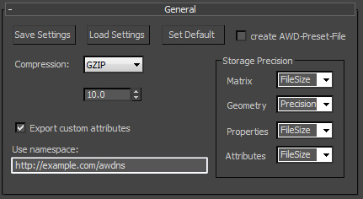

Presets (*.awdPreset)

Exporter-settings will allways be saved and restored automaticly.
You can also save exporter-settings into specific files or reload them as needed.
The extension of the saved file will be *.awdPreset, but they can be opened, viewed and edited by any text-editor.
If "" is enabled, the exporter settings will be saved into a awdPreset-file with the same name and to the same output-directory as the awd file to export.

Compression
For the compression of the complete awd-file, we have 3 options in AWD:
1: uncompressed, 2: zlip/deflate, 3: LZMA
The AWDExporter for 3dsmax only supportes uncompressed and zlib/deflate, as the LZMA encoding is not in a working state yet.

Scale
The 3dsmax scenes will most likly need to be scaled for best usage in away3d.
The scale will be applied to:
- position-vector of transformation-matrices (scenegraph-positions / skeleton-animations)
- verticles-positions
- camera far / camera near

Attention: The shadow-method-property "epsilon" is not affected by scale, but it maybe it should, as its effect depents on the scale ?

Storage Precision
For numbers, we can choose if we want them to be exported optimized for precision (float64) or filesize (float32).
This setting can be spezified individualy dependent on what the number is used for.
In AWD there are 4 different types of number-usage:
- Numbers used in Transformation-Matricies
- Numbers used in Geometry-data
- Numbers used in Object-propereties(e.g. Material-/Light-/EffectMethods-Properties)
- Numbers used in Custom Attributes

Custom-Attributes
"" lets you choose if to allow the export of custom-atributes or not.
All Custom-attributes have a namespace, so we can have custom-attributes with same names, but different namespaces.
(TODO: see how well are Namespaces implemented in AssetLibrary/Extra-Attributes)

2. Scene & Geometry

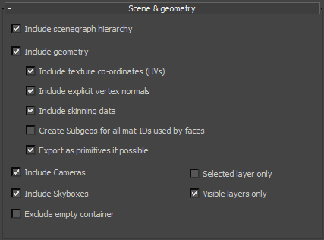

Scenegraph
The AWDExporter provides several options to filter the export of the scenegraph:

- Include scenegraph hirarchy: If disabled, no scene-object will be exported.
- Include geometry: If disabled, no geometry will be exported. Meshes will be exported with empty geometry.
- Include Cameras: Include Cameras in export
- Include SkyBox: Include Skyboxes in export
- Exclude empty container: container will only be created if a mesh is contained in the their hirarchy.
- Selected layer only: only objects on the selected layer (and their dependencies will be considered for export).
- Visible layer only: only objects on the visible layers (and their dependencies will be considered for export).

Geometry
When Geometry is not excluded from export, the following geometry-settings are available:

- Include texture co-ordinates (uv): Include UV-data in the exported geometry (in general UV-data is only needed when using textures on meshes)
- Include explicit vertex-normals: Include Vertex-Normal-Data in the exported geometry (in general Vertex-Normal-Data is used when using lights on the geometries materials)
- Include skinning data: Include the Data needed for skeleton-animation into the exported geometry. Skinning data is of course only available if the 3dsmax-object has a skin-modifier assigned.
- Create SubGeos for all mat-IDs used by faces: On export, the 3dsmax triangle-list of a mesh will be split and grouped into subgeometries for away3d according to their assigned materials. When this option is enabled, the AWDExporter, will reduce the number of exported Subgeometries, to the minimun needed to correctly display the mesh in away3d.
- Export as primitve if possible: Some of the 3dsmax primitves can be reconstructed in away3d. Enable this option to export supported primitve, whenever possible.

3. Materials & Lights

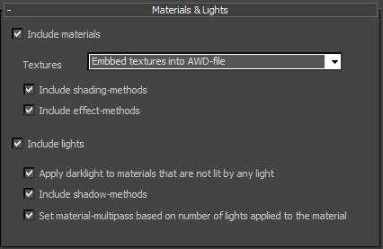

Materials
- Include materials: Include/Exlude all materials from export. Since textures are exported as dependencies of the materials, excluding materials will also exlude all textures.
- Textures: There are 4 options available for exporting textures (these settings may be overwritten by custom AWDTexture-Settings:
  - Do not export textures
  - Embbed textures into the AWD-File: The embedded data will be copied directly from the image-file into the AWD-file
  - External (relative): Store a relative path to a external texture file. (The texture file will be copied into a folder called "textures". This folder will be located next to the exported awd-file.)
  - External (absolut): Store a abolute path to a external texture file. (This is usefull for example when planning on using the awd file on a server. But be carefull with this option, as you have to make shure, that the texture-file can allways be found at the absolut path)
- Include shading-methods: Include/exclude shading methods.
- Include effect-methods: Include/exclude effect methods.

Lights
- Include lights: Include/Exlude all lights from export.
- Apply darklight to materials that are not lit by any light: only available if both materials and lights are included in export. If enabled, a light with intensity 0 will be assigned to all materials that have no lights assigned.
- Include shadow-methods: Include/Exlude shadow-methods from export.
- Set material-multipass based on number of lights applied to the material: only available if both materials and lights are included in export. If enabled, a material, that have 4 or more lights assigned, will allways be exported as multipass-material, even if custom-AWDSettings specify it as singlepass.

4. Animations

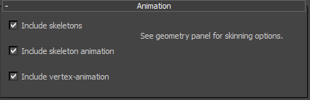

To export a valid Skeleton-Animation-setup into the AWD-file, make shure that the "Include skinning data" option of the geometry-settings is enabled.
- Include Skeleton: Include the Skeleton into export.
- Include Skeleton-Animation: Include the SkeletonAnimation-clips into export.
- Include Vertex-Animation: Include VertexAnimation into export.

5. Preview Options
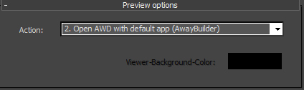

There are 4 actions that can be performed after the file is successfully exported:
- Do nothing:
- Open AWD with default app (AwayBuilder): Open the AWD-file in with the application that is used on your system to open AWD-files (AwayBuilder / Prefab3d)
- Open AWD in Browser (viewer.swf) - LOCAL: Saves a Viewer.swf and a html file together with the exported AWD, and opens the html-file with your default-browser. The viewer.swf used to load the AWD-file in the html, is compiled for local/offline usage.
- Open AWD in Browser (viewer.swf) - NETWORK: Saves a Viewer.swf and a html file together with the exported AWD, and opens the html-file with your default-browser. The viewer.swf used to load the AWD-file in the html, is compiled for network usage.

When using on of the actions that will open the AWD in the browser, we can set "Viewer-Background-Color" to customize the background shown in the browser.

The AWDToolBar and the AWDCommands

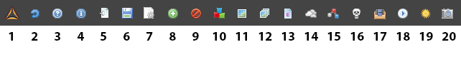
The AWDToolBar is a toolbar for 3dsmax that provides access to the AWDCommands.
The AWDCommands are a set of maxscript-usermacros, to help prepare a 3dsmax scene for export as AWD.

1. GotoAway3dForum

Open the Away3d-forum in your default browser.

2. CheckForUpdate

Check if a newer version is available.
If a newer version is available, the function will open your default browser and go to:
https://github.com/awaytools/AwayExtensions-3dsmax/releases

There you can download the latest version of the plugin.

3. OpenAWDHelp
Opens this pdf-file with your default application for reading pdf.

4. OpenAWDAbout

Opens a About-dialog showing the version number of the installed AwayExtensions3dsmax.

5. ImportAWD

Import a AWD-File into 3dsmax.
!!!Not in a working state yet. Sorry for teasing.!!!!

6. ExportAWD

Export the current scene as AWD.
!!!Using this command to trigger the export process has one unsolved issue:
- when the target awd-file allready exists, 3dsmax will ask 2 times if it should be overwritten!!!

7. OpenAWDHelperMenu

Opens a dialog containing the same buttons as the AWDToolBar.
Instead of icons, the buttons of these dialog are using the AWDCommand-names as labels.

8. IncludeSelectedObjects

Tags the selected objects so they will be included when exporting.
(Objects are included by default, this is only needed to re-include objects that were excluded earlier)

9. ExcludeSelectedObjects

Tags the selected objects so they will be excluded when exporting.
The childs of a excluded object will allways be excluded too.

10. AddAWDMaterialSettings

Adds AWDMaterialSettings to the material that is selected in the Material-editor.
Only StandartMaterials can hold AWDMaterialSettings.
If a MultiMaterial is selected in the Material-editor, the AWDMaterialSettings will be added to all StandartMaterials that are used by the MultiMaterial
If no material is selected in the Material-editor at all, a popup will ask if AWDMaterialSettings should be added to all materials of all selected objects.
If no object is selected, a popup will ask, if AWDMaterialSettings should be added to all materials found in the scene.

11. AddAWDTextureSettings

Adds AWDTextureSettings to the TextureBitmap that is selected in the Material-editor.
Only TextureBitmap can hold AWDTextureSettings.

If no TextureBitmap is selected in the Material-editor , but a Material is, a popup will ask if AWDTextureSettings should be added to all TextureBitmaps used by this material.
If this is a MultiMaterial, all TextureBitmaps connected to all StandartMaterials that are connected to the MultiMaterial will get AWDTextureSettings assigned.

If nothing is selected in the Material-editor at all, a popup will ask if AWDTextureSettings should be added to all textures, used by materials of all selected objects.
If no object is selected, a popup will ask, if AWDTextureSettings should be added to all textures found in the scene.

12. AddAWDCubeTexture

Creates a AWDCubeTexture (material), opens the Material-editor, and inserts the AWDCubeTexture into the first View of the Material-editor (creates new View if none exists).

13. AddAWDEffectMethod
Adds a new AWDEffectMethod to the selected object
If multiple objects are selected, a error pops up.
If no object is selected, a popup asks if all objects, that holds AWDEffectMethods, should be selected.

14. AddAWDSkyBox

Adds a new AWDSkyBox to the 3dsmax-scene, selects it, and opens the modifier-panel.
The new AWDSkyBox will have a size of 100.0.

15. AddAWDVertexAnimSource

Adds a new AWDVertexAnimSource-modifier to the selected object.
If more than 1 object is selected , than popup error.
If the selected object will not be exported as mesh, than popup error.
If the selected object allready has a AWDVertexAnimSource-modifier, than popup error.

If no object is selected, a popup will ask, if all objects should be selected, that are holding any AWDVertexAnimSource-modifier or AWDVertexAnimSourceClone-modifier.

16. AddAWDSkeleton

Adds a new AWDSkeleton-modifier to the selected object.
If more than 1 object is selected , than popup error.
If the selected object doesn not contain any children, than popup error.
If the selected object allready has a AWDSkeleton-modifier, than popup error.

If no object is selected, a popup will ask, if all objects should be selected, that are holding any AWDSkeleton-modifier or AWDSkeletonClone-modifier.

17. AddAWDAnimationSet

Adds a new AWDAnimationSet-modifier to the selected object.
If more than 1 object is selected , than popup error.

If no object is selected, a popup will ask, if all objects should be selected, that are holding any AWDAnimationSet-modifier.

18. AddAWDAnimator

Adds a new AWDAnimator-modifier to the selected object.
If more than 1 object is selected , than popup error.
If the selected object allready has a AWDAnimator-modifier, than popup error.

If no object is selected, a popup will ask, if all objects should be selected, that are holding any AWDAnimator-modifier.

19. AddAWDLight

Adds a new AWDLight-modifier to the selected light object.
AWDLight-modifier can be used to define AWD-Shadow-methods.

If no object is selected, a popup will ask, if all light-objects should be selected, that are holding any AWDLight-modifier.

20. AddAWDCamera

Adds a new AWDCamera-modifier to the selected camera object.
AWDCamera-modifier can also be used to define a AWD-TextureProjector.

If no object is selected, a popup will ask, if all camera-objects should be selected, that are holding any AWDCamera-modifier.

The AWDCustomSettings

The AWDCustomSettings can be applied to objects, as a means to define some object specific properties for export.
At this time are 3 different types of AWDCustomSettings:
- AWDObjectSettings (can be applied to all objects)
- AWDMaterialSettings (can only be applied to 3dsmax-StandartMaterials)
- AWDTextureSettings (can only be applied to 3dsmax-TextureBitmaps)

Please note that AWDCustomSettings can not be removed from the 3dsmax-object once they are applied.
This is due to restrictions of maxscript. (Acctually it would be possible to remove the AWDCustomSettings, but 3dsmax would have to get restarted after the process, so i dont think that is an option.)

1. AWDObjectSettings
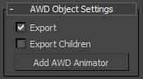

The AWDObjectSettings can be applied to all objects.
They provide 2 checkboxes to include/exclude a object and its children from export.
They also provide a Button, to create a AWDAnimator-modifier for this object.

2. AWDMaterialSettings
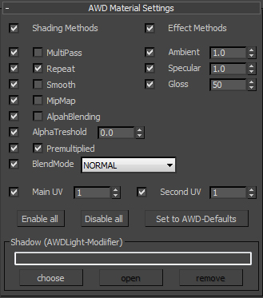

The AWDMaterialSettings can be applied only to 3dsmax-StandartMaterials.
While the exporter will try to convert the StandartMaterials properties to Away3d-material properties without using any , the AWDMaterialSettings provides a way to explicit define Away3d-materialproperties for export.
The AWDMaterialSettings provide a checkbox for each property. This checkboxes can be used to enable/disable the definition of specific properties.
The AWDMaterialSettings are getting parsed after the parsing of the 3dsmax-material. Properties that are enabled in the AWDmaterialSettings will overwrite the previous defined properties.

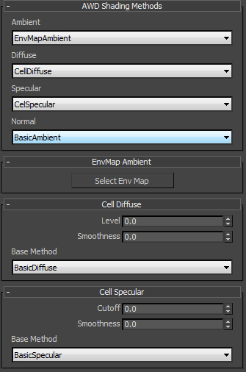
If the "Shading Methods" of the AWDMaterialSettings is enabled, the "AWD Shading Methods" Rollup will be visible. Here you can explicit select which Shading methods to use on the material.
Some of the AWDShadingMethods have no need for any properties. If you select a Shading-method that includes changeable properties, a Rollup will apear. (see above example for "EnvMap Ambient", "Cell-Diffuse" and "Cell Specular").

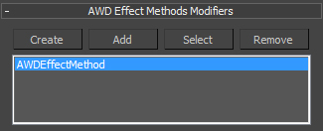

If the "effect methods" of the AWDmaterialSettings is enabled, the "AWD Efect Methods" Rollup will be visible. All AWDEffectMethod-modifiers that are listed here, will be exported as Effectmethods on the AWD-Material. (see. AWDEffectMethod-Modifier)

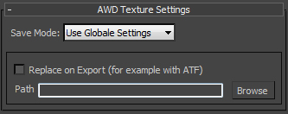
3. AWDTextureSettings

The AWDTextureSettings can only be applied to a 3dsmax BitmapTexture.
It provides a way to define per texture, if the texture should be embed into the AWD-file or as external jpg/png file.
It also provides a way, to replace the path of a texture with another path to a other texture on export.
This is meant so we can view a jpg/png file in 3dsmax, while exporting a ATF file to away3d.

The AWDModifier

AWDModifier are used to define sets of properties for objects.

The available AWDModifier types are:

- AWDSkeleton / AWDSkeletonClone
- AWDVertexAnimSource / AWDVertexAnimSourceClone
- AWDAnimator
- AWDAnimationSet
- AWDEffectMethod
- AWDShadowMethod

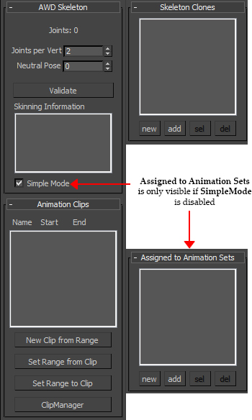
1. AWDSkeleton - / AWDSkeletonClone - modifier

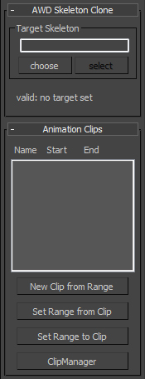
The AWDSkeleton should be applied to the root-joint of your rigg.
It provides a way to set the joint-per-vert (how many joints will affect each point), and the frame at which the rigg should be considered as neutral pose (t-pose).

After validating the AWDSkeleton (checking all the skins it is used by), some informations about the skinning will be visible in the Skinning-Information-listbox.

As long as SimpleMode is turned on, the exporter will automaticly create the needed AnimationSet and Animator to animate the skinned mesh. If SimpleMode is turned off, you have to manually assign the skeleton to one ore more AWDAnimationSets, using the "Assigned to Animation Sets"-listbox.

!!!ATM you should not manually create AnimationSets and Animators, but allways use the SimpleMode!!!!

To define Animation-Clips for export, the AWDSkeleton provides the Animation-Clips list.
The Animation-Clips-list only displays name, start-frame and end-frame for each AnimationClip, but you can open the ClipManager to access more of the AnimationClip-properties. (see ClipManager)

No Away3d scene-object will be created for a 3dsmax-object that holds a AWDSkeleton or a AWDSkeletonClone.

The SkeletonClone-list lets you link the AWDSkeletonClones to this AWDSkeleton.

It might be that you want to include a animation into your AWDFile, that does not exists on the joint-hirarchy that is used to drive the skin, but on a copy of this hirarchy.
This is what the AWDSkeletonClone is for.

A example fo the AWDSkletonClone workflow could be like this:

- Create a keyframe-animation on your base rigg (the one that is used by the skin)
- copy the joint hirarchy of the base rigg.
- Replace the AWDSkeleton with a AWDSkeletonClone
- Link the AWDSkeletonClone to the AWDSkeleton ("Target Skeleton")
- Remove the keyframe-animation from the base rigg
- now your baserigg is free to be animated again, but the animation will still be exported.

The AWDSkeletonClone provides the same interface for managing AnimationClips as the AWDSkeleton.

2. AWDVertexAnimSource - / AWDVertexAnimSourceClone - modifier
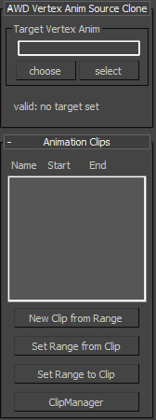
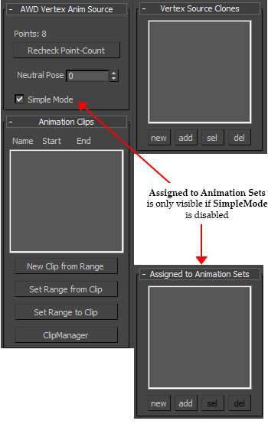
The AWDVertexAnimSource / AWDVertexAnimSourceClone are very similair to the AWDSkeleton/AWDSkeletonClone.

They provide the interface for working with AnimationClips as the AWDSkeleton/AWDSkeletonClone.

The AWDVertexAnimSource-modifier should be applied to a animated 3dsmax mesh object.

No Away3d scene-object will be created for a 3dsmax-object that holds a AWDSkeleton or a AWDSkeletonClone.

