C R E A T I V E

L E A R N I N G

+

W E A R A B L E

T E C H N O L O G Y

BECCA ROSE

@beccaerose

research.beccarose.co.uk

beccarose.co.uk

Overview

This session is about design, technology, and creative learning.

We will cover:

Creative learning

Ideation

Wearable Technology

Making

In a combination lecture, discussion, and making.

What is wearable technology?

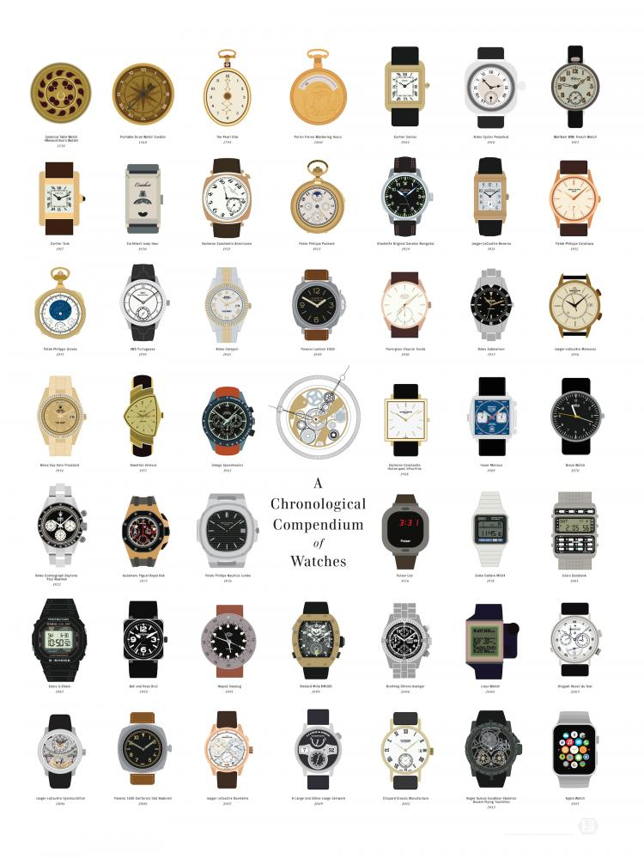

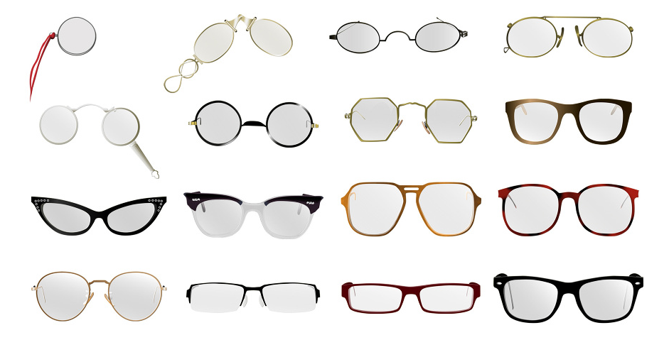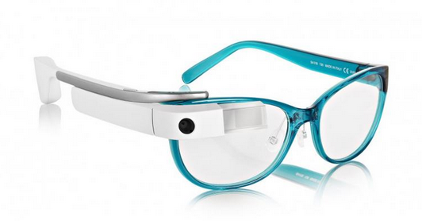

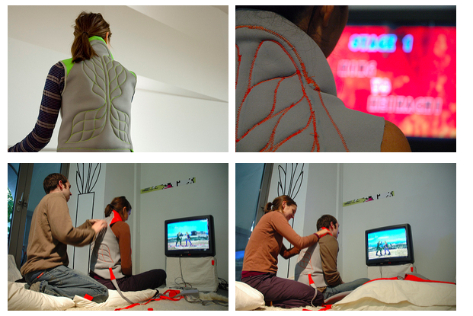

Kobakant “Massage me” 2007

A wearable massage interface that turns a video game player’s excess energy into a back massage.

[www.massage-me.at](http://www.massage-me.at/" \t "_blank)

Intel + spider dress (commercial community)

My take on wearable technology

Clipper Critter

Drawing Breath

Human Breadboards + research started in September –something I ma researching at Goldmsiths

How do you go beyond the swatch? (i.e. build wearable tech in to the curriculum in a meaningful and critical way)

How do you focus on process and learning, and not the product?

Creative learning for sustainable futures

"A boarder vision of technology education demands that socio-political, cultural and environmental facets of the 'multidiscipline' be integrated so that the subject is not simply focused on preparing future technologists but rather technology capable critical thinkers"

Elshof, L. (2009). Toward sustainable practices in technology education. International Journal of Technology and Design Education, 19(2), 133-147.

NuVu –storytelling project

Process (bus photo, written response was the most detailed and interesting from that point)

Process (discussion + prototyping)

Prototype

Development

Using technology with social implications: empathy, technology for solving problems, and an active engagement with capability of technology (beyond consuming)

What is more, they are excited about the capability

“quote from nu vu student about the arduino”

Activity 1

Identify areas of interest.

Parts of the body

Emotion

Empathy

Quick thinking and Passing on design

Discussion

Dialogical education

Paulo Friere

My experience at Lick Wilmerding and the atmosphere it created (i.e. learning teachers and teacters learning –you will never know all the things, enjoy that and bring it into your practice)

Transformative learning

Expansive learning

Activity 2

Circuit building: What is a circuit

Actualtos and sensors (Bare minimum)

Other Technology that is available

Programers (which ones to choose?!)

-quote from nuvu workshop girl

Tacit Knowledge and –get quote from dorit’s essay about making

E-textile summer camp and Swatch exchange

Activity 3

Making Acticities

Materials –SS Great Britian

3d sketching / rapid prototype

story-making / narrative

performance / roleplay / presentaion

Idea that design designs us and we design design (ontological design)

Feedback wall “what does creative learning mean for you”–and also write where you are from so we can gage who is in the workshop.

Discusssion Questions

(record discussion)