Introduction to Pandas
Pandas is a Python library for data manipulation and analysis.
It provides fast, flexible, and expressive data structures:
- Series → 1-dimensional
- DataFrame → 2-dimensional (rows & columns)

🔥 Why Pandas?
- Clean messy data
- Load data (CSV, Excel, SQL, JSON, etc.)
- Analyze and summarize data
- Work with time series
- Perform statistics
- Join, merge, group data
- Build datasets for Machine Learning

⭐ Key features
- Handling missing data
- Powerful indexing and slicing
- Fast vectorized operations
- Built-in plotting
- Integration with NumPy, Matplotlib, Scikit-Learn

1. Installing & Importing Pandas
pip install pandas

2. Import:
import pandas as pd

Pandas Series

What is a Series?
A Pandas Series is like a column in a table.
It is a one-dimensional array holding data of any type.
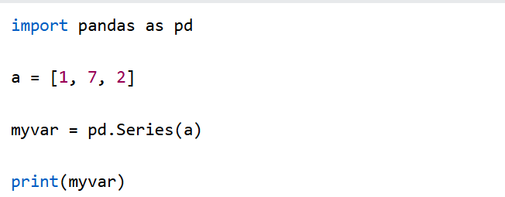
If nothing else is specified, the values are labeled with their index number. First value has index 0, second value has index 1 etc.
This label can be used to access a specified value.

Print (myvar[0])

Create Labels
With the index argument, you can name your own labels.
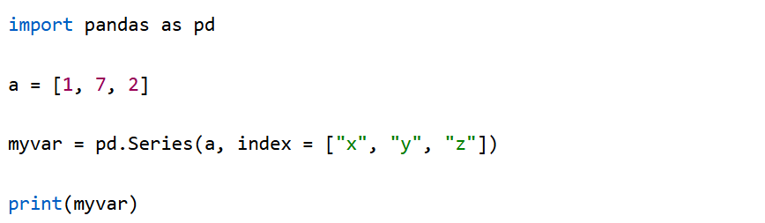

print(myvar["y"])

Pandas DataFrames

What is a DataFrame?
A Pandas DataFrame is a 2-dimensional data structure, like a 2-dimensional array, or a table with rows and columns.

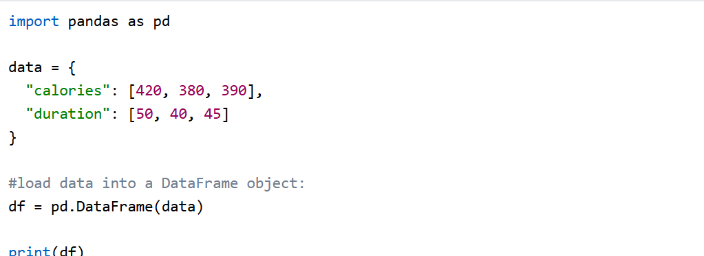

Creating a DataFrame from a List of Dictionaries
We can also create dataframe using List of Dictionaries. It represents data where each dictionary corresponds to a row. This method is useful for handling structured data from APIs or JSON files. It is commonly used in web scraping and API data processing since JSON responses often contain lists of dictionaries.

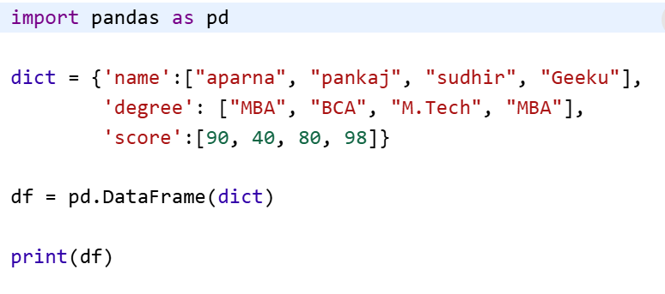

Pandas Access DataFrame

Accessing a dataframe in pandas involves retrieving, exploring, and manipulating data stored within this structure. The most basic form of accessing a DataFrame is simply referring to it by its variable name. This will display the entire DataFrame, which includes all rows and columns.

Output
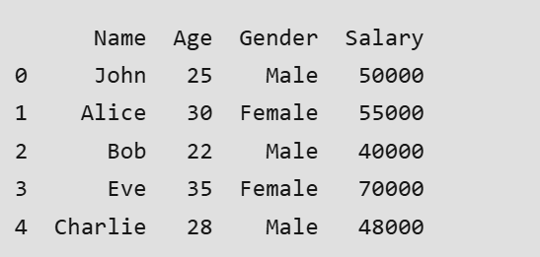

1. Accessing Columns From DataFrame
Columns in a DataFrame can be accessed individually using bracket notation Accessing a column retrieves that column as a Series, which can then be further manipulated.

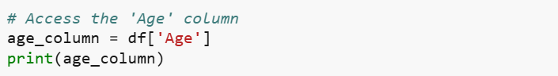

2. Accessing Rows by Index
To access specific rows in a DataFrame, you can use iloc (for positional indexing) or loc (for label-based indexing). These methods allow you to retrieve rows based on their index positions or labels.
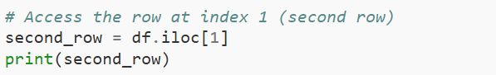

3. Accessing Multiple Rows or Columns
You can access multiple rows or columns at once by passing a list of column names or index positions. This is useful when you need to select several columns or rows for further analysis.

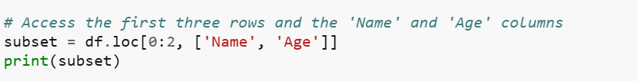

4. Accessing Rows Based on Conditions
Pandas allows you to filter rows based on conditions, which can be very powerful for exploring subsets of data that meet specific criteria.

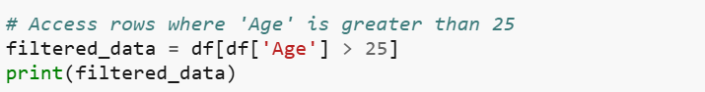

5. Accessing Specific Cells with at and iat
If you need to access a specific cell, you can use the .at[] method for label-based indexing and the .iat[] method for integer position-based indexing. These are optimized for fast access to single values.

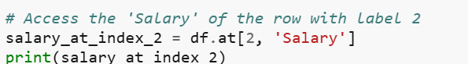

Adding and Removing Columns in Pandas
A column in a DataFrame represents a field/variable. Pandas provides simple methods to add, modify, and delete columns.

1. Adding a Column
Adding a column means creating a new variable in the DataFrame.
A new column must have the same number of rows as the DataFrame.

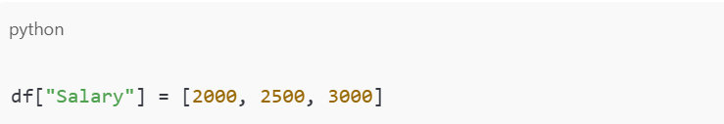

2. Removing a Column
When cleaning data, you often remove variables you don't need.

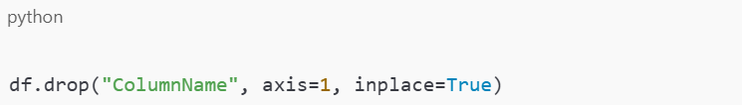
• axis=1 → remove column
• inplace=True → modifies df directly

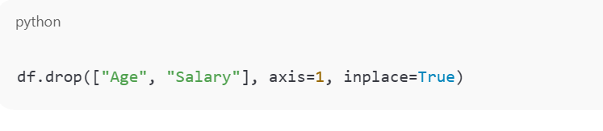

1 Structure & Metadata
Function / Attribute | Purpose
df.shape | Returns number of rows and columns (rows, columns)
df.size | Returns total number of elements
df.ndim | Returns number of dimensions (2 for DataFrame)
df.columns | List of column names
df.index | Row labels / index
df.dtypes | Data type of each column
df.info() | Summary of DataFrame: columns, datatypes, non-null count, memory usage
import pandas as pd

# Create a sample DataFrame
data = {
"Name": ["Amara", "Hawa", "John"],
"Age": [24, 29, 31],
"Country": ["SL", "SL", "GH"]
}

df = pd.DataFrame(data)

# 1. df.shape → number of rows and columns
print("Shape of DataFrame:", df.shape)

# 2. df.size → total number of elements
print("Total elements:", df.size)

# 3. df.ndim → number of dimensions
print("Number of dimensions:", df.ndim)

# 4. df.columns → list of column names
print("Column names:", df.columns)

# 5. df.index → row labels / index
print("Index labels:", df.index)

# 6. df.dtypes → data type of each column
print("Data types:\n", df.dtypes)

# 7. df.info() → summary of DataFrame
print("\nDataFrame info:")
df.info()

2️ Previewing Data
Function | Purpose
df.head(n) | First n rows (default n=5)
df.tail(n) | Last n rows (default n=5)

3. Inspecting Data
Purpose: Identify missing data, check summary statistics, unique values.
Method | Description | Example
df.isnull() | Detect missing values | df.isnull()
df.isnull().sum() | Count missing values per column | df.isnull().sum()
df.notnull() | Detect non-missing values | df.notnull()
df.describe() | Summary statistics for numeric columns | df.describe()

print(df.isnull())

print(df.isnull().sum())

print(df.describe())

