 being well-organized that you are blind to the needs of others? Are you so busy doing things that you have no time to assess their true value? Is your life so filled with activity that you never have a moment *to* relax? If a meeting is a minute late, do you fret and fume? Does *your* schedule tend to eliminate Bible study, prayer, church, or family? Have you robbed God by withholding from Him your time?

30. TONGUE (Ephesians 4:29; I Thessalonians 4:6; James 3:1-12; I Peter 3:3-10) – Do you ever by word or deed seek to hurt someone? Do you gossip? Do you speak unkindly concerning people when they are not present? Do you carry prejudice against true Christians because they are of some different group than yours or because they do not see everything exactly like you? Do you engage in empty and unprofitable conversation? Do you ever lie? Do you ever exaggerate? Is your daily conversation displeasing to God? Do you ever take God's name in vain? Are you boastful? Do you talk too much? Do you talk of what you have done rather than what Christ has done? Do you criticize God's servants rather than pray for them?

31. UNFORGIVING SPIRIT (Matthew 6:12,14-15; Ephesians 4:32) – Is there anyone against whom you hold a grudge? Anyone you haven't forgiven? Anyone you hate? Anyone you do not love? Are there any misunderstandings that you are unwilling to forget? Is there any person against whom you are harboring bitterness, resentment, .or jealousy? Anyone you dislike to hear praised or well spoken of? Do you allow anything to justify a wrong attitude toward another? Do you fine!. it ,hard to forgive a mistake or overlook a discourtesy? Do you forgive but not forget?

32. WEAK-WILLED (Ephesians 3:16; Philippians 4:13; Colossians 1: 11-12) – Do your wants and desires control your will? Are you unable to postpone the satisfaction of a present need in order to gain a higher and more permanent satisfaction at a later date? Are you unable to withstand frustration and cope with it? Does your weak will cause pre­mature action or reaction? Are you unable to accept the limitations of reality and live within them? Are you always manipulating and dis­torting reality to conform to some wish-fantasy? Are you enslaved by your own self-gratification? Do you tend to repeat the same wrongs?

33. WORLDLINESS (Romans 12:1-2; I John 2:15-17) – Have you allowed yourself to become "spotted" by the world? Is your manner of dress unpleasing to God? Do you spend beyond what is pleasing to God on anything? Do you neglect to pray? Do you read unworthy magazines? Do you attend unedifying movies? Do you watch unedifying TV pro­grams? Do you find it necessary to seek satisfaction from any questionable source? Are you doing certain things that show you are not satisfied with the Lord Jesus? Are you entangled or controlled by the things of this world, such as life styles, clothes, television, sports, entertainment, etc?

34. WORSHIP (Hebrews 10:25) – Do you stay away from meetings where the gospel is preached? Are you irregular in attendance at services? Do you neglect to attend or participate in meetings for prayer? Does your mind wander while God's Word is being read or preached? Is worship boring to you? Do you not have a personal" quiet time" of prayer and Bible reading?

HAVING CONFESSED EACH SIN TO CHRIST, BEGIN PRAISING HIM AND THANKING HIM FOR A CLEAR CONSCIENCE AND A PURE HEART. RECEIVE GOD'S FORGIVENESS. DON'T ACCEPT ANY CONDEMNATION FROM SATAN (Romans 8:1).SINS FORGIVEN ARE ALSO FORGOTTEN. (Psalm 103:3, 12; Jeremiah 31:34; Micah 7:19; Colossians 2:12­14; I John 1:9).

Celebrate Your Freedom In Christ!

Thank Him!

Praise Him!

**Section Two**

**STAYING FREE**

Repentance is maintained by renewing the mind to think right thoughts. It is a proven psychological fact that 95% of Americans are plagued with what psychologists call "stinking thinking." That's why Paul in Ephesians 6:17 has us to put on the helmet of salvation so that our minds would be protected from the fiery darts of the devil. Most often when we yield to the voice of Satan and renounce our repentance it is because of wrong thinking. Our thoughts create our words and our actions. To help you stay free, implement the following into your daily Christian walk.

A. THREE WAYS TO STAY FREE

Now that you are pure and clean before the Lord, you can maintain you position by:

1. THINKING RIGHT THOUGHTS (Proverbs 23:7)

* Realize you have the mind of Christ (Philippians 2:5).
* Set your mind on heavenly things (Colossians 3:2).
* Gird your mind for action (I Peter 1:13).
* Renew your mind (Romans 12:1-2).
* Bring every thought captive to the obedience of Christ (II Corinthians 10:5).
* Think on right things (Philippians 4:8).

How To Think Right Thoughts

* Mind - In your mind, listen to yourself (II Corinthians 10:3-5).
* Emotions - Identify your inner negative thoughts and silence them
* (Ephesians 6: 10-17).
* Will - Submit ourself to the Lord (James 4:7-10).

2. SPEAKING RIGHT WORDS

* Words reveal character (Matthew 12:34-37).
* Words set the direction for your life (James 3:1-12).
* Words come from the heart (Matthew 12:34; Matthew \15:18; Proverbs 23:7).
* Death and life are in the power of the tongue (Proverbs 18:21).
* There is power in a good confession (Mark 11:23-24).
* Use grace words (Ephesians 4:29).

3. DOING RIGHT THINGS

Begin to act on your positive thoughts and words and simply do what

you are told to do. Obey God's prompting.

Study Ephesians 5 and 6 and I Peter 1:1-10 and begin doing what the

word of God says.

THINKING RIGHT THOUGHTS LEADS TO SPEAKING RIGHT WORDS, RESULTING IN DOING RIGHT THINGS!

**B. POWER TO OVERCOME**

Overcoming power is available to every believer. In the Word we are given power,

*“For God has not given us a spirit of timidity, but of power and love and discipline.”*

(II Timothy 1:7)

*“Greater* is He *that* is *in you than he that* is *in the world.”*

(I John 4:4)

RPM's equal power in an engine. By increasing the speed of the engine, the RPM's are increased and the POWER is also increased.

In your spiritual life if you desire more spiritual power, you must increase your “RPM's”!

Read God's Word (II Timothy 2:15).

Pray without ceasing (I Thessalonians 5:17).

Memorize and meditate (psalm 119:11; Joshua 1:8).



c. **HOW TO PRAY A HEDGE**

*“Therefore, take up the full armor of God, that you may be able to resist in the evil day, and having done everything, to stand firm …”*

Having done everything, maintain your freedom in Christ by praying a daily hedge about yourself and others. Scriptural praying will help keep you free in Christ.

HOW TO PRAY A HEDGE

Job 1:8-10

*"And the Lord said* to *Satan, 'Have you considered My ser­vant Job? For there* is *no one like him on the earth, a blame­less and upright man, fearing God and turning away from evil. '*

*Then Satan answered the Lord, "Does Job fear God for nothing? Hast thou not made a hedge about him and his house and all that he has, on every side? Thou hast blessed the work of his hands, and his possessions have increased in the land.* ' "

THE ESCAPE (1 Corinthians 10:13)

THE POSITION (James 4:7-10)

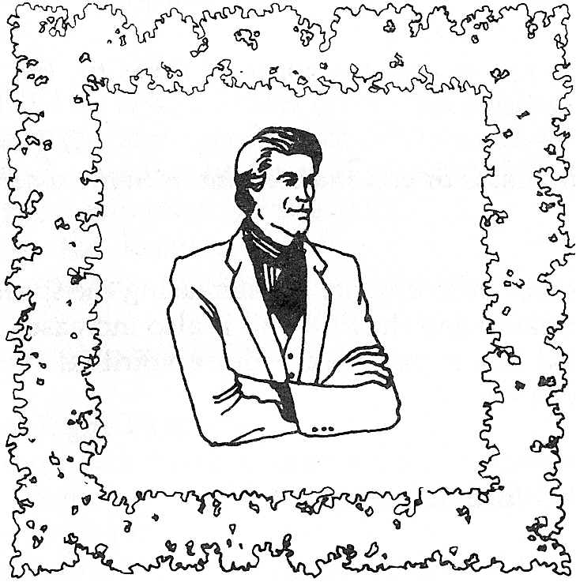

The Weapons (II Corinthians (10:3-5)

THE ARMOR (Romans 13:14, Ephesians 6:10-17)

THE ESCAPE PRAYERI Corinthians 10:13)

Lord, I realize that no temptation has overtaken me that is not com­mon to man. I confess that you are faithful and will not allow me to be tempted beyond what I am able. Thank you for providing The Way of Escape that I may be able to endure any work of the enemy.

THE WEAPONS PRAYER

THE WEAPONS (II Corinthians 10:3-5)



Lord, I ask you to move into my circumstances and pull down all strongholds and false reasonings raised up against the knowledge of God and bring my every thought captive to the obedience of Christ (II Corinthians 10:3-5). I pray that the peace of God which surpasses all comprehension shall guard my heart and mind in Christ Jesus. Help me to think on things that are honorable, right, pure, lovely and attractive

(Philippians 4:7-8).

THE ARMOR PRAYER

I pray that the Lord Jesus Christ will wrap himself about me and that I would make no provision for the flesh in regard to its lusts (Romans 13:14). I believe that the strong strength of the Lord and the full armor of

The Armor

(Ephesians 6:10-17)

God will enable me to stand firm against the schemes of the devil. I gird my loins with truth, and put on the breastplate of righteousness, and cover my feet with the preparation of the gospel of peace. I take up the shield of faith and the helmet of salvation and hold forth the sword of the spirit which is the word of God. With my armor in place, I come against the rulers and powers of darkness which would seek to take me captive and I bind them in the name, power, and blood of Jesus and place a protective hedge about my life (Ephesians 6:10-17).



THE POSITION PRAYER

The Position (James 4:7-10)

Lord Jesus, I submit myself to you and resist the devil knowing that he has to flee. I cleanse my hands and purify my heart and confess Godly sorrow for any sins committed against Holy God. I draw near to You and place the blood of Jesus between myself and all principalities, powers, and rulers of darkness. I humble myself in the presence of the humble (James 4:6-10). I claim the overcoming grace of God in my life, knowing that greater is He that is in me than he that is in the world (I John 4:4). Thank you for the indwelling power of the Holy Spirit which enables me to overcome because of the blood of the Lamb and because of the word of my testimony (Revelation 12:11). In the strong name of Jesus, I pray. AMEN!

KEEP THE HEDGE OF PROTECTION IN PLACE BY FOLLOWING JOB 22:21-25.

1. KNOW CHRIST INTIMATELY.

*"Yield now and be at peace with Him; thereby good will come*

to *you. "*

2. RECEIVE INSTRUCTION FROM HIM.

*"Please receive instruction from His mouth "*

3. ESTABLISH HIS WORDS IN YOUR HEART.

".. *.And establish His words in your heart."*

4. REMOVE ALL UNRIGHTEOUSNESS.FROM YOUR LIFE. *"If you will return* to *the Almighty, you will be restored; if you remove unrighteousness far from your tent. "*

5. LET GOD BE YOUR SOURCE.

*“And place your gold-in the dust, And the gold of Ophir among the stones of the brooks, then the Almighty will be your gold and choice silver* to *you.”*

*Now that you have completed this booklet, let me remind you that*

* CONFESSION is a daily process, not a one-time event.
* FREEDOM must be maintained through consistent Bible study, prayer, and a walk of faith.
* SUBMISSION to the Lord and RESISTANCE to the enemy give overcoming power in the believer’s life.

THIS IS NOT THE END …

YOU’VE ONLY JUST BEGUN!

