Manuscript
Word count 1000
Tables 1
Figures 1
Supplemental materials
Tables 0
Figures 0

Bridging resilience factors and successful ageing dimensions: A network analysis
Timothy Bang Hao Aw
PL4246: Networks in Psychology
March 6, 2026

Materials: The materials used for this project are available online through this link, which
includes the National Social Life, Health, and Ageing Project (NSHAP) dataset, the accompanying codebook, analysis scripts, and knitted results.

Bridging resilience factors and successful ageing dimensions: A network analysis Population ageing is a defining demographic shift of the 21st century. By 2050, more than 2.1 billion individuals will be aged 60 and above (Lin et al., 2020). With longer life expectancy, many older adults face challenges maintaining quality of life, including functional and cognitive decline, chronic disease, and bereavement. Successful ageing (SA) is a gerontological framework that conceptualises flourishing in later life across multiple indicators, including activities of daily living (ADL), physical health, and continued social engagement (Cosco, Howse, & Brayne, 2017). Resilience is a related construct, broadly defined as adaptive functioning in the context of adversity (Wu et al., 2013). Prior work has linked higher resilience with favourable successful ageing trajectories (Huisman, Klokgieters, & Beekman, 2017). However, resilience is frequently operationalised as a single latent factor or composite score (Hu, Zhang, & Wang, 2015), which can mask meaningful differences between its components. As a result, it remains unclear how specific resilience factors, such as physical activity and body-mass index, relate to successful ageing and its dimensions. To address these gaps, this study examined how resilience factors formed a network with successful ageing dimensions. First, community structures were detected to assess how resilience- and successful ageing-related nodes clustered into interpretable communities. This mapping may be used to guide targeted interventions aimed at improving specific successful ageing indicators. Second, resilience factors that formed strong bridges with the community of successful ageing dimensions were identified, to examine which resilience factors are most relevant for the general promotion of successful ageing.

Methods

Participants
Data were from 3,196 community-dwelling adults from Wave 2 of the National Social Life, Health, and Aging Project (NSHAP), a population-based study in the United States
(Suzman, 2009). Participant characteristics are reported in Table 1.

Preprocessing
All analyses were conducted in R (Version 4.5.1). Missingness (4.4%) was addressed via multiple imputation under a missing-at-random (MAR) assumption with missRanger
(Mayer & Mayer, 2019), consistent with previous NSHAP studies (Hawkley et al., 2014; You
& Kim, 2024). No items were skip-listed, avoiding induced dependencies during imputation
(Burger et al., 2023).

Variable selection
Variables were selected to align with prior network studies (Brinkhof et al., 2025; Koivunen et al., 2024) on resilience and constructs related to successful ageing, where available. All successful ageing indicators were coded non-arbitrarily, so higher values reflected more successful ageing. To reduce topological overlap, only conceptually distinct variables were included (Fried & Cramer, 2017), and redundancy checks with goldbricker() from networktools (Jones, 2017) detected no redundant variables.
Successful ageing dimensions followed established criteria (Rowe & Kahn, 2015):
lower chronic disease burden (chr), absence of difficulties with activities of daily living (adl), self-rated physical health (phy), cognitive functioning (cog), and social participation (soc). Resilience-related variables included depression (dep), anxiety (anx), happiness (hap), selfrated mental health (men), community participation (com), number of friends (fri), loneliness (lon), physical activity (act), alcohol consumption (alc), smoking history (smk), body mass index (bmi), and education (edu). Demographics included age (age) and household income (inc).

Network estimation
Network estimation was conducted in bootnet (Epskamp, Borsboom, & Fried, 2018) with edges defined as partial Spearman correlations. Given the sample size (N = 3,196) relative to the number of nodes (N = 19), sparsity assumptions may not hold (Epskamp, Rhemtulla, & Borsboom, 2017). Therefore, a model selection procedure, ggmModSelect(), was used in favour of specificity (Isvoranu & Epskamp, 2023). The network was visualised using qgraph (Epskamp et al., 2012). Nodewise predictability was estimated in mgm
(Haslbeck & Waldorp, 2020).

Community detection
Community structure was detected using walktrap, spinglass, Louvain, and fastgreedy algorithms in igraph (Csárdi et al., 2006) with partitions evaluated via modularity (Q).

Bridge expected influence
To examine bridging nodes between successful ageing and resilience factor communities, bridge expected influence (BEI) was computed in networktools. BEI is the signed sum of a node’s edge weights to nodes outside its community. Nodes above the 80th percentile of BEI were deemed significant (Jones, Ma, & McNally, 2021).

Stability and accuracy
Stability and accuracy were assessed using nonparametric bootstrapping (boots = 1,000) in bootnet. Correlation-stability (CS) coefficients for edges and bridge indices were assessed with case-dropping bootstraps in qgraph and networktools.

Results

Network description
The network is displayed in Figure 1. It was weighted and undirected, comprising 19 nodes and 67 non-zero edges (out of 171 possible). Network connectivity was moderate, with 39.2% of possible edges present. For mean degree, each node was connected to 7.05 nodes on average, with all nodes forming a single connected component. The global clustering coefficient was 0.42, suggesting moderate transitivity and locally clustered organisation. Edge stability was excellent (CS = 0.75), indicating robustness of the network structure to sampling variation.

Community detection
The walktrap and Louvain algorithm yielded identical community partitions and achieved the best modularity (Q = 0.36). The communities (see Figure 1) were interpretable as four domains: health (community 1), socioeconomic status (community 2), social connections (community 3), and mental well-being (community 4). Each community included both resilience- and successful-ageing nodes, except for community 4, which included only resilience-nodes.

Bridge expected influence
The stability for BEI was excellent (CS = 0.75). BEI difference tests identified the strongest resilience factors that acted as bridges with the successful ageing community. These were mental health (BEI = 0.443), education (BEI = 0.436), and physical activity (0.339). These values were reliably higher than the next-ranked resilience nodes, according to difference tests.

Discussion
Consistent with the study aims, the network clustered into coherent domains and highlighted a subset of key bridging nodes: mental health, education, and physical activity.
The diverse community structure supports multi-component models of resilience (Leys et al., 2020), and indicates that targeted interventions for specific successful ageing dimensions may be most effective through targeted interventions on resilience factors that it forms a community with (e.g. BMI and physical activity for improving physical health). For the general promotion of successful ageing, the findings suggest that prioritising mental health, continued education, or increasing physical activity may have the most general effect on improving successful ageing.

Table 1
Participant Demographics, Successful Ageing, Resilience Characteristics (N = 3,196)
Variables | M ± SD
Demographics  Age (in years) | 73.17 ± 7.34
Income (relative) | 2.77 ± 0.87
Successful Ageing  No chronic diseases | 8.96 ± 1.38
No difficulties with ADLs | 10.49 ± 3.45
Self-rated physical health | 3.20 ± 1.06
Cognitive functioning (MoCA) | 21.89 ± 5.71
Social participation (relative) | 4.26 ± 1.49
Resilience Factors  Happiness (relative) | 3.62 ± 0.87
Self-rated mental health | 3.63 ± 0.98
Physical activity | 2.56 ± 1.91
Alcohol consumption (days per week) | 1.30 ± 2.21
Smoking (cigarettes per day) | 1.59 ± 5.40
Education (categories) | 2.60 ± 1.06
Number of friends | 3.30 ± 1.27
Depression | 14.40 ± 4.46
Anxiety | 11.90 ± 3.67
Loneliness | 3.17 ± 2.28
Community participation | 7.27 ± 4.85
Body-mass index | 29.46 ± 6.49
Note.

Figure 1
Network and Communities of Successful Ageing Dimensions and Resilience Factors
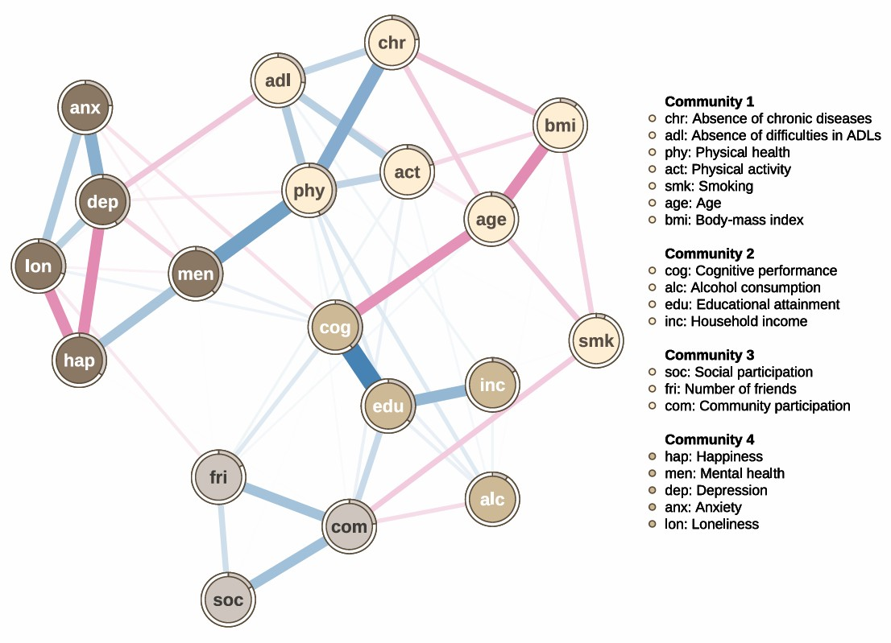
Note. Blue edges indicate positive associations, and pink edges represent negative associations. Edge thickness and saturation represent the strength of partial association. The
gray rings around each node (pie) indicate the proportion of explained variance explained
(R²) by other nodes.

References

Brinkhof, L. P., Ridderinkhof, K. R., de Wit, S., Krugers, H. J., & Murre, J. M. J. (2025). A cross-sectional network analysis of successful aging in a resilience-based framework.
PLoS One, 20(1), e0315445. https://doi.org/10.1371/journal.pone.0315445
Burger, J., Isvoranu, A. M., Lunansky, G., Haslbeck, J. M. B., Epskamp, S., Hoekstra, R. H. A., Fried, E. I., Borsboom, D., & Blanken, T. F. (2023). Reporting standards for psychological network analyses in cross-sectional data. Psychol Methods, 28(4), 806-
824. https://doi.org/10.1037/met0000471
Cosco, T. D., Howse, K., & Brayne, C. (2017). Healthy ageing, resilience and wellbeing.
Epidemiol Psychiatr Sci, 26(6), 579-583.
https://doi.org/10.1017/S2045796017000324
Csárdi, G., Nepusz, T., Traag, V., Horvát, S., Zanini, F., Noom, D., Müller, K., Schoch, D., &
Salmon, M. (2006). igraph: Network Analysis and Visualization.
https://doi.org/10.32614/CRAN.package.igraph
Epskamp, S., Borsboom, D., & Fried, E. I. (2018). Estimating psychological networks and their accuracy: A tutorial paper. Behav Res Methods, 50(1), 195-212.
https://doi.org/10.3758/s13428-017-0862-1
Epskamp, S., Cramer, A. O. J., Waldorp, L. J., Schmittmann, V. D., & Borsboom, D. (2012).
qgraph: Network Visualizations of Relationships in Psychometric Data. Journal of
Statistical Software, 48(4). https://doi.org/10.18637/jss.v048.i04
Epskamp, S., Rhemtulla, M., & Borsboom, D. (2017). Generalized Network Psychometrics:
Combining Network and Latent Variable Models. Psychometrika, 82(4), 904-927.
https://doi.org/10.1007/s11336-017-9557-x
Fried, E. I., & Cramer, A. O. J. (2017). Moving Forward: Challenges and Directions for
Psychopathological Network Theory and Methodology. Perspect Psychol Sci, 12(6),
999-1020. https://doi.org/10.1177/1745691617705892
Haslbeck, J. M. B., & Waldorp, L. J. (2020). mgm: Estimating Time-Varying Mixed Graphical Models in High-Dimensional Data. Journal of Statistical Software, 93(8). https://doi.org/10.18637/jss.v093.i08
Hawkley, L. C., Kocherginsky, M., Wong, J., Kim, J., & Cagney, K. A. (2014). Missing data in Wave 2 of NSHAP: prevalence, predictors, and recommended treatment. J
Gerontol B Psychol Sci Soc Sci, 69 Suppl 2(Suppl 2), S38-50.
https://doi.org/10.1093/geronb/gbu044
Hu, T., Zhang, D., & Wang, J. (2015). A meta-analysis of the trait resilience and mental health. Personality and Individual Differences, 76, 18-27.
https://doi.org/10.1016/j.paid.2014.11.039
Huisman, M., Klokgieters, S. S., & Beekman, A. T. F. (2017). Successful ageing, depression and resilience research; a call for a priori approaches to investigations of resilience.
Epidemiol Psychiatr Sci, 26(6), 574-578.
https://doi.org/10.1017/S2045796017000348
Isvoranu, A. M., & Epskamp, S. (2023). Which estimation method to choose in network psychometrics? Deriving guidelines for applied researchers. Psychol Methods, 28(4),
925-946. https://doi.org/10.1037/met0000439
Jones, P. (2017). networktools: Tools for Identifying Important Nodes in Networks. https://doi.org/10.32614/CRAN.package.networktools
Jones, P. J., Ma, R., & McNally, R. J. (2021). Bridge Centrality: A Network Approach to
Understanding Comorbidity. Multivariate Behav Res, 56(2), 353-367.
https://doi.org/10.1080/00273171.2019.1614898
Koivunen, K., Lindeman, K., Valimaa, M., & Rantanen, T. (2024). Investigating Resilience
Through Intrinsic Capacity Networks in Older Adults. J Gerontol A Biol Sci Med Sci,
79(10). https://doi.org/10.1093/gerona/glae048
Leys, C., Arnal, C., Wollast, R., Rolin, H., Kotsou, I., & Fossion, P. (2020). Perspectives on resilience: Personality Trait or Skill? European Journal of Trauma & Dissociation,
4(2). https://doi.org/10.1016/j.ejtd.2018.07.002
Lin, Y. H., Chen, Y. C., Tseng, Y. C., Tsai, S. T., & Tseng, Y. H. (2020). Physical activity and successful aging among middle-aged and older adults: a systematic review and metaanalysis of cohort studies. Aging (Albany NY), 12(9), 7704-7716.
https://doi.org/10.18632/aging.103057
Mayer, M., & Mayer, M. M. (2019). Package ‘missRanger’. R package, 820.
Rowe, J. W., & Kahn, R. L. (2015). Successful Aging 2.0: Conceptual Expansions for the
21st Century. J Gerontol B Psychol Sci Soc Sci, 70(4), 593-596.
https://doi.org/10.1093/geronb/gbv025
Suzman, R. (2009). The National Social Life, Health, and Aging Project: an introduction. J
Gerontol B Psychol Sci Soc Sci, 64 Suppl 1(Suppl 1), i5-11.
https://doi.org/10.1093/geronb/gbp078
Wu, G., Feder, A., Cohen, H., Kim, J. J., Calderon, S., Charney, D. S., & Mathe, A. A. (2013).
Understanding resilience. Front Behav Neurosci, 7, 10.
https://doi.org/10.3389/fnbeh.2013.00010
You, S., & Kim, G. (2024). Types of bereavement and depressive symptoms among older adults: Does race/ethnicity matter? Geriatr Gerontol Int, 24 Suppl 1(S1), 266-272.
https://doi.org/10.1111/ggi.14817

