**A PROJECT REPORT**

**ON**

**STUDY OF A CONVERTOR SYSTEM WITH THE USE OF MICROCONTROLLER**

**JAWAHARLAL NEHRU TECHNOLOGICAL UNIVERSITY**



**SUBMITTED TO**

**DEPARTMENT OF ELECTRONICS AND COMMUNICATION ENGINEERING**

**SUBMITTED BY**

**INSERT NAME**

**INSERT NAME**

**INSERT NAME**

**UNDER THE GUIDANCE OF**

**Mr.G.Venkataswamy**

**Hyderabad, India**

**FALL 2015**

# ACKNOWLEDGEMENT

We would like to express our gratitude towards **Department Head, Electronics and Communication Engineering Department, Anurag College of Engineering (Jawaharlal Nehru Technological University)** for their uniform support and encouragement. We also appreciate the effort spent by Mr. G. Venkataswamy, **our Project Supervisor**, which enabled us to meet the project's objectives. We are grateful to our instructors for motivating us both directly and indirectly. We also hold our parents in high regard as role models. We are also grateful to all of our friends for their supportive attitudes and assistance during this project.

# DECLARATION

The project entitled **Study of a convertor system with the use of microcontroller** is accomplished at **Anurag College of Engineering (Jawaharlal Nehru Technological University)** under the continuous support of **Mr. G. Venkataswamy** for completion of **Bachelor Degree of Electronics and Communication Engineering**. All the works are conducted by an equal participation of team members and the set goals are accomplished successfully. We further declare, the works are genuine and never been presented to other organizations previously.

**INSERT NAME**

**INSERT NAME**

**INSERT NAME**

# ABSTRACT

The appropriate converter model or system is designed where the overall control mechanism is done by the use of a microcontroller. The main function of the power converter in any electrical or electronics system is to manage the path of power flow from a source end to the load. In this project, a DC to DC type converter is designed which can alter voltage levels and can be used in several systems such as wind energy, PV system, and electric drives. Here, a detailed review or study of the converter circuits, microcontroller, and various components is conducted for acquiring complete knowledge about the system. The important documents from the study are highlighted and various materials and software for conducting the project are selected. An appropriate significant & efficient tool, a software platform, parameters, and components are chosen for preparing the general block diagram. A block diagram of the proposed system is prepared by using four blocks named as DC type power source, DC to DC type converter, load, and Microcontroller. Here Arduino is selected as a microcontroller. The four distinct circuit designs of the control circuits, boost converter, buck converter, and buck-boost converter are prepared by arranging the resistor, inductor, capacitor, diode, and MOSFETs in Proteus software. Finally, the prepared design is simulated in the software and their respective output in the form of the waveform is analyzed in a detailed way. The result shows that the proposed design is free of harmonics and distortion and can be utilized in real life.

Table of Contents

ACKNOWLEDGEMENT i

DECLARATION ii

ABSTRACT iii

LIST OF FIGURES vi

LIST OF TABLES vii

CHAPTER 1: INTRODUCTION 1

1.1 Overview 1

1.2 Background 1

1.3 Statement of Problem 1

1.4 Objectives 1

1.5 Scope of Project 2

1.6 Methodology 2

CHAPTER 2: LITERATURE REVIEW 3

CHAPTER 3: TERMINOLOGIES 6

3.1 Power Converter 6

3.2 Microcontroller 6

3.3 Resistors 6

3.4 Inductor 6

3.5 Diodes 6

3.6 MOSFETs 7

3.7 Arduino 7

3.8 Proteus 7

CHAPTER 4: DESIGN WORKS 8

4.1 Component Selection 8

4.2 Design Parameters and General Circuits 8

4.2.1 Circuit Design of Control Circuit 9

4.2.2 Buck Converter Circuit Design 9

4.2.2 Design of Boost Converter 10

4.3 Simulation Model Design 11

CHAPTER 5: RESULTS 12

5.1 Results and Analysis 12

5.2 Discussion 14

CHAPTER 6: CONCLUSION 15

6.1 Conclusion 15

6.2 Advantages 15

6.3 Disadvantages 15

6.4 Future Scopes 15

# LIST OF FIGURES

Figure 1. Project’s Methodology 2

Figure 2 Block Diagram 9

Figure 3 Circuit Design of the control circuit 10

Figure 4 Designed Model of a Boost Converter 10

Figure 5 Profile of Voltage for control circuit 11

Figure 6 Waveform obtained for boost converter 12

Figure 7 Waveform obtained for buck-boost converters 13

# CHAPTER 1: INTRODUCTION

## Overview

A circuit that regulates electrical energy flow between a load and a source is defined as a power converter. In primetime such converters are mainly used in traction systems, and in the industry for supplying the motors. But with the increase in technology power converts are also employed in various domestic and other applications such as automotive, Flexible Alternating current transmission system (FACTS), renewable energy type systems, etc. the increase of the electrical gadgets and devices has increased the need for voltage and the improper or unstable voltages causes malfunction and even characteristics degradation. The DC-DC converter not only converts the voltage but can also stabilize the voltage if further modification is added. A higher grade of accuracy, the capability of communication, flexibility, smaller sizes, and reliability for the users are some of the advantages that are offered by modern power converters. Generally, there are basically 2 kinds of DC to DC type converters: switched and linear. A resistive type voltage drop is used by a linear type DC-DC converter for regulating and creating a prescribed output voltage whereas switched converters store the given energy periodically and convert it by releasing stored energy to a different output voltage. Moreover, a tightly integrated circuit that is prepared to regulate the operation of the embedded system is termed as a microcontroller.

## Background

In past times, for lower applications, a DC supply of voltages was converted to a higher voltage in three different steps. In the first step, DC was converted into AC using an inverter or vibrator and then it was stepped up into required voltage using a transformer. Finally, in the third step of the process, a rectifier was used for converting AC into DC. Unlike lower applications, a motor-generator was mostly used whenever a higher power was required. In such a system required voltage was produced by driving the generator with the help of an electric motor. these methods were mostly used for powering the car radio as it needed a much higher voltage than the car battery i.e 6v to 12v. These were relatively expensive and inefficient designs. But with the advancement of IC and semiconductor devices, various designs were created for preparing the required system of the power converter. The first DC to DC converter was invented by US Slobodan Cuk in 1979 and it had 0 input and ripple current output. this was created through an integrated magnetics circuit.

## Statement of Problem

The alternating current can be transformed easily from lower to higher or higher to lower voltage by the use of a transformer. But DC voltage couldn’t be transformed from by transformer. In order to convert DC supply from one voltage rating to another, first of all, the DC is changed into AC and obtained AC is transformed to required voltage using a transformer and finally, the AC voltage is converted into required DC voltage. the required DC voltage is obtained in three different steps. The obtained voltage contains some ripple and is not free from distortion as well as harmonics. Also, the process is quite expensive as it requires an inverter, transformer, and rectifier. The weight of the overall system is also high as it contains heavy devices like a transformer. The system is also not reliable. So for this, a system is designed where heavy devices are illuminated and basic electrical parameters such as resistor, inductor, capacitor, diodes, and transistors are used. A direct DC to DC converter is designed whose output is free of ripples, harmonics, and distortion. Such a converter can also be used for increasing the energy harvest. Power converters are designed using a microcontroller to make it more reliable and practicable as they can be controlled automatically by assigning codes to the microcontroller. So this project makes harmonic-free, light power converters.

## 1.4 Objectives

The main objective of this project is to control and regulate the power converter in proteus by using the microcontroller. Along with this, these experiments also possess some other minor goals which are listed below:

* To regulate or direct the voltage in any electrical design or framework.
* To give greater voltage segregations to the components of any circuit.

## 1.5 Scope of Project

The project goal is to design a DC converter circuit that is controlled by a microcontroller. As physical preparation of the model and conduction of real experiment can arise many problems so the model is created in the simulation software where its actual output can be analyzed by conducting the simulation. The appropriate material, components, and tools are selected initially for preparing the design. The various circuit such as buck converter, boost converter, buck-boost converter, and control unit is designed in the proteus platform by arranging resistors, inductors, diode, MOSFETS, and capacitors. The prepared design is based on the control approaches of the Arduino (microcontroller). After that, the various parameters are set for all proposed models or circuits and simulated separately. Furthermore, the output is obtained from the simulation and is analyzed which is in form of the waveform.

## 1.6 Methodology

The project is conducted in multiple steps. The project's methodology contains a collection of the information by reviewing various documents such as articles, journals, past research papers, and academic books. The information about the microcontroller concentrated converter circuits is achieved and various materials are selected for conducting the project. The general overview or architecture of the DC to DC converter is studied. The Pin study of the Arduino which is used in the project as a microcontroller is done. The parameters of the circuits, as well as proteus software, are studied in detail. The transistor's switching mechanism is analyzed. The required components for conducting the project are selected. As the selection is completed, the design of the various unit is followed by the parameter assignment for the simulation process. The obtained result from the simulation is analyzed and the possible error that can be done during the project is described in the result and discussion section.

Figure Project’s Methodology

# CHAPTER 2: LITERATURE REVIEW

The DC-DC type power converters were controlled by implementing a fuzzy controller in this particular paper. A cheap 8-bit type microcontroller was used in this study. The external parts or components needed to be eliminated for conducting such functions and such elimination was obtained by using Pulse with modulation generator and “on-chip” A/D converter. The major problem for implementation included computational postponement, limited memory of on-chip (2KB), and unsigned number arithmetic. It was observed that the duty cycle of the power converter could be updated on each 8 switching cycles and this was because of the control calculations, and A/D transformation time requirement. Nonetheless, this paper showed that both boost and buck power could possess a stable response. Another significant outcome was that without any alteration of code same microcontroller controlled both sets of power controllers. This was possible because the behavior of the controller could be explained using a similar set of linguistic principles. **(T.Gupta. R.R. Boudreaux, 1997)**

A 65 nm framework on-a-chip that illustrated techniques to alleviate variation, reducing sun-threshold activity to 300 mV was presented in the paper. A microcontroller core of 16-bit was designed during the study. The designed core contained delays of propagation in logic gates, a timing approach (to address voltage output failures), and a custom sub-edge cell library. An 8 T bit-cell was employed using SRAM of 128 kb so that peripheral help circuitry and stability of reading could be ensured. The SRAM, as well as logic, functioned in the scope of 300 to 600 mV. The result showed that the backup power of 1 mW was consumed at 300 mV and 27.2 PJ per cycle was consumed at ideal $V_{DD}$ of 500 mV. As power levels were very low, an exchanged DC-DC capacitor converter was coordinated on-chip. The integration was conducted in order to provide variable voltages on low power levels. At the end of the paper, the outcomes showed that an efficiency of more than 75% was obtained while conveying the load power between 10 to 200 mW. **(J.Kwong., Y.K.Ramadass., A.P., & Cgandrakasan, 2009)**

In this specific paper, a new framework of Maximum power point tracking (MPPT) had been prepared which consisted of DC/DC buck type converter and this converter was constrained by a microcontroller-based unit. MPPT was mostly utilized in solar energy for increasing the output power which was being produced from photovoltaic cells or arrays. The important difference between this proposed system and other similar past reports was the material used for controlling the DC/DC type converter. Unlike other reports in this paper, the power coming from the photovoltaic array was used because of which the system became easier to understand. The prepared system had a lower-cost production, a higher efficiency, and could be modified easily for other energy sources also. the experiment was conducted and the results showed that the proposed MPPT control increased the power of PV yield by more than 15% of the DC to DC duty cycle type converter.  **(Koutroulis., Kalaitzaki., & Voulgaris, 2001)**

The advancement of SPWM (single-phase sinusoidal pulse width modulation) microcontroller depended inverter was presented in this particular paper. SPWM pulses were generated using a microcontroller which was the main difference of this paper over other similar projects. The microcontroller could store the expected orders for producing fundamental waveforms to regulate the inverter frequency through an appropriate plan of switching pulses. The sinusoidal wave of current and voltage output was pure and produced using the technique of SPWM. In this paper, the inverter was intended to be either for grid associated or stand-alone and was connected directly from PV cells supply. A detailed review of the technique used in SPWM switching, power circuit for the inverter, and control circuit for inverter was done in this paper. In the last stage of the paper, the outcomes of the experiments were discussed briefly. The 200W planned model of the inverter was tried with the resistive burden and noticed that THD (Total harmonic distortion) was under 8% for current and 4% for voltages. **(Ismail., Taib., Saad., Isa., & Hadzer, 2006)**

A new crisis ballast to be used in fluorescent lights was discussed in this paper. The main or principle block of this system was the microcontroller type control circuit. This controller had to perform the control and supervision function. A technique of high-frequency electronics was proposed for a battery charger with a higher power factor and light driver. These provided greater luminous adequacy. The proposed system or model had a much small size and weight than other available systems. As the microcontroller was implemented in this system, the system had the ability to auto test, showed an internal issue, and took a look at its practical state. Because of all of this, the system reliability was improved, and, alternately cost for maintenance was also diminished. In this way, this paper highlighted the importance of a microcontroller in a fluorescent lamp. **(Alonso., Villega., J., Blanco., & Rico, 1997)**

# CHAPTER 3: TERMINOLOGIES

## 3.1 Power Converter

An electrical circuit that converts a DC input into a different voltage of DC output is called as a power converter. Such conversion is acquired by the action of high frequency switching. Filter elements like inductor and capacitor are used for this purpose. A converter can do more than one function. Some of the uses of the converter are polarity inversion, increment & decrement of input voltage magnitude, etc. Power converter behaves as a link between power supply output and source of power. There are mainly 4 kinds of power converters based on their input source and output voltage which are DC to DC converter, DC to AC converter (inverter), AC to DC converter (rectifier), and AC to AC converter.

## 3.2 Microcontroller

It can be defined as a compact IC (integrated chip) mainly designed to control a particular operation in any system. A general microcontroller contains three basic parts such as I/O peripherals (input and output), memory, and a processor. These all components are addressed on a single chip. It can also be called as a squeezed micro-computer. Mainly it is utilized in devices and products that are controlled automatically like remote controls, power tools, toys, engine control systems of the automobiles, office machines, appliances, etc. Microcontrollers are functioned by using programming languages such as C, C++. The results or tasks done by the microcontroller are accurate and the time required is also low.

## 3.3 Resistor

It is a passive electrical parameter that implements electrical resistance in any circuit. The resistor is a 2 terminal component of electrical which is mostly used for opposing the current in the system. It has also multiple functions depending on its adjustment. Resistors are used in electronic circuits for adjusting the level of signals, reducing current flow, bias active element, voltage divider, terminating transmission lines, etc. The SI unit of the resistor is the ohm (**Ω).** Depending upon the properties and their uses in the circuits there exist several kinds of available resistors.

## 3.4 Inductor

It is 2- a terminal component of electrical that captures and stores energy in a form of a magnetic field whenever an electric current pass from it. Like a resistor, it is also a passive component. The inductor is also termed reactor, choke, or coil. It generally consists of a wire that is wounded into a coil. The value of the inductor is characterized as inductance and is the ratio of voltage to the current’s rate of change. Its SI unit is henry (H). It is mostly used in AC electronic devices and also used in filters for separating signals of various frequencies. If an inductor is used for blocking AC and the pass of DC is allowed then it is termed as Chokes. It is one of the important parameters of electrical and electronics components.

## 3.5 Diodes

Diodes are 2-terminal components of electronics that conduct current in only one single direction. It possesses low or ideally zero resistance in one direction, and ideally infinite resistance in another direction. These are mostly used in rectifiers for converting alternating current into direct current. The behavior or characteristics of the diodes in any circuit is provided by its I-V graph or Current-voltage characteristics. Generally, diodes works depend on the phenomenon of reverse bias and forward bias. Normally such diodes are made by semiconductors. There exist various types of diodes depending upon their production or uses such as Avalanche diodes, Schottky diodes, photodiodes, pin diodes, laser diodes, etc.

## 3.6 MOSFETs

The metal oxide semiconductor field-effect transistor abbreviated as MOSFETs is the kind of transistor that is utilized in circuits for switching or amplifying the voltages. It is an insulated gate FET that is fabricated by silicon. It is the most basic element of modern electronic equipment. A higher rating of MOSFET can be easily reduced to a lower dimension. They consume lower power and quite higher density is allowed than the bipolar type transistor. It also possesses a rapid switching speed. MOSFETs can be utilized as an inverter, can be added in a digital circuit, also taken as a high-frequency amplifier, etc. Depletion and enhancement are the two types of MOSFETS that are classified on the basis of operational mode. The efficiency of MOSFET is higher for the lower voltage operation too and it doesn’t draw any current.

## 3.7 Arduino

An open-source type electronic platform that is based on convenient-to-use software and hardware is called an Arduino. This consists of several boards and pins. The pins and boards of Arduino can read inputs such as a finger on a button, any messages, light on a sensor, and convert it into output by activating a motor, turning LED, etc. An Arduino IDE software is used for writing the codes and uploading them to the boards. These are most popular than others because their hardware is easy, code is simpler than others.

## 3.8 Proteus

The Proteus is a software mainly utilized for electronic design automation. This software is mostly used by electronic and design engineers as well as a technician for creating the electronics and schematic prints to develop PCB (printed circuit boards). This software is developed by LaCenter electronics limited in Yorkshire, England. The system can be designed as well as the prepared model can be simulated in this software. This can be bought in several configurations, depending on the design size and the necessity of simulation for the microcontroller.

# CHAPTER 4: DESIGN WORKS

## 4.1 Component Selection

## The overall devices and components which is required for completing the project are selected. Along with the component selection, the rating or its specification is also chosen if required. Initially, The basic components are chosen for preparing the system. in order to power, the system there needed a power source so a direct current (DC) of 16V is selected. The microcontroller along with the entire circuit gets supply from this 16V DC supply. with the development in the technology any circuit which is to be developed can be tested without its physical preparation by conducting the simulation. here, simulation software called as Proteus is used for preparing and simulating the circuit. Among various microcontrollers available, Arduino Uno is selected for the circuit. The circuit design of the three converters i.e. boost converter, buck converter, and buck-boost converter along with the control unit is done. These three converter circuits are controlled by a switch. Two sets of MOSFETs are chosen as a switch in this project. A diode is taken here for two proposes i.e. for preventing the current’s bidirectional flow and rectifying the DC level from one to another. Various parameters such as inductors, capacitors, transistors, and resistors are utilized as per their need for completing the converter circuits. A digital type oscilloscope is decided for observing the output as well as the input of the overall system.

## 4.2 Design Parameters and General Circuits

To understand the working procedure and mechanism of the overall system, a system’s general block diagram is created. Here, mainly four components are used for preparing the diagram. A block of DC-type power source is added in front of the system and it is attached with the DC to DC converter. The main function of this power source is to provide a constant power (DC) to the converter block. furthermore, an Arduino which is used as a microcontroller is linked with the converter. This microcontroller block receives and passes the given commands to the linked block. the final block of the load is kept at the last part of the diagram and it is linked with the converter as well as a microcontroller (Arduino). This block determines the outcomes given by the converter circuit. Several codes are written in Arduino software. The prepared block diagram of the offered system is shown below;

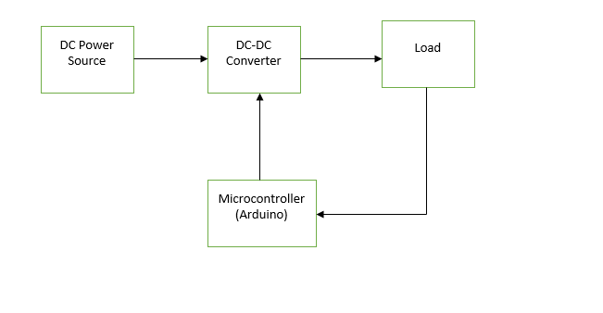

Figure 1; block diagram

### 4.2.1 Design

The circuit design for conducting the simulation is discussed in this part. Various circuits are designed using the tools of proteus software. First of all, the circuit design of the control circuit is prepared. The ARD Arduino Uno is connected for giving control signals in order to control and execute the modules. A resistor is associated with the 7th pin of the Arduino for opposing the current. The resistor connection is continued till the NPN type transistor. One more resistor R2 is used in the circuit to link the oscilloscope with the Q2 (2N2222 transistor). The prepared design of the control circuit is shown in figure 2. After completing the control circuit, the design of the three converters is also done. The control circuit is designed first because in all converters there needs the presence of the control circuits. For the design of the buck converter, the control circuit is dragged with a Q4 transistor and R4 resistor, and a MOSFET is connected in front of it. A MOSFET is connected in series with the voltage source, and diode. The inductor and resistor are connected in series and this arrangement is linked with the diode branch as shown in figure 3. One point of all branches is connected with the voltage source. Finally, all the branches are connected to an oscilloscope to obtain their respective outcomes. In this way, the circuit model of the buck converters is designed in proteus. Similarly, the models for the rest of the 2 converters are prepared. The only difference in the model is the arrangement and selection of resistor, inductor, and capacitors. For boost converters, the inductor which is used in buck type converter is replaced by a C1 capacitor and connected in parallel with the R3 resistor. This arrangement is further connected in series with the diode as shown in figure 4. Another inductor is connected to voltage sources and the diode both is a series arrangement. Moreover, all these arrangements are ended on an oscilloscope. The last remaining design is of the buck-boost converter and for this, the arrangement is the same as that of the boost converter but the inductor is added in series with the MOSFET.

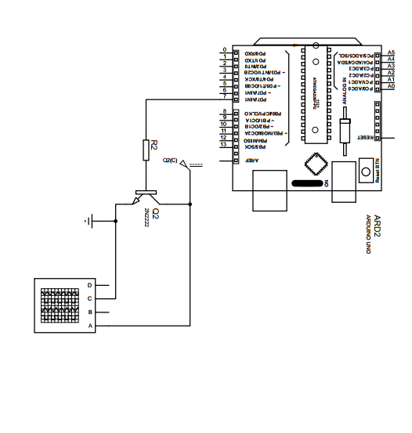

Figure 2: circuit design of the control circuit

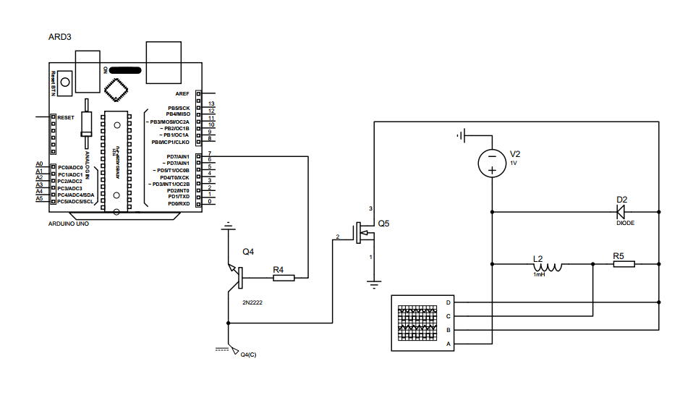

Figure 3: buck converter circuit design

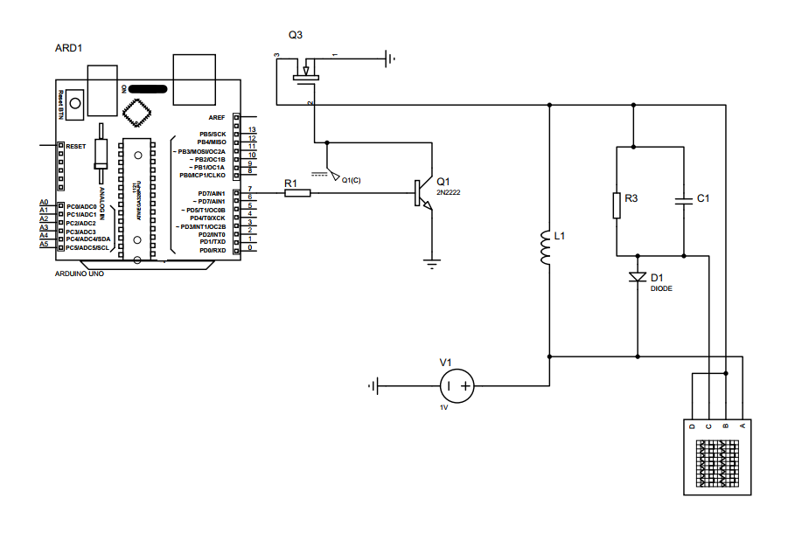

Figure 4: the designed model of a boost converter

## 4.3 Simulation Model Design

The overall simulation of the designed system is conducted in this chapter. In order to obtain the result, one must initially set up all the simulation parameters that are required for obtaining the result. A 16 V DC power is set for supplying the overall circuits. The next step is the assignment of the values for several components (such as inductors, resistors, and capacitors) which are used in circuits design. The resistance of the resistor which is used in the control circuit is allotted as 1 kΩ. but the value of this resistor is changed to 25 Ω for converter circuits. The inductance and capacitance attached to the converters are specified as 0.2H, and 54µF respectively. Furthermore, duty cycle and frequency parameter is taken as 0.6 and 1.1 kHz for the three converter circuits. The Diodes and MOSFETS types are selected as BYY56, and IRF540 respectively. All three converts are simulated separately by assigning the boundary or parameters individually. The final parameter which is required for conducting the simulation is simulation time and it is set as 2 seconds for the proposed design of the circuits. The respective outcomes and waveform of the designed circuits are obtained from the oscilloscope.

# CHAPTER 5: RESULTS

## 5.1 Results and Analysis

The proposed models of the circuits are simulated and its outputs are obtained in the form of waveform. The generated waveform of the control circuit, boost, buck, and buck-boost converters are analyzed. The outcome obtained for the simulation of control circuits is shown in figure 5 and it shows that waveform of the load voltage is rectangular and symmetric too. The simulation result of buck type converter is also waveform. The waveform of this converter depicts the result of load voltage and current. The red line in the waveform shows load current and yellow line shows load volatge and are triangular and rectangular respectively. Similalrly, for boost converters the obtained waveform from the simulation is shown in figure 6. The red line and green line in the wavefor shows the load current and voltage waveform and is traingular and rectangular respectively. The result propells that obtained voltage is constant and possesses low ripples. At the last, output waveform of the buck-boost type converters is obtained and shown in fig 7 which is similar as boost converter. the changing signals from Arduino aare consistently given to the converter circuit to control the degree of voltage transformation by the converter. The results are found as expected and is ideal qualities of the converter circuit. the result of all converters are liberated from the distortions and the harmonics are diminished to a level where it can be neglected.

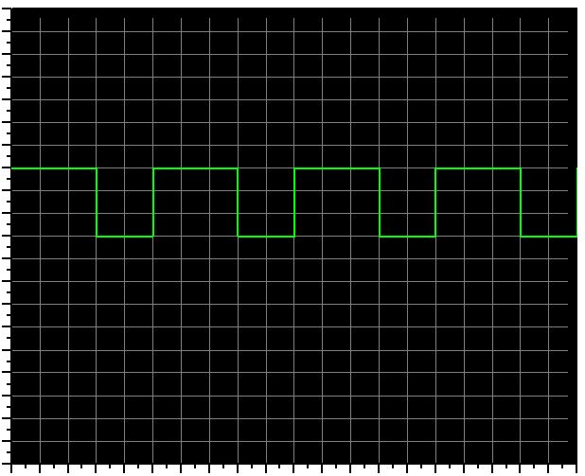

Figure 5: profile of voltage for control circuit 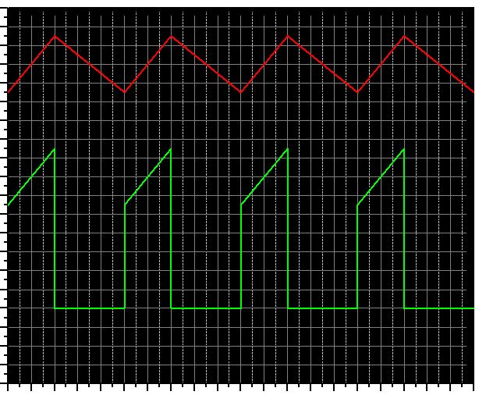

Figure 6: waveform obtained for boost converters 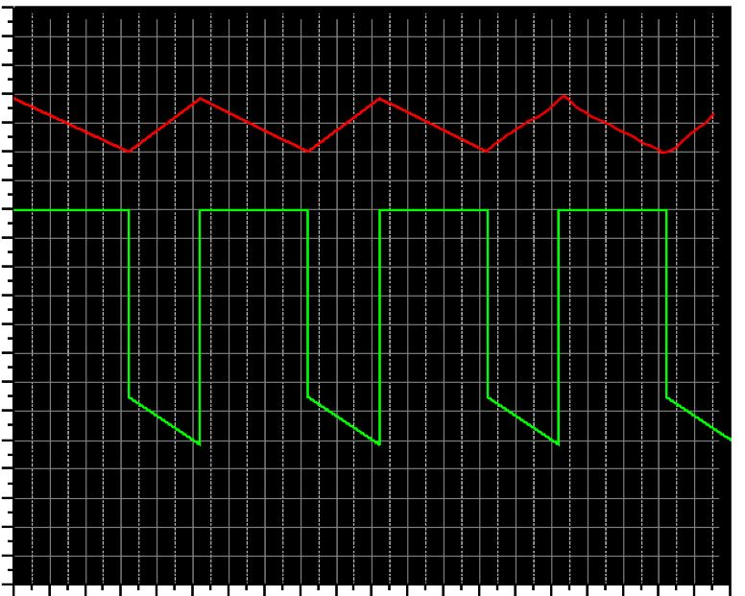

## Figure 7: waveform obtained for buck-boost converters

## 5.2 Discussion

The goal of this project is to study the converter system where a microcontroller has been used. The circuits for the converts are prepared in proteus. One must assign or set the parameters for obtaining the waveform before conducting the simulation. the addition of the parameters such as resistors, inductors, and capacitors on the converts must be added with great concern else it may result in unpredicted outcomes. For example, if capacitors are not used while designing the converters circuit then the waveform obtained from simulation might be irregular. These waveforms contain distortion and high ripples which makes the system ineffective. Further, their waveform also may not be constant. So in order to obtain the expected results, one must be very careful in arranging the parameters while designing the converters circuits as even a single missing of the components would lead to the improper output.

# CHAPTER 6: CONCLUSION

## 6.1 Conclusion

The task is initiated by performing the research work concerning about power converter and microcontroller. Before conducting the design, various materials are selected that are required for the project completion. In order to create the project flow, a general block diagram of the system is prepared which shows the working mechanism of the system. Then the control circuits, buck converter, boost converter, and buck-boost converter are designed in the proteus software. The Arduino board supplies the pulse which is essential for providing the switching action to the semiconductor. Efficient and simple control of the system is offered by the board of an Arduino. Finally, the prepared circuits are simulated separately and their respective results are studied for concluding the system performance. The results show that the output of the converter is free from harmonics level and ripples. A microcontroller such as Arduino can be used effectively to control various converters circuits.

## 6.2 Advantages

Some of the advantages of the system are listed below:

* the output obtained from the converters is ripple, distortion, and harmonics-free.
* These converters have low weight and small sizes also so can be used in various electronic gadgets such as laptops, cellular phones, etc.
* The use of a microcontroller makes the system more appealing as various codes could be assigned which saves the human effort.
* The overall system cost is low.

## 6.3 Disadvantages

This system also has some drawbacks which are listed below:

* Some of the converters are prone to noise. They produce certain decibel noises.
* As various parameters are used in the design, the defect of any one parameter will stop the functioning of the system.

Once microcontrollers are programmed then re-programming can not be done.

## 6.4 Future Scopes

Though a practicable circuit or system is designed in this project, some modifications or addition can be done in future days to make the project more appealing or acceptable. Some of the suggestions for the future are shown here:

* The feature of voltage regulation can also be added to the system.
* The power converters can be turned into power optimizers for maximizing the harvest of energy for wind and PV systems.

Some filters or beads may be added for reducing the noise or sound coming from the circuits.