CS148

Aaron Brunet

Assignment: Final

myGlutenFree Burlington

Version <1.0>

Table Of Contents

Time Log 3

Introduction 4

Purpose 4

Definitions, acronyms, and abbreviations 4

Overall Description 4

Story Board 5

Assignment requirements 6

Specific requirements 7

Data Dictionary 8

Schema 9

|  |  |  |  |
| --- | --- | --- | --- |
| Time Log | | | |
| Estimated time to complete assignment => | | | 75 Hours |
| Date | Time Spent  (in hours) | Description | Author |
| 2013 | 20 | Initial build of myGlutenFree for CS110 | Aaron |
| 11/14 | 3 | Prepping software specs and ERD |  |
| 11/17 | 3 | Adjusting ERD, building draft schema |  |
| 11/17 | 2 | Editing ERD/Schema, building data dictionary |  |
| 11/25 | 4 | Creating of initial pages; initial commit to github |  |
| 11/25 | 2 | Drafting schema |  |
| 11/25 | 3 | Modifying CRUD elements |  |
| 11/25 | 2 | Adding schema to PHP pages, drafting |  |
| 11/25 | 2 | Creating register form options, updating database |  |
| 11/26 | 1.5 | Creating logged-in status and tweaking email pmk |  |
| 11/27 | 3 | Creating login functions, login form, login status |  |
| 11/27 | 1 | Account page recognizes logged user |  |
| 11/27 | 2 | Multiple users can log in and out, nav depends on log status |  |
| 11/27 | 1.5 | Detaching from tblRegister |  |
| 11/27 | 2 | Creating restaurant submission form |  |
| 11/27 | 2 | Attach restaurant submission to user login |  |
| 11/27 | 1 | Tweak restaurant options |  |
| 11/28 | 2 | Create basic restaurant display from tblRestaurant |  |
| 11/28 | 3 | Save checboxes created and given function |  |
| 11/28 | 1 | Unsave and resave added, hooked up to relevant SQL databases |  |
| 11/28 | .5 | Formatting SQL entries |  |
| 11/29 | 4 | Restructuring and reformatting display, tweaking all other functions |  |
| 11/29 | 1 | Checking w3c validation |  |
| 11/29 | 3 | Editing schema, ERD, data dictionary |  |
| 11/29 | 2 | Troubleshooting php errrors |  |
| 11/30 | 2 | CSS building |  |
| 11/30 | 3 | Reformatting Account page |  |
| 11/30 | 3 | Adding page content |  |
| 11/30 | 3 | CSS editing and tweaking |  |
| 11/30 | 1 | Finished home page content |  |
|  |  |  |  |
|  | 78.5 | <=Total Time Spent |  |
|  |  |  |  |

# Introduction

### Purpose

The purpose of this document is to describe the requirement specification for the web site myGlutenFree Burlington.

The intended audience for this document is the client. In this case, it’s you, Bob.

### Definitions, acronyms, and abbreviations

HTML – Hypertext markup language – used to define your content.

PHP – Personal Home Page – language that helps to customize html.

CSS – Cascading Style Sheets – used to define the look of a web site.

W3 Validation – refers to both Html and CSS validation tool provided by the W3c.org. the html validator is located at:

<http://validator.w3.org/>

with the CSS validator located at:

<http://jigsaw.w3.org/css-validator/>

# Overall Description

myGlutenFree Burlington will be a community-driven site to display and share gluten-free restaurants in the greater Burlington area. While there are sites that collect gluten-free places, the nature of user submission means that users can be confident that other patrons have had a positive gluten-free experience at these restaurants. This can be instrumental and even life-saving for people who struggle with Celiac’s and other severe gluten sensitivities. Users will be able to submit and save restaurants, and receive an email for each. Admins will be able to delete restaurants and approve other admins.

# Story Board & ERD

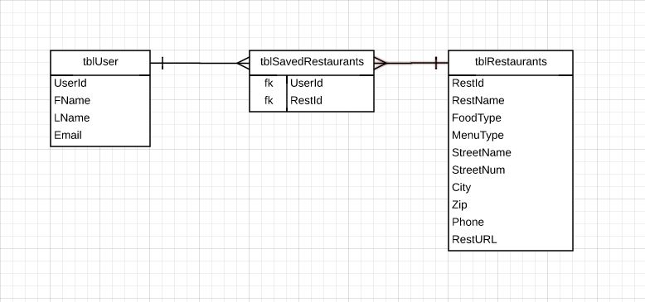VERSION 1

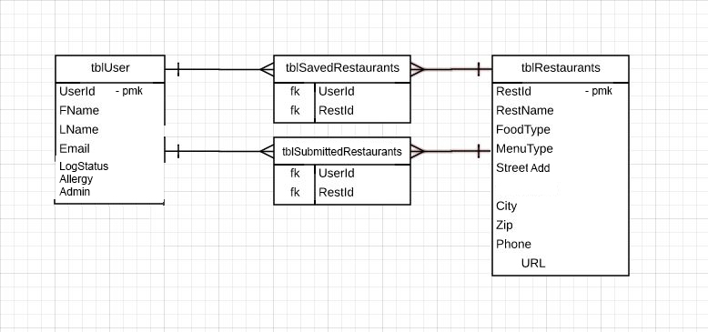VERSION 2

NAV

Home

Home

RESTAURANT LIST

RESTAURANT []Save?

RESTAURANT []Save?

RESTAURANT []Save?  
(admins can also delete)

SUBMIT NEW RESTAURANT

*form elements*

[SUBMIT]

Account Information

SAVED RESTAURANT []

SAVED RESTAURANT []

SAVED RESTAURANT []

HOME PAGE CONTENT

Home

Home

# Specific requirements

1. *Title for main page*: *myGlutenFree Burlington.*
2. *Meta Description*: *A community-driven collection of gluten-free restaurants in the greater Burlington Area.*
3. *Meta Character set*: UTF - 8
4. *Users who register their email will be able to do the following:*
   1. *Submit new restaurants*
   2. *Save a restaurant for later (receiving an email with the restaurant information)*
   3. *Unsave and resave as many restaurants as they would like at any time*
   4. *Request admin access* 
      1. *Admins can delete submitted restaurants, which removes them from all relevant tables*
5. *There should be a page for the About, a page to Register, a page to Log in and view your own Account, a page to Submit new restaurants, and a page to Browse all existing restaurants*
   1. *The Browse page should only allow options for their corresponding users*
      1. *Admins and registered users can save*
      2. *Admins can delete*
   2. *The Account page should list all saved restaurants for that account and allow unsaving*
6. *Bob’s requirements:*
   1. *Insert data into >=2 tables* **DONE**
   2. *Text box for email* **DONE**
   3. *Two additional text boxes* **DONE**
   4. *One list box* **DONE**
   5. *3 check boxes* **DONE (browse restaurants, account page)**
   6. *3 radio buttons* **DONE**
   7. *Submit button* **DONE**
   8. *Field sets/Legend* **DONE**
   9. *Data validation* **DONE**
   10. *Email user* **DONE**
   11. *Save data to database (one form should save to two tables at once)* **DONE (submit and save save to two tables at once)**
   12. *Add new records* **DONE (submit restaurants)**
   13. *Update existing* **DONE (save and unsave, Admin approval)**
   14. *Delete records* **DONE (delete restaurants, unsave restaurants)**
   15. *Use git/github* **DONE** [**HERE**](https://github.com/awbrunet/assignment10)
   16. *6 webpages* **DONE**
   17. *W3c validation* **DONE**

# Data Dictionary

|  |  |
| --- | --- |
| tblUser |  |
| Field | Data Type |
| pmkUserId | int |
| fldFName | varchar |
| fldLName | varchar |
| fldEmail | varchar |
| fldLogStatus | int |
| fldAllergy | varchar |
| fldAdmin | int |

|  |  |
| --- | --- |
| tblRestaurants |  |
| Field | Data Type |
| pmkRestId | int |
| fldRestName | varchar |
| fldFoodType | varchar |
| fldMenuType | varchar |
| fldStreetAdd | varchar |
| fldCity | varchar |
| fldState | varchar |
| fldZip | varchar |
| fldPhone | varchar |
| fldURL | varchar |

|  |  |
| --- | --- |
| tblSubmittedRestaurants |  |
| Field | Data Type |
| fnkUserId | int |
| fnkRestId | int |

|  |  |
| --- | --- |
| tblSavedRestaurants |  |
| Field | Data Type |
| fnkUserId | int |
| fnkRestId | int |

# Schema (also found in Schema.sql)

CREATE TABLE IF NOT EXISTS tblUser (pmkUserId int(11) NOT NULL AUTO_INCREMENT, fldFName varchar(20) DEFAULT NULL,

fldLName varchar(20) DEFAULT NULL,

fldEmail varchar(65) DEFAULT NULL,

fldLogStatus int(11) NOT NULL DEFAULT "0",

fldAllergy varchar(20) DEFAULT NULL,

fldAdmin int(11) NOT NULL DEFAULT "0",

PRIMARY KEY (pmkUserId) )

ENGINE=MyISAM DEFAULT CHARSET=utf8 AUTO_INCREMENT=1;

CREATE TABLE IF NOT EXISTS tblSavedRestaurants (fnkUserId int(11) NOT NULL,

fnkRestId int(11) NOT NULL,

PRIMARY KEY (fnkUserId, fnkRestId) )

ENGINE=MyISAM DEFAULT CHARSET=utf8 AUTO_INCREMENT=1;

CREATE TABLE IF NOT EXISTS tblRestaurants (pmkRestId int(11) NOT NULL AUTO_INCREMENT,

fldRestName varchar(50) DEFAULT NULL,

fldFoodType varchar(20) DEFAULT NULL,

fldMenuType varchar(30) DEFAULT NULL,

fldStreetAdd varchar(50) DEFAULT NULL,

fldCity varchar(20) DEFAULT NULL,

fldState varchar(20) DEFAULT NULL,

fldZip varchar(10) DEFAULT NULL,

fldPhone varchar(15) DEFAULT NULL,

fldURL varchar(100) DEFAULT NULL,

PRIMARY KEY (pmkRestId) )

ENGINE=MyISAM DEFAULT CHARSET=utf8 AUTO_INCREMENT=1;

CREATE TABLE IF NOT EXISTS tblSubmittedRestaurants (fnkUserId int(11) NOT NULL,

fnkRestId int(11) NOT NULL,

PRIMARY KEY (fnkUserId, fnkRestId) )

ENGINE=MyISAM DEFAULT CHARSET=utf8 AUTO_INCREMENT=1;