Outline

The aim is to create a reduced order model at each frequency (and maybe wavenumber) using SPOD modes and propagate the sound for the round and the serrated jet. This is inspired by the Jovanovic input-output paper, where they created a ROM of the acoustic field of an axisymmetric jet using 24 output modes and compared it to the real acoustic field. Why do I use the SPOD basis instead of the resolvent basis? Because the SPOD modes represent the actual linear and nonlinear harmonic (but not intermittent) dynamics of the flow instead of the idealised dynamics resulting from white noise forcing which is what resolvent modes represent. Hopefully, the sound from the reduced-order model of the round and serrated jet have the required spectral characteristics, like crossover at $St=1$, meaning that we can explain the far-field spectral changes caused by the chevrons using the physics contained in the first however many SPOD modes we have chosen to construct the ROM.

How would the link between the near and far-field be established?

1. Investigate the differences between the near-field SPOD modes caused by serrations. This is already underway, and broadly the serrations destroy KH near the nozzle and enhance streaks
2. Construct the sound source from the ROM of the near-field quantities and project it to the far-field to get the spectrum. See if the ROM sources can qualitatively capture the spectral change caused by the serrations.
3. If the ROM sources can qualitatively capture the spectral change caused by the serrations, we still don't know why they can capture it. To do this, we need to examine the differences between the ROM sources and how these differences link to the far-field. One link that can be made is the acoustic matching link - we can calculate the axial wavenumber spectra of the ROM sources and see how serrations have changed it. We can also get more detailed information by looking at the combination of the ROM sources and the Green's function to see which spatial changes to the ROM source caused by the chevrons are actually significant in affecting the far-field spectrum.

Solution to Lighthill equation in the frequency domain for the round jet

The Lighthill equation is

$${∇^{2}ρ^{'}-\frac{1}{c_{0}^{2}}∂}_{t}^{2}ρ^{'}={-\frac{1}{c_{0}^{2}}∂}_{ij}^{2}T_{ij}$$ | (1)

, where $ρ^{'}=ρ-ρ_{0}$ with $ρ_{0}$ the ambient density in the stationary medium outside the jet, $ρ$ the density, $c_{0}$ the ambient sound speed outside the jet, and $T_{ij}$ the Lighthill stress tensor, given by

$$T_{ij}=ρv_{i}v_{j}+\left(p-ρc_{0}^{2}\right)δ_{ij}+τ_{ij}$$ | (2)

, where $v_{i}$ is the velocity, $p$ is the pressure and $τ_{ij}$ are the viscous forces. The subscript 0 denotes the value of the quantity in the ambient medium outside the jet. Following Goldstein (1976), we can neglect the viscous stresses for a high Reynolds number turbulent jet and the term $\left(p-ρc_{0}^{2}\right)δ_{ij}$ for a cold jet. We also assume the jet is sufficiently cold that density variations are not too large in the jet, so that $ρ≈ρ_{0}$. Then, the Lighthill tensor can be approximated as

$$T_{ij}≈ρ_{0}v_{i}v_{j}$$ | (3)

In the absence of solid boundaries, we can solve (1) using a simple Green’s function approach and additional manipulations detailed in Goldstein (1976) to obtain

$$ρ^{'}\left(x,t\right)≈\frac{1}{4πc_{0}^{2}}\int{dy} \frac{R_{i}R_{j}}{c_{0}^{2}R^{3}}\frac{∂^{2}}{∂t^{2}}T_{ij}\left(y,t-\frac{R}{c_{0}}\right)$$ | (4)

when $x$ is in the far-field, where $R=x-y$ is the separation vector between the observation point $x$ and a source point $y$. We can Fourier transform this in time and multiply by $c_{0}^{2}$ (provided $D_{t}S=0$ – see Goldstein (1976)) to obtain the far-field pressure:

$${\hat{p}}^{'}\left(ω;x\right)=-\frac{ω^{2}}{4πc_{0}^{2}}\int{dy {\frac{R_{i}R_{j}}{R^{3}}e}^{-ikR}}{\hat{T}}_{ij}\left(ω;y\right)$$ | (5)

, where $k=\frac{ω}{c_{0}}$. We can expand $R$ to the leading order correction to $x$ in the far-field using the following manipulation:

$$R=\left|x-y\right|=x\left|\hat{x}-\frac{y}{x}\right|=x\sqrt{\left(\hat{x}-\frac{y}{x}\right)∙\left(\hat{x}-\frac{y}{x}\right)}=x\sqrt{1-2\frac{\hat{x}∙y}{x}+\frac{y^{2}}{x^{2}}}≈x\left(1-\frac{\hat{x}∙y}{x}\right)=x-\hat{x}∙y$$

Then, (5) becomes

$${\hat{p}}^{'}\left(ω;x\right)=-\frac{ω^{2}}{4πc_{0}^{2}}\frac{x_{i}x_{j}}{x^{3}}e^{-ikx}\int{dy e^{ik\hat{x}∙y}}{\hat{T}}_{ij}\left(ω;y\right)$$ | (6)

This is the same expression derived in Dowling (2004):

Since our system is the round jet, it is useful to use a cylindrical coordinate system, with $y_{x}$ being the axial coordinate, $y_{r}$ the radial coordinate and $α$ the azimuthal coordinate. We now azimuthally decompose ${\hat{T}}_{ij}\left(y,ω\right)$:

$${\hat{T}}_{ij}\left(ω;y\right)={\hat{T}}_{ij}\left({ω;y}_{x},y_{r},α\right)=\sum_{m=-∞}^{∞}{{\tilde{T}}_{ij}\left({m,ω;y}_{x},y_{r}\right)e^{imα}}$$ | (7)

Substitute this azimuthal decomposition into (6):

$${\hat{p}}^{'}\left(ω;x\right)=-\frac{ω^{2}}{4πc_{0}^{2}}\frac{x_{i}x_{j}}{x^{3}}e^{-ikx}\sum_{m=-∞}^{∞}{\int{dy_{x}dy_{r}dα y_{r} e^{ik\left({\hat{x}}_{1}y_{x}+{\hat{x}}_{2}y_{r}\cos{α}\right)}}{\tilde{T}}_{ij}\left({m,ω;y}_{x},y_{r}\right)e^{imα}}$$ | (8)

, where we have simplified the phase term of the exponential using the fact that in Cartesian coordinates, $x=\left(x_{1},x_{2},0\right)$ so that $\hat{x}=\left({\hat{x}}_{1},{\hat{x}}_{2},0\right)={\left(x_{1}^{2}+x_{2}^{2}\right)}^{-\frac{1}{2}}x$, and $y=\left(y_{x},y_{r}\cos{α},y_{r}\sin{α}\right)$. Note that we have set the $z$ component of the observation point $x$ equal to zero WLOG owing to the axisymmetry of the jet. The $α$ integral in (8) is

$$\int_{0}^{2π}{dαe^{iAα}e^{imα}}$$ | (9)

, where $A=k{\hat{x}}_{2}y_{r}$. Now the Jacobi-Anger expansion https://en.wikipedia.org/wiki/Jacobi%E2%80%93Anger_expansion is :

$$e^{iA\cos{α}}=\sum_{n=-∞}^{∞}{i^{n}J_{n}\left(A\right)e^{inα}}$$ | (10)

Substitute this into the above integral:

$$\int_{0}^{2π}{dαe^{iA\cos{α}}e^{imα}}=\sum_{n=-∞}^{∞}{i^{n}J_{n}\left(A\right)\int_{0}^{2π}{dαe^{i\left(m+n\right)α}}}=\sum_{n=-∞}^{∞}{i^{n}J_{n}\left(A\right)2πδ_{n,-m}}=2πi^{-m}J_{-m}\left(A\right)$$ | (11)

Now from Wikipedia https://en.wikipedia.org/wiki/Bessel_function, we see that for all integers $m$,

$$J_{-m}\left(A\right)={\left(-1\right)}^{m}J_{m}\left(A\right)$$ | (12)

Also,

$$i^{-m}={\left(\frac{1}{i}\right)}^{m}={\left(-i\right)}^{m}={\left(-1\right)}^{m}i^{m}$$ | (13)

Therefore,

$$\int_{0}^{2π}{dαe^{iA\cos{α}}e^{imα}}=2πi^{-m}J_{-m}\left(A\right)=2πi^{m}J_{m}\left(A\right)$$ | (14)

Substituting this result into (8), we get

$${\hat{p}}^{'}\left(ω;x\right)=-\frac{ω^{2}}{2c_{0}^{2}}\frac{x_{i}x_{j}}{x^{3}}e^{-ikx}\sum_{m=-∞}^{∞}{i^{m}\int{dy_{x}dy_{r} y_{r} e^{ik{\hat{x}}_{1}y_{x}}}J_{m}\left(k{\hat{x}}_{2}y_{r}\right){\tilde{T}}_{ij}\left({m,ω;y}_{x},y_{r}\right)}$$ | (15)

Now the Hankel transform of order $ν$ of a function $f\left(y_{r}\right)$ is denoted by $H\left(ν;k\right)f$ and is given by

$$H\left(ν;k\right)f=\int_{0}^{∞}{dy_{r}y_{r}J_{ν}\left(ky_{r}\right)f\left(y_{r}\right)}$$ | (16)

The (one-sided) fourier transform of $f\left(y_{x}\right)$ is denoted as $F\left(k\right)f$ and is given by

$$F\left(k\right)f=\int_{0}^{∞}{dy_{x}e^{iky_{x}}f\left(y_{x}\right)}$$ | (17)

Then, we can write the round jet pressure as

$${\hat{p}}^{'}\left(ω;x\right)=-\frac{ω^{2}}{2c_{0}^{2}}\frac{x_{i}x_{j}}{x^{3}}e^{-ikx}\sum_{m=-∞}^{∞}{i^{m}}H\left(m;k{\hat{x}}_{2}\right)F\left(k{\hat{x}}_{1}\right){\tilde{T}}_{ij}\left(m,ω\right)$$ | (18)

Now using the same arguments as in (18) and (19) of the document ‘SPOD for negative modes and frequencies’, we can express the negative azimuthal modes of the Lighthill tensor in terms of their positive counterparts using

$${\tilde{T}}_{ij}\left({-m,ω;y}_{x},y_{r}\right)={\tilde{T}}_{ij}^{*}\left({m,-ω;y}_{x},y_{r}\right), m≥0$$ | (19)

Separating the sum in (14) into three sums, the first from $m=-∞$ to $m=-1$, the second from $m=1$ to $m=∞$ and the third containing only the $m=0$ component, and sending $m→-m$ in the first sum and using (15), we can write.

$${\hat{p}}^{'}\left(ω;x\right)=-\frac{ω^{2}}{2c_{0}^{2}}\frac{x_{i}x_{j}}{x^{3}}e^{-ikx}\left\{H\left(0;k{\hat{x}}_{2}\right)F\left(k{\hat{x}}_{1}\right){\tilde{T}}_{ij}\left(0,ω\right)+\sum_{m=1}^{∞}{i^{m}H\left(m;k{\hat{x}}_{2}\right)F\left(k{\hat{x}}_{1}\right)\left[{\tilde{T}}_{ij}\left(m,ω\right)+{\tilde{T}}_{ij}^{*}\left(m,-ω\right)\right]}\right\}$$ | (20)

, where we have again used (11). To calculate (19), one needs to calculate ${\tilde{T}}_{ij}\left({m,ω;y}_{x},y_{r}\right)$. From (3), this is a convolution:

$$T_{ij}=ρv_{i}v_{j}$$

Far-field spectrum for a model source

Assume an axisymmetric source given by

$${\tilde{T}}_{11}\left(0,ω;y_{x},y_{r}\right)=κρ_{0}U^{2}{St}^{-3}\exp\left(-\frac{{\left(y_{x}-x_{0}\right)}^{2}}{2Δx^{2}}\right)e^{iαy_{x}}e^{-βy_{r}}$$ | (21)

Let us perform the axial transform first:

$$F\left(k{\hat{x}}_{1}\right)\exp\left(-\frac{{\left(y_{x}-x_{0}\right)}^{2}}{2Δx^{2}}\right)e^{iαy_{x}}=\int_{0}^{∞}{dy_{x}e^{ik{\hat{x}}_{1}y_{x}}\exp\left(-\frac{{\left(y_{x}-x_{0}\right)}^{2}}{2Δx^{2}}\right)e^{iαy_{x}}}$$  $$=\exp\left(-\frac{x_{0}^{2}}{2Δx^{2}}\right)\int_{0}^{∞}{dy_{x}\exp\left(-\frac{1}{2Δx^{2}}\left[y_{x}^{2}-2\left(ikΔx^{2}{\hat{x}}_{1}+iαΔx^{2}+x_{0}\right)y_{x}\right]\right)}$$  $$=\exp\left(-\frac{x_{0}^{2}}{2Δx^{2}}\right)\int_{0}^{∞}{dy_{x}\exp\left(-\frac{1}{2Δx^{2}}\left\{{\left[y_{x}-\left(ikΔx^{2}{\hat{x}}_{1}+iαΔx^{2}+x_{0}\right)\right]}^{2}-{\left(ikΔx^{2}{\hat{x}}_{1}+iαΔx^{2}+x_{0}\right)}^{2}\right\}\right)}$$  $$=\exp\left(-\frac{\left\{x_{0}^{2}-{\left(ikΔx^{2}{\hat{x}}_{1}+iαΔx^{2}+x_{0}\right)}^{2}\right\}}{2Δx^{2}}\right)\int_{0}^{∞}{dy_{x}\exp\left(-\frac{1}{2Δx^{2}}\left\{{\left[y_{x}-\left(ikΔx^{2}{\hat{x}}_{1}+iαΔx^{2}+x_{0}\right)\right]}^{2}\right\}\right)}$$ | (22)

Now, send $y_{x}→y_{x}+\left(ikΔx^{2}{\hat{x}}_{1}+iαΔx^{2}+x_{0}\right)$:

$$F\left(k{\hat{x}}_{1}\right)\exp\left(-\frac{{\left(y_{x}-x_{0}\right)}^{2}}{2Δx^{2}}\right)e^{iαy_{x}}=\exp\left(-\frac{\left\{x_{0}^{2}-{\left(ikΔx^{2}{\hat{x}}_{1}+iαΔx^{2}+x_{0}\right)}^{2}\right\}}{2Δx^{2}}\right)\int_{-\left(ikΔx^{2}{\hat{x}}_{1}+iαΔx^{2}+x_{0}\right)}^{∞}{dy_{x}\exp\left(-\frac{y_{x}^{2}}{2Δx^{2}}\right)}$$ | (23)

Now, send $y_{x}→\sqrt{2}Δxy_{x}$:

$$F\left(k{\hat{x}}_{1}\right)\exp\left(-\frac{{\left(y_{x}-x_{0}\right)}^{2}}{2Δx^{2}}\right)e^{iαy_{x}}=\sqrt{2}Δx\exp\left(-\frac{\left\{x_{0}^{2}-{\left(ikΔx^{2}{\hat{x}}_{1}+iαΔx^{2}+x_{0}\right)}^{2}\right\}}{2Δx^{2}}\right)\int_{-\frac{ikΔx^{2}{\hat{x}}_{1}+iαΔx^{2}+x_{0}}{\sqrt{2}Δx}}^{∞}{dy_{x}\exp\left(-y_{x}^{2}\right)}$$ | (24)

Now, the integral can be evaluated using the identity

$$\frac{\sqrt{π}}{2}erfc\left(z\right)=\int_{z}^{∞}{dy_{x}\exp\left(-y_{x}^{2}\right)}$$ | (25)

The phase term can be simplified:

$$\frac{\left\{x_{0}^{2}-{\left(ikΔx^{2}{\hat{x}}_{1}+iαΔx^{2}+x_{0}\right)}^{2}\right\}}{2Δx^{2}}=\frac{k^{2}Δx^{2}{\hat{x}}_{1}^{2}+α^{2}Δx^{2}-2x_{0}ik{\hat{x}}_{1}-2x_{0}iα+2αkΔx^{2}{\hat{x}}_{1}}{2}$$  $$=\frac{Δx^{2}}{2}{\left(k{\hat{x}}_{1}+α\right)}^{2}-ix_{0}\left(k{\hat{x}}_{1}+α\right)$$ | (26)

Overall then, we have

$$F\left(k{\hat{x}}_{1}\right)\exp\left(-\frac{{\left(y_{x}-x_{0}\right)}^{2}}{2Δx^{2}}\right)e^{iαy_{x}}=\sqrt{\frac{π}{2}}Δx\exp\left(-\frac{{\left(k{\hat{x}}_{1}+α\right)}^{2}Δx^{2}}{2}\right)e^{i{\left(k{\hat{x}}_{1}+α\right)x}_{0}}\operatorname{erfc}\left(-\frac{i\left(k{\hat{x}}_{1}+α\right)Δx}{\sqrt{2}}-\frac{x_{0}}{\sqrt{2}Δx}\right)$$ | (27)

Now, perform the radial Hankel transform:

$$H\left(0;k{\hat{x}}_{2}\right)e^{-βy_{r}}=\int_{0}^{∞}{dy_{r}y_{r}J_{0}\left(k{\hat{x}}_{2}y_{r}\right)e^{-βy_{r}}}$$ | (28)

Define

$$I≡\int_{0}^{∞}{dy_{r}J_{0}\left(k{\hat{x}}_{2}y_{r}\right)e^{-βy_{r}}}=\frac{1}{\sqrt{β^{2}+k^{2}{\hat{x}}_{2}^{2}}}$$ | (29)

This comes from equation (27) in the besselfunc document. We have

$$H\left(0;k{\hat{x}}_{2}\right)e^{-βy_{r}}=-∂_{β}I=-∂_{β}\frac{1}{\sqrt{β^{2}+k^{2}{\hat{x}}_{2}^{2}}}=\frac{β}{{\left(β^{2}+k^{2}{\hat{x}}_{2}^{2}\right)}^{\frac{3}{2}}}$$ | (30)

Using (27) and (30), we have

$${\hat{p}}^{'}\left(ω;x\right)=-\frac{κk^{2}}{2}\frac{x_{1}^{2}}{x^{3}}e^{-ikx}ρ_{0}U^{2}{St}^{-3}\sqrt{\frac{π}{2}}Δx\exp\left(-\frac{{\left(k{\hat{x}}_{1}+α\right)}^{2}Δx^{2}}{2}\right)e^{i{\left(k{\hat{x}}_{1}+α\right)x}_{0}}\operatorname{erfc}\left(-\frac{i\left(k{\hat{x}}_{1}+α\right)Δx}{\sqrt{2}}-\frac{x_{0}}{\sqrt{2}Δx}\right)\frac{β}{{\left(β^{2}+k^{2}{\hat{x}}_{2}^{2}\right)}^{\frac{3}{2}}}$$ | (31)

Now, we can use the fact that $k=\frac{ω}{c_{0}}=\frac{2πf}{c_{0}}=\frac{2πStU}{Dc_{0}}=\frac{2πStM}{D}$ to simplify the prefactors:

$${\hat{p}}^{'}\left(ω;x\right)=-\frac{κ\sqrt{2}π^{\frac{5}{2}}St^{-1}M^{2}ρ_{0}U^{2}Δx}{D^{2}}\frac{x_{1}^{2}}{x^{3}}e^{-ikx}\exp\left(-\frac{{\left(k{\hat{x}}_{1}+α\right)}^{2}Δx^{2}}{2}\right)e^{i{\left(k{\hat{x}}_{1}+α\right)x}_{0}}\operatorname{erfc}\left(-\frac{i\left(k{\hat{x}}_{1}+α\right)Δx}{\sqrt{2}}-\frac{x_{0}}{\sqrt{2}Δx}\right)\frac{β}{{\left(β^{2}+k^{2}{\hat{x}}_{2}^{2}\right)}^{\frac{3}{2}}}$$ | (32)

The analytical intensity of the model source is finally given by:

$$I\left(ω;x\right)=\frac{{\left|{\hat{p}}^{'}\left(ω;x\right)\right|}^{2}}{ρ_{0}c_{0}}=\frac{2π^{5}κ^{2}M^{4}ρ_{0}U^{4}Δx^{2}}{D^{4}c_{0}St^{2}}\frac{x_{1}^{4}}{x^{6}}e^{-{\left(k{\hat{x}}_{1}+α\right)}^{2}Δx^{2}}{\left|\operatorname{erfc}\left(-\frac{i\left(k{\hat{x}}_{1}+α\right)Δx}{\sqrt{2}}-\frac{x_{0}}{\sqrt{2}Δx}\right)\right|}^{2}\frac{β^{2}}{{\left(β^{2}+k^{2}{\hat{x}}_{2}^{2}\right)}^{3}}$$ | (33)

Extension to a non-axisymmetric model

Now, say we have a model at a particular azimuthal wavenumber $m>0$, i.e

$${\tilde{T}}_{11}\left(m,ω;y_{x},y_{r}\right)=κρ_{0}U^{2}{St}^{-3}\exp\left(-\frac{{\left(y_{x}-x_{0}\right)}^{2}}{2Δx^{2}}\right)e^{iαy_{x}}e^{-βy_{r}}$$ | (34)

Then, the pressure is given by

$${\hat{p}}^{'}\left(ω;x\right)=-\frac{ω^{2}}{2c_{0}^{2}}\frac{x_{i}x_{j}}{x^{3}}e^{-ikx}i^{m}H\left(m;k{\hat{x}}_{2}\right)F\left(k{\hat{x}}_{1}\right)\left[{\tilde{T}}_{ij}\left(m,ω\right)+{\tilde{T}}_{ij}^{*}\left(m,-ω\right)\right]$$ | (35)

We use the approximation ${\tilde{T}}_{ij}^{*}\left(m,-ω\right)={\tilde{T}}_{ij}\left(-m,ω\right)≈\tilde{T}\left(m,ω\right)$ due to plane symmetry. Then, we have

$${\hat{p}}^{'}\left(ω;x\right)=-2\frac{ω^{2}}{2c_{0}^{2}}\frac{x_{i}x_{j}}{x^{3}}e^{-ikx}i^{m}H\left(m;k{\hat{x}}_{2}\right)F\left(k{\hat{x}}_{1}\right){\tilde{T}}_{ij}\left(m,ω\right)$$ | (36)

The analytical intensity will then be given by

$$I\left(ω;x\right)=4\frac{2π^{5}κ^{2}M^{4}ρ_{0}U^{4}Δx^{2}}{D^{4}c_{0}St^{2}}\frac{x_{1}^{4}}{x^{6}}e^{-{\left(k{\hat{x}}_{1}+α\right)}^{2}Δx^{2}}{\left|\operatorname{erfc}\left(-\frac{i\left(k{\hat{x}}_{1}+α\right)Δx}{\sqrt{2}}-\frac{x_{0}}{\sqrt{2}Δx}\right)\right|}^{2}{\left|H\left(m;k{\hat{x}}_{2}\right)e^{-βy_{r}}\right|}^{2}$$ | (37)

Let us evaluate $H\left(m;k{\hat{x}}_{2}\right)e^{-βy_{r}}$. Now we have the Laplace transform

$$A_{m}\left(β\right)=\int_{0}^{∞}{dy_{r}e^{-βy_{r}}J_{m}\left(ky_{r}\right)}=\frac{k^{m}}{s{\left(s+β\right)}^{m}}, where s=\sqrt{β^{2}+k^{2}}$$ | (38)

Then we have

$$H\left(m;k\right)e^{-βy_{r}}=-∂_{β}A_{m}\left(β\right)=k^{m}\left[\frac{∂_{β}s}{s^{2}{\left(s+β\right)}^{m}}+\frac{m\left(∂_{β}s+1\right)}{s{\left(s+β\right)}^{m+1}}\right]=k^{m}\frac{\left(s+β\right)∂_{β}s+ms\left(∂_{β}s+1\right)}{s^{2}{\left(s+β\right)}^{m+1}}$$ | (39)

Now $∂_{β}s=\frac{β}{s}$, so replacing $k$ with $k{\hat{x}}_{2}$ so that $s=\sqrt{β^{2}+{\left(k{\hat{x}}_{2}\right)}^{2}}$, we have

$$H\left(m;k{\hat{x}}_{2}\right)e^{-βy_{r}}=\frac{{\left(k{\hat{x}}_{2}\right)}^{m}\left(ms+β\right)}{s^{3}{\left(s+β\right)}^{m}}$$ | (40)

Then, (37) becomes

$$I\left(ω;x\right)=4\frac{2π^{5}κ^{2}M^{4}ρ_{0}U^{4}Δx^{2}}{D^{4}c_{0}St^{2}}\frac{x_{1}^{4}}{x^{6}}e^{-{\left(k{\hat{x}}_{1}+α\right)}^{2}Δx^{2}}{\left|\operatorname{erfc}\left(-\frac{i\left(k{\hat{x}}_{1}+α\right)Δx}{\sqrt{2}}-\frac{x_{0}}{\sqrt{2}Δx}\right)\right|}^{2}\frac{{\left(k{\hat{x}}_{2}\right)}^{2m}{\left(ms+β\right)}^{2}}{s^{6}{\left(s+β\right)}^{2m}}$$ | (41)

Integration of the model source over a finite domain

When comparing the analytical solution with the quadrature, the quadrature underestimates the sound intensity compared to the analytical solution for high $m$ and low polar angles, i.e low $k_{r}$. This may be because high $m$ and low $k_{r}$ leads to slow variation of source amplitude in the radial direction, meaning that the quadrature cuts off a significant portion of source amplitude by only integrating over the finite radial domain $\left[0,5D\right]$, as opposed to the analytical solution, which is calculated through integration over the semi-infinite radial domain $\left[0,∞\right)$.

For this reason, we compute the analytical far-field intensity with integration over the finite radial domain $\left[0,R\right]$. We start again with the model source:

$${\tilde{T}}_{11}\left(m,ω;y_{x},y_{r}\right)=κρ_{0}U^{2}{St}^{-3}\exp\left(-\frac{{\left(y_{x}-x_{0}\right)}^{2}}{2Δx^{2}}\right)e^{iαy_{x}}e^{-βy_{r}}$$ | (42)

Then, the pressure is given by

$${\hat{p}}^{'}\left(ω;x\right)=-\frac{ω^{2}}{2c_{0}^{2}}\frac{x_{i}x_{j}}{x^{3}}e^{-ikx}i^{m}H_{fin}\left(m;k{\hat{x}}_{2}\right)F\left(k{\hat{x}}_{1}\right)\left[{\tilde{T}}_{ij}\left(m,ω\right)+{\tilde{T}}_{ij}^{*}\left(m,-ω\right)\right]$$ | (43)

, where $H_{fin}\left(m;k{\hat{x}}_{2}\right)$ denotes integration over the finite radial domain $\left[0,R\right]$. We use the approximation ${\tilde{T}}_{ij}^{*}\left(m,-ω\right)={\tilde{T}}_{ij}\left(-m,ω\right)≈\tilde{T}\left(m,ω\right)$ due to plane symmetry. Then, we have

$${\hat{p}}^{'}\left(ω;x\right)=-2\frac{ω^{2}}{2c_{0}^{2}}\frac{x_{i}x_{j}}{x^{3}}e^{-ikx}i^{m}H_{fin}\left(m;k{\hat{x}}_{2}\right)F\left(k{\hat{x}}_{1}\right){\tilde{T}}_{ij}\left(m,ω\right)$$ | (44)

We first evaluate the $x$ integral over the full semi-infinite domain $\left[0,∞\right)$:

$$F\left(k{\hat{x}}_{1}\right)\exp\left(-\frac{{\left(y_{x}-x_{0}\right)}^{2}}{2Δx^{2}}\right)e^{iαy_{x}}=\sqrt{\frac{π}{2}}Δx\exp\left(-\frac{{\left(k{\hat{x}}_{1}+α\right)}^{2}Δx^{2}}{2}\right)e^{i{\left(k{\hat{x}}_{1}+α\right)x}_{0}}\operatorname{erfc}\left(-\frac{i\left(k{\hat{x}}_{1}+α\right)Δx}{\sqrt{2}}-\frac{x_{0}}{\sqrt{2}Δx}\right)$$ | (45)

Let us evaluate $H_{fin}\left(m;k{\hat{x}}_{2}\right)e^{-βy_{r}}$. First, define the quantity

$$A_{m}\left(β\right)≡\int_{0}^{∞}{dy_{r}e^{-βy_{r}}J_{m}\left(k{\hat{x}}_{2}y_{r}\right)}=\frac{{\left(k{\hat{x}}_{2}\right)}^{m}}{s{\left(s+β\right)}^{m}}, where s=\sqrt{β^{2}+{\left(k{\hat{x}}_{2}\right)}^{2}}$$ | (46)

, as shown in the previous section. Now define

$$A_{m}^{fin}\left(β\right)≡\int_{0}^{R}{dy_{r}e^{-βy_{r}}J_{m}\left(k{\hat{x}}_{2}y_{r}\right)}=A_{m}\left(β\right)-A_{m}^{rem}\left(β\right)$$ | (47)

, where

$$A_{m}^{rem}\left(β\right)≡\int_{R}^{∞}{dy_{r}}e^{-βy_{r}}J_{m}\left(k{\hat{x}}_{2}y_{r}\right)$$ | (48)

We expand $J_{m}\left(k{\hat{x}}_{2}y_{r}\right)$ in its power series from Arfken:

$$J_{m}\left(k{\hat{x}}_{2}y_{r}\right)=\sum_{n=0}^{∞}{\frac{{\left(-1\right)}^{n}}{n!Γ\left(n+m+1\right)}{\left(\frac{k{\hat{x}}_{2}y_{r}}{2}\right)}^{2n+m}}$$ | (49)

Substituting (49) into (48), we get

$$A_{m}^{rem}\left(β\right)≡\sum_{n=0}^{∞}{\frac{{\left(-1\right)}^{n}}{n!Γ\left(n+m+1\right)}{\left(\frac{k{\hat{x}}_{2}}{2}\right)}^{2n+m}\int_{R}^{∞}{dy_{r}}e^{-βy_{r}}{y_{r}}^{2n+m}}$$ | (50)

Sending $y_{r}→y_{r}/β$, we have

$$A_{m}^{rem}\left(β\right)≡\sum_{n=0}^{∞}{\frac{{\left(-1\right)}^{n}}{n!βΓ\left(n+m+1\right)}{\left(\frac{k{\hat{x}}_{2}}{2β}\right)}^{2n+m} \int_{βR}^{∞}{dy_{r}}e^{-y_{r}}{y_{r}}^{2n+m}}$$ | (51)

From Arfken, the definition of the upper incomplete Gamma function is

$$Γ\left(a,x\right)=\int_{x}^{∞}{dte^{-t}t^{a-1}}$$ | (52)

Therefore, (51) becomes

$$A_{m}^{rem}\left(β\right)≡\sum_{n=0}^{∞}{\frac{{\left(-1\right)}^{n}}{n!βΓ\left(n+m+1\right)}{\left(\frac{k{\hat{x}}_{2}}{2β}\right)}^{2n+m} Γ\left(2n+m+1,βR\right)}$$ | (53)

Substituting (53) into (47), we get

$$A_{m}^{fin}\left(β\right)=\frac{k^{m}}{s{\left(s+β\right)}^{m}}-\sum_{n=0}^{∞}{\frac{{\left(-1\right)}^{n}}{n!Γ\left(n+m+1\right)}{\left(\frac{k{\hat{x}}_{2}}{2}\right)}^{2n+m}\frac{Γ\left(2n+m+1,βR\right)}{β^{2n+m+1}}}$$ | (54)

Now

$$H_{fin}\left(m;k{\hat{x}}_{2}\right)e^{-βy_{r}}=\int_{0}^{R}{dy_{r}y_{r}e^{-βy_{r}}J_{m}\left(k{\hat{x}}_{2}y_{r}\right)}=-∂_{β}A_{m}^{fin}\left(β\right)=-∂_{β}A_{m}\left(β\right)+∂_{β}A_{m}^{rem}\left(β\right)$$ | (55)

We have already calculated the $β$ derivative of $A_{m}\left(β\right)$. Let us calculate the $β$ derivative of $A_{m}^{rem}\left(β\right)$. The relevant integral is

$$∂_{β}\left(β^{-a}Γ\left(a,βR\right)\right), where a=2n+m+1$$  $$=-aβ^{-\left(a+1\right)}Γ\left(a,βR\right)+β^{-a}∂_{β}Γ\left(a,βR\right)$$ | (56)

Now, using the fundamental theorem of calculus, we have

$$∂_{β}Γ\left(a,βR\right)=∂_{β}\int_{βR}^{∞}{dy_{r}}e^{-y_{r}}{y_{r}}^{a-1}=R^{a}∂_{β}\int_{β}^{∞}{dy_{r}e^{-Ry_{r}}y_{r}^{a-1}}$$  $$=R^{a}\lim_{h→0}{\frac{1}{h}\left(\int_{β+h}^{∞}{dy_{r}e^{-Ry_{r}}y_{r}^{a-1}}-\int_{β}^{∞}{dy_{r}e^{-Ry_{r}}y_{r}^{a-1}}\right)}=-R^{a}\lim_{h→0}{\frac{1}{h}\int_{β}^{β+h}{dy_{r}e^{-Ry_{r}}y_{r}^{a-1}}}$$  $$=-R^{a}\lim_{h→0}{\frac{1}{h}he^{-Ry_{r}^{'}}{y_{r}^{'}}^{a-1}}$$ | (57)

, where in the process of deriving (57), we have first sent $y_{r}→Ry_{r}$ and then used the definition of the derivative, and finally the mean value theorem. $y_{r}^{'}$ is some value between $β$ and $β+h$. As $h→0$, $y_{r}^{'}→β$, and (57) becomes

$$∂_{β}Γ\left(a,βR\right)=-R^{a}β^{a-1}e^{-βR}$$ | (58)

Substituting (58) into (56), we get

$$∂_{β}\left(β^{-a}Γ\left(a,βR\right)\right)=-aβ^{-\left(a+1\right)}Γ\left(a,βR\right)-R^{a}β^{-1}e^{-βR}$$ | (59)

Substituting (59) into (55), we get

$$H_{fin}\left(m;k{\hat{x}}_{2}\right)e^{-βy_{r}}=\frac{{\left(k{\hat{x}}_{2}\right)}^{m}\left(ms+β\right)}{s^{3}{\left(s+β\right)}^{m}}-\sum_{l=0}^{∞}{\frac{{\left(-1\right)}^{l}}{β l!\left(l+m\right)!}{\left(\frac{k{\hat{x}}_{2}}{2}\right)}^{2l+m}\left[\left(2l+m+1\right)β^{-\left(2l+m+1\right)}Γ\left(2l+m+1,βR\right)+R^{2l+m+1}e^{-βR}\right]}$$ | (60)

, where in the last line, we used the fact that $Γ\left(l+m+1\right)=\left(l+m\right)!$.

The far-field intensity is then given by

$$I\left(ω;x\right)=4\frac{2π^{5}κ^{2}M^{8}ρ_{0}c_{0}^{3}Δx^{2}}{D^{4}St^{2}}\frac{x_{1}^{4}}{x^{6}}e^{-{\left(k{\hat{x}}_{1}+α\right)}^{2}Δx^{2}}{\left|\operatorname{erfc}\left(-\frac{i\left(k{\hat{x}}_{1}+α\right)Δx}{\sqrt{2}}-\frac{x_{0}}{\sqrt{2}Δx}\right)\right|}^{2}{\left|H_{fin}\left(m;k{\hat{x}}_{2}\right)e^{-βy_{r}}\right|}^{2}$$ | (61)

Testing this formula out in MATLAB shows that actually the finiteness of the integration doesn’t make a lot of difference for radial decay lengthscales $1/β$ which are not too large.

Intensity for the real jet at a general far-field position

So far, we have restricted the far-field position to lie on the jet axis. If we express the far-field position in terms of spherical polar coordinates $\left(x,θ,ϕ\right)$ with polar axis being the jet axis, our restriction is equivalent to $ϕ=0$. We can write (18) as

$${\hat{p}}^{'}\left(ω;x\right)=-\frac{ω^{2}}{2c_{0}^{2}}\frac{x_{i}x_{j}}{x^{3}}e^{-ikx}\sum_{m=-∞}^{∞}{i^{m}}H\left(m;k\sin{θ}\right)F\left(k\cos{θ}\right){\tilde{T}}_{ij}\left(m,ω\right)$$ | (42)

Now, let us relax this restriction and let $ϕ$ take any value in the interval $\left[0,2π\right)$. The Cartesian coordinates of the observer are then $x=\left(x_{1},x_{2},x_{3}\right)=\left(x\cos{θ},x\sin{θ}\cos{ϕ},x\sin{θ}\sin{ϕ}\right)$. The Cartesian coordinates of the source are as befoe, $y=\left(y_{x},y_{r}\cos{α},y_{r}\sin{α}\right)$. Then, we go back to (6) and plug in the azimuthal decomposition (7):

$${\hat{p}}^{'}\left(ω;x\right)=-\frac{ω^{2}}{4πc_{0}^{2}}\frac{x_{i}x_{j}}{x^{3}}e^{-ikx}\sum_{m=-∞}^{∞}{\int{dy_{x}dy_{r}dα y_{r}\exp\left[ik\left({\hat{x}}_{1}y_{x}+{\hat{x}}_{2}y_{r}\cos{α}+{\hat{x}}_{3}y_{r}\sin{α}\right)\right]{\tilde{T}}_{ij}\left({m,ω;y}_{x},y_{r}\right)e^{imα}}}$$ | (43)

We can write ${\hat{x}}_{2}y_{r}\cos{α}+{\hat{x}}_{3}y_{r}\sin{α}$ in terms of one cosine term:

$${\hat{x}}_{2}y_{r}\cos{α}+{\hat{x}}_{3}y_{r}\sin{α}=y_{r}\sin{θ}\cos\left(α-ϕ\right)$$ | (44)

(43) can then be written as

$${\hat{p}}^{'}\left(ω;x\right)=-\frac{ω^{2}}{4πc_{0}^{2}}\frac{x_{i}x_{j}}{x^{3}}e^{-ikx}\sum_{m=-∞}^{∞}{\int{dy_{x}dy_{r}dα y_{r}\exp\left[ik\left({\hat{x}}_{1}y_{x}+y_{r}\sin{θ}\cos\left(α-ϕ\right)\right)\right]{\tilde{T}}_{ij}\left({m,ω;y}_{x},y_{r}\right)e^{imα}}}$$ | (45)

Let us isolate the azimuthal integral:

$$\int_{0}^{2π}{dαe^{iA\cos\left(α-ϕ\right)}e^{imα}}$$ | (46)

, where $A≡ky_{r}\sin{θ}$. We employ the Jacobi-Anger expansion:
$$e^{iA\cos\left(α-ϕ\right)}=\sum_{n=-∞}^{∞}{i^{n}J_{n}\left(A\right)e^{in\left(α-ϕ\right)}}$$ | (47)

Substituting (47) into (46), we get

$$\sum_{n=-∞}^{∞}{i^{n}J_{n}\left(A\right)e^{-inϕ}\int_{0}^{2π}{dαe^{i\left(m+n\right)α}}}=2πi^{-m}J_{-m}\left(A\right)e^{imϕ}=2πi^{m}J_{m}\left(A\right)e^{imϕ}$$ | (48)

Substituting (48) into (45), we get

$${\hat{p}}^{'}\left(ω;x\right)=-\frac{ω^{2}}{2c_{0}^{2}}\frac{x_{i}x_{j}}{x^{3}}e^{-ikx}\sum_{m=-∞}^{∞}{i^{m}e^{imϕ}\int{dy_{x}dy_{r} y_{r}J_{m}\left(ky_{r}\sin{θ}\right)\exp\left[iky_{x}\cos{θ}\right]{\tilde{T}}_{ij}\left({m,ω;y}_{x},y_{r}\right)}}$$ | (49)

Or, writing in terms of axial and Hankel transforms,

$${\hat{p}}^{'}\left(ω;x\right)=-\frac{ω^{2}}{2c_{0}^{2}}\frac{x_{i}x_{j}}{x^{3}}e^{-ikx}\sum_{m=-∞}^{∞}{i^{m}e^{imϕ}}H\left(m;k\sin{θ}\right)F\left(k\cos{θ}\right){\tilde{T}}_{ij}\left(m,ω\right)$$ | (50)

Let us change notation and define

$$T_{ij}\left(m,ω;k_{x},k_{r}\right)≡H\left(m;k_{r}\right)F\left(k_{x}\right){\tilde{T}}_{ij}\left(m,ω\right)$$ | (51)

(50) then becomes

$${\hat{p}}^{'}\left(ω;x\right)=-\frac{ω^{2}}{2c_{0}^{2}}\frac{x_{i}x_{j}}{x^{3}}e^{-ikx}\sum_{m=-∞}^{∞}{i^{m}e^{imϕ}T_{ij}\left(m,ω;k\cos{θ},k\sin{θ}\right)}$$ | (52)

The intensity $I\left(ω;x\right)={\left|{\hat{p}}^{'}\left(ω;x\right)\right|}^{2}/ρ_{0}c_{0}$ calculated from (50) is

$$I\left(ω;x\right)=\frac{ω^{4}}{4c_{0}^{4}}\frac{x_{i}x_{j}x_{k}x_{l}}{x^{6}}\sum_{m,n=-∞}^{∞}{i^{m-n}e^{i\left(m-n\right)ϕ}T_{ij}\left(m,ω;k\cos{θ},k\sin{θ}\right)T_{kl}^{*}\left(n,ω;k\cos{θ},k\sin{θ}\right)}$$ | (53)

Now expanding the components in (52), we have

$${\hat{p}}^{'}\left(ω;x\right)=-\frac{ω^{2}}{2c_{0}^{2}x}e^{-ikx}\sum_{m=-∞}^{∞}{i^{m}e^{imϕ}\left(T_{xx}\cos^{2}{θ}+2T_{xy}\cos{θ}\sin{θ}\cos{ϕ}+2T_{xz}\cos{θ}\sin{θ}\sin{ϕ}+T_{yy}\sin^{2}{θ}\cos^{2}{ϕ}+2T_{yz}\sin^{2}{θ}\cos{ϕ}\sin{ϕ}+T_{zz}\sin^{2}{θ}\sin^{2}{ϕ}\right)}$$ | (54)

, where the arguments $\left(m,ω;k\cos{θ},k\sin{θ}\right)$ in the $T_{ij}$ terms have been omitted. Let us take the azimuthal average. We need to calculate the following integrals:

$$\frac{1}{2π}\int_{0}^{2π}{dϕe^{imϕ}}=δ_{m,0}$$

$$\frac{1}{2π}\int_{0}^{2π}{dϕe^{imϕ}\cos{ϕ}}=\frac{1}{2}\left(δ_{m,-1}+δ_{m,1}\right)$$

$$\frac{1}{2π}\int_{0}^{2π}{dϕe^{imϕ}\sin{ϕ}}=-\frac{i}{2}\left(δ_{m,-1}-δ_{m,1}\right)$$

$$\frac{1}{2π}\int_{0}^{2π}{dϕe^{imϕ}\cos^{2}{ϕ}}=\frac{1}{2}δ_{m,0}+\frac{1}{4}\left(δ_{m,-2}+δ_{m,2}\right)$$

$$\frac{1}{2π}\int_{0}^{2π}{dϕe^{imϕ}\cos{ϕ}\sin{ϕ}}=-\frac{i}{4}\left(δ_{m,-2}-δ_{m,2}\right)$$

$$\frac{1}{2π}\int_{0}^{2π}{dϕe^{imϕ}\sin^{2}{ϕ}}=\frac{1}{2}δ_{m,0}-\frac{1}{4}\left(δ_{m,-2}+δ_{m,2}\right)$$

Using these integrals, the azimuthal average of (54) is

$${\hat{p}}_{az}^{'}\left(ω;x\right)=-\frac{ω^{2}}{2c_{0}^{2}x}e^{-ikx}\left(T_{xx}^{\left(0\right)}\cos^{2}{θ}-\frac{1}{2}\left[i\left(T_{xy}^{\left(-1\right)}-T_{xy}^{\left(1\right)}\right)+T_{xz}^{\left(-1\right)}+T_{xz}^{\left(1\right)}\right]\sin{2θ}+\left[\frac{1}{2}T_{yy}^{\left(0\right)}-\frac{1}{4}\left(T_{yy}^{\left(-2\right)}+T_{yy}^{\left(2\right)}\right)+\frac{i}{2}\left(T_{yz}^{\left(-2\right)}-T_{yz}^{\left(2\right)}\right)+\frac{1}{2}T_{zz}^{\left(0\right)}+\frac{1}{4}\left(T_{zz}^{\left(-2\right)}+T_{zz}^{\left(2\right)}\right)\right]\sin^{2}{θ}\right)$$ | (55)

Intensity results

Left to right: without subtracting mean or ambient, with ambient subtracted, with mean subtracted. Evaluated at 50 diameters from the nozzle. Colorbar is in decibels relative to $I_{0}=10^{-12}W$. Polar angle is measured in degrees. Second row is after using $2xyT_{xy}$ instead of the incorrect $xyT_{xy}$. Third row is with $2xyT_{xy}$ and using $ρ$ instead of $ρ_{0}$.

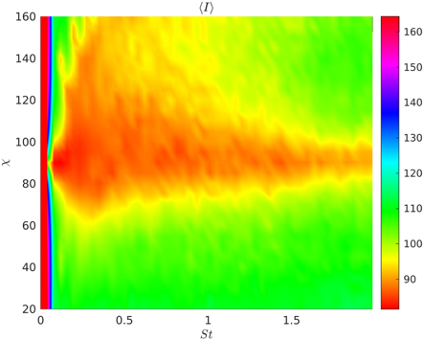  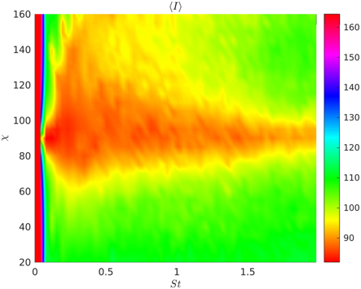  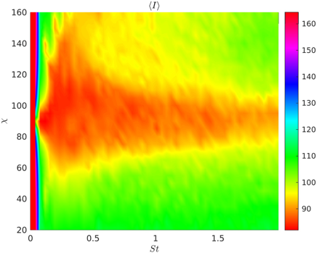 | 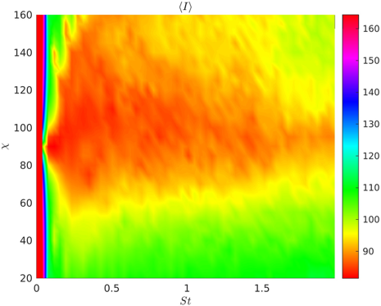  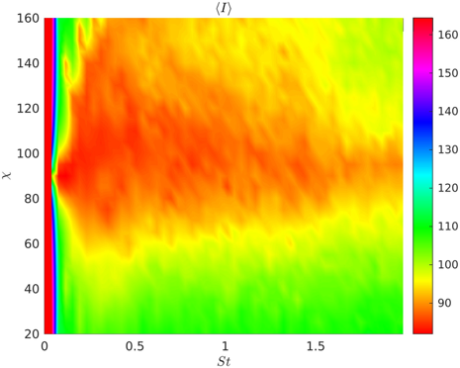  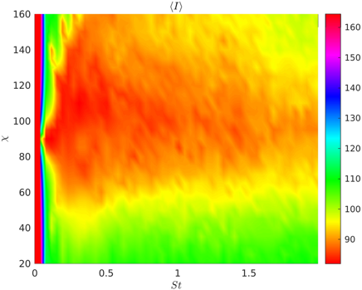 | 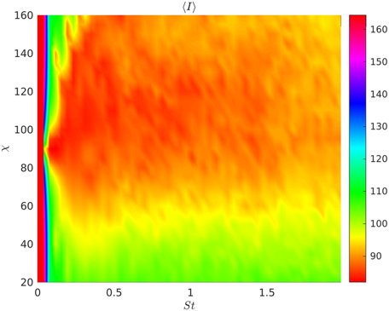  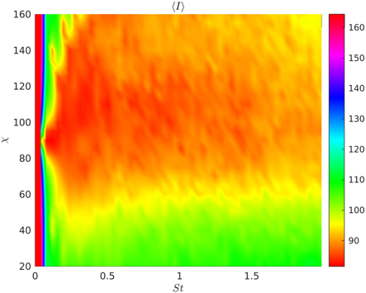  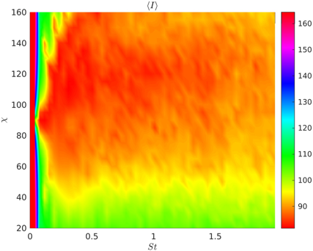

Without the first two frequencies which have very high intensity

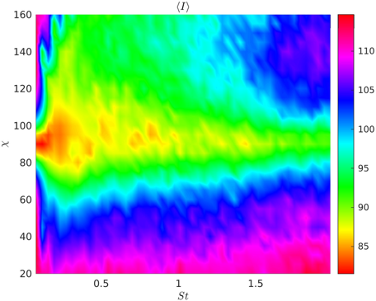  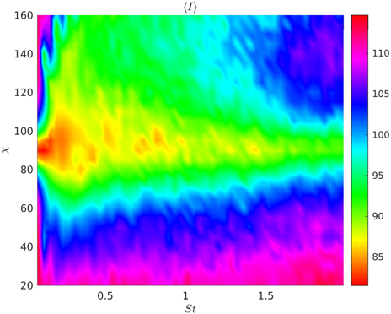  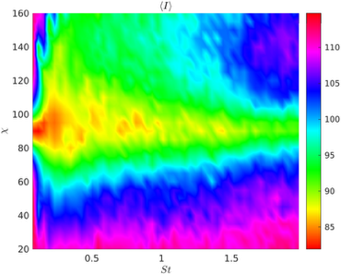  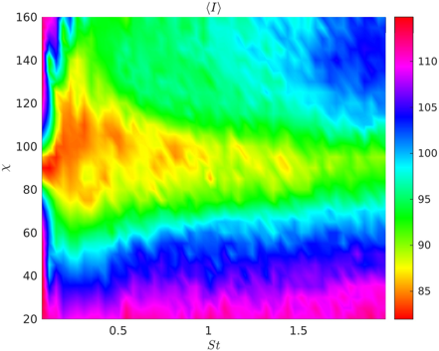 | 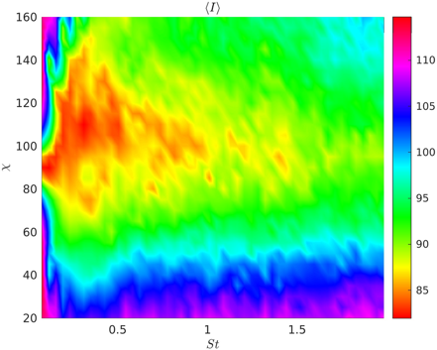  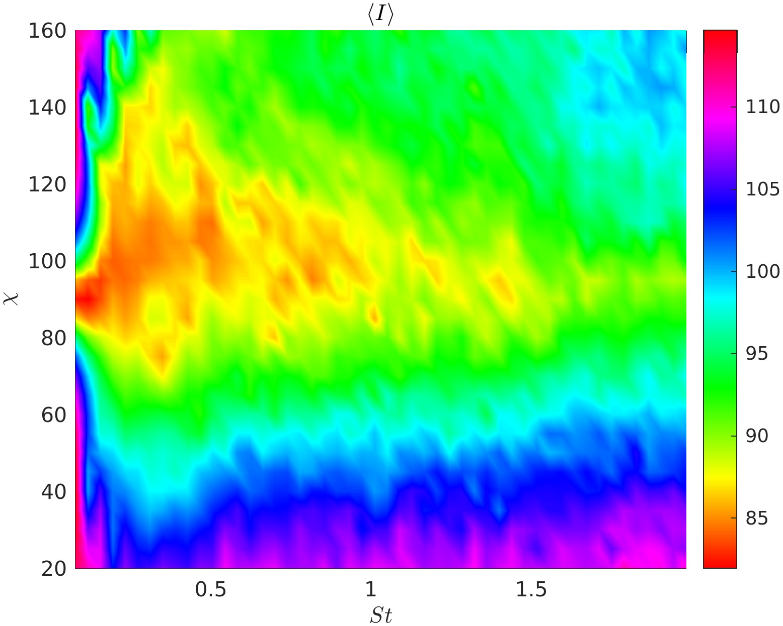  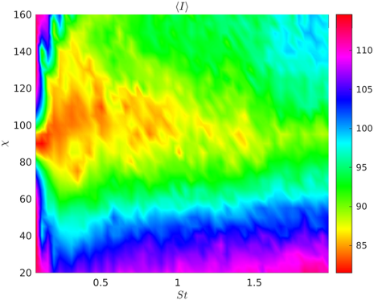 | 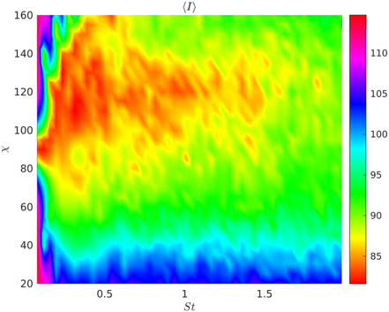  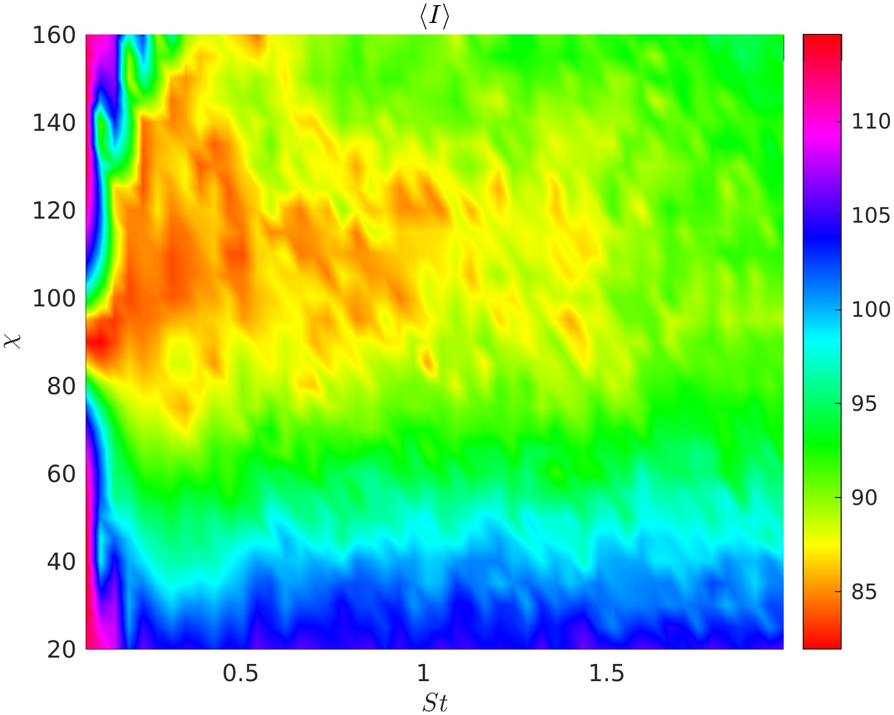  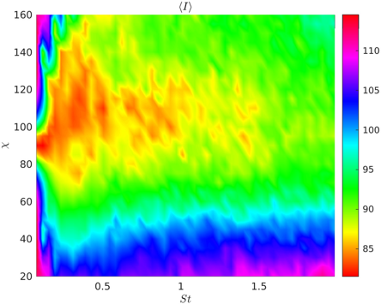

Intensity integrated over polar angle

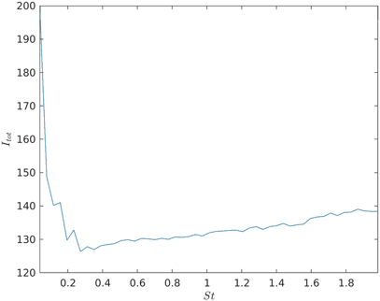  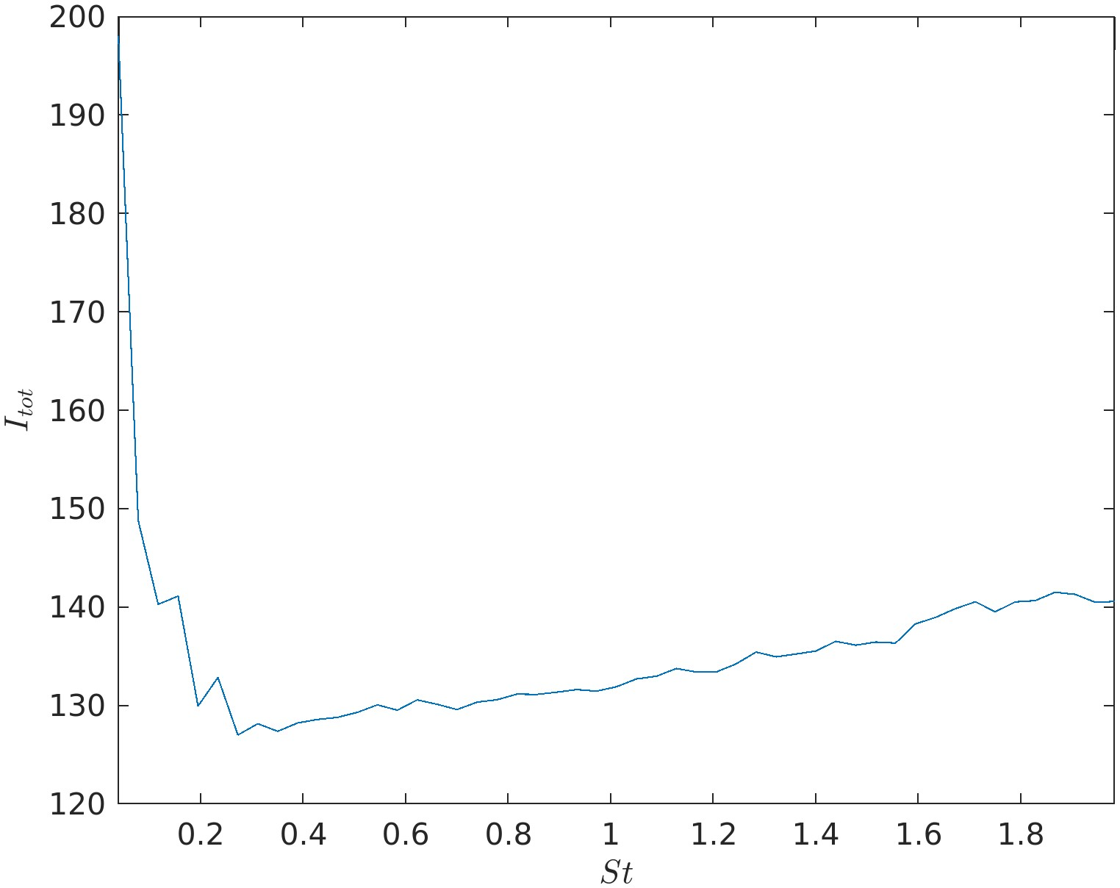  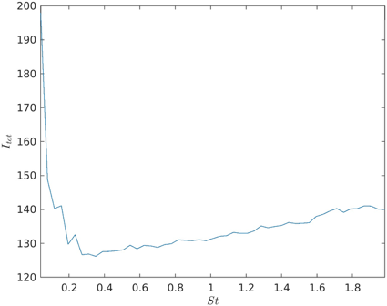 | 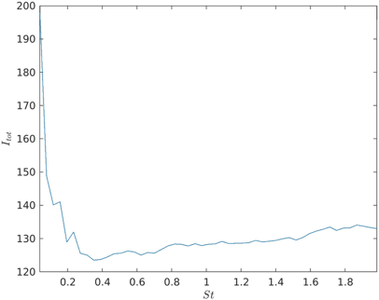  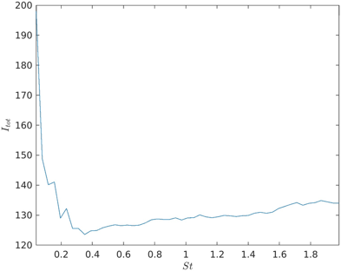  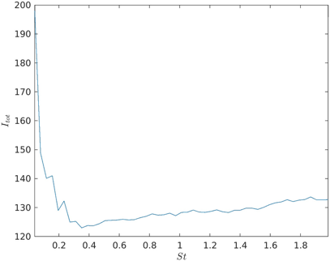 | 