Paper Title
Completed Research Paper
First author’s name  Neu-Ulm University of Applied Sciences  name@student.hnu.de | Second author’s name  Neu-Ulm University of Applied Sciences  name@student.hnu.de
Abstract
Include your abstract here followed by the keywords as indicated. The abstract should not be longer than 150 words.
Keywords: keyword 1, keyword 2, …

Introduction
You should format your paper exactly like this document. The easiest way to use this template is to replace the placeholder content with your own material. The template file contains specially formatted styles (e.g., Normal, Heading, Bullet, References, Title, Author, Affiliation) that are designed to reduce the work in formatting your final submission.

Page Size and Spacing
On each page, your material (not including the header and footer) should fit within a rectangle of 16.5 x 22.8 cm (6.5 x 9 in.), centered on a US letter page, beginning 1.27 cm (0.5 in.) from the top of the page. Please adhere to the US letter size only (in MS Word, you can check the page format in the menu: File --> Page Setup). If you cannot do so, please contact the review coordinator for assistance. All final publications will be formatted and displayed in US letter size. Right margins should be justified, not ragged. All margins must measure 1” (2.5 cm) around. Beware, especially when using this template on a Macintosh, Word may change these dimensions in unexpected ways.
Please ensure your manuscript complies with the following instructions:
- Line spacing should be single (exactly 1.0);
- Margins should be 1 inch (2.54 cm);
- Do not change character or word spacing;
- Please do not use double spaces between sentences – this is a tradition no longer necessary on modern word processors;
- Please do not edit the styles in this template;
- Please ensure all text is justified, not “ragged”.

Structure
The structure of your paper should follow the canonical structure for a SLR in IS:
- Introduction
Remember: the motivation must justify reviewing, not just justify caring about the topic.
- Conceptual background
Definition and boundaries of the focal concept, plus the theoretical lens if there is one. Remember: This section is what makes the inclusion/exclusion criteria defensible later.
- Review method
The research design as specified in your review protocol including review type and scope, search strategy, inclusion/exclusion criteria, selection process, quality appraisal, data extraction and analysis. Remember: we should be able to rerun this and land on approximately the same corpus?
- Descriptive results
The bibliometric layer — publications over time, outlets, geographies, methods used, theories mobilized. Keep it short.
- Synthesis of findings
The heart of the paper. Remember: it is concept-centric, not author-centric (Webster & Watson 2002) and the output is a synthesis: a framework, a typology, a process model, or a set of tensions and contradictions across the corpus.
- Discussion
What we collectively know, what the synthesis adds beyond the individual studies, and implications for theory and practice. Including a research agenda outlining specific gaps derived visibly from the concept matrix, ideally as propositions or a table of research questions with a suggested approach for each – this reflects the candidates for your work in semester 2 and 3. Plus limitations of the review (search bias, database coverage, publication bias, coder subjectivity; not limitations of the primary studies).
- Contribution statement
Who did what, followed by the declaration on the use of GenAI. Both are mandatory parts of the paper and do not count towards the page limit.
- Appendices
The evidence that your review can be reproduced: protocol, search documentation, selection counts, coding scheme, corpus and intercoder agreement. Does not count towards the page limit.

Length
Your submission is a completed research paper. It must not exceed 16 pages, counting everything from the title to the end of the reference list: title, abstract, body text, all figures and tables, the contribution statement, and the references. The appendices belong in the same file, follow the references, and do not count towards this limit. Do not change the page setup, the fonts, the styles or the spacing to gain space. A submission that exceeds the limit is returned without assessment.
As an indication of proportions: the synthesis of findings should be the longest section of the paper. If the conceptual background and the review method together take up more room than the synthesis, you have written a protocol rather than a review.

Title
Your paper’s title should be using the “Title” style in this template (which is configured as Georgia 20-point bold). Ensure proper capitalization within your title (i.e. “The Next Frontier of Information Systems” versus “the next frontier of Information systems.”
All proper nouns should be capitalized. Articles (the, a), coordinating conjunctions (and, but, or, for, nor, etc.) should not be capitalized, unless, of course, they are used as the first word in the title. Likewise for prepositions (on, at, to, from, by, etc.).

Normal or Body Text
Please use the “Normal” style for normal text – this style is configured as a 10-point Georgia font (similar to Times New Roman, but more easily read online) or, if it is unavailable, another proportional font with serifs, as close as possible in appearance to Times New Roman 10-point. Please use sans-serif or non-proportional fonts (such as Arial or Courier) only for special purposes, such as source code text (SpecialStyle). [References to Georgia font from this point forward should be interpreted as “Georgia or equivalent.”]

Sections
The heading of a section should be using the “Heading 1” style, each work should be capitalized – configured as Georgia 13-point bold, left justified. Sections should not be numbered.

Subsections
Headings of subsections should be using the style “Heading 2” – configured as Georgia 11-point bold italics with initial letters capitalized. (Note: for sub-sections and sub-subsections, words like ‘the’, ‘of’, ‘a’, ‘an’ are not capitalized unless it is the first word of the heading.)

Sub-subsections
Headings for sub-subsections should be using “Heading 3” – configured as Georgia 10-point bold with initial letters capitalized. Please do not go any further into another layer/level.

Figures, Tables & Captions
Place figures and tables close to the relevant text (or where they are referenced in the text).
Captions should be using the “Caption” style – configured as Georgia 10-point bold. They should be numbered (e.g., “Table 1” or “Figure 2”), centered and placed beneath the figure or table. Please note that the words “Figure” and “Table” should be spelled out (e.g., “Figure” rather than “Fig.”) wherever they occur. The proceedings will be made available online, thus color figures are possible.

Inserting Images
Occasionally MS Word generates larger-than-necessary PDF files when images inserted into the document are manipulated in MS Word. To minimize this problem, use an image editing tool to resize the image at the appropriate printing resolution (usually 300 dpi), and then insert the image into Word using Insert | Picture | From File...
As indicated in Figure 1, using tables to hold places can work very well in Word. If you want to copy a figure from another application (such as PowerPoint) and then paste to the place where you want your figure to be, make sure that (1) the figure stays in the position, and (2) it does not take up too much space. You can ensure the former by double clicking the figure, then go to “Layout” tab, and select “In line with text.” To ensure the latter, use “Paste Special,” then select “Picture.” You can resize the figure to your desired size once it is pasted.

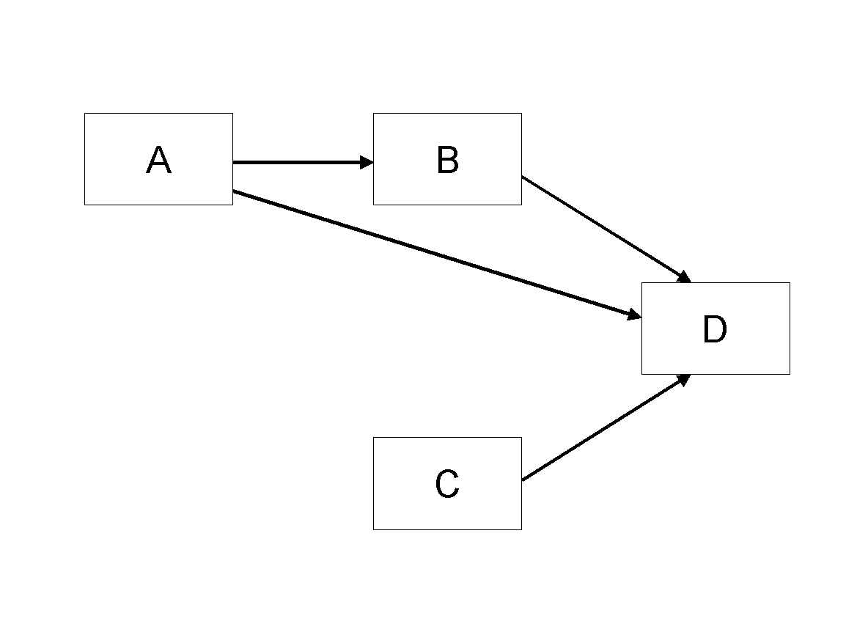
Figure 1. Modified Research Model

Table Style
Inserting a table in the text can work well. You may want to adjust the vertical spacing of the text in the tables. (In Word, use Format | Paragraph… and then the Line and Page Breaks tab. Generally, text in each field of a table will look better if it has equal amounts of spacing above and below it, as in Table 1.)
 | Treatment 1 | Treatment 2
Setting A | 125 | 95
Setting B | 85 | 102
Setting C | 98 | 85
Table 1. A Very Nice Table

Other Visual Media (e.g., video clips)
Submissions that rely on the use of visual media such as video, animation, visual analytics, etc., should embed links to these in their submission pdf. The visual media portion of the submission should be no more than 5 minutes (in total). Given the limitations of the review system, the visual media portion of the paper must be hosted outside the review system. We ask each author to create his/her own account with an open access provider of choice (e.g., linked video could be hosted in Vimeo or YouTube). Please use a pseudo user name in order to maintain anonymity during the review process. The visual media portion of the submission must be playable in a generic Internet browser. Please fine-tune for Firefox. Please verify that all links to visual media work as expected in the system-generated PDF prior to submitting the paper to the review system. Do not change your online media after submitting the paper for review. We recommend using Creative Commons Licenses for the visual media portion of the submission. If you have any other questions, please contact the program co-chairs.

Language, Style, and Content
With regard to spelling and punctuation, you may use any dialect of English (e.g., British, Canadian, US, etc.) provided this is done consistently. Hyphenation is optional. To ensure suitability for an international audience, please pay attention to the following:
- Write in a straightforward style.
- Try to avoid long or complex sentence structures.
- Briefly define or explain all technical terms that may be unfamiliar to readers.
- Explain all acronyms the first time they are used in your text – e.g., “primary care provider (PCP)”.
- Explain local references (e.g., not everyone knows all city names in a particular country).
- Be careful with the use of gender-specific pronouns (he, she) and other gendered words (chairman, manpower, man-months). Use inclusive language that is gender-neutral (e.g., they, s/he, chair, staff, staff-hours, person-years).

Conclusion
It is important that you write for a general audience. It is also important that your work is presented in a professional fashion. This guideline is intended to help you achieve that goal. By adhering to the guideline, you also help the conference organizers tremendously in reducing our workload and ensuring impressive presentation of your conference paper. We thank you very much for your cooperation and look forward to receiving a professional looking, camera-ready version!

References and Citations
References should be listed alphabetically by author name at the end of the paper in conformance with APA 7th edition. In-text citations should be indicated by the author’s last name and year of publication, e.g., (DeGross, 1977) or DeGross (1977). References must be complete, i.e., include, as appropriate, volume, number, month, publisher, city and state, editors, last name & initials of all authors, page numbers, etc. If you use EndNote, be aware that different versions of the software change the styles, creating some inconsistencies.
Your references should comprise only published (or preprint) materials accessible to the public. Proprietary information may not be cited.
References should be ordered in alphabetic order.

References
[Please ensure that all references are present, complete, and accurate as per the examples below, including DOIs]
Ackoff, R. L. (1967). Management misinformation systems. Management Science, 14(4), 147-156. https://doi.org/10.1287/mnsc.14.4.B147
Benbasat, I., & Zmud, R. W. (2003). The identity crisis within the IS discipline: Defining and communicating the discipline's core properties. MIS Quarterly, 27(2), 183-194. https://doi.org/10.2307/30036527
Bonini, C. P. (1963). Simulation of information and decision systems in the firm. Prentice-Hall.
Broadbent, M., Weill, P., O’Brien, T., & Neo, B. S. (1996). Firm context and patterns of IT infrastructure capability. Proceedings of the 14th International Conference on Information Systems, 13, 174-194. https://aisel.aisnet.org/icis1996/13
Carroll, J. (2005). The Blacksburgh Electronic Village: A study in community computing. In P. van den Besselaar & S. Kiozumi (Eds.), Digital Cities III: Information Technologies for Social Capital (pp. 43-65). Springer-Verlag. https://doi.org/10.1007/11407546_3

Contribution Statement and Declaration on the Use of GenAI
Place the contribution statement and the declaration on the use of GenAI at the end of the paper, directly after the references. Both are mandatory, both count towards the page limit, and a paper submitted without them is not assessed. Delete this paragraph in your final submission.

Contribution Statement
Complete the table below. For each task, state the contribution of each author (for example lead, support, or equal). Every task must be assigned. “Equal” is a legitimate entry where the work was genuinely shared; “both” without further detail is not. Delete this paragraph in your final submission.
Task | First author’s name | Second author’s name
Review question and conceptual framing
Search strategy and execution
Screening and selection
Coding and data extraction
Double coding and agreement check
Synthesis and framework development
Writing — original draft
Writing — revision and editing
Figures, tables and appendices
Table X. Contribution Statement

Declaration on the Use of GenAI
[The declaration covers the paper as a whole and applies to both authors. Complete it jointly and name both authors underneath.]
[If you have not used GenAI keep the following sentence and delete the rest of the text.]
In the preparation of this paper, we have not used systems based on generative artificial intelligence (GenAI).
[If you have used GenAI delete the sentence above and complete the following declaration.]
In the preparation of this paper, we have used the tools based on generative artificial intelligence (GenAI) listed in the table below.
We further declare that
- We have labeled the content taken from the GenAI tools listed above with my details in the table below,
- we have verified that the content generated by the above-mentioned GenAI tools and adapted by me is factually correct,
- we are aware that, as the author of this work, we are responsible for the information and the statements made in it, and
- we are aware that violating the disclosure of the use of generative AI in my work is a deception and leads to an evaluation with an insufficient grade.
GenAI tool | Section / page | Purpose of use | Prompt or type of input | How the output was checked and adapted
Table X. Use of GenAI Tools

Appendices
The appendices are part of this file. They follow the references, are labelled Appendix A, Appendix B and so on, and each one is referred to at least once in the text. They do not count towards the page limit — but they are not a place for material that was cut for length. Anything that carries your argument belongs in the paper; the appendices hold the evidence that your review can be reproduced.
The following appendices are mandatory:
- Appendix A — Review protocol
Review type and goal, the scope of the review (for example along Cooper’s taxonomy: focus, goal, organisation, perspective, audience, coverage), and the review question(s) in their final wording.
- Appendix B — Search documentation
For every database searched: the exact search string as it was entered, the fields searched (e.g., title, abstract, keywords), all filters and limiters, the date of the search, and the number of hits.
- Appendix C — Selection documentation
The inclusion and exclusion criteria, each with a one-sentence rationale; the number of records at every stage, including backward and forward search; and the reasons for exclusion at the full-text stage.
- Appendix D — Coding scheme
Every code with its definition, its decision rule, and an example passage from the corpus. Indicate which codes were defined a priori and which emerged during coding.
- Appendix E — Corpus
The complete list of included publications with full reference, outlet, year, research method, theory used and the codes assigned — that is, the full concept matrix if it does not fit into the paper.
- Appendix F — Intercoder agreement
Which subsample was coded independently by both authors, the agreement measure and its value, and how disagreements were resolved.
Further appendices are permitted, for example extended descriptive statistics or additional tables. Large working files such as an extraction spreadsheet may in addition be deposited in a repository and linked, but the appendices in this file must be complete enough to follow the review without it.

Appendix A — Review Protocol
[Your content here.]

