Extended Proposal

# Structure

The proposal serves to illustrate the most important aspects of your thesis:

1. What do you want to investigate in your work and which results do you expect?

*Aim of your research – WHAT?*

1. How do you want to achieve the aims of your work?

*Design of your research – HOW?*

Your proposal is an important first step for your thesis. The proposal helps you to understand your own research topic and to express your idea and working method. Moreover, the proposal serves as a written agreement over your thesis between you and your supervisor.

The thesis proposal should follow following structure:

1. Working title of your thesis
2. Problem statement

*What is the topic and why should we care?*

1. Current state of research

*What do we already know form research regarding the topic?*

1. Research gap and research question(s)

*What is not yet known and why does it matter?*

*What question your research intends to answer?*

1. Initial research model

*What are your theoretical considerations (so far)?*

1. Research design

*How do you plan to answer the research question?*

1. Expected contributions

*What do you expect to contribute to the body of knowledge?*

1. Schedule until delivery of your thesis

*What do you need to do until when?*

In addition:

1. Abstract (first draft of the introduction, max. 2 pages)

*How would you set the hook of a future paper that summarizes your thesis?*

Writing your proposal and already thinking about all these aspects is a challenge and needs a lot of reading, thinking and hard work. The good part is, that once you have written and discussed your proposal with your supervisor, the road for your thesis is paved and you can start work straight according to plan.

# Formal requirements

## Indexes

Tables of contents and lists of figures/tables are not required.

## Formatting

You should format your paper exactly like this document. The template file contains specially formatted styles that are designed to reduce the work in formatting your paper and increase comparability.

## Length

The extended proposal should be at least 6 pages long, but not exceed 8 pages; the abstract max. 2 pages (excluding the references and the appendix).

## Header and Footer

Please modify the header from page 2 on (running title) and the footer accordingly.

## Sections

Use the heading styles for sections, subsections, and sub-subsections.

### Sub-subsections

Please do not go any further into another layer/level.

## Figures

Place figures and tables close to the relevant text (or where they are referenced in the text).

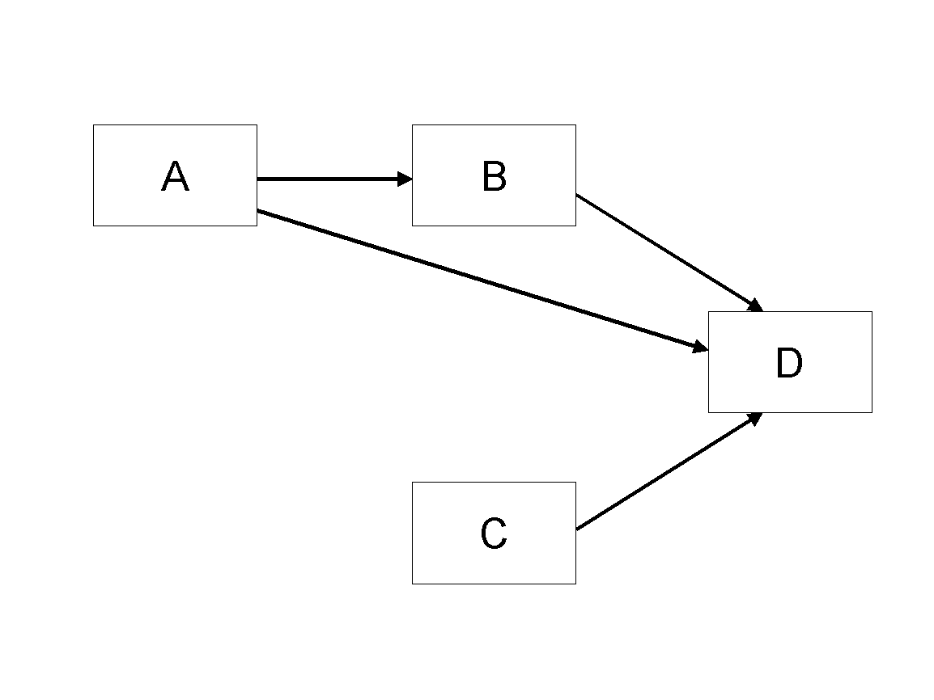

Figure 1. Model

## Tables

Inserting a table in the text can work well. You may want to adjust the vertical spacing of the text in the tables. (In Word, use Format | Paragraph… and then the Line and Page Breaks tab. Generally, text in each field of a table will look better if it has equal amounts of spacing above and below it, as in Table 1.)

|  |  |  |
| --- | --- | --- |
|  | **Treatment 1** | **Treatment 2** |
| **Setting A** | 125 | 95 |
| **Setting B** | 85 | 102 |
| **Setting C** | 98 | 85 |

Table 1. A Very Nice Table

## References and Citations

References are to be formatted using the **new** *MIS Quarterly* style (<http://www.misq.org/manuscript-guidelines> under MISQ References Format). References must be complete, i.e., include, as appropriate, volume, number, month, publisher, city and state, editors, last name & initials of all authors, page numbers, etc. If you use EndNote, be aware that different versions of the software change the styles, creating some inconsistencies. Please also be aware that the *MIS Quarterly* style provided by default in the EndNote X4 software (and all earlier versions) is for the **old** *MIS Quarterly* style. You may access the End Note Style [here](http://endnote.com/downloads/style/mis-quarterly).

Your references should comprise only published materials accessible to the public. Proprietary information may not be cited.

References should be ordered in alphabetic order.

# References

Haki, Kazem; Beese, Jannis; Aier, Stephan; and Winter, Robert. 2020. "The Evolution of Information Systems Architecture: An Agent-Based Simulation Model," *MIS Quarterly*, (44: 1) pp.155-184.

# Appendix

## Glossary

### Business capability

The capacity—including people, processes, assets, data and services—to drive a business outcome such as generating revenue …