Topic

# Structure

Your paper needs to cover following sections. Each section starts on a new page with a corresponding level 1 heading.

* Research Problem (1 page)
* Literature stream (1-2 pages)
* Literature synthesis (2 pages)
* Theory (3-5 pages)
* Method (2-3 pages)
* References

All page counts exclude figures and tables. One page equals approx. 550 words.

# Formal requirements

## Indexes

Tables of contents and lists of figures/tables are not required.

## Formatting

You should format your paper exactly like this document. The template file contains specially formatted styles that are designed to reduce the work in formatting your paper and increase comparability.

## Length

Seminar paper should be at least 4.500 words, but not exceed 5.500 words (excluding tables, figures, and references)

## Header and Footer

Please modify the header from page 2 on (running title) and the footer accordingly.

## Sections

Use the title style for your working title,   
the heading styles for sections, subsections, and sub-subsections.

### Sub-subsections

Please do not go any further into another layer/level.

## Figures

Place figures and tables close to the relevant text (or where they are referenced in the text).

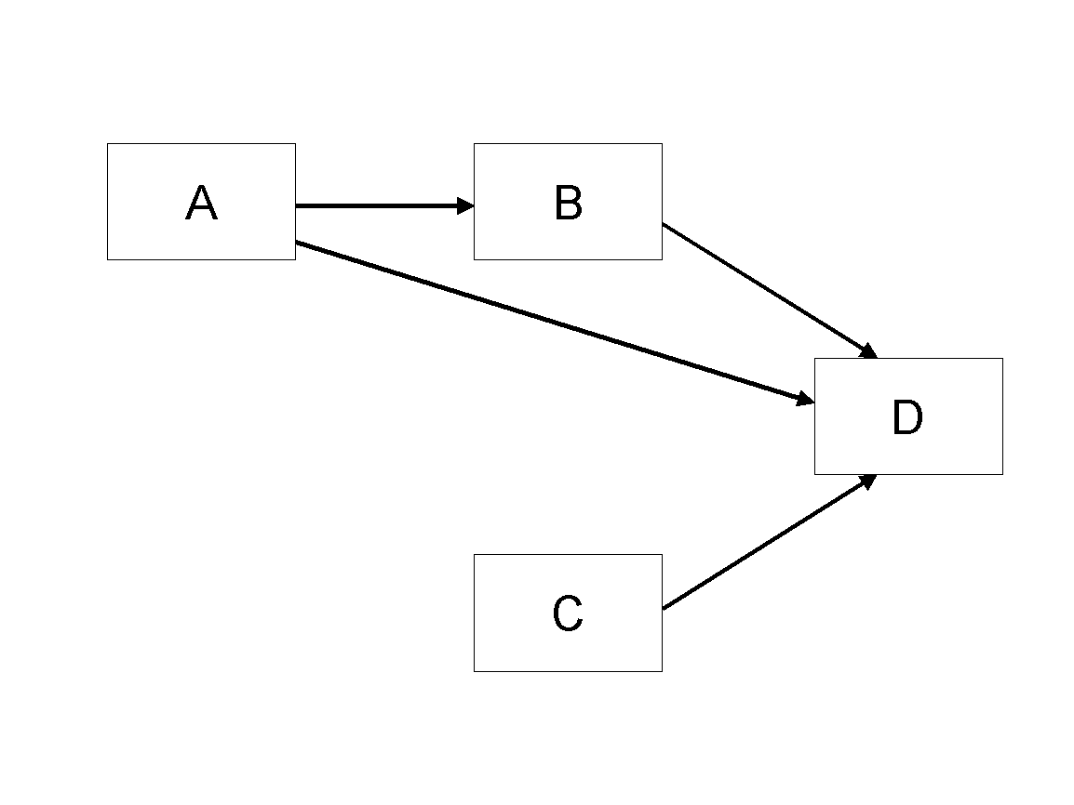

Figure 1. Model

## Tables

Inserting a table in the text can work well. You may want to adjust the vertical spacing of the text in the tables. (In Word, use Format | Paragraph… and then the Line and Page Breaks tab. Generally, text in each field of a table will look better if it has equal amounts of spacing above and below it, as in Table 1.)

|  |  |  |
| --- | --- | --- |
|  | **Treatment 1** | **Treatment 2** |
| **Setting A** | 125 | 95 |
| **Setting B** | 85 | 102 |
| **Setting C** | 98 | 85 |

Table 1. A Very Nice Table

## References and Citations

References are to be formatted using the **new** *MIS Quarterly* style (<http://www.misq.org/manuscript-guidelines> under MISQ References Format). References must be complete, i.e., include, as appropriate, volume, number, month, publisher, city and state, editors, last name & initials of all authors, page numbers, etc. If you use EndNote, be aware that different versions of the software change the styles, creating some inconsistencies. Please also be aware that the *MIS Quarterly* style provided by default in the EndNote X4 software (and all earlier versions) is for the **old** *MIS Quarterly* style. You may access the End Note Style [here](http://endnote.com/downloads/style/mis-quarterly).

Your references should comprise only published materials accessible to the public. Proprietary information may not be cited.

References should be ordered in alphabetic order.

# References

Haki, Kazem; Beese, Jannis; Aier, Stephan; and Winter, Robert. 2020. "The Evolution of Information Systems Architecture: An Agent-Based Simulation Model," *MIS Quarterly*, (44: 1) pp.155-184.