Title

# Structure

Your paper needs to cover following contents:

* **Title** that briefly summarizes the content (max. 10 words)  
  *Example: Using chatbots to increase gratitude — a design science approach*
* **Research problem** (max. 300 words)  
  *Very brief introduction to the phenomena to be studied and the theory used as well as the research question that should be answered*
* **Research design** (1.000 to 1.700 words)

*Presentation and justification of the research design (i.e., data collection and data analysis) that shows how you intend to generate meaningful answers to the research question*

* **References**

All page counts exclude figures, tables, and references.

In addition, you need to declare the use of GenAI tools.  
Please use the template provided below (Appendix).

# Formal requirements

## Indexes

Tables of contents and lists of figures/tables are not required.

## Formatting

You should format your paper exactly like this document. The template file contains specially formatted styles that are designed to reduce the work in formatting your paper and increase comparability.

## Length

Paper should be at least 1.200 words, but not exceed 2.000 words (excluding tables, figures, and references)

## Footer

Please modify the footer accordingly.

## Sections

Use the title style for your short title, the heading style 1 for sections and heading style 2 for subsections. Please do not go any further into another layer/level.

## Figures

Place figures and tables close to the relevant text (or where they are referenced in the text).

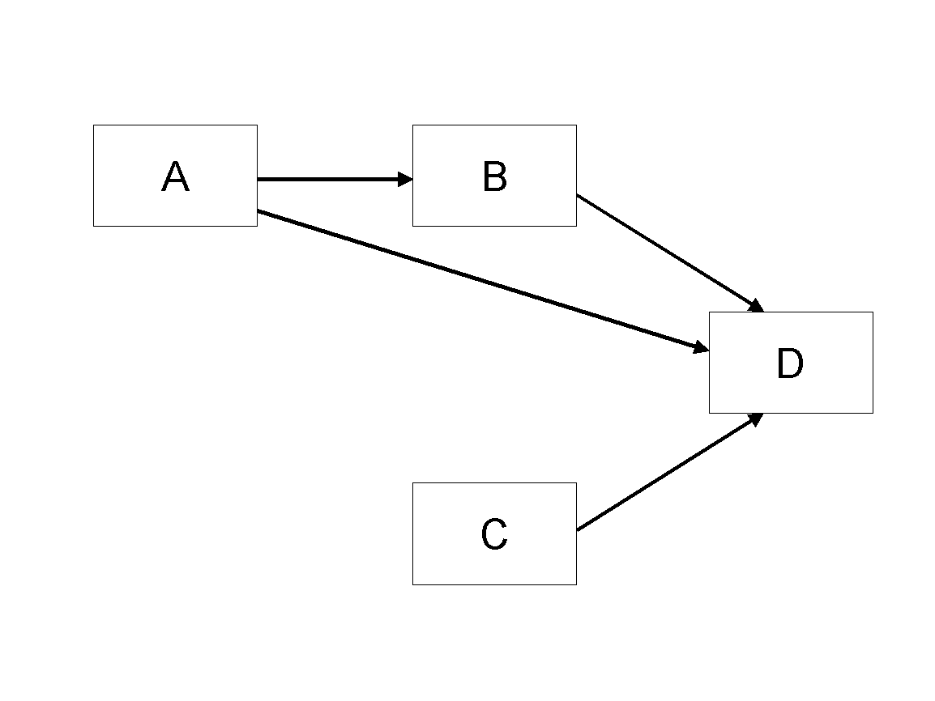

Figure 1. Model

## Tables

Inserting a table in the text can work well. You may want to adjust the vertical spacing of the text in the tables. (In Word, use Format | Paragraph… and then the Line and Page Breaks tab. Generally, text in each field of a table will look better if it has equal amounts of spacing above and below it, as in Table 1.)

|  |  |  |
| --- | --- | --- |
|  | **Treatment 1** | **Treatment 2** |
| **Setting A** | 125 | 95 |
| **Setting B** | 85 | 102 |
| **Setting C** | 98 | 85 |

Table 1. A Very Nice Table

## References and Citations

References are to be formatted using the *APA 7th* style. References must be complete, i.e., include, as appropriate, volume, number, month, publisher, city and state, editors, last name & initials of all authors, page numbers, etc.

Your references should comprise only published materials accessible to the public. Proprietary information may not be cited.

References should be ordered in alphabetic order.

# References

Haki, Kazem; Beese, Jannis; Aier, Stephan; and Winter, Robert. 2020. "The Evolution of Information Systems Architecture: An Agent-Based Simulation Model," *MIS Quarterly*, (44: 1) pp.155-184.

# Appendix: Declaration on the use of GenAI tools

[If you have not used GenAI keep the following sentence and delete the rest of the text.]

In the preparation of this paper, I have not used systems based on generative artificial intelligence (GenAI).

[If you have used GenAI complete the following declaration.]

In the preparation of this paper, I have used following tools based on generative artificial intelligence (GenAI):

1. ChatGPT
2. DeeplWrite

[List other systems if others where used.]

I further declare that

* I have labeled the content taken from the GenAI tools listed above with my details in the table below,
* I have verified that the content generated by the above-mentioned GenAI tools and adapted by me is factually correct,
* I am aware that, as the author of this work, I am responsible for the information and the statements made in it, and
* I am aware that violating the disclosure of the use of generative AI in my work is a deception and leads to an evaluation with an insufficient grade.

I have used the above-mentioned AI systems as indicated below.

|  |  |  |
| --- | --- | --- |
| **Areas of contribution** | **AI tool(s) used** | **Manner of use[1]** |
| Development and conception of the research project | [Add AI tool] |  |
| Identification of literature |  |  |
| Synthesizing of literature |  |  |
| Structuring the text |  |  |
| Formulation of text |  |  |
| Revision of text |  |  |
| Creation of visualizations |  |  |
| Further contributions |  |  |
| [Other areas, if applicable] |  |  |

# Sample Text (500 words)

Please delete this page. It is only a demonstration of how text should be formatted. Ligula eget dolor. Aenean massa. Cum sociis natoque penatibus et magnis dis parturient montes, nascetur ridiculus mus. Donec quam felis, ultricies nec, pellentesque eu, pretium quis, sem. Nulla consequat massa quis enim. Donec pede justo, fringilla vel, aliquet nec, vulputate eget, arcu. In enim justo, rhoncus ut, imperdiet a, venenatis vitae, justo. Nullam dictum felis eu pede mollis pretium. Integer tincidunt. Cras dapibus. Vivamus elementum semper nisi. Aenean vulputate eleifend tellus. Vestibulum ante ipsum primis in faucibus orci luctus et.

## Subsection

Aenean leo ligula, porttitor eu, consequat vitae, eleifend ac, enim. Aliquam lorem ante, dapibus in, viverra quis, feugiat a, tellus. Phasellus viverra nulla ut metus varius laoreet. Quisque rutrum. Aenean imperdiet. Etiam ultricies nisi vel augue. Curabitur ullamcorper ultricies nisi. Nam eget dui. Etiam rhoncus. Maecenas tempus, tellus eget condimentum rhoncus, sem quam semper libero, sit amet adipiscing sem neque sed ipsum. Nam quam nunc, blandit vel, luctus pulvinar, hendrerit id, lorem. Maecenas nec odio et ante tincidunt tempus. Donec vitae sapien ut libero venenatis faucibus.

Etiam sit amet orci eget eros faucibus tincidunt. Duis leo. Sed fringilla mauris sit amet nibh. Donec sodales sagittis magna. Sed consequat, leo eget bibendum sodales, augue velit cursus nunc, quis gravida magna mi a libero. Fusce vulputate eleifend sapien. Vestibulum purus quam, scelerisque ut, mollis sed, nonummy id, metus. Nullam accumsan lorem in dui. Cras ultricies mi eu turpis hendrerit fringilla. Vestibulum ante ipsum primis in faucibus orci luctus et ultrices posuere cubilia Curae; In ac dui quis mi consectetuer lacinia. Nam pretium turpis et arcu. Duis arcu tortor, suscipit eget, imperdiet nec, imperdiet iaculis, ipsum. Sed aliquam ultrices mauris. Integer ante arcu, accumsan a, consectetuer eget, posuere ut, mauris. Praesent adipiscing. Phasellus ullamcorper ipsum rutrum nunc. Nunc nonummy metus. Vestibulum volutpat pretium libero. Cras id dui. Aenean ut eros et nisl sagittis vestibulum. Nullam nulla eros, ultricies sit amet, nonummy id, imperdiet feugiat, pede. Sed lectus. Donec mollis hendrerit risus. Phasellus nec sem in justo pellentesque facilisis. Etiam imperdiet imperdiet orci. Nunc nec neque. ultrices posuere cubilia curae.

Phasellus leo dolor, tempus non, auctor et, hendrerit quis, nisi. Curabitur ligula sapien, tincidunt non, euismod vitae, posuere imperdiet, leo. Maecenas malesuada. Praesent congue erat at massa. Sed cursus turpis vitae tortor. Donec posuere vulputate arcu. Phasellus accumsan cursus velit. Vestibulum ante ipsum primis in faucibus orci luctus et ultrices posuere cubilia Curae; Sed aliquam, nisi quis porttitor congue, elit erat euismod orci, ac placerat dolor lectus quis orci. Phasellus consectetuer vestibulum elit. Aenean tellus metus, bibendum sed, posuere ac, mattis non, nunc. Vestibulum fringilla pede sit amet augue. In turpis. Pellentesque posuere. Praesent turpis. Aenean posuere, tortor sed cursus feugiat, nunc augue blandit nunc, eu sollicitudin urna dolor sagittis lacus. Donec elit libero, sodales nec, volutpat a, suscipit non, turpis. Nullam sagittis. Suspendisse pulvinar, augue ac venenatis condimentum, sem libero volutpat nibh, nec pellentesque velit pede quis nunc. Phasellus dolor. Maecenas vestibulum mollis.

1. Description of the manner of use and compliance with good scientific practice  
   (if applicable, please indicate the section of the paper)