Case Study Title

# Formal requirements

## Formatting

You should format your paper exactly like this document. The template file contains specially formatted styles that are designed to reduce the work in formatting your final submission.

## Length

The paper should be at least 12 pages long and must not exceed 16 pages (each excluding the references and the appendix).

## Header and Footer

Please modify the header from page 2 on (title) and the footer (name and student number) accordingly.

## Sections

Use the heading styles for sections, subsections, and sub-subsections.

### Sub-subsections

Please do not go any further into another layer/level.

## Figures

Place figures and tables close to the relevant text (or where they are referenced in the text).

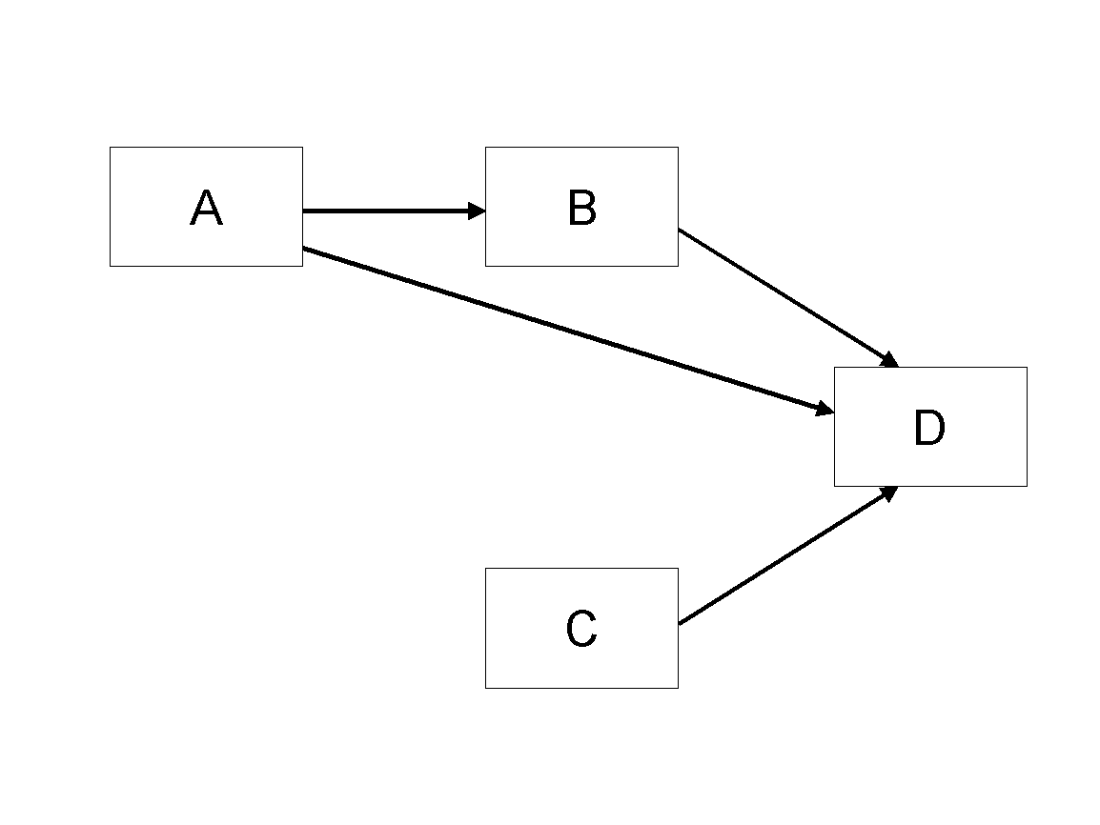

Figure 1. Modified Research Model

## Tables

Inserting a table in the text can work well. You may want to adjust the vertical spacing of the text in the tables. (In Word, use Format | Paragraph… and then the Line and Page Breaks tab. Generally, text in each field of a table will look better if it has equal amounts of spacing above and below it, as in Table 1.)

|  |  |  |
| --- | --- | --- |
|  | **Treatment 1** | **Treatment 2** |
| **Setting A** | 125 | 95 |
| **Setting B** | 85 | 102 |
| **Setting C** | 98 | 85 |

Table 1. A Very Nice Table

## References and Citations

References are to be formatted using the *MIS Quarterly* style or the current APA specification.

References must be complete, i.e., include, as appropriate, volume, number, month, publisher, city and state, editors, last name & initials of all authors, page numbers, etc. If you use EndNote, be aware that different versions of the software change the styles, creating some inconsistencies. Please also be aware that the *MIS Quarterly* style provided by default in the EndNote X4 software (and all earlier versions) is for the **old** *MIS Quarterly* style. You may access the End Note Style [here](http://endnote.com/downloads/style/mis-quarterly).

Your references should comprise only published materials accessible to the public. Proprietary information may not be cited.

References should be ordered in alphabetic order.

# Appendix A: Declaration on the use of GenAI tools

[If you have not used GenAI keep the following sentence and delete the rest of the text.]

In the preparation of this paper, I have not used systems based on generative artificial intelligence (GenAI).

[If you have used GenAI complete the following declaration.]

In the preparation of this paper, I have used following tools based on generative artificial intelligence (GenAI):

1. ChatGPT
2. DeeplWrite

[List other systems if others where used.]

I further declare that

* I have labeled the content taken from the GenAI tools listed above with my details in the table below,
* I have verified that the content generated by the above-mentioned GenAI tools and adapted by me is factually correct,
* I am aware that, as the author of this work, I am responsible for the information and the statements made in it, and
* I am aware that violating the disclosure of the use of generative AI in my work is a deception and leads to an evaluation with an insufficient grade.

I have used the above-mentioned AI systems as indicated below.

|  |  |  |
| --- | --- | --- |
| Areas of contribution | AI tool(s) used | Description of the manner of use and compliance with good scientific practice (if applicable, please indicate the section of the paper) |
| Development and conception of the research project | None |  |
| Identification of literature |  |  |
| Synthesizing of literature |  |  |
| Structuring the text |  |  |
| Formulation of text |  |  |
| Revision of text | 2 |  |
| Creation of visualizations |  |  |
| Further contributions |  |  |
| […] |  |  |