Your Title

# Team

Please add the name of your team to the headline and complement the table below:

|  |  |  |
| --- | --- | --- |
| **Surname & Name** | **Student ID** | **Study Program** |
|  |  |  |

# Formal requirements

## Formatting

You should format your paper exactly like this document. The template file contains specially formatted styles that are designed to reduce the work in formatting your final submission.

Delete comments.

## Length

The paper should contain at least 10 pages text per person and must not exceed 15 pages (each excluding images, references, and the appendix).

## Header and Footer

Please modify the header from page 2 on (title) and the footer (name and student number) accordingly.

## Sections

Use the heading styles for sections, subsections, and sub-subsections.

### Sub-subsections

Please do not go any further into another layer/level.

## Figures

Place figures and tables close to the relevant text (or where they are referenced in the text).

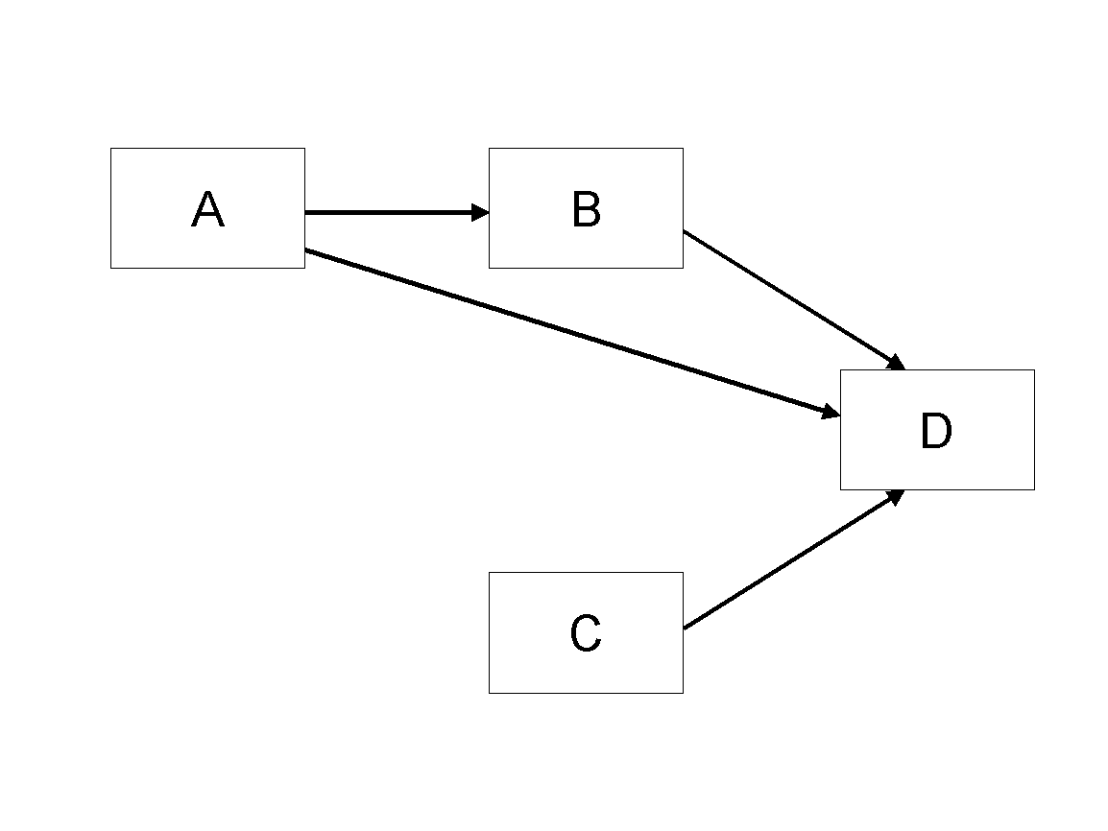

Figure 1. Modified Research Model

## Tables

Inserting a table in the text can work well. You may want to adjust the vertical spacing of the text in the tables. (In Word, use Format | Paragraph… and then the Line and Page Breaks tab. Generally, text in each field of a table will look better if it has equal amounts of spacing above and below it, as in Table 1.)

|  |  |  |
| --- | --- | --- |
|  | **Treatment 1** | **Treatment 2** |
| **Setting A** | 125 | 95 |
| **Setting B** | 85 | 102 |
| **Setting C** | 98 | 85 |

Table 1. A Very Nice Table

## References and Citations

References are to be formatted using the **new** *MIS Quarterly* style (<http://www.misq.org/manuscript-guidelines> under MISQ References Format). References must be complete, i.e., include, as appropriate, volume, number, month, publisher, city and state, editors, last name & initials of all authors, page numbers, etc. If you use EndNote, be aware that different versions of the software change the styles, creating some inconsistencies. Please also be aware that the *MIS Quarterly* style provided by default in the EndNote X4 software (and all earlier versions) is for the **old** *MIS Quarterly* style. You may access the End Note Style [here](http://endnote.com/downloads/style/mis-quarterly).

Your references should comprise only published materials accessible to the public. Proprietary information may not be cited.

References should be ordered in alphabetic order.

# Appendix