Project: TODO Application
Course: CSD-380
Description: Test plan
Date: 2025/11/13
To complete the test case plan, fill out the information for Project, Course, Description and Date in the header below.
.
TABLE OF CONTENTS
Access Website via Standard URL 2
Edit an Existing Todo Task 2
Create a New Todo Task 3
Prevent Empty Task Submission 4
Delete a Todo Task Item 4

For each test, the developer should: provide a test description, a test objective, the developer name and date tested. For each step, fill out the actions to be taken and describe the expected results, and indicate yes or no for each step depending upon the result. The peer tester should provide their name, date tested, indicate yes or no for each step depending upon the result, and a screenshot (thumbnail) of the result.

Test 1 | Access Website via Standard URL
 | Test Objective: Verify that users can access the Todo application via the provided URL. | Developer: Nardos Gebremedhin  Date tested: 2025/11/13 | Peer tester: Amanda Wedergren  Date tested: 2025/11/14
Step | Action | Expected results: | Developer pass/fail | Tester pass/fail  + Screenshot
1 | Open google | Google opens successfully | <yes/no> | 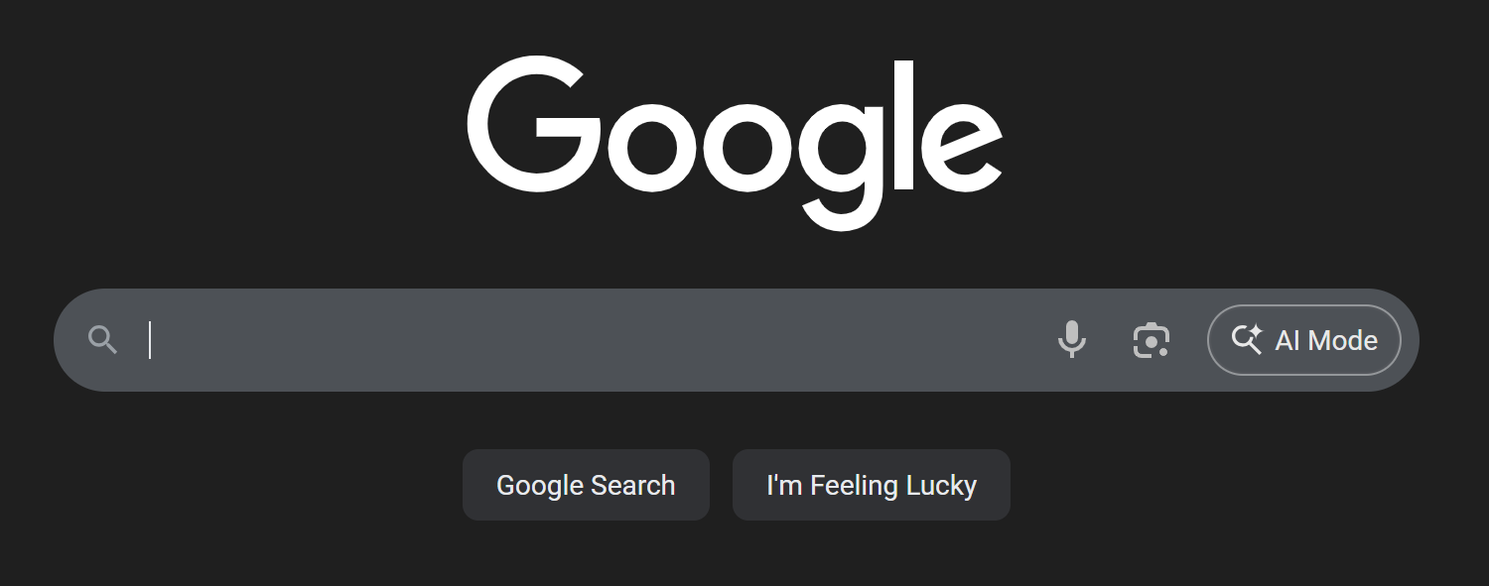  yes
2 | Navigate to https://buwebdev.github.io/todo/ | Todo app loads without errors | <yes/no> | 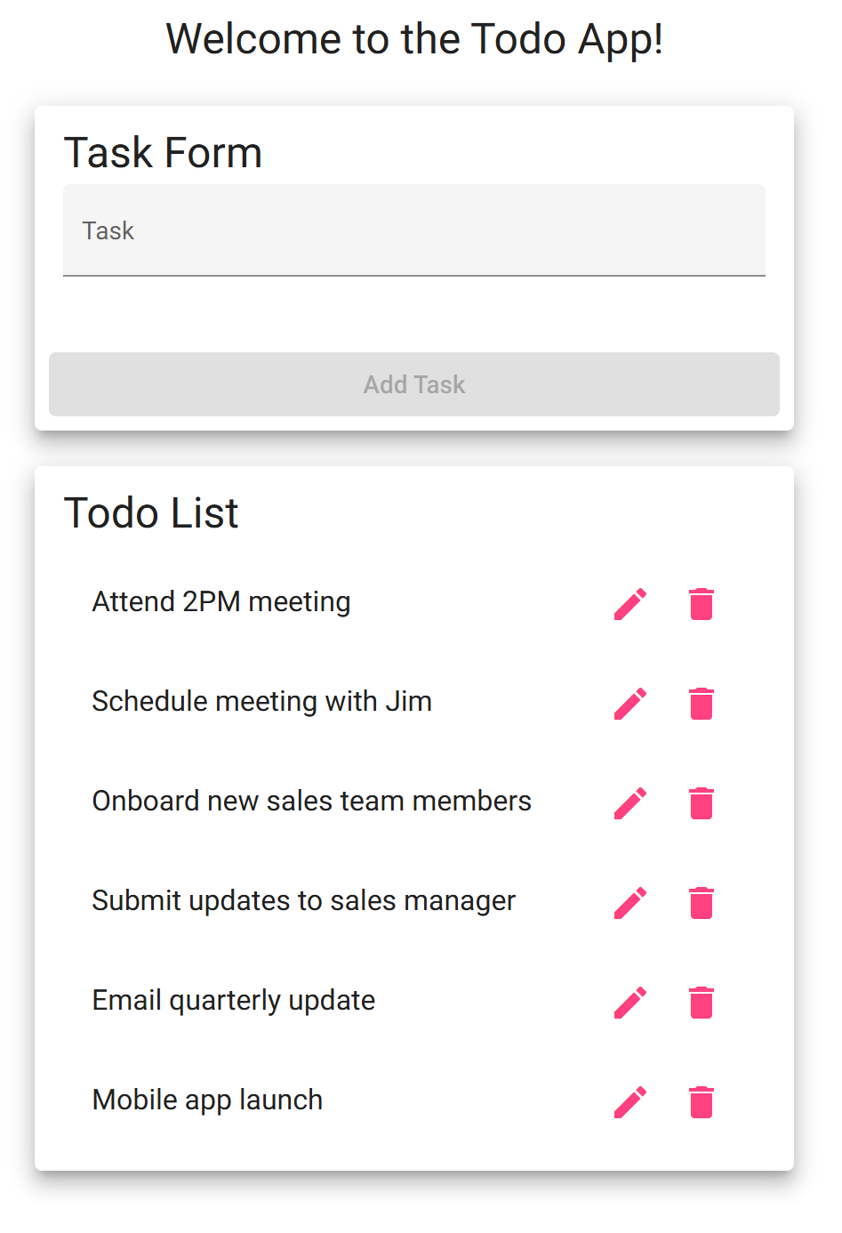  yes
3 | Refresh the browser window | Page reloads correctly | <yes/no> | yes
4 | Click around the Todo page | All links and buttons respond appropriately | <yes/no> | 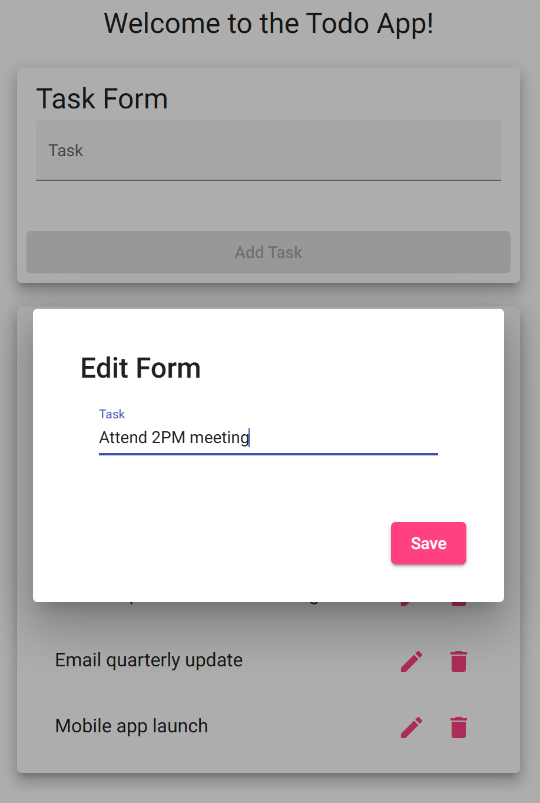  yes
5 | Check for HTTPS in the address bar | Secure connection is confirmed | <yes/no> | yes
Comments | This test proves that the website URL functions properly. The website can be accessed through the URL and the page loads as expected. The functions within the app also respond appropriately when clicked.

Test 2 | Edit an Existing Todo Task
 | Test Objective: Verify that users can edit a task item. | Developer: Nardos Gebremedhin  Date tested: 2025/11/13 | Peer tester: Amanda Wedergren  Date tested: 2025/11/14
Step | Action | Expected results: | Developer pass/fail | Tester pass/fail
1 | Locate an existing task | Task is visible in the list | <yes/no> | 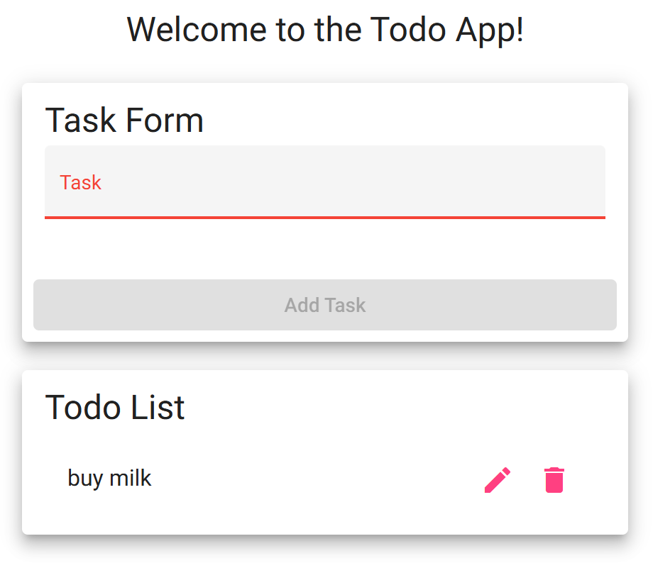  yes
2 | Click the pencil/pen icon | An edit box should pop up | <yes/no> | 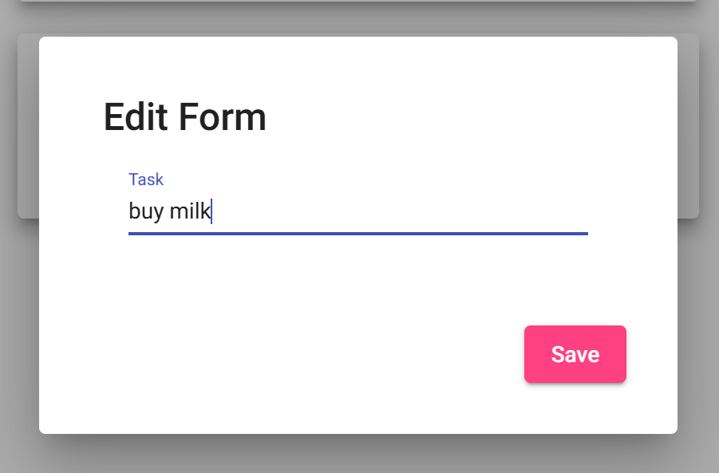  yes
3 | Change text to "Watch Blade" | New text appears in the field | <yes/no> | 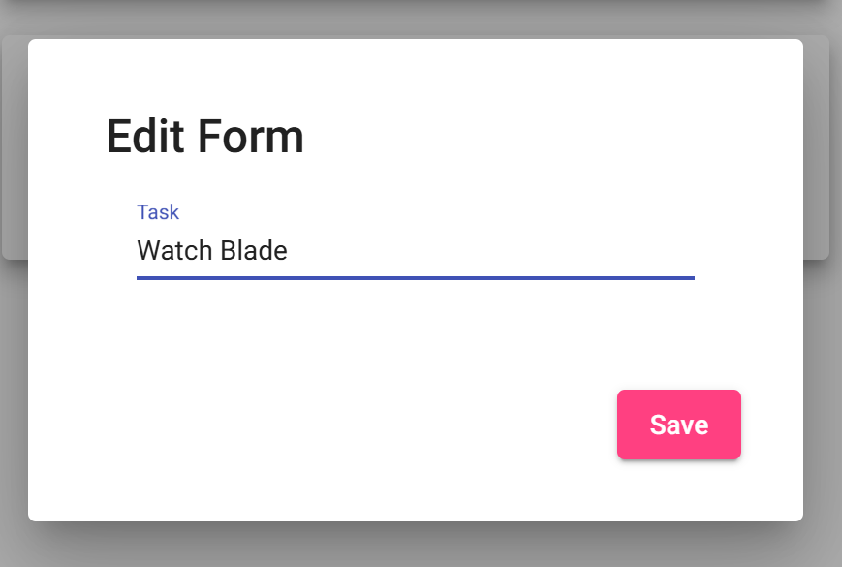  yes
4 | Click “Save” | Task updates in the list | <yes/no> | 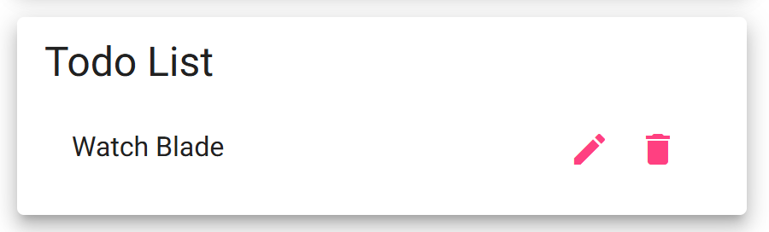  yes
5 | Confirm updated task is visible | "Watch Blade" is shown | <yes/no> | yes
Comments | This test was able to successfully allow a task within the list to be edited. A task that has been added to the list can then be edited and changed to a new task. Once the “save” button has been clicked, the newly edited task shows up in the task list.

Test 3 | Create a New Todo Task
 | Test Objective: Ensure users can successfully create a new task item. | Developer: Nardos Gebremedhin  Date tested: 2025/11/13 | Peer tester: Amanda Wedergren  Date tested: 2025/11/14
Step | Action | Expected results: | Developer pass/fail | Tester pass/fail
1 | Navigate to the Todo app | Page loads successfully | <yes/no> | 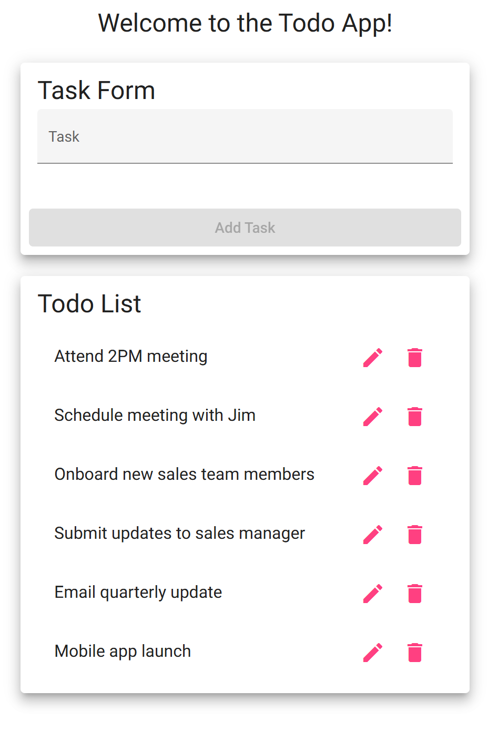  yes
2 | Enter "Wash the dishes " in the input field | Text appears in the field | <yes/no> | 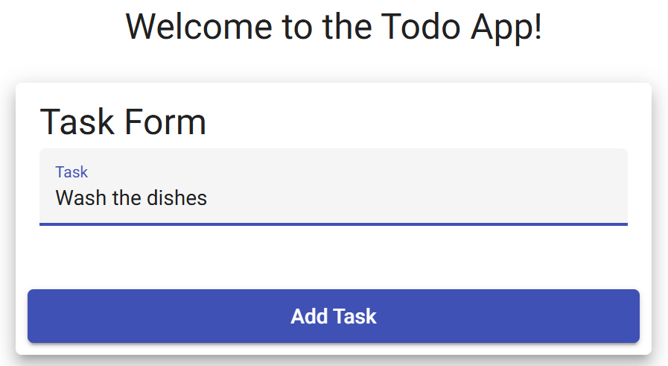  yes
3 | Click the "Add Task" button | Task is added to the list | <yes/no> | 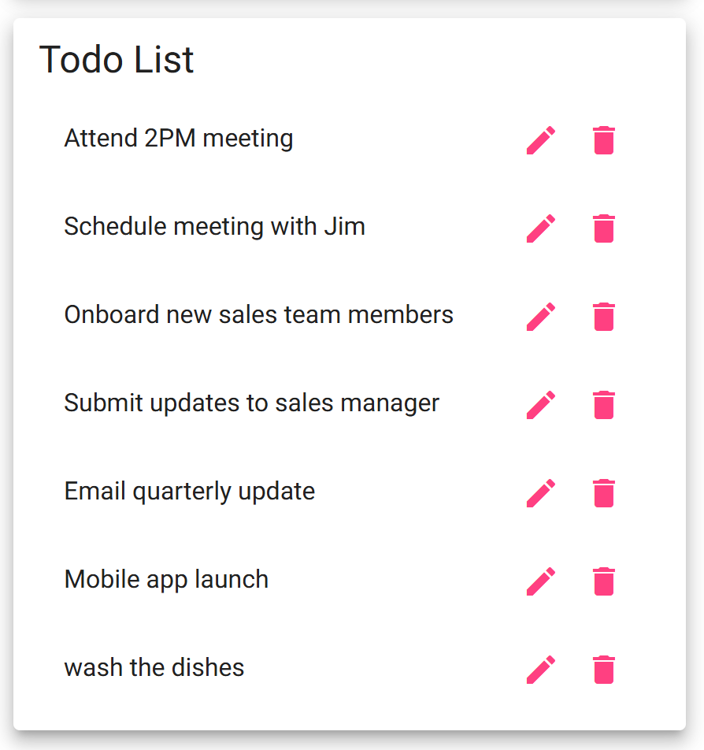  yes
4 | Confirm tasks appear in the list | “Wash the dishes” is visible in the list | <yes/no> | yes
5 | Refresh the page | Task should remain in the list | <yes/no> | 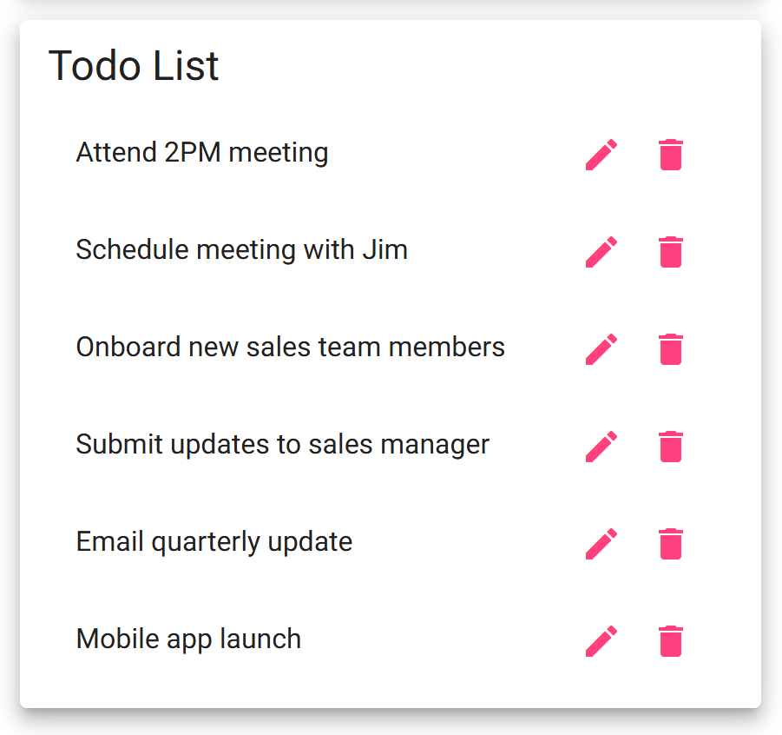  no
Comments | This test did prove the ability to add a task to the list on the Todo app. A task was successfully added once it was put in the input field and the “add task” button was clicked. However, when refreshing the page to see if the task would remain in the list, it was no longer showing. Refreshing the page seems to revert the list back to the starting list, removing any newly added tasks.
Test 4 | Prevent Empty Task Submission
 | Test Objective: Ensure users cannot submit an empty task. | Developer: Nardos Gebremedhin  Date tested: 2025/11/13 | Peer tester: Amanda Wedergren  Date tested: 2025/11/14
Step | Action | Expected results: | Developer pass/fail | Tester pass/fail
1 | Navigate to the Todo app | Page loads successfully | <yes/no> | yes
2 | Leave input field blank | No text entered | <yes/no> | 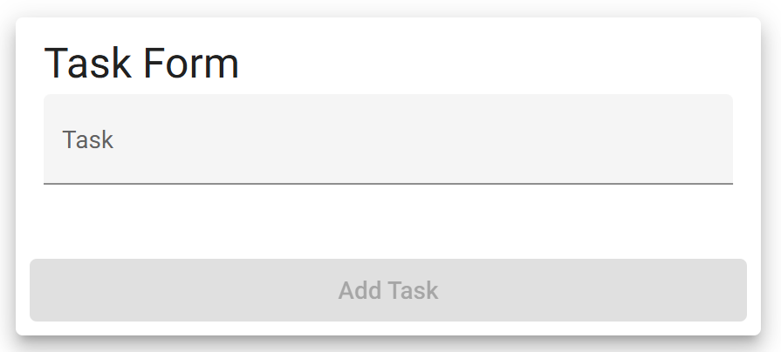  yes
3 | Click the "Add Task" button | No action | <yes/no> | yes
4 | Try submitting again without text | No action | <yes/no> | yes
5 | Enter valid text and submit | Task is added successfully | <yes/no> | 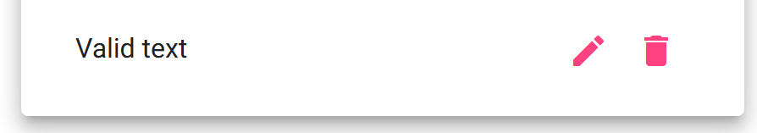  yes
Comments | This test was able to successfully prove that the Todo app will not add an empty task. When leaving the input field blank, the “add task” button is greyed out and unavailable. It does not show as an available option until at least one character is typed into the input field.

Test 5 | Delete a Todo Task Item
 | Test Objective: Verify that users can successfully delete a task from the list. | Developer: Nardos Gebremedhin  Date tested: 2025/11/13 | Peer tester: Amanda Wedergren  Date tested: 2025/11/14
Step | Action | Expected results: | Developer pass/fail | Tester pass/fail
1 | Navigate to the Todo app | Page loads successfully | <yes/no> | 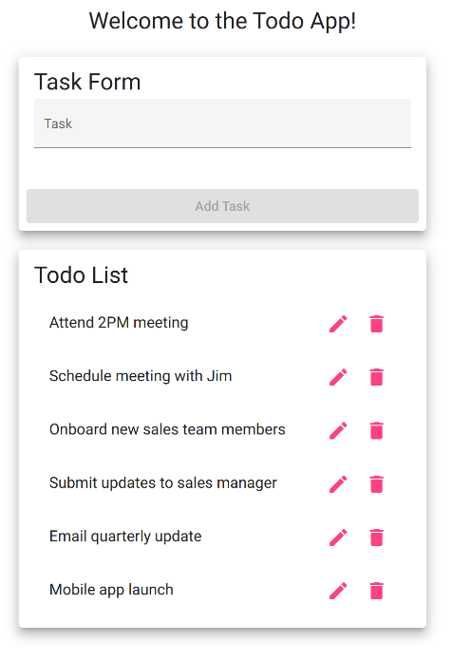  yes
2 | Add a new task called "Test delete" | “Test delete” is in the list | <yes/no> | 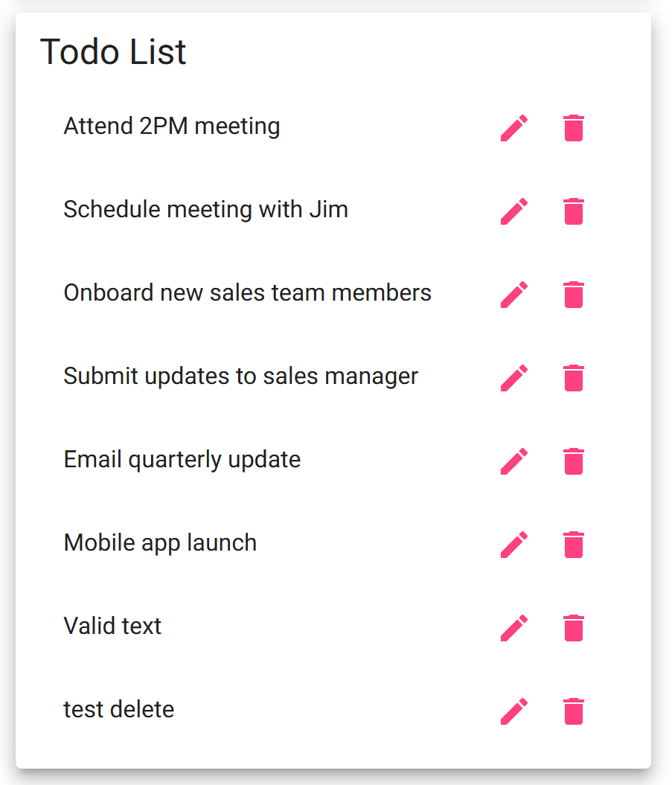  yes
3 | Click the trash icon | Task is removed from the list | <yes/no> | 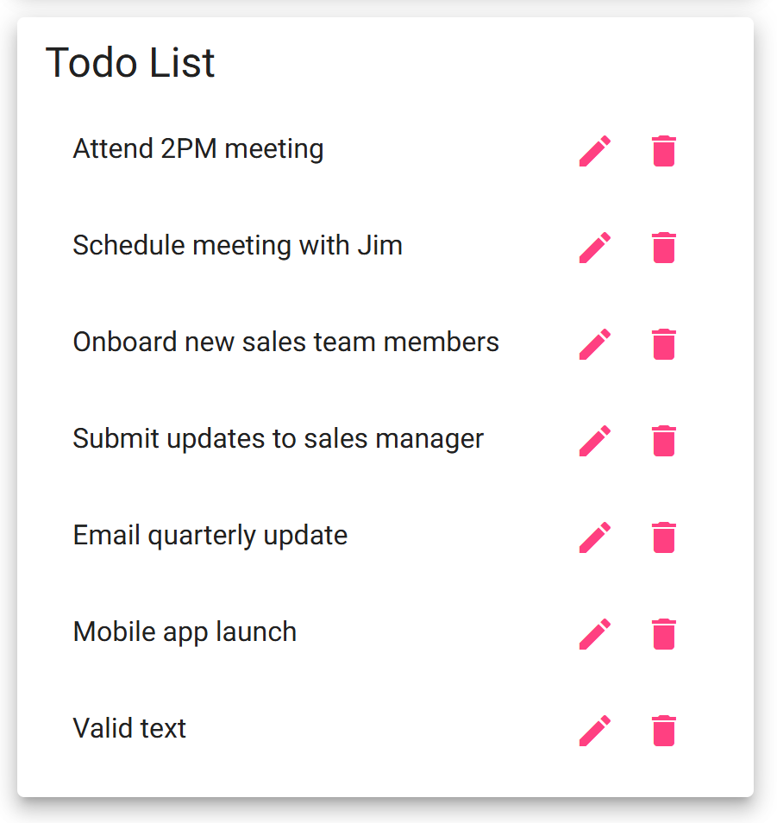  yes
4 | Confirm the task is deleted | Verify task is removed | <yes/no> | yes
5 | Refresh page to confirm task is still deleted | Task is still gone after page reload | <yes/no> | 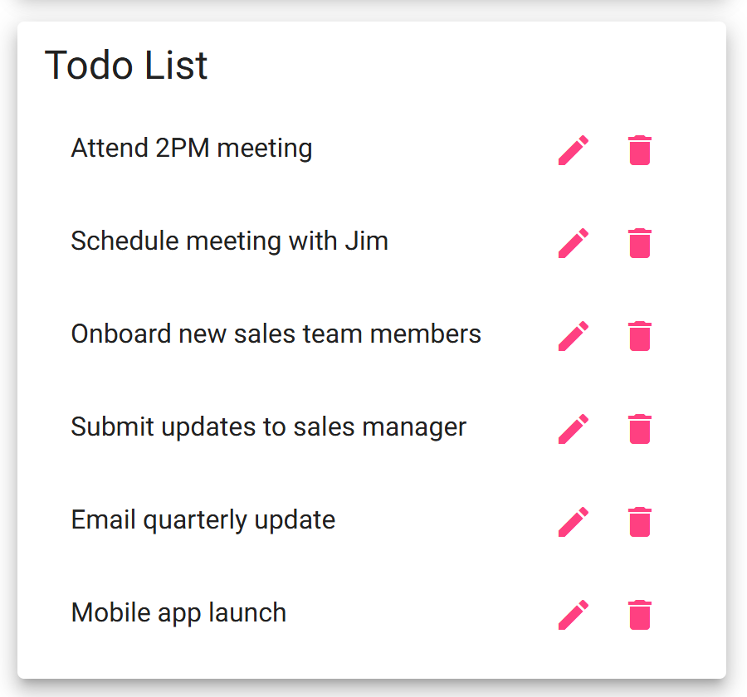  yes
Comments | Task is still deleted after refresh. However, you can see that a previous task that had been added was also gone upon refresh. The refresh seems to have the result of putting the Todo app back to it’s starting state, reverting back to the original list.

