Project: Test Plan
Course: CSD 380
Description: Tests that need to cover specific Business Requirements
Date: 11-12-2025

To complete the test case plan, fill out the information for Project, Course, Description and Date in the header below.

TABLE OF CONTENTS

- Accesing URL & Custom 404
II. Mobile View Test
III. Adding Tasks and Blocking Empty Changes
IV. Edit Task and Blocking Empty Changes
V. Delete Tasks from List

For each test, the developer should: provide a test description, a test objective, the developer name and date tested. For each step, fill out the actions to be taken and describe the expected results, and indicate yes or no for each step depending upon the result. The peer tester should provide their name, date tested, indicate yes or no for each step depending upon the result, and a screenshot (thumbnail) of the result.

Test 1 | Accessing URL & Custom 404 (Incorrect URL)
 | Test Objective: Verify if URL works and if input is wrong, provide 404 message | Developer: Justin Marucci  Date tested: 2025/11/11 | Peer tester: Amanda Wedergren  Date tested: 2025/11/14
Step | Action | Expected results: | Developer pass/fail | Tester pass/fail  + Screenshot
1 | Navigate to the URL https://buwebdev.github.io/todo/ | Page loads without error | Yes | 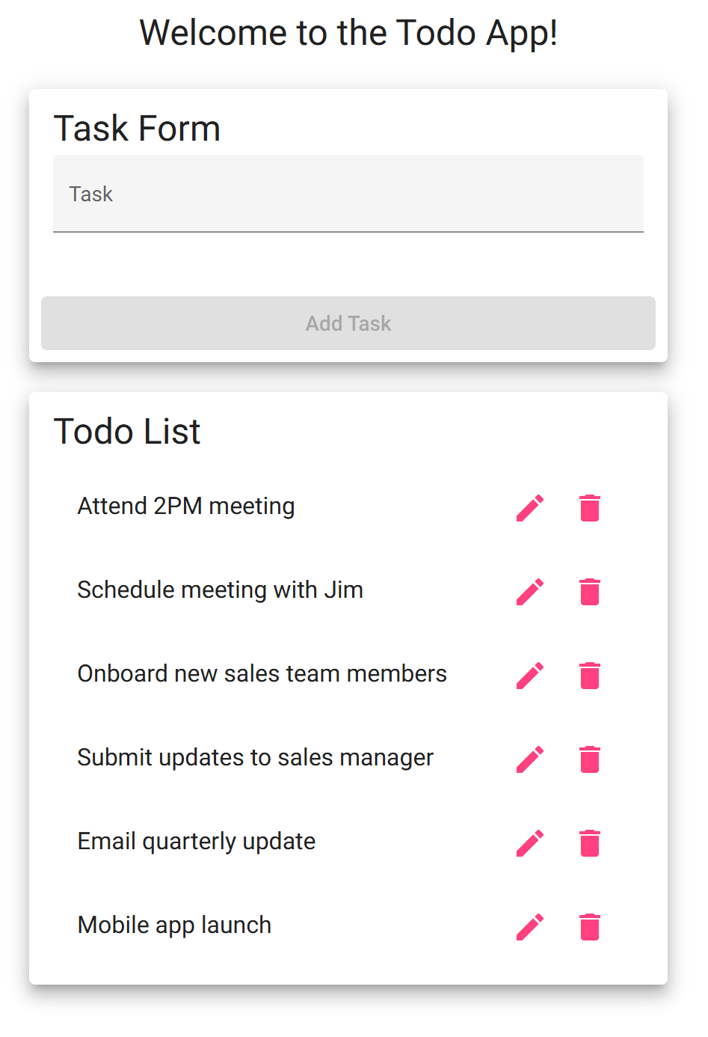  yes
2 | Refresh the page | Page reloads sucessfully and useful | Yes | yes
3 | Input the wrong URL | Custom 404 page appears | Yes | 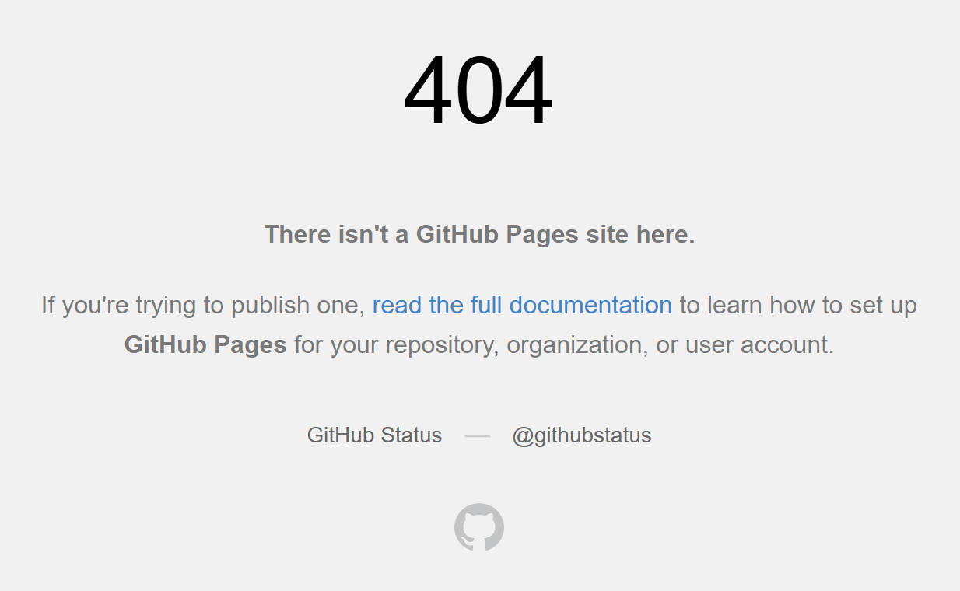  yes
Comments | This test verifies that the URL functions correctly, bringing the user to the Todo app. In addition, the app is able to be refreshed successfully and still function correctly. When putting in the wrong URL, a custom 404 error page pops up to let you know that it is not a valid URL. These all align with the expected outcomes.

Test 2 | Mobile View Test
 | Test Objective: Confirm UI works on mobile device | Developer: Justin Marucci  Date tested: 2025/11/11 | Peer tester: Amanda Wedergren  Date tested: 2025/11/14
Step | Action | Expected results: | Developer pass/fail | Tester pass/fail
1 | Open the Todo URL on your phone | The page loads and fits on the screen | Yes | 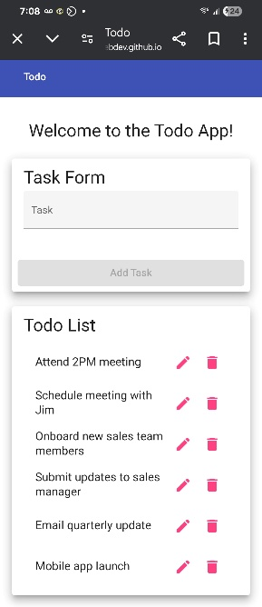  yes
2 | Type a task into the box then add task | Task adds to Todo list with no issues | Yes | 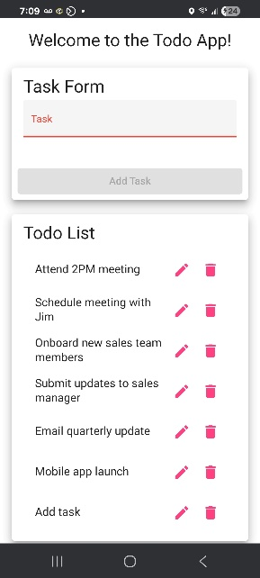  yes
3 | Scroll up, down, left and right | Interface doesnt scroll left or right, application in “mobile mode” (only scrolls up and down) | Yes | 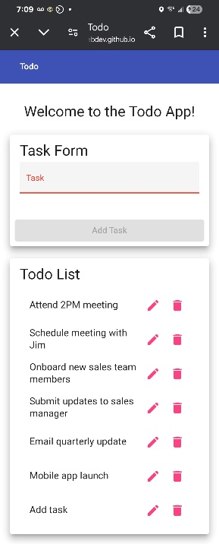  yes
4 | Refresh page | Interface is still works and is able to use | Yes | yes
Comments | This test was able to successfully confirm that the Todo app is able to be accessed on a mobile device. The app loads correctly and has the intended functionality. Tasks can be successfully added to the list. The app also fits to the smaller screen of the mobile device and does not allow side to side scrolling, only up and down.

Test 3 | Adding Tasks and Blocking Empty Changes
 | Test Objective: Verify we can create new tasks and block empty entries | Developer: Justin Marucci  Date tested: 11-11-2025 | Peer tester: Amanda Wedergren  Date tested: 2025/11/14
Step | Action | Expected results: | Developer pass/fail | Tester pass/fail
1 | Type “ 11am SCRUM Meeting” into task form and hit “Add Task” button | Item appears on todo list | Yes | 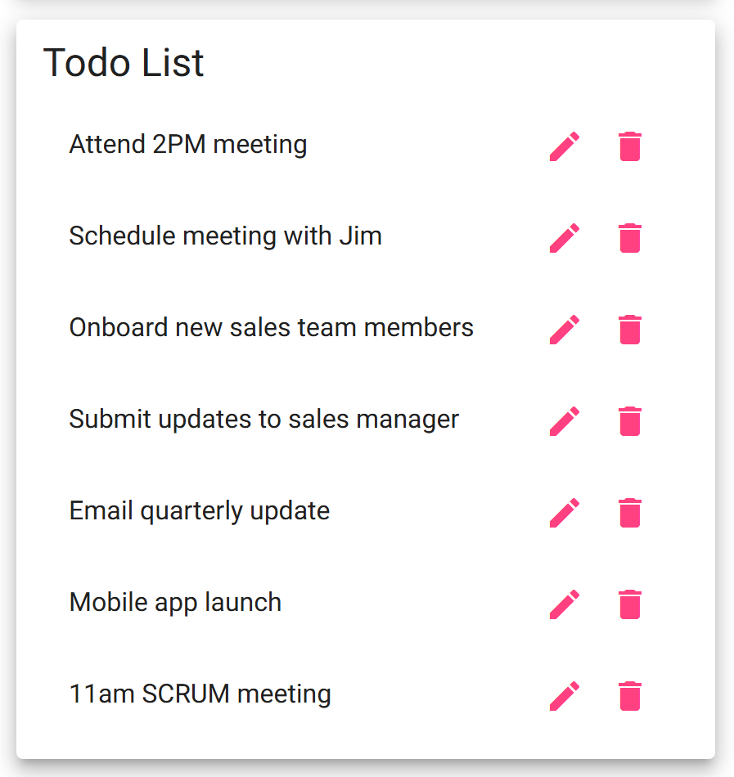  yes
2 | Input nothing into the task form, try and add it to todo list and hit add task button | “Add” button remains greyed out and cannot add to todo list | Yes | 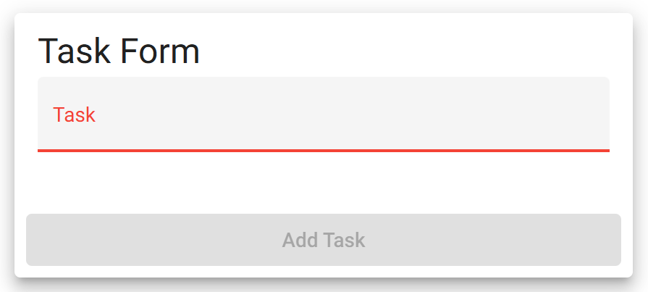  yes
Comments | This test is able to successfully verify that adding a task to the Todo app functions as expected. A task is able to be added to the list. When attempting to add a blank task to the list, the “add “ button remains greyed out and not able to submit the blank task to the list.

Test 4 | Edit Task and Blocking Empty Changes
 | Test Objective: Verifies user can edit tasks on the todo list and saving an empty input is blocked | Developer: Justin Marucci  Date tested: 2025/11/11 | Peer tester: Amanda Wedergren  Date tested: 2025/11/14
Step | Action | Expected results: | Developer pass/fail | Tester pass/fail  + Screenshot
1 | Hit pencil (edit) icon on todo list | Edit window appears to update the list item | Yes | 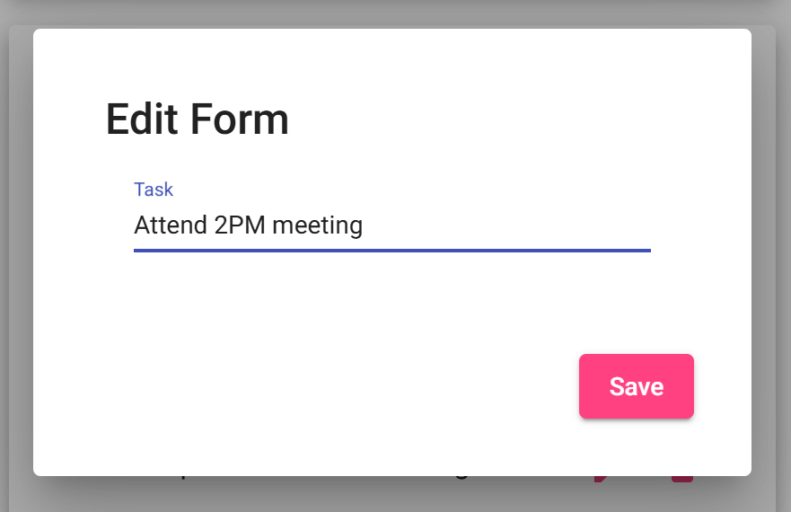  yes
2 | Update list item in edit window and hit save | List item updates and is added to todo list | Yes | 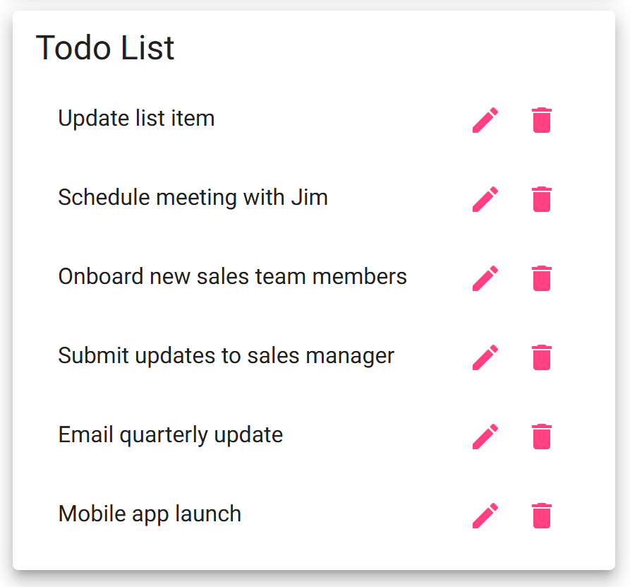  yes
3 | Hit pencil icon, delete list item and hit save | Window pops up stating “Please enter task” with “OK” button | No | 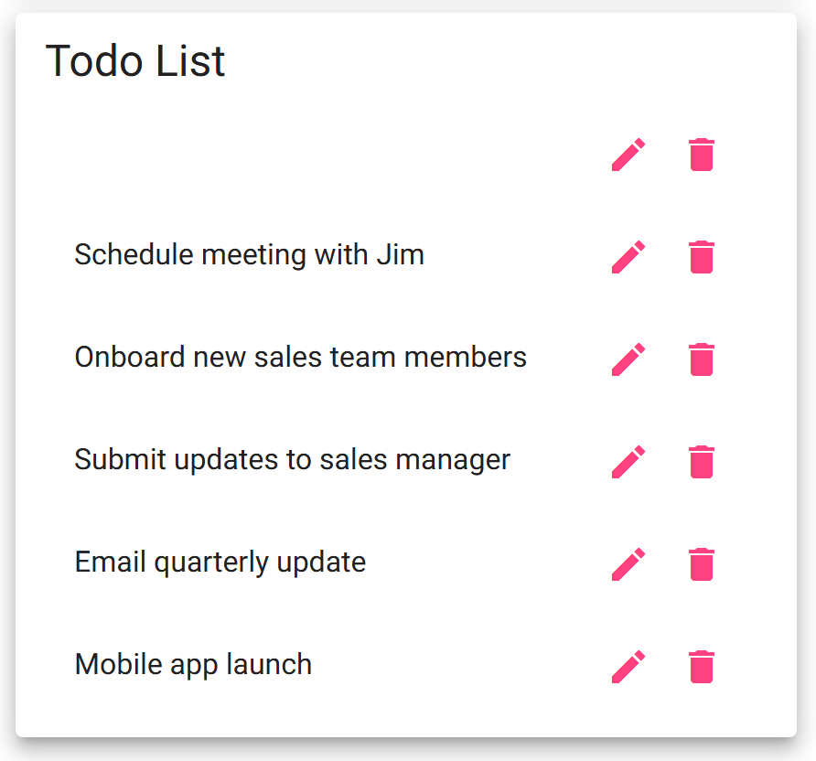  no
Comments | This test was able to successfully show that a task item can be updated on the Todo app. When deleting the task while editing, the expected outcome that would not allow an item to be edited with an empty task did not work. Instead of getting a popup that would disallow the blank edit, a blank task was saved to the list.

Test 5 | Delete Task Item
 | Test Objective: Verifies a usr can delete a task item on the todo list | Developer: Justin Marucci  Date tested: 2025/11/11 | Peer tester: Amanda Wedergren  Date tested: 2025/11/14
Step | Action | Expected results: | Developer pass/fail | Tester pass/fail  + Screenshot
1 | Click garbage can icon (delete button) | Task Disappears from list | Yes | 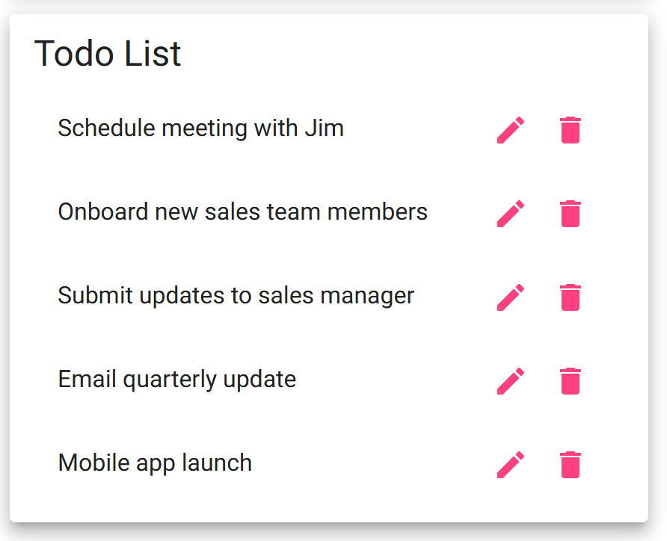  yes
2 | Refresh Page | Item does not reappear | Yes | 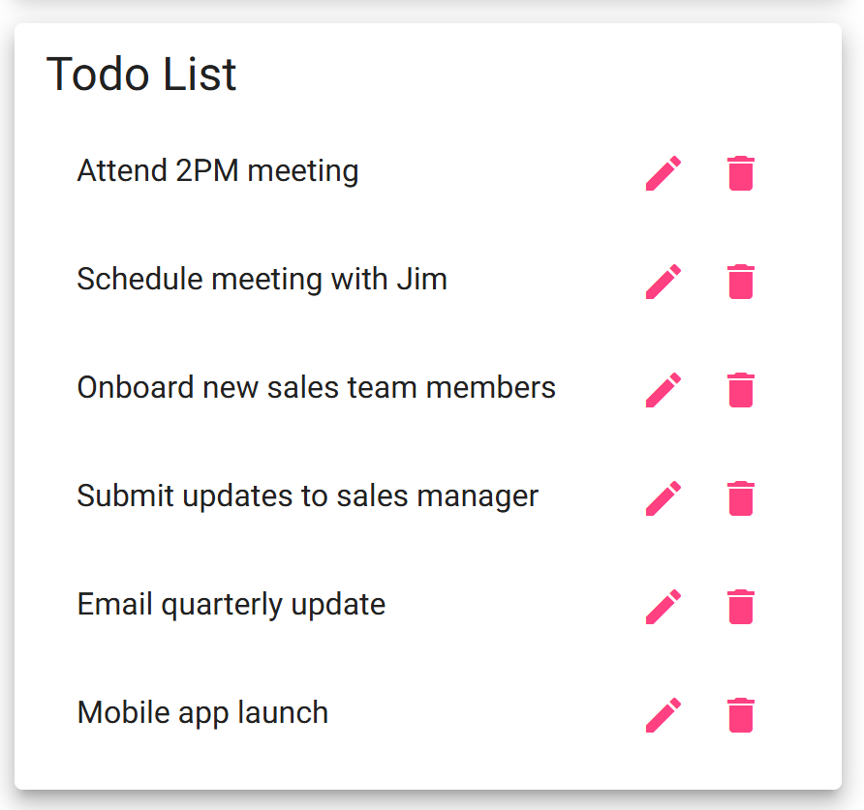  no
Comments | This test did prove that the functionality to delete an item works. However, once the page is refreshed, the item reappears in the list. The item that was deleted was part of the original list when accessing the Todo app.

