

Module Title: | Advanced Programming Techniques
Module Code: | B9CY108
Module Instructor: | Swati Dongre
Assessment Title: | TASK 1: Menu- Console driven App  TASK 2: C# to access the first 30 elements of the Periodic Table  TASK 3: Server and Client Connection  TASK 4: Web Scraping
Student Name | Tobiloba George Awe
Student ID: | 20070761
Course | MSc. Cybersecurity
Total Word Count | 671 Words
Github Link | GITHUB CA 1 LINK

TASK 1: CHURROS ORDERING SYSTEM (CHURROS.CS, ORDER.CS & MAIN.CS AND CHURROS UNIT TESTING)
In this task, a simple ordering system for a churros shop was developed using C#. The system allows users to select items, calculate total costs, and display order summaries.
- Churros.cs File
The Churros.cs file represents the product (churros) in the application. It defines what a churros iten is and how it should behave in the whole system.
- Order.cs File
The Order.cs file defines the structure of an order, including properties such as item name, quantity, and price. Methods were implemented to calculate the total cost and return formatted order details.
- Main.cs File
The Main.cs file serves as the entry point of the application and handles user interaction, including input validation and menu navigation.

Overall, key concepts applied include object-oriented programming (OOP), encapsulation, and basic control structures such as loops and conditional statements. Error handling was also implemented to ensure valid user input. The system was tested using different order scenarios to verify accuracy in calculations and output formatting.
UNIT TESTING PASSED
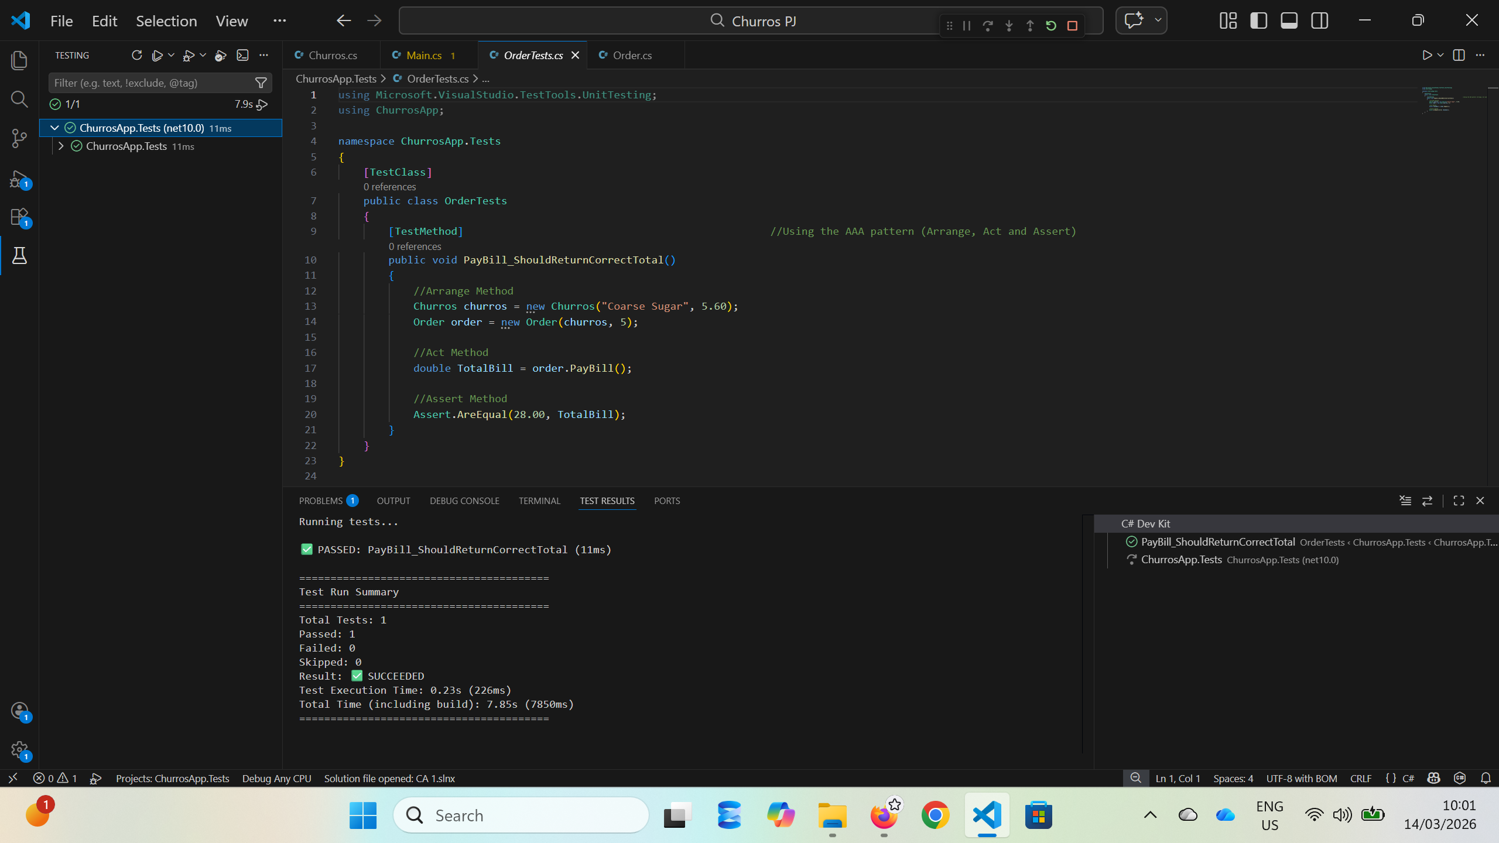
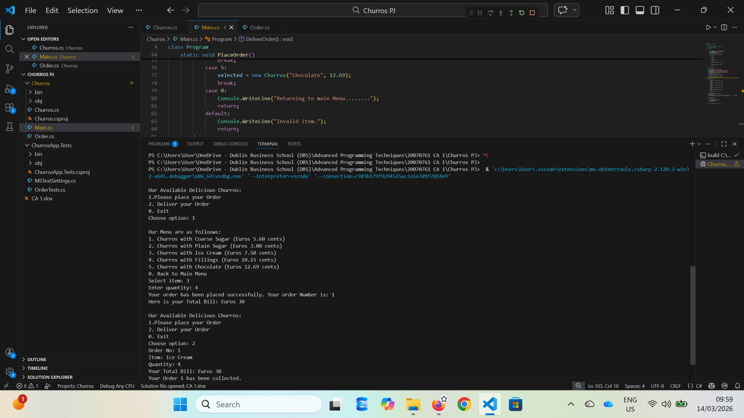
MAIN.cs output

TASK 2: PERIODIC TABLE DESIGN (DESIGN.CS)
This task involved designing a graphical user interface (GUI) representing a simplified periodic table. The application was built using Windows Forms in C#.

The Periodic_Table_Elements.cs file manages the layout and appearance of elements. Buttons were used to represent chemical elements, and event handlers were implemented to display additional information when an element is clicked. This task demonstrated skills in GUI development, event driven programming, and layout management.
Periodic_Table_Elements output
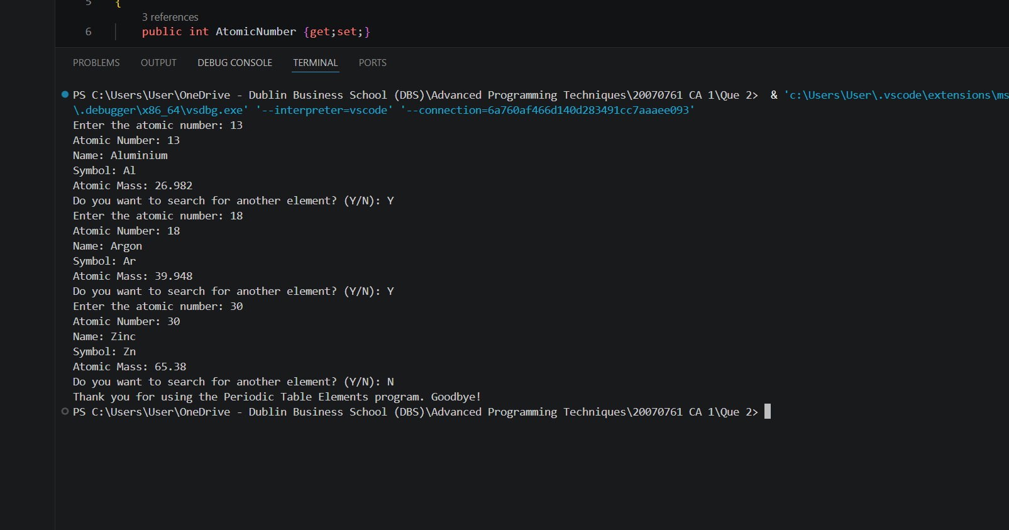

TASK 3: SERVER AND CLIENT CONNECTION
In this task, a client-server application was developed using Python sockets and SQLite for database management. The server handles incoming client requests, processes data, and stores driver’s information in a database.
The server program establishes a TCP connection and listens for client requests. It generates a random registration number and stores driver’s details such as name, address, PPS number, and license in an SQLite database. The client program connects to the server and sends user input.
Key concepts include socket programming, database integration, and data persistence. The use of SQLite ensured lightweight and efficient data storage. Testing involved running both server and client on separate terminals and verifying successful communication and database insertion.

Easydrive.db
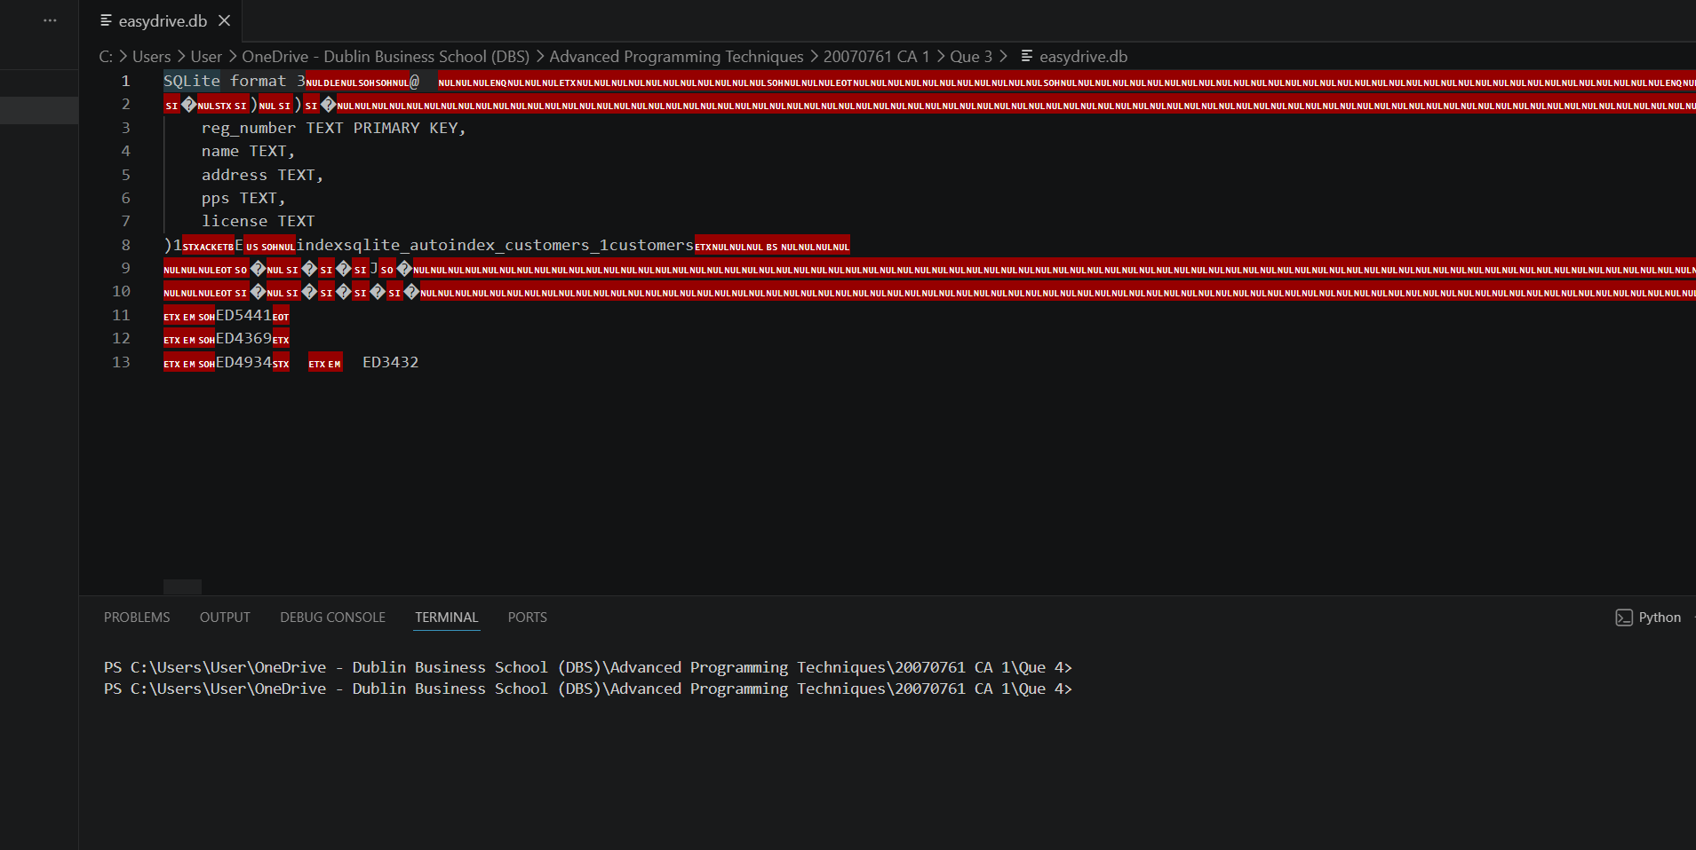
Server and Client connections
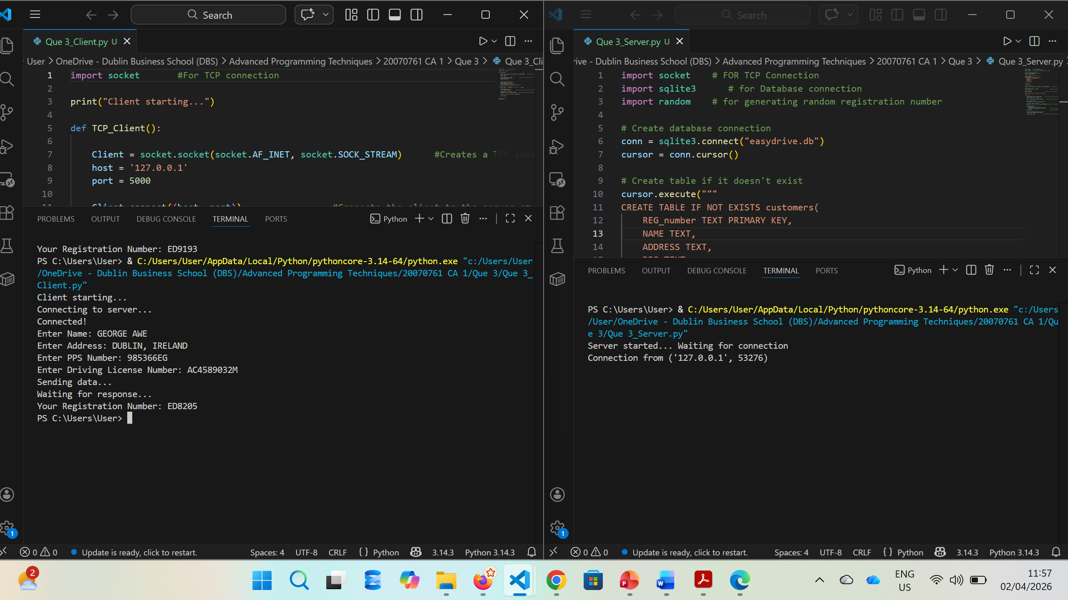

TASK 4: WEB SCRAPING
This task involved extracting data from a website using web scraping techniques. Python libraries such as requests and BeautifulSoup were used to retrieve and parse HTML content.
The scraper sends a request to a webpage, processes the HTML structure, and extracts relevant information such as titles or data fields. The extracted data is then displayed or stored for further use.
This task demonstrated skills in handling external data sources, parsing structured content, and automating data collection. Challenges included identifying correct HTML tags and handling dynamic content, which were resolved through inspection tools and iterative testing.
Que 4.py (Web Scraping from Travel2/ )output
Books.csv from Travel_2
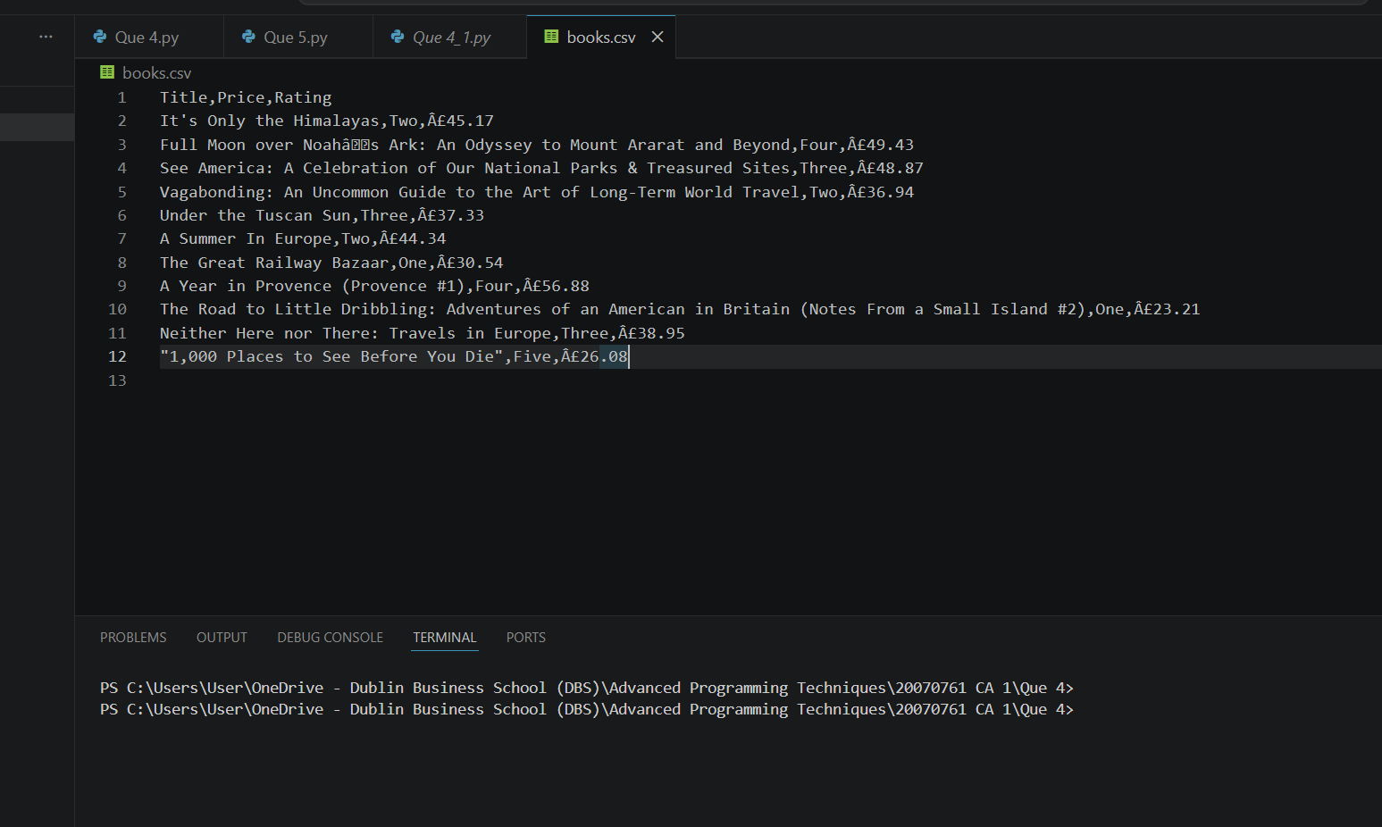
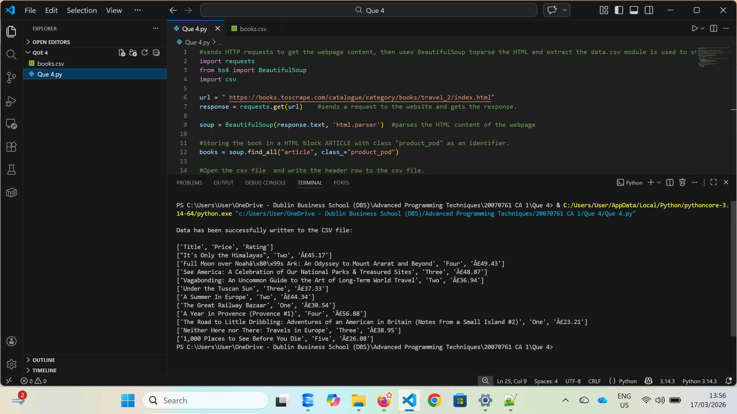
CONCLUSION
Overall, these tasks provided hands-on experience in multiple areas of programming, including OOP, GUI design, networking, databases, and web scraping. Each task contributed to developing problem-solving skills and practical understanding of real-world applications. The project highlights the ability to design, implement, and test software systems effectively.

REFERENCES

- Microsoft (2024) C# documentation. Available at: https://learn.microsoft.com/en-us/dotnet/csharp/ (Accessed: 16 March, 2026).
- Microsoft (2024) Windows Forms documentation. Available at: https://learn.microsoft.com/en-us/dotnet/desktop/winforms/ (Accessed: 20 April 2026).
- Python Software Foundation (2024) socket — Low-level networking interface. Available at: https://docs.python.org/3/library/socket.html (Accessed: 1 April 2026).
- Python Software Foundation (2024) sqlite3 — DB-API 2.0 interface. Available at: https://docs.python.org/3/library/sqlite3.html (Accessed: 30 March 2026).
- Richardson, L. (2024) Beautiful Soup Documentation. Available at: https://www.crummy.com/software/BeautifulSoup/bs4/doc/ (Accessed: 16 March 2026).

