Nicotiana

BP

10 03 2020

1. Fv/Fm (szalka, concentration, yield) - yield.csv

* Kontola (brak hormonów ) - kontrola
* 2mg/ IAA 1mg/l K - alfa
* 2 mg/l IAA - beta
* 2 mg/l IAA 1 mg/l BAP - gamma
* 0,5 mg/l 2,4d 0,25mg/l bap - delta
* 2mg/l 2,4-D 1 mg/l BAP - epsilon
* 1 mg/l 2,4-D 0,5 mg/l BAP - dzeta

library(ggplot2)  
library(ggpubr)

## Loading required package: magrittr

yield = read.csv("./yield.csv")  
yield$szalka = as.factor(yield$szalka)  
yield$concentration = as.factor(yield$concentration)  
summary(yield)

## szalka concentration yield   
## 2 : 23 alfa :31 Min. :0.5600   
## 8 : 20 beta :38 1st Qu.:0.7900   
## 11 : 20 delta :33 Median :0.8200   
## 9 : 18 dzeta :43 Mean :0.8082   
## 6 : 16 epsilon :31 3rd Qu.:0.8400   
## 5 : 15 gamma :43 Max. :0.8700   
## (Other):143 kontrola:36

ggplot(data = yield) +   
 geom_boxplot(aes(x=concentration, y=yield)) +  
 geom_jitter(aes(x=concentration, y=yield, color=szalka)) +  
 xlab("Kombinacja hormonow") +   
 ylab("Fv/Fm")

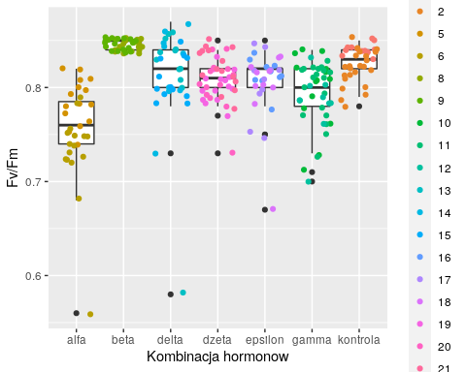

* porownanie grup zapisane do pliku yield_results.txt

kruskal.test(yield ~ concentration, data = yield)

##   
## Kruskal-Wallis rank sum test  
##   
## data: yield by concentration  
## Kruskal-Wallis chi-squared = 123.67, df = 6, p-value < 2.2e-16

results = compare_means(yield ~ concentration, data = yield)  
write.table(results, "./compare_means/yield_results.txt") # porownanie grup zapisane do pliku yield_results.txt

1. Kiełkowanie nasion, rozwój kalusa

2.1 Hormony (takie samo oznaczenie jak w Fv/Fm)

* Kontola (brak hormonów ) - kontrola
* 2mg/ IAA 1mg/l K - alfa
* 2 mg/l IAA - beta
* 2 mg/l IAA 1 mg/l BAP - gamma
* 0,5 mg/l 2,4d 0,25mg/l bap - delta
* 2mg/l 2,4-D 1 mg/l BAP - epsilon
* 1 mg/l 2,4-D 0,5 mg/l BAP - dzeta

2.1 Czy w poszczególnych dniach ilość siewek/ kalusów jest różna?

library(ggplot2)  
library(ggpubr)  
  
kielkowanie = read.csv("./kielkowanie.csv")

2.1.1 Dzień 7

* siewki

ggplot(data = subset(kielkowanie, day == 7)) +  
 geom_jitter(aes(x=concentration, y=siewki))

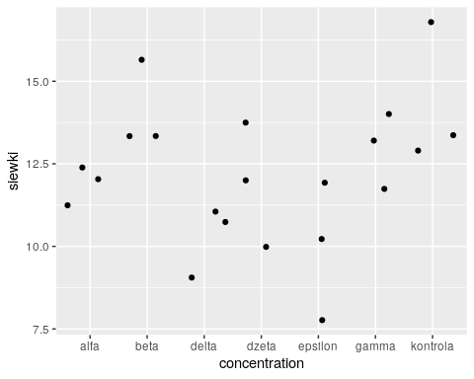

kruskal.test(siewki ~ concentration, data = subset(kielkowanie, day == 7))

##   
## Kruskal-Wallis rank sum test  
##   
## data: siewki by concentration  
## Kruskal-Wallis chi-squared = 13.177, df = 6, p-value = 0.04031

results7s = compare_means(siewki ~ concentration, data = subset(kielkowanie, day == 7))  
write.table(results7s, "./compare_means/results7s.txt")

* kalusy - niewidoczne

2.1.2 Dzień 14

* siewki

ggplot(data = subset(kielkowanie, day == 14)) +  
 geom_jitter(aes(x=concentration, y=siewki))

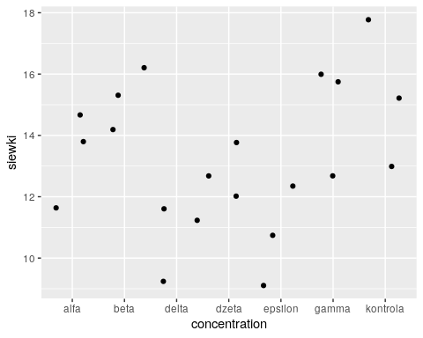

kruskal.test(siewki ~ concentration, data = subset(kielkowanie, day == 14))

##   
## Kruskal-Wallis rank sum test  
##   
## data: siewki by concentration  
## Kruskal-Wallis chi-squared = 14.012, df = 6, p-value = 0.0295

results14s = compare_means(siewki ~ concentration, data = subset(kielkowanie, day == 14))  
write.table(results14s, "./compare_means/results14s.txt")

* kalusy - niewidoczne

2.1.3 Dzień 21

* siewki

ggplot(data = subset(kielkowanie, day == 21)) +  
 geom_jitter(aes(x=concentration, y=siewki))

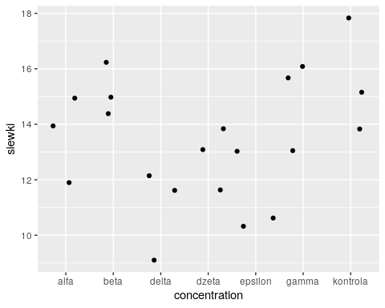

kruskal.test(siewki ~ concentration, data = subset(kielkowanie, day == 21))

##   
## Kruskal-Wallis rank sum test  
##   
## data: siewki by concentration  
## Kruskal-Wallis chi-squared = 13.417, df = 6, p-value = 0.03687

results21s = compare_means(siewki ~ concentration, data = subset(kielkowanie, day == 21))  
write.table(results21s, "./compare_means/results21s.txt")

* kalusy - niewidoczne

2.1.4 Dzień 28

* siewki

ggplot(data = subset(kielkowanie, day == 28)) +  
 geom_jitter(aes(x=concentration, y=siewki))

## Warning: Removed 1 rows containing missing values (geom_point).

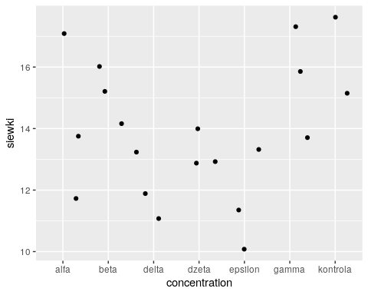

kruskal.test(siewki ~ concentration, data = subset(kielkowanie, day == 28))

##   
## Kruskal-Wallis rank sum test  
##   
## data: siewki by concentration  
## Kruskal-Wallis chi-squared = 13.226, df = 6, p-value = 0.03958

results28s = compare_means(siewki ~ concentration, data = subset(kielkowanie, day == 28))  
write.table(results28s, "./compare_means/results28s.txt")

* kalusy

ggplot(data = subset(kielkowanie, day == 28)) +  
 geom_jitter(aes(x=concentration, y=kalusy))

## Warning: Removed 1 rows containing missing values (geom_point).

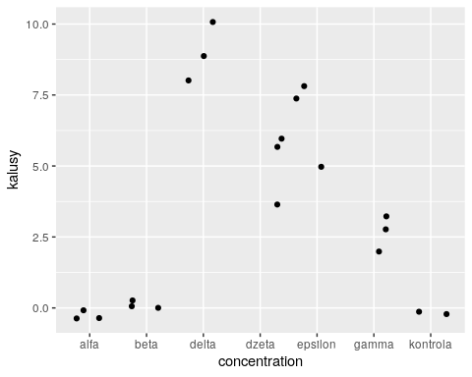

kruskal.test(kalusy ~ concentration, data = subset(kielkowanie, day == 28))

##   
## Kruskal-Wallis rank sum test  
##   
## data: kalusy by concentration  
## Kruskal-Wallis chi-squared = 18.409, df = 6, p-value = 0.005287

results28k = compare_means(kalusy ~ concentration, data = subset(kielkowanie, day == 28))  
write.table(results28k, "./compare_means/results28k.txt")

2.1.5 Dzień 33

* siewki

ggplot(data = subset(kielkowanie, day == 33)) +  
 geom_jitter(aes(x=concentration, y=siewki))

## Warning: Removed 1 rows containing missing values (geom_point).

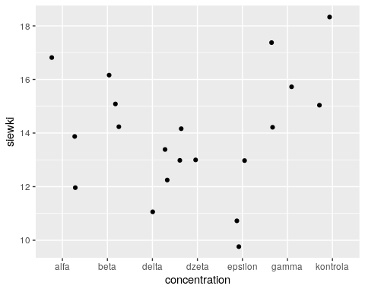

kruskal.test(siewki ~ concentration, data = subset(kielkowanie, day == 33))

##   
## Kruskal-Wallis rank sum test  
##   
## data: siewki by concentration  
## Kruskal-Wallis chi-squared = 13.226, df = 6, p-value = 0.03958

results33s = compare_means(siewki ~ concentration, data = subset(kielkowanie, day == 33))  
write.table(results33s, "./compare_means/results33s.txt")

* kalusy

ggplot(data = subset(kielkowanie, day == 33)) +  
 geom_jitter(aes(x=concentration, y=kalusy))

## Warning: Removed 1 rows containing missing values (geom_point).

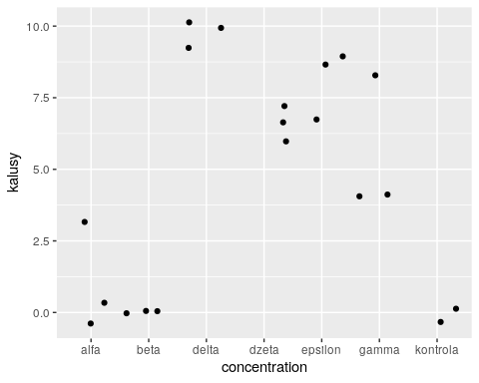

kruskal.test(kalusy ~ concentration, data = subset(kielkowanie, day == 33))

##   
## Kruskal-Wallis rank sum test  
##   
## data: kalusy by concentration  
## Kruskal-Wallis chi-squared = 17.547, df = 6, p-value = 0.00747

results33k = compare_means(kalusy ~ concentration, data = subset(kielkowanie, day == 33))  
write.table(results33k, "./compare_means/results33k.txt")

2.1.6 Dzień 39

* siewki

ggplot(data = subset(kielkowanie, day == 39)) +  
 geom_jitter(aes(x=concentration, y=siewki))

## Warning: Removed 3 rows containing missing values (geom_point).

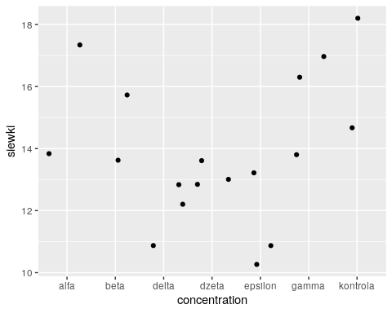

kruskal.test(siewki ~ concentration, data = subset(kielkowanie, day == 39))

##   
## Kruskal-Wallis rank sum test  
##   
## data: siewki by concentration  
## Kruskal-Wallis chi-squared = 13.687, df = 6, p-value = 0.03333

results39s = compare_means(siewki ~ concentration, data = subset(kielkowanie, day == 39))  
write.table(results39s, "./compare_means/results39s.txt")

* kalusy

ggplot(data = subset(kielkowanie, day == 39)) +  
 geom_jitter(aes(x=concentration, y=kalusy))

## Warning: Removed 3 rows containing missing values (geom_point).

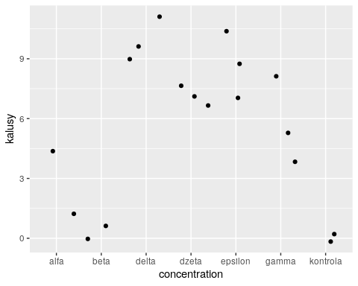

kruskal.test(kalusy ~ concentration, data = subset(kielkowanie, day == 39))

##   
## Kruskal-Wallis rank sum test  
##   
## data: kalusy by concentration  
## Kruskal-Wallis chi-squared = 14.968, df = 6, p-value = 0.0205

results39k = compare_means(kalusy ~ concentration, data = subset(kielkowanie, day == 39))  
write.table(results39k, "./compare_means/results39k.txt")

2.1.7 Dzień 41

* siewki

ggplot(data = subset(kielkowanie, day == 41)) +  
 geom_jitter(aes(x=concentration, y=siewki))

## Warning: Removed 3 rows containing missing values (geom_point).

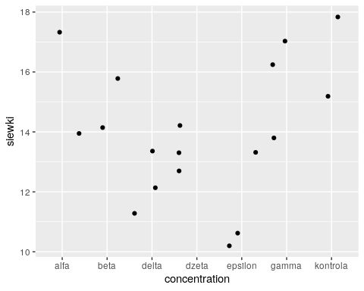

kruskal.test(siewki ~ concentration, data = subset(kielkowanie, day == 41))

##   
## Kruskal-Wallis rank sum test  
##   
## data: siewki by concentration  
## Kruskal-Wallis chi-squared = 13.687, df = 6, p-value = 0.03333

results41s = compare_means(siewki ~ concentration, data = subset(kielkowanie, day == 41))  
write.table(results41s, "./compare_means/results41s.txt")

* kalusy

ggplot(data = subset(kielkowanie, day == 41)) +  
 geom_jitter(aes(x=concentration, y=kalusy))

## Warning: Removed 3 rows containing missing values (geom_point).

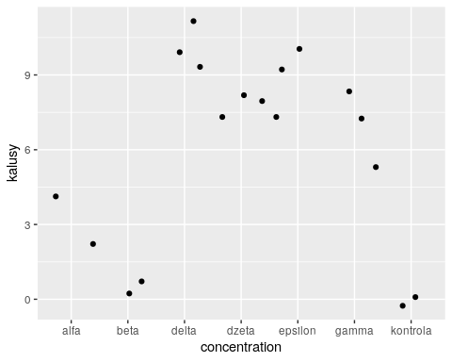

kruskal.test(kalusy ~ concentration, data = subset(kielkowanie, day == 41))

##   
## Kruskal-Wallis rank sum test  
##   
## data: kalusy by concentration  
## Kruskal-Wallis chi-squared = 14.953, df = 6, p-value = 0.02063

results41k = compare_means(kalusy ~ concentration, data = subset(kielkowanie, day == 41))  
write.table(results41k, "./compare_means/results41k.txt")

1. Zmiany liczby siewek podczas kolejnych dni

ggplot(data = kielkowanie) + geom_jitter(aes(x = day, y = siewki)) + facet_wrap(~concentration, nrow = 3) + theme_bw()

## Warning: Removed 8 rows containing missing values (geom_point).

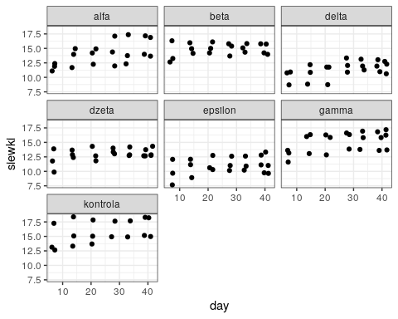

1. Zmiany liczby kalusów podczas kolejnych dni

ggplot(data = kielkowanie) + geom_jitter(aes(x = day, y = kalusy)) + facet_wrap(~concentration, nrow = 3) + theme_bw()

## Warning: Removed 8 rows containing missing values (geom_point).

