1. Autocomplete Suggestions are not removed, if cursor is leaving the field

is user jumps to the next field, autocomplete proposals should be hidden.

i.e. i press on check address, or move to next field, autocomplete remains open.

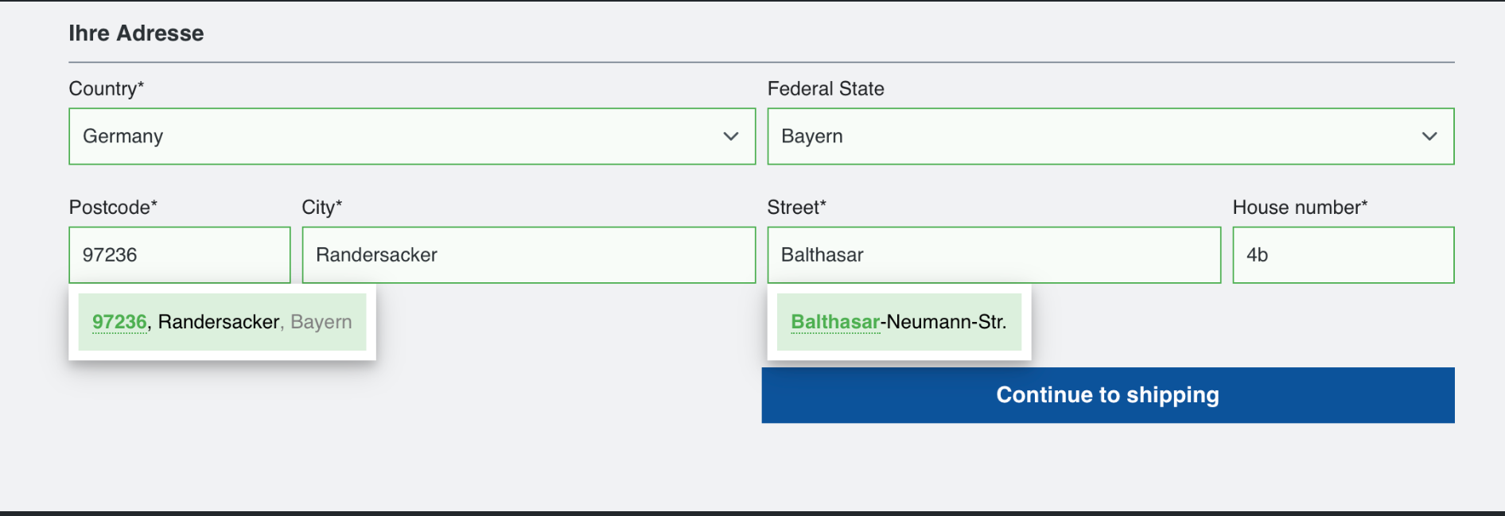

2. Namecheck: wrong statuscode interpretation

- Namecheck:

* a name can have multiple statuscodes and

* a form can have multiple values for gender selection

https://github.com/Endereco/enderecoservice_api/blob/master/name-check-examples.md

- Status of name

* firstname is male

* firname is female

* firstname is organisation

* firstname

* divers (not clear do identify)

* organisation

* status of form:

* not selected

* male

* female

* divers

* else

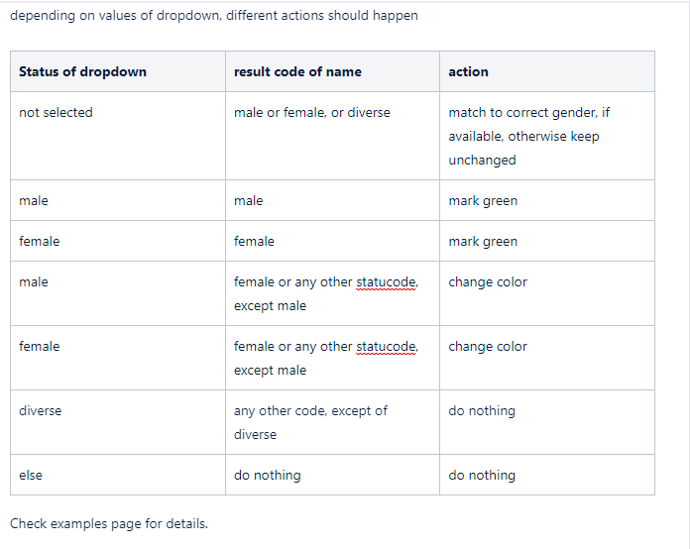

3. Implement addresscheck functionality

**Case 1: Address entered is correct**

Example Address: Germany 97236 Randersacker Balthasar-Neumann-Str. 4b

**Expected Behavour:** All Addressfields are highlighted in green - no blocking of Form submission

Status: Passed

**Case 2**: House number is not correct / not existing

Example Address: Germany 97236 Randersacker Balthasar-Neumann-Str. 999

**Expected Behavour:** Popup with correct statuscode is shown

**Status**:

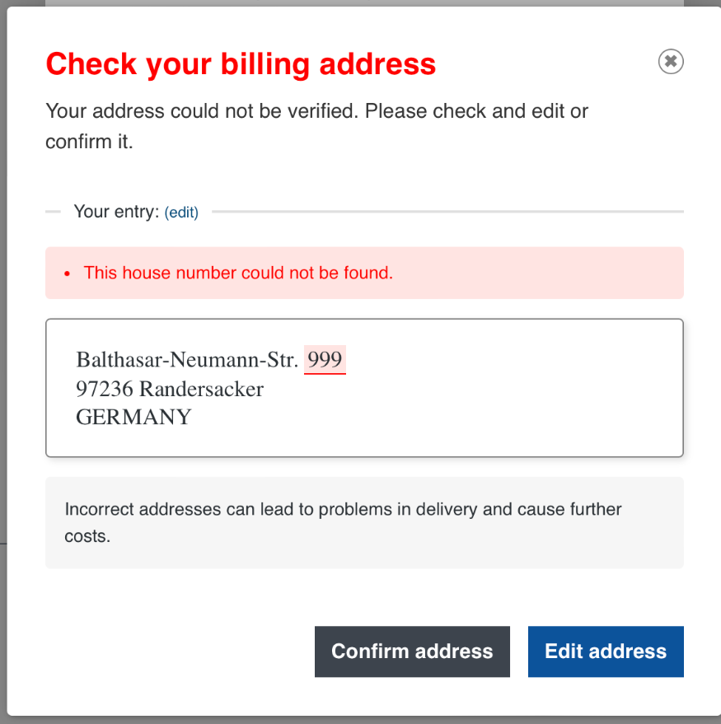

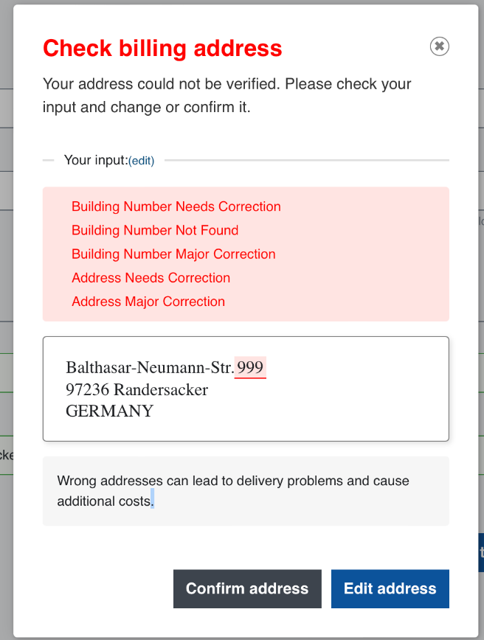

Failed - all statuscodes are displayed - no language file to maintain correct code - check screenshots

**Case 3: address with minor correction status**

**Example Address:** Germany 97234 Randersacker Balthasar-Neumann-Str. 4b

**Expected Behavour** : Addres data with gereral status minor correction should be corrected without customer notice automatically on the first entry. if customer has manually edited address one time, then popup should apear, so we can not run into endless loop

**Status**: Failed - Check video and screenshot

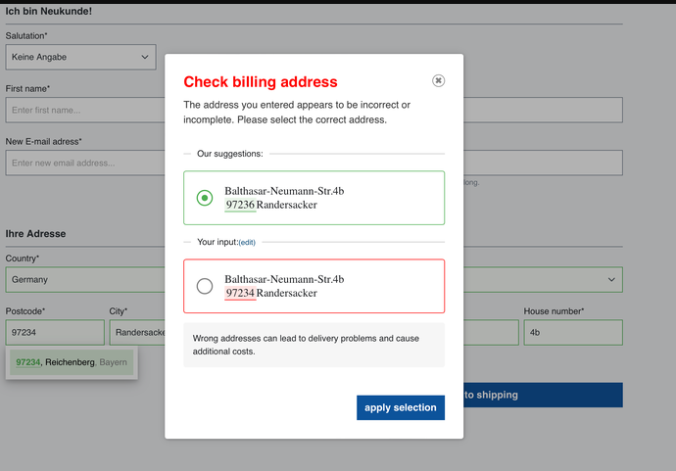

**Case 4** Address with Major correction - but porposal is possible

**Example Address**: Germany 97236 Randersacker Balthasar 4b

**Status**: Failed -

Text for causes by wrong addresses is visible on popup, but should only be visible if radio button has selected customers entered address (below)

