**Software Design Specifications**

**[Help.com]**

**Version: [1.0]**

|  |  |
| --- | --- |
| **Project Code:** |  |
| **Supervisor:** | Ms. Zain Noreen |
| **Co Supervisor** |  |
|  |  |
| **Project Team:** | Awesh Kumar (21K-4526)  Danish Nanjiani (21K-3959)  Anil Kumar (20K-0444) |
| **Submission Date:** | 12/12/2024 |

**Document History**

[Revision history will be maintained to keep a track of changes done by anyone in the document.]

|  |  |  |  |
| --- | --- | --- | --- |
| Version | Name of Person | Date | Description of change |
| 1.0 | Awesh Kumar | November  05, 2024 | Document Created |
| 1.0 | Awesh Kumar | November  06, 2024 | Added ER Diagram and Data  Dictionary |
| 1.0 | Aneel Kumar | November  08, 2024 | Added Introduction |
| 1.0 | Danish Nanjiani | November  14, 2024 | Added Design Considerations |
| 1.0 | Aneel Kumar | November  18, 2024 | Added System Architecture |
| 1.0 | Danish Nanjiani | November  28, 2024 | Added Activity and State Machine  Diagram |
| 1.0 | Awesh Kumar | December  5, 2024 | Added Sequence and  Communication Diagram |

**Distribution List**

[Following table will contain list of people whom the document will be distributed after every sign-off]

|  |  |
| --- | --- |
| **Name** | **Role** |
| Ms. Zain Noreen | Supervisor |
|  |  |
|  |  |

**Document Sign-Off**

[Following table will contain sign-off details of document. Once the document is prepared and revised, this should be signed-off by the sign-off authority.

Any subsequent changes in the document after the first sign-off should again get a formal sign-off by the authorities.]

|  |  |  |  |  |
| --- | --- | --- | --- | --- |
| **Version** | **Sign-off Authority** | **Project Role** | **Signature** | **Sign-off Date** |
|  |  |  |  |  |
|  |  |  |  |  |
|  |  |  |  |  |
|  |  |  |  |  |
|  |  |  |  |  |
|  |  |  |  |  |
|  |  |  |  |  |

**Document Information**

| **Category** | **Information** |
| --- | --- |
| Customer | FAST-NU |
| Project | Help.com |
| Document | Software Design Specification |
| Document Version | 1.0 |
| Status | Draft |
| Author(s) | Awesh Kumar(21K-4526)  Danish Nanjiani(21K-3959)  Anil Kumar(20K-0444) |
| Approver(s) |  |
| Issue Date |  |
| Document Location |  |
| Distribution | Advisor  Project Coordinator’s Office (through Advisor) |

**Definition of Terms, Acronyms and Abbreviations**

[This section should provide the definitions of all terms, acronyms, and abbreviations required to interpret the terms used in the document properly. ]

| **Term** | **Description** |
| --- | --- |
|  |  |
|  |  |
|  |  |
|  |  |
|  |  |
|  |  |
|  |  |
|  |  |

**Introduction** 5

1.1 Purpose of Document 5

1.2 Intended Audience 5

1.3 Document Convention 5

1.4 Project Overview 5

1.5 Scope 6

**2** **Design Considerations** 7

2.1 Assumptions & Dependencies 7

2.2 Risks and Volatile Areas 7

**3** **System Architecture** 8

3.1 System Level Architecture 8

3.1.1 Component Diagram 8

3.1.2 Deployment Diagram 9

3.2 Software Architecture 10

**4** **Design Strategy 11**

**5** **Detailed System Design 12**

5.1 Database Design 12

5.1.1 ER Diagram 12

5.1.2 Data Dictionary 13

5.1.2.1 General Login 13

5.1.2.2 Volunteer Signup 14

5.1.2.3 Donar 15

5.1.2.4Donations 16

5.1.2.5Needy Request 17

5.1.2.6Pick up Items 18

5.1.2.7Drop Items 18

5.1.2.8Task 19

5.1.2.9Admin 19

5.1.2.10Matching System 20

5.2 Application Design 21

5.2.1 Sequence Diagram 21

5.2.1.1 Admin 21

5.2.1.2 Donor 22

5.2.1.3 Needy One 23

5.2.1.3 Volunteer Login 24

5.2.1.3 Volunteer 25

5.2.2 State Diagram 26

5.2.2.1 Admin 26

5.2.2.2 Donor 27

5.2.2.3 Volunteer 28

5.2.2.3 Needy One 29

**6** **References 30**

**7****Appendices 30**

**1.Introduction**

**1.1 Purpose of Document**

The purpose of this Software Design Specification (SDS) is to serve as a detailed framework for the architectural and technical implementation of Help.com. This document aims to:

* Translate the requirements outlined in the Software Requirements Specification (SRS) into a comprehensive design blueprint.
* Provide a clear and structured design plan for developers, stakeholders, and testers to follow during the development lifecycle.
* Ensure the system architecture, database schema, module interactions, and user interface designs align with the project’s objectives of creating a robust, user-friendly social welfare platform.
* Facilitate efficient collaboration among team members by providing detailed design artifacts, including diagrams and descriptions.

By utilizing this SDS, the team can ensure the successful development of a scalable, maintainable, and efficient platform that empowers communities through effective management of donations and volunteer activities.

**1.2 Intended Audience**

* **Stakeholders:** Supervisors, donors, volunteers, organizations.
* **Developers:** Developers working on the MERN stack implementation.
* **Testers:** Quality assurance teams.
* **End Users:** Individuals, volunteers, and organizations.

**1.3 Document Convention**

**Font:** Arial

**Font-size:**

Heading: 20px

Subheading: 14px

Description: 12px

**1.4 Project Overview**

Help.com is an web-based platform aimed at streamlining the process of charitable contributions, including donations and volunteer activities. The platform connects individuals, volunteers, and organizations, enabling them to collaborate effectively for the greater good. By integrating modern web technologies, Help.com offers a centralized and user-friendly experience to facilitate donation management, volunteer coordination, and community support.

Through features like personalized volunteer profiles, AI-powered chat assistance, and logistics management, Help.com simplifies the act of giving and receiving help. Donors can post items for donation, request assistance, sign up for volunteering opportunities, and track contributions in real time. Advanced features like location-based matching algorithms, Google Maps API integration, and an admin dashboard ensure efficient operations and an enhanced user experience.

**1.5 Scope**

**Help.com** aims to transform how communities contribute and receive help by offering a centralized platform for donations, volunteering, and resource management. Volunteers can create detailed profiles, post or request donations, and sign up for volunteer opportunities with ease. Through its advanced features like AI-powered assistance and location-based logistics, the platform ensures a seamless user experience. By bridging the gap between donors, volunteers, and those in need, **Help.com** fosters collaboration and promotes impactful community engagement, making social welfare accessible and efficient for everyone.

**2.Design Considerations**

**2.1 Assumptions and Dependencies**

User interface and some functionalities can change during the development process of

project,. and also new functionalities can be added which is able to change the dependent

system requirements.

**2.2 Risks and Volatile Areas**

1. Performance issues during high traffic.

2. changes in APIs could impact system functionality.

3. Introduction of new features or significant changes in user requirements could delay development..

4. Regularly monitor and test system performance to address scalability challenges.

5. Maintain a contingency plan for backup services or APIs in case of failures.

**3.System Architecture**

**3.1 System Level Architecture**

**3.1.1 Component Diagram**

Our System consists of four modules Admin, Donar, Volunteer, Needy One As

System level architecture shows the top level that is why no internal description is given.

Figure 1: Component Diagram

**3.1.2 Deployment Diagram**

Figure 2: Deployment Diagram

**3.2 Software Architecture**

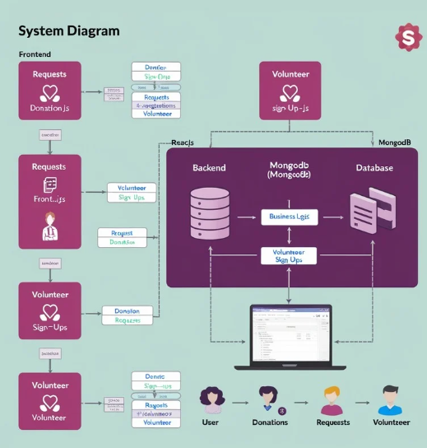

Figure 3: System Diagram

**4.Design Strategy**

* MongoDB has been used for databases to store all the information of the users and user activities.
* NodeJS has been used for backend as its giving response in less time for

verification purposes than python.

* ReactJS has been used for the frontend on which the complete application is built.

# **5.Detailed System Design**

**5.1 Database Design**

**5.1.1 ER Diagram**

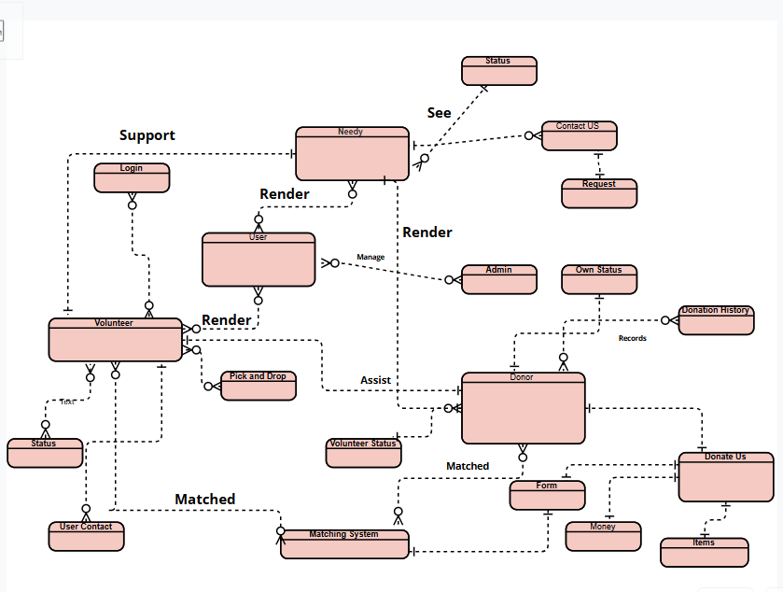

Figure 4: ERD

**5.1.2 Data Dictionary**

**5.1.2.1 General login**

|  |  |  |
| --- | --- | --- |
| **General Login** | | |
| **Name** | | General Login |
| **Alias** | | Login |
| **Where-used/how-used** | | Visit Web Page Whole |
| **Content description** | | Any Admin Volunteer Donor Needy Visit Webiste |
|  | | |
| **Attribute** | **Description** | |
| UserId | Unique identifier | |
| Name | Full name of the User | |
| Role | Role of User (Admin, Volunteer, Donor, Needy One) | |

**5.1.2.2 Volunteer Signup**

|  |  |  |
| --- | --- | --- |
| **Volunteer** | | |
| **Name** | | Volunteer |
| **Alias** | | Volunteer |
| **Where-used/how-used** | | In the Feature of Volunteer |
| **Content description** | | Volunteer signup |
|  | | |
| **Attribute** | **Description** | |
| volunteerId | Unique identifier for each volunteer | |
| userId | Links the volunteer to a user account | |
| Ful Name | Full Name of Volunteer | |
| Email | Email address for Contact | |
| Phone Number | Phone Number for Contact | |
| Location | Location for Items Drop or Pick Up | |
| Availability | Check availability | |
| Area of Experitse | Have which Skills | |
| Additional Information | Description of Volunteer | |

**5.1.2.3 Donor**

|  |  |  |
| --- | --- | --- |
| **Donor** | | |
| **Name** | | Donor |
| **Alias** | | Donor |
| **Where-used/how-used** | | In Donor Feature in Navbar |
| **Content description** | | Show how many donations made the donor |
|  | | |
| **Attribute** | **Description** | |
| donorId | Unique identifier for each donor | |
| userId | Links the donor to a user account | |
| donationHistoiry | List of donations made by the donor | |

**5.1.2.4 Donations**

|  |  |  |
| --- | --- | --- |
| **Donations** | | |
| **Name** | | Donations |
| **Alias** | | Donations |
| **Where-used/how-used** | | In Help Center Feature in Navbar |
| **Content description** | | Show Donations |
|  | | |
| **Attribute** | **Description** | |
| donatioId | Unique identifier for each donation | |
| donorId | Links the donation to a donor | |
| Full Name | Donor Enter Full Name | |
| Email | Email Address for Contact | |
| Donation amount | Amount to be Donated | |
| Payment Method | Select Payment Method (Bank Transfer, etc.) | |
| Condition | Select Condition (Wear, New) | |
| Pick Up Location | Enter Location for Pickup | |
| Quantity | Enter how many quantities have | |
| Items Types | Food, clothes etc | |

**5.1.2.5 Needy Request**

|  |  |  |
| --- | --- | --- |
| **Needy** | | |
| **Name** | | Needy |
| **Alias** | | Needy |
| **Where-used/how-used** | | In Navbar in Help Center Feature |
| **Content description** | | Needy request for help |
|  | | |
| **Attribute** | **Description** | |
| Needy ID | Unique identifier for each person in need | |
| User ID | Links the needy person to a user account | |
| Item Needed | Enter which how many item needed | |
| Reason For Request | For what Request made | |
| Quantity need | Amount needed | |

**5.1.2.6 Pick Up Items**

|  |  |  |
| --- | --- | --- |
| **Pick Up Items** | | |
| **Name** | | Pick Up Items |
| **Alias** | | Pick Up Items |
| **Where-used/how-used** | | In Navbar in Help Center Feature |
| **Content description** | | Needy request for help |
|  | | |
| **Attribute** | **Description** | |
| Pick Up id | Unique Identifier for pick up items | |
| Pick Up address | Enter location for pick up items | |
| Phone Number | Contact Number for Pickup items | |
| Preferred Pick Up Time | Time when pick up items | |

**5.1.2.7 Drop Items**

|  |  |  |
| --- | --- | --- |
| **Drop Items** | | |
| **Name** | | Drop Items |
| **Alias** | | Drop Items |
| **Where-used/how-used** | | In Navbar in Help Center Feature |
| **Content description** | | Needy request for help |
|  | | |
| **Attribute** | **Description** | |
| Drop id | Unique Identifier for Drop items | |
| Category | Choose category for Drop | |
| Quantity | How many items to drop | |
| Condition | Define Condition (wear, new, etc.) | |
| Dorp Off Location | Enter Location where drop | |

**5.1.2.8 Task**

|  |  |  |
| --- | --- | --- |
| **Task** | | |
| **Name** | | Task |
| **Alias** | | Task |
| **Where-used/how-used** | | In Navbar in Help Center Feature |
| **Content description** | | Task assigned to volunteer |
|  | | |
| **Attribute** | **Description** | |
| Task id | Unique identifier for each task | |
| Volunteer | Links the task to a volunteer | |
| Description | Details about the task | |
| Status | Status of the task (Pending , Completed) | |
| dateAssigned | Date the task was assigned | |

**5.1.2.9 Admin**

|  |  |  |
| --- | --- | --- |
| **Admin** | | |
| **Name** | | Admin |
| **Alias** | | Admin |
| **Where-used/how-used** | | In Navbar in Admin Center |
| **Content description** | | Manage whole website |
|  | | |
| **Attribute** | **Description** | |
| Admin id | Unique identifier for admin | |
| User id | Link the admin to a to user account | |
| Managed Requests | List of requests managed by the admin | |
| Managed Donations | List of donations managed by the admin | |

**5.1.2.10 Matching System**

|  |  |  |
| --- | --- | --- |
| **Matching System** | | |
| **Name** | | Matching System |
| **Alias** | | Matching System |
| **Where-used/how-used** | | In Navbar in Help Center Feature |
| **Content description** | | Connections between |
|  | | |
| **Attribute** | **Description** | |
| Match id | Unique identifier for the match | |
| Donation id | Links to the donation | |
| Request Id | Links to the request | |
| status | Status of the match (Pending, Matched) | |

**5.2 Application Design**

**5.2.1 Sequence Diagram**

**5.2.1.1 Admin**

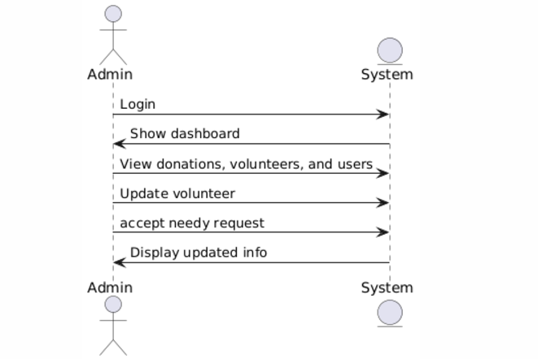

Figure 5: Sequence Diagram

**5.2.1.2 Donor**

Figure 6: Sequence Diagram

**5.2.1.3 Needy One**

Figure 7: Sequence Diagram

**5.2.1.4 Volunteer Login**

Figure 8: Sequence Diagram

**5.2.1.5 Volunteer**

Figure 9: Sequence Diagram

**5.2.2 State Diagram**

**5.2.2.1 Admin**

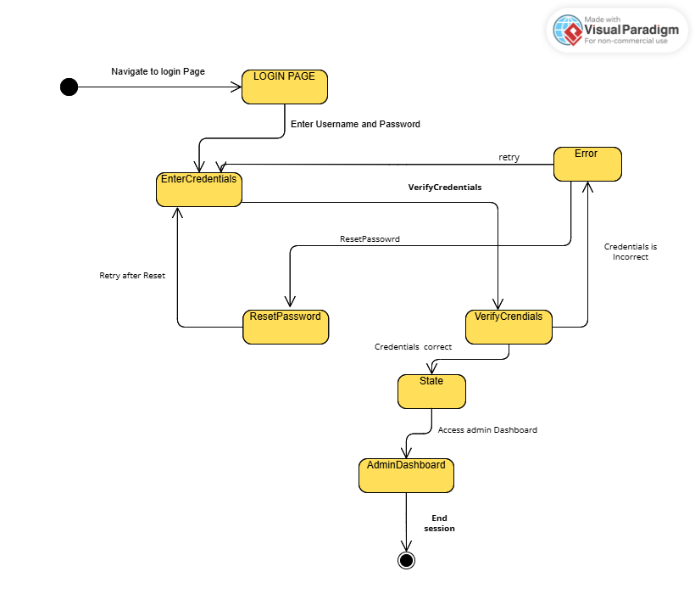

Figure 10: State Diagram

**5.2.2.2 Donor**

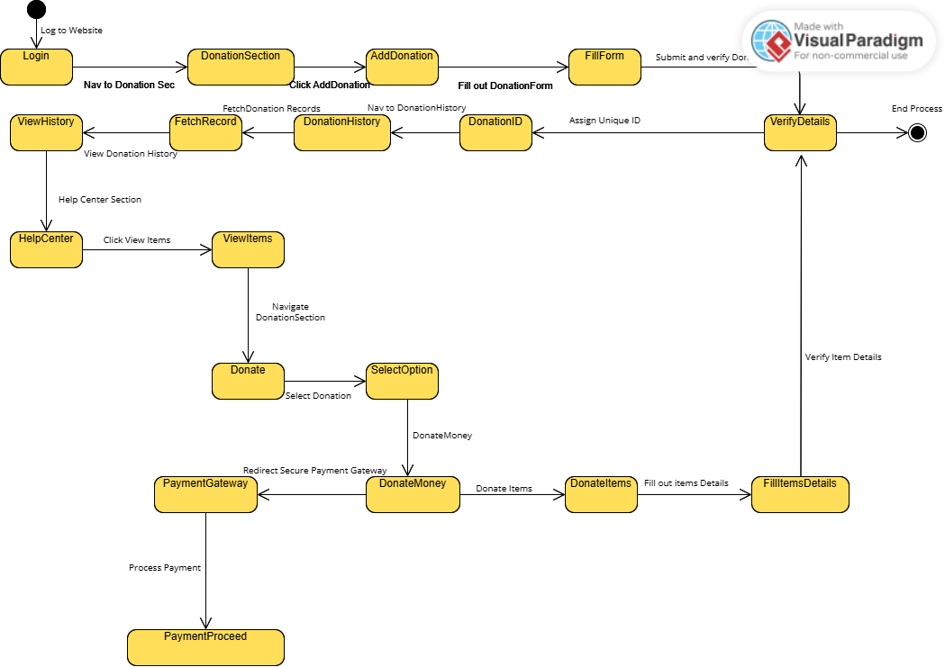

Figure 1: State Diagram

**5.2.2.3 Volunteer**

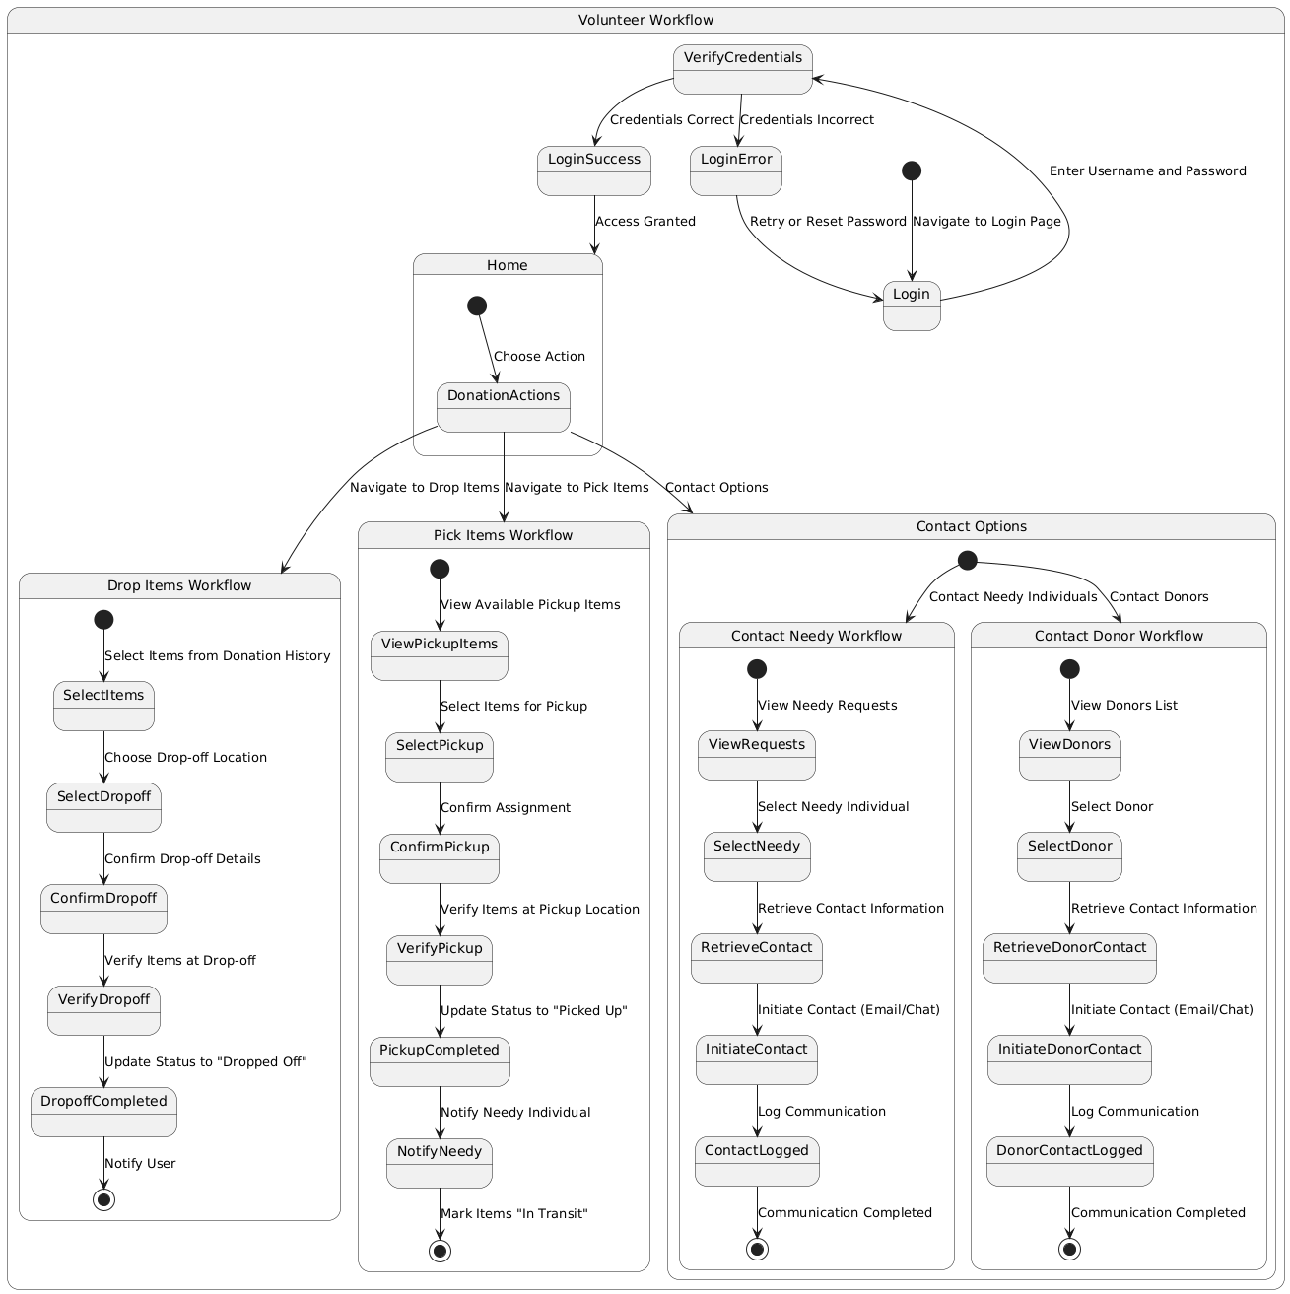

Figure 1: State Diagram

**5.2.2.4 Needy One**

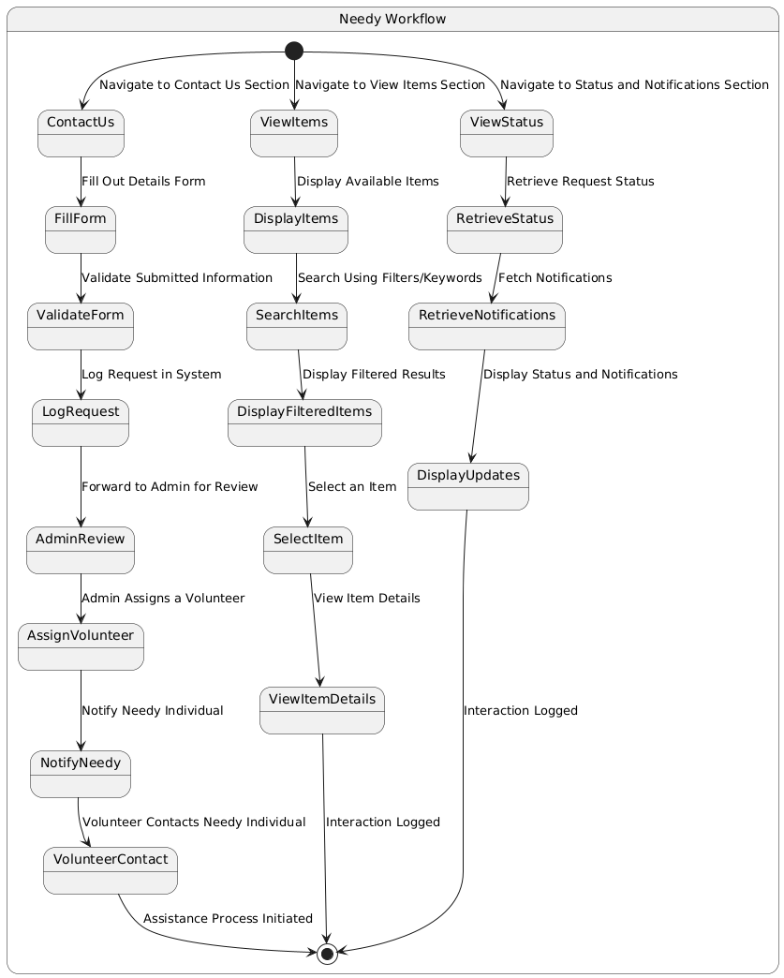

Figure 1: State Diagram

**6.Reference**

1. "Building Scalable Applications with MERN Stack," Developer Resources, 2024.
2. "Designing Social Welfare Systems Using AI Chatbots," AI Research Journal, Vol. 15, 2023.
3. GoogleMapsAPIDocumentation: https://developers.google.com/maps/documentation
4. Dialogflow Documentation: https://cloud.google.com/dialogflow/docs
5. "Social Welfare Initiatives: Technology and Impact," Social Development Reports, 2023.
6. Steele, J., and Adams, D., Full Stack React, Node, and MongoDB: Learn to Build Modern Web Applications, Addison-Wesley, Boston, 2019.
7. [https://www.gofundme.com](<https://www.gofundme.com>

**7.Appendices**