Patent Data Overview

Overview—
- Total Number of Patents: 34

Patent Application Yearly Trend
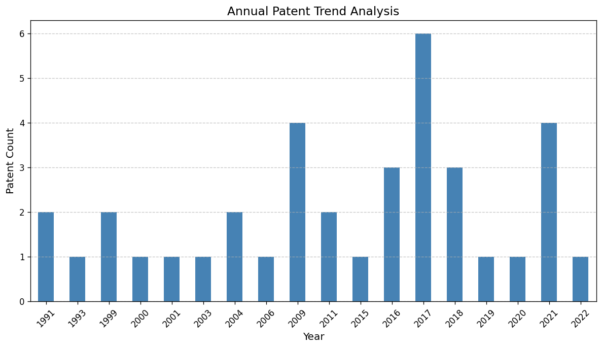
Trend Chart

Patent Distribution by Country/Region
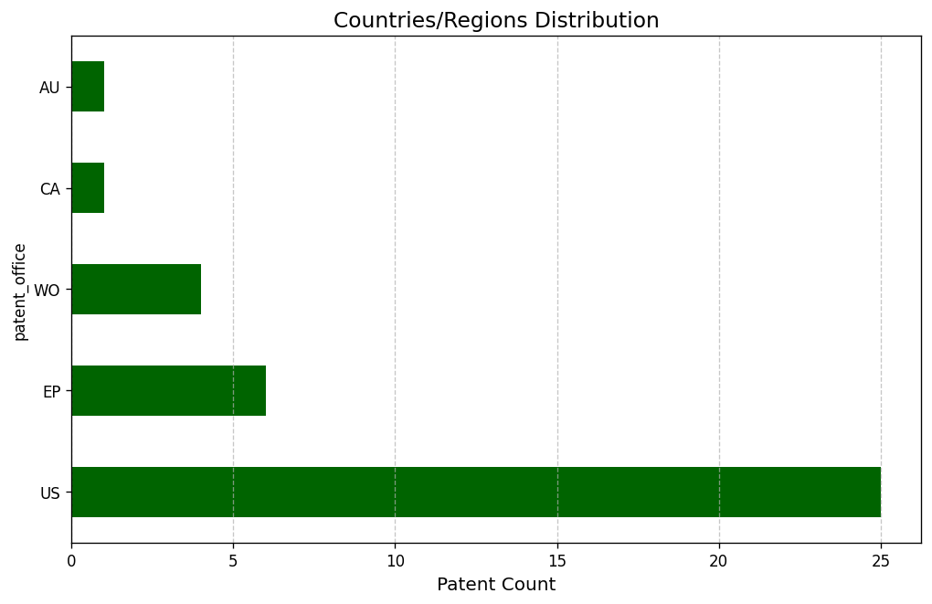
Country Patent Chart

