1. Proposed Model of Siamese Structure
2. Proposed model of emotional analysis
3. Face detection accuracy ouput

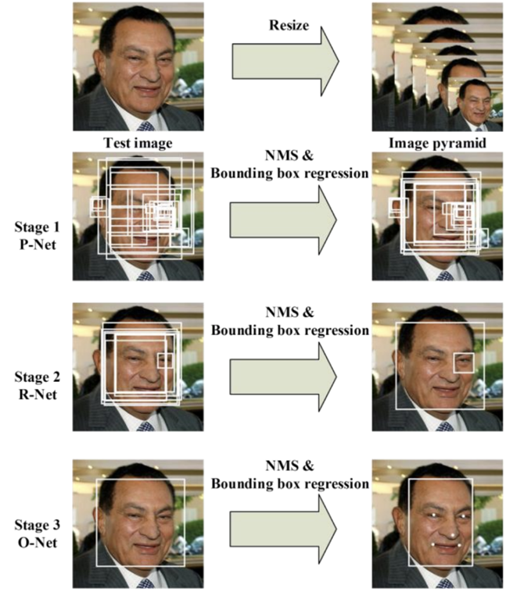

**Pipeline of MTCNN method**



1. **128-dimensional vector embeddings for each face**
2. **Dataset Images**
3. **Experimental Setup**

**Frameworks and Libraries used**

**Dataset used**

1. **Five facial points image capture**
2. **Device detection module**
3. **Proctor module**
4. **Training and testing graph**
5. **Graph given by Ranjit sir**