## Importing as Git Project

Import > Git > Projects from Git

URI = <https://github.com/awesomeankz/SpringMicroServices.git>

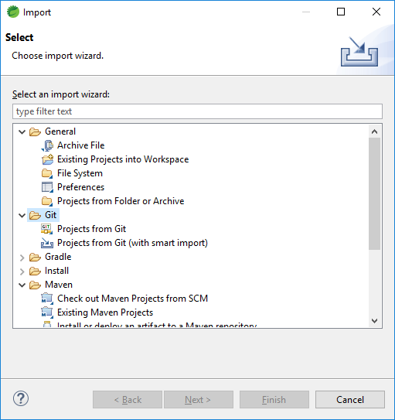

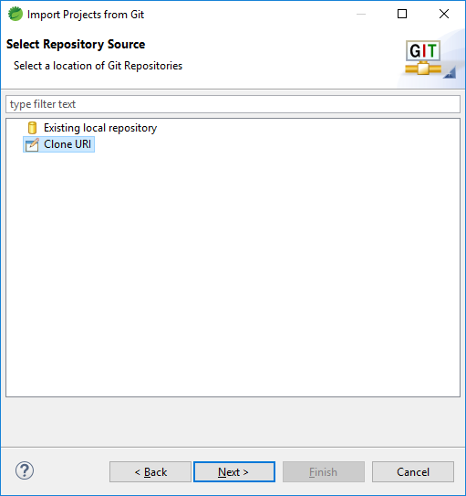

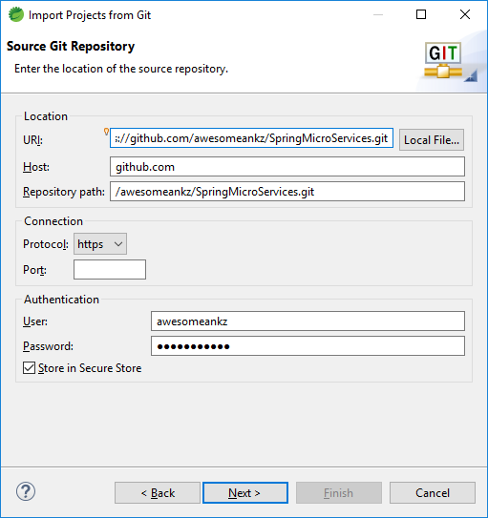

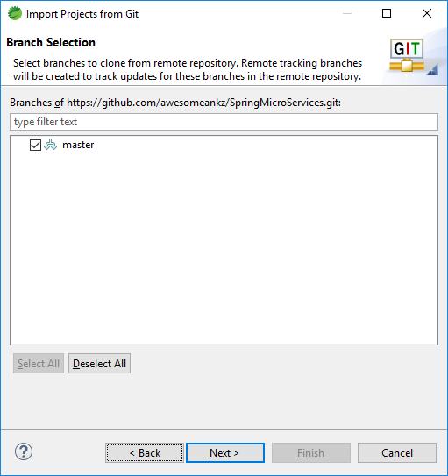

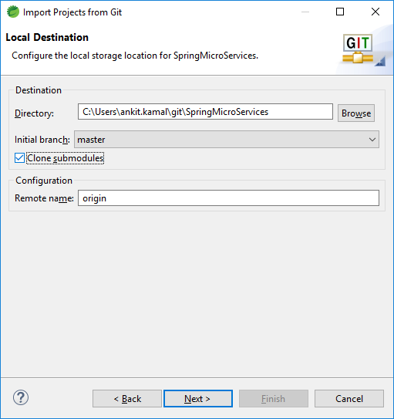

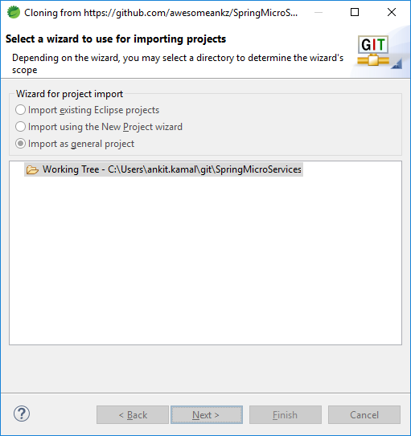

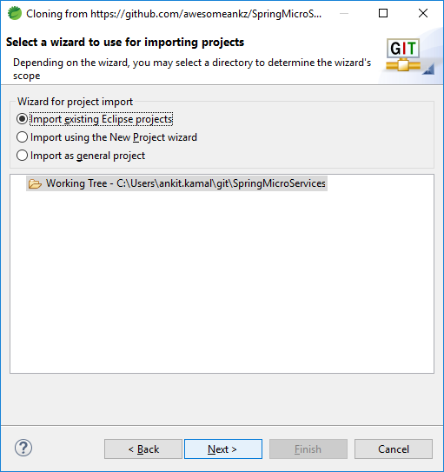

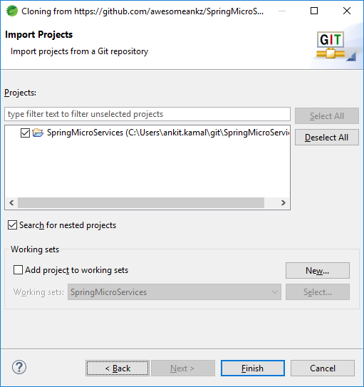

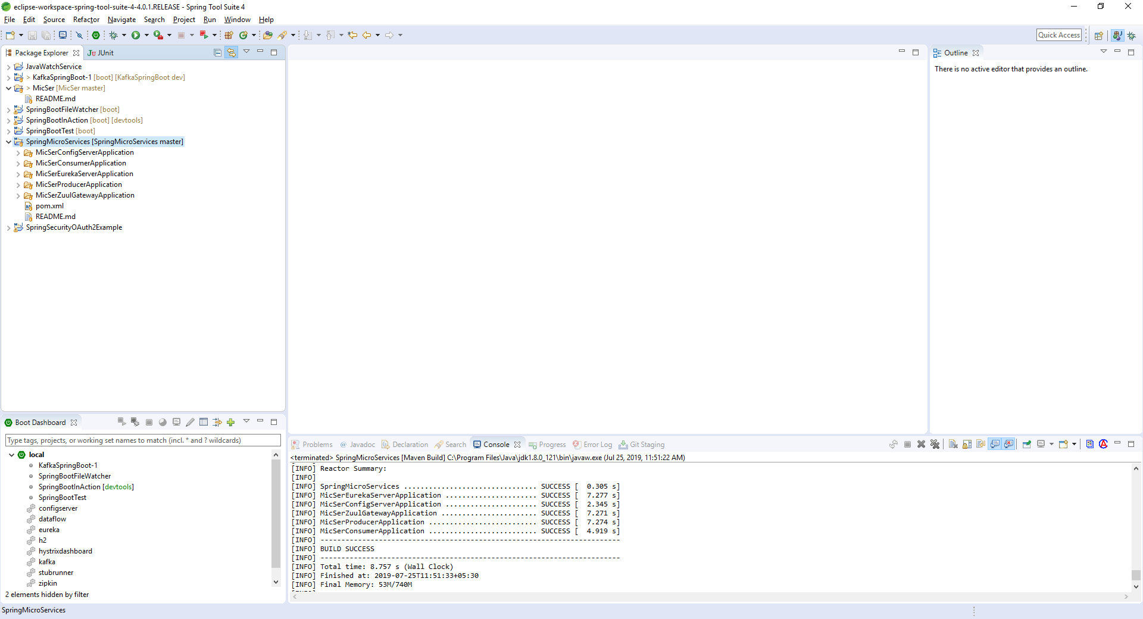

Parent Project with all sub-modules.

## Importing as Maven Project

Import > Maven > Check Out Maven Projects from SCM

URI = <https://github.com/awesomeankz/SpringMicroServices.git>

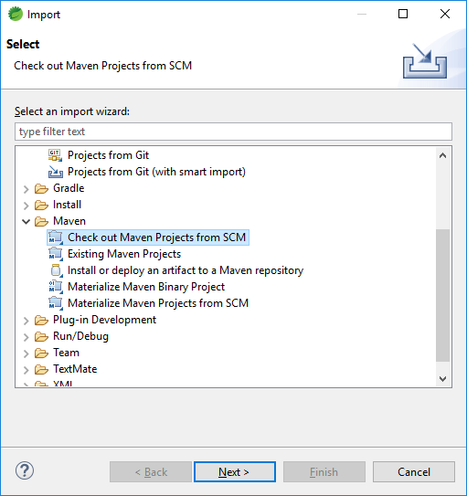

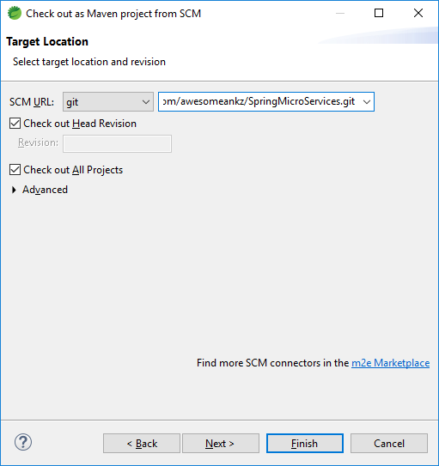

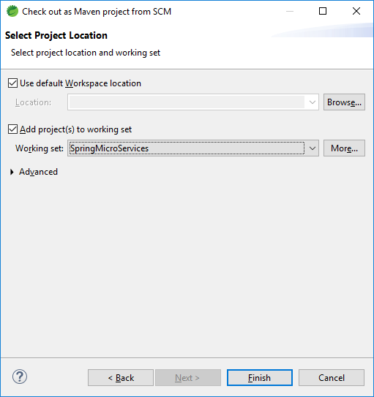

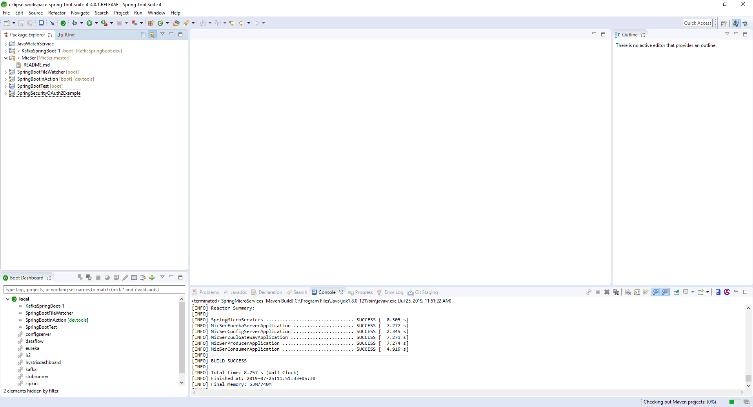

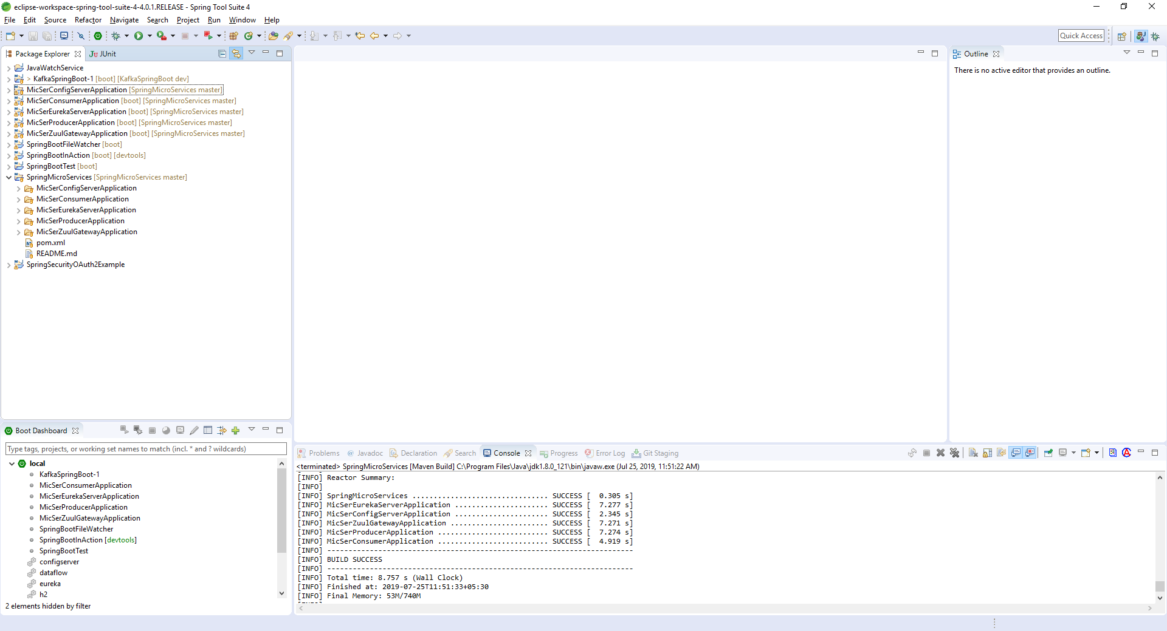

Parent Project  **SpringMicroServices** with all sub-modules checked out separately.

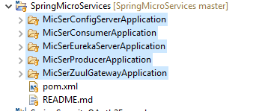

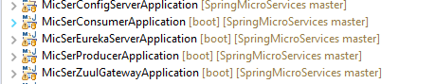



Figure 1 : Parent POM



Figure 2: ChildPOM

## Directory Structure

Parent – SpringMicroServices

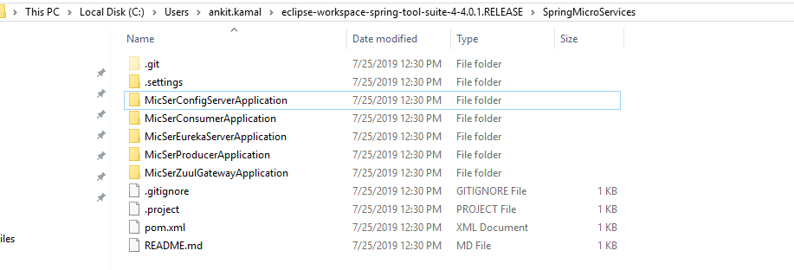

<https://spring.io/guides/gs/multi-module/>

<https://stackoverflow.com/questions/49971286/how-to-make-existing-maven-parent-project-child-of-newly-created-maven-project>

Since your all projects are all in the same level, you should have:

In Project A:

<modules>  
 <module>../projectB</module>  
</modules>

And in Project B:

<parent>  
 ...  
 <relativePath>../projectA/pom.xml</relativePath>  
</parent>