Chapter 3: Research methodology
3.0 Introduction
This chapter describes how the Poacher Guard anti-poaching detection system was designed, built and evaluated. The study set out to establish whether a low-cost laptop prototype, combining pretrained machine learning models with a Bluetooth Low Energy (BLE) ranger tag and an ESP32 flame sensor, could detect human intrusion, gunshots and fires and pass an alert to rangers quickly enough to support a response. The chapter explains the research philosophy and design, the prototype that served as the test platform, the datasets used for each detector, how those datasets were annotated, how the models were trained or adapted and how their performance was measured. Model evaluation results obtained on public benchmark data are reported in Section 3.8 so that the reader can judge the training procedure alongside its outcome. Field measurements on the prototype hardware are reported separately and are marked where they still have to be inserted.
3.1 Research philosophy and approach
A positivist philosophy was adopted because the questions addressed by this study concern measurable quantities: the proportion of people that the vision model finds, the proportion of gunshots that the audio model detects, the number of false alarms produced by non-threat sounds and the delay between the first sighting of a person and the alert. These quantities can be observed and counted without depending on the interpretation of the researcher, which suits a positivist position (Saunders, Lewis and Thornhill, 2019). A deductive and quantitative approach followed from this choice. Performance targets were set from the design goals of the system, the models were tested against labelled data and the results were compared with those targets.
The work also has the character of design science research, in which an artefact is built to address a practical problem and then evaluated with rigorous methods (Hevner, March, Park and Ram, 2004). The artefact in this case is the detection and alerting prototype. Treating the prototype as an artefact under evaluation made it possible to separate two kinds of evidence. The first is model evidence, obtained by testing each detector on labelled data under controlled conditions. The second is system evidence, obtained by running the complete prototype with its sensors and dashboard. Both kinds were needed because a model that scores well on a benchmark can still fail as part of a system that has to run continuously on modest hardware.
3.2 Research design
An experimental research design was used. For each detector the independent variable was the model or configuration under test (for example a pretrained model against the same model after fine-tuning) and the dependent variables were precision, recall, F1-score, average precision and false positive rate on a held-out test set. Test sets were fixed before any training took place and were never used to choose hyperparameters or thresholds, so that the reported figures estimate how the models would behave on unseen data. Random seeds were fixed at 42 for dataset splitting and model training so that the experiments can be repeated.
The design was carried out in two stages. In the first stage the person detector and the gunshot detector were trained and evaluated on public datasets, because labelled field data from a protected area were not yet available in sufficient quantity. In the second stage the complete prototype, including the ESP32 flame node and the BLE ranger tag, is tested under controlled field conditions. This chapter reports the first stage in full and sets out the procedure for the second stage. All model experiments were run on a computer with a four-core Intel Xeon central processing unit (CPU) at 2.1 GHz, 15 GB of memory and no graphics processing unit, which is similar to the laptop on which the prototype runs, so the timing figures reported are relevant to deployment.
3.3 Prototype used as the test platform
The first build of the system is a laptop prototype rather than the solar-powered field nodes described in the system design. The laptop runs two machine learning models: a person detector on the webcam feed and a gunshot detector on the microphone signal. A separate ESP32 microcontroller with an infrared flame sensor reports fire over Wi-Fi, and rangers carry an ESP32 BLE tag so that the system can tell a ranger from a suspected poacher. Every alert is stored in a SQLite database together with a snapshot image and is pushed to a web dashboard built with FastAPI. Figure 3.1 shows how these parts are connected and Table 3.1 summarises the role of each detector.
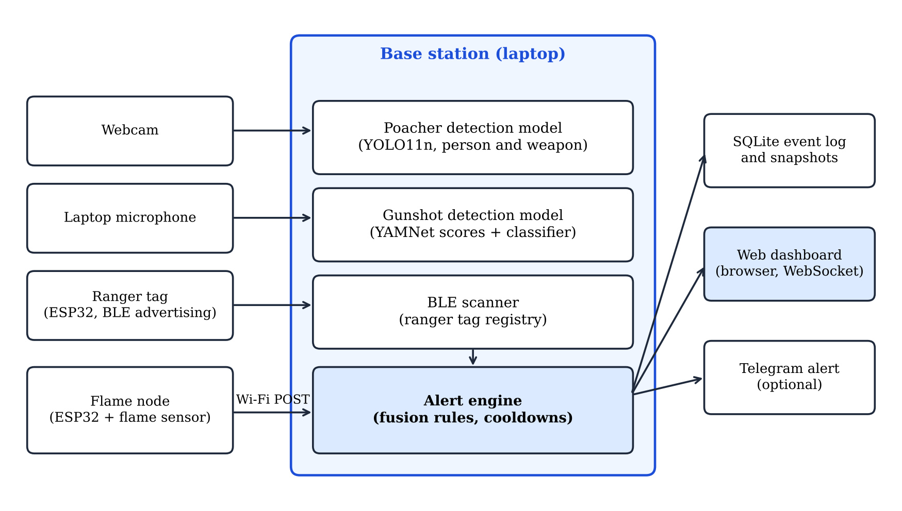
Figure 3.1: Architecture of the laptop prototype used as the test platform
Table 3.1: Detectors in the laptop prototype
Function | Input | Model or method | Alert rule
Person detection | Laptop webcam, 640 x 480 pixels | YOLO11n object detector, person class | Person found in at least 3 of the last 6 processed frames with confidence of 0.45 or more
Ranger or poacher | BLE tag worn by the ranger | BLE advertisement scan with received signal strength (RSSI) | Registered tag heard above -90 dBm in the last 15 s means ranger, otherwise suspected poacher
Gunshot detection | Laptop microphone, 16 kHz | YAMNet audio classifier, five gunshot-related AudioSet classes | Gunshot score at or above the threshold (0.35 in the prototype configuration)
Fire detection | ESP32 with infrared flame sensor | Threshold on the analogue reading or the module output | Reading below 1,500 on a scale of 0 to 4,095 for three consecutive readings 250 ms apart

The person rule in Table 3.1 means that the vision model does not need to recognise poachers as such. It only needs to find people reliably, and the BLE check decides whether the person is authorised, as shown in Figure 3.2. The quality of the whole intrusion function therefore depends on the recall of the person detector and on the reliability of the tag reading. The gunshot function depends on the ability of the audio model to separate gunshots from other impulsive sounds that occur in the bush, such as thunder, breaking branches and fireworks. These two models were the subject of the training and evaluation experiments described in the rest of this chapter.
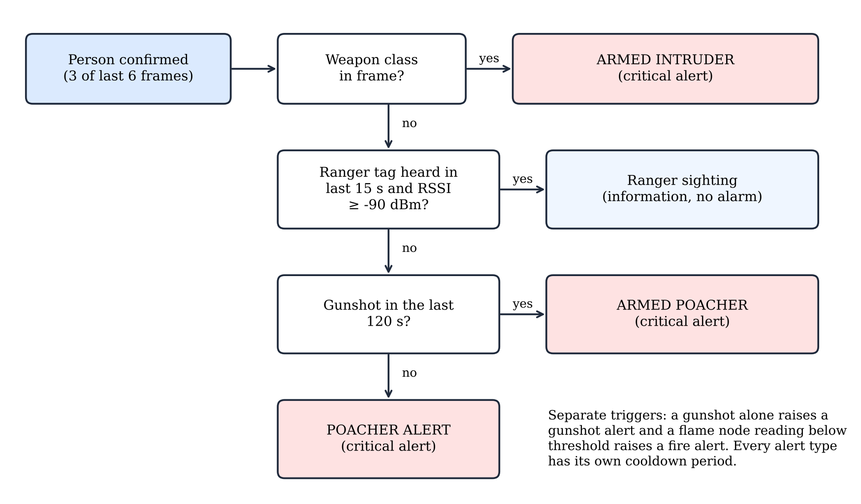
Figure 3.2: Decision logic of the alert engine
3.3.1 Enclosure requirements
The laptop prototype described above needed a physical housing before it could be tested outdoors, because loose boards and cables cannot be fixed to a tree or protected from handling. The enclosure was therefore treated as a second artefact within the design science approach of Section 3.1 and was developed in five steps: requirements, concept, parametric modelling, digital verification and validation in independent computer-aided design (CAD) software. Each step left a file in the project repository, so the geometry can be regenerated and every dimension in this section can be traced to the model that produced it. The requirements were set at the start of the work and were refined as each iteration exposed a problem. Table 3.2 lists them together with the design response to each.
Table 3.2: Enclosure requirements and the design response to each
Requirement | Design response
Body 150 mm high, 100 mm wide and 45 mm deep | Walls of 2.6 mm and a back plate of 4.5 mm give a cavity of 144.8 x 94.8 x 37.9 mm inside a body that measures exactly 150 x 100 x 45 mm
Mounted on a tree trunk in portrait orientation | Four strap lugs on the back plate, each with a 30 x 5 mm window for a 25 mm strap, and four rubber-foot pockets that grip the bark
Able to stand on its own end | Flat bottom end and a ballast tray that holds about 180 g of steel washers or lead shot to lower the centre of mass
Flame sensor visible from outside | Round hole of 6.8 mm diameter in the front face, through which the 5 mm infrared sensor head projects 6 mm
ESP32 programmable and powered without opening the casing | Port of 22 x 9 mm in the side wall, lined up with the micro-USB socket of the board
Webcam connected directly to the laptop | No pass-through for the webcam lead. The webcam stands on a recessed deck at the top end and is held by four cable ties
Printable on a desktop printer without support material | Two parts: the shell is printed with its roof on the bed and the base plate is printed flat
Boards fit with clearance | Clearance of 0.35 mm around each board and automatic overlap checks on the model

3.3.2 Design methodology
The casing was modelled parametrically instead of being drawn by hand. A Python script built every solid from named parameters (wall thickness, plate thickness, corner radius, fit clearance, cavity size and the positions of the ports and the sensor hole) and combined the solids with Boolean union and difference operations in the Manifold geometry engine, accessed through the trimesh library. Because the outer size is derived from the parameters, a change such as a thicker wall or a different board size regenerates the shell, the base plate and the fit checks in one run. The same script exports the two printable parts as STL files, and a second script places stand-in models of the boards, webcam, cables, screws and feet at the positions that the casing expects.
The ESP32 DevKit V1 (30-pin version) was modelled as a board 51.5 mm long, 28.5 mm wide and 1.6 mm thick with pins 10 mm long, and the flame sensor module as a board 32 mm long, 14 mm wide and 1.6 mm thick. These are typical catalogue values and were not measured on the boards used in the study. [DETAIL REQUIRED: measured length, width and pin height of the ESP32 board and the flame module used.] A clearance of 0.35 mm was left around each board so that small differences between supplier batches would not prevent assembly.
Four design iterations were completed. The first model was a flat case that stood on a table, with a narrow slit in front of the flame sensor and a cable port in the rear wall. The second iteration changed the body to a portrait shape for mounting on a tree, added four strap lugs to the back plate and replaced the slit with a round hole so that the infrared sensor head projects out of the casing. In the third iteration the ESP32 port was moved to the side wall, in line with the micro-USB socket of the board, the pass-through for the webcam lead and the ventilation slots were removed, and the outer size was fixed at 150 x 100 x 45 mm. The fourth iteration added the ballast tray after a stability estimate showed that the unit would tip too easily when standing on its end. A removable stand foot was also modelled and was then dropped, because the casing was required to stand without a separate part.
The back plate and the shell are separate parts joined by four M3 screws driven from the tree side, and a locating lip on the plate centres the shell and keeps the joint aligned. Mounting the webcam outside the casing keeps the body sealed apart from the sensor hole and one port, and the webcam lead runs directly to the laptop. The principal dimensions that result from these decisions are given in Table 3.3.
Table 3.3: Principal dimensions of the enclosure (millimetres)
Feature | Dimension
Body (height x width x depth) | 150 x 100 x 45
Width over the strap lugs | 136
Height including the webcam stand-in | about 183
Shell (printed part) | 150 x 100 x 40.5
Base plate with lugs (printed part) | 150 x 136 x 29.5
Wall thickness, back plate thickness, corner radius | 2.6, 4.5 and 7
Strap lug (length x projection x thickness) and window | 44 x 18 x 6 and 30 x 5
Sensor hole and height above the bottom end | diameter 6.8 at 102.4
ESP32 port and height of its lower edge above the bottom end | 22 x 9 at 11.6
Camera deck recess (width x depth x depth of recess) | 50 x 26 x 0.8
Screws and rubber feet | 4 x M3 x 16 and 4 x diameter 10 pockets
Ballast tray | 36 x 32 x 18

3.3.3 Digital verification
Two kinds of automatic check were run each time the model was regenerated. The first confirmed that both printed parts were watertight solids, and the second measured the volume of overlap between each stand-in component and the shell and base plate. The ESP32 board, flame module, USB plug, webcam, cable ties and rubber feet all showed 0.0 mm3 of overlap, which means that every component fits inside the space provided. Each of the four screws overlapped the shell by 24.2 mm3, which represents the intended thread engagement of an M3 screw in its pilot hole and is not an error.
The centre lines of the two USB leads were also tested against the walls. The ESP32 lead stayed at least 11.5 mm from any solid, and the webcam lead, which has a radius of 2.2 mm, kept a minimum clearance of 2.32 mm where it passes the rounded corner of the shell, so it does not touch the casing. Mass and stability were estimated from the model volumes, assuming PETG at 1.27 g/cm3 and 20 per cent infill. The two printed parts came to about 170 g, and the centre of mass lay about 106 mm above the bottom end without ballast and about 75 mm with 180 g of ballast, which raised the estimated tip angle from 8 to 14 degrees. These are estimates and the margin is small, so the unit stands on a level surface but can be toppled by a pull on a cable. [RESULT REQUIRED: measured mass of the printed parts and the angle at which the printed unit tips.]
3.3.4 Orthographic views
Orthographic views were produced from the same model that is printed, so the drawings cannot disagree with the geometry. Figure 3.3 shows the front view from the weather side and the left view from the side wall that carries the USB port. Figure 3.4 shows the top end, where the camera deck is cut, and the back view from the tree side, which shows the strap windows, the screw holes and the rubber-foot pockets. The shaded outline above the casing is the webcam stand-in, which is not part of the printed casing.
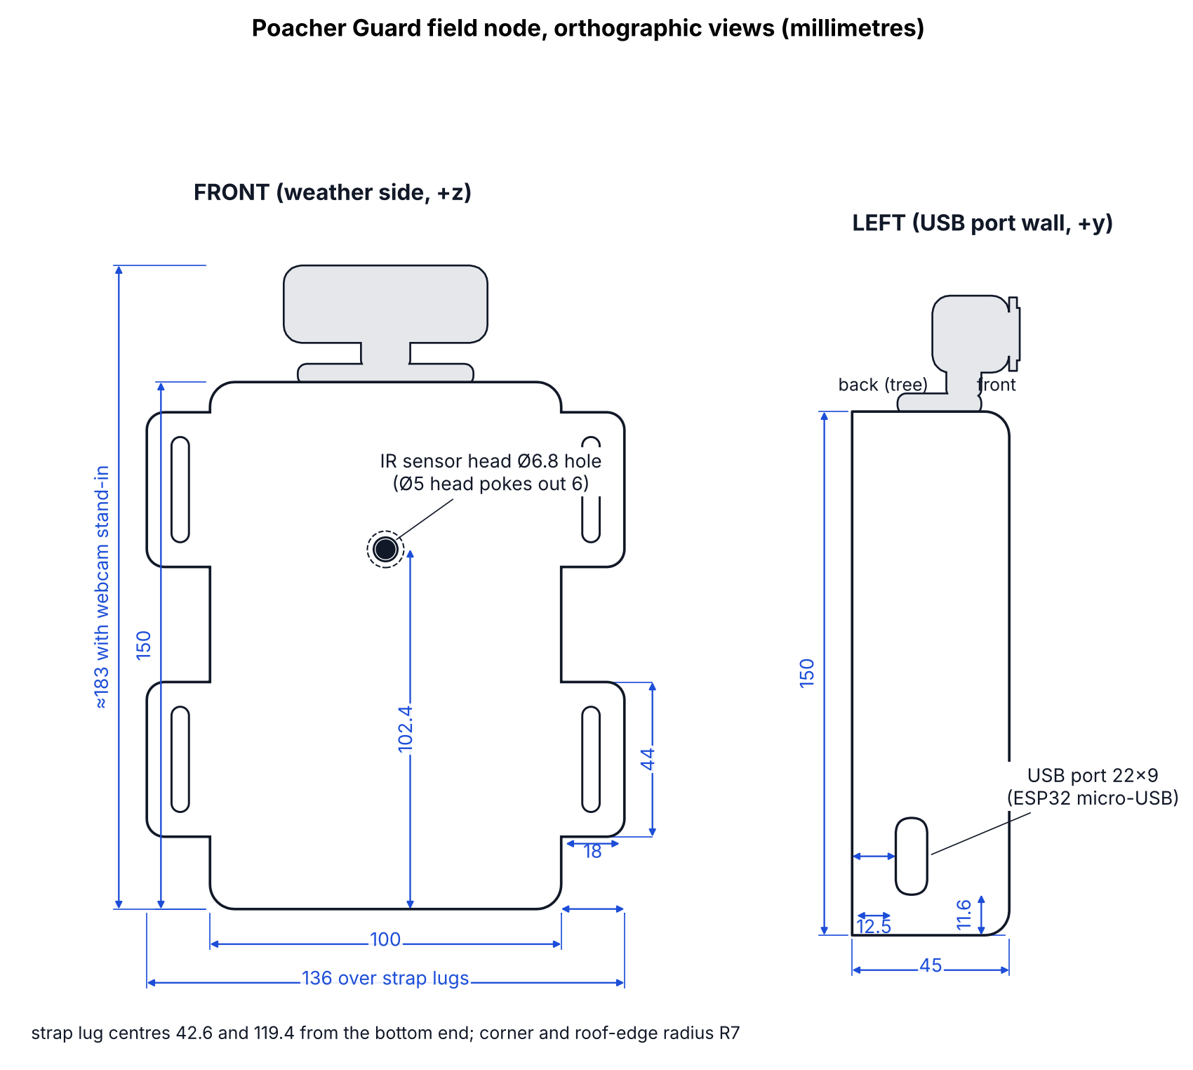
Figure 3.3: Front and left orthographic views of the field node enclosure with dimensions in millimetres
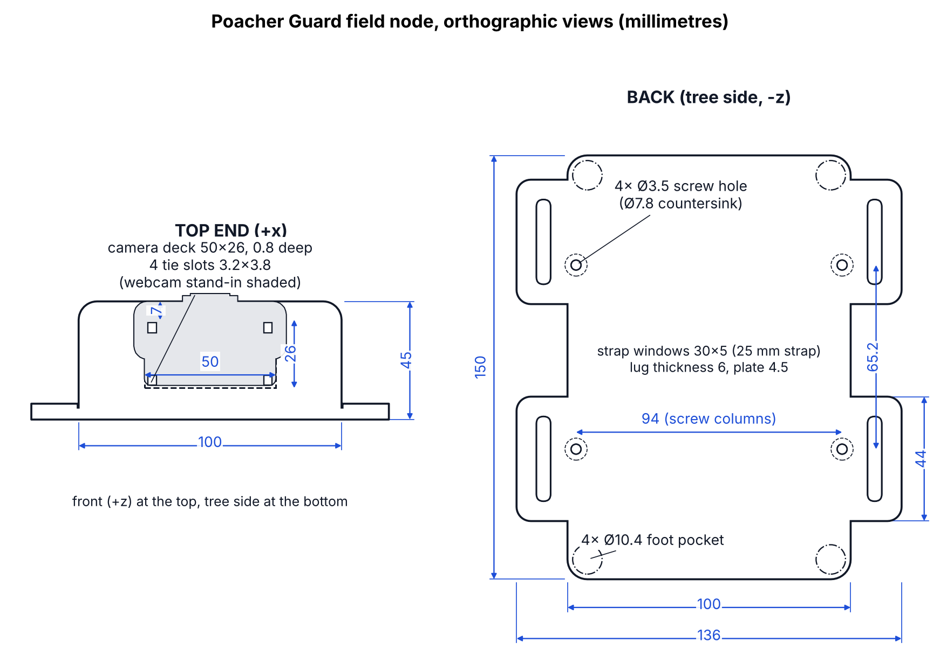
Figure 3.4: Top end and back orthographic views of the field node enclosure with dimensions in millimetres
3.3.5 Validation in SolidWorks
The assembly was exported from the model as a STEP file with 32 named and coloured parts and was opened in SolidWorks Design Premium 2026 SP0.0 and saved as a part file. The feature tree listed 30 solid bodies, which matches the 30 solid parts in the export, and the two USB leads were carried over as swept tubes. The colours and shapes were preserved, which shows that the exchange file can be used for further CAD work such as manufacturing drawings or finite element analysis. Figure 3.5 shows the imported model from the tree side, with the base plate, the strap lugs and the rubber feet, and Figure 3.6 shows it from the weather side, with the sensor hole in the shell and the webcam on the top end.
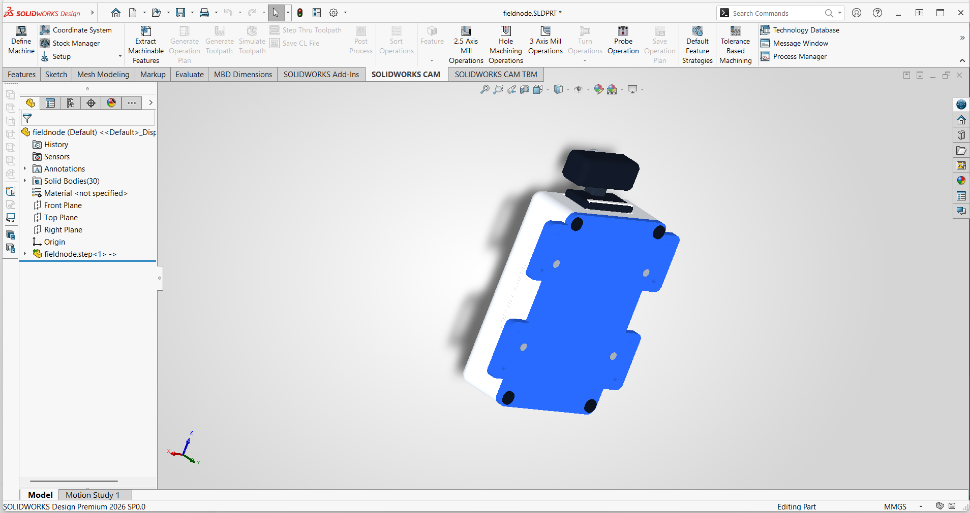
Figure 3.5: Enclosure assembly imported into SolidWorks, seen from the tree side
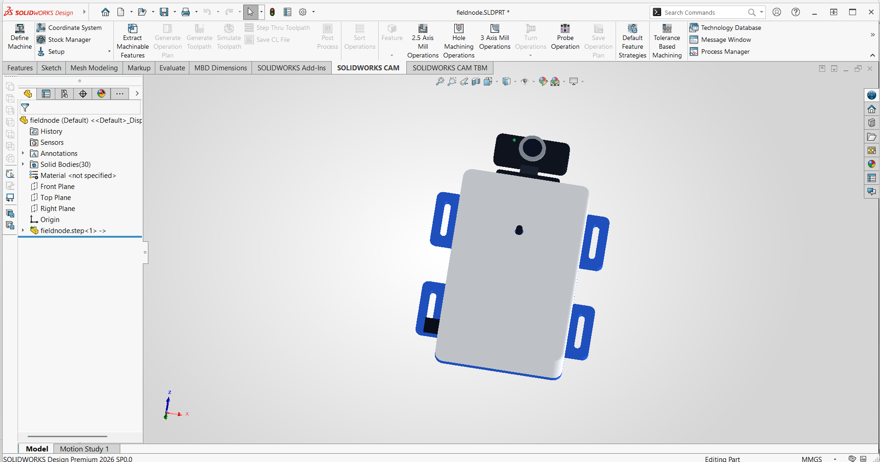
Figure 3.6: Enclosure assembly imported into SolidWorks, seen from the weather side
The enclosure had not been printed at the time of writing, so the fit of the real boards, the strength of the strap lugs and the behaviour of the unit on a trunk remain to be tested. [RESULT REQUIRED: printer and material used, print time, whether the boards and webcam fitted without modification, and the result of a strap test on a trunk.] The parameters in the generating script are the means of correcting any mismatch, because a changed dimension regenerates all parts and checks. Any such change is recorded in the repository history, so later versions of the casing can be compared with the one described here.
3.4 Data collection
3.4.1 Image data for person detection
The PASCAL Visual Object Classes (VOC) 2007 dataset was used for training and testing the person detector (Everingham, Van Gool, Williams, Winn and Zisserman, 2010). It was chosen for three reasons. Its person annotations were produced by trained annotators under a published protocol, which makes them a reliable reference. The images show people at many scales and in partial occlusion, which is closer to the view of a concealed camera than posed portraits. Its other classes include cows, horses, sheep, dogs, cats and birds, so images without people contain animals that the detector must not mistake for intruders. The YOLO11n model used in the prototype was pretrained on the Microsoft COCO dataset (Lin et al., 2014), and VOC 2007 was therefore used as an independent check of the pretrained model, although the two collections may share some photographs [CITATION REQUIRED: overlap between COCO and VOC 2007].
Images were drawn at random from the official VOC 2007 lists with a fixed seed. The training set took 1,200 images containing people and 400 images without people from the trainval list, and a validation set of 300 images was taken at random from the remainder of that list for monitoring training. The test set was 1,000 images sampled from the separate official test list, so no test image was seen during training. Table 3.4 gives the composition of each split together with the two additional test sets described in the next paragraph. Objects flagged as difficult in the VOC annotations were excluded, following the convention of the VOC benchmark.
The people in the VOC images are mostly European and North American, which means the VOC test set under-represents the people the detector sees in Zimbabwean conservation areas, namely Black Africans in rural and bush settings. A separate African test set was therefore built from the Open Images dataset (Kuznetsova et al., 2020), whose images carry person bounding boxes and a Creative Commons Attribution licence. Candidate images were those from the train, validation and test splits whose original photograph title named a sub-Saharan African country, city, region or people, such as Zimbabwe, Kenya, Tanzania, Lesotho or the Masai Mara, and whose person boxes were not marked as groups or depictions. This gave 912 candidates. A random sample of 640 candidates was downloaded and every image was reviewed visually. Photographs were kept when they showed real people of the local population clearly enough to judge, and were rejected when they showed paintings, statues, posters, mixed groups with a foreign majority, or people too small, dark or distant to judge. This left 205 images. A stricter rule was then applied by script: titles that said only Africa or African without naming a place were removed, because such a title can describe an event on another continent. The final African test set held 168 images with 672 person boxes, of which 42 images with 167 boxes show rural, farm, village or bush scenes. The review was done by one reviewer on the basis of appearance, which is a limitation, and the list of image identifiers, titles and photographers is stored with the project code so that the selection can be checked [DETAIL REQUIRED: confirm who carried out the review. The first pass was made with AI assistance and the author must re-check the list in results/chapter3/african_test_set.csv before submission].
Open Images also differs from VOC in how it was annotated: it labels many more small and distant people, so its scores are lower for any detector. To separate the effect of the population from the effect of the dataset, a control test set of 168 Open Images photographs was drawn at random from images whose titles name no African place, with the same filters and the same balance of source splits (151 train, 8 validation and 9 test). Comparing the African set with this control set, rather than with VOC, isolates the difference that is linked to the people and places in the images. One difference could not be removed. The African set was reviewed for clarity and the control set was not, so the African set may contain fewer unclear images than the control set. Neither Open Images set was used for training.
Table 3.4: Composition of the person detection dataset (VOC 2007 subsets and Open Images test sets)
Split | Source list | Images | Images containing people | Person boxes
Training | VOC 2007 trainval | 1,600 | 1,200 | 2,755
Validation | VOC 2007 trainval (random, not in training) | 300 | 67 | 161
Test | VOC 2007 test | 1,000 | 387 | 897
African test set | Open Images, titles naming a sub-Saharan African place, reviewed | 168 | 168 | 672
African rural and bush subset | Part of the African test set | 42 | 42 | 167
Control test set | Open Images, random, no African place in title | 168 | 168 | 669

Public images differ from what a concealed camera sees in a conservation area. Field images are taken from fixed positions, often at night under infrared illumination, and show people partly hidden by vegetation, in camouflage clothing and at long range. To close this gap a field image set is collected at the study site with the prototype camera. The collection protocol is as follows: images are captured at distances of 5, 10, 20 and 30 m, in daylight and at night, with consenting participants walking, crouching and partly hidden by vegetation, and with frames that contain only animals or empty scenes as negatives. [DATA REQUIRED: number of field images collected, site, dates, camera model and the number of participants.]
3.4.2 Audio data for gunshot detection
Gunshot recordings were obtained from the Gunshot Audio Dataset (Aydemir, n.d.), as redistributed in a public GitHub repository (Harihara-Valliappan, n.d.). Three firearm classes were available in that copy: the AK-47, the AK-12 and the IMI Desert Eagle pistol, giving 263 clips of between 1 and 4 s. The AK-47 class is of direct interest because rifles of this pattern are reported in poaching incidents in Southern Africa [CITATION REQUIRED]. Negative examples came from the ESC-50 dataset (Piczak, 2015), which supplied 2,000 five-second clips of 50 everyday and natural sound classes, among them rain, wind, thunderstorm, crackling fire, insects, birds, frogs, cows, sheep, fireworks and aircraft. Fireworks, glass breaking, can opening and thunderstorms were of particular interest as hard negatives, because a detector that responds to any loud impulse would produce false alarms in the field.
The data were split at the level of whole clips. For ESC-50 the dataset's own fold 5 was used as the test set and folds 1 to 4 as the training set, which keeps clips cut from the same original recording in the same fold. For the gunshot classes, 20 per cent of the clips of each firearm class were drawn at random with a fixed seed for testing. Table 3.5 shows the resulting composition. All audio was converted to mono and resampled to 16 kHz, the rate used by the prototype microphone stream.
Table 3.5: Composition of the gunshot detection dataset
Source | Label | Clip length (s) | Training clips | Test clips | Windows (train / test)
Gunshot Audio Dataset (AK-47, AK-12, Desert Eagle) | Gunshot | 1.0 to 4.0 | 211 | 52 | 593 / 148
ESC-50 (50 classes) | Not gunshot | 5.0 | 1,600 | 400 | 14,400 / 3,600
Total |  |  | 1,811 | 452 | 14,993 / 3,748

By firearm class the training clips numbered 58 for the AK-47, 73 for the AK-12 and 80 for the IMI Desert Eagle, and the test clips numbered 14, 18 and 20 respectively. The gunshot clips were recorded close to the weapon and are much cleaner than a shot heard several hundred metres away through vegetation. Field recordings are therefore collected with the prototype microphone, using recorded gunshots played through a loudspeaker at measured distances where live firing is not permitted, together with recordings of the background sounds of the study site at different times of day. These background recordings matter as much as the gunshots, because wind, insects, birds and livestock are what the detector hears for most of the day. [DATA REQUIRED: number and duration of field recordings, distances, site and equipment used.]
3.4.3 Sensor and system data
Data on the flame sensor, the BLE tag and the alert path were collected through structured tests of the prototype rather than from datasets. Each test recorded the stimulus, the distance, the time the stimulus was applied and the time the alert appeared on the dashboard, read from the timestamps stored in the event database. The tests that could be run without field hardware were run, and their results are reported in Section 3.8.3. The remaining tests are listed in Table 3.12 and their results are to be inserted after the field session.
3.5 Data annotation
3.5.1 Bounding-box annotation of images
Object detectors learn from images in which each target object is enclosed by a rectangle and given a class label. Label Studio, an open-source labelling tool that runs in a web browser, was used as the annotation environment (Tkachenko, Malyuk, Holmanyuk and Liubimov, 2020). A project was set up with a rectangle labelling interface and three classes: person, vehicle and animal. Only the person class was used in the experiments reported here, while the other two classes were kept so that field images can later be labelled for a multi-class node model. Figure 3.7 shows the labelling interface with person boxes on an image from the African test set, showing villagers gathered on a hillside in Lesotho. The same rules were adopted for new annotation: each box is drawn tightly around the visible extent of the person, and a person who is partly hidden is boxed around the visible part only, which matches the VOC annotation guidelines. The boxes shown in the figure are the Open Images boxes imported into the project, which is how the test sets were inspected, and they were not drawn by the author.
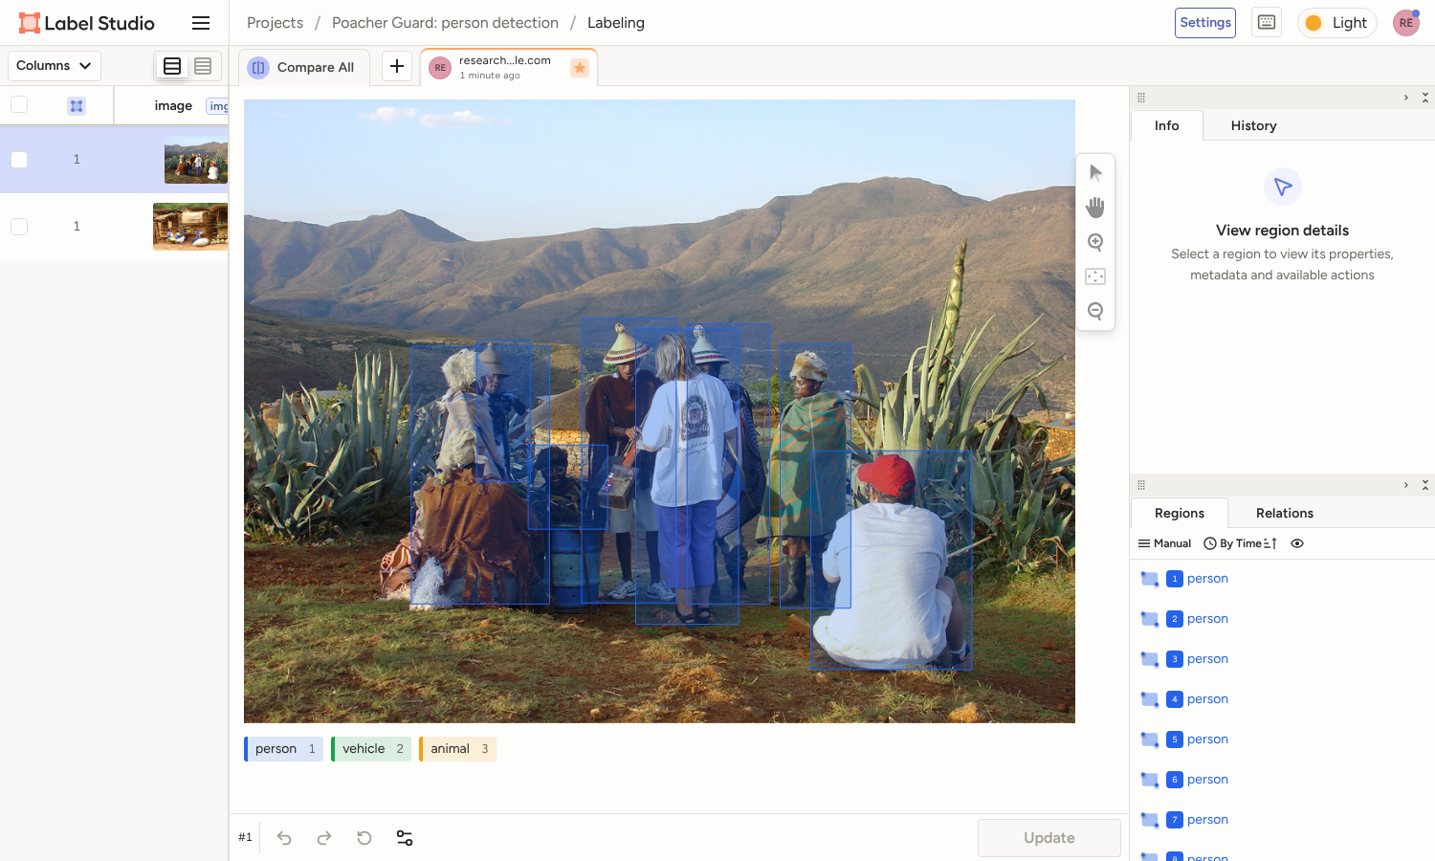
Figure 3.7: Bounding-box annotation of persons in Label Studio (Open Images photograph by Di Jones, CC BY 2.0)
Annotations were exported in the YOLO text format that the training software reads. Each image has a text file with one line per object, giving the class index followed by the centre coordinates, width and height of the box, all normalised to the range 0 to 1 by the image dimensions. Figure 3.8 shows three images from the African test set with their boxes drawn from the label files, with the content of each file printed underneath. The VOC 2007 annotations were converted to this format by a script that reads the original XML files, keeps person objects that are not flagged as difficult and writes the normalised coordinates, and the Open Images boxes were converted from their corner coordinates in the same way. The conversion was checked by drawing the boxes from the label files back onto a sample of the images, as in Figure 3.8, which confirmed that the boxes were placed correctly.
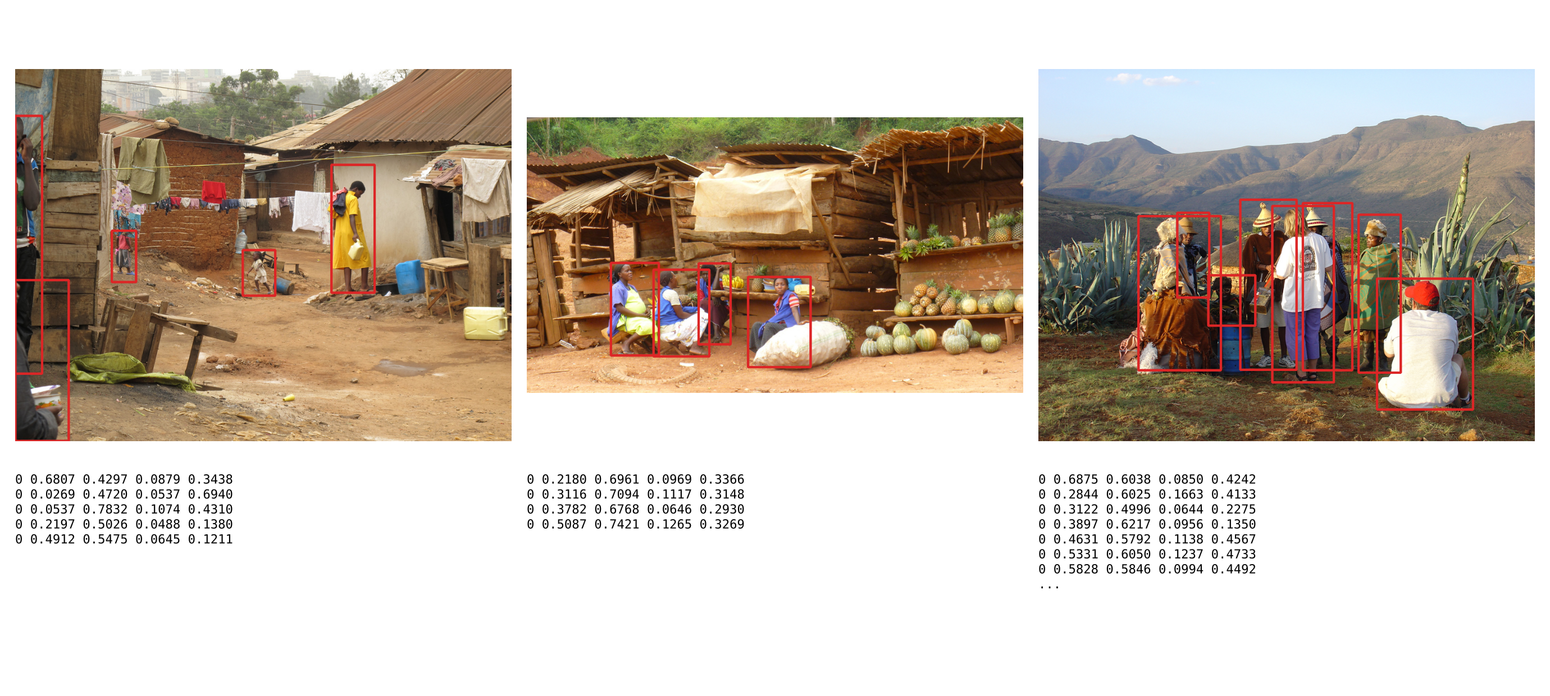
Figure 3.8: Images from the African test set with person boxes drawn from their YOLO label files (class, x-centre, y-centre, width, height); photographs from Open Images, CC BY 2.0, credited in the image credits
Field images from the study site are annotated in the same Label Studio project using the same rules. A second person reviews a random 10 per cent of the annotated field images, and disagreements are resolved before training so that label noise is kept low. The review is done in the same Label Studio project, so the reviewer sees exactly the boxes that are used for training. [DATA REQUIRED: number of field images annotated and the agreement found in the review.]
[FIGURE REQUIRED] Screenshot of your own field image in the Label Studio project, with its boxes, once field images have been collected from consenting participants.
Figure 3.9: Annotation of a field image from the study site
3.5.2 Labelling of audio clips
Audio was labelled at clip level with two classes, gunshot and not gunshot. A clip-level label was sufficient because each gunshot clip contains a single shot or a short burst and the detector in the prototype makes one decision for each analysis window of 0.975 s. The labels of the public sets were taken from their folder names and metadata files. A sample of clips from each source was inspected as a waveform and mel spectrogram before use, as shown in Figure 3.10. The AK-47 recording shows a sustained burst of automatic fire with energy across the whole frequency range for almost one second, the can opening shows three sharp clicks with a short decay, and the thunderstorm shows energy concentrated below 1 kHz and spread over several seconds. These differences are what the audio model has to learn.
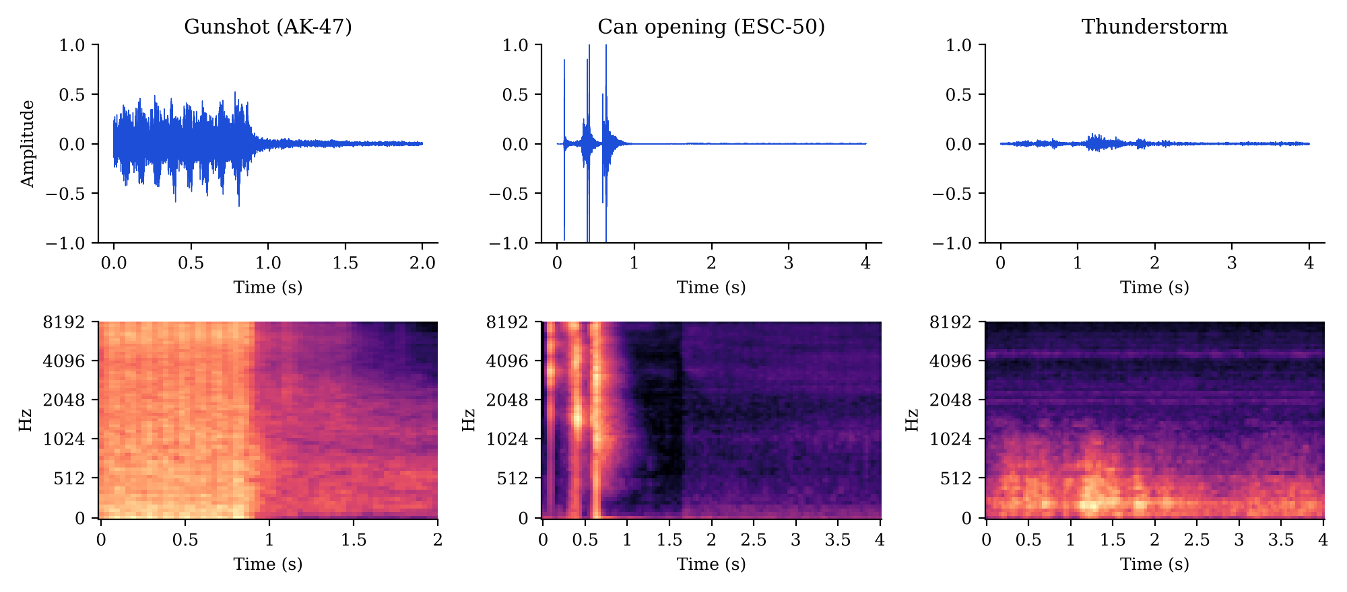
Figure 3.10: Waveforms (top) and mel spectrograms (bottom) of a labelled gunshot, a can opening and a thunderstorm clip
Field recordings are labelled in Audacity using a label track, marking the start and end of each gunshot and of each impulsive non-gunshot sound such as a branch breaking or a door closing at the ranger station. The marked regions are then cut into clips of the same form as the public data. Audacity was chosen because it is free, opens the recorder's WAV files directly and exports label tracks as text files that a script can read. [DATA REQUIRED: number of field events labelled.]
3.6 Model training
3.6.1 Fine-tuning of the person detector
YOLO11n was selected as the person detector because it is the smallest model in the YOLO11 family, with about 2.6 million parameters after layer fusion, and runs on a laptop CPU at tens of frames per second (Jocher and Qiu, 2024). YOLO detectors predict boxes and class scores in a single pass over the image, which suits real-time use (Redmon, Divvala, Girshick and Farhadi, 2016). The weights pretrained on COCO were used as the starting point and fine-tuned on the VOC training split described in Section 3.4.1. Fine-tuning rather than training from scratch was chosen because the training set was small and because the pretrained network already detects people well in general scenes.
Two ways of adapting the network were tried. In the first, the output layer was replaced by a new single-class layer for person. After the first training epoch this run reached a validation mAP@0.5 of only 0.233, far below the pretrained model, because the new output layer started from random weights and the small training set could not retrain it quickly on a CPU. This run was stopped. In the second approach, which was used for all reported results, the original 80-class output layer was kept with all its pretrained weights and the network was trained on images in which only people were labelled. The person output therefore started from its pretrained state and was adjusted to the new data, while the unused classes were ignored at inference time in the same way as in the prototype. Table 3.6 lists the training settings.
Table 3.6: Training settings for the person detector
Setting | Value | Reason
Starting weights | YOLO11n pretrained on COCO | Transfer of general person features
Input size | 512 x 512 pixels | Balance between small-object detail and CPU training time
Optimiser | AdamW, initial learning rate 0.001 (Loshchilov and Hutter, 2019) | Weight decay applied separately from the gradient step
Batch size | 16 | Fits in memory on the CPU machine
Epochs completed | 14 (time budget of 48 minutes, 48.5 minutes used) | Training was limited by CPU time
Augmentation | Mosaic, random scaling, translation, horizontal flip, HSV colour changes (library defaults) | Increases variety in a small training set
Random seed | 42, deterministic mode | Repeatability
Software | Ultralytics 8.4.189, PyTorch 2.14.1, Python 3.13.17

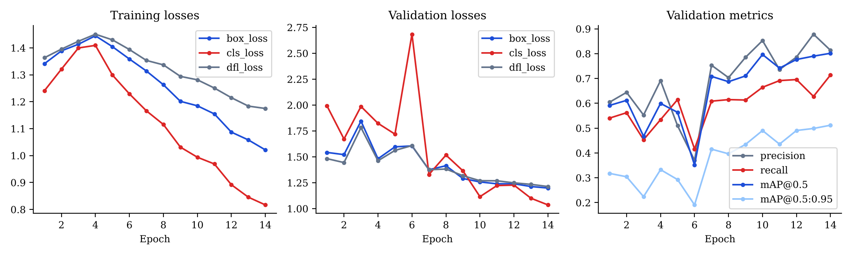
Figure 3.11: Training losses and validation metrics of the person detector across epochs
Training was stopped by the time budget after 14 epochs. Figure 3.11 shows that the training losses rose during the first four epochs, which coincides with the warm-up period in which the Ultralytics trainer raises the learning rate from a low starting value, and then fell steadily. The validation classification loss peaked at 2.68 in epoch 6, where the validation mAP@0.5 also fell to 0.351, and both recovered afterwards. The validation mAP@0.5 rose from 0.592 after the first epoch to 0.802 at epoch 14. The validation losses were still decreasing and the validation metrics were still rising when training stopped, so the model had not converged. The weights with the best validation score (epoch 14) were kept for testing.
3.6.2 Training of the gunshot detector
The prototype scores the microphone signal with YAMNet, an audio event classifier based on the MobileNet architecture and trained on the AudioSet ontology (Howard et al., 2017; Plakal and Ellis, 2020). AudioSet is a collection of more than two million labelled ten-second clips from online videos covering 527 sound classes, including the classes gunshot or gunfire, machine gun, fusillade, artillery fire and cap gun (Gemmeke et al., 2017). The TensorFlow Lite version of YAMNet used in the prototype returns a score for each of 521 classes for every window of 0.975 s, and it is small enough to run on the laptop and on the gateway computer proposed in the system design. The experiments reported here used exactly this model, so the evaluated detector is the detector that runs in the prototype.
Each clip was cut into windows of 0.975 s with a hop of 0.5 s, matching the input length of YAMNet and the update interval of the prototype. Two configurations were then evaluated. In the zero-shot configuration the pretrained network was used without any training: the gunshot score of a clip was the highest score given to any of the five gun-related AudioSet classes in any window, which is the scoring rule used by the prototype. The alert threshold of 0.35 from the prototype configuration was applied, and a second threshold (0.51) was chosen as the value that maximised F1-score on the training split. In the transfer-learning configuration the 521 class scores of every window were used as features for a logistic regression classifier trained with scikit-learn (Pedregosa et al., 2011), and a clip was flagged when the highest window probability reached the threshold, as in the prototype. Class weights were balanced to offset the small number of gunshot clips, and the regularisation constant C was chosen from 0.01, 0.1, 1, 10 and 100 by five-fold stratified cross-validation on the training clips, which selected C = 10 with a cross-validated average precision of 0.994. Because balanced class weights shift the predicted probabilities, the alert threshold of the classifier was chosen from the out-of-fold training scores as the value that maximised F1-score, which gave 0.99, and the conventional value of 0.5 was also reported. Audio loading and resampling used librosa (McFee et al., 2015) and SciPy.
3.6.3 Fire detection and ranger tag
No model was trained for fire detection in the laptop prototype. The infrared flame sensor module has an onboard comparator whose sensitivity is set with the module's potentiometer, so that the digital output switches for a lighter flame at the intended range. [DETAIL REQUIRED: the range at which the sensitivity was set.] The ESP32 reads this output and the analogue intensity value every 250 ms, declares a fire after three consecutive hot readings, and sends a fire event to the server when the state changes and as a heartbeat every 10 s, with a cooldown of 60 s between alerts of the same type at the base station. Ranger identification was likewise rule-based: the laptop scans for BLE advertisements and treats a person as a ranger when a registered tag has been heard above an RSSI of -90 dBm within the last 15 s. Both settings depend on the site and are calibrated through the tests described in Section 3.8.3.
3.7 Evaluation metrics
The person detector was evaluated with the metrics of the PASCAL VOC and COCO benchmarks (Everingham et al., 2010; Lin et al., 2014; Padilla, Netto and da Silva, 2020). A predicted box was counted as a true positive (TP) when its intersection over union (IoU) with an unmatched ground-truth box was at least 0.5, where IoU is the area of overlap of the two boxes divided by the area of their union. Predictions that did not match a ground-truth box were false positives (FP), and ground-truth boxes left unmatched were false negatives (FN). Precision, recall and F1-score were then calculated as follows.
Precision = TP / (TP + FP) | (3.1)
Recall = TP / (TP + FN) | (3.2)
F1 = 2 x Precision x Recall / (Precision + Recall) | (3.3)
Average precision (AP) is the area under the precision-recall curve obtained by sweeping the confidence threshold from high to low, computed here with 101-point interpolation. The value at an IoU threshold of 0.5 is reported as mAP@0.5, and the mean over IoU thresholds from 0.5 to 0.95 in steps of 0.05 is reported as mAP@0.5:0.95, which also rewards precise box placement. Because only the person class was evaluated, mAP is the AP of that class. The evaluation code was checked against the Ultralytics validation routine on the VOC test set, which gave a mAP@0.5 of 0.895 against 0.893 from the evaluation code and a mAP@0.5:0.95 of 0.657 against 0.662. Because the prototype raises an alert when any person is found in a frame, an image-level confusion matrix was also produced. An image counted as a true positive when it contained at least one person and the model returned at least one person with confidence of 0.5 or more, and as a false positive when the model fired on an image without people. Inference time per image was measured on the CPU, excluding the first five images to remove start-up effects.
The gunshot detector was evaluated at clip level with precision, recall and F1-score from Equations 3.1 to 3.3, together with the false positive rate (FPR), the proportion of non-gunshot clips that were wrongly flagged, as defined in Equation 3.4. Average precision and the area under the receiver operating characteristic curve (ROC AUC) were reported as threshold-free measures (Davis and Goadrich, 2006). With only 52 gunshot clips in the test set, a single missed clip changes recall by almost two percentage points, so 95 per cent Wilson confidence intervals (Wilson, 1927) were calculated for recall and false positive rate, and for the recall of people in each size group.
FPR = FP / (FP + TN) | (3.4)
False alarms were given particular weight in this study. A false alarm in the field costs a ranger a journey and, when repeated, erodes trust in the system, so a model with slightly lower recall but far fewer false alarms may be the better choice for deployment. For this reason false positives were also broken down by the category of sound that caused them, and the highest-confidence false positives of the person detector were inspected by eye.
3.8 Model evaluation results
3.8.1 Person detector
Both the pretrained and the fine-tuned person detectors were tested on the same 1,000 VOC 2007 test images, which contain 897 person boxes, using the same evaluation script and an input size of 640 pixels, the size used by the prototype. The pretrained model is the one that runs in the prototype, so the comparison also shows whether the prototype would have been improved by the fine-tuned weights. Table 3.7 gives the results and Figures 3.12 and 3.13 show the curves and the image-level confusion matrices.
Table 3.7: Person detection results on the VOC 2007 test subset (1,000 images, 897 person boxes)
Measure | Pretrained YOLO11n (COCO) | Fine-tuned YOLO11n (VOC)
mAP@0.5 | 0.893 | 0.832
mAP@0.5:0.95 | 0.662 | 0.540
Precision at confidence 0.5 (%) | 84.2 | 86.8
Recall at confidence 0.5 (%) | 82.5 | 69.5
Boxes: TP / FP / FN at confidence 0.5 | 740 / 139 / 157 | 623 / 95 / 274
Best F1-score (confidence threshold) | 0.837 (0.58) | 0.783 (0.40)
Images with people missed at 0.5 (of 387) | 21 | 40
Images without people flagged at 0.5 (of 613) | 25 | 20
Mean CPU time per image at 640 pixels (ms) | 38 | 36

The fine-tuned model performed worse than the pretrained model on every summary measure except precision. Its mAP@0.5 fell from 0.893 to 0.832 and its mAP@0.5:0.95 from 0.662 to 0.540. At the prototype threshold of 0.5 it gave slightly higher precision (86.8 against 84.2 per cent) but much lower recall (69.5 against 82.5 per cent), and at image level it missed people in 40 of the 387 images that contained them, compared with 21 for the pretrained model. Since a missed intruder is the most costly error for this system, the pretrained model is the better of the two on this evidence. A repeat of the test at an input size of 512 pixels, the size used in training, gave the same ordering (mAP@0.5 of 0.885 against 0.826), so the gap was not caused by the change of input size.
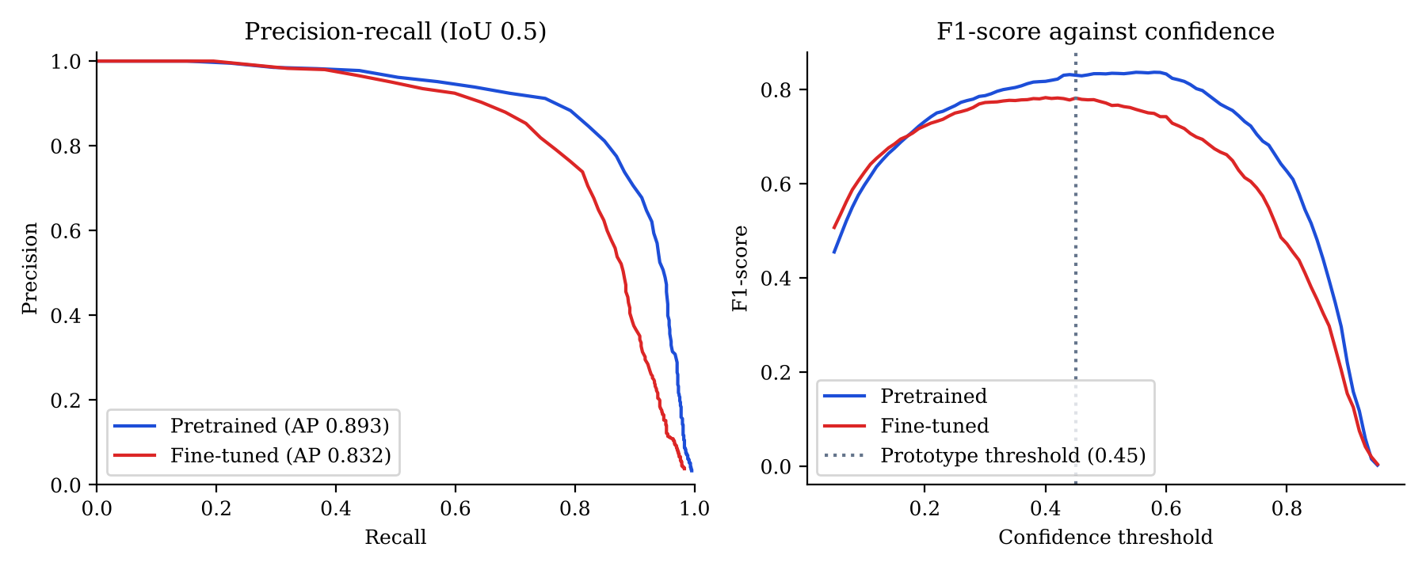
Figure 3.12: Precision-recall curves and F1-score against confidence threshold for the person detectors on the VOC test set
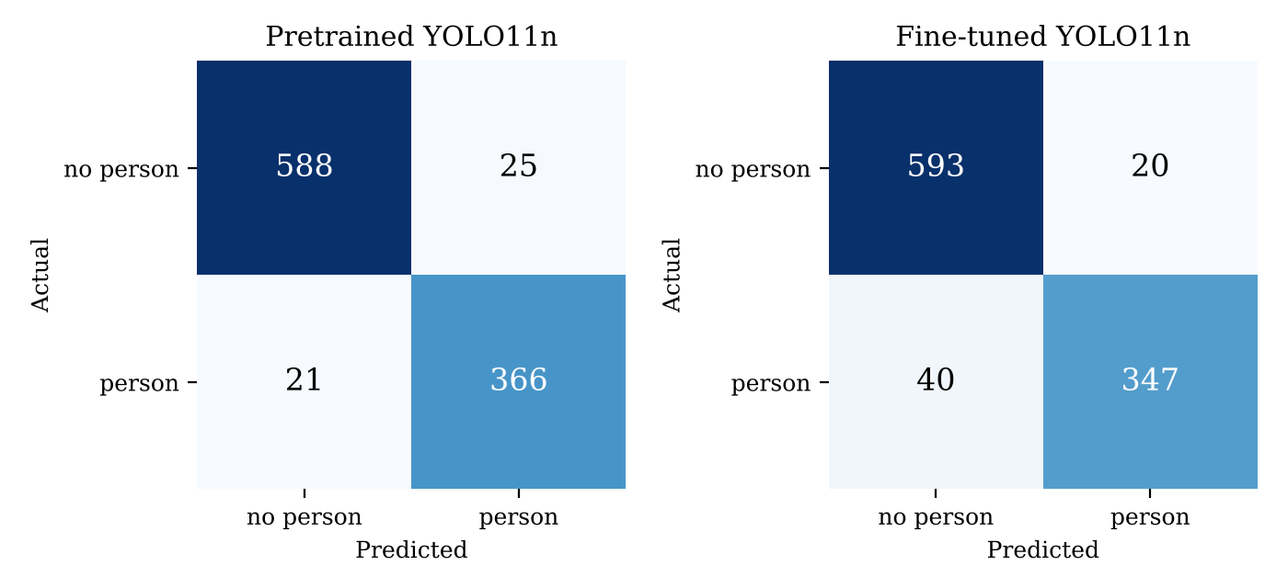
Figure 3.13: Image-level confusion matrices of the person detectors at confidence 0.5 on the VOC test set
Three explanations fit this result. The pretrained model had already learned the person class from the COCO dataset, which contains far more labelled people than the 1,600 training images used here, so the small VOC set added little new information while the updates disturbed features that were already good. Training stopped after 14 epochs on a CPU, before the validation scores had levelled off (Figure 3.11), and the instability around epoch 6 suggests that the initial learning rate of 0.001 with the AdamW optimiser was higher than ideal for fine-tuning. VOC and COCO also show similar everyday scenes, which leaves little domain gap for fine-tuning to close. The precision-recall curves in Figure 3.12 agree with this reading: the two models are nearly identical at high confidence, and the fine-tuned model loses ground mainly in the high-recall region, where hard cases such as small, crowded and partly hidden people lie.
On the basis of these results the pretrained YOLO11n was kept as the person detector in the prototype. The experiment indicates that fine-tuning is worth repeating only with data that differ from COCO in ways that matter for this system, namely the field images described in Section 3.4.1, including night-time infrared frames and people in camouflage. It also indicates that such a run should freeze the early layers of the network, use a lower learning rate and train until the validation score stops improving, which requires a graphics processing unit or a cloud training service. [RESULT REQUIRED: results of fine-tuning on the field image set, evaluated on held-out field images.]
The VOC results describe how the detector performs on everyday scenes of mostly European people, which is not the population of the study area. Both detectors were therefore also tested on the African test set, its rural and bush subset and the non-African control set described in Section 3.4.1, using the same evaluation script and settings. Table 3.8 gives the results, and Figure 3.14 breaks recall down by the size of the person in the image.
Table 3.8: Person detection on Open Images test sets (African subjects, rural and bush subset, non-African control)
Measure | African set, pretrained | African set, fine-tuned | Rural and bush, pretrained | Rural and bush, fine-tuned | Control, pretrained | Control, fine-tuned
Images / person boxes | 168 / 672 |  | 42 / 167 |  | 168 / 669
mAP@0.5 | 0.787 | 0.661 | 0.801 | 0.663 | 0.721 | 0.587
mAP@0.5:0.95 | 0.483 | 0.368 | 0.474 | 0.350 | 0.417 | 0.311
Precision at 0.5 (%) | 87.2 | 81.8 | 89.8 | 81.4 | 91.0 | 85.5
Recall at 0.5 (%) | 63.8 | 50.3 | 58.1 | 41.9 | 48.1 | 37.1
Images where no person was found at 0.5 | 1 | 6 | 1 | 2 | 19 | 41

Scores on both Open Images sets were below the VOC scores. The pretrained detector reached a mAP@0.5 of 0.721 on the control set against 0.893 on VOC, which shows that most of the drop comes from the stricter Open Images annotation, in which many more small and distant people are boxed, and not from the people shown. Against the control set, the African set scored higher and not lower: 0.787 against 0.721, with recall at the prototype threshold of 63.8 per cent against 48.1 per cent. The rural and bush subset scored 0.801. The fine-tuned model was again worse than the pretrained model on every set, which agrees with the VOC result and supports keeping the pretrained model in the prototype. These figures should be read with care for two reasons. The African set was reviewed for clarity and the control set was not, which favours the African set, and the Open Images boxes are not complete, as described below.
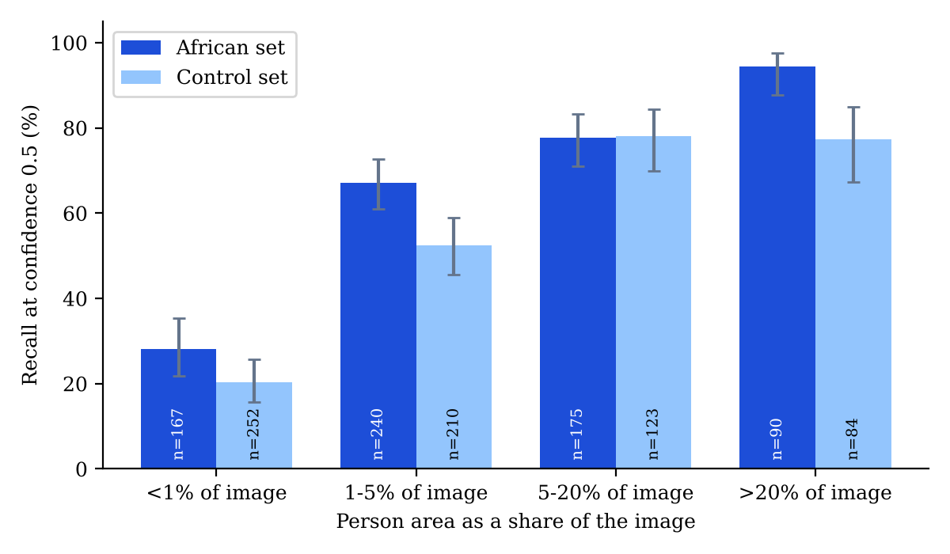
Figure 3.14: Recall of the pretrained person detector by person size, with 95 per cent Wilson confidence intervals
Figure 3.14 shows why the African set scored higher. For people covering between 5 and 20 per cent of the image, recall was the same on the African and control sets (77.7 and 78.0 per cent). For large people it was higher on the African set (94.4 against 77.4 per cent) and between 1 and 5 per cent it was 67.1 against 52.4 per cent, with confidence intervals that do not overlap. For people covering less than 1 per cent of the image, recall was 28.1 per cent on the African set against 20.2 per cent on the control set, and these intervals overlap. The control set also contains a larger share of very small people (252 of its 669 boxes against 167 of 672), which accounts for much of the difference in the overall scores. In this sample the detector therefore showed no shortfall for the African subjects at any size. The study cannot say whether this holds for field images, because the photographs vary in scene, camera and clothing together, because they were selected for clarity, and because skin tone, background and image quality cannot be separated in them. Recall for small people is low on both sets, which matters for a concealed camera in the bush. [SUPERVISOR CONFIRMATION REQUIRED: whether a larger, controlled comparison is expected].
The ground truth of Open Images does not box every visible person, and this lowers the precision and mAP of any detector. The twenty highest-confidence false positives of the pretrained model on each set were inspected. On the African set all twenty were real people, either missing from the annotation (for example the woman and the official walking along the red carpet, and the boy holding a balloon) or boxed with a different extent from the annotated box. On the control set eleven of the twenty were real people and the remainder were statues, costumes, close-up faces or ambiguous scenes. The precision and mAP values in Tables 3.7 and 3.8 are therefore lower bounds, and recall is the more reliable measure.
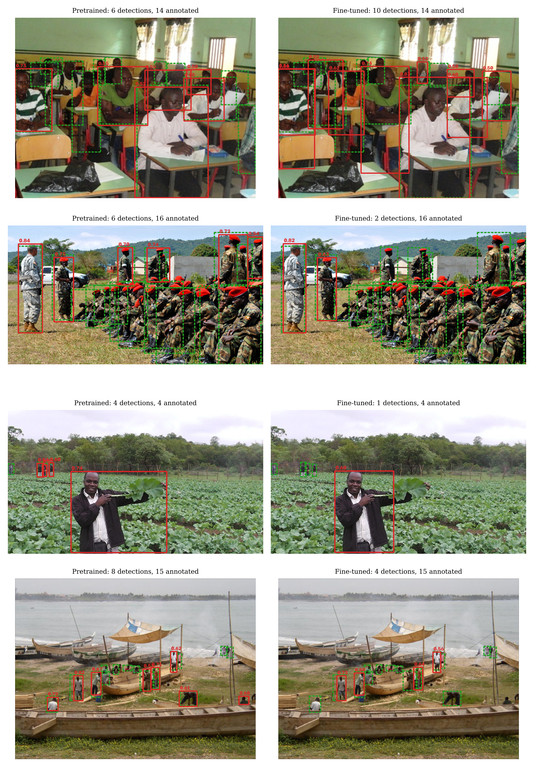
Figure 3.15: Detections at confidence 0.5 on four images from the African test set, pretrained model on the left and fine-tuned model on the right (red: detections with confidence; green dashed: ground-truth person boxes). Photographs from Open Images, CC BY 2.0, credited in the image credits
Figure 3.15 shows typical cases. In the first image, a classroom in Freetown, Sierra Leone, the people overlap heavily and the fine-tuned model returned more detections (10 against 6 for the pretrained model, with 14 people annotated). In the second image, Ugandan military police in training, both models detected the standing officers, but the pretrained model returned 6 detections and the fine-tuned model 2 among 16 annotated people, because the seated rows of soldiers in red berets overlap almost completely. In the third image a man holds a leaf in a vegetable field in Zimbabwe: both models detected the man, although he is not annotated in Open Images, and the pretrained model also detected the three small annotated figures at the fence that the fine-tuned model missed. In the fourth image, a boat-building site at Elmina harbour in Ghana, the pretrained model returned 8 detections and the fine-tuned model 4 among 15 annotated people, and the missed people were small, distant or partly behind boats. Missed people of this kind are those a concealed camera in the bush is most likely to see: small, distant, partly hidden and in shade.
This result matters for the design of the system more than the VOC result does. The recall at the prototype threshold for people covering less than 1 per cent of the image is low enough on both sets that a distant intruder could pass a camera unnoticed. Three measures follow from it and are carried into the recommendations. Field images of local people taken with the deployed camera are needed for fine-tuning and testing, cameras should be placed so that people at the expected range fill a larger part of the frame, and a lower confidence threshold combined with the multi-frame rule should be tested, since the best F1-score on the African set was reached at a confidence of 0.27, well below the prototype threshold of 0.45 used on live frames. The image-level result is more favourable: at confidence 0.5 the pretrained model found at least one person in 167 of the 168 African images, and an alert needs only one person.
3.8.2 Gunshot detector
Table 3.9 compares the gunshot configurations on the 452 test clips, and Figures 3.16 and 3.17 show the curves and confusion matrices. With the prototype threshold of 0.35 the zero-shot YAMNet model found 50 of the 52 gunshots, but it also flagged 9 of the 400 non-gunshot clips, a false positive rate of 2.2 per cent. Its precision was therefore 84.7 per cent, meaning that about 15.3 per cent of its alerts would have been false. The threshold-free measures show that the zero-shot scores already ranked gunshots above other sounds well (AP 0.975, ROC AUC 0.997), so the weakness lay mainly in the threshold. Raising the threshold to 0.51, the value chosen on the training split, cut false positives to 4 but missed 5 gunshots.
Table 3.9: Gunshot detection results on the test split (52 gunshot and 400 non-gunshot clips)
Configuration | Threshold | TP | FP | FN | TN | Precision (%) | Recall (%) [95% CI] | F1 | FPR (%) [95% CI] | AP
Zero-shot | 0.35 | 50 | 9 | 2 | 391 | 84.7 | 96.2 [87.0 to 98.9] | 0.901 | 2.2 [1.2 to 4.2] | 0.975
Zero-shot | 0.51 | 47 | 4 | 5 | 396 | 92.2 | 90.4 [79.4 to 95.8] | 0.913 | 1.0 [0.4 to 2.5] | 0.975
Logistic regression | 0.50 | 51 | 13 | 1 | 387 | 79.7 | 98.1 [89.9 to 99.7] | 0.879 | 3.2 [1.9 to 5.5] | 0.985
Logistic regression | 0.99 | 50 | 1 | 2 | 399 | 98.0 | 96.2 [87.0 to 98.9] | 0.971 | 0.2 [0.0 to 1.4] | 0.985

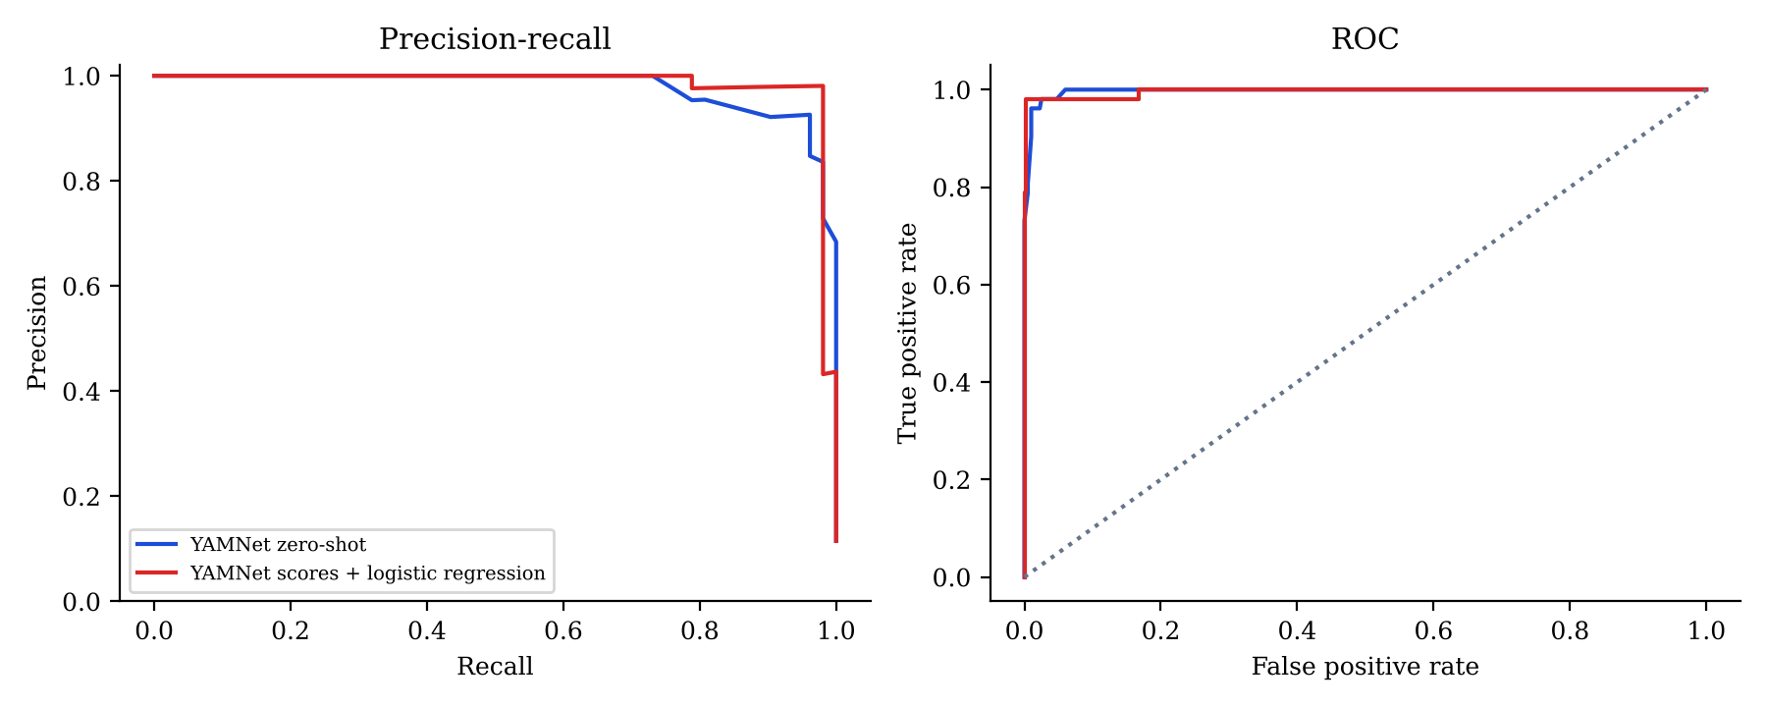
Figure 3.16: Precision-recall and ROC curves of the gunshot detector on the test split
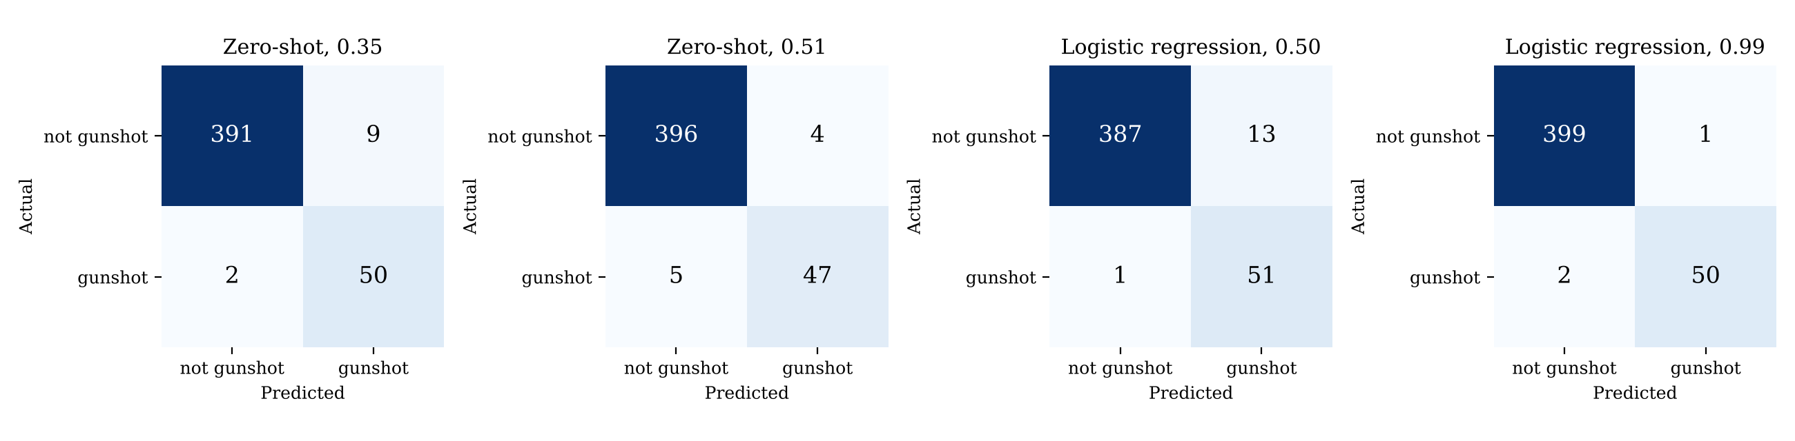
Figure 3.17: Confusion matrices of the gunshot detector on the test split
The transfer-learned classifier ranked clips best (AP 0.985), but its result depended strongly on the threshold. At the conventional threshold of 0.5 it detected 51 of the 52 test gunshots, the single miss being an AK-47 recording, yet it raised 13 false alarms, more than the zero-shot model, probably because the balanced class weights push the predicted probabilities upwards and because a clip is flagged when any one of its windows crosses the threshold. With the threshold chosen from the cross-validated training scores (0.99) it detected 50 of 52 gunshots and raised 1 false alarm in 400 non-gunshot clips, an F1-score of 0.971, a precision of 98.0 per cent and a false positive rate of 0.2 per cent. Because the test set is small, these figures should be read with their confidence intervals: the true recall could plausibly be as low as 87.0 per cent and the true false positive rate as high as 1.4 per cent. The classifier did not fit the training clips perfectly (57 of 1,811 training clips were misclassified at 0.5), so the test scores are less likely to be inflated than a perfect training fit would suggest, although field audio is still expected to be harder, as discussed in Section 3.9.
Table 3.10: Non-gunshot test clips flagged as gunshots, by sound category
Sound category | Test clips | Zero-shot (0.35) | Logistic regression (0.50) | Logistic regression (0.99)
can opening | 8 | 5 | 0 | 0
airplane | 8 | 2 | 1 | 0
glass breaking | 8 | 1 | 2 | 0
thunderstorm | 8 | 1 | 2 | 1
fireworks | 8 | 0 | 5 | 0
crackling fire | 8 | 0 | 1 | 0
crow | 8 | 0 | 1 | 0
footsteps | 8 | 0 | 1 | 0
All other 42 ESC-50 categories | 336 | 0 | 0 | 0

Table 3.10 shows where the false alarms came from. For the zero-shot model, can opening caused 5 of the 9 false alarms, followed by aircraft, glass breaking and thunderstorm clips. For the classifier at a threshold of 0.5, fireworks caused 5 of the 13, which is the confusion that was expected from an impulsive sound with a gunshot-like onset, and thunderstorm and glass breaking caused two each. At the cross-validated threshold only one thunderstorm clip was flagged. Thunder in particular is common in the rainy season, so it remains the most likely source of false alarms in the field.
A further test examined how detection degrades in a noisy outdoor setting. Each of the 52 test gunshots was mixed, at a random position within five seconds, with a randomly chosen ESC-50 test clip of a bush-type background (rain, wind, crickets, insects, birds, frogs, crackling fire, sheep, cows or roosters) at signal-to-noise ratios (SNR) of 20, 10, 0 and -10 dB, where the SNR was computed from the average power of the whole clips. The results are given in Table 3.11 and Figure 3.18.
Table 3.11: Gunshot recall when mixed with bush-type background sound
SNR (dB) | Recall, zero-shot at 0.35 (%) | Recall, logistic regression at 0.50 (%) | Recall, logistic regression at 0.99 (%)
20 | 90.4 | 98.1 | 92.3
10 | 78.8 | 88.5 | 78.8
0 | 50.0 | 76.9 | 53.8
-10 | 32.7 | 50.0 | 34.6

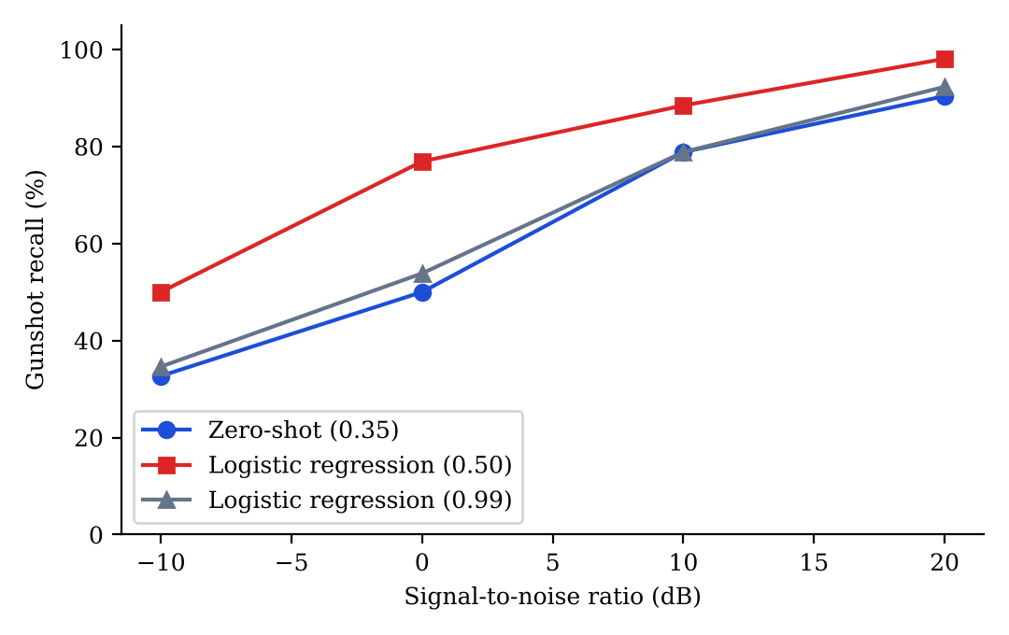
Figure 3.18: Gunshot recall against signal-to-noise ratio
Recall fell as the background became louder for every configuration. At 20 dB the zero-shot model detected 90.4 per cent of the gunshots and the classifier at 0.5 detected 98.1 per cent. At 0 dB, where the background carries as much energy as the gunshot clip, recall was 50.0 per cent for the zero-shot model and 76.9 per cent for the classifier, and at -10 dB it was 32.7 and 50.0 per cent. The strict threshold of 0.99 that gave the fewest false alarms also gave the lowest recall in noise (53.8 per cent at 0 dB), which shows the trade-off between false alarms and missed shots. None of the training gunshots contained background noise, and since a distant shot reaches the microphone weakened and mixed with wind and insects, this result shows that field recordings or noise-mixed training data are needed before the gunshot detector can be relied on at range. It also supports a multi-node confirmation rule, under which a gunshot heard by two nodes is treated as stronger evidence than a single detection.
3.8.3 Prototype hardware and alert tests
The tests in Table 3.12 measure the parts of the system that cannot be evaluated on public data. Those that depend only on software were run on the CPU machine with the real vision worker and alert engine of the prototype, using three-second video clips made from test photographs as the camera source. They therefore exclude camera exposure, lens effects and network delay. Latency was measured from the read time of the first frame that contained a person to the moment the alert was raised by the alert engine. The remaining tests need the camera, the BLE tag, the microphone at distance and the flame node, and each is to be repeated at least ten times so that a success rate and a mean latency can be reported.
Table 3.12: Prototype tests and their results
Test | Procedure | Measured result
Person alert, software only | Real vision worker and alert engine; 3 s clip of each of 60 African test photographs and 60 control photographs; no ranger tag registered | African: alert raised for 58 of 60 clips (96.7%); latency median 0.21 s, mean 0.24 s, 95th percentile 0.38 s. Control: 55 of 60 (91.7%); median 0.20 s
Detector processing rate | Looped video file of 30 African test photographs, read as fast as the CPU allows, 70 s, rate read every 5 s | Mean 52.5 frames per second (range 45.6 to 59.0, 12 readings), with the person detector run on every second frame
Person alert latency with the webcam | Participant walks into the webcam view at 3, 5 and 10 m; time from entry to dashboard alert | [RESULT REQUIRED]
Ranger tag recognition | Participant with tag walks in at 1, 3, 5 and 10 m; proportion recognised as ranger | [RESULT REQUIRED]
BLE RSSI calibration | Mean RSSI of the tag at 1, 3, 5, 10 and 15 m, in the open and in bush | [RESULT REQUIRED]
Gunshot alert, laptop mic | Recorded gunshots played at 5, 10, 20 and 50 m; detection rate | [RESULT REQUIRED]
Gunshot false alarms | One hour of site background sound; number of false gunshot alerts | [RESULT REQUIRED]
Flame sensor range | Lighter flame at 10, 20, 30, 50 and 80 cm; detection rate | [RESULT REQUIRED]
Fire alert latency | Flame applied; time to dashboard alert over Wi-Fi | [RESULT REQUIRED]

In the software-only test an alert was raised for 58 of the 60 African photographs and 55 of the 60 control photographs, which follows from the image-level recall in Section 3.8.1 and from the confirmation rule that requires a person in at least three processed frames. The median time from the first frame to the alert was 0.21 s, and the longest was 1.32 s, so the vision stage is not a significant part of the delay between a person entering the view and a ranger seeing the alert. The processing rate of 53 frames per second applies to a video file read as fast as possible, and a webcam delivers 30 frames per second at most, so the prototype keeps pace with the camera on this CPU. Figure 3.19 shows the dashboard during this test with the camera source set to an African test photograph, in which the four people at the market stalls were detected and the poacher alert was raised because no ranger tag was registered.
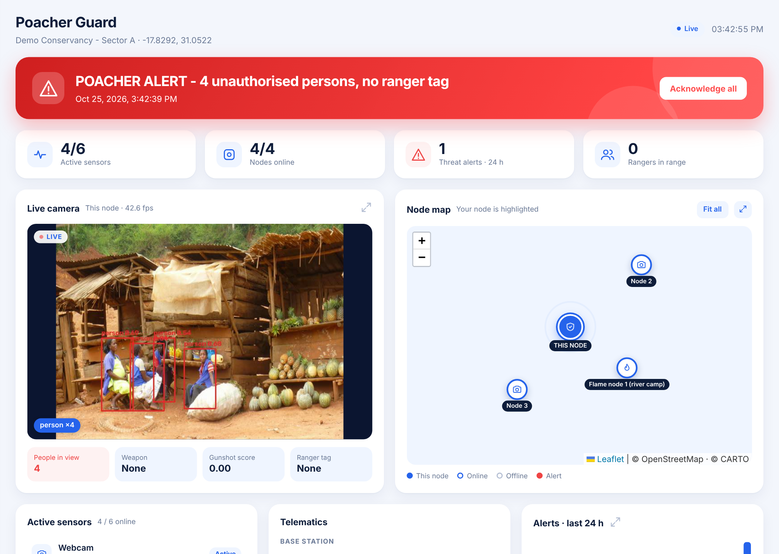
Figure 3.19: Ranger dashboard during the software test, with an African test photograph (Open Images, CC BY 2.0, credited in the image credits) as the camera source and the other nodes filled with simulated readings
3.9 Reliability and validity
Reliability was addressed by making every experiment repeatable. Dataset splits were produced by scripts with a fixed random seed, the training run used a fixed seed in deterministic mode, and the same evaluation script was applied to the pretrained and fine-tuned person detectors so that differences between them cannot be caused by differences in the scoring procedure. The evaluation code was also checked against the Ultralytics validation routine. The scripts, split lists and result files are stored with the project source code. For the audio experiments the ESC-50 predefined folds were respected, so that clips cut from one original recording did not appear in both training and test sets. A single training run was made for the person detector because of the CPU time it needed, so the variation between runs is not known.
Internal validity was protected by keeping the test sets apart from all training and tuning decisions. The alternative gunshot thresholds were chosen on the training split and only then applied to the test split, and the regularisation strength and the classifier threshold were chosen by cross-validation within the training split. Some threats remain. The gunshot clips in the public set may include several clips from the same recording session, and a random split can place near-identical clips in both training and test sets, which would make the test results optimistic. The gunshot test set is also small, which is why confidence intervals are reported. The African person test set was selected by one reviewer from photograph titles and appearance, so some images may be misclassified, its photographs come from many photographers and cameras rather than from a fixed concealed camera, and it was reviewed for clarity while the control set was not. The Open Images boxes are incomplete, which lowers precision and mAP on both sets. The set of VOC test images may also overlap with the COCO images on which the pretrained model was trained.
External validity is the main limitation of the model results. The VOC images and the public gunshot recordings were not captured in a conservation area, and the noise-mixing test showed that gunshot recall falls sharply when the background is loud. The results in Section 3.8 should therefore be read as evidence that the training and evaluation procedure works and as a baseline for comparison, not as a measure of field performance. The field data collection in Sections 3.4.1 and 3.4.2 and the tests in Table 3.12 provide the evidence on field performance.
3.10 Ethical considerations
All public datasets were used under their published terms for research purposes and are cited in this dissertation. The Open Images photographs reproduced in the figures are published under the Creative Commons Attribution 2.0 licence, which permits reproduction with credit to the photographer, and each reproduced photograph is credited at the end of this chapter. The ESC-50 clips carry a Creative Commons non-commercial licence [CITATION REQUIRED: licence terms of ESC-50 and of the Gunshot Audio Dataset]. No photographs were taken of identifiable individuals for this part of the study, and the photographs of people are used only to test whether a detector finds a person, not to identify anyone.
The African test set was assembled by looking at photographs of people and deciding whether the people shown belonged to the local population of the title place, so a person's appearance was used to decide which photographs entered the set. This was done only so that the detector could be tested on the people it is expected to see at the intended sites, and it carries a risk of reviewer error and of stereotyping. No model was trained or evaluated to classify people by skin tone or ethnicity, the classes of the detector describe objects and not people, and the decision to raise a poacher alert depends on the absence of a ranger tag and not on how a person looks. Two further issues are specific to this system. A camera network in a protected area may capture images of community members who pass through for legitimate reasons, so the deployed system stores snapshots only when an alert is raised and no face recognition is used. Field images of consenting participants are collected only after ethics clearance and written consent [SUPERVISOR CONFIRMATION REQUIRED: ethics committee and reference number], and the handling of personal data should follow the Cyber and Data Protection Act of Zimbabwe [CITATION REQUIRED].
3.11 Chapter summary
This chapter has described a quantitative, experimental approach to building and evaluating the Poacher Guard system. A laptop prototype served as the test platform for a YOLO11n person detector, a YAMNet-based gunshot detector, a BLE ranger tag check and an ESP32 flame sensor. The person detector was tested on 1,000 VOC 2007 images and on two Open Images test sets of 168 photographs each, one of African subjects and one non-African control, and the gunshot detector was tested on 452 clips. Fine-tuning on the VOC training images made the person detector worse than the pretrained model, so the pretrained model was kept. The gunshot detector reached an F1-score of 0.971 with a classifier threshold chosen from training data, and its recall fell sharply in loud background noise. The limitations of the public data and the incomplete Open Images annotation were stated, and the field tests that remain are marked for insertion. The next chapter presents and interprets the results.
References for this chapter
Aydemir, E. (n.d.). Gunshot audio dataset [Data set]. Kaggle. Retrieved from https://www.kaggle.com/datasets/emrahaydemr/gunshot-audio-dataset [DETAIL REQUIRED: confirm year and author details]
Davis, J., & Goadrich, M. (2006). The relationship between precision-recall and ROC curves. In Proceedings of the 23rd International Conference on Machine Learning (pp. 233-240). New York, NY: ACM.
Everingham, M., Van Gool, L., Williams, C. K. I., Winn, J., & Zisserman, A. (2010). The PASCAL visual object classes (VOC) challenge. International Journal of Computer Vision, 88(2), 303-338.
Gemmeke, J. F., Ellis, D. P. W., Freedman, D., Jansen, A., Lawrence, W., Moore, R. C., Plakal, M., & Ritter, M. (2017). Audio Set: An ontology and human-labeled dataset for audio events. In 2017 IEEE International Conference on Acoustics, Speech and Signal Processing (pp. 776-780). IEEE.
Harihara-Valliappan. (n.d.). Gun-classification-using-gunshot [Computer software and data]. GitHub. Retrieved from https://github.com/Harihara-Valliappan/Gun-classification-using-gunshot
Hevner, A. R., March, S. T., Park, J., & Ram, S. (2004). Design science in information systems research. MIS Quarterly, 28(1), 75-105.
Howard, A. G., Zhu, M., Chen, B., Kalenichenko, D., Wang, W., Weyand, T., Andreetto, M., & Adam, H. (2017). MobileNets: Efficient convolutional neural networks for mobile vision applications. arXiv preprint arXiv:1704.04861.
Jocher, G., & Qiu, J. (2024). Ultralytics YOLO11 (Version 11.0.0) [Computer software]. Retrieved from https://github.com/ultralytics/ultralytics
Kuznetsova, A., Rom, H., Alldrin, N., Uijlings, J., Krasin, I., Pont-Tuset, J., ... Ferrari, V. (2020). The Open Images Dataset V4: Unified image classification, object detection, and visual relationship detection at scale. International Journal of Computer Vision, 128, 1956-1981.
Lin, T.-Y., Maire, M., Belongie, S., Hays, J., Perona, P., Ramanan, D., Dollar, P., & Zitnick, C. L. (2014). Microsoft COCO: Common objects in context. In European Conference on Computer Vision (pp. 740-755). Cham: Springer.
Loshchilov, I., & Hutter, F. (2019). Decoupled weight decay regularization. In International Conference on Learning Representations.
McFee, B., Raffel, C., Liang, D., Ellis, D. P. W., McVicar, M., Battenberg, E., & Nieto, O. (2015). librosa: Audio and music signal analysis in Python. In Proceedings of the 14th Python in Science Conference (pp. 18-25).
Padilla, R., Netto, S. L., & da Silva, E. A. B. (2020). A survey on performance metrics for object-detection algorithms. In 2020 International Conference on Systems, Signals and Image Processing (pp. 237-242). Niteroi: IEEE.
Pedregosa, F., Varoquaux, G., Gramfort, A., Michel, V., Thirion, B., Grisel, O., ... Duchesnay, E. (2011). Scikit-learn: Machine learning in Python. Journal of Machine Learning Research, 12, 2825-2830.
Piczak, K. J. (2015). ESC: Dataset for environmental sound classification. In Proceedings of the 23rd ACM International Conference on Multimedia (pp. 1015-1018). Brisbane: ACM.
Plakal, M., & Ellis, D. (2020). YAMNet [Computer software]. TensorFlow Model Garden. Retrieved from https://github.com/tensorflow/models/tree/master/research/audioset/yamnet
Redmon, J., Divvala, S., Girshick, R., & Farhadi, A. (2016). You only look once: Unified, real-time object detection. In Proceedings of the IEEE Conference on Computer Vision and Pattern Recognition (pp. 779-788).
Saunders, M., Lewis, P., & Thornhill, A. (2019). Research methods for business students (8th ed.). Harlow: Pearson.
Tkachenko, M., Malyuk, M., Holmanyuk, A., & Liubimov, N. (2020). Label Studio: Data labeling software [Computer software]. Retrieved from https://github.com/HumanSignal/label-studio
Wilson, E. B. (1927). Probable inference, the law of succession, and statistical inference. Journal of the American Statistical Association, 22(158), 209-212.
Image credits
CDKNetwork. RSAF-0010_Zimbabwe_Pascal Manyakaidze of Shurugwi Partners during veg production monitoring jan 2013_Pascal Manyakaidze [Photograph]. Flickr, via Open Images (image a34bd8df20a43c97). Licence: CC BY 2.0. https://www.flickr.com/photos/52797059@N06/8558364703
CIVICUS: World Alliance for Citizen Participation. League of Christian Youths - Freetown, Sierra Leone [Photograph]. Flickr, via Open Images (image 01f26ca52e27a8d9). Licence: CC BY 2.0. https://www.flickr.com/photos/civicus/14270965637
Di Jones. Malealea Band, Lesotho [Photograph]. Flickr, via Open Images (image 811c1136b815cc28). Licence: CC BY 2.0. https://www.flickr.com/photos/lesotho/7357596636
Paul Arps. Boat production in Elmina harbour (Ghana 2005) [Photograph]. Flickr, via Open Images (image 1525b8b93964df9e). Licence: CC BY 2.0. https://www.flickr.com/photos/slapers/6688922963
Shack Dwellers International. Age of Zinc | Kampala, Uganda [Photograph]. Flickr, via Open Images (image 646b5e7801b64a50). Licence: CC BY 2.0. https://www.flickr.com/photos/sdinet/12832077775
US Army Africa. Uganda railways assessment 2010 [Photograph]. Flickr, via Open Images (image 4142ef0217d47a2d). Licence: CC BY 2.0. https://www.flickr.com/photos/usarmyafrica/5117351511
US Army Africa. Ugandan military police train for future AMISOM mission [Photograph]. Flickr, via Open Images (image 7c0c635959d1b8c9). Licence: CC BY 2.0. https://www.flickr.com/photos/usarmyafrica/10454164035

