Gesture based Presentation Pointer using MEMS Sensors

Praveen Venkatesh, Varun Jain
Discipline of Electrical Engineering, IIT Gandhinagar, Gujarat-382355, India

Abstract— This paper demonstrates light-activated tuning of the longitudinal surface plasmon resonance (LSPR) of gold nanorods submerged in hydroquinone solution. The LSPR exhibits a light-controlled red-shift of more than 100 nm, but only under continuous illumination. It is also possible to return to the starting LSPR value by washing the nanorods with cetyltrimethyl ammonium bromide solution.
Keywords— light-induced; tuning; longitudinal surface plasmon resonance; gold nanorods; optical microscope;

Introduction
.
In this paper, we demonstrate a new method that offers in-situ tuning of the LSPR wavelength of individual AuNRs. A large red shift is obtained by the light-induced interaction of AuNRs with the hydroquinone molecules. The LSPR can be tuned to a specific value by simply controlling the duration of the illumination. Once the desired LSPR value has been reached, the hydroquinone solution can safely be removed without any further change of the LSPR. An important feature of this work is that the red shift obtained by the light-induced interaction can be reversed, if required, by incubating the AuNRs in cetyltrimethylammonium bromide (CTAB). The combination of light-induced hydroquinone-mediated red shift and the subsequent CTAB-induced blue shift leads to highly controlled fine-tuning of the LSPR wavelength of AuNRs.

Sample preparation and experimental set-up

Synthesis of AuNRs and sample preparation for single-particle study
The AuNRs Gold nanorods with average dimensions of 68 nm x 26 nm, were synthesized by following a seed-mediated-growth method that we had reported earlier [10]. The LSPR wavelength of these nanorods was 678 nm in water. Gold nanorods were spin-coated on an ozone-cleaned glass substrate for single particle photoluminescence studies. The glass substrate was subsequently repeatedly washed with water and treated with oxygen plasma to remove the CTAB present on the AuNRs. This glass substrate (sample) was then incorporated into a home-made flow cell through which the reactants (hydroquinone, water and CTAB) were flowed.

Optical microscope set-up and optical characterisation of individual gold nanorods
The photoluminescence signal from individual AuNRs was studied using a home-built confocal microscope (Fig. 1a). A 532 nm diode pumped solid-state laser was used as an excitation source. The excitation light was focused on individual AuNRs by an oil-immersion objective (numerical aperture of 1.3). The photoluminescence signal was collected by the same objective and was guided to either an avalanche photodiode (APD) or a charge coupled device (CCD) spectrometer. A notch filter was used to remove the excitation laser wavelength. Photoluminescence images were obtained by scanning the sample across the laser beam using an XYZ nano-positioning piezoelectric scanner. Single-particle photoluminescence spectra were acquired with a CCD-spectrometer (Fig. 1d).
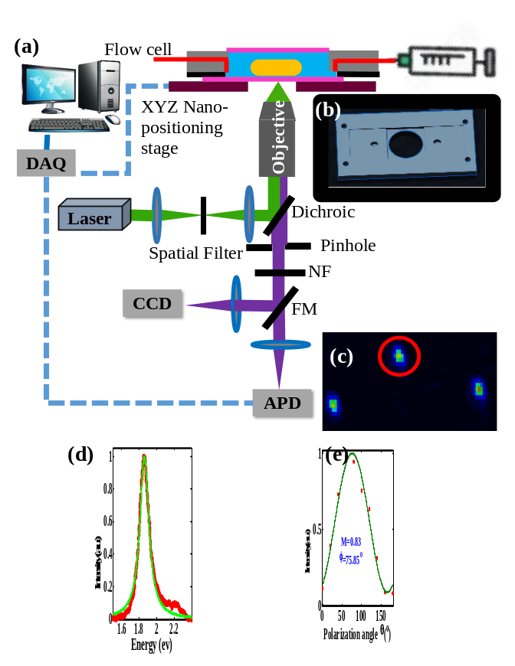
Fig. 1 (a) A simplified schematic of the experimental setup. NF: notch filter, FM: flip mirror. (b) Top view of the home-made flow cell. (c) One-photon excited luminescence image of AuNRs isolated on a glass cover slip and covered in water. The excitation wavelength was 532 nm, and the power was 100 kW/cm2. (d) Luminescence spectra (red line) of single nanorod (encircled red in figure 1(c)) and a Lorentiaz fit to the longitudinal plasmon (blue). (e) Photoluminescence intensities (red circles) as a function of polarization angle and a fit (green line) to .

Experimental Results
A typical luminescence image of a AuNR on a glass surface and covered with water is shown in Fig. 1c. The Lorentzian line shape of the LSPR (green curve in Fig 1d) confirms the luminescence spectrum (red curve in Fig. 1d) is from a single AuNR [11]. To further confirm the presence of a single AuNR in the diffraction-limited spot, polarization studies were performed by inserting a linear polarizer before the APD (Fig. 1e). The luminescence spectrum is fitted to the expression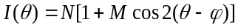, where I(θ) is the intensity as function of polarizer angle (θ), φ denotes the orientation of the nanorod’s principal axis, M is termed as the modulation depth representing the average anisotropy of the absorption dipole projected onto the sample plane. The fit yields a modulation depth of 0.83, indicating the presence of single dipole, and therefore a single AuNR [12].
The light-induced effect was studied by injecting a 10 mM hydroquinone solution in to the home-made flow cell. The AuNR-hydroquinone interaction was monitored in real-time by recording the one-photon luminescence spectra of AuNRs over time with continuous illumination by the 532 nm laser. As shown in Fig. 2a a gradual but large red shift of the LSPR wavelength is observed over 34 minutes. During this period, the LSPR exhibited a total red shift of 116 nm (from 638 nm to 754 nm) as shown in Fig. 2b. The red shift can be arrested at any time simply by switching the laser off. After 34 minutes, the hydroquinone solution was removed with a syringe from the flow cell, and the sample was cleaned with milli-Q water. The sample was kept in milli-Q water for 6 hours with no illumination. No further shift of the AuNR’s LSPR wavelength was observed. This demonstrates the remarkable stability of the LSPR once the light-induced AuNR-hydroquinone interaction has produced the red-shift. It also proves that there is no reaction with water under the dark condition. The shift of the LSPR can thus be fine-tuned by controlling the duration of illumination.
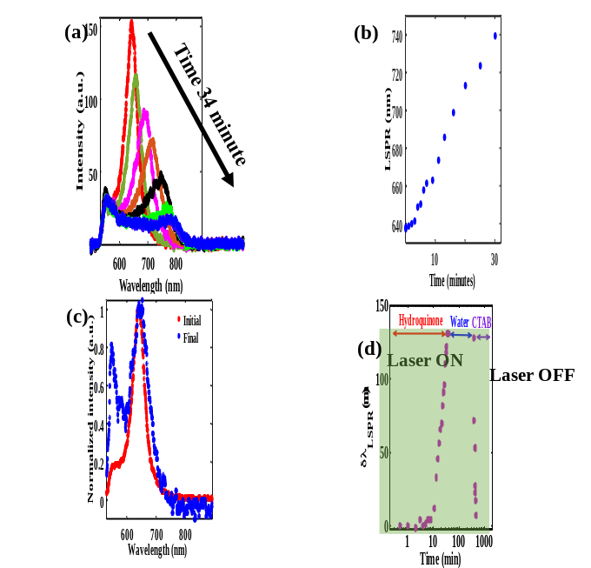
Fig. 2(a) Luminescence spectra of a AuNR under continuous excitation with 532 nm laser for 34 minutes in 10 mM of hydroquinone, followed with 6 hours in water and one hour in 100 mM CTAB. The nanorod was isolated on a glass substrate. (b) Variation of LSPR wavelength as a function of time during illumination. (c) Luminescence spectra of a gold nanorod before (red) and after continuous illumination with 532 nm laser followed by washing with CTAB solution (blue). (d) Variation of the LSPR shift as a function of time. The excitation laser power was 100 kW/cm².
We also observed that the shift of the LSPR wavelength is reversible. It is possible to return to the AuNR’s initial LSPR wavelength by switching off the 532 nm laser and washing the CTAB solution for approximately 1 hour. The LSPR wavelength exhibits a blue shift from 754 nm to 644 nm in one hour, after which no further change was observed. The initial spectrum of the AuNR (red curve 1 in Fig 2c) matches well with the spectrum obtained after flowing CTAB (blue curve in Fig 2c). This confirms the restoration of the LSPR wavelength of a nanorod. The large red shift of nanorod’s LSPR wavelength is a light-induced phenomenon. This is evident from the fact that the LSPR shift is arrested as soon as the laser illumination is turned off. Additionally, the LSPR wavelength of a AuNR remains unchanged even when it is kept in the hydroquinone for over two hours with the light turned off. This red shift is light-induced phenomena, where hydroquinone molecule gets adsorbed on the AuNR. To rule out the possiblity of laser intensity induced shape deformation or dissolution of gold atoms from the AuNRs, we illuminated a AuNR in water for 30 minutes with constant illumination of the same power. The luminescence spectra before and after 30 minutes of illumination shows no significant red shift. This observation also precludes the possibility of melting of the glass substrate in the vicinity of a nanorod as a possible reason for the red shift of AuNR LSPR wavelength.

Conclusion
In conclusion, we demonstrated very large and highly controllable light-induced in situ tuning of the LSPR wavelength of AuNRs to longer wavelengths. The amount of shift can be precisely controlled by varying the light exposure time. Additionally, the LSPR wavelength can be tuned back to its initial position by washing with CTAB solution. These results are key to achieving tight control over the tuning of the LSPR to a desired wavelength for a given application. This method could be used to develop a multi-channel sensing platform in which each channel could have AuNRs with specific LSPRs functionalized by a specific antibody.

Acknowledgment
We acknowledge financial support from DST Nano Mission (SR/NM/NS-65/2016), extramural research support from SERB (EMR/2015/001013) and IIT Gandhinagar for the seed grant and excellence in research fellowship.

References
[1] H. Chen, L. Shao, Q. Li, and J. Wang, “Gold nanorods and their plasmonic properties,” Chem. Soc. Rev., vol. 42, no. 7, pp. 2679–2724, 2013.
[2] L. Vigderman, B. P. Khanal, and E. R. Zubarev, “Functional Gold Nanorods: Synthesis, Self-Assembly, and Sensing Applications,” Advanced Materials, vol. 24, no. 36, pp. 4811–4841, Sep. 2012.
[3] S. S. Aćimović et al., “LSPR Chip for Parallel, Rapid, and Sensitive Detection of Cancer Markers in Serum,” Nano Letters, vol. 14, no. 5, pp. 2636–2641, May 2014.
[4] K. Xu et al., “Plasmonic Optical Imaging of Gold Nanorods Localization in Small Animals,” Scientific Reports, vol. 8, no. 1, Dec. 2018.
[5] K.-Q. Lin et al., “Size Effect on SERS of Gold Nanorods Demonstrated via Single Nanoparticle Spectroscopy,” The Journal of Physical Chemistry C, vol. 120, no. 37, pp. 20806–20813, Sep. 2016.
[6] P. Zijlstra, P. M. R. Paulo, and M. Orrit, “Optical detection of single non-absorbing molecules using the surface plasmon resonance of a gold nanorod,” Nature Nanotechnology, vol. 7, no. 6, pp. 379–382, Jun. 2012.
[7] X. Ye et al., “Improved Size-Tunable Synthesis of Monodisperse Gold Nanorods through the Use of Aromatic Additives,” ACS Nano, vol. 6, no. 3, pp. 2804–2817, Mar. 2012.
[8] B. N. Khlebtsov, V. A. Khanadeev, J. Ye, G. B. Sukhorukov, and N. G. Khlebtsov, “Overgrowth of Gold Nanorods by Using a Binary Surfactant Mixture,” Langmuir, vol. 30, no. 6, pp. 1696–1703, Feb. 2014.
[9] A. Carattino, S. Khatua, and M. Orrit, “In situ tuning of gold nanorod plasmon through oxidative cyanide etching,” Physical Chemistry Chemical Physics, vol. 18, no. 23, pp. 15619–15624, 2016.
[10] P. Ghosh, V. Thambi, S. Khatua, and A. L. Chakraborty, “Synthesis of Gold Nanorods with Tunable Surface Plasmon Resonance for Near-Infrared Biosensing Applications,” in 2017 IEEE Workshop on Recent Advances in Photonics (WRAP), Hyderabad, 2017, pp. 1–3.
[11] A. Tcherniak et al., “One-Photon Plasmon Luminescence and Its Application to Correlation Spectroscopy as a Probe for Rotational and Translational Dynamics of Gold Nanorods,” The Journal of Physical Chemistry C, vol. 115, no. 32, pp. 15938–15949, Aug. 2011.
[12] W.-S. Chang, J. W. Ha, L. S. Slaughter, and S. Link, “Plasmonic nanorod absorbers as orientation sensors,” Proceedings of the National Academy of Sciences, vol. 107, no. 7, pp. 2781–2786, Feb. 2010.

