Vector Operations

**Learning Objective**

To introduce vector operations, including buffer, dissolve, and overlay operations.

Vector operations refers to a variety of tools that operate on vector data. While far from exhaustive, this lab tutorial walks through a set of extremely commonly used operations. Each section of the tutorial is essentially a standalone mini-tutorial that introduces how a specific operation works, using data from Philadelphia, Pennsylvania. You will notice that each of these operations has a variety of settings and capabilities beyond what you are instructed to do. You are encouraged to explore the various functionalities of these tools. In the assignment, you will be asked to work with several of these tools in sequence, performing a classic **site suitability analysis**, through which these tools identify optimal locations based on a set of spatial criteria.

First, complete the tutorial by following the steps below. Then, using the skills you’ve learned in the tutorial, complete the assignment given following the tutorial.

## TUTORIAL

## Acquiring the Data

We will work with data for Philadelphia (and one data set for Pennsylvania) made publicly available by PASDA, the Pennsylvania Geospatial Clearinghouse ([PASDA](http://www.pasda.psu.edu)). From PASDA, use the search function to find and download the following files layers:

SEPTA High Speed Stations (2012)

These are the **subway stations**.

SEPTA Regional Rail Stations (2016)

These are the **regional rail stations**.

SEPTA Routes Spring (2016)

These are the **bus routes**.

Philadelphia Health – Healthy Corner Stores (2016)

These are **corner stores** participating in the Food Trust’s Healthy Corner Store Initiative – <http://thefoodtrust.org/what-we-do/corner-store>.

Philadelphia Health – Farmers Markets (2016)

These are **farmers markets**.

Philadelphia Empowerment Zones (2012)

These are **empowerment zones** – areas targeted by the City of Philadelphia for investment – <http://www.phila.gov/commerce/neighborhoods/Pages/EmpowermentZones.aspx>.

2015 Cartographic Boundary File, State-County-Census Tract for Pennsylvania, 1:500,000 (2015)

These are Pennsylvania **census tracts** – US Census Bureau enumeration units.

Some of these files will be used for the tutorial portion of the lab. Others will be used for the assignment.

Move all files to your workspace folder and unzip any zip files.

## Explore and Integrate the Data into a Common CRS

Open ArcCatalog and explore each of the downloaded data sets, including the maps and tables.

Pay particular attention to the CRS of each data set. Note that most are in Pennsylvania State Plan South, which is the CRS used by the City of Philadelphia for its GIS data. The exceptions are the regional rail stations, the bus routes, and the census tracts. Using the Project tool in ArcCatalog, convert these data sets to Pennsylvania State Plane. Use these converted data sets in the remainder of the tutorial and assignment.

## Adjust the Environment Settings

Now, we will set up the Environment in ArcMap. This will specify a workspace folder for all of the data files generated when running different operations and make it easier to save output files.

1. Open ArcMap, select the Geoprocessing file menu, and choose Environments.
2. Under Workspace, set the Current and Scratch Workspaces to your workspace folder (See example below; your path will differ.) You do not need to modify any of the other fields. Click OK. Each time you run an operation, the output will be saved to your workspace. Be sure to set up your Environment in ArcMap and/or ArcCatalog each time you begin working.

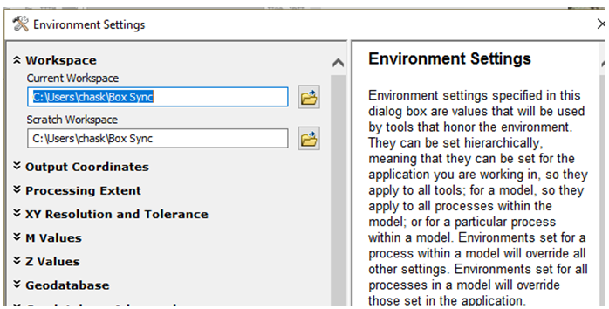

## Retrieve Line Length and Polygon Area Measurements

Here, you will learn how to use ArcMap to calculate line length and polygon area and encode these values in an attribute table.

We will start by adding a new field and populating the field with new length values in feet.

1. Add the bus routes layer to ArcMap (be sure to add the new data set you created that is in Pennsylvania State Plane CRS).
2. Open the attribute table. Explore the data by selecting some different routes so you understand that each record in the table represents one bus route.
3. Add a new field to the table. Name the new field Lengthft. Make it a double data type, and press OK.
4. Right click on the header for the new field (where it says Lengthft) and go to Calculate Geometry.
5. Click Yes to confirm you want to edit this field. In the Calculate Geometry dialog box make sure Property is set to Length and the Units is set to Feet US [ft]. Click OK. You should see the new length values appear in the field. This is the length of each bus route in feet.

It is also possible to calculate the area of polygons.

1. Turn off the bus routes layer, and add the empowerment zones shapefile to ArcMap.
2. Open the empowerment zones attribute table.
3. Add a new field called Areaft. Calculate the area of each empowerment zone for this new field by following the analogous procedures as above, but instead of length choose to calculate the area in square feet.
4. Remove all data layers from ArcMap.

## Buffer

Here, you will learn how to use ArcMap to perform a buffer operation. We will buffer points here but it is also possible to buffer lines and polygons in the same way.

1. Add the farmers markets shapefile to ArcMap.
2. Go to the Geoprocessing menu and select Buffer. (The Buffer tool can also be accessed from ArcToolbox by going to Analysis Tools→Proximity→Buffer.)
3. In the Buffer dialog box, for the Input Features choose the farmers markets. Name the output shapefile farmark_1320ft and make sure it saves to your workspace. For the Distance box, under Linear Unit, enter 1320 feet. Leave the rest of the options as the defaults. Press OK.
4. View the new shapefile in ArcMap. Zoom in to where there are clusters of farmers markets to see how the buffer polygons overlap. Open the attribute table and see that each buffer disk is represented as a single record in the attribute table.  
   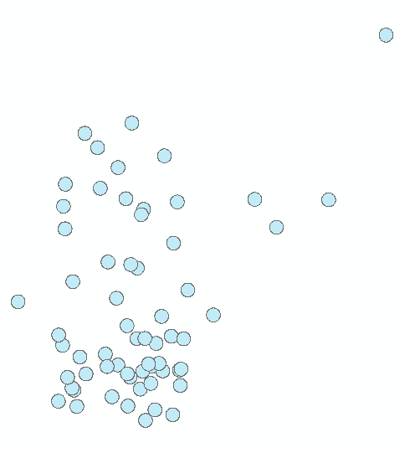
5. Repeat the buffer analysis, but this time, for Dissolve Type (options) choose All. Call the output farmark_1320ft_dissolve.
6. View the new shapefile in ArcMap. Zoom in to a cluster of farmers markets to see how the buffers merge together (i.e. are dissolved as single polygons in these locations). Open the attribute table and see that *all* polygons are represented by a single record in the attribute table. This is called a ‘multipart object’ (in this specific case a ‘multipolygon’) because a single feature (i.e. the one record in the attribute table) has multiple parts (i.e. multiple individual polygons).  
   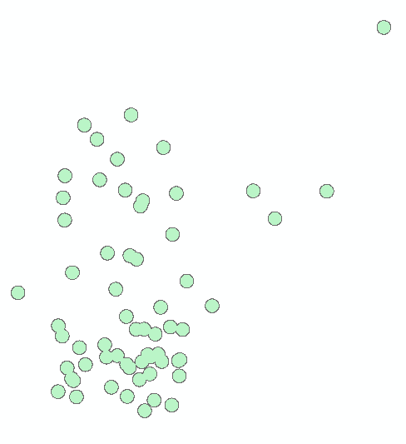

It is often useful to have an individual record in the attribute table for each polygon. Here, we will convert this multipart layer to a singlepart layer using a Multipart to Singlepart operation.

1. In ArcMap, go to ArcToolbox→Data Management Tools→Features→Multipart to Singlepart. In the Multipart to Singlpart dialog box, for Input Features select farmark_1320ft_dissolve. Name the output farmark_1320ft_dissolve_single. Press OK.
2. View the resulting shapefile. Notice it appears graphically the same as the original farmark_1320ft_dissolve shapefile. Open the attribute. Notice that it now has 43 records—one for each separate polygon.
3. Explore this new shapefile by selecting certain records in the attribute table to see which polygon is associated with a single record.  
   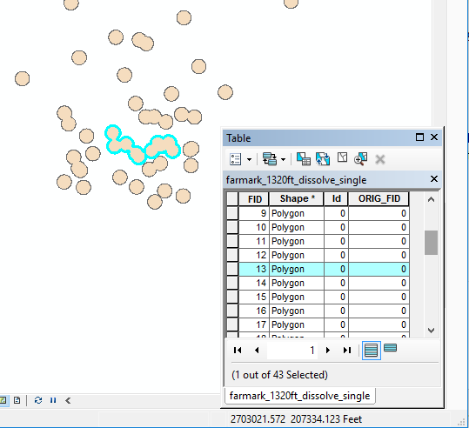
4. Remove all data layers from ArcMap.

## Map Dissolve

Here, you will learn how to use ArcMap to generalize a data layer by dissolving the boundaries of adjacent polygons.

1. Add the census tracts shapefile (be sure to add the one in Pennsylvania State Plane CRS).
2. First we will dissolve all the tract boundaries to yield the boundary of the state. Go to the Geoprocessing file menu and select Dissolve. (The Dissolve tool can also be accessed from ArcToolbox (ArcToolbox→Data Management Tools→Generalization→Dissolve).
3. For Input Features select the census tracts shapefile. Name the output file PA_bnd. Press OK.
4. View the resulting shapefile. Note that the new shapefile is simply a boundary of Pennsylvania – the operation has dissolved all the boundaries between the tracts, resulting in an outline of the entire set of features (i.e. the entire state of Pennsylvania). You’ll notice that the resulting feature has one record in the attribute table.  
   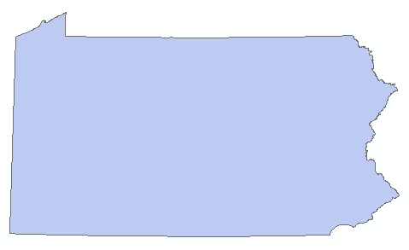

Now we will compare what you have just done to what happens when you dissolve by an attribute.

1. Open the attribute table of the original census tracts shapefile and find the field COUNTYFP10. This field is a 3-digit identifier for each individual county (e.g. 091 for Montgomery County) in the state. You’ll notice that the GEOID code full name for all the tracts in Philadelphia begins 42101 (42 for Pennsylvania; 101 for Philadelphia County). Of course, many individual tracts share the same value for this field. It is thus possible to perform a map dissolve operation on the PA tracts shapefile, using the COUNTYFP10 field as the dissolve field.
2. Perform another dissolve operation on the original census tracts shapefile, but this time under Dissolve_Field(s) (optional) check the COUNTYFP box. This will dissolve the boundaries among adjacent tracts that share the same county identification. Name the output shapefile counties. Press OK.
3. View the resulting shapefile in ArcMap. You’ll see that the tracts have been dissolved by the county identifier, resulting in a shapefile of county outlines.  
   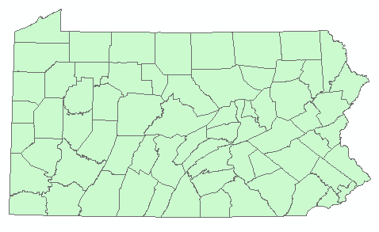
4. Remove all data layers from ArcMap.

## Point in Polygon Overlay

Here, you will learn how to use ArcMap to create a **spatial join** based on a point in polygon overlay. Point in polygon is a type of spatial relationship used to find points that are geographically contained by a polygon. Other types of spatial relationships are possible. A spatial join is used when you want to attach data in one vector layer to another layer based on a spatial relationship. Very commonly the attributes from a polygon data layer are attached to the points in a point layer. It is possible to do spatial joins with other vector data types, for example to attach county names (from a polygon layer) to road segments (in a line layer), or attach a voting precinct (from a polygon layer) to residential buildings (in a polygon layer).

Here, as an example, we will join data from the polygon counties layer onto the regional rail station points.

1. Add the regional rail stations and the counties shapefiles (which you just created) to ArcMap. Review each of their attribute tables and note the fields that are included in each.
2. Right click the regional rail stations shapefile and choose Joins and Relates→Join.
3. In the new window, in the top drop down menu ‘What do you want to join to this layer’ choose Join data from another based on spatial location.

Note: As is so often the case, there’s an additional way to implement spatial join functions in ArcGIS generally, the “Spatial Join” tool. In Toolbox, click on Analysis Tools→Overlay→Spatial Join. You will see that compared to the route we are taking (Joins and Relates→Join), the more comprehensive Spatial Join tool offers quite a few additional options. It is worth exploring more fully if you are interested in getting a deeper understanding of point- and line-in-polygon operations.

1. Under Choose the layer to join to this layer, or load spatial data from disk: select the counties layer. You are also given a choice of how to associate each polygon with a given point. Here, choose “it falls inside”.
2. Name the new shapefile rail_stations_w_counties
3. Press OK
4. View the new shapefile. Note that spatially it is identical to the original regional rail stations shapefile. Open the new shapefile’s attribute table. You will observe that the attributes from the counties file are now appended to the attributes of the original regional rail stations shapefile, based on the county within which each station resides.

You can also join points to polygons. The problem, however, is that many points can fall within a single polygon. Since we cannot store multiple values of a single attribute for a single polygon (a violation of first normal form), the software provides a few options for transforming multiple point values to a single value for each polygon.

1. Right click on the counties shapefile and choose Joins and Relates→Join. In the new window, the top drop down menu should read “Join data from another based on spatial location”.
2. Choose the regional rail stations shapefile as the layer to join to the counties layer.
3. Note that it now reads “You are joining: Points to Polygons”. You are given a choice for how to summarize the point data. Option one counts the number of points within each polygon and then offers some statistical functions based on combining the attributes of multiple points that fall within each polygon. Option two simply takes the point nearest the polygon, or if many points fall within a single polygon, it takes the first point that the algorithm comes to.
4. Here, choose the first option (you don’t have to choose any statistical summary option).
5. Name the output file counties_w_railstations.
6. View the new shapefile and open its attribute table. You should see a new field called Count that contains the number of regional rail station points that fall within each county polygon. Most counties have none, of course, since these are counties for all of Pennsylvania, but there should be many regional rail stations in Philadelphia county and the surrounding counties.
7. Remove all the layers from ArcMap.

## Polygon Overlay: Clip

A Clip operation is akin to a “cookie cutter” operation whereby one layer (points, lines, or polygons) is clipped to the boundaries of another polygon data layer. As an example, we will clip the bus routes lines to the empowerment zones polygons.

1. Add the empowerment zones and bus routes shapefiles to ArcMap.  
   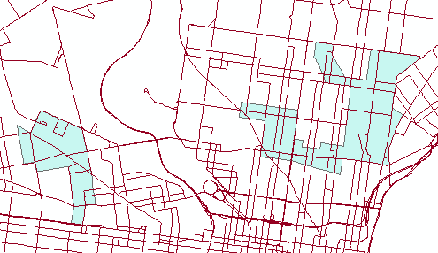
2. Go to the Geoprocessing file menu and select Clip. Note that the clip tool can also be accessed from ArcToolbox (ArcToolbox→Analysis Tools→Extract→Clip).
3. In the Clip dialog box, for Input Features select the bus routes layer. For clip Features select the empowerment zones layer. Name the output shapefile bus_routes_clip. Press OK.
4. View the new shapefile, which should include only the bus routes within the empowerment zones polygons. It may be helpful to turn off the original bus routes layer.  
   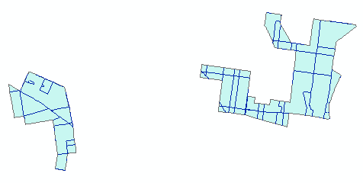
5. Open the attribute tables for the original bus routes layer and the new clipped bus routes layer. Note that they have the identical set of fields.

## Polygon Overlay: Erase

An Erase operation is akin to a “pencil eraser” operation whereby one polygon layer use to erase (or eliminate) the features of another point, line, or polygon layer which fall within its boundaries. As an example, we will erase the bus routes lines that fall within the empowerment zones polygons (i.e. the complement of the previous clip operation).

1. Turn on only the empowerment zones and the original bus routes layers (or add them to ArcMap if you have removed them).
2. Go to the Geoprocessing file menu and select Search for Tools. In the text box type in erase and choose Erase (Analysis). Note that the erase tool can also be accessed from ArcToolbox (ArcToolbox→Analysis Tools→Overlay→Erase).
3. In the Erase dialog box, for Input Features select the bus routes layer. For Erase Features select the empower zones layer. Name the output shapefile bus_routes_erase. Press OK.
4. View the new shapefile, which should include only the bus routes which are NOT within the empowerment zones polygons. It may be helpful to turn off the original bus routes layer and make the empowerment zones hollow.  
   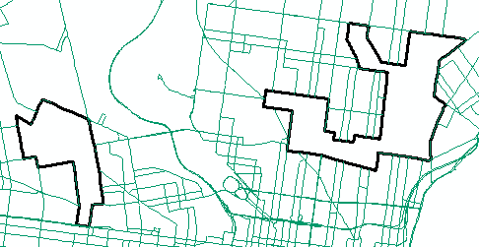
5. Remove all data layers from ArcMap.

## Polygon Overlay: Intersect

The intersect overlay operation creates a new data layer from the areas that overlap when you overlay multiple polygons shape files (that is, the output data layer only includes areas that are spatially coincident to all the input layers). As an example we will intersect the empowerment zones with a buffer of the corner stores which we perform here.

1. Add the empowerment zones layer and the corner stores layers to ArcMap.
2. Perform a buffer operation on the corner stores using a buffer distance of 1320 feet and using the dissolve all option. Name the new shapefile stores_1320ft.
3. Turn off the corner stores layer. Change the symbology of the empowerment zones so it is hollow. Then order the layers so that the empowerment zones is on top. You can see the area of intersection – the area where the stores_1320ft and the empowerment zones are spatially coincident, or overlap each other.  
   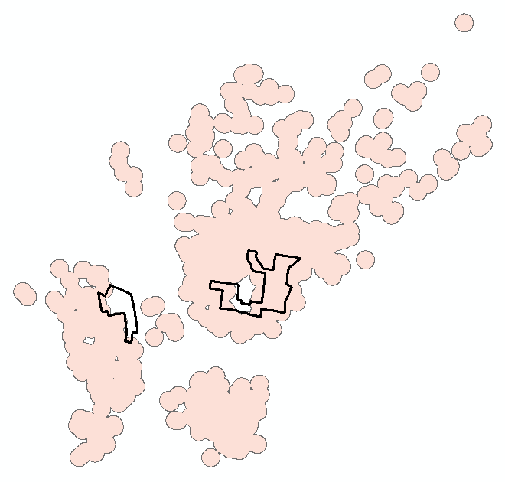
4. Go to the Geoprocessing file menu and choose Intersect. Note that the intersect tool can also be accessed from ArcToolbox (ArcToolbox→Analysis Tools→Overlay→Intersect).
5. For Input Features first add the empowerment zones and then enter the stores_1320ft layer (the order of entry does not matter). Name the output layer zones_storebuf_intersect. Press OK.
6. View the resulting shapefile. It may be helpful to toggle the other layers on and off to see it – the area within both the empowerment zones and the store buffer layers.  
   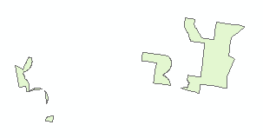
7. Open the attribute table for the new shapefile. Note that it has fields from both the empowerment zones and the stores_1320ft attribute tables. It also has only two records, though there are more than two polygons, indicating it is a multipart layer.

## Polygon Overlay: Union

The union overlay operation creates a new data layer representing the combination of all the areas from all the input layers. As an example we will union the empowerment zones with the buffer of the corner stores you created in the last step.

1. In ArcMap, turn on the empowerment zones and the stores_1320ft layers and turn off the other layers.
2. Go to the Geoprocessing file menu and choose Union. Note that the union tool can also be accessed from ArcToolbox (ArcToolbox→Analysis Tools→Overlay→Union).
3. For Input Features first add the empowerment zones and then enter the stores_1320ft layer (the order does not matter). Name the output layer zones_storebuf_union. Press OK.
4. View the resulting shapefile. It may be helpful to toggle the other layers on and off to see it – the area that includes all of both the empowerment zones and the stores_1320ft layers.

* 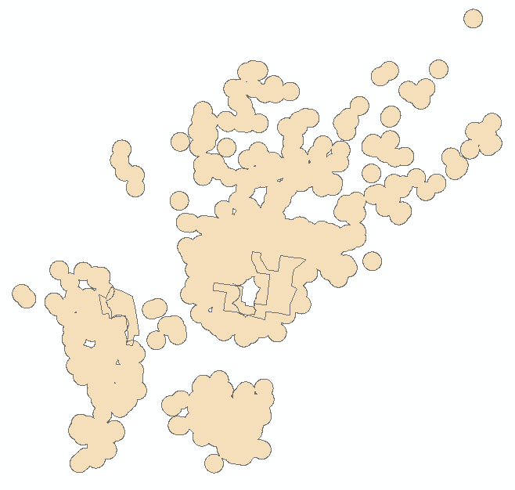

1. Open the attribute table. Note that it contains fields from the both the input layers.
2. Note there are only 5 records in the attribute table. Select each of the records and view which polygons are selected in the map. There are clearly multiple polygons associated with certain records, i.e. it is a multipart shapefile.
3. Note the FIS_stores field, and its values - -1 and 0. These values indicate whether a polygon is inside or outside the original stores_1320ft buffer. A value of -1 indicates the feature is outside the buffer; a value of 0 indicates the feature is inside the buffer. To demonstrate this, select those records in the table that equal -1. Those polygons outside the 1320 foot buffer distance of a corner store, but within the empowerment zones, will be selected.

* 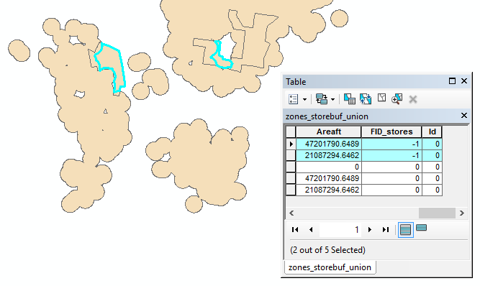

It often helpful to convert the result of a union operation from multipart to a singlepart shapefile. Here, we will convert the zones_storebuf_union shapefile.

1. Clear your selection, if you have any features still selected.
2. In ArcMap, in Geoprocessing->Search for Tools, search for and execute the Multipart to Singlepart tool. Perform the multipart to singlepart operation on the zones_storebuf_union shapefile.
3. View the resulting shapefile. It should now have 29 records in the attribute table – one for each separate polygon.

# ASSIGNMENT

## Objective

Consider the city government is choosing a location to encourage the development of a new store selling healthy foods. The target location should be: within an area targeted for investment, accessible by public transit, and not nearby current farmers markets or corner stores participating in the Healthy Corner Store Initiative.

The following specific spatial criteria are given:

1. Within a Philadelphia empowerment zone
2. Within 2000 feet of a subway station or regional rail station
3. NOT within 1200 feet of a farmers market or corner store participating in the Healthy Corner Store Initiative.
4. A larger contiguous area is preferable to increase the likelihood of securing a potential property.

## Deliverables

**Turn in a report in the format described in the syllabus.**

Be sure to include the following information:

1. One or more maps illustrating the data sets used and a step in the methodology.
2. A map showing the area(s) that meet the spatial criteria.
3. State the area in square feet for each area that meets the criteria and make a recommendation for the best area for a new store selling healthy foods.

The **Introduction** section should state the research objective and the relevant spatial criteria for locating the new store.

The **Data and Methods** section should state the data sets used in the analysis, from where those data were acquired, and the GIS operations employed. The maps illustrating the data sets used and a part of the methodology should be cited in the text here (e.g. Figure 1, 2, etc.)

The **Results** section should state the results (i.e. a brief description of the areas that meet the criteria, the square footage of each, and your recommendation as to the best area for the store). The map of the potential area(s) for the store should be cited in the text here.

The **Discussion** section should state an interpretation of the results (i.e. where in Philadelphia is the recommended area, what is advantageous about this particular location), limitations of the analysis, and how the analysis could be improved or expanded.

The **Tables** **and Figures** section should contain the maps, each on a separate page with a caption. The maps should be cited in the text.

## Getting Started

Make sure all layers and your data frame are in State Plane Pennsylvania South CRS.

There are many ways to complete this analysis (but only one correct answer). All of the tools that you need to complete the lab are described in the lab tutorial. Here is one strategy.

**Start by creating an inclusive layer of the areas where the new store MUST be located.**

1. Buffer the regional rail stations and the subway stations (be sure to use Dissolve All in the buffer operation).
2. Union the resulting regional rail station buffer and the subways station buffer.
3. Intersect the resulting regional rail station/subway station buffer union layer with the empower zones. Name this layer ‘inclusive’ because it describes the area where the new store MUST be located.

**Then create an exclusive layer of the areas where the new store CAN’T be located.**

1. Buffer the farmers markets and the corner stores.
2. Union the resulting farmers markets buffer and the corner stores buffer. Name this layer ‘exclusive’ because it describes the area where the new store CAN’T be located.

**Then create a layer of the candidate areas where the new store MUST be located, but without the areas where it CAN’T be.**

1. Erase the exclusive layer from the inclusive layer. Name this layer ‘candidates’ because it represents the candidates for the final area you recommend.

**Clean up the candidates layer.**

1. Use a multipart to singlepart operation on the candidates layer so that each polygon is represented by one record in the attribute table (clear your selections first).

**Calculate the area of each candidate polygon.**

1. Add a field to the resulting layer’s attribute table to hold the area value of each polygon. Calculate the area of each polygon in square feet.