luca

bouncy boi

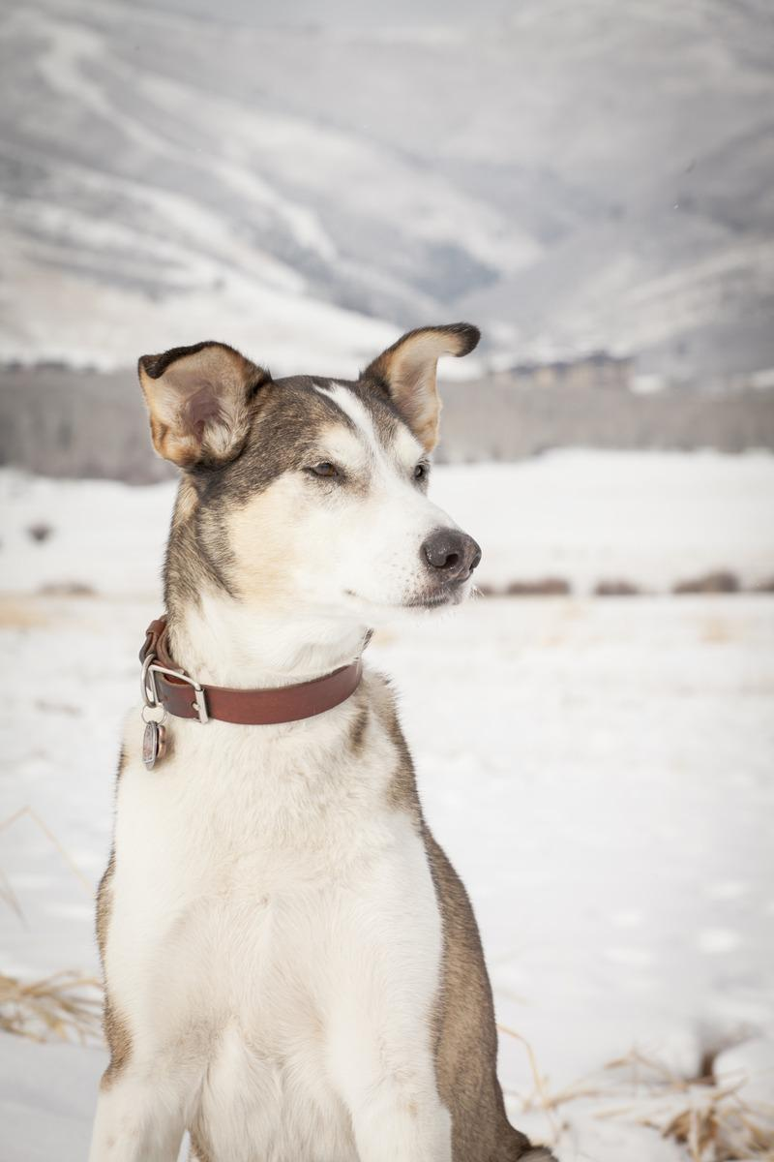

Age: 2  
Sex: male  
Weight: 3lbs  
Breed: greyhound

A small green rectangle to divide sections of the document

# PERSONALITY

crazy

A small green rectangle to divide sections of the document

# HEALTH & GROOMING

heres another description

A small green rectangle to divide sections of the document

# THE OWNER

kevin