$name

$title

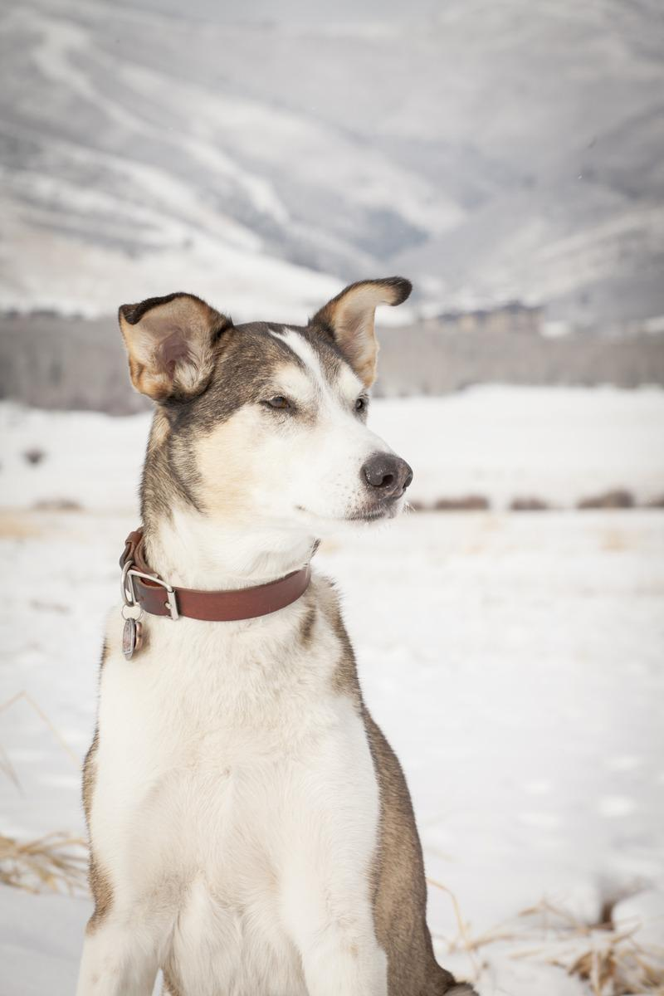

**Age:** $age  
**Sex:** $sex  
**Weight:** $weight  
**Breed:** $breed

A small green rectangle to divide sections of the document

# PERSONALITY

$personality

A small green rectangle to divide sections of the document

# HEALTH & GROOMING

$description

A small green rectangle to divide sections of the document

# THE OWNER

$owner