**Key words**: takeaway, pollution of takeaway, solid waste, garbage disposal

**1 Introduction**

**1.1 Background**

Nowadays as takeaway is increasingly welcomed by the general public, the pollution that it brings is also receiving increasing public concern. With An article posted in September 2017, titled “Takeaways Are Destroying Our Next Generation” in wechat moments, the pollution of takeaway immediately became the focus of the discussion. So, is the degree of contamination brought by takeaway really such a large amount among solid watse, or that, in the finalize how much is it, which has become the problem we need to address, or to some degree, to face.

**1.2 Statement of Problem**

This paper is aimed to build a model estimating the number of solid waste in a different classification using the data of area size and a roughly proportional sample in this area. Based on the data released by some agencies or first-hand, it can work out the relationship between solid waste caused by takeaways and the characteristics of the residents quantitatively. Also, we need to analyze its reliability, strengths, weaknesses and the source of errors, as well as predict the growth rate of various types of rubbish. After all the work, on the basis of the degree of pollution of the environment, we will propose some options which is more optimized and feasible treatment than before.

**1.3 Literature Review**

Based on the data published by takeaway companies, Wu Xingren(2016) roughly estimated the environmental damage caused by takeaway, claiming the daily use of plastic bags can cover 420,000 square meters, about the equivalent of 59 football pitches, about 15 days to cover West Lake(if a single takeaway with a plastic bag, and 0.06 square meters per plastic bag). Also, Fu Yunxia et al(2014) investigated the distribution of garbage in an area and tried to find a clue. And Zeng Xianlai et al(2001) are based on different types of rubbish on the severity of environmental pollution to explore what kind of garbage should be promptly dealt with. However, most of the above documents were mostly rough estimates. There was no "trait" in the calculation of trash produced by takeaways in a particular place. At the same time, the links between garbage generated from takeaways and solid waste also need to be investigated, which is exactly this paper’s objective.

**2 Assumptions**

(1) For the same area, it will still have the same distribution characteristics of solid waste, unless it is reduced to a extremely small area ( such as residential area, industrial area), that is, for a specific area, The wide range of suitable distribution characteristics also apply to small areas, vice versa.

(2) For the above extremely small area, they have roughly the same solid waste components and proportions for different areas. For example, the residential areas in different areas should have the same solid waste component and the proportion of each component should be roughly the same at the same time.

**3 Analysis of the Problem**

There are three main tasks in this paper:

(1) build a model estimating the number of solid waste in a different classification,

(2) work out the relationship between solid waste caused by takeaways and the characteristics of the residents quantitatively, and

(3) propose some options which is more optimized and feasible treatment than before.

Besides, we have to gather related information and datum about takeaway outbreak, so that we can build our models consist with the facts.

**4 Model 1(Classification Model)**

**4.1 the Standard of Classification**

To analyze the problem better, we propose several ways of garbage classification:

**Classification 1**: Solid waste collected from several recycling sites will be collected daily to determine the weight of them, and then they will be divided into the following categories: recyclable paper (such as newspaper, wrapping paper, paper box, etc.), non-recyclable paper (such as sanitary paper and water-soluble paper towels, etc.), recyclable plastic (such as mineral water bottles, plastic packaging, etc.), non-recyclable plastic (such as plastic bags, disposable plastic lunch boxes, tableware, etc.), food debris, and other (such as leather, glass, etc.).

If their weight percentages are denoted as $n_{1}, n_{2}, n_{3}, n_{4}, n_{5}, n_{6},$ a set of six-dimensional vectors ($n_{1}, n_{2}, n_{3}, n_{4}, n_{5}, n_{6}$) characterizing the sequence is obtained. Considering the linear correlation ($n_{1}+ n_{2}+n_{3}+ n_{4}+n_{5}+n_{6}=1$), for a sequence labeled i, give its eigenvector $\overset{⃑}{X_{i}}$ =($n_{1},n_{2},n_{3},n_{4},n_{5},n_{6}$). Obviously, any eigenvector of this sequence is mapped to a six-dimensional space.

**Classification 2**: In the above classification method, you can see the non-recyclable paper, non-recyclable plastic and food debris hold the characteristics of takeaway, named as takeaway signature, and their weight percentages denoted as $a_{1}=n_{2}+n_{4}+n_{5}.$ The remaining three do not have this feature, named as non-takeaway signature, and their weight percentages denoted as $a_{2}=n_{1}+n_{3}+n_{6}.$ Similarly, a set of two-dimensional vectors ($a_{1},a_{2}$) characterizing the sequence is obtained. Considering the linear correlation ($a_{1}+a_{2}=1$), for a sequence labeled k, give its eigenvector $\overset{⃑}{Y_{k}}$ = $a_{1},a_{2}$). Obviously, any eigenvector of this sequence is mapped to a two-dimensional space.

**Classification 3**: Different from the above classification methods, divide solid waste into dry garbage and wet garbage, and denote their weight percentages as $b_{1},b_{2}.$ a set of two-dimensional vectors ($b_{1},b_{2}$) characterizing the sequence is obtained. Considering the linear correlation ($b_{1}+b_{2}=1$), for a sequence labeled j, give its eigenvector $\overset{⃑}{Z_{j}}$ = $(b_{1},b_{2}$). Obviously, any eigenvector of this sequence is mapped to a two-dimensional space.

**4.2 Foundation of the Model**

Define the residential areas, commercial areas (restaurants, entertainment), schools, business districts as A, B, C, D class. At this point the problem can be transformed into: there are k categories $G_{1},G_{2},……G_{k}$. For any sample x belonging to class $G_{1}$, its eigenvector $\overset{⃑}{X}$ can be obtained . Now give a learning sample of some known samples such as $x_{1},x_{2}……x_{n}$, based on the value of its eigenvector $\overset{⃑}{X}$, making a judgment of the category to which a certain sample x from these k categories belongs.

Taking Classification 1 as an example (the following models are also explained taking Classification 1 as an example), established a model to study the relationship between solid waste distribution and resident characteristics:

In classification 1 , k =4, $G_{1}=A,G_{2}=B,G_{3}=C,G_{4}=D,$ and eigenvector $\overset{⃑}{X}$ is six-dimensional. The learning sample contains a total of n = 20 samples.5 samples belong to A, 5 belong to B, 5 belong to C and 5 belong to D. We use the Euclid distance classification model, the Mahalanobis distance classification model and Fisher discriminant model to classify the sequence samples.

**4.3 Euclid Distance Classification Model**

In this model, each sample is regarded as a point in six-dimensional space, and its Euclid distance to the geometric centers of different sets is taken as a criterion. The specific algorithm is as follows:

(1) Give the geometric center of the set of 20 sample points belonging to class A, class B, class C and class D:

$$\overset{⃑}{C_{A}}=\frac{1}{5}Σ_{i=1}^{5}\overset{⃑}{X_{i}}$$

$$\overset{⃑}{C_{B}}=\frac{1}{5}Σ_{i=6}^{10}\overset{⃑}{X_{i}}$$

$$\overset{⃑}{C_{C}}=\frac{1}{5}Σ_{i=11}^{15}\overset{⃑}{X_{i}}$$

$$\overset{⃑}{C_{D}}=\frac{1}{5}Σ_{i=16}^{20}\overset{⃑}{X_{i}}$$

*\*

(2) For a given sample point $X_{i}$, compute the Euclid distance $D_{A}=\left|\overset{⃑}{X_{i}}-\overset{⃑}{C_{A}}\right|$ from this point to $\overset{⃑}{C_{A}}$, the Euclid distance $D_{B}=|\overset{⃑}{X_{i}}-\overset{⃑}{C_{B}}|$ from this point to $\overset{⃑}{C_{B}}$, the Euclid distance $D_{C}=|\overset{⃑}{X_{i}}-\overset{⃑}{C_{C}}|$ from this point to $\overset{⃑}{C_{C}}$, and the Euclid distance $D_{D}=|\overset{⃑}{X_{i}}-\overset{⃑}{C_{D}}|$ from this point to $\overset{⃑}{C_{D}}$.

(3) The standards for judgment are as follows:

1. If min {}, then is judged as Class A;

2. If min {}, then is judged as Class B;

3. If min {}, then is judged as Class C;

4. If min {}, then is judged as Class D;

5. If , then $\overset{⃑}{X}$ is judged as indistinguishable class;

**4.4 Mahalanobis Distance Classification Model**

In order to overcome the defects when using Euclid distance, we use Mahalanobis distance to optimize the Euclid distance.The improved algorithm is as follows:

Suppose that the mean of six-dimensional global $\overset{⃑}{G}$ is $\overset{⃑}{μ}={\left(μ_{1},μ_{2},μ_{3},μ_{4},μ_{5},μ_{6}\right)}^{T}$ and the covariance matrix is non-singular matrix $V_{6×6}$, the Mahalanobis distance from the six-dimensional sample $\overset{⃑}{X}$ to the overall $\overset{⃑}{G}$ is:

$$dm \left(\overset{⃑}{X},\overset{⃑}{G}\right)=\sqrt{{\left(\overset{⃑}{X}-\overset{⃑}{μ}\right)}^{T}V^{-1}(\overset{⃑}{X}-\overset{⃑}{μ})}$$

where the mean of the samples is used instead the unknown $\overset{⃑}{μ}$, and the covariance matrix V can be replaced by the sample covariance matrix of the learning samples.

The Mahalanobis distance is used to discriminate the model, following the criteria as follows:

1. If min {}, then is judged as Class A;

2. If min {}, then is judged as Class B;

3. If min {}, then is judged as Class C;

4. If min {}, then is judged as Class D;

5. If , then $\overset{⃑}{X}$ is judged as indistinguishable class;

**4.5 Fisher Discriminant Model**

The method of classification in multidimensional space is not only distance classification, commonly used Fisher discriminant model is another classification based on geometric characteristics. In the Fisher discriminant model, the sample $\overset{⃑}{X}$ in the six-dimensional space is mapped to a one-dimensional distance y for judgment.

The specific approach is to first introduce a to-be-determined vector $\overset{⃑}{u}$ with the same dimension as the sample, and then take y as a linear combination of X coordinates $y=u^{T}x$, while u should be chosen such that y generated by the same category is as close as possible,while generated by the different category is as far as possible we can define the distance from sample $\overset{⃑}{X}$ to a certain class $\overset{⃑}{G}$ as the Euclidean distance between $y=u^{T}x$ and $yc=u^{T}c$:

$$L\left(\overset{⃑}{X},\overset{⃑}{G}\right)=\left|y-yc\right|=|u^{T}(x-c)|$$

Where c is the geometric center of $\overset{⃑}{G}$.

Fisher classification criteria are:

1. If min {}, then is judged as Class A;

2. If min {}, then is judged as Class B;

3. If min {}, then is judged as Class C;

4. If min {}, then is judged as Class D;

5. If , then $\overset{⃑}{X}$ is judged as indistinguishable class;

According to the requirements of $\overset{⃑}{u}$, Fisher proposed a more effective selection algorithm.

**4.6 Comparison of Three Models and the Final Model of Classification**

The three models have some differences in the classification results, and apart from the classification by distance, we must also consider the area density (kg / m) of a certain area is close to the geometric center of the class in a certain error range.

In this case, we propose a joint judgment criterion: for any sequence, when the results of the three classification methods are exactly the same and the area density (kg / m) is close, it is considered valid. Otherwise, when the results of the three taxonomies are inconsistent, the sequence is considered as a indistinguishable class, and the sequence that can not be correctly classified by all three methods can be considered as an abnormal condition without affecting the performance of the algorithm.

**4.7 Strength and Weakness of this Model**

Euclid distance as a criterion is simple and intuitive, but there are obvious defects: From the perspective of probability and statistics, it is not good to describe the distance between random points by the Euclid distance, so when the sample to be classified is a random sample, with a certain statistical nature, this model does not describe well the closeness between two random points.

The Mahalanobis distance between two points is independent of the unit of measurement of the raw data; the Mahalanobis distance can also exclude the interference of the correlation between the variables, Its downside is that it exaggerates the effect of small variations.

Fisher's linear discriminant not only applies to deterministic pattern classifier, but also applies to stochastic situation, and it can be extended to many kinds of problems. But for the linear inseparable situation, it cannot determine the classification.

Through the use of three ways at the same time classification, we can reduce the limitations of a method to achieve the purpose of accurate classification.

**5 Model 2(Pollution Weight Model)**

Now that we have got the solid waste classification corresponding to the nature of each resident and the number of each classification according to the classification estimation. Based on these classification conditions, we decided to analyze the government's governance approach to the different region by analyzing the degree of pollution so as to obtain a more optimized and viable solution.

At present, the total amount of urban domestic garbage in China is roughly $6×{10}^{9}t$, the occupied land area is nearly $5×{10}^{8}m^{2}$. Approximately, there are two-thirds of the cities surrounded by rubbish, while one-fourth of the cities have no suitable place for rubbish. The treatment and utilization of domestic waste are of great importance. However, most of the nation-wide composting plants or incinerators have stagnated. The reason is that it does not take into account the actual situation in this region or the ill-considered, while using the method of waste disposal in other regions blindly.

In fact, in municipal solid waste, different pollutants have different degrees of environmental pollution, even if the same pollutants have different levels of environmental pollution in different regions, that is to say, the pollution weights are different. To get a more effective treatment plan, we must calculate the weight of pollutants in the region.

**5.1 Model Preparation**

After analysis, the pollution weight of pollutants is related to the three major factors of pollutant hazards, governance costs and pollution generated by governance (secondary pollution), and should be a function of these three factors:

$$w_{i}=h_{i}c_{i}v_{i}$$

Where $h_{i}$ is the hazard of the $i^{th}$ component of the pollutant; $c_{i}$ is the governance cost of the $i^{th}$ component; $v_{i}$ is the secondary pollution of the $i^{th}$ component. (i = 1, 2, ... 6)

Because of the different dimensions of the raw data for the three main project indicators of rubbish pollution weight, the data need to be normalized. After normalized:

$${\hat{w}}_{i}=\frac{w_{i}}{\sum_{i=1}^{n}{w_{i}}}$$

Where $w_{i}$ is the weight of the $i^{th}$ component (i = 1, 2, ... 6), ${\hat{w}}_{i}$ is the weight of the $i^{th}$ component after processing;

**5.2 Determination of Model Parameters**

Use mature AHP to determine. Analytic Hierarchy Process (AHP) was proposed by Thomas L. Sadi, University of Pittsburgh, a famous American operations research scientist in 1971. It is a combination of qualitative and quantitative methods to systematically. In this paper, we use nine scales AHP method to compare the weight of each factor.

Sort the trash types first: recyclable paper, non-recyclable paper, recyclable plastic, non-recyclable plastic, food debris, and other respectively 1,2 ... 6. For example, the harm of non-recyclable paper contaminants is $h_{3}$.

After reviewing the relevant information, we finally got the following three comparison matrices：

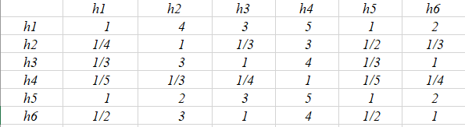

Pollution Hazard Comparison Matrix

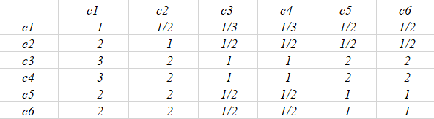

Governance Cost Comparison Matrix

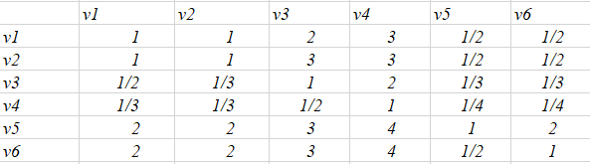

Secondary Pollution Comparison Matrix

The final $w_{i}=h_{i}c_{i}v_{i}$ table is as follows

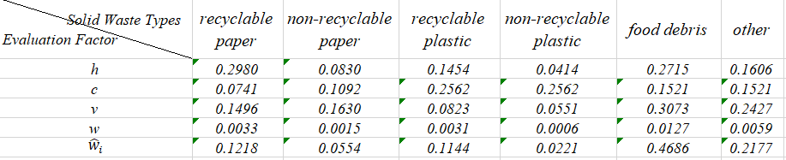

So, we get different pollution weight ${\hat{w}}_{i}$ of different kinds of solid waste. However, in the process of analysis, we consider that the number of pollutants and the total growth rate of pollutants need to be considered in formulating an optimal and feasible treatment plan.

For the number of different types of pollutants in different regions, we have some data in the classification model established before, but with the development of cities, the growth rate of pollutants has also become an indispensable factor in the formulation of governance programs. If the regional production of waste is estimated too high, the corresponding design of waste treatment storage capacity will inevitably increase, which will result in a tremendous waste of financial and material resources; if the regional production of waste is estimated too low, it will lead to the amount of waste disposal can not meet the needs of the actual situation. So, it is particularly important to forecast the future garbage production correctly.

**5.3 Gray Prediction GM (1,1) Model**

1. Data inspection and processing:

To ensure the feasibility of the GM (1,1) modeling method, we first need to do the necessary test on the known data.

Set initial data as $x^{(0)}=(x^{0}(1),x^{0}(2),….x^{0}(n))$, calculate the rank of the series:

$λ(k)=x^{0}(k-1)x^{0}(k)$*，k=2,3…n*

If all ranks fall within the allowable coverage area *X= $\left(e^{\frac{-2}{n+1}},e^{\frac{2}{n+1}}\right)$,* Then the sequence $x^{(0)}$ can establish a GM (1,1) model and can be gray-predicted. Otherwise, we need to do the appropriate transformation of the data.

2.Establish Gray Prediction GM (1,1) Model

(1) It is necessary to calculate the accumulative generating sequence and the equal weight generating sequence of the initial sequence

the accumulative generating sequence(once): $x^{(1)}=(x^{1}\left(1\right),x^{1}\left(2\right),…x^{1}(k)),k=1,2,…n$

$${ x}^{1}\left(k\right)=\sum_{i=1}^{k}{x^{0}\left(i\right),k=1,2,…n}$$

${Equal weight adjacent value generation number of x}^{(1)}$:

$$z^{(1)}=(z^{1}\left(1\right),z^{1}\left(2\right),…z^{1}(k)),k=1,2,…n$$

$$z^{1}\left(k\right)=\frac{1}{2}(x^{1}\left(k\right)+x^{1}(k-1)),k=1,2,…n$$

(2) Establish The GM (1,1) Model based on the initial sequence

$$x^{0}\left(k\right)+az^{1}\left(k\right)=b,k=1,2,…n$$

(3) Transform the GM (1,1) model into its albino model

albino GM (1,1) model: for the gray differential equation of GM (1,1), the previous $x^{(1)}$ is treated as the time t function if the time k = 2, 3, ..., n are treated as continuous variables t. $x^{0}(k)$ becomes the derivative of the continuous function $\frac{dx^{1}(t)}{dt}$ and the whitened background value $z^{1}(k)$ corresponds to the derivative $x^{1}(t)$. Then the gray differential equation of GM (1,1) corresponds to the white differential equation:

$$\frac{dx^{1}(t)}{dt}+ax^{1}\left(t\right)=b$$

(4) Seeking albino model solution is:

$$x^{1}\left(t\right)=\left(x^{0}\left(1\right)-\frac{b}{a}\right)e^{-a(t-1)}+\frac{b}{a}$$

(5) Get the predicted value:

$${\hat{x}}^{1}\left(k+1\right)=\left(x^{0}\left(1\right)-\frac{b}{a}\right)e^{-ak}+\frac{b}{a},k=1,2,…n$$

$${\hat{x}}^{0}\left(k+1\right)={\hat{x}}^{1}\left(k+1\right)-{\hat{x}}^{1}\left(k\right),k=1,2,…n$$

(6) Calculate the growth rate: Suppose the growth rate of k + 1 year is p, then:

3. Test the prediction, get the model error

(1) Residual test: Calculate the relative residuals

$$ε（k）=\frac{x^{0}\left(k\right)-{\hat{x}}^{0}\left(k\right)}{x^{0}\left(k\right)},k=1,2,…n$$

If all $\left|ε\left(k\right)\right|<0.1$, a higher requirement is reached; Otherwise, the general requirement is considered for all $|ε(k)|<0.2$*.*

(2) Rank deviation test:

$$p\left(k\right)=1-\frac{1-0.5a}{1+0.5a}λ(k),k=1,2,…n$$

If all $|ρ(k)|<0.1$, a higher requirement is reached; Otherwise, the general requirement is considered for all $|ρ(k)|<0.2$*.*

**5.4 Model Result**

Use this model to predict the growth rate of solid waste in Chengdu:

1. Data Sources

According to the industry standard promulgated by the Ministry of Construction, "Calculation and Prediction of Municipal Solid Waste Production" (CJ / T106-1999), when the forecasting base is selected "It is necessary to base the production of refuse which has been traced back continuously for 6 to 8 years beginning with the year of the adjacent year of the forecast." In the study of domestic waste production in Nanjing forecast, the basic data used in the forecast are taken from the amount of domestic garbage in Sichuan Province during 2010-2016. (Table I)

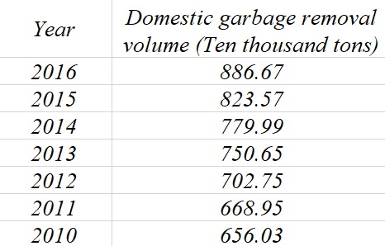

Table I 2010-2016 Sichuan garbage removal volume / year

First of all, we test the data and found that the data $λ(k)$ of the original series are all between $e^{-4}$ and $e^{4}$, which can be predicted by the GM (1,1) model. (Table II)

C:\Users\王志浩\Documents\Tencent Files\965443660\Image\C2C\J~G6~C)V%[)C3YX0U@75{)6.png

Table II The value of $λ(k)$

According to gray forecasting model modeling steps, the selected basic data are processed, and the forecasting model of domestic solid waste transportation volume in Sichuan Province is:

$$x^{0}\left(k\right)+(-0.0553)z^{1}\left(k\right)=611.7995,k=1,2,…n$$

On the basis of the predictive model obtained, the accuracy of the model is tested by residual method and post-difference method. It can be seen from Table III that the fluctuation between the predicted value and the actual value is small, ranging from -0.86 to 0.93, meeting the requirement of residual error $ε（k）<10．00％$. The deviation p range from 0 to 3.65, which also satisfies the requirement of the level deviation $p\left(k\right)<10.00％$. The model has higher accuracy and does not need to be modified to meet the prediction requirements.

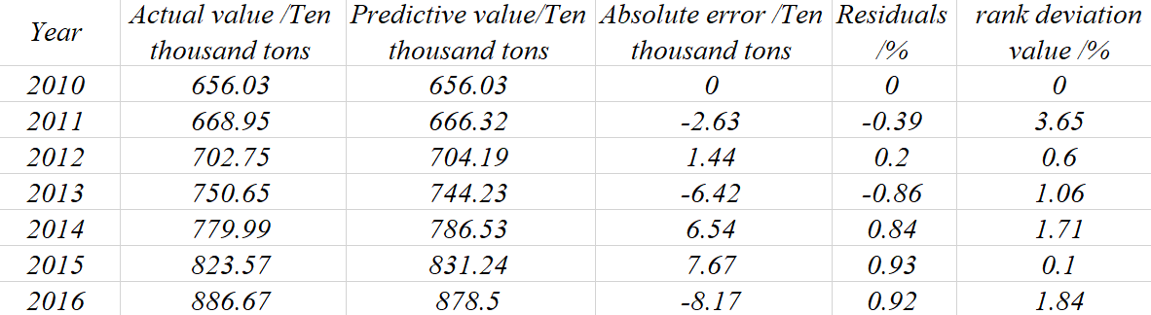

Table III Model Test

Therefore, the estimated amount of garbage transportation in Sichuan Province will be 9,284,400 tons by 2017, and the growth rate of garbage will be 4.70%.

**4 Strength and** **Weakness**

4.1 Strength

4.2 Weakness

**5 Conclusions**

**Reference**

[1] Fu Yunxia, Qiu Zhongping, Fu Chunxia, Zhu Dan & Yin Yue: Composition and Physical and Chemical Analysis of Domestic Waste in Urban Area of Chengdu, [A], 1001-3644(2014) 06-0126-04

[2] Zeng Xianlai, Zhang Jiangqiang & Liu Xiaohong: Establishment and Validation of Weights Model for Ingredients in Municipal Solid Waste, [A], 1672-2043(2004) 04-0774-03

[3] Han Yiping, Yu Hang & Liu Wei: DNA sequence classification, *Mathematical in Practice and Theory*:33-1, Jan. 2001

[4] Wu Xingren:Accustomed to takeaway, how much environmental cost we have to pay, *Liberation Daily*, 24th, May.2016

**Appendices**