DBMS PROJECT

TEAM MEMBERS

* ALY AKHTAR
* DHAWAL ARORA
* MANAFF KHAN

E.R.

DIAGRAM

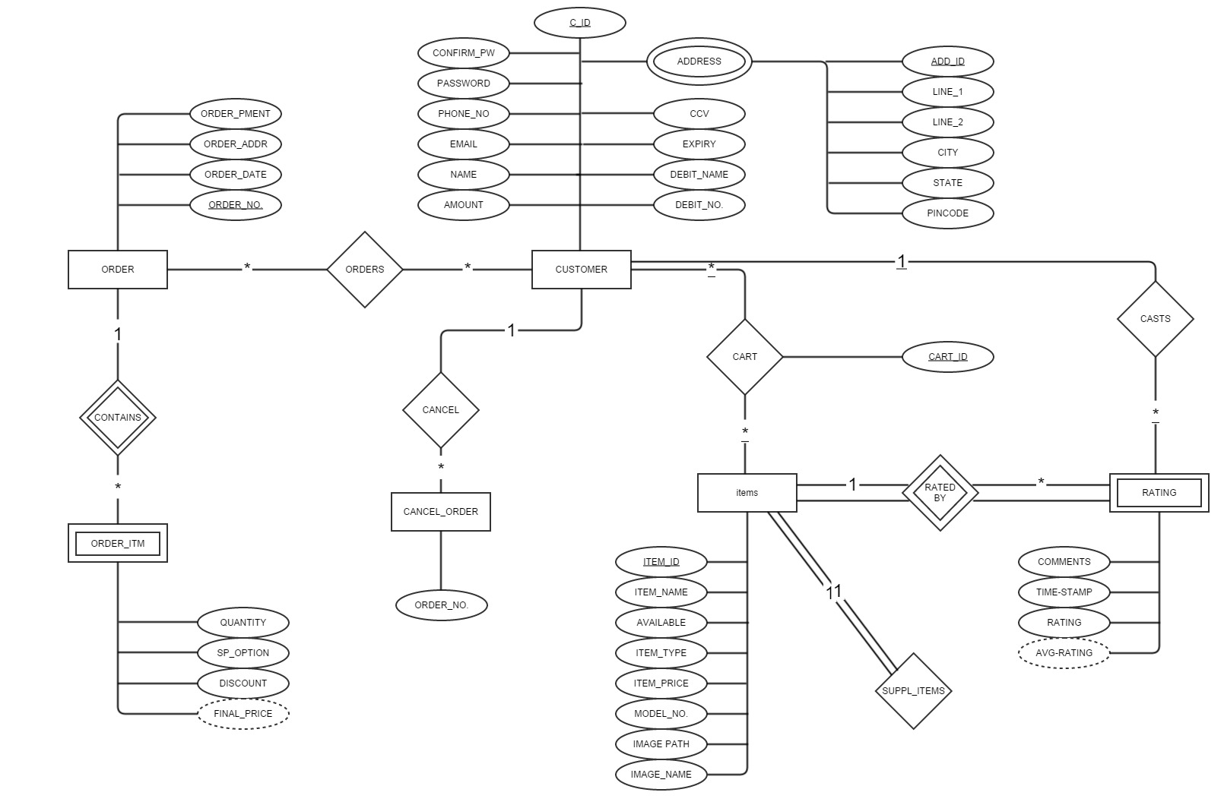

CONVERSION

OF

ER DIAGRAM

INTO

TABLES

ITEMS

|  |  |  |
| --- | --- | --- |
| NAME | TYPE | KEY |
| Item_id | Varchar | Primary |
| Supp_id | Varchar | Foreign |
| Item_name | Varchar | - |
| Available | Int | - |
| Item_price | Int | - |
| Image_path | .jpg | - |
| Image_name | Varchar | - |

CUSTOMER

|  |  |  |
| --- | --- | --- |
| NAME | TYPE | KEY |
| C_id | Varchar | Primary |
| Add_id | Varchar | Foreign |
| Name | Varchar | - |
| Email | Varchar | - |
| Password | Varchar | - |
| Phone_no. | Varchar | - |
| CVV | Varchar | - |
| Expiry | Date | - |
| Debit_name. | Varchar | - |
| Debit_no. | Varchar | - |
| Amount | Int | - |

ADDRESS

|  |  |  |
| --- | --- | --- |
| NAME | TYPE | KEY |
| Add_id | Varchar | Primary |
| Line_1 | Varchar | - |
| Line_2 | Varchar | - |
| City | Varchar | - |
| State | Varchar | - |
| Pincode | Varchar | - |

ORDER

|  |  |  |
| --- | --- | --- |
| NAME | TYPE | KEY |
| Order_no. | Varchar | Primary |
| C_id | Varchar | Foreign |
| Order_pment | Varchar | - |
| Order_addr. | Varchar | - |
| Order_date | Date | - |

ORDER ITEM

|  |  |  |
| --- | --- | --- |
| NAME | TYPE | KEY |
| Order_no. | Varchar | Foreign |
| Item_id | Int | Foreign |
| Quantity | Int | - |
| Special_option | Varchar | - |
| Discount | Int | - |
| Final_price | Int | - |

CONTAINS

|  |  |  |
| --- | --- | --- |
| NAME | TYPE | KEY |
| Order_no. | Varchar | Foreign |
| Item_id | Int | Foreign |

RATING

|  |  |  |
| --- | --- | --- |
| NAME | TYPE | KEY |
| Item_id | Int | Foreign |
| Comments | Varchar | - |
| Rating | Int | - |
| Avg_rating | Int | - |

CART

|  |  |  |
| --- | --- | --- |
| NAME | TYPE | KEY |
| Cart_id | Varchar | Primary |
| C_id | Varchar | Foreign |
| Item_id | Int | Foreign |

S.R.S

ADMIN SCOPE

* ADD ITEMS
* DELETE/MODIFY ITEMS
* ADD/DELETE USER
* ORDER MAINTENANCE
* COMMENET DELET/MAKE
* USER DETAILS ACCESS/MODIFICATION
* REPLY TO USER

USER SCOPE

* COMMENT
* ORDER, CART
* MESSAGE ADMIN
* CANCEL THE ORDER
* CHANGE/EDIT DETAILS

GUEST SCOPE

* LOGIN
* VISIT